AI Orchestrator
Architecture Document (High-Level Design)
Enterprise AI Orchestration API over the Model Context Protocol (MCP)
Version 1.0 — 31 August 2026
Classification: Internal

Document Control
Version | Date | Author | Summary of changes
1.0 | 2026-08-31 | AI Orchestrator Team | Initial release, based on the working reference implementation in this repository.

Companion document | 02-technical-design.docx — low-level design, code-level detail, configuration reference, and run instructions.
Source of truth | This document describes the buildable .NET 8 solution delivered alongside it. Every diagram, endpoint and code reference reflects that implementation, not a hypothetical design.

Contents
1. Executive Summary
2. Business Context & Objectives
3. Scope
4. Key Architecture Decisions
5. High-Level Architecture
6. Intent Analysis & Orchestration Flow
7. MCP Integration Architecture
8. Deployment Architecture (Local)
9. Non-Functional Requirements
10. Security Considerations
11. Scalability & Production Evolution Path
12. Risks & Mitigations
13. Glossary
Appendix A — Technology Stack Summary

1. Executive Summary
This document describes the architecture of the AI Orchestrator: a .NET 8 API that accepts a single plain-English question and returns a synthesized answer drawn from one or more internal backend systems. The orchestrator does not hard-code which system answers which question. Instead it hands the question, together with the machine-readable catalog of tools each connected internal system exposes, to a large language model (LLM); the model decides which tool(s) — if any — are relevant, and the orchestrator executes them and feeds the results back to the model to produce the final answer.
Internal systems are integrated exclusively through the Model Context Protocol (MCP): each backend (payee management, business security/fraud, approval workflow) is wrapped by its own small MCP server process that advertises a handful of named tools. The orchestrator is a generic MCP host — it has no knowledge of payees, risk scores or approvals baked into it; all domain knowledge lives in the MCP servers' tool catalogs and descriptions, which the LLM reads at run time.
Two design choices make the system easy to extend and to reason about. First, the LLM is accessed through a single generic ILlmProvider interface, so the reference implementation ships against Anthropic's Claude API but can be pointed at any other vendor without touching the orchestration logic. Second, the MCP client and server layers implement the real MCP JSON-RPC 2.0 wire protocol (initialize, tools/list, tools/call) over the standard stdio transport, so adding a fourth, fifth or Nth internal system is purely additive: write a new MCP server, add one line of configuration, and it is available to every future question without any orchestrator code changes.
The accompanying repository is a fully buildable, fully tested .NET 8 solution — not a prototype sketch. It builds, an automated test suite runs (11/11 passing at the time of writing), and the full request pipeline (API → LLM → three real MCP server child processes → synthesized answer) has been exercised end-to-end during development, including with a deterministic offline stand-in for the LLM so the plumbing can be verified without live API access.

2. Business Context & Objectives
Internal users — operations staff, compliance analysts, support agents — routinely need information that lives across several disconnected internal systems (“Is this payee active and low-risk, and is there a pending approval blocking their next payment?”). Answering that today means knowing which of several internal APIs to call, in what order, and how to stitch the results together — usually by opening two or three different internal tools.
The AI Orchestrator's objectives:
- Give users a single natural-language entry point instead of several system-specific UIs or APIs.
- Let the LLM — not hand-written if/else routing rules — decide which internal system(s) are relevant to a given question, so new question types work without new orchestrator code.
- Keep every backend integration behind a uniform, inspectable protocol (MCP) rather than bespoke, ad-hoc glue code per system.
- Make the LLM vendor a configuration choice, not an architectural commitment, given how quickly that landscape moves.
- Produce an auditable trace of exactly which internal system(s) and tool(s) were consulted for every answer.

3. Scope

3.1 In scope (this delivery)
- A single public endpoint, POST /api/query, accepting a plain-English question and returning a synthesized answer plus a tool-invocation trace.
- A generic, provider-agnostic LLM integration seam (ILlmProvider), with a working Claude implementation.
- A hand-rolled but spec-faithful MCP client (JSON-RPC 2.0 over stdio: initialize, tools/list, tools/call) able to host any number of MCP servers.
- Three example MCP servers — Payee, Business Security, Approval Workflow — each wrapping a mocked internal API with realistic sample data, standing in for the real internal systems.
- Local, single-host deployment: the API process launches each MCP server as a managed child process.
- A lightweight automated test suite covering the JSON-RPC codec and the orchestration loop.

3.2 Out of scope (this delivery) / future scope
- Connecting the three example MCP servers to real internal APIs (the Mock*ApiClient classes are the intended replacement seam — see the technical design document).
- Cloud/production deployment (containers, orchestration, autoscaling, managed secrets) — this delivery is explicitly local-only, per the requested scope; §8 and §11 describe the evolution path.
- Authentication/authorization on the public endpoint and on inter-service calls (see §10).
- Conversation memory beyond a single request/response (the sessionId field is carried through today for future use but not yet used to persist multi-turn history server-side).
- Streaming responses (Server-Sent Events / chunked responses) — the current endpoint is request/response.

4. Key Architecture Decisions
Decision | Rationale | Consequence
LLM accessed via a generic ILlmProvider interface, not a hard dependency on any one SDK. | The user explicitly asked for flexibility to switch providers later; the LLM vendor landscape changes faster than internal system integrations should. | Orchestration logic in AiOrchestrator.Core never references Claude, OpenAI, or any vendor type. Swapping providers is a new project + one line of DI registration.
Internal systems integrated exclusively via true MCP protocol (JSON-RPC 2.0, stdio transport), not direct REST calls from the orchestrator. | MCP gives a uniform, self-describing contract (tool name, description, JSON-Schema input) that the LLM can reason about without the orchestrator hard-coding domain knowledge. | Adding a new internal system never touches orchestrator code — only a new MCP server and one config entry.
One flat tool namespace exposed to the LLM, tool names encoded as “{serverId}__{toolName}”. | LLM tool-calling APIs take one flat list of tools; two different MCP servers can legitimately expose a same-named tool (e.g. get_status). | The orchestrator can unambiguously route every tool call back to the correct MCP server, and the scheme survives adding more servers.
Bounded ReAct-style loop (configurable MaxToolIterations) rather than an unbounded agent loop. | Prevents a confused model from looping indefinitely, bounds latency and token spend, and gives a predictable worst case. | A very complex, many-hop question may hit the iteration cap; the response says so plainly rather than guessing.
Zero external NuGet package dependencies — the whole solution builds from the .NET SDK and ASP.NET Core shared framework alone. | This build environment had no NuGet access; rather than fight that, the constraint was embraced as a deliberate design goal. | Smaller supply-chain surface and a build that can never fail due to a package registry outage. The MCP protocol and test framework are hand-rolled instead of using the official MCP SDK / xUnit — documented as an explicit, reversible trade-off in the technical design document.
Local, single-host deployment (each MCP server is a child process of the API, communicating over stdio). | Matches the requested scope for this delivery; stdio is the simplest MCP transport and needs no network/ports/TLS for local use. | Horizontal scaling and multi-host deployment require moving to the HTTP+SSE MCP transport — see §11.

5. High-Level Architecture
The system has four logical layers: the API layer (single public entry point), the orchestration layer (intent analysis and the tool-calling loop), the LLM provider layer (vendor-specific translation behind a generic interface), and the MCP layer (client-side transport/protocol plus N independent MCP server processes, each fronting one internal system).
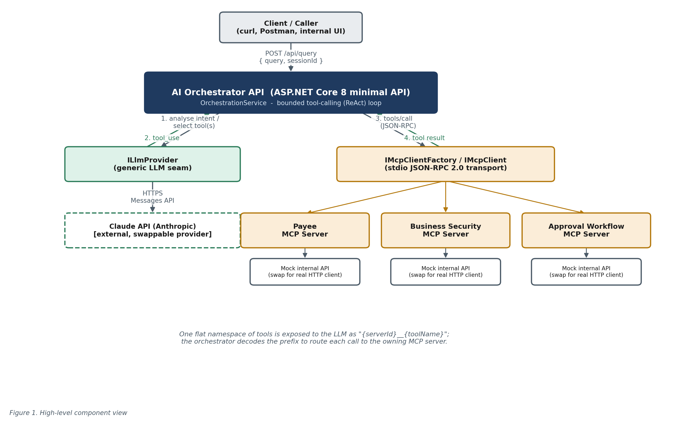
Figure 1. High-level component view

5.1 Component responsibilities
Component | Responsibility
AI Orchestrator API (AiOrchestrator.Api) | ASP.NET Core 8 minimal API host. Exposes POST /api/query, GET /api/tools, GET /health. Composition root: wires up the LLM provider, MCP client stack, and orchestration service via dependency injection.
OrchestrationService (AiOrchestrator.Core) | Runs the bounded tool-calling loop: sends the query and available tools to the LLM, executes any requested MCP tool calls, feeds results back, repeats until the LLM produces a final answer or the iteration budget is exhausted. Vendor- and server-agnostic.
ToolCatalog (AiOrchestrator.Core) | Aggregates the tool list from every healthy connected MCP server into the single flat catalog the LLM is shown each turn; caches it and refreshes on demand.
ILlmProvider / ClaudeLlmProvider | Generic seam to “ask a model a question and let it call tools”. The Claude implementation translates the vendor-neutral request/response model to and from Anthropic's Messages API wire format.
IMcpClientFactory / McpClientFactory | Owns the lifecycle of every configured MCP server: launches each as a child process at API startup, performs the MCP handshake, and disposes them cleanly at shutdown.
IMcpClient / McpClient + StdioMcpTransport | Client-side MCP protocol implementation: sends JSON-RPC requests (initialize, tools/list, tools/call) and correlates responses over a newline-delimited JSON stdio transport to one server process.
MCP servers (Payee / Business Security / Approval Workflow) | Independent processes, each exposing 3 domain-specific tools over the same MCP protocol, backed today by an in-memory mock of the corresponding internal API.

6. Intent Analysis & Orchestration Flow
“Intent analysis” in this system is not a separate classification step — it is delegated entirely to the LLM's native tool-use / function-calling capability. On every turn, the orchestrator sends the model: a system prompt describing its role, the full conversation so far, and the complete catalog of tools currently available (name, description, JSON-Schema input) aggregated across all connected MCP servers. The model itself decides whether any tool is relevant, which one(s), and with what arguments — the orchestrator only executes what the model asks for and reports back what happened.
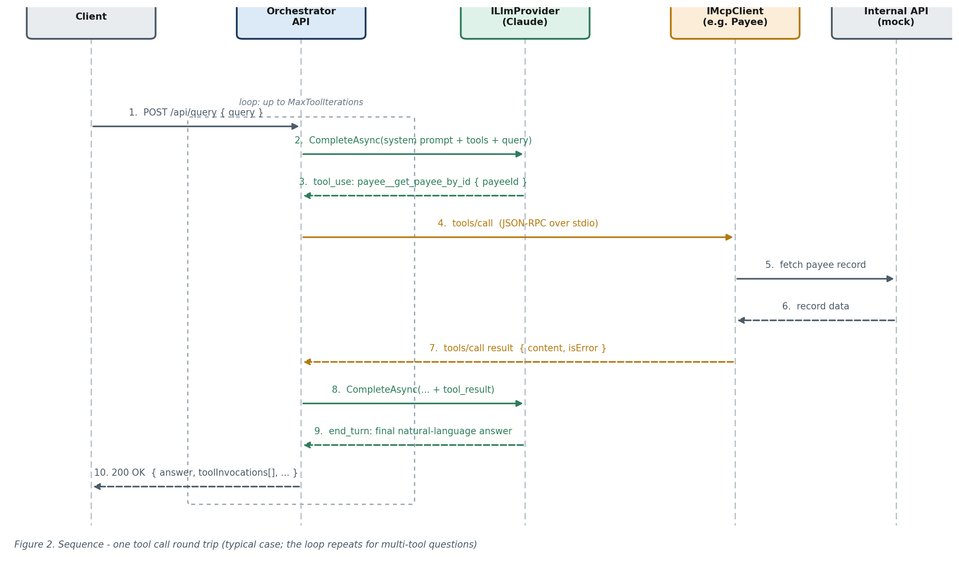
Figure 2. Sequence — one tool-call round trip

6.1 The bounded loop, step by step
1. The client posts a plain-English query to POST /api/query.
2. The orchestrator fetches the current tool catalog (cached, refreshed on demand) and sends it, the system prompt, and the query to the configured ILlmProvider.
3. If the model's response is a final answer (stop reason “end_turn”), the loop ends immediately and the answer is returned — no tool was needed.
4. If the response instead requests one or more tool calls (stop reason “tool_use”), the orchestrator decodes each requested tool name back to its owning MCP server, invokes it, and records a trace entry (server, tool, arguments, result, duration, success/failure).
5. Every tool result is fed back to the model as an observation, and step 2 repeats.
6. The loop is capped at Orchestrator:MaxToolIterations round trips (default 6). If that cap is reached without a final answer, the orchestrator returns a plain-language fallback message rather than guessing or looping forever.
Because the model can request multiple tool calls in a single turn, and the loop can span several turns, the same mechanism transparently supports both single-fact questions (“Is PAY-1001 active?”, one tool call) and multi-hop questions that need evidence from more than one internal system (“Is PAY-1001 high-risk and does it have a pending approval?”, tool calls to two different MCP servers in sequence or in the same turn).

7. MCP Integration Architecture
The Model Context Protocol standardizes how an AI application (the “host”/“client”) discovers and invokes tools exposed by independent “servers”. This solution implements the client side (in the orchestrator) and the server side (in each of the three example services) of the JSON-RPC 2.0 subset of MCP needed for tool discovery and invocation, communicating over the standard stdio transport.
MCP method | Purpose in this system
initialize | Client ↔ server handshake: exchanges protocol version, capabilities, and client/server identity when a server process starts.
notifications/initialized | Client notification confirming the handshake is complete.
tools/list | Server returns its full tool catalog (name, description, JSON-Schema input) — called once at startup and cached in the orchestrator's tool catalog.
tools/call | Client invokes one named tool with JSON arguments; server returns text content plus an isError flag.
ping | Liveness check (implemented server-side; not currently used by the client's steady-state flow).
Every server advertises 3 tools; see the technical design document for the full list, JSON-Schema definitions, and sample payloads. All 9 tools across the 3 example servers were confirmed reachable and callable end-to-end during verification (see §11 of the technical design document).
Design note — hand-rolled MCP vs. the official SDK
The build environment this solution was produced in had no NuGet registry access, so the official ModelContextProtocol C# SDK could not be restored. The JSON-RPC 2.0 envelope and the MCP methods listed above were implemented directly against the public MCP specification instead, entirely with .NET's built-in System.Text.Json and System.Diagnostics.Process. Both the client (AiOrchestrator.Mcp) and server (AiOrchestrator.McpServers.Common) sides are isolated behind the IMcpClient interface and the McpServerHost class respectively, so adopting the official SDK later — for full spec coverage (resources, prompts, sampling, HTTP+SSE transport, auth) — is a contained, drop-in change, not a rewrite.

8. Deployment Architecture (Local)
This delivery targets local deployment only, as scoped. The API process is the single entry point; it launches each configured MCP server as a managed child process over stdio, and is the only process that makes an outbound network call (to the LLM provider, when using a real provider).
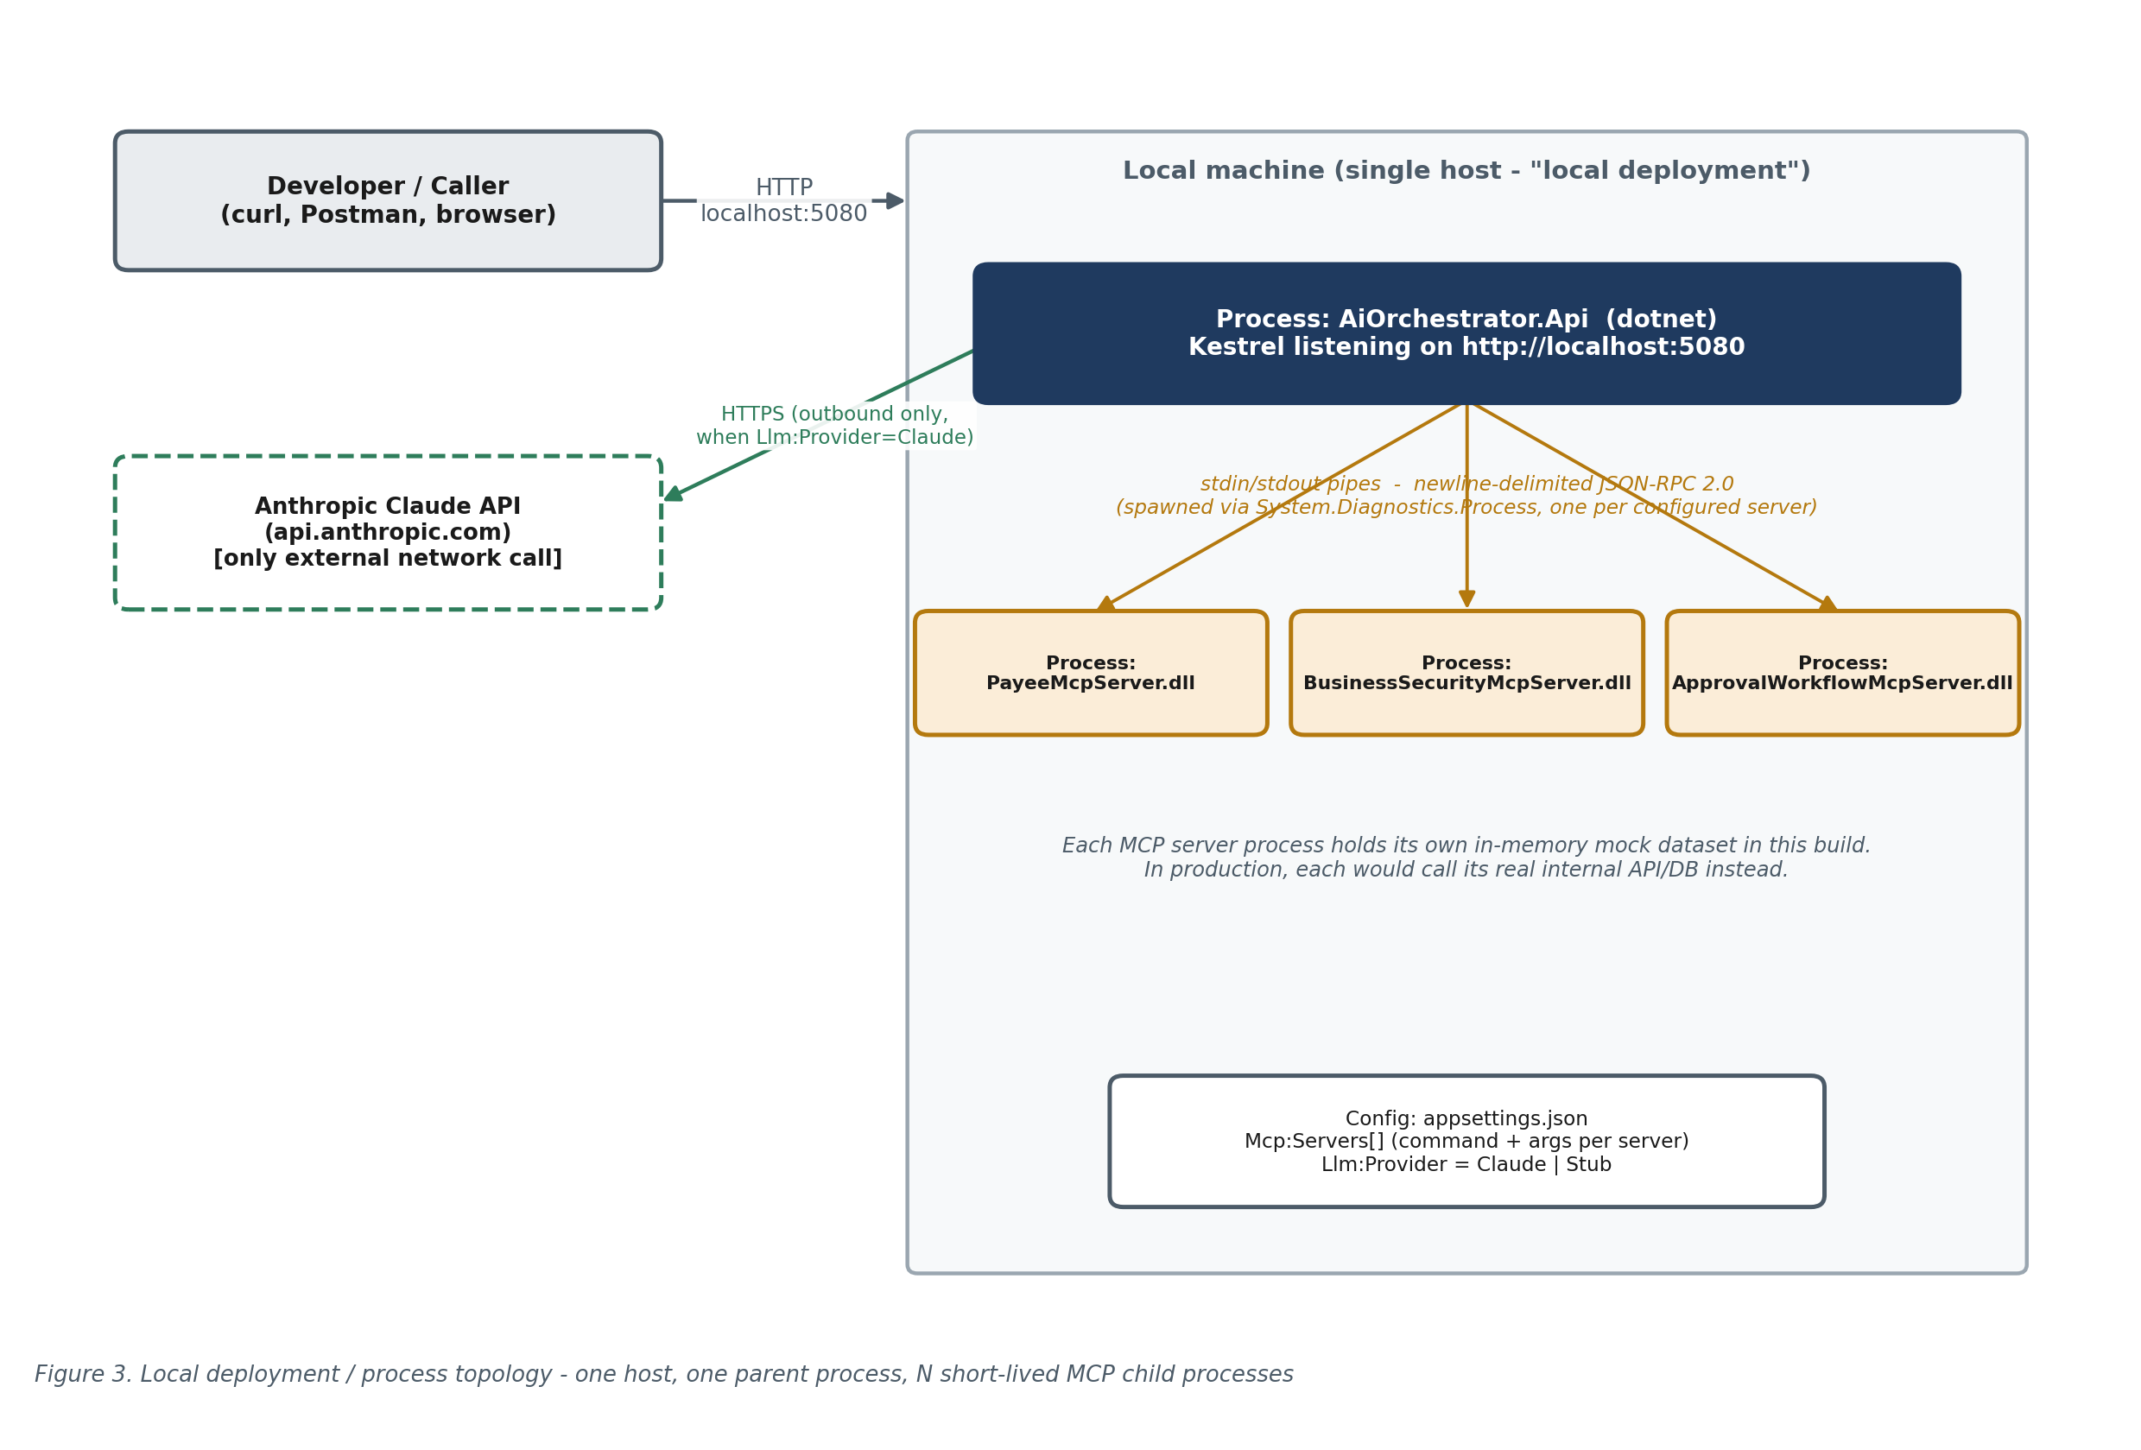
Figure 3. Local deployment / process topology
The MCP server process set is entirely configuration-driven (Mcp:Servers in appsettings.json: id, display name, launch command/args, environment, enabled flag). Restarting the API re-launches every enabled server and rediscovers its tools; no server list is hard-coded in application code.

9. Non-Functional Requirements
Attribute | How it is addressed in this design
Reliability | Startup timeouts and per-call timeouts on every MCP request (Mcp:StartupTimeoutSeconds / CallTimeoutSeconds); an unhealthy or crashed MCP server is skipped by the tool catalog rather than failing every request; a failed/unknown tool call is recorded as an error trace entry, never an unhandled exception; the orchestration loop always terminates (bounded iterations).
Extensibility | New internal systems: add an MCP server + one config entry, zero orchestrator changes. New LLM vendors: implement ILlmProvider, zero orchestration changes. Both extension points are exercised by this delivery (3 MCP servers; a Claude provider and an offline Stub provider both implement ILlmProvider today).
Observability | Structured logging throughout (Microsoft.Extensions.Logging) covering MCP server startup/health, tool discovery, every tool invocation (server, tool, duration, success), and LLM round trips. Every API response carries a full tool-invocation trace, not just the final answer, so any consumer can audit what evidence an answer was based on.
Testability | The orchestration loop depends only on interfaces (ILlmProvider, IMcpClientFactory), so it is unit-tested end-to-end against fake, deterministic implementations with no network or process I/O — see the automated test suite described in the technical design document.
Auditability | QueryResponse.ToolInvocations gives, per call: the server and tool invoked, the exact arguments sent, the result received, whether it errored, and how long it took — sufficient to reconstruct why the system gave a particular answer.
Performance (local) | Sample local runs observed individual MCP tool calls completing in roughly 25–30ms once servers are warm; end-to-end latency for a real deployment is dominated by the LLM round trip(s), not the MCP layer.
Portability | Zero external NuGet dependencies means the solution builds identically on any machine with the .NET 8 SDK installed, with no package-registry access required.

10. Security Considerations

10.1 Secrets handling
- The Claude API key is never stored in configuration or source control — only the name of the environment variable that holds it is configured (Llm:Claude:ApiKeyEnvironmentVariable, default ANTHROPIC_API_KEY). Absence of the key fails clearly and safely (HTTP 500 with an explanatory message) rather than silently.
- In a production evolution of this design, that environment variable would be sourced from a managed secret store (e.g. a cloud secrets manager or vault) injected at deploy time, never committed.

10.2 Process and protocol isolation
- Each MCP server runs as its own OS process with its own memory space; a crash or bug in one server cannot corrupt another server's state or the orchestrator's.
- The MCP stdio transport reserves stdout exclusively for JSON-RPC frames; all diagnostic logging is written to stderr, so a server can never accidentally corrupt the protocol stream with a stray log line.
- Tool inputs are JSON-Schema-described and parsed defensively; unknown/malformed tool calls (e.g. the model naming a tool that doesn't exist) are caught and reported back as a structured error rather than throwing.

10.3 Trust boundary (current scope vs. production)
As scoped, this is a local, single-user, single-host system with no authentication on the public endpoint and no network exposure of the MCP servers (they only ever communicate over local stdio pipes to their parent process). That is an appropriate trust boundary for local development and demonstration, but not for a shared or internet-facing deployment. Before any such deployment:
- Add authentication/authorization to POST /api/query (e.g. OAuth2/OIDC bearer tokens, validated at the API gateway or in-process).
- If MCP servers move to a network transport (HTTP+SSE, for horizontal scaling — see §11), add service-to-service authentication between the orchestrator and each MCP server, and do not expose MCP server ports beyond the internal network.
- Add per-user/per-tenant authorization if different callers should see different internal data — today every tool call runs with the same (implicit, developer-level) trust as the API process itself.
- Add rate limiting and input-size limits on the public endpoint.
- Review each Mock*ApiClient's real replacement for how it authenticates to the actual internal API (service credentials, mTLS, etc.) — that is entirely outside this solution's current scope.

11. Scalability & Production Evolution Path
The architecture was deliberately kept close to the eventual production shape so that moving beyond local deployment is additive, not a rewrite:
Today (local) | Production direction | What changes
MCP servers are child processes over stdio. | MCP servers run as independently deployable, independently scalable services over the HTTP+SSE (or streamable HTTP) MCP transport. | Swap StdioMcpTransport for an HTTP-based IMcpTransport implementation behind the same IMcpClient interface; McpServerConfig gains a URL instead of a command/args.
Hand-rolled MCP JSON-RPC subset. | Official ModelContextProtocol C# SDK, for full spec coverage (resources, prompts, sampling, auth). | Replace AiOrchestrator.Mcp / AiOrchestrator.Mcp.Protocol internals behind the existing IMcpClient / IMcpClientFactory interfaces; OrchestrationService is unaffected.
Single ILlmProvider (Claude), chosen by config. | Multiple providers with fallback/routing (e.g. cost- or latency-based). | Add more ILlmProvider implementations and a routing decorator that implements the same interface.
Single API process, no horizontal scaling. | Multiple stateless API replicas behind a load balancer. | OrchestrationService is already stateless per request; this mainly requires the MCP transport change above so a replica doesn't need its own local child processes.
In-memory mock data per MCP server. | Real internal API calls (HTTP/gRPC/DB) from each MCP server. | Replace each Mock*ApiClient with a real client; the MCP tool surface (Program.cs registrations) is unchanged.
No caching. | Cache tool catalogs and, where safe, tool results. | IToolCatalog already centralizes catalog access, and a caching decorator can wrap IMcpClient.CallToolAsync without touching OrchestrationService.
Synchronous request/response. | Streamed responses (tokens and/or tool-invocation events) for long-running multi-hop questions. | Add a streaming endpoint alongside POST /api/query; OrchestrationService's loop structure already produces discrete, streamable events per iteration.

12. Risks & Mitigations
Risk | Impact | Mitigation
Model calls a tool with malformed or incomplete arguments. | Tool call fails or returns an unhelpful result. | Each MCP tool validates required arguments and returns a clear text error (isError: true) rather than throwing; the model sees the error and can retry or explain the limitation to the user.
Model loops indefinitely trying different tools. | Unbounded latency and LLM spend. | Hard cap via Orchestrator:MaxToolIterations; a clear fallback message is returned when the cap is hit.
An MCP server process crashes or fails to start. | That system's data becomes unavailable. | ToolCatalog skips unhealthy servers when building the tool list; the model is simply not offered tools it cannot use, and other servers are unaffected.
LLM vendor API key missing or invalid. | All queries fail. | Fails fast with a clear, actionable error (not a generic 500) at query time; startup itself still succeeds so /health and /api/tools remain usable for diagnosis.
Two MCP servers expose identically-named tools. | Ambiguous routing. | Tool names are namespaced per-server (“{serverId}__{toolName}”) before being shown to the model, so collisions across servers cannot occur.
Hand-rolled MCP/JSON-RPC layer has a spec gap versus the official SDK. | Reduced interoperability with third-party MCP servers/clients. | Implementation follows the public MCP spec for the methods it supports; both client and server sides are isolated behind stable interfaces so the official SDK can be substituted without touching business logic (see §7 design note).

13. Glossary
Term | Meaning
MCP | Model Context Protocol — an open protocol for connecting AI applications to external tools/data sources via a standardized client/server, JSON-RPC-based interface.
MCP host / client | The application that connects to MCP servers and lets an LLM use their tools. In this system, the AI Orchestrator API is the MCP host.
MCP server | An independent process/service that exposes a set of named tools over MCP. This system ships three: Payee, Business Security, Approval Workflow.
Tool | A single named, schema-described action an MCP server exposes (e.g. get_payee_by_id).
Tool use / function calling | An LLM API capability where the model can, instead of replying with text, ask the caller to invoke a named function/tool with given arguments and return the result.
ReAct loop | Reason + Act: an agent pattern where the model alternates between reasoning and taking an action (here, a tool call), observing the result, and reasoning again.
JSON-RPC 2.0 | A lightweight remote-procedure-call protocol encoded as JSON, the wire format MCP is built on.
stdio transport | An MCP transport where the client and server exchange JSON-RPC messages over the child process's standard input/output streams.
ILlmProvider | This solution's vendor-neutral interface for “ask a model a question, optionally with tools”; ClaudeLlmProvider is the shipped implementation.

Appendix A — Technology Stack Summary
Layer | Technology
Runtime / language | .NET 8, C# 12
API host | ASP.NET Core 8 minimal APIs (Kestrel)
LLM integration | Custom ILlmProvider abstraction; Anthropic Claude Messages API via plain HttpClient + System.Text.Json (no vendor SDK package)
Internal system integration | Model Context Protocol, JSON-RPC 2.0 over stdio, hand-implemented against the public spec
Serialization | System.Text.Json (built-in)
Dependency injection / hosting / logging | Microsoft.Extensions.* (DependencyInjection, Hosting, Logging, Options, Http) — obtained via FrameworkReference to the ASP.NET Core shared framework, not NuGet packages
Testing | A minimal custom [Fact]/Assert-style console test runner (see technical design document §10 for why, in place of xUnit/NUnit)
External package dependencies | None — zero NuGet PackageReference entries anywhere in the solution
Deployment target (this delivery) | Local, single host, multi-process (one API process + one child process per MCP server)

End of document.

