1) New/Edit User

- common page for New/Edit

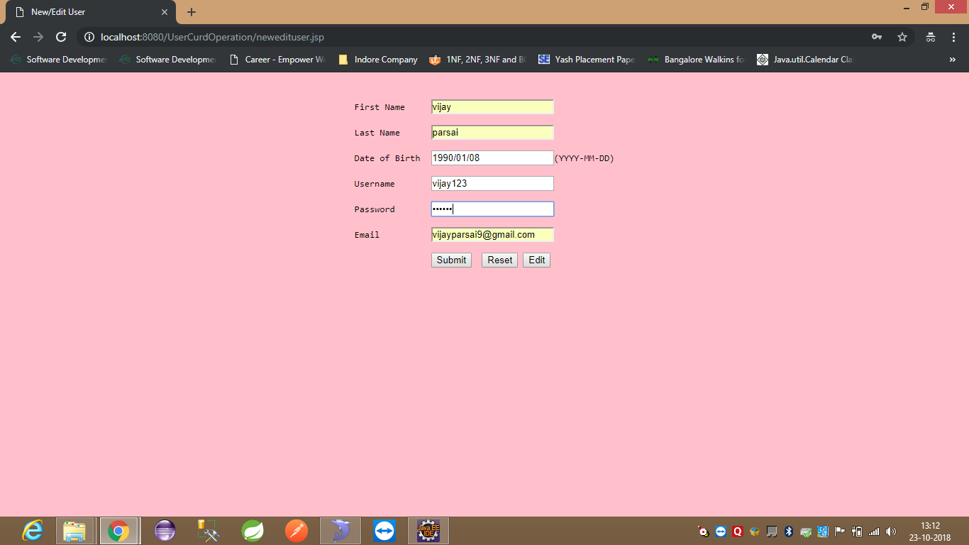

2) List of Users

- Columns: Name, Date of Birth, Username, Email, Edit, Delete

