Vision Transformer for Mango Leaf Disease Detection
TensorFlow version: 2.18.0
preprocessing dataset
classes
C1: Anthracnose images
C2: Bacterial Canker images
C3: Cutting Weevil images
C4: Die Back images
C5: Gall Midge images
C6: Healthy images
C7: Sooty Mould images
Dataset : 3500 images
Image shape: (224, 224, 3)
Training set: 2800 images
Validation set: 700 images
Using device: cuda
Epoch | Training Loss | Validation Loss | Accuracy
1 | 0.2700 | 0.0561 | 0.9800
2 | 0.0314 | 0.0360 | 0.9886
3 | 0.0628 | 0.2063 | 0.9371
4 | 0.0651 | 0.0474 | 0.9857
5 | 0.0131 | 0.0534 | 0.9786
Validation Accuracy: 0.9786
Classification Report:

 | precision | recall | f1-score | support
Anthracnose | 0.99 | 0.97 | 0.98 | 100
Bacterial Canke | 1.00 | 1.00 | 1.00 | 100
Cutting Weevil | 1.00 | 1.00 | 1.00 | 100
Die Back | 1.00 | 0.99 | 0.99 | 100
Gall Midge | 0.97 | 0.96 | 0.96 | 100
Healthy | 0.90 | 1.00 | 0.95 | 100
Sooty Mould | 1.00 | 0.93 | 0.96 | 100
accuracy |  |  | 0.98 | 700
macro avg | 0.98 | 0.98 | 0.98 | 700
weighted avg | 0.98 | 0.98 | 0.98 | 700

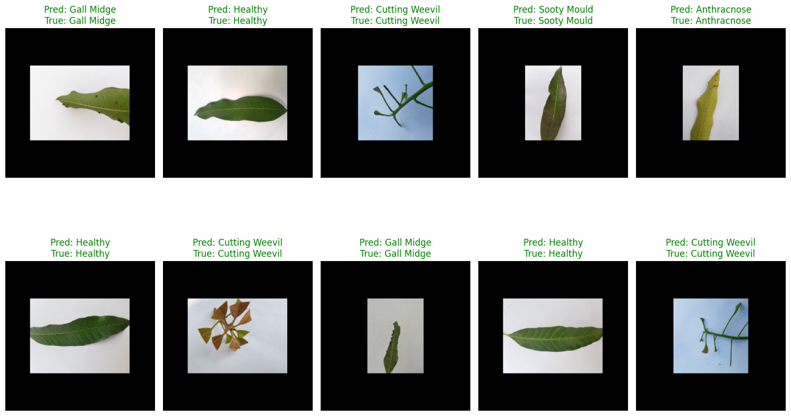

Challenges in classifying high-resolution agricultural images:
- High intra-class variability: The same disease may appear differently depending on lighting, leaf age, or growth stage.
- Small and subtle patterns: Diseases may appear as fine textures or color changes that are difficult to learn without fine-grained features.
- Complex backgrounds: Leaves might overlap or have shadows, water droplets, or other distractions.
- Data imbalance: Some diseases might be underrepresented, making it harder for the model to generalize.
- Computational cost: High-resolution images demand more memory and processing power, especially when training on GPUs with limited resources.

