[cs.nott.ac.uk/~hxm02u/index.html](http://www.cs.nott.ac.uk/~hxm02u/index.html)

Harry Mumford-Turner

4188335 - hxm02u

## G51WPS

### Website Design:

The website design features two side columns, right containing the picture of the shirt and left with the shirt editor. When the user is finished editing the T-Shirt the order conformation screen is displayed and the shirt order is processed.

Advantages:

* The simple layout with two columns enables the user to easily figure out how the website works and how it is divided.
* 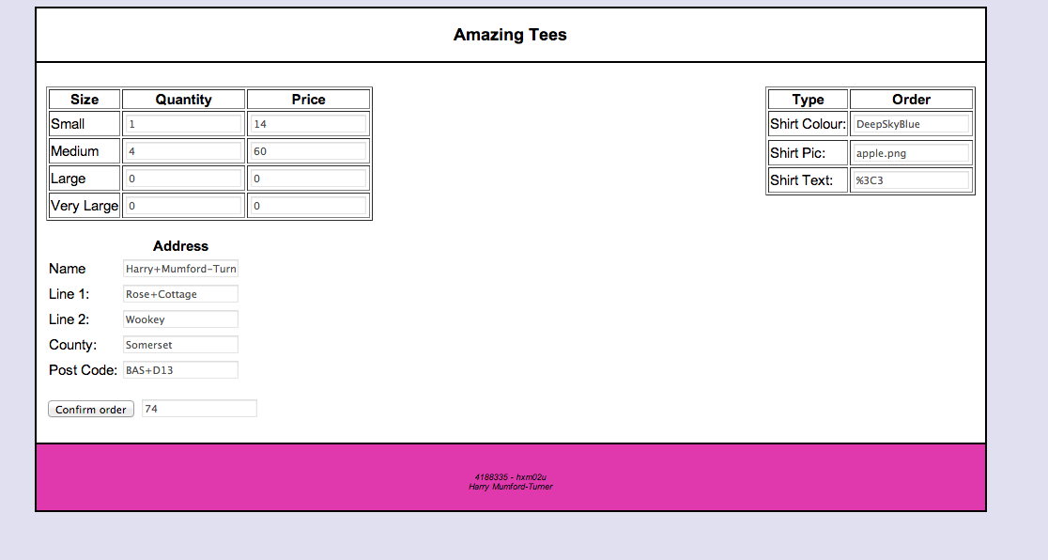The colour contrast between the pink and the grey creates a complementing soft view of the page.
* When ordering multiple T-Shirts at any one time the sum of all the T-Shirts is calculated and printed for the user when confirming their order.
* The cluster of buttons means all of the user control is focused in a single area so they can quickly use and test all of the functions available on the website

Disadvantages:

* The website has only two pages to navigate around which makes it difficult for the user to map the website,
* A navigation pane isn’t there so users cannot locate a home page to go back to.
* Once the user has edited the T-Shirt, is happy with it and pressed the confirm order button they can only press the back button on their browser to navigate back instead of a home page link.

### Web Technologies:

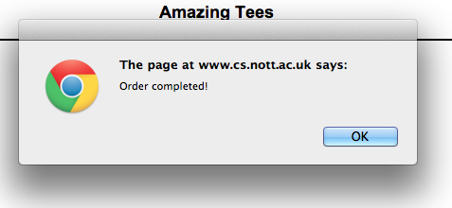The T-Shirt is edited through a series of text boxes and selection boxes, which changes the T-Shirt upon change of the boxes. When the user is happy with the selection the information entered is passed into another form where some of that information is displayed as a conformation e.g. the quantity of T-Shirts. When the user confirms the order, the data is written to a comma-separated file stored on the given server.

Advantages:

* When the user confirms the order of the T-Shirt a popup alert is produced only when the comma-separated file has been written to, so the user definitely knows that it has been completed.
* By using a comma-separated file extraction of the data via the reading end makes the data easily accessible by another program.
* The size of the comma-separated file is very small when adding large amounts of orders so multiple orders are easily handled.
* The data is stored from colour of the shirt first to the address of the customer. The orders are divided up with the colour of the shirt so every 15 lines is a new order.

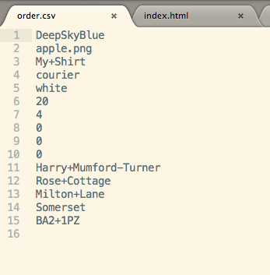

Note the 4 followed by 3 zeros in the picture denotes small medium large very large, so 4 small in this case.

* The system stores detailed information about the designed T-Shirt in the comma-separated file, which is stored on the given server. This enables the company to make a very specific T-Shirt, which has been edited by the user in a very sophisticated manner.

Disadvantages:

* Information such as the users address is unsecure when passed through forms, because it appears in the URL, although this is only really seen by the user so security is debatable in this case.