**RESUME**

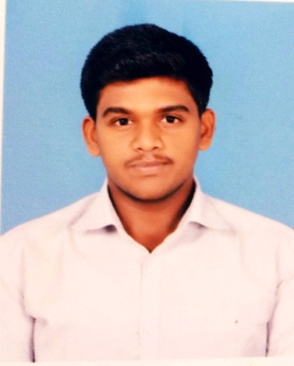

**N.VIJAY**

**Mobile No: 7708197852**

S/O: S. NAVEENA DURAI,

135, FOREST ROAD 4TH STREET,

THENI (DT).

PIN CODE: 625531.

**Email**: [vijaybeeee2020@gmail.com](mailto:vijaybeeee2020@gmail.com)

|  |  |
| --- | --- |
| * **CARRER OBJECTIVES** | * To explore myself fully and realize my potential willing to work as a Software and Electrical field in challenging and creative environment. |

|  |  |  |  |  |  |
| --- | --- | --- | --- | --- | --- |
| * **EDUCATIONAL DETAILS** | **COURSE** | **INSTITUTION** | **BOARD EXAM** | **% OF MARKS** | **YEAR OF PASSING** |
| B.E-EEE | Nadar Saraswathi College of Engineering and Technology | Anna University | 69.02% | 2020 |
| H.S.C | Nadar Saraswathi Higher Secondary School. | State Board | 78.67% | 2016 |
| S.S.L.C | Nadar Saraswathi Higher Secondary School. | State Board | 90.2% | 2014 |

|  |  |  |  |  |
| --- | --- | --- | --- | --- |
| * **WORKING**   **EXPERIENCE** | **COMPANY NAME** | **DURATION** | **CORE** | **POSITION** |
| Squares InfoTech Private  Limited(Product Based) | 4month  Internship | Java | Back-end Developer |
| Spring Boot |
| PSQL |
| REACT JS |
| Then Crypto Currency  club | 1month | Beltex Coin  Based | Office Executive Manager |

|  |  |
| --- | --- |
| * **SOFTWARE**   **SKILLS** | * GitHub * Postman * VS Code * Mongo DB * Dip trace |

|  |  |  |
| --- | --- | --- |
| * **TECHNICAL**   **SKILLS** | **Basic Level**  **(20-45%)** | * Django Framework * Git * ReactJs |
| **Intermitted Level**  **(46%-80%)** | * C * HTML, CSS, JavaScript * PSQL, MySQL * Java |
| **Advanced Level**  **(81%-95%)** | * C++ * Python |

|  |  |
| --- | --- |
| * **AREA OF**   **INTEREST** | * Full Stack Developer * System Engineer * Programming Tutor |

|  |  |  |
| --- | --- | --- |
| * **PROJECTS** | **Mini**  **Projects** | * Rescue of Environmental Vehicle smoke detection and controller. * Power saving system |
| **Main**  **Projects** | * Economical Refabrication of Monoblock Pump. * It has designed at Coimbatore on 29.01.2020 to 22.02.2020. |

|  |  |  |
| --- | --- | --- |
| * **INDUSTRIAL**   **EXPOSURE** | **Intern Ship** | * Academic skill development institute as Training in GEE (27.05.2019 TO 25.06.2019) In Salem. * Attended the IPT provided by TNEB.(11.12.2017 to 15.12.2017) * Attended the IPT provided by Sun best company.(16.12.2019 to 31.12.2019) |
| **Industrial Visit** | * Kundha hydro power plant at OOTY.(31.08.2019) * Siva Sakthi Graviers.(03.08.2019) At Theni |
| **Work Shop** | * PCB Design at Nadar Saraswathi College of Engineering and Technology.(04.12.2017 to 08.12.2017) * We have conducted a Power Supply PCB design program at NSCET.(06.08.2019 to 08.08.2019) |
| **Conference** | * I have attended the international conference at Nadar Saraswathi college of engineering and technology.(14.03.2020) |

|  |  |
| --- | --- |
| * **SYMPOSIUMS** | * I have attended the “EVATAR 2K19” symposium at Kamarajar College of Engineering and Technology in Virudhunagar.(07.08.2019) * I have attended the “TECH CORE 2K17”symposium at Nadar Saraswathi College of Engineering and Technology in Theni.(30.08.2017) * I have attended the “QUASARZ-T20”symposium at Bharath Niketan Engineering College in Theni.(12.03.2020) |

|  |  |  |
| --- | --- | --- |
| * **PERSONAL DETAILS** | Name | Vijay N |
| Dob | 03/04/1999 |
| Gender | Male |
| Fathers name | Naveena Durai S |
| Mothers name | Kavitha N |
| Hobbies | DSA,Django Learning |
| Language known | Tamil, English |
| Nationality | Indian |

|  |  |
| --- | --- |
| * **DECLARATION** | * I hear declare that the above mentioned information is correct up to my knowledge and I bear the responsibility for the correctness of the above mentioned particular. |

Place: Theni Signature

Date: N.vijay