Group # | 05 |  | Week ending:  (Saturday) | 10/22/16 |  |  |  |  | Report # |  |  | 07
Project Title: |  | Spectrum Sensing and Signal Identification using USRP
Group Leader: |  | Thomas Wright |  |  | Advisor: | Bruce McNair
Sponsor/Client: |  | MITRE Corporation
Total number of person-hours spent on project by group during past week: |  |  |  |  |  |  |  | 15
Is project on schedule? |  |  |  |  | Yes |  | [X] |  |  | No | [ ]

Weekly status:

This week, the group was heavily involved in preparing and modifying our midterm report. It was completed, turned in, and was the bulk of the work this week. Also, the GNU Radio tutorials using the radios were started this week. Further developments and modifications were made to the our project’s design which is nearing its completion. Each of the team member’s were also assigned to watch and try the GNU Radio tutorials necessary for getting started on the actual technical aspect of this design.

“I Pledge my Honor that I have abided by the Stevens Honor System.”

Andrew Guthrie Joseph Pang Kunal Patel


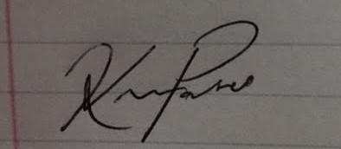

Thomas Wright Vijayrahul Raja
