Group # | 05 |  | Week ending:  (Saturday) | 10/29/16 |  |  |  |  | Report # |  |  | 08
Project Title: |  | Spectrum Sensing and Signal Identification using USRP
Group Leader: |  | Thomas Wright |  |  | Advisor: | Bruce McNair
Sponsor/Client: |  | MITRE Corporation
Total number of person-hours spent on project by group during past week: |  |  |  |  |  |  |  | 15
Is project on schedule? |  |  |  |  | Yes |  | [X] |  |  | No | [ ]

Weekly status:

Last week, the group got into the technical aspects of the radio, the project was divided up, and specific tasks were assigned to individuals. Major tasks involve converting the spectrum back and forth from time/frequency domains in order to isolate signals, and an alternative to looping (for, while, etc.) in GNURadio. Others include creating simple Tx profiles, looking into machine learning concepts, and so on. The website is in final development, and we are working to input required information about the radio’s functions and related operations.

“I Pledge my Honor that I have abided by the Stevens Honor System.”

Andrew Guthrie Joseph Pang Kunal Patel

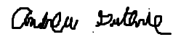
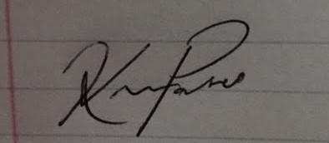

Thomas Wright Vijayrahul Raja
