Group # | 05 |  | Week ending:  (Saturday) | 11/05/16 |  |  |  |  | Report # |  |  | 09
Project Title: |  | Spectrum Sensing and Signal Identification using USRP
Group Leader: |  | Thomas Wright |  |  | Advisor: | Bruce McNair
Sponsor/Client: |  | MITRE Corporation
Total number of person-hours spent on project by group during past week: |  |  |  |  |  |  |  | 15
Is project on schedule? |  |  |  |  | Yes |  | [X] |  |  | No | [ ]

Weekly status:

This week our team work on continuing to investigate the technical aspects of the project. We have partitioned the project into two main sections; isolating signals, and machine learning modulation classification. On the side of isolating signals, we are looking into current isolation techniques, particularly into identifying signals before they are demodulated. For classifying modulation, the team is working on creating TX profiles so we have various modulations to test the system when the time is appropriate. WE are learning how to create custom blocks in GNURadio so we can create the machine learning code in a flowgraph, and finally we are looking into making the machine learning code real-time as opposed to code that takes in training and then test examples and outputs results of testing.

“I Pledge my Honor that I have abided by the Stevens Honor System.”

Andrew Guthrie Joseph Pang Kunal Patel

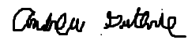
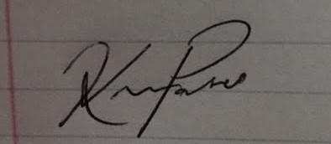

Thomas Wright Vijayrahul Raja
