Group # | 05 |  | Week ending:  (Saturday) | 11/12/16 |  |  |  |  | Report # |  |  | 10
Project Title: |  | Spectrum Sensing and Signal Identification using USRP
Group Leader: |  | Thomas Wright |  |  | Advisor: | Bruce McNair
Sponsor/Client: |  | MITRE Corporation
Total number of person-hours spent on project by group during past week: |  |  |  |  |  |  |  | 15
Is project on schedule? |  |  |  |  | Yes |  | [X] |  |  | No | [ ]

Weekly status:

This week our team work on continuing to investigate the technical aspects of the project. We have partitioned the project into two main sections; isolating signals, and machine learning modulation classification. On the side of isolating signals, we have investigated identifying a signal’s characteristics (center frequency and bandwidth), and then resampling to actually isolate the signal. For classifying modulation, the team is working on creating TX profiles so we have various modulations to test the system when the time is appropriate. We learned how to create custom blocks in GNURadio so we can create the machine learning code in a flowgraph for ease of access. We are looking into making the machine learning code real-time, meaning it does not read pickle files but instead can take in live data from the radio and produce results. We are also making it real time to potentially further train it. The website has been implemented using Github Pages (vijayrahulr.github.io).

“I Pledge my Honor that I have abided by the Stevens Honor System.”

Andrew Guthrie Joseph Pang Kunal Patel

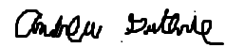
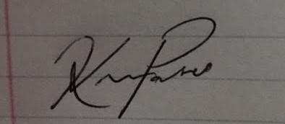

Thomas Wright Vijayrahul Raja
