|  |  |  |  |  |  |  |  |  |  |  |  |  |
| --- | --- | --- | --- | --- | --- | --- | --- | --- | --- | --- | --- | --- |
| **Group #** | **05** | | **Week ending:**  **(Saturday)** | **1/21/17** | | | | | **Report #** | | | **1** |
| **Project Title:** | | **Spectrum Sensing and Signal Identification using USRP** | | | | | | | | | | |
| **Group Leader:** | | **Thomas Wright** | | | **Advisor:** | **Bruce McNair** | | | | | | |
| **Sponsor/Client:** | | **MITRE Corporation** | | | | | | | | | | |
| **Total number of person-hours spent on project by group during past week:** | | | | | | | | **10** | | | | |
| **Is project on schedule?** | | | | | **Yes** | | **[X]** | | | **No** | **[ ]** | |

|  |
| --- |
| **Weekly status:**  The team reacquainted itself this week and shared status updates of work accomplished over the break. We set weekly meetings times and are beginning to coordinate with our advisor to schedule meetings. |

**“I Pledge my Honor that I have abided by the Stevens Honor System.”**

Andrew Guthrie Joseph Pang Kunal Patel

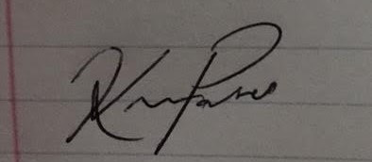



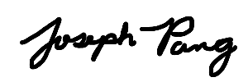

Thomas Wright Vijayrahul Raja

