|  |  |  |  |  |  |  |  |  |  |  |  |  |
| --- | --- | --- | --- | --- | --- | --- | --- | --- | --- | --- | --- | --- |
| **Group #** | **05** | | **Week ending:**  **(Saturday)** | **2/04/17** | | | | | **Report #** | | | **3** |
| **Project Title:** | | **Spectrum Sensing and Signal Identification using USRP** | | | | | | | | | | |
| **Group Leader:** | | **Thomas Wright** | | | **Advisor:** | **Bruce McNair** | | | | | | |
| **Sponsor/Client:** | | **MITRE Corporation** | | | | | | | | | | |
| **Total number of person-hours spent on project by group during past week:** | | | | | | | | **25** | | | | |
| **Is project on schedule?** | | | | | **Yes** | | **[X]** | | | **No** | **[ ]** | |

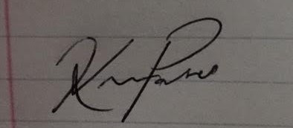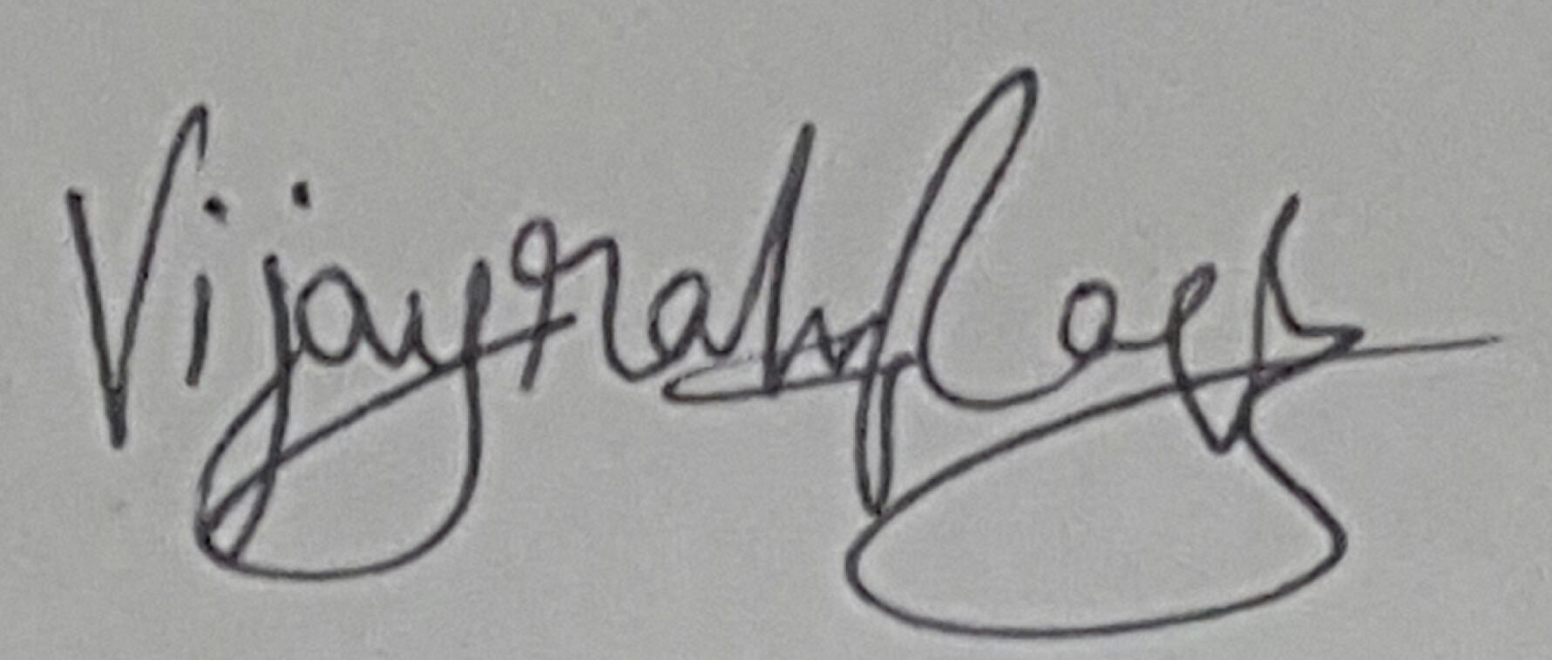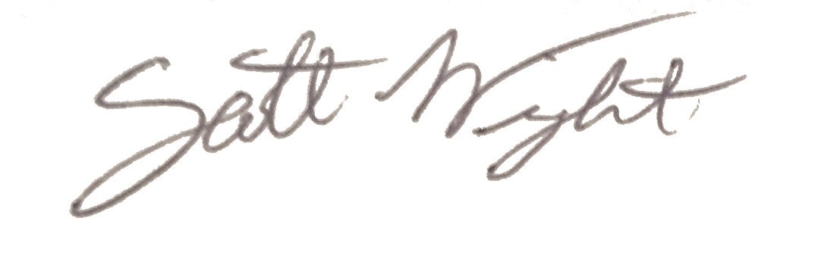

|  |
| --- |
| **Weekly status:**  Our team focused on collecting inputs from our developed machine learning algorithm and defining the data types. We are setting up a large test to be run on the radios to verify functionality across the system. We also started analyzing and making the value proposition and mission statement for our TG as well.  **“I Pledge my Honor that I have abided by the Stevens Honor System.”**  Andrew Guthrie Joseph Pang Kunal Patel    Thomas Wright Vijayrahul Raja |