|  |  |  |  |  |  |  |  |  |  |  |  |  |
| --- | --- | --- | --- | --- | --- | --- | --- | --- | --- | --- | --- | --- |
| **Group #** | **05** | | **Week ending:**  **(Saturday)** | **2/25/17** | | | | | **Report #** | | | **6** |
| **Project Title:** | | **Spectrum Sensing and Signal Identification using USRP** | | | | | | | | | | |
| **Group Leader:** | | **Thomas Wright** | | | **Advisor:** | **Bruce McNair** | | | | | | |
| **Sponsor/Client:** | | **MITRE Corporation** | | | | | | | | | | |
| **Total number of person-hours spent on project by group during past week:** | | | | | | | | **25** | | | | |
| **Is project on schedule?** | | | | | **Yes** | | **[X]** | | | **No** | **[ ]** | |

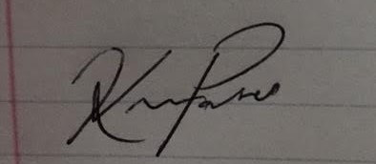

|  |
| --- |
| **Weekly status:**  We have continued with more system testing this week, now focusing on AM signals. Discussion and design has begun on a simple GUI that can be presented to aid in system presentation. Significant effort is also beign put towards optimizing each portion of our system so it runs as fast as possible.  **“I Pledge my Honor that I have abided by the Stevens Honor System.”**  Andrew Guthrie Joseph Pang Kunal Patel  Thomas Wright Vijayrahul Raja |



