RESOURCE-EFFICIENT EMBEDDED SPIROMETER FOR REAL-TIME RESPIRATORY HEALTH MONITORING

Submitted under Undergraduate Research Opportunities Programme (UROP)

SRM INSTITUTE OF SCIENCE AND TECHNOLOGY

AUTHORS: Lenin Valentine C (RA2311004010073) and Harshith Kamal R (RA231100401094)
GUIDE: Dr. S. Vasanthadev Suryakala Assistant Professor (Sr. G) Department of Electronics & Communication Engineering

Department of Electronics and Communication Engineering SRM Institute of Science and Technology, Kattankulathur
1. Introduction
A spirometer is a medical diagnostic device used to assess pulmonary function by measuring the volume of air inhaled and exhaled, along with the rate at which air flows through the respiratory airways. The clinical procedure performed using this device is known as spirometry and is a fundamental tool in respiratory medicine.
Spirometry is widely employed for:
- Diagnosis of respiratory disorders such as asthma, chronic obstructive pulmonary disease (COPD), chronic bronchitis, and pulmonary fibrosis
- Monitoring disease progression and evaluating response to treatment
- Assessment of pulmonary fitness prior to surgical procedures
A spirometer operates by measuring airflow generated during respiratory maneuvers and converting this signal into lung volume and flow-based parameters using numerical signal processing techniques.
Recent advances in wearable and portable medical technologies have shifted respiratory care from episodic, clinic-based testing toward continuous and point-of-care monitoring. As spirometry remains the gold standard for diagnosing and managing obstructive lung diseases, the development of portable, embedded spirometers is critical for early intervention and personalized healthcare. However, implementing spirometry on resource-constrained embedded platforms introduces challenges related to real-time processing, timing determinism, and efficient memory utilization.
2. Background Research
2.1 Spirometric Signal Processing Overview
The primary objective of spirometry is the accurate computation of standardized lung function parameters from measured airflow signals. In embedded implementations, these parameters must be computed online, concurrently with signal acquisition, under strict timing and memory constraints. Unlike offline clinical systems, embedded spirometers must guarantee deterministic execution to preserve temporal accuracy.

2.2 Detection of Respiratory Maneuver Phases
Accurate parameter computation begins with reliable detection of key phases of the respiratory maneuver. Two critical events are identified:
- Start of forced expiration, detected when airflow exceeds a predefined threshold following maximum inhalation
- End of expiration, detected when airflow falls below a minimum threshold for a sustained duration
These events are time-critical and require precise timestamping. Any delay or jitter in detecting the onset of forced expiration directly affects the accuracy of time-dependent parameters such as Forced Expiratory Volume in one second (FEV₁).
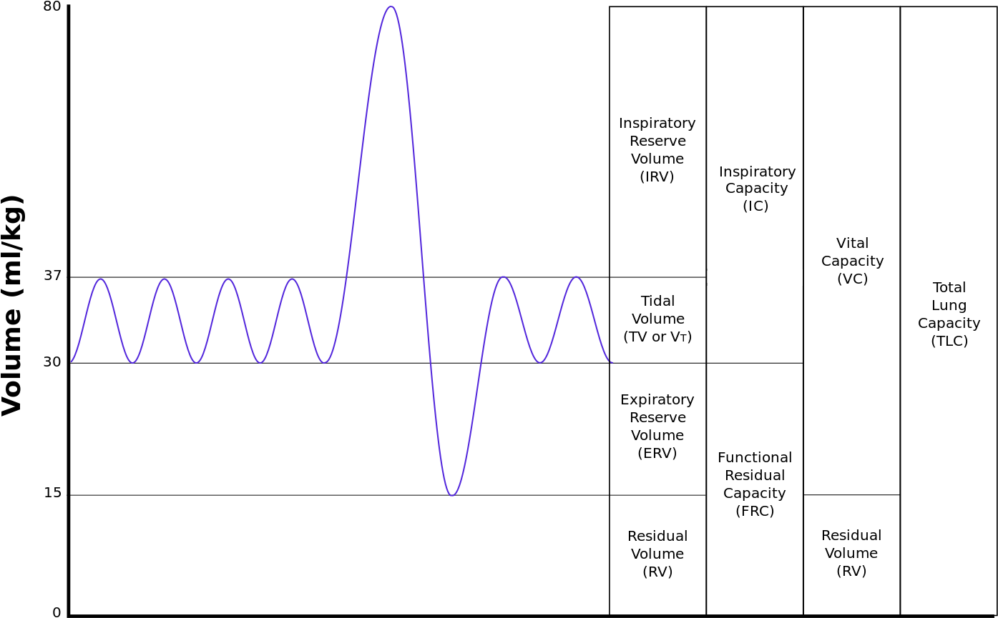
2.3 Computation of Volumetric Parameters
2.3.1 Flow-to-Volume Conversion
The instantaneous airflow signal $Q(t)$is converted into lung volume through numerical integration:
$$V(t)=\int_{0}^{t}{Q(τ) dτ}$$
In discrete embedded implementations, this integration is typically performed as:
$$V[n]=V[n-1]+Q[n]Δt$$
where $Δt$is the sampling interval. Stable sampling and bounded execution latency are essential to prevent integration drift and accumulated numerical error.

2.3.2 Forced Expiratory Volume Parameters
- Forced Expiratory Volume in 1 second (FEV₁)
$${\text{FEV}}_{1}=V(t=1\text{ s})$$
This represents the volume of air exhaled during the first second of forced expiration and is a primary indicator of airway obstruction.
- Forced Vital Capacity (FVC)
$$\text{FVC}=V(t=T_{\text{end}})$$
This corresponds to the total volume of air forcibly exhaled until expiration terminates and reflects overall lung capacity.
- Forced Expiratory Volume in 6 seconds (FEV₆)
$${\text{FEV}}_{6}=V(t=6\text{ s})$$
FEV₆ is often used as a practical substitute for FVC in portable spirometers, as it reduces maneuver duration while retaining diagnostic relevance.

2.4 Computation of Flow-Based Parameters
2.4.1 Peak Expiratory Flow (PEF)
Peak Expiratory Flow represents the maximum instantaneous airflow achieved during forced expiration and is computed as:
$$\text{PEF}=max⁡\{Q(t)\}$$
PEF is highly sensitive to sampling rate, filtering delay, and execution latency. Inadequate temporal resolution or excessive processing delay may lead to underestimation of peak flow values.

2.4.2 Flow–Volume Loop Capture
The Flow–Volume Loop (FVL) is generated by plotting airflow against lung volume:
- x-axis: Lung volume (L)
- y-axis: Airflow (L/s)
The FVL provides valuable diagnostic insight, enabling visualization of obstructive versus restrictive respiratory patterns, detection of upper airway obstruction, and shape-based clinical interpretation. Capturing the FVL requires synchronized storage of flow–volume samples with sufficient temporal resolution.

2.5 Parameters Implemented in the Current System
Category | Parameter | Computation
Volume | Total Volume | $$∫Q(t) dt$$
Time-based | FEV₁ | $$V(1 s)$$
Time-based | FEV₆ | $$V(6 s)$$
Capacity | FVC | $$V(T_{\text{end}})$$
Ratio | FEV₁/FVC | Division
Flow | PEF | $$max⁡(Q)$$
Graphical | FVL | Flow–volume samples

2.6 Implications for Real-Time Scheduling and Resource Design
The real-time computation of spirometric parameters imposes combined constraints on system design:
- Latency: Delays in task execution directly affect time-based parameters such as FEV₁ and FEV₆
- Jitter: Variability in sampling or processing distorts numerical integration and peak flow detection
- Memory footprint: Continuous buffering of flow and volume samples must be achieved without excessive SRAM usage
To meet these requirements, the firmware architecture must provide predictable task scheduling, bounded execution times, and controlled memory utilization. These constraints motivate the use of a real-time operating system (RTOS) and systematic evaluation of timing and memory behavior.

3. Literature review:
Paper | Architecture | Key Contributions | Identified Gap | Inference for This Work
“TeleSpiro: A Low-Cost Mobile Spirometer for Resource-Limited Settings” (Carspecken et al., IEEE PHT 2013) | Single-core MCU, differential pressure sensor, mobile-powered | Demonstrates feasibility of low-cost embedded spirometry meeting ATS/ERS accuracy; on-device signal acquisition | No RTOS, no latency/WCET/jitter analysis, no memory footprint evaluation | Embedded spirometry feasibility proven, but real-time firmware behavior is uncharacterized
“Design and Development of a Portable Spirometer for Pulmonary Function Test” | Single-core microcontroller-based spirometer | On-device airflow acquisition and spirometric parameter computation | Scheduling, timing determinism, and memory usage not analyzed | “Real-time” operation assumed, not quantitatively validated
“Development of a Low-Cost Portable Spirometer for Pulmonary Disease Monitoring” | Embedded pulmonary monitoring system | Continuous respiratory monitoring with parameter extraction | No RTOS-level timing metrics or deadline analysis | Functional correctness prioritized over determinism
“IoT-Based Smart Spirometer for Respiratory Health Monitoring” | Embedded + IoT architecture | Parameter extraction and visualization | Latency and memory footprint not quantified | Highlights need for on-device processing, but lacks system-level evaluation
“Spirometry Reference Values and Clinical Interpretation in Pulmonary Diseases” (BMC Pulmonary Medicine, 2022) | Clinical software-based analysis | Clinical validation of spirometric parameters | Not embedded-focused; no system constraints | Confirms clinical importance of FEV₁, FVC, PEF
“Global Trends in Spirometry Use for Pulmonary Diagnosis” (BMC Pulmonary Medicine, 2025) | Population-scale clinical study | Large-scale validation of spirometry metrics | No embedded or real-time considerations | Reinforces need for timing-accurate embedded computation
“Deep Learning–Based Spirometry Analysis for Pulmonary Disease Detection” (Scientific Reports, 2025) | ML-heavy software pipelines | Advanced interpretation accuracy | Computationally intensive; non-real-time | Unsuitable for resource-constrained embedded systems
“Real-Time Embedded Signal Processing Pipelines for Cyber-Physical Systems” (ACM EMSOFT 2023) | Embedded signal-processing pipelines | Structured embedded processing frameworks | No biomedical real-time validation | Architectural concepts reusable, but not medical-timing-aware
“Embedded Biomedical Signal Processing: Architectures and Applications” (JMIR Biomedical Engineering, 2023) | Embedded biomedical pipelines | End-to-end biosignal processing | No WCET, jitter, or deadline analysis | RTOS impact on biomedical signals not quantified
“Biomedical Signal Processing on Resource-Constrained Embedded Systems” (Springer Book Chapter, 2022) | Single-core embedded DSP | Efficient filtering and feature extraction | Single-core assumption; no scalability analysis | Algorithms transferable, architecture unstudied
“IoT-Based Embedded Healthcare Systems: Design and Implementation” (Springer Book Chapter, 2021) | Embedded + cloud healthcare systems | System-level integration | Cloud-dependent latency | Not suitable for time-critical spirometry
“Edge Computing for Biomedical Signal Processing” (Springer Book Chapter, 2023) | Edge biomedical platforms | Embedded intelligence at the edge | Resource usage not quantified | Resource efficiency not demonstrated
“Modular Design and Optimization of Biomedical Applications for Ultralow Power Heterogeneous Platforms” (IEEE TCAD, 2020) | Heterogeneous multicore (ULP) biomedical platform | Demonstrates parallelism improves energy efficiency | No medical real-time deadlines or jitter/WCET analysis | Multicore benefits shown, but determinism not evaluated
“Inter-Core Communication Performance Evaluation of a Multicore Microcontroller for Edge Computing Applications” | Dual-core microcontroller | Quantifies IPC latency and throughput | Application-agnostic | Essential groundwork for dual-core spirometry design
“Exploration of Power-Savings on Multi-Core Architectures with Offloaded Real-Time Operating System” | Multicore RTOS with task offloading | Demonstrates energy reduction through offloading | No biomedical workload | Supports resource-efficiency motivation
“Resource and Performance Trade-Offs in Real-Time Embedded Control Systems” (Real-Time Systems, 2013) | RTOS-based real-time systems | Formal resource–performance trade-off framework | Control-focused, not biomedical | Provides evaluation methodology applicable to spirometry

4. Research Gap and Scope
Based on the reviewed literature, several gaps are identified:
- Lack of RTOS-level real-time analysis: Existing works do not quantify end-to-end latency, worst-case execution time (WCET), or jitter.
- Absence of memory evaluation: Prior studies rarely report SRAM usage or task stack requirements.
- No comparative evaluation of multicore execution: The impact of dual-core architectures on time-critical spirometric computation remains unexamined.
5. Scope of the Present Work
This work focuses on the design of a resource-efficient, RTOS-based embedded spirometer on an STM32 platform, prioritizing:
- Fully on-device computation of FEV₁, FVC, FEV₆, PEF, and FVL.
- Quantitative evaluation of real-time metrics (latency, jitter, WCET).
- Comparative analysis between single-core and heterogeneous dual-core execution.

6. Performance & Evaluation Parameters
Category | Parameters Evaluated
Real-Time Performance | End-to-End Latency, WCET, Deadline Miss Rate
Scheduling & Timing | Task Start-Time Jitter, Response Time, Context Switch Rate
CPU Efficiency | Utilization per Core, Idle Time/Cycles Percentage
Memory & Safety | Total SRAM Footprint, Heap Usage, Stack High Water Mark
Output Consistency | FEV₁, FVC, and PEF deviation across architectures

