What Is MongoDB?

MongoDB is a document database with the scalability and flexibility that you want with the querying and indexing that you need
MongoDB stores data in flexible, JSON-like documents, meaning fields can vary from document to document and data structure can be changed over time
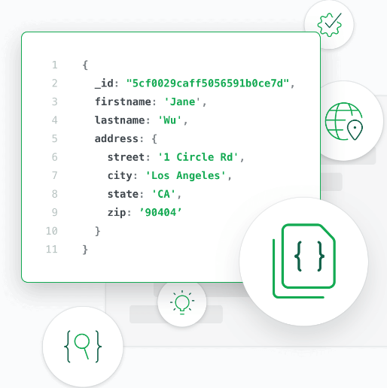
- The document model maps to the objects in your application code, making data easy to work with
- Ad hoc queries, indexing, and real time aggregation provide powerful ways to access and analyze your data
- MongoDB is a distributed database at its core, so high availability, horizontal scaling, and geographic distribution are built in and easy to use

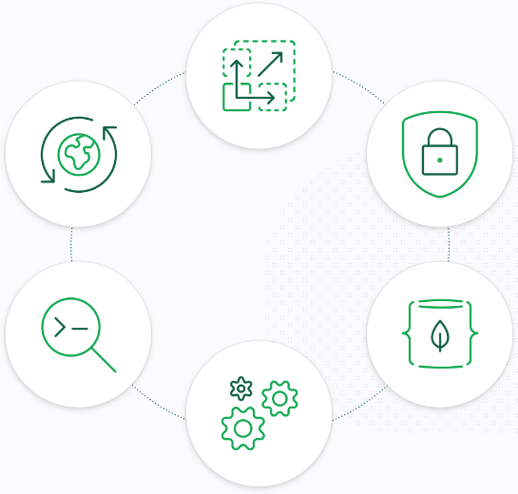
- Need to run MongoDB?High availability through built-in replication and failover
- Horizontal scalability with native sharding
- End-to-end security
- Native document validation and schema exploration with Compass
- Management tooling for automation, monitoring, and backup
- Fully elastic database as a service with built-in best practices

MongoDB Architecture
MongoDB is designed to meet the demands of modern apps with a technology foundation that enables you through:
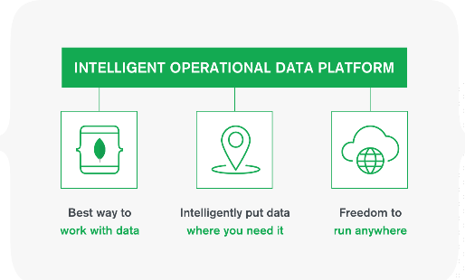
- The document data model – presenting you the best way to work with data.
- A distributed systems design – allowing you to intelligently put data where you want it.
- A unified experience that gives you the freedom to run anywhere – allowing you to future-proof your work and eliminate vendor lock-in.


Best way to work with data

Easy: Work with data in a natural, intuitive way

Fast: Get great performance without a lot of work

Flexible: Adapt and make changes quickly

Versatile: Supports a wide variety of data and queries


Put data where you need it

Availability: Deliver globally resilient apps through sophisticated replication and self-healing recovery

Scalability: Grow horizontally through native sharding

Workload Isolation: Run operational and analytical workloads in the same cluster

Locality: Place data on specific devices and in specific geographies for governance, class of service, and low-latency access


Freedom to run anywhere

Portability: Database that runs the same everywhere

Cloud Agnostic: Leverage the benefits of a multi-cloud strategy with no lock-in

Global coverage: Available as a service in 50+ regions across the major public cloud providers

Replication
A replica set in MongoDB is a group of mongod processes that maintain the same data set. Replica sets provide redundancy and high availability, and are the basis for all production deployments. This section introduces replication in MongoDB as well as the components and architecture of replica sets.

Note
minimum 3 nodes to required for mongodb replication
maximum 70 nodes supported

Why Replication?
- To keep your data safe
- High (24*7) availability of data
- Disaster recovery
- No downtime for maintenance (like backups, index rebuilds, compaction)
- Read scaling (extra copies to read from)
- Replica set is transparent to the application
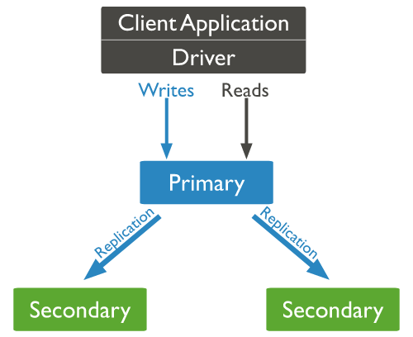
Replication in MongoDBA replica set is a group of mongod instances that maintain the same data set. A replica set contains several data bearing nodes and optionally one arbiter node. Of the data bearing nodes, one and only one member is deemed the primary node, while the other nodes are deemed secondary nodes.
The primary node receives all write operations.
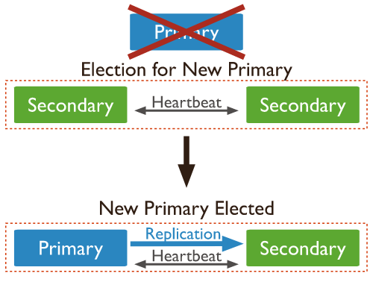

The secondaries replicate the primary’s oplog and apply the operations to their data sets such that the secondaries’ data sets reflect the primary’s data set. If the primary is unavailable, an eligible secondary will hold an election to elect itself the new primary

