Name | Vijay Rajesh R
Branch | CSE[AIML]
Reg.no | 23BAI10917
Subject | Introduction to Problem Solving and Programming



ASSIGNMENT

1.Multiplication Table using For-Loops

Aim:
To generate and display a multiplication table for the number 2, showing the products of 2 multiplied by numbers ranging from 1 to 20 in an organized format.

Algorithm:
1. Ask the user to enter a number and store it in the variable `num_to_mult`.
2. Use a `for` loop to iterate over the numbers from 1 to 10 using `range(1, 11)`.
3. Inside the loop, calculate the product of the current iteration value (`i`) and the input number `num_to_mult` and store it in the variable `ans`.
4. Print the multiplication equation in the format "i * num_to_mult = ans" using the `print` statement.
5. Repeat steps 3 and 4 for each iteration of the loop, printing the multiplication table for the input number.

Program:
num_to_mult=int(input("Enter the number: "))

for i in range (1,11):
ans=i*num_to_mult
print(i,'*',num_to_mult,'=',ans)



Output:
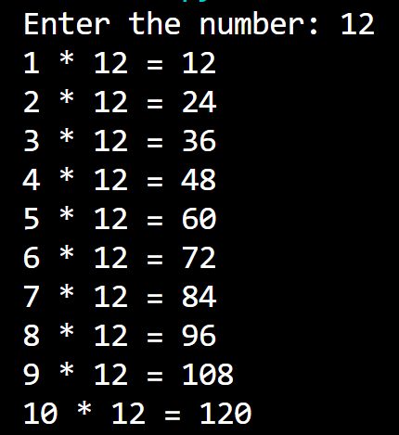

Result:
The result of the program is the multiplication table for the number entered by the user, ranging from 1 to 10. It displays a series of equations in the format "i * num_to_mult = ans," where `i` represents numbers from 1 to 10, `num_to_mult` is the input number provided by the user, and `ans` represents the product of `i` and `num_to_mult`.



2.Sum Of 10 Numbers Using For-Loops

Aim:
To calculate the sum of the first n natural numbers, where n is a positive integer entered by the user. The program uses a for-loop to add numbers from 1 to n and then displays the result.
Algorithm:
1. Ask the user to enter a positive integer and store it in the variable n.
2. Initialize a variable ans to 0. This variable will be used to keep track of the running sum of the numbers.
3. Use a for-loop that iterates from 1 to n using range (1, n + 1).
4. Inside the loop, add the current value of i to the ans variable. This accumulates the sum of the numbers from 1 to n.
5. Then print the result in a sentence at last.

Program:
n = int(input("\n\n\tEnter the number you want to add 10 times: "))
ans = 0
#For-Loop
for i in range(1, n + 1):
ans += i
print("\n\n\tThe sum of the first", n, "numbers is:", ans,".")



Output:
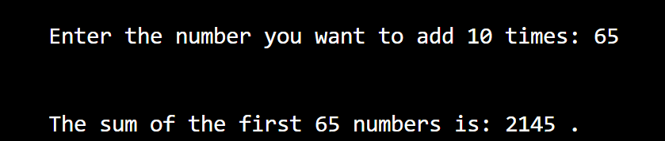

Result:
The sum is adding up of numbers till the number the user has given as input,
Then, output is given as the result of the sum of numbers.


3.Sum Of Odd and Even Numbers Between the Given Range

Aim:
To find the Sum of Odd and Even Numbers Between the given Range and print the output.

Algorithm:
1. Initialize sum_odd and sum_even to 0.
2. Prompt the user to enter the initial value and store it in initial_val.
3. Prompt the user to enter the final value and store it in final_val.
4. For each number i in the range from initial_val to final_val (inclusive):
a. If i is even (i % 2 == 0), add i to sum_even.
b. If i is odd (i % 2 != 0), add i to sum_odd.
5. Display "The Sum of Odd Numbers between initial_val and final_val is: sum_odd".
6. Display "The Sum of Even Numbers between initial_val and final_val is: sum_even".
7. End.

Program:
sum__odd=0
sum__even=0
initial__val=int(input("\n\tEnter Initial Value : "))
final__val=int(input("\n\tEnter Final Value : "))

for i in range(initial__val,final__val+1):
if i%2==0:
sum__even+=i
else:
sum__odd+=i
print("\n\tThe Sum of Odd Numbers between ",initial__val," and ",final__val," is : ",sum__odd)


print("\n\tThe Sum of Odd Numbers between ",initial__val," and ",final__val," is : ",sum__odd)

Output:
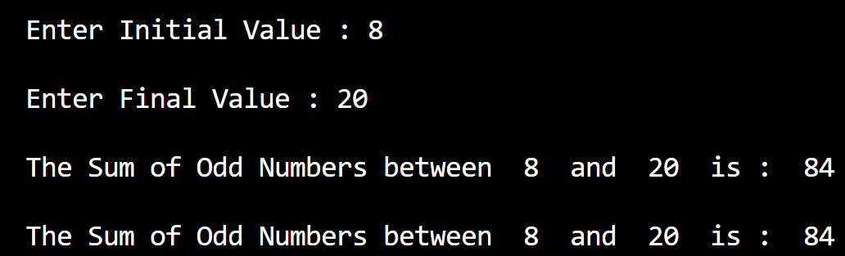

Result:
The sum of Odd Numbers between the Initial and Final Value is printed and the value is given at last in the sentence.


3.Sum Of Odd and Even Numbers Between the Given Range

Aim:
To find the Sum of Odd and Even Numbers Between the given Range and print the output.

Algorithm:
1. Initialize sum_odd and sum_even to 0.
2. Prompt the user to enter the initial value and store it in initial_val.
3. Prompt the user to enter the final value and store it in final_val.
4. For each number i in the range from initial_val to final_val (inclusive):
a. If i is even (i % 2 == 0), add i to sum_even.
b. If i is odd (i % 2 != 0), add i to sum_odd.
5. Display "The Sum of Odd Numbers between initial_val and final_val is: sum_odd".
6. Display "The Sum of Even Numbers between initial_val and final_val is: sum_even".
7. End.

Program:
sum__odd=0
sum__even=0
initial__val=int(input("\n\tEnter Initial Value : "))
final__val=int(input("\n\tEnter Final Value : "))

for i in range(initial__val,final__val+1):
if i%2==0:
sum__even+=i
else:
sum__odd+=i
print("\n\tThe Sum of Odd Numbers between ",initial__val," and ",final__val," is : ",sum__odd)


print("\n\tThe Sum of Odd Numbers between ",initial__val," and ",final__val," is : ",sum__odd)

Output:


Result:
The sum of Odd Numbers between the Initial and Final Value is printed and the value is given at last in the sentence.


4. To Generate Pseudoprime Numbers

Aim:
Objective is to print or generate sequence of pseudoprime numbers.

Algorithm:
1. Function `is_prime_miller_rabin(n, k=5)`:
- Return True if \(n\) is 2 or 3.
- Return False if \(n\) is even or 1.
- Express \(n\) as \(d \times 2^r + 1\), where \(r\) is the largest non-negative integer and \(d\) is odd.
- Repeat the Miller-Rabin primality test \(k\) times:
- Generate a random integer \(a\) such that \(2 \leq a \leq n - 2\).
- Compute \(x \equiv a^d \pmod{n}\).
- If \(x \equiv 1 \pmod{n}\) or \(x \equiv n - 1 \pmod{n}\), continue to the next iteration.
- Repeat \(r - 1\) times:
- Update it again.
- break the loop.
- If return False (indicating \(n\) is composite).
- Return True (indicating \(n\) is probably prime).

2. Generate Pseudoprime Number with 16 Bits:
- Initialize a variable `pseudoprime` to 0.
- Repeat until a pseudoprime is found:
- Generate a random 16-bit integer and assign it to `pseudoprime`.
- If `is_prime_miller_rabin(pseudoprime)` returns True, exit the loop.
- Otherwise, repeat the process.

3. Example Usage:
- Call the algorithm to generate a pseudoprime number with 16 bits.
- Print the resulting pseudoprime number.

Program:
import random

def is_prime_miller_rabin(n, k=5):
if n == 2 or n == 3:
return True
if n % 2 == 0 or n == 1:
return False

# Write n as d * 2^r + 1
r, d = 0, n - 1
while d % 2 == 0:
r += 1
d //= 2

# Perform Miller-Rabin primality test k times
for _ in range(k):
a = random.randint(2, n - 2)
x = pow(a, d, n)
if x == 1 or x == n - 1:
continue

for _ in range(r - 1):
x = pow(x, 2, n)
if x == n - 1:
break
else:
return False # n is composite

return True # n is probably prime

# Generate a pseudoprime number with 16 bits
pseudoprime = 0
while not is_prime_miller_rabin(pseudoprime):
pseudoprime = random.getrandbits(16)


print(f"Pseudoprime number with 16 bits: {pseudoprime}")

Output:
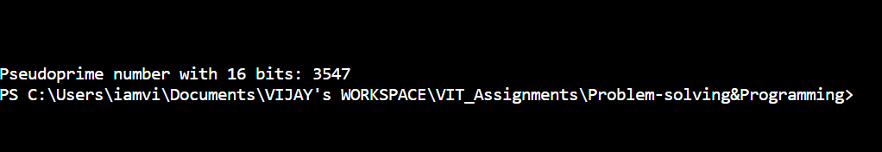

Result:
The output shows the result having pseudoprime prime numbers printed such that the aim is achieved.


5. Raise to Larger Number

Aim:
Intention of this program is to write a program that gives rise to a larger number.

Algorithm:
1. Initialize Variables:
- Set `base` to the desired base value (e.g., 2).
- Set `exponent` to the desired exponent value (e.g., 1000).

2. Calculate Exponentiation using `**` Operator:
- Calculate `result` by raising `base` to the power of `exponent` using the `**` operator.

3. Print Result using `**` Operator:
- Print the result of the exponentiation using the `**` operator.

4. Calculate Exponentiation using `pow()` Function:
- Calculate `result_pow` by calling the `pow()` function with arguments `base` and `exponent`.

5. Print Result using `pow()` Function:
- Print the result of the exponentiation using the `pow()` function.

6. Example Usage:
- Initialize `base` and `exponent`.
- Perform exponentiation using both the `**` operator and the `pow()` function.
7.Print the results.

Program:
base = 2
exponent = 5
result = base ** exponent
print(f"{base} raised to the power of {exponent} is: {result}")

# Using the pow() function
result_pow = pow(base, exponent)
print(f"{base} raised to the power of {exponent} using pow() is: {result_pow}")

Output:
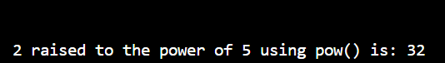

Result:
Hence,The aim of the program is achieved successfully by inferring the correct output that matches qualifies the aim.


6.To Find The Smallest Divisor using Loops

Aim: The intention of the program is to print or find the smallest divisor using python programming.

Algorithm:
1. Function `smallest_divisor(n)`:
- Accepts an integer `n` as input.
- If `n` is equal to 1, return 1 (as 1 is a special case with itself as the smallest divisor).

2. Iterating to Find the Smallest Divisor:
- Iterate through numbers from 2 to the square root of `n` (inclusive) using the loop variable `i`.
- In each iteration:
- Check if `n` is divisible by `i` without a remainder (`n % i == 0`).
- If it is divisible:
- Print the message indicating that `i` is the smallest divisor of `n`.
- Break out of the loop since we've found the smallest divisor.

3. Handling Prime Numbers:
- If no divisor is found in the loop:
- Print a message indicating that `n` is a prime number.
- Prime numbers have no divisors other than 1 and themselves.

4. Input and Function Call:
- Accept an integer input from the user (`number`).
- Call the `smallest_divisor` function with the provided input (`number`).

Program:
def smallest_divisor(n):

if n == 1:
return 1

for i in range(2, int(n**0.5) + 1):

if n % i == 0:
print(f"\n\tThe smallest divisor of {n} is: {i}")
break
else:
# If no divisor is found in the loop, n is a prime number
print(f"\n\t{n} is a prime number. It has no divisors other than 1 and itself.")

number = int(input("\n\tEnter a number: "))
#function_calling
smallest_divisor(number)

Output:
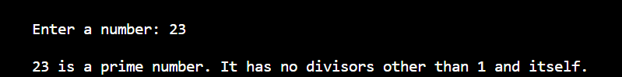

Result:
The algorithm efficiently determines the smallest divisor of a given number by iteratively checking divisors up to the square root. It also identifies prime numbers by recognizing when no divisor other than 1 and the number itself is found during the iteration.

