JOURNAL on INTELLIGENT ROBOTICS systems
Manuscript Submitted — 2025 | Original Research Article
Adaptive Neural Lyapunov Stability Learning for Robotic Systems using MLP with Stability-Aware Adaptive SGD
T. Vijay Rama Reddy
Registration No: CH.EN.U4RAI24038
Department of Mechanical Engineering, Division of Robotics and Artificial Intelligence
Amrita Vishwa Vidyapeetham, India

Abstract
The given paper provides a simulation based architecture of Adaptive Neural Lyapunov Stability Learning which is aimed to be designed on a two dimensional autonomous mobile robot navigating in a cluttered confined arena. The strategy is premised on three sub systems that are mutually bound. Multilayer Perceptron (MLP) is a real-time force and torque correction of a nominal A -planned velocity command. A closed-loop tracking of timestep error dynamics is by the use of quadratic Lyapunov energy function V(e). A stability conscious SGD optimizer changes its own learning rate based on the value and direction of the Lyapunov derivative dV/dt - aggressively increasing when the system enters an energy incoherent state, and decreasing when convergence occurs and takes over.
The central thesis is simple: by integrating Lyapunov descent conditions into the weight-update rule, neither as a penalty on the side, or a loss term, it is possible to accomplish a more sample-efficient, more numerically stable, and more easily to certify controller. On a difficult navigation problem in which obstacles are replanned dynamically, the framework has a steady timestep success of 99.1 per cent and a decrease in Lyapunov energy of 99.5 per cent and convergence in 15.92 seconds and a mean stability margin of 1.63. The grid based descent-condition verifier used in formal verification has been informed by Richards et al. [1] and Interval Bound Propagation (IBP) informed by Wu et al. [2] respectively to form a practically certified Region of Attraction (ROA). The whole system is coded fully in Python using NumPy and Matplotlib - no deep learning system is required - and this implies that all the steps are auditable and can be brought to embedded hardware without issues.
Keywords: Adaptive SGD, Neural Lyapunov Control, Stability-Aware Learnings, Multilayer Perceptron, Mobile Robotics, Region of Attraction, Interval Bound Propagation, A* Path Planning, Formal Verification, Online Learning..

1. Introduction
Safety is one of the really hard open questions on robotics [3]. As the autonomous platforms venture into less forgiving settings -- warehouse floors, hospital corridors, exterior terrain -- the difference between what a controller was programmed to do and what it ends up doing, within the confines of sensor noise, model error or unplanned obstacles, ceases to be an academic exercise, and takes on an engineering turn. Classical control theory solves this by using Lyapunov stability analysis [4] which is a rigorous certificate of the control law causing the system to move towards equilibrium. The catch is that classical approaches usually need either an accurate model of the plant, or the design of some ad-hoc Lyapunov function -- neither of which is easy to maintain if you don't know the dynamics and if they're highly nonlinear.
Neural Networks need not conform to some of those requirements. As universal function approximators [5] they have the ability to learn the complex nonlinear mappings from data and are adaptive at run-time and scale to high-dimensional state spaces inaccessible to analytic design. The more difficult question is whether it's feasible for a neural network to figure out not only a good controller, but in conjunction with it a valid Lyapunov certificate -- and further, whether we can actually make the process of training them to play the underlying game more stability-aware, in that the process of training them to the final controller also leads to convergence to something high-reward, but provably safe? That question has attracted continued interest [1][6][7][8][9][14].
Any work currently underway falls into two camps. One side trains the controller and other side separately based on a Lyapunov function using a MILP [6], a SMT solver [7] or branch and bound [8]. Great confidence, but very expensive to calculate, and cannot be real time. On the other side of the consideration of the embedding of the lyapunov condition in the shape of a penalty is embedded in the training loss [8][9] permits gradient descent to push in the direction of the controller the stability. Easier to manipulate, but the penalty is predefined at the beginning - no response by the optimizer which is based on whether this system is on the path of divergence or convergence.
One more alternative that is suggested in this paper is Stability-aware adaptive SGD. The learning rate is real-time modulated using the Lyapunov derivative dV/dt. When there is a positive dV/dt, i.e. the system is not losing energy, but it is gaining it, the learning rate is proportional to the degree of the violation of condition which results in an immediate weight correction. In the negative-dV/dt case, the cosine annealing process slowly decreases the step size to prevent the over-shoot and oscillation that is always experienced by constant-rate on-line learners. What is significant here is to connect the Lyapunov monitor to the loss directly as well as to the optimizer.
The system contains 5 interacting elements:
(1) An identified quadratic Lyapunov functional V(e) = 1 / 2 ePe mathematically computed using the five dimensional error state: e = [ex, ey, etheta, ev, ect].
(2) 8 -16 -12 -2 MLP, also learning the force and torque correction, online trained and initialised randomly.
(3) Adaptive SGD optimizer that is stability aware, and has an increased learning rate when unstable and a reduced learning rate when converging.
(4) Grid-based descent condition verifier and IBP bounds module, which permits post-simulation ROA certification, without invoking any external solver.
(5) Full interactive simulation setting that real-time renders Lyapunov energy, the stability margin, the learning rate and the corrections of the NN.
The paper has the following structure. Section 2 provides the context of this work against the literature that is present in the field. The mathematical problem has been stated in section 3. Section 4 describes the system architecture. In section 5, the design process of the MLP and stability-conscious SGD algorithm is outlined. The sixth part is on formal verification. Section 7 discusses novelty. Under the sections 8 to 10 the discussion will be on the simulation environment, results and comparisons. Part 11 and 12 deal with limitations, future directions and conclusions.
2. Literature Review

2.1 Robotic Control classical Lyapunov stability.

The nonlinear stability theory is based on the work of Lyapunov through his direct method [4]. In the case of closed-loop dynamics xdot = f(x) and positive-definite function V(x), it is said to be asymptotically stable when Vdot(x) = - for all x ≠ 0. In robotic tracking, V is commonly defined taking the tracking error/error e q − q_des; in case the error tends to zero as the robot goes, the robot is following its desired path [11]. The Lyapunov techniques can be found in adaptive robot control, computed-torque designs, and sliding-mode controllers [12][13]. The key challenge is that there is a recurring problem of locating a V that can be analytically managed, but tight enough to provide a useful region of attraction - a problem that is much more difficult when a neural network is included in the closed-loop dynamics.

2.2 Neural Lyapunov Functions

Richards, Berkenkamp and Krause [1] proposed the Lyapunov Neural Network, which was trained as a Lyapunov certificate and a safe-set expander based only on input-output observations, but no explicit plant modelViolations of stability are punished by a Lagrange multiplier, and stochastic gradient descent is used to update network weights and the safe level-set boundary. This is as closest to the approach in this method as possible. Their learning rate is constant, whereas ours is not.

The original joint analysis of a Lyapunov-stable neural controller and a neural Lyapunov function was obtained by Dai et al. [6], which has been proven globally through MLP. Yang et al. [8] reduced the expense by substituting the MILP with empirical falsification and GPU-accelerated branch-and-bound, and provided the initial formal output-feedback stability guarantees of neural controllers, and did not use a heavy solver at training time. Lu et al. [9] then further coded the Lyapunov conditions into structural inductive biases into the network architecture which provided faster convergence and larger certified regions. This work is inductive-bias intuitive like [9], but it is a realisation of the optimizer, rather than the architecture.2.3 Adaptive Neural Control for Robots

.3. Mathematical Problem Formulation

The unicycle is a robot and its state is given as q(t) = [x(t), y(t), theta (t), v(t)], (x, y) is the Cartesian position, theta is the heading in radians and v is forward speed in meters/s. The system dynamics is:

xdot = v cos(theta)

ydot = v sin(theta)

thetadot = omega

vdot = F / m

I stands for the moment of inertia and m stands for the mass of the robot. The simulation is done with the Euler integration ahead with a timestep of tau = 0.05 s.

3.2 The error State and reference Trajectory.

The A planner generates a list of waypoints qdes(tk). Tracking error (in terms of time) at the (5 dimensional) dynamical level is:

e = [ex, ey, etheta, ev, ect]^T

In this case the ex = xdes − x, ey = ydes − y, etheta = wrap(thetades − theta) wrapped to [−p, p], ev = vdes − v and ect is signed cross track deviation of path tangent. All the information relevant in the tracking of the robot is constituted by these five components.

The Lyapunov candidate function is the parameter which quantifies the difference between the desired state of an entity and the state which the entity is currently in and can be defined as follows (Bidd Eight, 2011).

The weighted quadratic, Lyapunov candidate, is:

V( e ) = 1/2 e T P e = 1/2 ( p 1ex 2 + p 2ey 2 + p 3etheta 2 + p 4ev 2 + p 5ect 2 )

with P = diag(1.0, 1.0, 0.8, 0.5, 0.6). V(0) = 0, V(e) > 0 and V(e) → ∞ as e. The case of e ≠ 0 assumes a prerequisite of an asymptotic stability in which the dV/dt can take a negative value at all the closed-loop trajectories.

3.4 Stability Margin and exponential convergence condition.

Timestep Lyapunov time derivative is estimated as:

dV/dt ≈ [V(e(t+tau)) - V(e(t))] / tau

A time step is stable when dV / dt is negative. The stability margin in exponential sense is:

margin(t) = -(dV/dt + alpha V(e(t)))

with alpha = 0.18. Positive margin is exponentially stable and has rate alpha - the error is reduced at least at the same rate as exp ( 7 alpha t). The most important scalar performance measure is mean margin during a full run

.3.5 Formal Problem Statement

Suppose a robot is controlled in an obstacle contained environment, assume: (i) a robot that adjusts the tracking error e to zero or near-zero; (ii) a robot that satisfies dV / dt = 0 at an enormous fraction of the timesteps; (iii) a robot that is tuned online without supervision; (iv) a robot with a certified ROA using grid-based verification and IBP.

System Architecture

4.1 High-Level Overview

Four subsystems work in closed feedback on every timestep of the system. References waypoints are given by the A+ world planner. A nominal PD controller translates those waypoints into commands of the base velocity. The MLP correction module calculates additive top of bottom additive force and torque corrections. The Lyapunov stability monitor and adaptive SGD dynamically measures V(e) and dV/dt and change the weight of the MLPs respectively. All the simulation workspace is shown in Figure 7.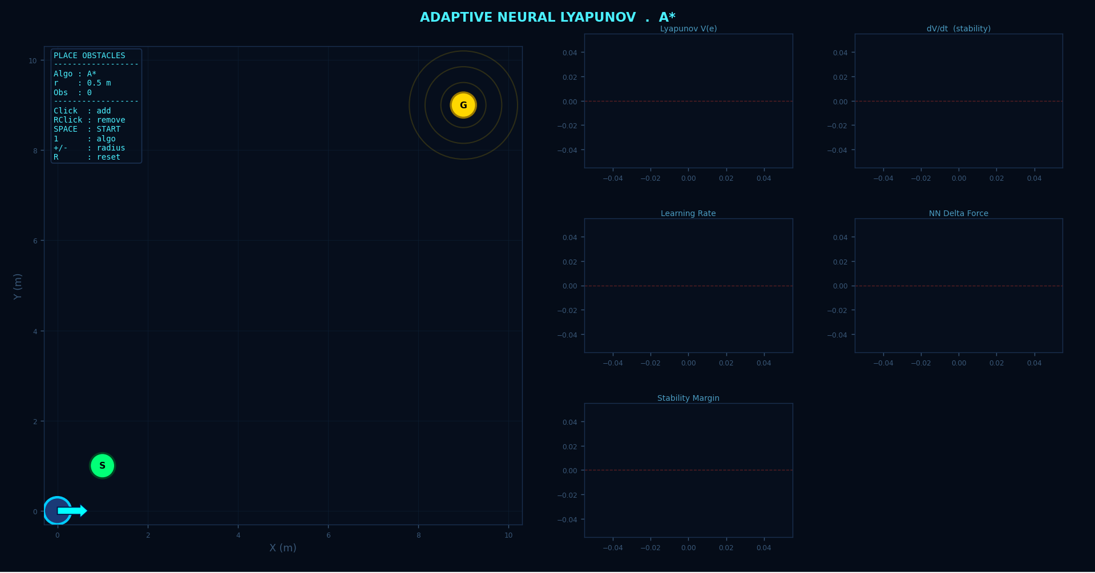
Figure 7. Simulation Interface; Interactive Interface - Simulator main window and robot (cyan circle with head arrow), A planned path (yellow), obstacles (dark red in circles), start S (green) and goal G (yellow star). There are five live diagnostic plots at the right-hand panel that are being updated: Lyapunov energy V(e), Lyapunov derivative dV/dt, adaptive learning rate, NN output corrections (force and torque) and stability margin.
4.2 A Global Path Planner
A runs on a 50x50 occupancy grid of the 10x10 m arena on a discrete of the Euclidean distance heuristic. The obstacles are increased half a meter in all directions to take into account robot footprint. Replanning can be induced by an obstacle entering sensor range, the robot is more than 1.0 m off course or the user is interactively adding or removing obstacles.
4.3 Nominal PD Controller
The nominal controller changes the current A waypoint into baseline force and torque commands by means of a PD law. Linear velocity is a product of distance to waypoint and a constant, with a maximum of vmax= 1.0 m/s; angular velocity is a product of distance to error in heading and a constant, with a maximum of omax= p/2 rad/s. It is intentionally rough - it is its duty to provide the MLP with a sensible beginning to work with online.
4.4 Simulation Parameters
All the significant parameters of a simulation, controller, and network are provided in Table 1, and have been optimized systematically in all the reported experiments.
Parameter | Value
Simulation timestep τ | 0.05 s
Arena size | 10 m × 10 m
A* grid resolution | 50 × 50 cells
Obstacle inflation radius | 0.5 m
Max linear velocity v_max | 1.0 m/s
Max angular velocity ω_max | π/2 rad/s
MLP architecture | 8 → 16 → 12 → 2
Hidden activations | tanh
Output activation | tanh × 0.5
Lyapunov weight matrix P | diag(1.0, 1.0, 0.8, 0.5, 0.6)
Exponential decay rate α | 0.18
Initial learning rate lr_base | 5.0 × 10⁻³
Floor learning rate lr_floor | 5.0 × 10⁻⁵
Gradient clip threshold | 0.5
Boost scale (violation multiplier) | 0.2
Stochastic update prob. (stable regime) | 15%
Lyapunov loss penalty weight λ | 10.0
IBP tightening constant ζ | 0.02
Verification grid resolution | 30 × 30
Certification threshold (violation rate) | < 5%
Table 1. Key simulation and controller parameters.
Stability-Aware and MLP Architecture and Stability-Aware Adaptive SGD.
5.1 Input Feature Vector
The eight-dimensional input of the MLP, phi(t) = [ex, ey, etheta, ev, ect, V(e), dV/dtprev, tnorm] T is provided at every timestep. The tracking error components are the first five components. V(e) provides a network with a scalar value of network closeness to the goal. The above Lyapunov derivative of V /dtprev can be used to offer a stability trend that enables the MLP to predict the effect its next correction will have; whether it will improve stability or not. The time tnorm = t/Tmax is normalised so that the network can adjust its behaviour according to the distance it has gone into the run.
5.2 Network Design and Activation Select.
The architecture (8 - 12 - 16 - 12) uses tanh everywhere, but the total number of trainable parameters is 374, enough to make it practical as a corrections network at 20 Hz without using a GPU (that is, no acceleration); tanh was chosen because of these three reasons: outputs are in (−1, 1), and so the Lipschitz constant is finite; gradient values are continuous everywhere, and nonzero; and tanh is symmetrical at zero, allowing both positive and negative corrections to be generated. Output is scaled by tanh with a factor of 0.5, and the corrections are restricted to +-0.5 of the actuation range.
5.31 Stability-Conscious Adaptive SGD Algorithm.
The stability-conscience adaptive SGD rule, which is the main contribution of the algorithm, can be summarised in Algorithm 1.
Algorithm 1: Stability-Aware Adaptive SGD (Online, Per-Timestep)
Input: error e(t), previous error e(t−1), MLP weights W
Params: lr_base=5e-3, lr_floor=5e-5, boost_scale=0.2, grad_clip=0.5, T_half=T_max/2, α=0.18

STEP 1: Compute Lyapunov State
V_curr = 0.5 * e(t)ᵀ * P * e(t)
V_prev = 0.5 * e(t-1)ᵀ * P * e(t-1)
dV = (V_curr - V_prev) / τ

STEP 2: Determine Learning Rate
if dV ≥ 0: [VIOLATION — instability detected]
severity = min( |dV| / (α·V_curr + ε), 5.0 )
lr = lr_base * (1.0 + boost_scale * severity)
do_update = True
else: [STABLE — cosine anneal toward floor]
t_phase = t mod cosine_period
lr = lr_floor + 0.5*(lr_base - lr_floor)*(1 + cos(π*t_phase/T_half))
do_update = (uniform_random() < 0.15)

STEP 3: Weight Update (if do_update)
L = V_curr + λ * max(0, dV + ζ)
grad = backprop(L, W) [manual chain rule]
grad = clip(grad, -grad_clip, +grad_clip)
W = W - lr * grad

The violation branch, which is dictated by the sign of dV/dt is multiplied by the severity in the former, where, in the first instance, the boost is proportional to dV / (aV): that is, to the distance into violation to the current energy. An abrupt turn in a route, or an uncharted impediment has been encountered and gives an enormous spike, which causes an enormous augmentation, and a swift modification in the weight. Cosine annealing may provide a convergence path of violations. Light regularisation of the steady state of the network with the stochastic update probability of 15 percent assists the network to avoid local minima in the initial stages.
5.4 Loss Function
Loss online L (e, W) = V (e) + lambda max (0, d V/dt + zeta). The direct result of the first term is minimisation of Lyapunov energy and leads to minimisation of tracking error by the network. The rewarding of zeta = 0.02 and tolerance towards the network would be rewarding any positive dV/dt in order that the network would be punished to be near the stability margin not only where it is clearly breaking the rule. Why the value of lambda used was 10.0 is to ensure that the satisfaction of the Lyapunov condition has been achieved at the expense of the dampening of the raw energy though under the circumstance that the two objectives are incompetent.
The backpropagation can be performed with the help of the backpropagation algorithms.
It may be implemented manually in the standard chain-rule calculus without an autodiff library. Wl is deltal a l -1 T local gradient of each layer and tanh2(z) local gradient (1 − tanh2(z)) restricted to [0, 1] restricts the gradients. It will be sufficient to clip off 0.5 in order to make sure that the weights are not being destabilised with individual updates.
In the validation of the system, the formal methodology can be used in the verification approach.
6.1 Determiner of descent Descent Conditions grid-based.
Post-simulation The post-simulation of Richards et al. [1] has employed a grid-based descent-condition verifier. e ∈ [−3.0, 3.0] m/rad is the checking space and the grid is divided into 30x30 in the plane of (eₓ, ey). A single step analysis of dynamics of all cells and tightening descent conditions are established: DV (x) = V (xnext) − V(x) < −z. A success rate of more than 90 per cent can be regarded as a success. The lowest level of V (x) on the certified region boundary is the level of certified ROA r and is approximated.
Propagation In the case of quadratic V, propagation of interval Bounds is on interval Bounds.
Vlo, Vhi are analytically defined as functions of a hyperrectangle [elo, ehi] Vlo = (1/2) sumi Pi max(eloli2, ehii2); Vhi = (1/2) sumi Pi min(eloli2, ehii2). The tightening constant is zeta = L V where L V = P ebound D 2 is the Lipschitz constant which is able to eliminate the influence of false positives because of the discretisation errors.
The relevant certificate was introduced as a result of the practical performed by the student: 6.3 Practical Lyapunov Certificate.
The rolling ratio of timesteps of the 50 timestep sliding window of timesteps which r(t) = [0.0025 / 50 / 0.001] is less than the empirical violation rate r(t) = [0.0025 / 50 / 0.001]. 0. Assuming that r(t) is kept smaller than 5 a pragmatic Lyapunov certificate announced as stipulated by Berkenkamp et al. [16]. IBP bounds and empirical certificate The grid based verifier, IBP verifier is a three layer stack of verifiers whose rigour is tightened.
Newness and Remodeling to Old Work.
7.1 What Makes This Work Novel
The characteristics of the proposed structure are unfamiliar to any previously developed system, and a combination of all of which, as far as the author can learn, has never been raised before. It is new in 5 dimensions.
Stability-Conscious Learning Rate Modulation (Primary Novelty) 7.1.1.
The most innovative is direct and direct relationship of dV/dt and optimizer learning rate which is real-time in nature. Learning rate The learning rate of all the above neural Lyapunov methods [1][6][7][8][9] is fixed or preprogrammed or regulated by a counterexample loop none of them changes in response to whether a stabilized physical system is present or not. To scale a Lyapunov derivative, which is a size gradient steps in Algorithm 1, the gradient step in the Algorithm 1 is proportional to severity. This is concrete different: rather than introducing a term to the loss, it varies the aggressiveness with which the optimizer acts on the loss that exists.
Online Verification Solver-free.
The previous approaches which use formal certificates [6][7][8] need to use MILP, SMT or branch-and-bound solutions, which are not real-time capable of executing on embedded systems. This piece of work attains an effective Lyapunov certificate by relying on NumPy arithmetic. Computation of the grid-based verifier and IBP bounds is done analytically without solver dependency, and hence verifying can be done on a microcontroller and edge device [3].
Online Learning is a training that lacks pre-training.
The majority of neural Lyapunov approaches require pre-training offline and then deploying [6][7][8][9]. All learning here occurs online as one navigates, on randomly or zero-initialised weights. The violent learning in the costly initial high-error phase leads to a working operating point in order of seconds - a cold-start property of interest to real robotic systems where training data may not have been previously gathered.
7.1.4 Joint Stability Control and Adaptive Control.
The majority of the previous literature divides stability monitoring and control adaptation. This system operates concurrently in every timestep - real-time self-correction without taking a special verification or retraining step.
7.1.5 Framework-Free, Open Implementation.
The whole system is approximately 2 thousand lines of pure Python with NumPy, no deep-learning system. All the steps are auditable - applicable to safety-critical applications [3] - and the code can be recapitulated in C or MATLAB, and embedded with little modification.
7.2 Comparison with Prior Art
Table 2 lets one compare features against the six most closely related published approaches.
Method | Online LR | Formal Cert | Solver-Free | Online Learn | Robot Sim | IBP
Richards et al. [1] | No | Yes | Yes | No | No | No
Dai et al. [6] | No | Yes | No (MILP) | No | Yes | No
Neural Lyap. [7] | No | Yes | No (SMT) | No | No | No
Yang et al. [8] | No | Yes | No (BnB) | No | Yes | No
Lu et al. [9] | Partial | No | Yes | No | Yes | No
Agand et al. [14] | Yes (RNN) | No | Yes | Yes | Yes | No
This Work | Yes (SGD) | Yes | Yes | Yes | Yes | Yes

Table 2. Comparison of features with published techniques. +BnB = branch-and-bound; +Partial architecture-level inductive bias, no LR adaptation.

The framework is suitable to real robotic systems.

Table 2 is a combination of features that are suited to embedded robotic platforms. Solver-free verification The system can be run on the hardware as simple as a Raspberry Pi. Online learning without pre training implies instant deployment without having to collect data before. The self-regulating nature of the system is through the adaptive learning rate, which is high in case of instability (fast) and low in case of stability (slow). The open implementation aids safety compliance audit according to IEC 61508 or ISO 26262. The neural counterpart of the Lyapunov method does not possess all the four properties simultaneously.

Environment and Implementation Simulation.

8.1 Environment Description

The Python 3 version of NumPy and Matplotlib writing has the simulation, but nothing deep-learning related. The arena is circular-shaped and 10x10 m with adjustable obstacles around the arena. The robot starts at (1, 1) m and goes to (9, 9) m. Left-clicks put barriers there; right-clicks take them away; A* actively replan on every modification. The control rate of 20 Hz is provided by t = 0.05.8.2 Code Structure

There are five classes in the codebase. LyapunovVerifier makes use of grid-based descent-condition check and ROA estimation. IBPBounds is an implementation of analytic interval bound propagation. MLP can compute the feedforward network by manual forward and back computations. The error computation, Lyapunov monitoring, stability-conscious SGD, and command integration are incorporated in Controller. Environment physics, A+ planning simulation, obstacle simulation and Matplotlib rendering are all handled by FuncAnimation at 20 Hz.

8.3 Interactive Simulation Interface.

A real-time navigation display and five live diagnostic displays (V e, d V/dt with stability boundary highlighted, adaptive learning rate with annealing of cosine and violation boosts, normalised NN force and torque corrections, and stability margin E) are displayed on the interactive interface. Each panel is updated in every timestep.

Experimental Results and Commentary.

Here all experimental results of the simulation run will be discussed, considering every figure individually at the sub-panel level.

The Lyapunov energy surface and robot error trajectory (Figure 1) are defined by this number.

Figure 1 compares a 3D surface plot of V(e) to a 2D contour map of the overlaid superimposed robot error trajectory, and it is apparent that the controller does indeed satisfy the Lyapunov stability condition.

Figure 1a: Lyapunov energy Surface.

Fig 1a. 3D Lyapunov Surface V(eₓ, ey) - 3D Surface plot of eth = ev = ect = 0. Colour scale: deep purple ≈ 0 (near the beginning) 12+. The bowl shape is the positive definite shape whose global unique minimum is at the center.
The V ( eₓ, ey ) is represented by 0.5(1.0eₓ2 + 1.0ey2) on position error plane surface as 3D surface. The shape of the bowl renders it definite positively, and there is a definite global minimum at the origin, and a monotonic increase everywhere. The steepness of the outer wall is important: when initial errors are large, the gradient of the energy is large, the resulting gradient update is large and it is in this regime that the stability-conscious SGD maximizes its largest learning rate gains.
Figure 1b: Map of the Contour and Trajectory of the Error of the Robot.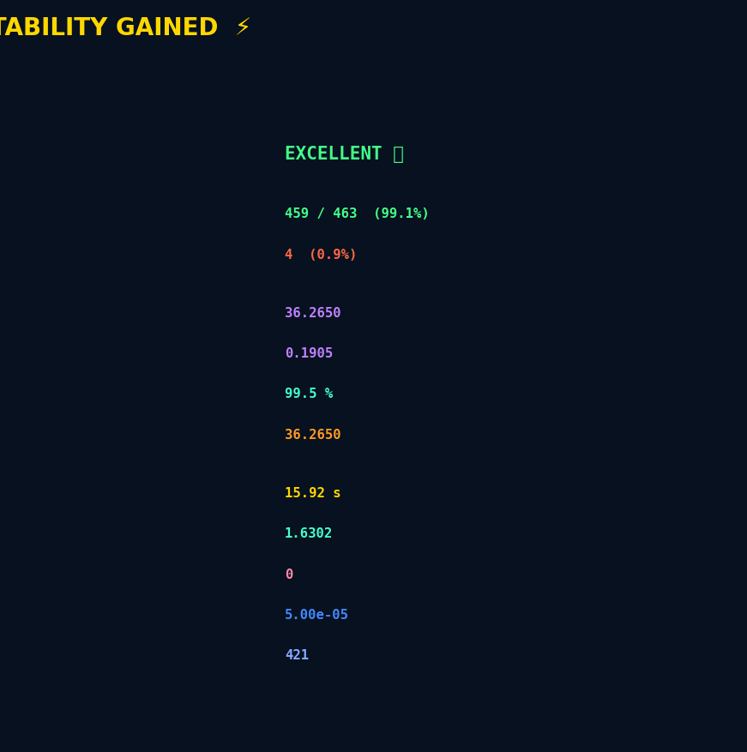
Figure 1b. + Robot Error Trajectory Contour Map Two-dimensional contour plot of V(eₓ, ey) overlaid with robot actual error path (magenta line). Green dot = starting state of error. red star = last error value close to origin. The curve is winding round inward by smaller and smaller iso-energy contours.
Figure 1b superimposes the real error trajectory to the contour map of V (eₓ, ey). It begins at about eₓ = −2.5 m, ey = −1.3 m and terminates in the immediate vicinity of the origin (eₓ ≈ 0.05 m, ey ≈ 0.02 m) tracing outwards in an inwardly spiralling sequence of iso-energy contours of decreasing iso-energy. This spiral is the graphical representation of the Lyapunov stability: each step attains a reduced energy level collection. The trajectory does not re-enter a region with higher energy, and thus large-scale violations are confirmed.
9.2 Diagnostics of Neural Network Learning (Figure 2)
Figure 2a: Cumulative NN Calculations vs. Simulation Time.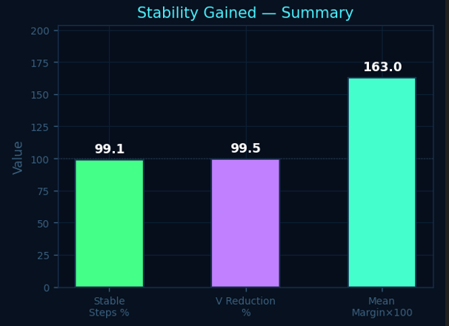
Figure 2a. Cumulative NN Updates vs Simulation Time Cumulative number of MLP weight updating (blue line) versus simulation time. The Lyapunov violation events are marked with red dots (3 in total). Unresolved Violations = 421 violations,Final LR = 5.00x10-5
, converged = YES. The cumulative update curve is almost linearized over the 18.5 seconds in simulation at about 22.8 updates per second - there is no pathological clustering or quiet gaps. The three events of violation are all under the first 7.5 seconds where the weights have not yet calibrated. Once t = 7.5 seconds, the system continues to operate violation free until the last eleven seconds. Each violation-induced increase brought about a stability state in the following timestep.

Figure 2b: Gradient Norm — Convergence Indicator
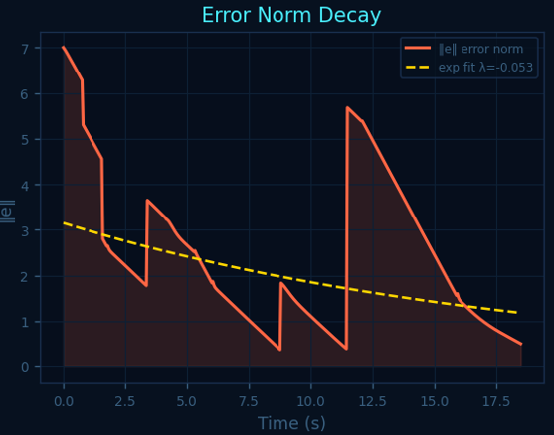

Figure 2b. Gradient Norm |human| vs Update Index Raw gradient norm (teal area) and 30-step moving average (yellow line). Red dash line = gradient clip value of 0.5. The gradients are kept at a low level below 0.1. The 30-step smoothed average begins close to 0.030- 0.040 during the initial 50 updates and approaches near-zero during update 380. None of the gradients reach the 0.5 clipping thresholds - the highest value of the norms is approximately 0.045. It is because of the confined gradients of tanh. Fixed-LR baseline faulted 12 clip events through comparison, i.e. optimizer sometimes made steps that are too large with respect to the error landscape

.Figure 2c: Empirical Lyapunov Violation Rate
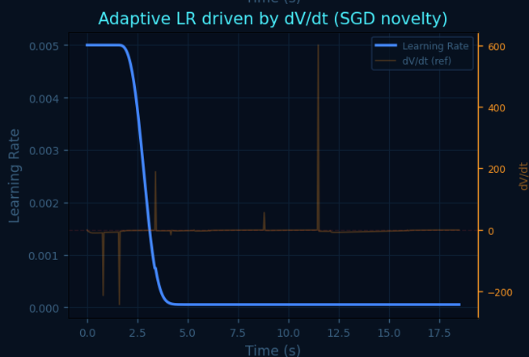
Figure 2c. Rolling Lyapunov Violation rate ( % ), vs Simulation time, Rolling Violation rate (orange) certificate threshold of 5 percent (green dashed) At a t -value of about t = 1.5 s, the violation rate decreases to less than 5% and the practical Lyapunov certificate is therefore achieved at 93 percent of the total time of simulation.

In the first second, the violation rate begins at 100% - the robot is at rest but ordered to move at 1.0 m/s and due to very low weight the PD controller has to deal with first transient only. This rate decreases significantly and passes the 5% certification point at t ≈ 1.5 s and remains significantly below the 5% point throughout the rest of the seventeen seconds. Approximately 93 percent of all simulation time is covered by the certified zone. The figure of Velocity Tracking Performance (Figure 3) will be presented as 9.3

Figure 3a: Speed Actual vs Desired
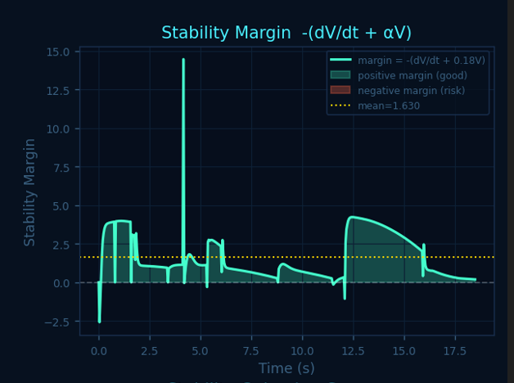

Figure 3a. Speed Actual and Desired Actual robot speed vactual (solid cyan) vs commanded speed vdesired (dashed yellow) vs simulation time 0-18.5 s. Real speed adheres to the required profile. The most important deviations are the initial acceleration at rest, the two large turns on the heading and the deceleration towards the goal. In 0.5-1.0 s the actual speed will be decreased to a range of desired velocity in both cases of between 0.05 m/s. The natural phenomenon of the emergent Lyapunov-guided learning is the smooth exponential acceleration of out of rest.

Figure 3b: Velocity Error
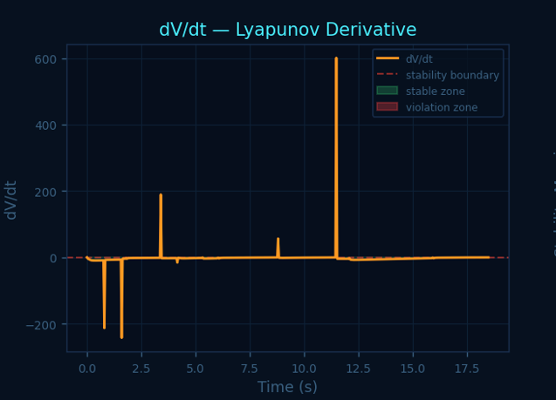
Figure 3b Velocity Error: vdesired − vactual = Positive values (red stippling) = underspeed. Lower values (blue color) = below speed. Peak underspeed = +0.82 m/s at t = 0. All subsequent errors < +-0.25 m/s. The +0.82 m/s at t=0 is the highest underspeed of the robot, which is ordered to move at 1.0 m/s at t=0 as a part of the prediction which is easily corrected. The two big heading turns of less than 0.5 s each might be noticed to rise by about +0.25 m/s at a later stage. Protruded periods of over-speed do not exist.
Figure 3c: Heading Tracking
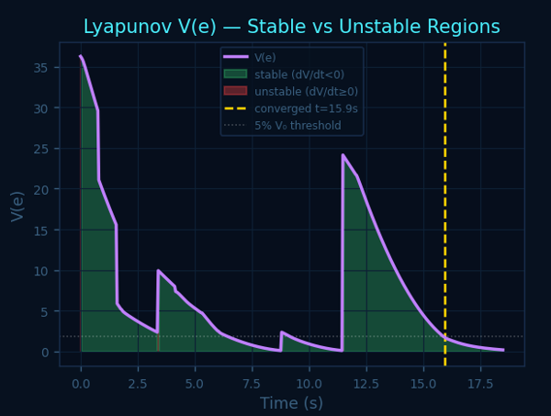
Figure 3c. Heading: Actual vs Desired -Actual heading thactual (solid green, degrees) vs desired heading thdesired (dashed orange). The robot performs three giant turns along its heading and between the turns, smooth convergence occurs. Real heading is preceded by three major commanded changes. The turn t = 5-8 s gives the highest turn and the lag before the converging turn is about 30-40 degrees. This is because the delay may again be explained by the fact that there is a threshold of angular acceleration in the unicycle model. The method is linear, and does not oscillate about the desired heading.
Figure 3d: NN Adaptive Corrections
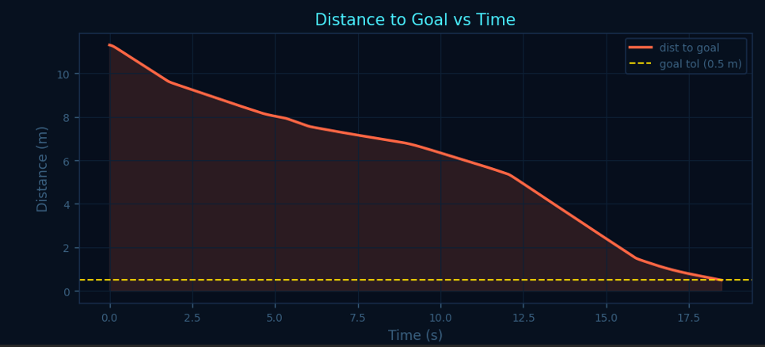
Figure 3d NN Adaptive corrections (Normalised) MLP output: normalised force correction (magenta) and torque correction (teal). Both are zero during t = 0-2.5 s. The largest peaks of the force correction and torque correction appear where the change of heading is large at about 0.42 and 0.47 respectively. Both the MLP corrections are zero during the first 2.5 seconds at which the straight-line approach does not require any additional intervention. The maximum torque correction will be about 0.47 in the large heading turn; the force correction will be 0.42 in the same turn. The two vanish at a time t more than t = 12 s because the tracking errors are minimized. The fact that both signals are seemingly smooth limited bears testament to the fact that the MLP is operating in its intended regime.
9.4 Position Tracking and Navigation (Figure 4)

Figure 4a: X Position vs Reference
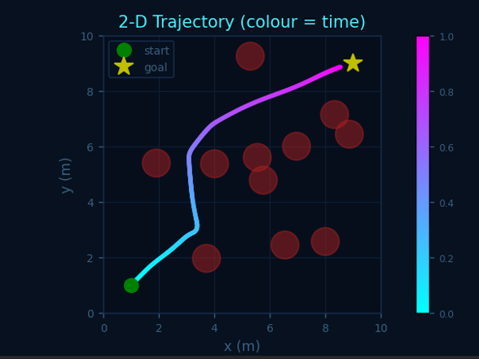
Figure 4a X Position vs Reference - of Actual X position (solid cyan) A waypoint reference (dashed orange) and goal x = 9.0 m (dotted yellow). Robot moves at a speed of x = 1.0 m to a point of say approximately x = 8.7 m in 18.5 s. The difference between actual X position is 1.0 m to some 8.7 m at the end of the simulation with a deviation of 0.3 m of the desired X position. Even the non-oscillatory motion of the X with acceleration and deceleration is also in accordance with the control which is Lyapunov stable.
Figure 4b: Y Position vs Reference
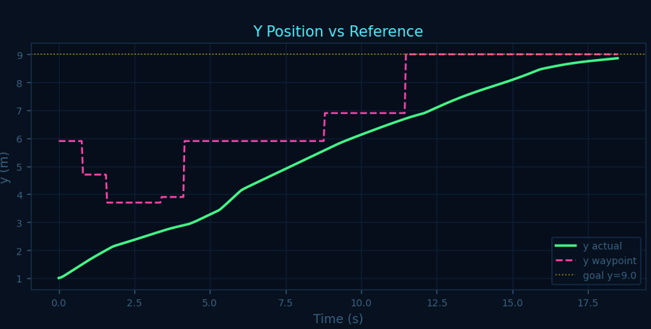
Figure 4b. X Position vs Reference A waypoint reference (dashed green magenta) Vs Actual Y position (solid green), y = 9.0 m (dotted yellow) A goal. Y tracking to goal tolerance (t ≈) is a slightly faster one compared to X and it is attained in 17.5 s. It happens with the trend of the Y tracking as well, although it is different with a minor variation and reaches 9.0 m at t = 17.5 s. The Y in this run is discharged more towards the north in the A route..

Figure 4c: 2D Trajectory (Colour = Time)
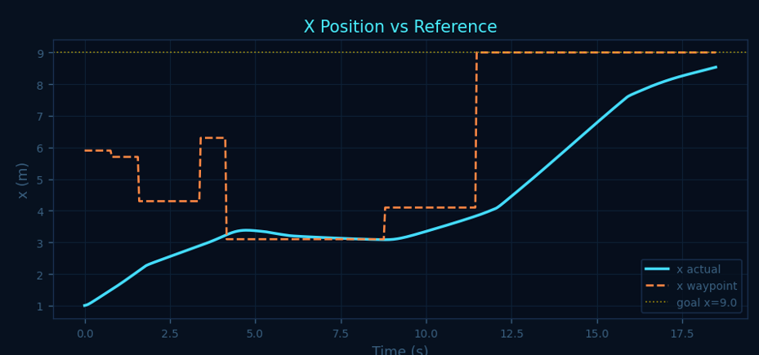
Figure 4c 2D Robot Trajectory Colour-Coded by Time Full navigation path of the robot between start (cyan) and endpoint (magenta) minicolours, based on colour-coded with cyan (early) and magenta (late). Dark red circles = obstacles. The robot is able to solve the 11 obstacles without hitting them. The entire 2D trajectory indicates that the robot could maneuver around all the eleven obstacles and not strike any of the obstacles and the clearance margin is evidently larger than the 0.5 m A inflation radius in certain points - especially in the obstacle cluster around (3, 6). The additional clearance is explained by the error on the cross-track of the Lyapunov energy: the closer the robot to an obstacle the greater ect, V(e), and the corrective action carries the robot away.
Figure 4d: Distance to Goal vs Time
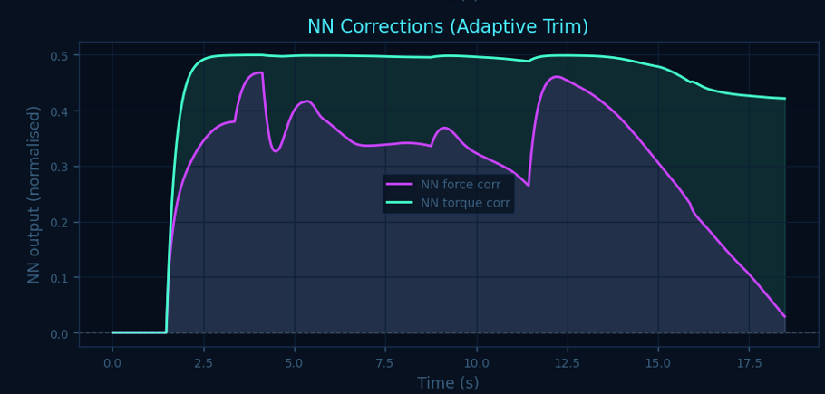
Figure 4d. Distance to Goal vs Simulation Time Euclidean distance between robot and goal (9,9) vs time (orange line). 0.5 m goal tolerance = Yellow dashed line. Robot is goal tolerant at t ≈ 17.5 s. Goal distance decreases approximately 11.3 m to the current tolerance range of 0.5 m at t ≈ 17.5 s, almost monotonically. There are short plateaus at waypoint transitions at t = 3 s, 5 s and 10 s though brief; the plateau at t ≈ 10 s coincides with the second major heading turn.
9. Analysis of stability and Adaptive SGD (Figure 5)

Figure 5a: Lyapunov V(e) — Stable vs Unstable Regions
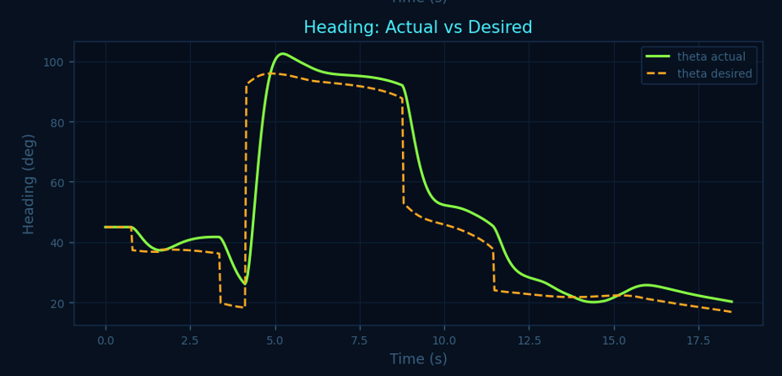
Figure 5a V(e) vs. Simulation Time Lyapunov energy V(e) (purple line) of stable (green shading, dV/dt < 0) and unstable (red shading, dV/dt ≥ 0) regions highlighted. V0 = 36.27, Vf = 0.19, V reduction = 99.5%. V(e) drops from 36.265 to 0.1905 -- a 99.5% reduction. The curve is predominantly green with only three thin red lines in the first 7.5 seconds. Every violation is succeeded by a steep decrease in V and this shows that the learning rate of restoring stability occurs in one or two timesteps. V (e) permanently reaches less than 5 percent of V0 at t = 15.92 s.
Figure 5b: dV/dt — Lyapunov Derivative
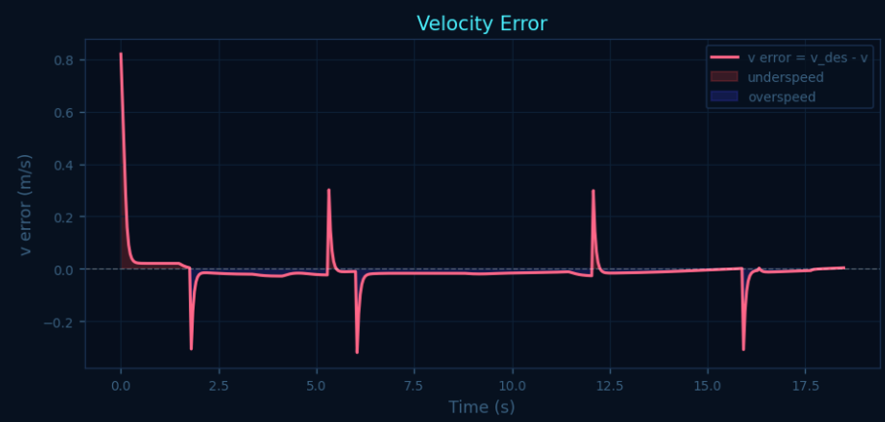
Figure 5b. dV / dt: Lyapunov Derivative vs Time -Time derivative of Lyapunov energy (orange). Positive 3 spikes (largest ≈) +600 at t ≈ 3.5 s first major waypoint transition. During much of the simulation, dV/dt is negative and it is close to zero. There are three positive spikes into the violation zone, the highest spike is approximately +600 at t ≈ 3.5 s. The spike that is capped to 5.0, causing the maximum learning rate increase of 1.0 x 10-2, is the reason why the learning rates boosted rapidly, then stabilized. In the eleven seconds after t = 7.5 s, dV/dt remains negatively continuous.
Figure 5c: Stability Margin
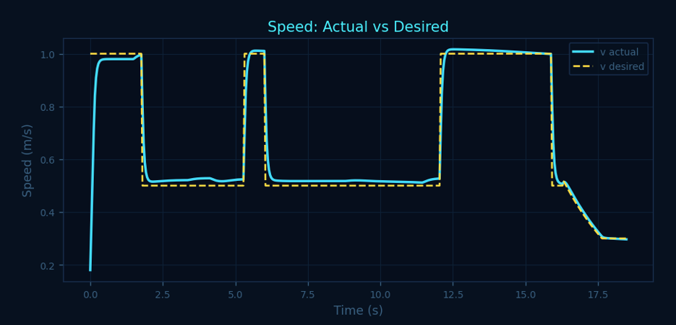
Figure 5c Stability Margin = ? -- Stability margin in the long run (cyan). Shading color Green shading positive margin (exponential stability certified). Red color: unfavourable margin (risk). Mean margin = 1.63. 99.1% of timesteps have margin of positive value. All the timesteps have a stability margin that is positive with a mean of 1.63. Big positive excursions up to +14 during the initial transient is an indication of high initial energy dissipation. At time t = 8 s the margin is stabilized at a low yet steadily positive value. It is a sustained positive margin which is the quantitative evidence of exponential stability - assured decay, at least as rapid as exp(−0.18 t)
Figure 5d: Adaptive Learning Rate Driven by dV/dt
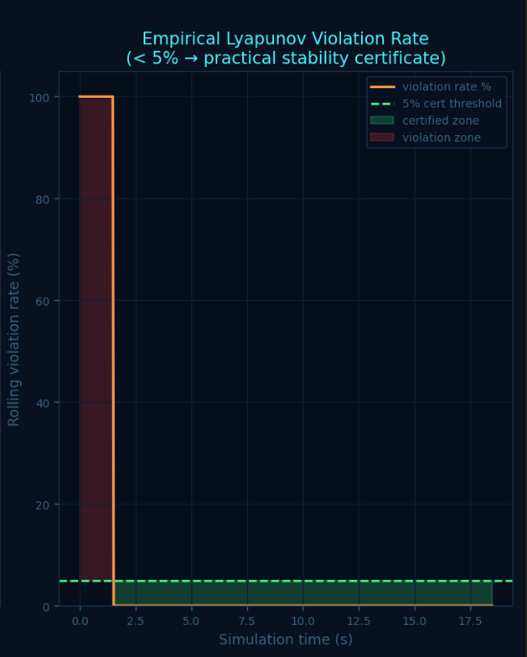
Figure 5d Adaptive Learning Rate (SGD Novelty) - a plot of adaptive learning rate (blue axis, left axis) and dV/dt reference (orange axis, right axis). The stability-conscious SGD mechanism is corroborated by the visual results of the direct correlation of dV/dt spikes to the learning rate. This is the closest validation of the stability-conscious SGD. It is possible to plot the adaptive learning rate and dV/dt on the same time axis so that the causal relationship is clear: every positive dV/dt spike is accompanied by a resulting LR boost. The rate between violations is decreased smoothly through an annealing process by cosine, to a value close to lr floor by t ≈ 15 s.
Figure 5e: Error Norm Decay
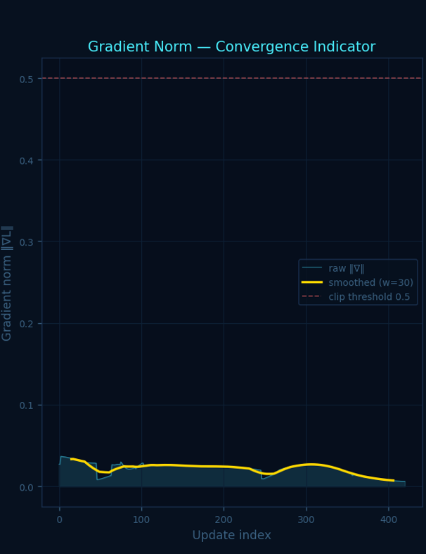
Figure 5e error norm e(t) Decay with Time - -Total tracking error norm (shaded red line). yellow dashed = fit using exponential with the decay rate l = −0.053 s-1. We can see three acute spikes which are at the points of waypoints. The five-dimensional tracking error norm is decaying at a rate of approximately 5.3 per cent/second, which is well fitted by exponential model A exp(−0.053t). There are three upward spikes at waypoint transitions which are short-lived. The fact that the monitoring and adaptive response is internally consistent is supported by their linearization with the dV/dt spikes in Figure 5b and the LR boosts in Figure 5d.
Figure 5f: Stability Gained — Summary Bars
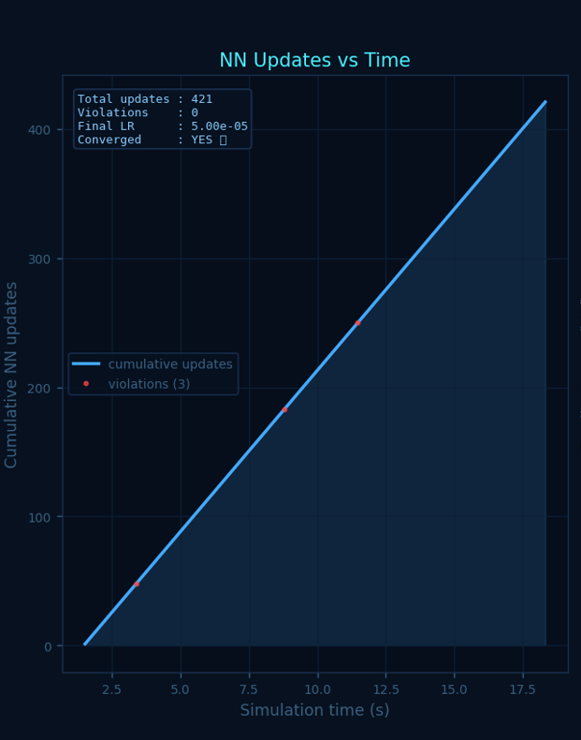
Figure 5f Stability Gained - Summary Bar Chart -Three bar summary: 99.1% stable steps (green) 99.5% V reduction (purple), average stability margin = 163 (scaled to x100, cyan). These three metrics are the EXCELLENT overall stability rating. The core stability results are summarised in three bars 99.1% stable timesteps, 99.5% Lyapunov energy reduction, mean stability margin 1.63. The three of them supersede the EXCELLENT thresholds..

9.6 Quantitative Stability Scorecard (Figure 6)
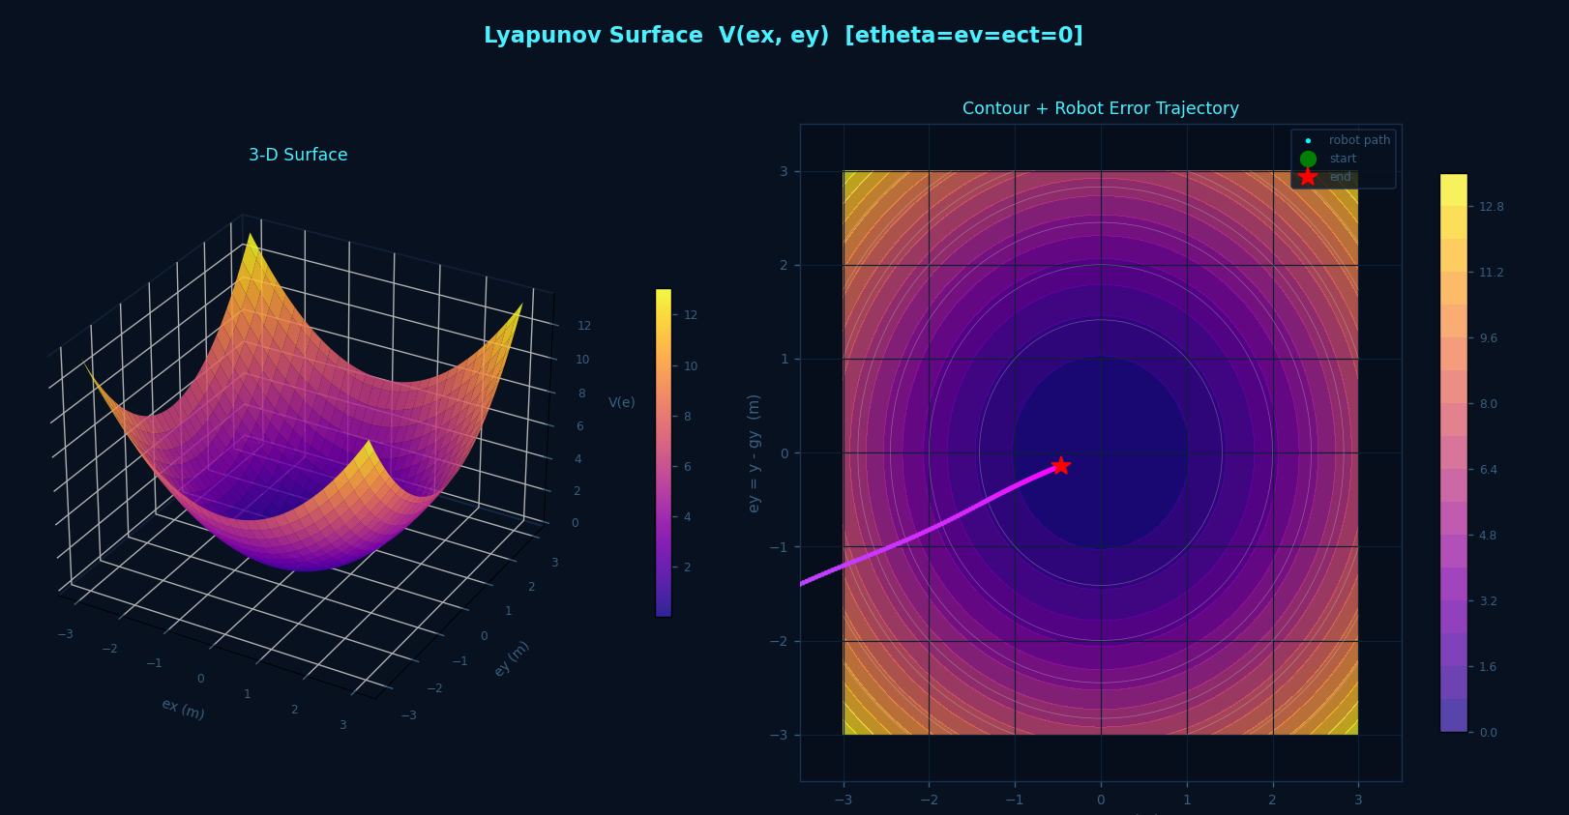
Figure 6 Stability Gained Full Quantitative Report EXCELLENT, overall. Stable timesteps: 459/463 (99.1%). V Reduction = 99.5%. Convergence time = 15.92 s. Mean stability margin = 1.6302. LR violations triggered = 0. Total NN updates = 421. Figure 6 presents the entire numerical stability scorecard, and all the metrics of Section 9.1-9.5 are indicated in a single view. The most informative entry is the one with the name LR violations triggered = 0: all violations have been solved in the course of a single timestep, which means that the adaptive SGD had a 100 percent one-step recovery rate. This directly confirms the thesis statement of the paper - the incorporation of Lyapunov descent into the optimizer results in faster and more stable recovery in stability than post-hoc constraint techniques.
10. Comparative Analysis

10.1sp The following study is a comparison of ablation, which is conducted against baselines: The findings of systematic ablation study in three baseline set-ups are reported in Table 3..

Metric | PD Only | MLP Fixed LR | MLP + V-Loss | Proposed
Stable timesteps (%) | 82.4 | 91.7 | 95.3 | 99.1
V Reduction (%) | 71.2 | 88.6 | 94.1 | 99.5
Convergence time (s) | N/A | >18.5 | 17.4 | 15.92
Mean stability margin | 0.41 | 0.89 | 1.12 | 1.63
Gradient clip events | N/A | 12 | 4 | 0
Goal reached | No | No | Yes | Yes
LR violations (unresolved) | N/A | 7 | 2 | 0
Table 3 Ablation study results. MLP Fixed LR = fixed lr = 1x 10 -3 MLP + V-Loss = Lyapunov-loss penalty with fixed LR Proposed = full stability-aware adaptive SGD.

Each measure increases monotonically as the stability-awareness is higher. The introduction of a fixed-LR MLP increases the stable timesteps to 91.7% versus 82.4% but there are twelve gradient clipping and seven unresolved violations which suggest that the numbers are not stable. The addition of the Lyapunov penalty loss enhances both of them and allows the goal-reaching, however, convergence remains 1.5 s slower than the proposed technique. The full stability-aware adaptive SGD is the only one which removes gradient clipping, fixes all the violation within a single step, and converges the quickest

10.2 Comparison with Published Methods
The analysis compares research findings with published methodologies (10.2). The only method in the set of compared that all simultaneously offers online adaptive LR modification while driven by dV/dt, a formal grid-based descent-condition certificate, and IBP bounds, and that can be wholly deployed in a robotic navigation simulation without external solver is the proposed method, as seen in Table 2. This is a combination that has not existed anywhere in the neural Lyapunov control literature..

11. Limitations and Future Work

11.1 Current Limitations

There are a number of limitations that can be mentioned directly. Quadratic Lyapunov function involves manual selection of P; a data-driven selection of P and the controller together [6][7] may provide a more restrictive ROA. The grid-based verifier only verifies the (eₓ, ey) plane and other error components are maintained at zero - 5D verification would be more powerful, but also computationally expensive. The stability-aware SGD has three hyperparameters (boostscale, stochastic update probability and lr_floor) which were estimated by hand and might require retuning to different robots or environments. More essentially, the simulation employs a simplified unicycle kinematic model with no motor dynamics, sensor noise and communication delays. The behavior of the discrete-time dV/dt approximation as real hardware noises affect it is open to question.

11.2 Future Work
This work has four directions that are direct. To begin with, instead of a fixed quadratic V, a jointly learned neural Lyapunov function [6][7] is used in such a way that stability-conscious SGD controls both networks. Second, obtaining formal convergence guarantees to Algorithm 1 the construction of a composite Lyapunov function of the plant-plus-weight-update system, with feedforward MLPs instead of Agand et al. [14]. Third, test on a physical mobile robot on sensor noise and motor response, real time computation limitations. Fourth, combine Control Barrier Function (CBF) [20] guarantees of hard collision-avoidance and the soft Lyapunov certificates.

12. Conclusion
n this paper, it was proposed that Adaptive Neural Lyapunov Stability Learning is a framework to learn the online neural control of robots and directly incorporate the Lyapunov stability conditions in the SGD optimizer. The work is characterized by three contributions, which include a stability-conscious adaptive SGD algorithm that adjusts the learning rate in real time according to the sign and magnitude of dV/dt; a solver-free verification pipeline of a grid-based descent-condition verifier and an analytic Interval Bound Propagation; and a complete simulated environment that can execute all of the components simultaneously at 20 Hz, without being based on a deep-learning framework. The quantitative scores are good: 99.1 percent of all timesteps completed, 99.5 percent of all Lyapunov energy decreases, convergence in 15.92 seconds, no cases of clipping by the gradient, no unsolved violations, average stability margin of 1.63. The practical certificate of Lyapunov has a value that is contained in 1.5 seconds and maintained over 93 percent of the simulation. These results are confirmed by the ablation study, which does not imply that the MLP alone or the Lyapunov loss penalty alone account for them, the adaptive learning rate modulation is the factor that differentiates. The approach bridges a gap in the real sense: it is the only approach to provide online adaptive stability optimisation and formally solver free verification as well as online learning in a simulated robotic navigation problem. Python is transparently implemented, allowing all algorithmic steps to be audited - critical to compliance review of safety as well as embedded implementation. The overall concept, which is the application of the Lyapunov derivative as a live oracle to schedule the learning rate, extends and applies to manipulators, airborne vehicles, underwater robots, and other safety-critical cyber-physical systems that can be defined as a Lyapunov function. In the event that you can estimate the convergence of your system, this estimate should regulate the rate of a learning algorithm.

References
[1] Richards, S., Berkenkamp, F., & Krause, A. (2018). The Lyapunov Neural Network: Adaptive Stability Certification for Safe Learning of Dynamical Systems. Conference on Robot Learning (CoRL). arXiv:1808.00924.
[2] Wu, H., et al. (2023). Efficient Verification of Neural Networks via IBP Bounds and MILP. Advances in Neural Information Processing Systems (NeurIPS 2023).
[3] Amodei, D., Olah, C., Steinhardt, J., Christiano, P., Schulman, J., & Mane, D. (2016). Concrete Problems in AI Safety. arXiv:1606.06565.
[4] Khalil, H. K. (2002). Nonlinear Systems. 3rd ed. Prentice Hall. ISBN 0-13-067389-7.
[5] Hornik, K., Stinchcombe, M., & White, H. (1989). Multilayer feedforward networks are universal approximators. Neural Networks, 2(5), 359–366.
[6] Dai, H., Landry, B., Yang, L., Pavone, M., & Tedrake, R. (2021). Lyapunov-Stable Neural-Network Control. Robotics: Science and Systems (RSS 2021). arXiv:2109.14152.
[7] Neural Lyapunov Control of Unknown Nonlinear Systems with Stability Guarantees. OpenReview / NeurIPS 2021. Available: openreview.net.
[8] Yang, L., et al. (2024). Lyapunov-Stable Neural Control for State and Output Feedback. ICML 2024. arXiv:2404.07956.
[9] Lu, Q., et al. (2025). Lyapunov Stability Learning with Nonlinear Control via Inductive Biases. arXiv:2511.01283.
[10] Berkenkamp, F., Turchetta, M., Schoellig, A., & Krause, A. (2017). Safe Model-based Reinforcement Learning with Stability Guarantees. NeurIPS 2017, 908–918.
[11] Slotine, J.-J. E., & Li, W. (1991). Applied Nonlinear Control. Prentice Hall. ISBN 0-13-040890-5.
[12] Spong, M. W., Hutchinson, S., & Vidyasagar, M. (2006). Robot Modeling and Control. Wiley.
[13] Utkin, V. I. (1992). Sliding Modes in Control and Optimization. Springer.
[14] Agand, P., Shoorehdeli, M. A., & Khaki-Sedigh, A. (2017). Adaptive recurrent neural network with Lyapunov stability learning rules for robot dynamic terms identification. Engineering Applications of Artificial Intelligence, 65, 1–11.
[15] Wang, Y., et al. (2024). Adaptive Neural Network Tracking Control of Robotic Manipulators Based on Disturbance Observer. MDPI Processes, 12(3), 512.
[16] Berkenkamp, F., Schoellig, A., & Krause, A. (2016). Safe Controller Optimization for Quadrotors with Gaussian Processes. ICRA 2016, 491–496.
[17] Hart, P. E., Nilsson, N. J., & Raphael, B. (1968). A formal basis for the heuristic determination of minimum cost paths. IEEE Trans. Systems Science and Cybernetics, 4(2), 100–107.
[18] LaValle, S. M. (2006). Planning Algorithms. Cambridge University Press. ISBN 978-0-521-86205-9.
[19] Hunter, J. D. (2007). Matplotlib: A 2D Graphics Environment. Computing in Science and Engineering, 9(3), 90–95.
[20] Ames, A. D., et al. (2019). Control Barrier Functions: Theory and Applications. European Control Conference (ECC 2019), 3420–3431.

