1. Five ideas you need first
Kerberos is a system where you prove who you are once, and then get small tickets to use individual services without sending your password again. Think of a music festival.
Term | Festival analogy | In this document
KDC (Key Distribution Center) | The ticket office | Active Directory (AD) plays this role
TGT (ticket-granting ticket) | A wristband that lets you ask the ticket office for any ride ticket | A full login. Powerful if stolen; usually valid about 10 hours and renewable up to 7 days
Service ticket | A ticket for one specific ride | A ticket for Hive, HDFS, a file share, etc. Useful for that one service only
PKINIT | Getting your wristband by showing a signed ID card (a certificate) instead of a password | Used by all three CRAFT modes
Constrained delegation (S4U) | A trusted concierge who can fetch ride tickets for you, but only for rides on an approved list | Used by krb-credd

The shared problem. Your HPC users log in with a CAC, which cannot give them a Kerberos wristband on Linux, and forwarding one over SSH is blocked. So something else must get their Kerberos credentials. CRAFT (three modes) and krb-credd are four ways to do that.

How to read the diagrams
Colour | Meaning
Blue boxes | Ordinary Linux programs or files, running as the user
Red-tinted boxes | Privileged Linux programs: they hold secrets such as keytabs or keys
Orange boxes | Windows / Active Directory services
Green boxes | Where tickets or key files are stored
Purple outline | The services the user finally wants to reach
Numbered arrows | The order in which data moves; each number matches the step table under the diagram

2. The four approaches on one page
All four start from a user who is already logged in to the HPC. They differ in who gets the credential from AD and what the user ends up holding.
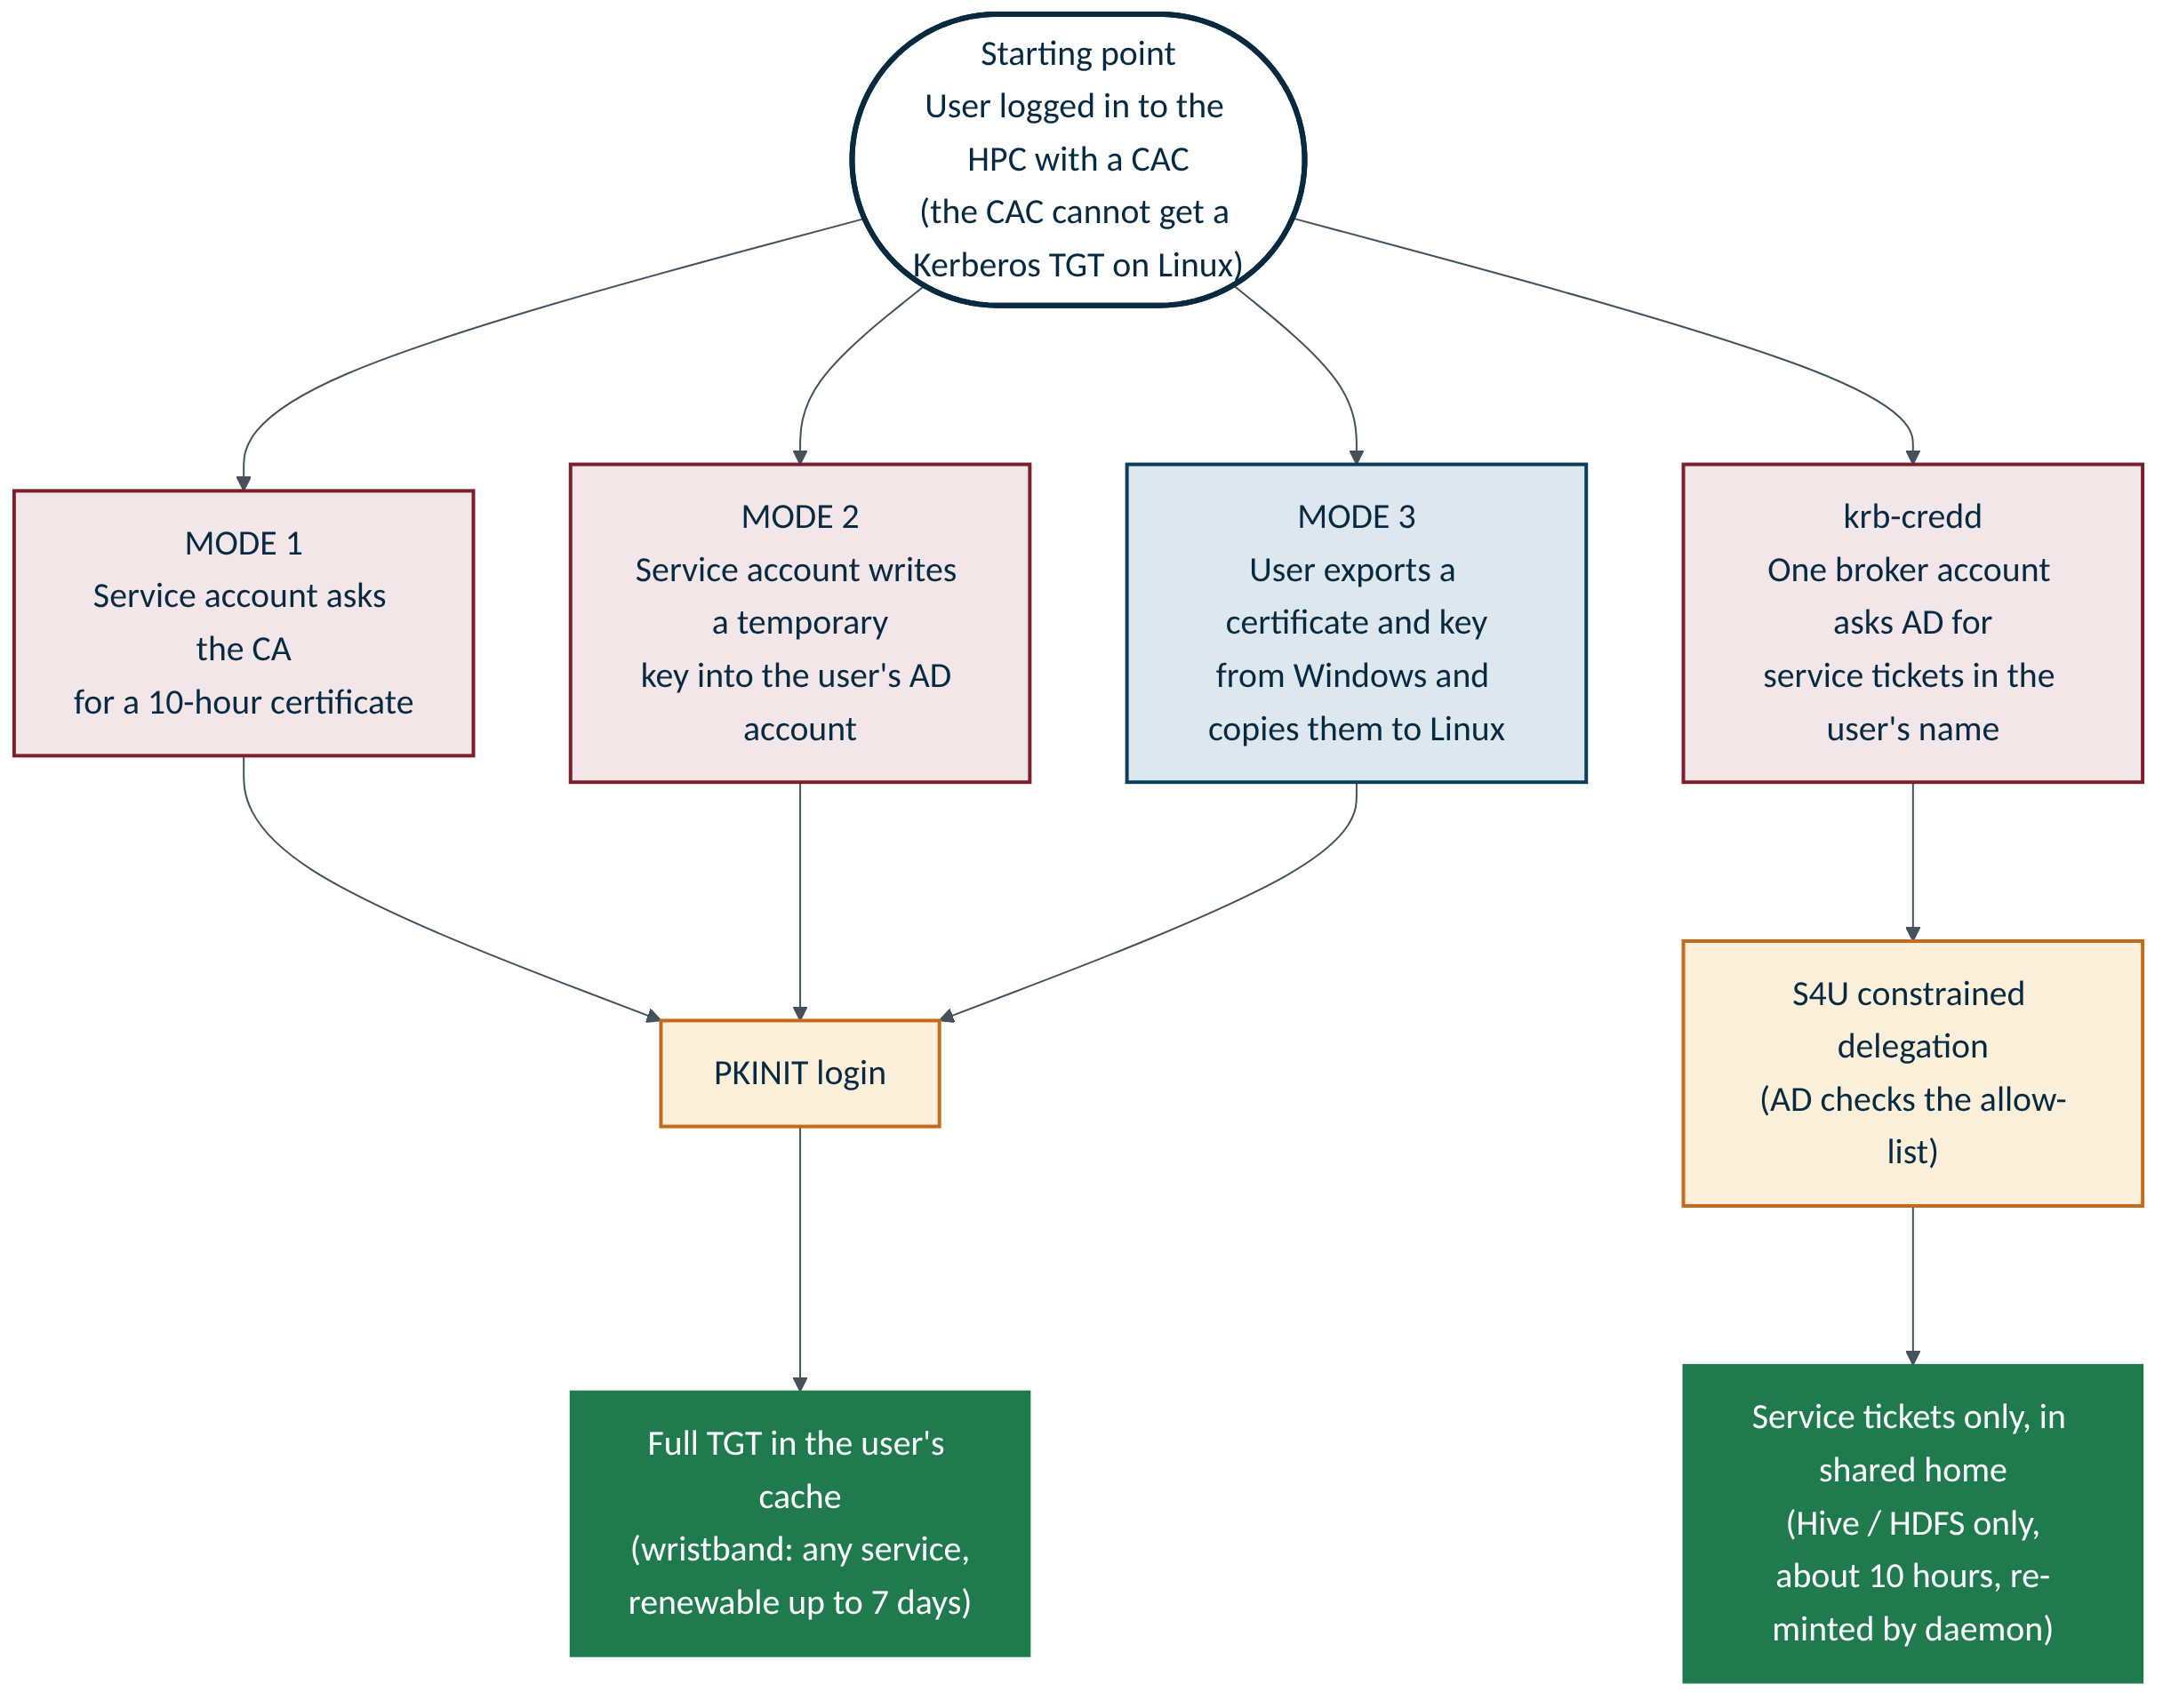

3. CRAFT mode 1: a certificate from the certificate authority
A privileged service account asks the CA for a short-lived certificate in the user's name, then uses it to log in. The user ends up with a full TGT.
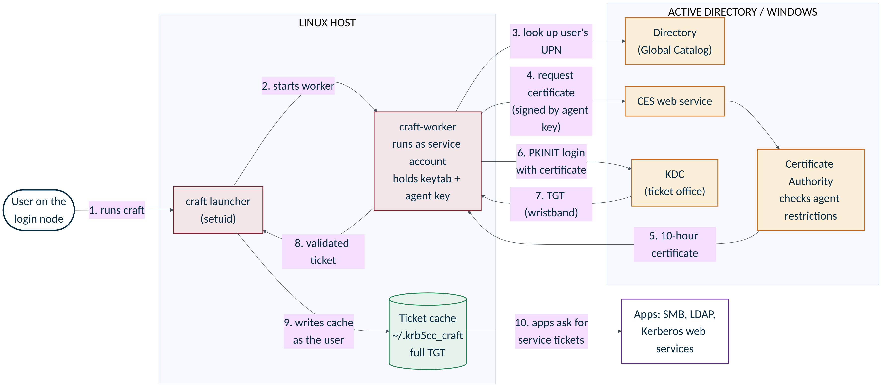

CRAFT mode 1: a certificate from the certificate authority: step by step
Step | What happens | What data moves | Watch for
1 | The user runs craft as themselves, no sudo. Linux identifies the caller by user ID. | Nothing yet | Never run it with sudo
2 | The setuid launcher starts the worker as the craft service account. | User ID, config | The service account holds a keytab and an agent key
3 | The worker looks the user up in AD's Global Catalog. | Username, then the user's UPN | Exactly one match is required
4 | The worker makes a key pair and a certificate request, signs it with the enrollment-agent key, and sends it to CES. | Public key and signed request | The agent key can request certificates for others
5 | The CA checks its enrollment-agent restrictions and issues a certificate of about ten hours. | The certificate | The CA, not CRAFT, decides who is allowed
6 | The worker proves possession of the private key to the KDC (PKINIT). | Certificate and signature | Needs current CRLs and a KDC certificate
7 | The KDC returns the TGT. | TGT and session key | Must be AES; lifetime is checked
8 | The worker hands the result to the launcher, which validates user, flags, encryption and times. | Validated ticket | Bad grants are rejected, old cache is kept
9 | The launcher writes the cache in the user's home as the user. The certificate and key are discarded. | Cache file ~/.krb5cc_craft (mode 0600) | The CA keeps an issuance record
10 | Apps use the TGT to ask the KDC for tickets to individual services. | Service ticket requests | TGT is renewable up to 7 days

Things to remember
- Strongest control point: the CA's list of who the agent may request certificates for.
- Heaviest setup: CA, CES, template, agent restrictions, KDC certificate, CRLs on every host.
- If the agent key or keytab leaks, certificates can be requested for everyone in the approved group.

4. CRAFT mode 2: a temporary key written into the user's AD account
The service account adds a temporary public key to the user's AD account, logs in with it, then removes it. No certificate authority is involved. The user ends up with a full TGT.
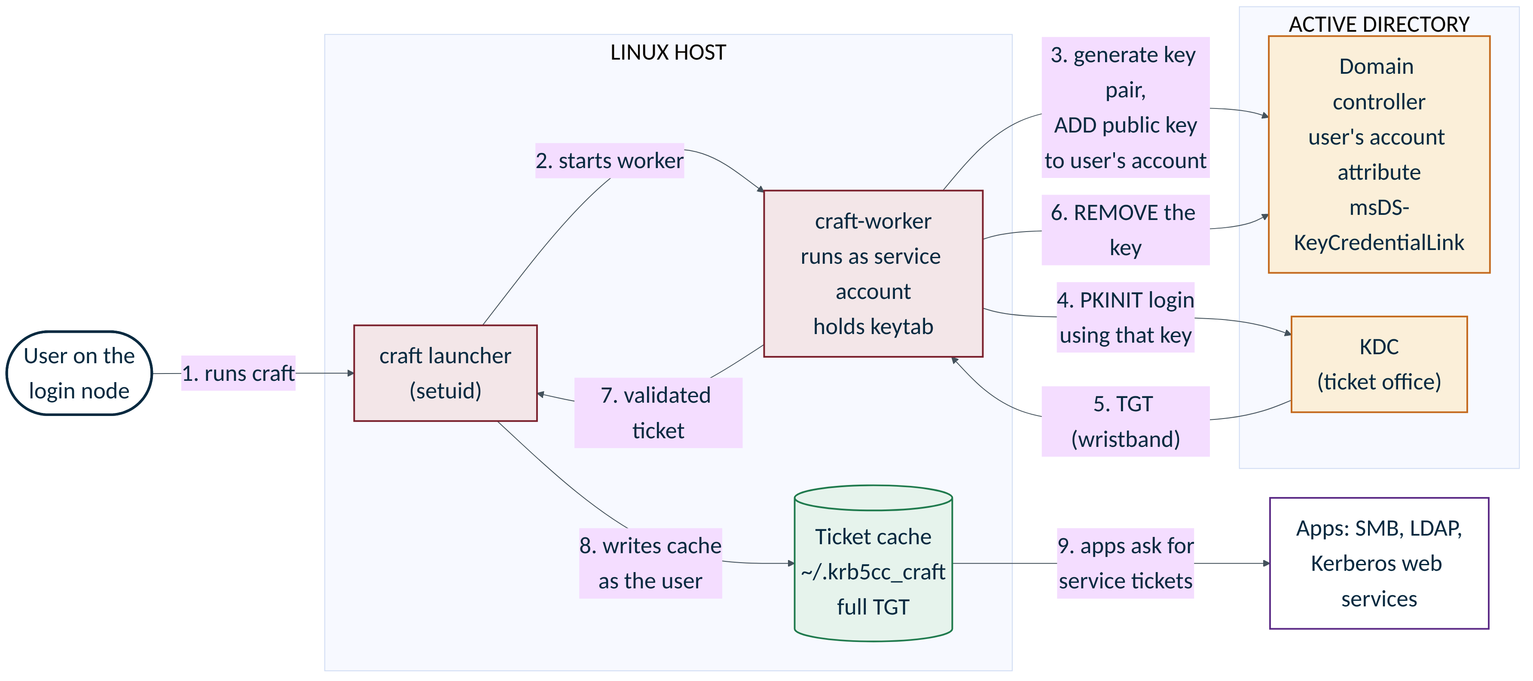

CRAFT mode 2: a temporary key written into the user's AD account: step by step
Step | What happens | What data moves | Watch for
1 | The user runs craft as themselves. | Nothing yet | No sudo
2 | The launcher starts the worker as the service account. | User ID, config | Worker holds a keytab
3 | The worker generates a key pair and ADDS the public key to the user's msDS-KeyCredentialLink attribute on a chosen domain controller. | Public key credential, written to AD | Uses a narrow AD permission over a reviewed set of users
4 | The worker logs in to the KDC using that key (Key Trust PKINIT). | Signed login request | Use the same DC for the write and the login
5 | The KDC returns the TGT. | TGT and session key | Checked: user, AES, lifetime
6 | The worker REMOVES its key from the account (existing keys are preserved). | Delete of one attribute value | If this fails, the cache is not published and a CRITICAL log appears
7 | The worker passes the validated ticket to the launcher. | Validated ticket | No ticket is cached until cleanup succeeds
8 | The launcher writes the cache as the user. | Cache file ~/.krb5cc_craft | Same cache as mode 1
9 | Apps use the TGT to get service tickets. | Service ticket requests | TGT is renewable up to 7 days

Things to remember
- Strongest control point: the AD permission. It must cover only ordinary users, because write access to this attribute equals the ability to log in as that account.
- Lighter setup than mode 1: no CA, CES or templates, but you still need a Key Trust-capable DC and KDC certificate.
- A leftover key in AD is a standing credential until an admin removes it.

5. CRAFT mode 3: the user brings their own certificate
The user exports a certificate and private key from Windows and copies them to their Linux home. Nothing privileged runs on Linux. The user ends up with a full TGT.
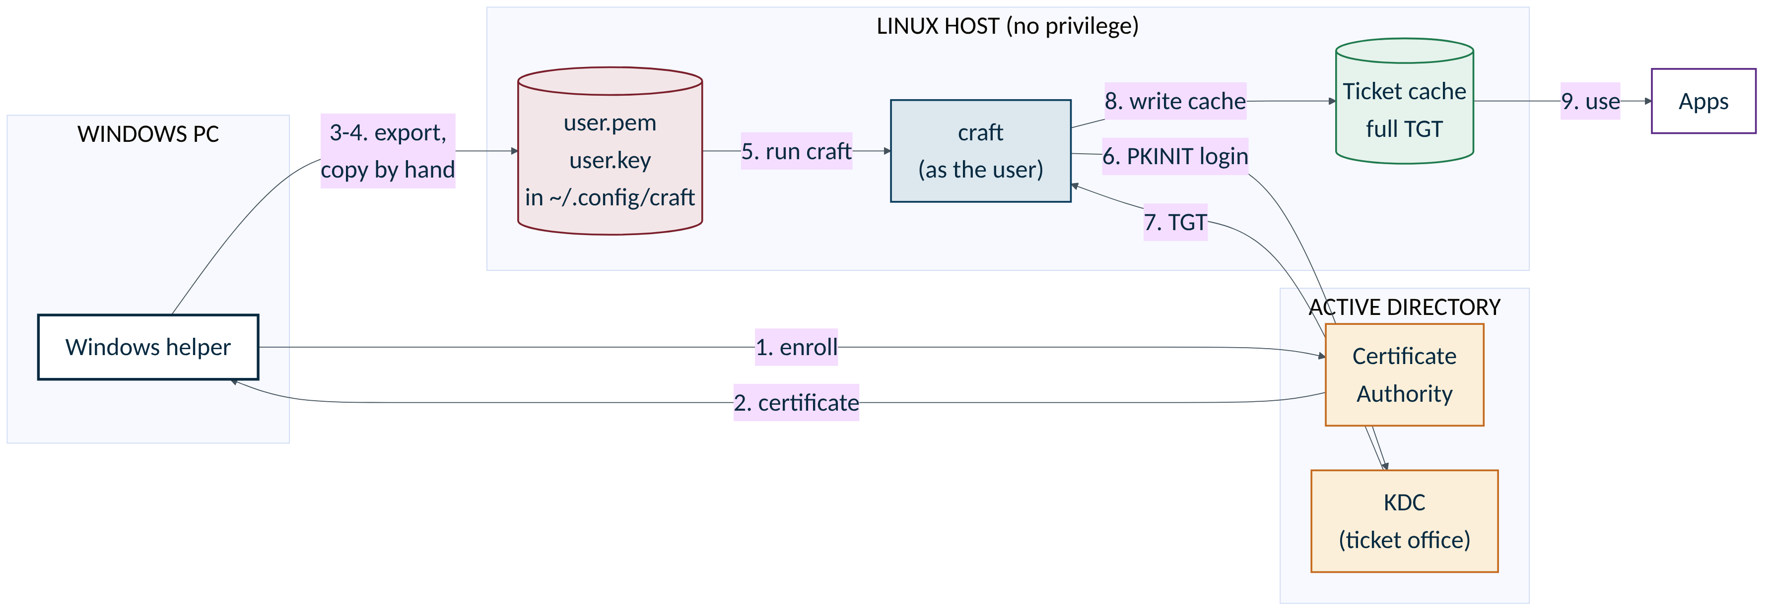

CRAFT mode 3: the user brings their own certificate: step by step
Step | What happens | What data moves | Watch for
1 | On Windows, the helper script enrolls a certificate as the signed-in user (not elevated). | Certificate request, from the user's own session | Needs a template that allows the user to enroll
2 | The CA issues the certificate. | Certificate | Its validity is the CA's choice
3 | The helper exports the certificate and an unencrypted private key. | user.pem and user.key | The key is not password protected
4 | The user copies both files to Linux by a secure route (manual). | Two files | Delete transfer copies afterwards
5 | Files sit in ~/.config/craft/ with strict permissions (0700 folder, 0600 files). | Same files | On shared NFS homes, every node can see them
6 | The user runs craft. It logs in to the KDC with the files (PKINIT). | Certificate and signature | No directory lookup; the KDC maps certificate to account
7 | The KDC returns the TGT. | TGT and session key | Checked for user, AES, lifetime
8 | CRAFT validates and writes the cache. | Cache file | Nothing renews the certificate pair
9 | Apps use the TGT to get service tickets. | Service ticket requests | Replace the pair before it expires

Things to remember
- Strongest control point: certificate issuance and KDC account mapping.
- No privileged service on Linux, so there is no central credential to steal. But every user holds a reusable credential.
- Replacing and securely transferring certificates is an ongoing job for users or admins.

6. krb-credd: one broker gets service tickets for the user
A root daemon holds a single broker keytab. Using constrained delegation, it asks AD for service tickets in each user's name, to an approved list of services only, and places them in the user's shared home. The user never holds a TGT.
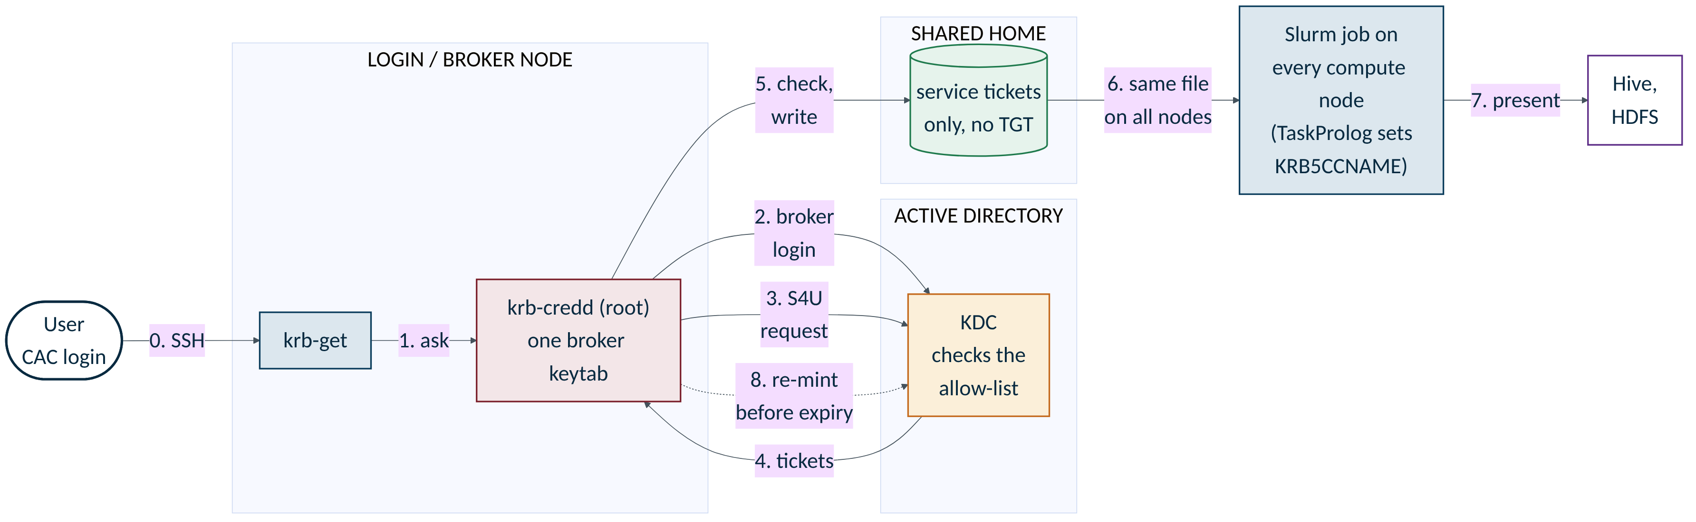

krb-credd: one broker gets service tickets for the user: step by step
Step | What happens | What data moves | Watch for
0 | The user logs in to the HPC with a CAC from a Windows PC. Linux now knows them by user ID. | CAC login (SSH) | Linux login is the proof of identity
1 | krb-get (or a Slurm job in the queue) asks the daemon for tickets over a local UNIX socket. | Request; the kernel reports the caller's user ID | The daemon trusts the user ID, not what the user says
2 | The daemon logs in as the broker account from its keytab, and renews that login automatically. | Broker TGT | One secret, on one machine
3 | The daemon asks the KDC for service tickets in the user's name (S4U2Self, then S4U2Proxy). | Delegation requests | Only for enrolled users who are allowed to be delegated
4 | The KDC returns tickets only for the listed services (msDS-AllowedToDelegateTo). | Service tickets for Hive, HDFS | No TGT is issued
5 | The daemon checks the cache (right user, every service present, no TGT, AES, at least 5 minutes left), then writes it into the user's shared home as the user. | Cache file $HOME/.krb5/krb5cc_hpc (0600) | Tickets on shared storage are readable by anyone acting as that user ID
6 | On each compute node, the Slurm TaskProlog sets KRB5CCNAME to that file. Every node already sees the same home. | An environment variable | No ticket copying needed
7 | The user's job presents the service tickets to Hive or HDFS. | Service tickets | Valid about 10 hours; not renewable
8 | In the background the daemon watches squeue and mints fresh tickets before the old ones expire. | Repeat of steps 3 to 5 | If the daemon stops, long jobs lose access when tickets expire

Things to remember
- Strongest control point: the AD allow-list of services the broker may impersonate users for.
- Least infrastructure: one service account and its delegation setting; no PKI, no CRLs, nothing to compile.
- If the broker keytab or the login node is compromised, an attacker can get tickets to the listed services as any eligible user.

7. Side by side
 | Mode 1 | Mode 2 | Mode 3 | krb-credd
User ends up with | Full TGT | Full TGT | Full TGT | Service tickets only
Who gets the credential from AD | Service account on the host | Service account on the host | The user (via Windows) | One broker account
What AD proves it to | Certificate from the CA | Key written to the account | The user's exported certificate | Delegation allow-list
Privileged piece on Linux | Setuid launcher plus service account | Setuid launcher plus service account | None | Root daemon on one node
Standing secret | Agent key and keytab | Keytab | One key file per user | One broker keytab
Slurm and multi-node support | None built in | None built in | None built in | Built in (shared home plus TaskProlog)
If one user's cache is stolen | Full TGT, renewable 7 days | Same | Same, plus a reusable key file | Listed services only, about 10 hours
Needs CRLs and PKI upkeep | Yes | Yes | Yes | No
Needs the user to do something | No | No | Yes (export, copy, renew) | No

Sources. CRAFT repository (github.com/nomorefood/craft, commit e028341): README, source/README.md, SECURITY.md, docs on enrollment agents and Key Trust delegation. shared-home-kerberos repository (github.com/vijayrattehalli-cloud/shared-home-kerberos): README and ARCHITECTURE.md. Neither tool was run in preparing these diagrams; they show the documented design. The ten-hour and seven-day figures are the tools' default requests; the KDC decides the actual grant.

