Introduction To AI COM727
VIJAY SINGH RAWAT
Student Number: Q102588329
Group:
Arash Mehrdad
Parteek Sharma
Mehrdad Madadi

Professors: Dr. Shakeel Ahmad
Dr. Kashif Talpur
SOLENT UNIVERSITY SOUTHAMPTON
2024 - 2025
Medical Chatbot

Table Of Contents
- Introduction ………………………………………………………………………………………………… 3
- Need For Your Prototype ………………………………………………………………………………. 4
- Statement Of The Problem ………………………………………………………………………………. 4
- Aims And Objectives ………………………………………………………………………………………. 4
- Proposed Solution………………………………………………………………………………………….. 5
- Prototype Design…………………………………………………………………………………………… 6
- Prototype Development And AI Algorithms Used……………………………………………. 6
- Functions…………………………………………………………………………………………………………… 7
- Implementation………………………………………………………………………………………………….. 8
  - Clean up sentence ……………………………………………………………………………
  - bow(sentence, words)
  - predict_class
  - chatbot
  - Algorithm Used
- Evaluation…………………………………………………………………………………………………………..11
- Limitation……………………………………………………………………………………………………………11
- Conclusion………………………………………………………………………………………………………. 12
- Reference List…………………………………………………………………………………………………….12

List Of Figures
- Figure 1: clean up sentence Code Snippet
- Figure 2: predict class Code Snippet
- Figure 3: get response Code Snippet
- Figure 4: chatbot Code Snippet

Introduction

Artificial intelligence Has Gain Lot Of Attention In Several Years. Due To Its Super Fast Problem Solving Skills And The Debate Has Been Started Artificial Intelligence Is Safe For Humans Or Not . Elon Musk Co-Founded And Leads Tesla, Spacex, Neuralink And The Boring Company .Elon Mush Warns In A Interview .Artificial Intelligence Could Be Cause Of Civilization Destruction . AI Often Collect Large Amount Of Personal Data To Analyze .This Concern Comes To Privacy Of Individuals This Data Can Be Mislead By AI Medical chatbot Has Created By Using Artificial Intelligence And Natural Language Processing (NLP) Technologies
The Medical chatbot Is Chatbot To Help Patient .It Does Not Cause Any Legal Issue Or Ethical Issue .This Is A Medical Chatbot And It Requires Health Data To Give Right Information About Particular Issue. For The Society Aspect This Chatbot Does Not Raise Any Issue . Because It Is Focus On To Help User For Best Remedy For Their Issue. As Per Professional Aspect The World Has Faced Shortage Of Doctor In 2019 Due To COVID-19.Even With Help Of Medical chatbot Doctors Can Save Their Time From Doing Manual Task . They Do Not Need To Interact With Customers This Medical chatbot Design To Help People Who Is Suffering From Health Issue Can Get Right Remedy In Short Span Time

Need For Your Prototype

All Around The World Death Raised Has Been Increased Due To Non Availability Of Doctors . Even The Capital City Of England And UK Also Facing This Issue .In London Nearly 1,800 Gps Are Needed Across London With 92 Of These Doctors Needed In Ealing Alone. As Per NHS Report . Even For Small Infection. Patients Have To Wait For Months To Get Appointments The Weighting Time Has Been Increased For 2 Weeks. The Medical chatbot Help User To Find The Diseases And As Per Their Diseases Suggest Better Medicine It Saves Time And Money Of Patient As Well As Patient Who Is Suffering From Small Diseases Can Get Prescription Using Medical chatbot . And The Problem Of Getting An Appointment Will Be Decreased.
And Patient With Human Interactions Probably Not That Much Comfortable To Share Their Personal Health Details Specially When There Is Mental Health Or abuse .The Medical chatbot Provides A Safe Space For Interaction With A Patient .So People Might Get Confident With The Interaction Apart From This Some People Are Prefer To Get Doctor At Home Doctor Helps Those Patient To Consult With A Chatbot Known As Medical chatbot

Statement Of the Problem
In the UK, there are many foreign students. As of 2024, there are approximately 600,000 international students studying in the UK. They come from different environments, and due to weather changes, the chances of getting sick are high. It takes time to get familiar with the UK weather. Common diseases they face include fungal infections, itching, skin rash, nodal skin eruptions, and dischromic patches. Consulting a private doctor can be costly, especially for students. When they register for a local GP, they may have to wait for 2 or 3 weeks. The Doctorbot is a user-friendly chatbot that helps users get quick responses for their diseases.

Aims And Objectives

- This Medical chatbot helps people by providing a user-friendly interface to interact with and suggests the best remedy based on symptoms in the absence of professional doctors.
- People who cannot afford the fees of professional doctors can use Medical chatbot without any cost.
- Medical chatbot helps reduce the cost of healthcare services.
- Medical chatbot uses algorithms to help patients around the world with the best remedy for particular diseases.
- Medical chatbot helps improve the quality of care for patients and their level of satisfaction.
- The world will be introduced to a new AI doctor. This chatbot will improve patient interaction and engagement.
- Medical chatbot helps users get knowledge about their symptoms before arranging for an in-person professional doctor.

Proposed Solution

A chatbot known as Medical chatbot has been created as a prescriptive chatbot. It works similarly to a conversational chatbot. Medical chatbot is designed to provide information as a professional medical guide to patients. Unlike human doctors, Medical chatbot is not bound by working hours. As long as the server is running, patients can interact with the chatbot anytime without needing an appointment.

Prototype Design

The global trend to get health information was a big challenge because of the complex vocabulary. An AI-based chatbot for doctors can save a lot of time because patients can get different information from different sources, which can lead to confusion. The main objective of the chatbot called Doctorbot is to interact with users and provide the right information or prescription based on their problems.

Prototype Development And AI Algorithms Used

- Natural Language Processing (NLP):
  - Tokenization: Splitting text into individual words.
  - Lemmatization: Reducing words to their base form.
  - Stop words Removal: Filtering out common words that do not add significant meaning.
- Machine Learning:
  - Bag Of Words: Representing text data as numerical vectors.
  - Neural Network: A Multi-Layer Perceptron (MLP) model is used for classification.
  - Stochastic Gradient Descent (SGD): An optimization algorithm used to minimize the loss function during training.
- Deep Learning:
  - Sequential Model: A linear stack of layers in TensorFlow.Keras.
  - Dense Layers: Fully connected layers in the neural network.
  - Dropout Layers: Layers used to prevent overfitting by randomly setting a fraction of input units to 0 during training.

Prototype Development

- Library Installation: NLTK, NumPy, TensorFlow.
- Data Preprocessing:
  - Nltk word tokenize: Function used to split sentences into words.
  - Lemmatization: Used to reduce words to their base or root form.
  - Stop words Removal: Used to remove common words (e.g., "like," "is," "and," "the").
  - Bag Of Words: Used to convert text data into numerical data using the Bag of Words model.
- Data Preparation:
  - Pickle: Used to save words and classes for inference.
  - Training Data: Prepared by creating input-output pairs.
- Model Building:
  - TensorFlow: Used to build a sequential model with Tensor Flow Keras.
  - ReLU: The model consists of dense layers with ReLU activation and dropout layers to prevent overfitting.
  - Softmax Activation Function: Used for multi-class classification in the final layer.
- Model Training:
  - Stochastic Gradient Descent: Used to compile the model.
  - Epochs: Used to test the data a specific number of times on prepared data.

Implementation

- Clean up sentence(sentence):
  - Purpose: Preprocesses the input sentence by converting it to lowercase, tokenizing it, and lemmatizing each word.
  - Parameters: Sentence (a string input from the user).
  - Returns: A list of lemmatized words from the input sentence.
  - 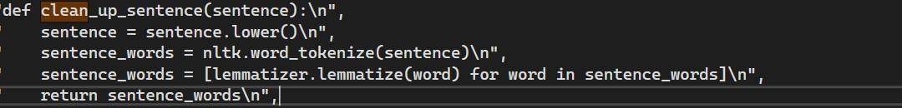

- bow(sentence, words)

  - Purpose: Converts the input sentence into a Bag-Of-Words (BoW) representation, which is a binary vector indicating the presence of known words.
  - Parameters: Sentence (a string input from the user), Words (a list of known words).
  - Returns: A NumPy array representing the BoW vector.
  - 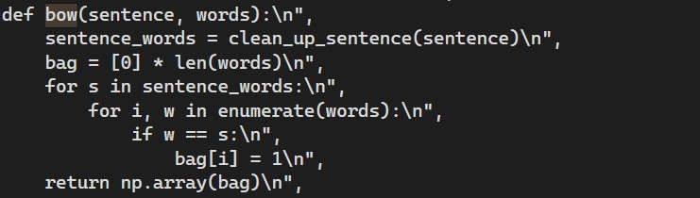

- Predict class(sentence):

  - Purpose: Predicts the class (intent) of the input sentence using the trained model.
  - Parameters: Sentence (a string input from the user).
  - Returns: A list of dictionaries, each containing an intent and its probability.

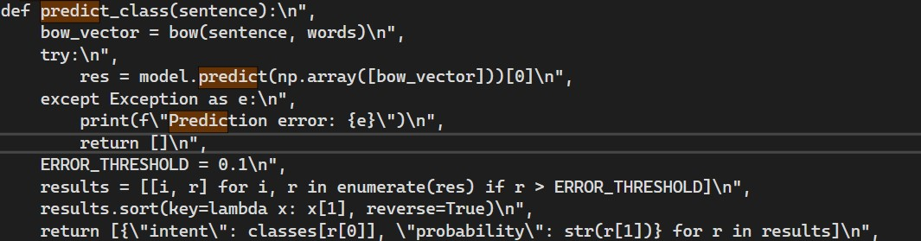

- Get response (intents list, intents json):

  - Purpose: Generates a response based on the predicted intent.
  - Parameters: Intents list (a list of predicted intents), Intents json (the JSON object containing all intents and responses).
  - Returns: A string response corresponding to the highest probability intent.
  - 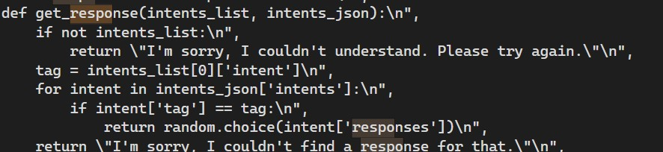

- chatbot():
  - Purpose: Runs the chatbot in an interactive loop, taking user input, predicting the intent, and generating a response.
  - Parameters: None.
  - Returns: None. It prints the chatbot's responses to the console.
  - 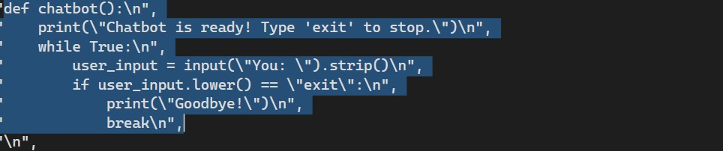

Steps To Run The Chatbot
- Go to Google Collab and upload the medical_chatbot.ipynb file.
- Upload the intents.json file.
- Run the main function to interact with the chatbot.
- GIT HUB LINK : - https://github.com/vijayrawat0611/com727.git

Evaluation

The Doctorbot has been tested by the Pioneers team using the chatbot function. We have developers from the medical domain who deployed the chatbot to the group and collected their feedback. We are all aware of medical issues and provided our inputs individually to find outputs from Doctorbot. Manual testing involved interacting with the chatbot and providing various inputs to see how it responds, noting any issues or unexpected behavior.

Limitation
Some challenges and limitations faced while developing Doctorbot include:
- Language Support: Doctorbot is currently unable to support multiple languages. Only users who can input in English will get output.
- Limited Training Data: We have a limited dataset to drive the chatbot’s responses concerning a range of possible patient queries.
- Speech To Text: Doctorbot does not have a voice feature to interact. Users have to type the input to get output.

Conclusion

- Expand training data One Of The Main Aspect Of Doctorbot Will Be To Increase The Diversity And Size Of Training Dataset To Improve The Chatbot's Understanding And Response Accuracy.
- Language Support : Enable Multiple Language Support .Develop A System For The Patient All Round The World . So They Can Interact With Doctorbot To Get Output
- Voice Feature :- Enable Voice Feature In Doctorbot So User Can Interact With Chatbot To Speaking.
- Security And Privacy Is The Main Priority Specially When It Comes To Individual’s Health Data And Secure The Data To Misuse

Reference List

• Reports on AI in Medicine:
- World Health Organization (WHO), 2021. Artificial Intelligence in Health: An Overview. [online] Available at: https://www.who.int [Accessed 1 January 2025].
• Medical Chatbot Development:
- Bickmore, T.W. and Giorgino, T., 2006. Health Dialog Systems for Patients and Consumers. Journal of Biomedical Informatics, 39(5), pp. 1-22
National Health Service (NHS), 2023. The Impact of Artificial Intelligence in Healthcare. [online] Available at: https://www.nhs.uk [Accessed 1 January 2025]
The risk of something seriously dangerous happening is in the five-year timeframe. 10 years at most."
(Source: Musk speaking at the MIT Aeronautics and Astronautics Department conference, 2014)

National Health Service (NHS), 2023. NHS faces shortage of GPs across London and UK. [online] Available at: https://www.nhs.uk [Accessed 1 January 2025].

