Git & Flask Assignment Report Template
Name: VIJAY R GALI
GitHub Repo: https://github.com/vijayrgali26/Flask_Git_Assignment.git
Date: 21/07/2026

1. Repository Creation
Commands:
Screenshots:
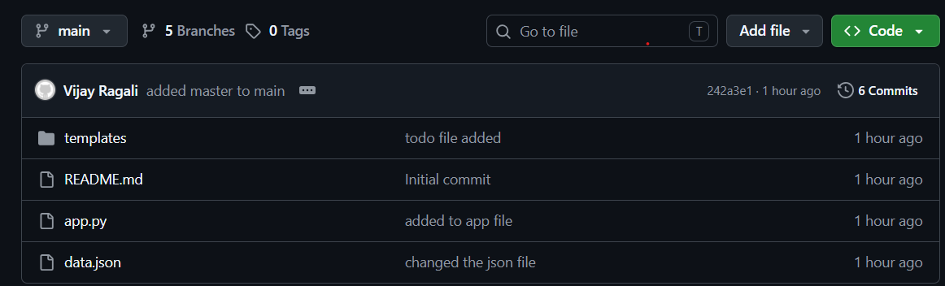
- GitHub repository
- SSH key
- Clone

2. Username Branch
Commands:
git checkout -b vijayrgali26
git add .
git commit -m "Added Flask project"
Screenshot:
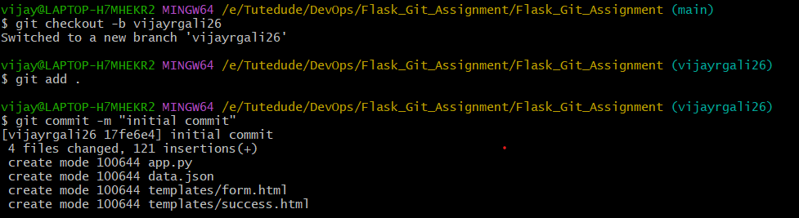

3. vijayrgali_new Branch
Commands:
Update JSON
Commit
Merge
Screenshots:
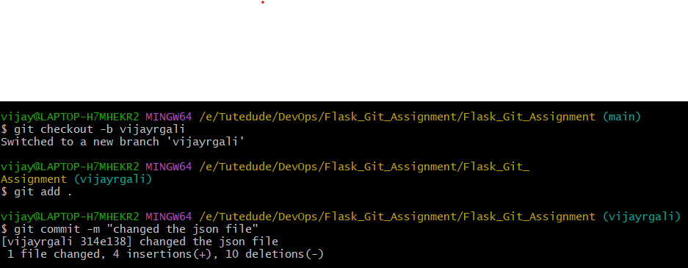

4. master_1
Created To-Do page.
Commands:
Screenshots:
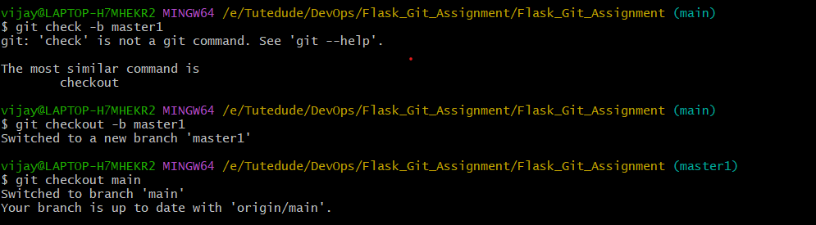

5. master_2
Created /submittodoitem API.
Commands:
Screenshots:
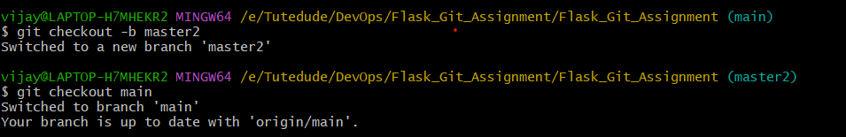

6. Merge
Commands:
git merge master_1
git merge master_2
Screenshots:
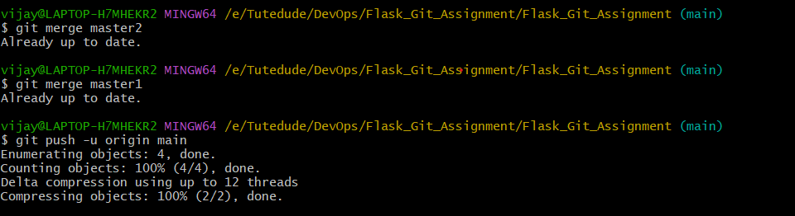

7. Separate Commits
Commit 1: Item ID
Commit 2: Item UUID
Commit 3: Item Hash
Paste git log screenshot.
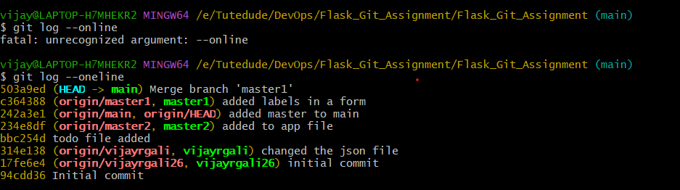

8. Git Reset
Command:
git reset --soft <commit_id>
Screenshot:
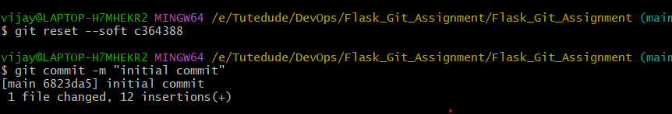

9. Git Rebase
Command:
git rebase main
Screenshot:
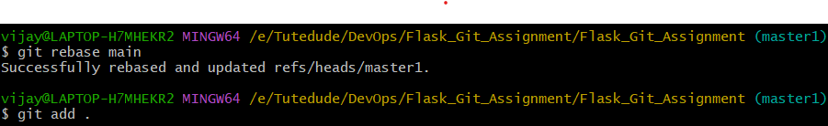
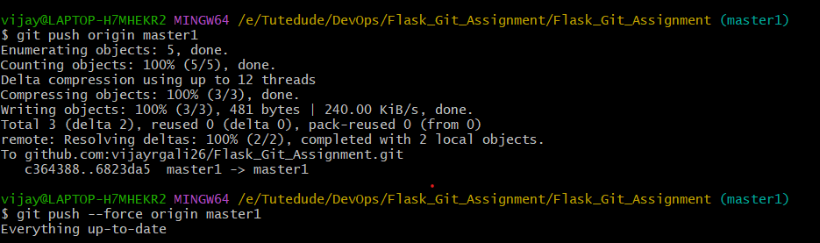

10. Conclusion

Repository Link:
https://github.com/vijayrgali26/Flask_Git_Assignment.git

