Linux Basics Assignment Report
Name: VIJAY R GALI
Course: DevOps

1. Create Directory
Command:
mkdir test_dir
Explanation: Creates a directory named test_dir.
Screenshot:
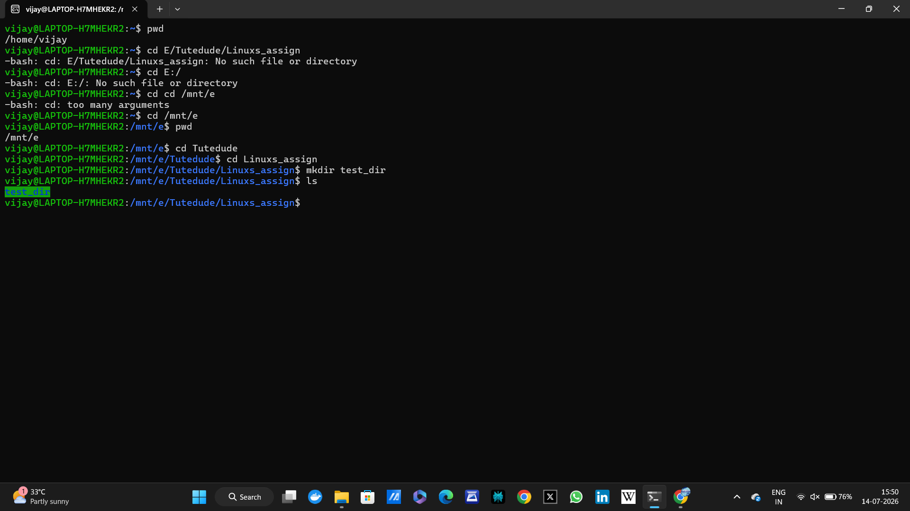

2. Create File
Command:
touch test_dir/example.txt
Explanation: Creates an empty file.
Screenshot:
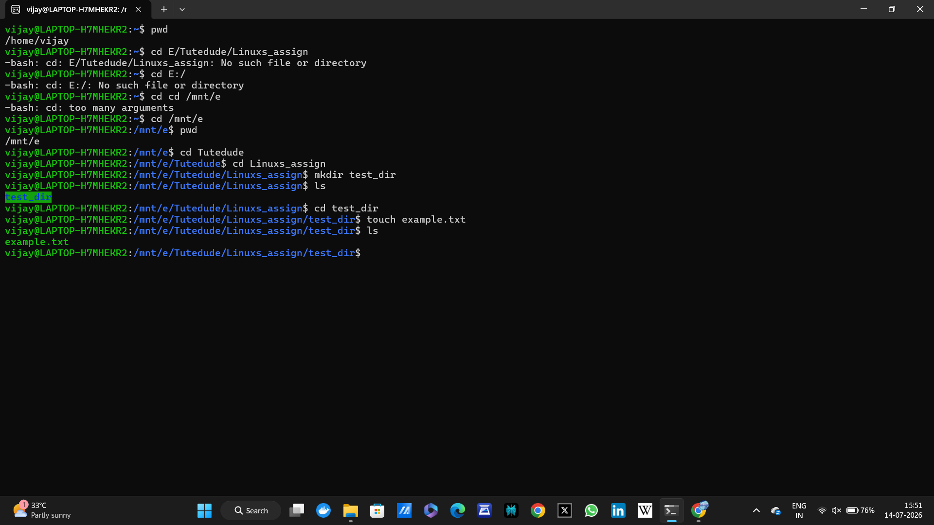

3. Rename File
Command:
mv test_dir/example.txt test_dir/renamed_example.txt
Explanation: Renames the file.
Screenshot:
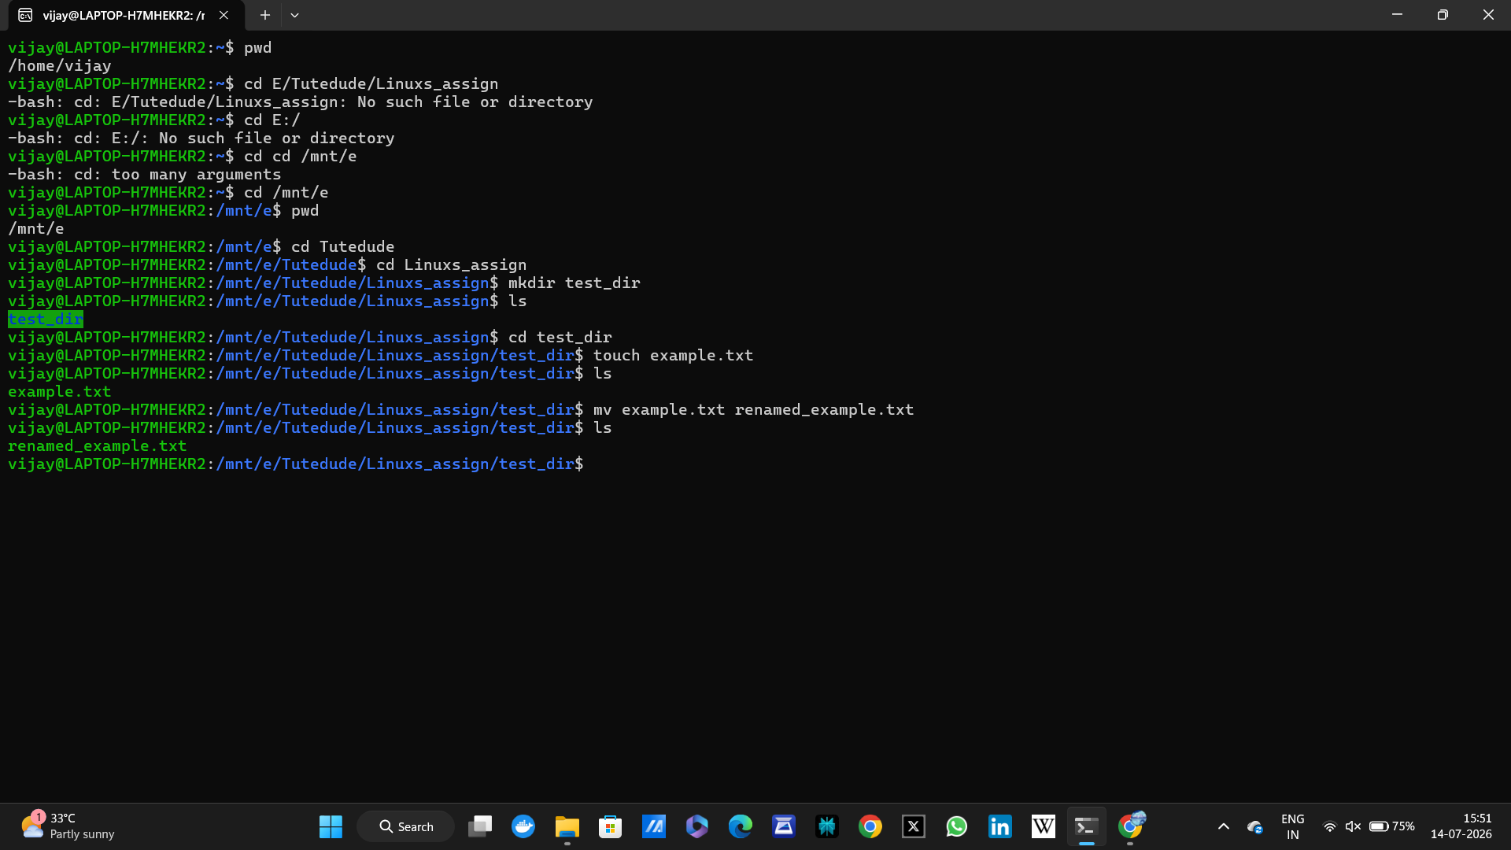

4. View /etc/passwd
Command:
cat /etc/passwd
Explanation: Displays entire file.
Screenshot:
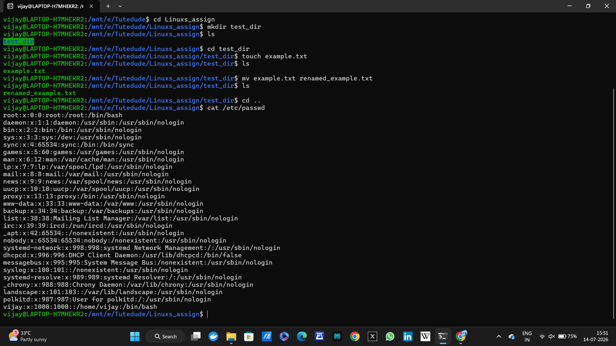

5. First 5 Lines
Command:
head -5 /etc/passwd
Explanation: Shows first five lines.
Screenshot:
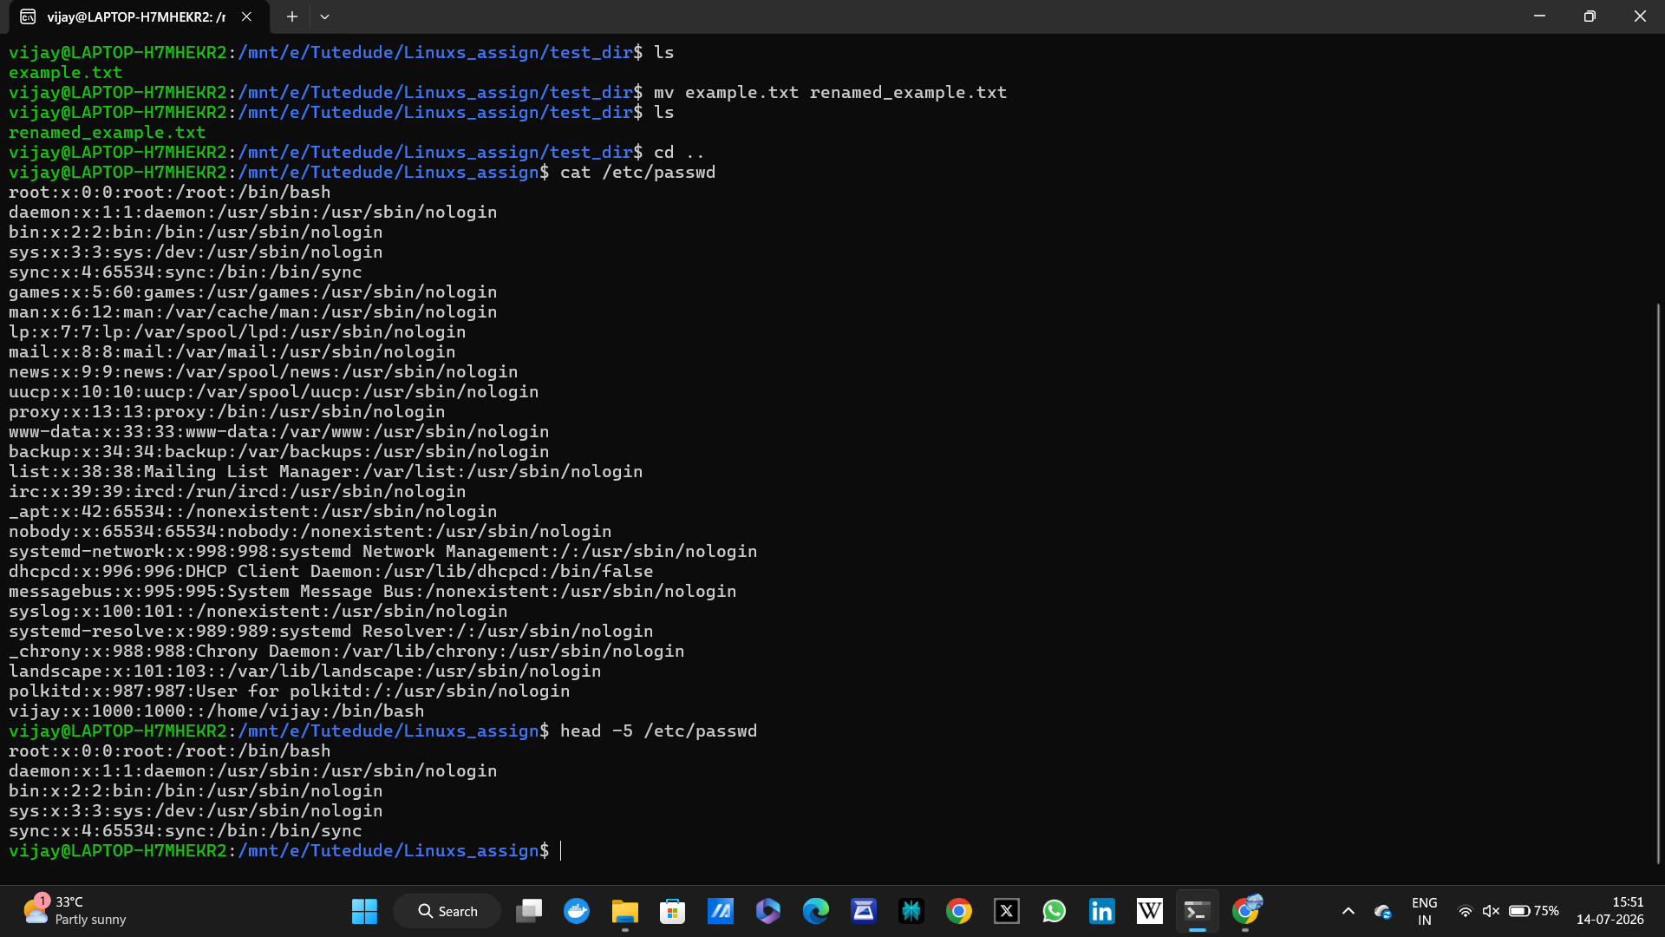

6. Last 5 Lines
Command:
tail -5 /etc/passwd
Explanation: Shows last five lines.
Screenshot:
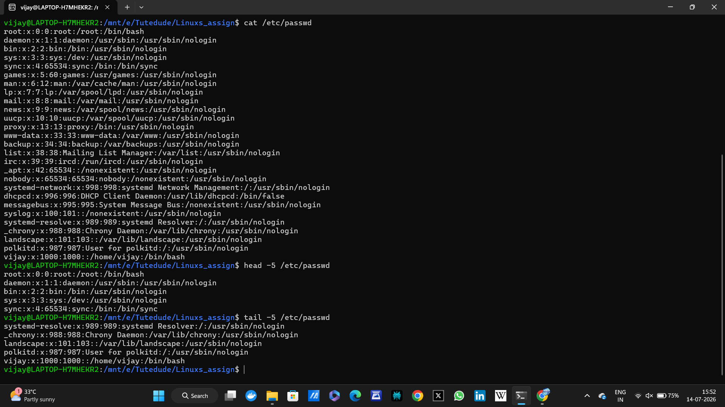

7. Search root
Command:
grep root /etc/passwd
Explanation: Searches for lines containing root.
Screenshot:
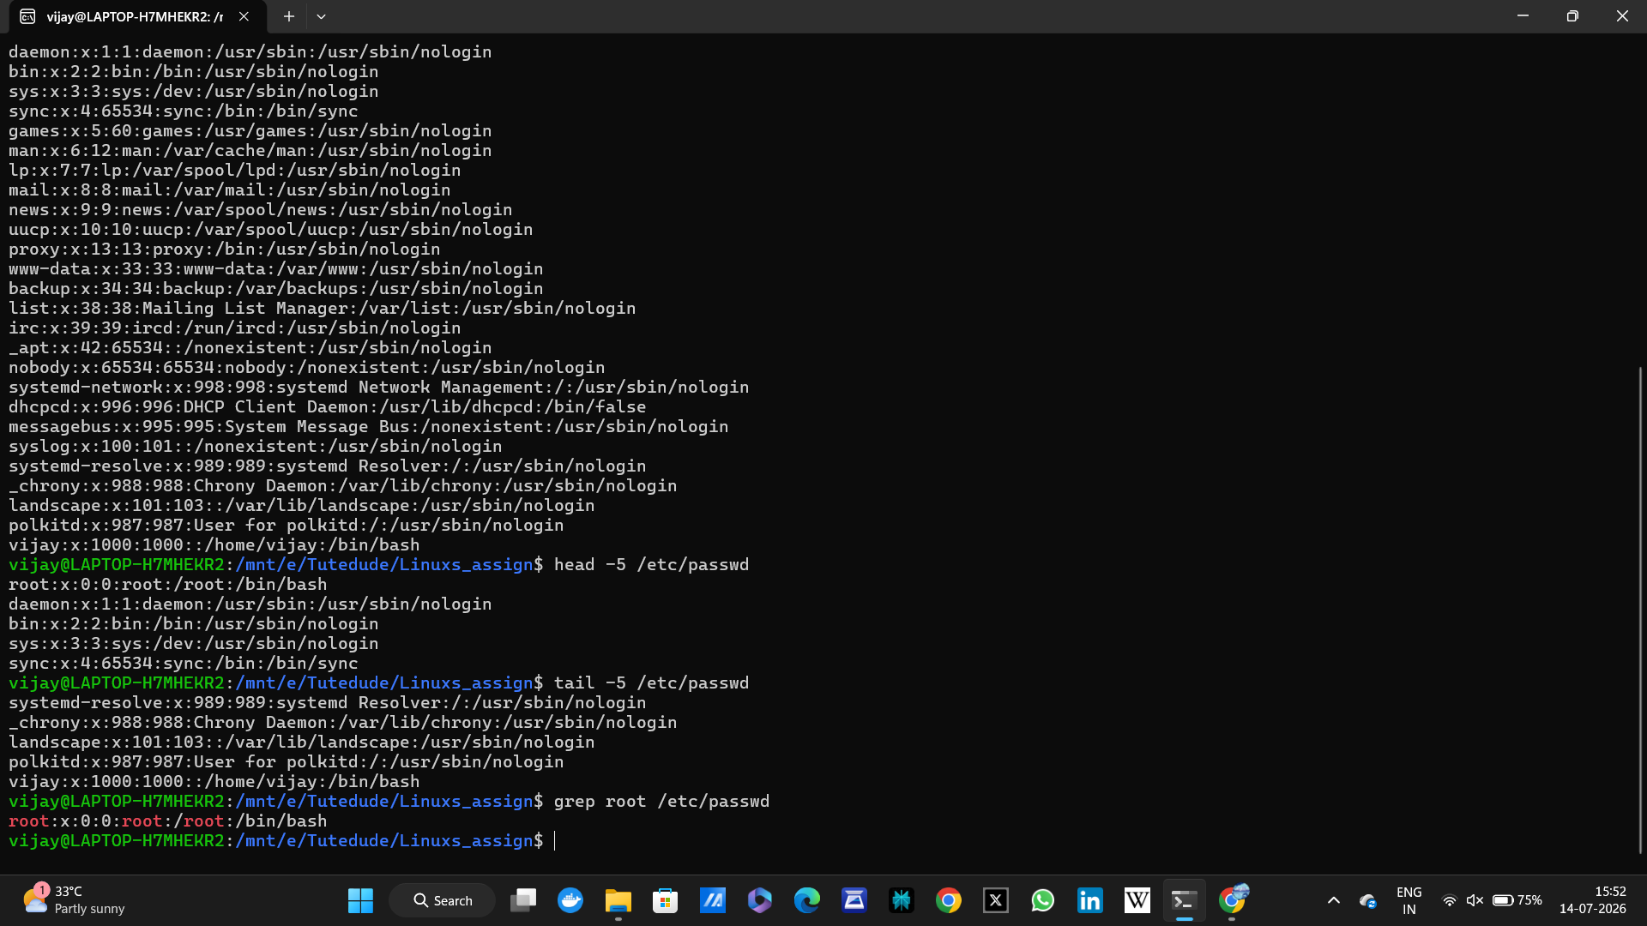

8. Zip Directory
Command:
zip -r test_dir.zip test_dir
Explanation: Compresses the directory.
Screenshot:
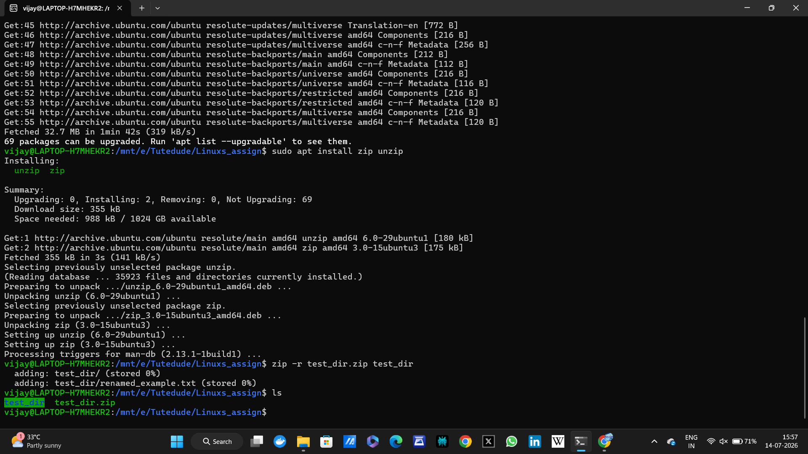

9. Unzip
Command:
unzip test_dir.zip -d unzipped_dir
Explanation: Extracts into new folder.
Screenshot:
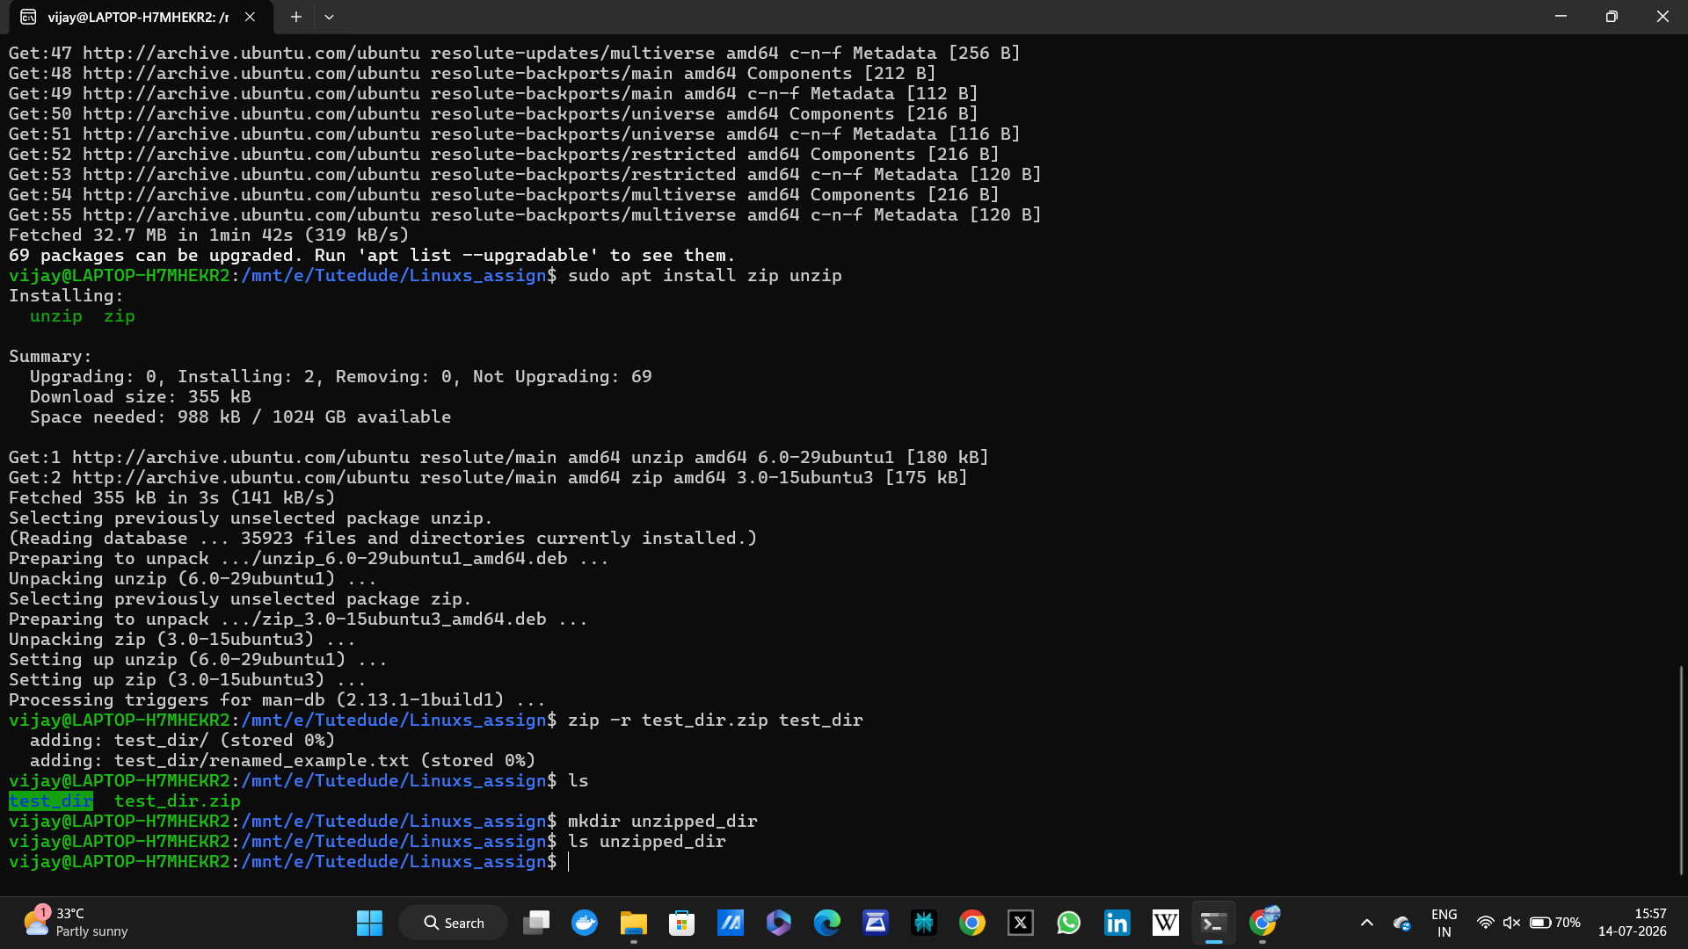

10. Download File
Command:
wget https://example.com
Explanation: Downloads a file/webpage.
Screenshot:
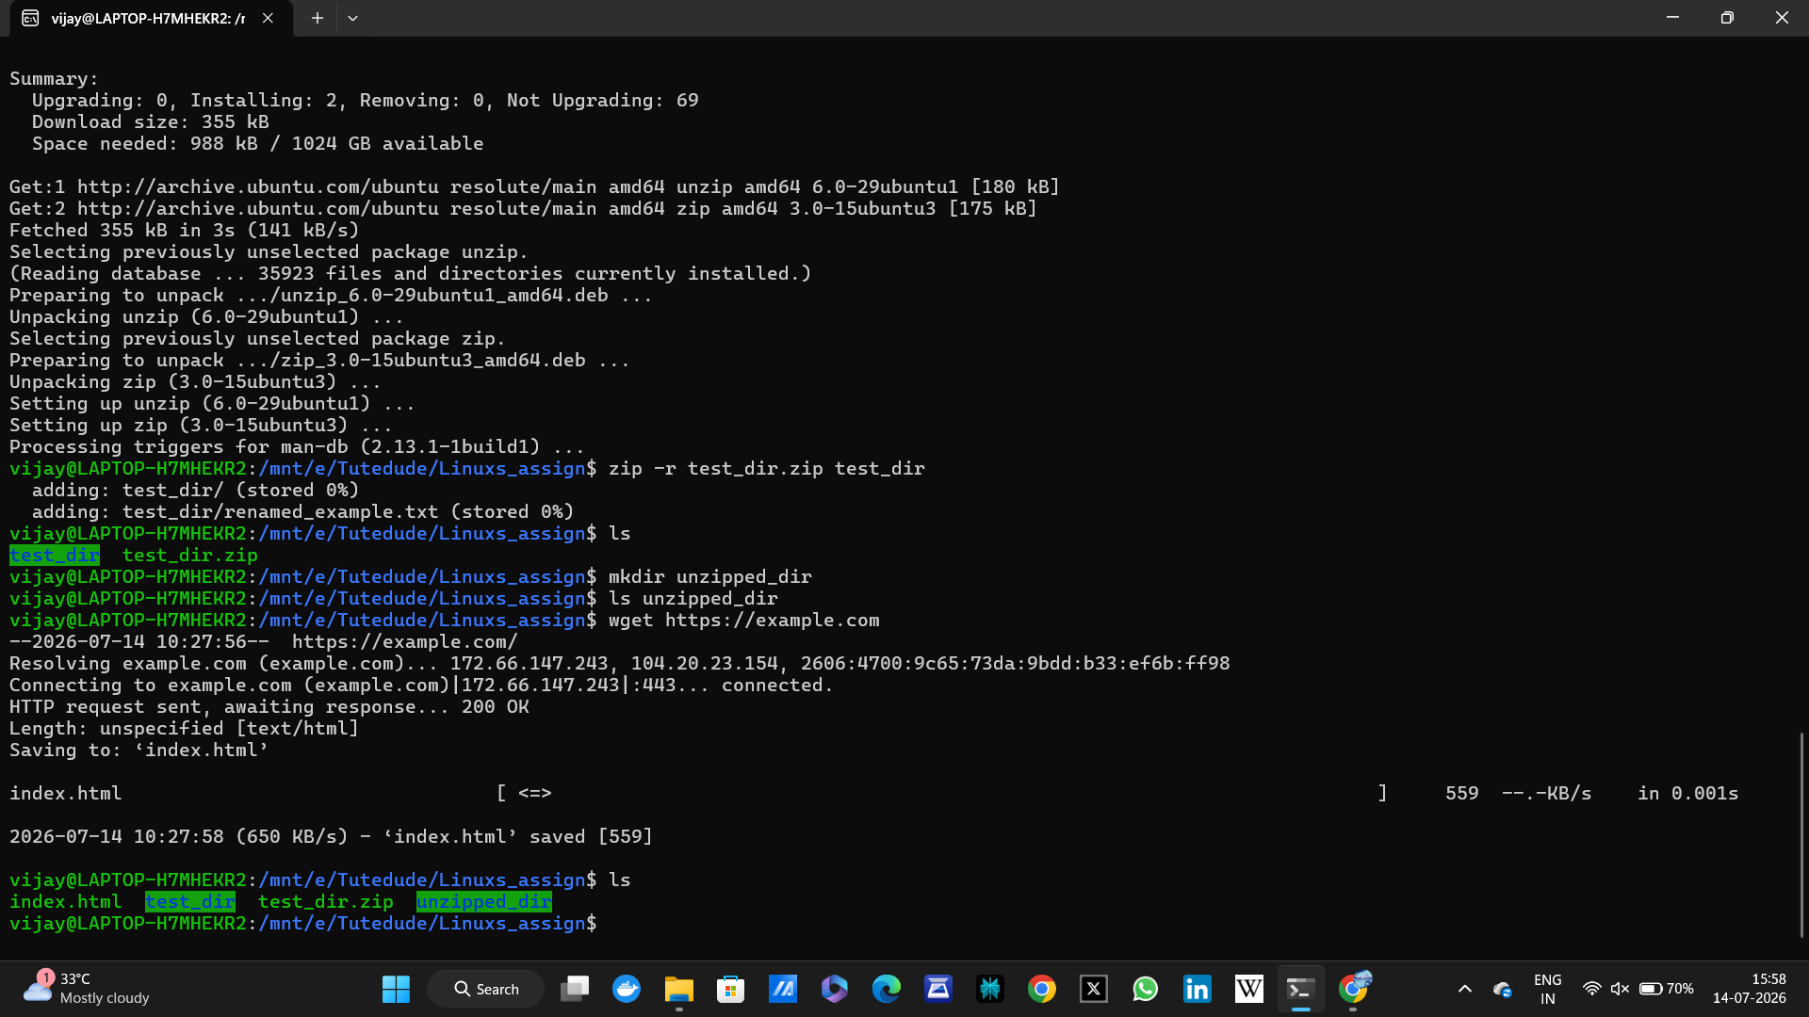

11. Change Permissions
Command:
touch secure.txt
chmod 444 secure.txt
Explanation: Makes file read-only.
Screenshot:
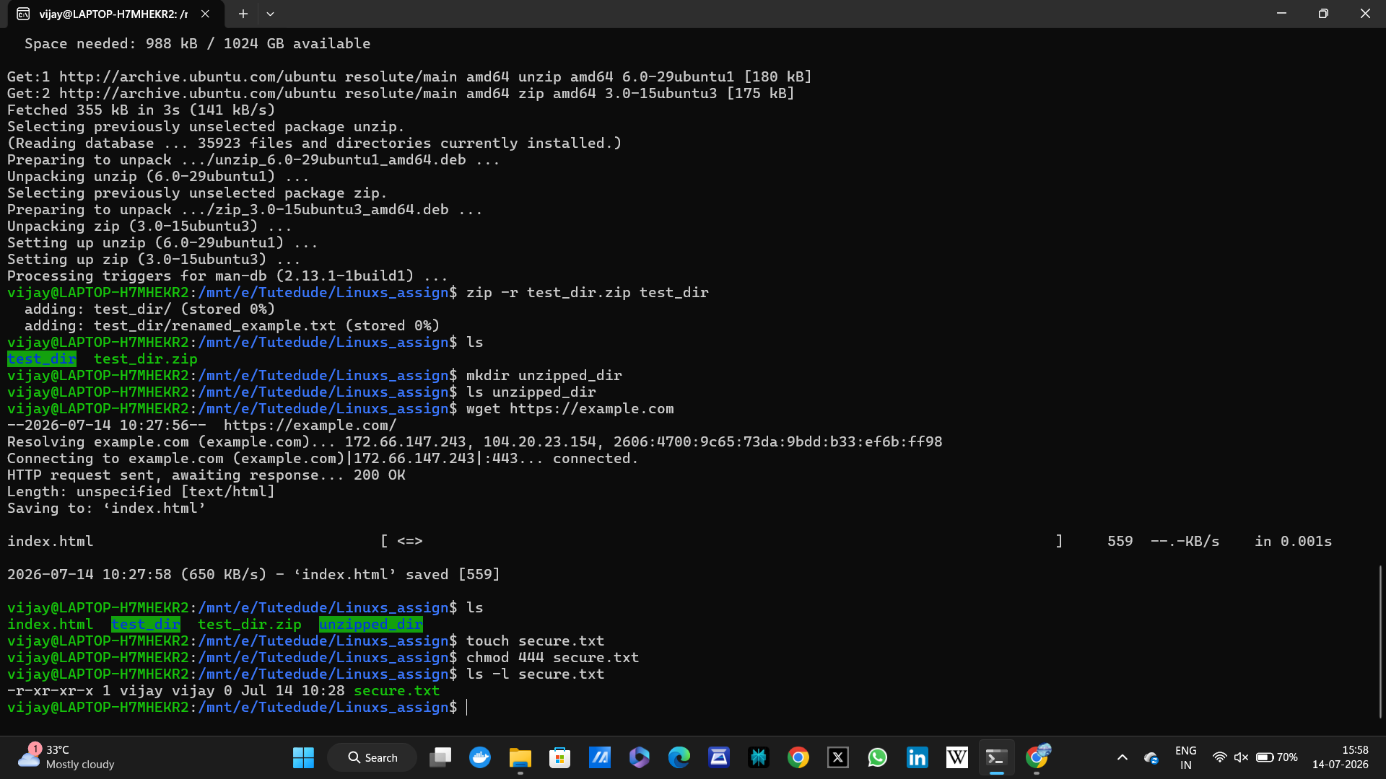

12. Environment Variable
Command:
export MY_VAR="Hello, Linux!"
echo $MY_VAR
Explanation: Creates and verifies environment variable.
Screenshot:
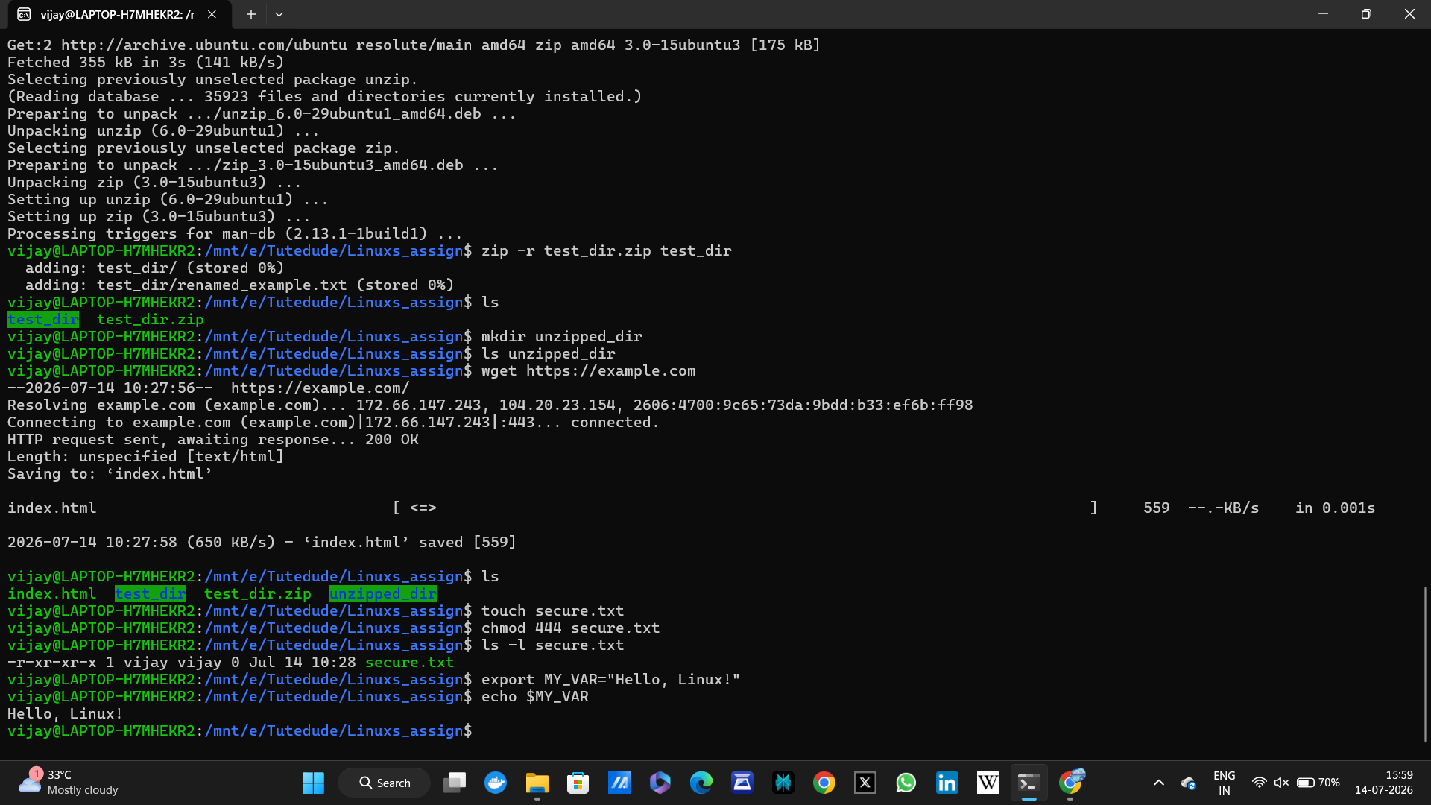

GitHub Repository Link
Repository URL: https://github.com/vijayrgali26/Linux-Basics-Assignment.git

