Flask & MongoDB Assignment Report Template
Name: VIJAY R GALI
GitHub Repository Link: https://github.com/vijayrgali26/flask_mongo_assignment.git
Date: 21/07/2026

Objective
1. Create a Flask application with an /api route that reads JSON data from a backend file and returns it.
2. Create a frontend form that inserts data into MongoDB Atlas and redirects to a success page on success or shows an error on failure.

Prerequisites
• Python
• Flask
• MongoDB Atlas
• Git
• VS Code

Task 1: Flask API
Explain how the /api route was implemented.
Commands Used:
Screenshots:
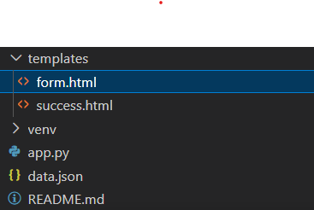
- Project structure
- data.json
- app.py (/api route)
- Browser/Postman output

Task 2: Frontend Form
Describe the HTML form and its fields.
- Form page
- HTML code

Task 3: MongoDB Atlas
Explain MongoDB Atlas connection and collection.
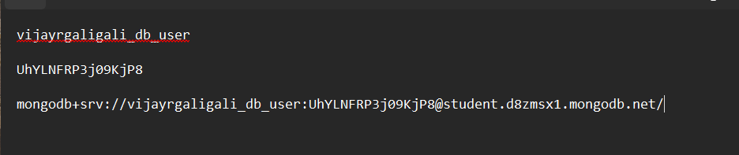
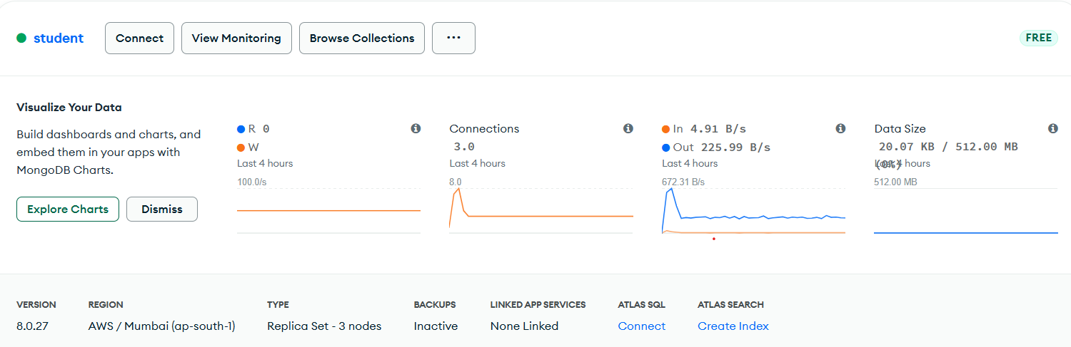
- Atlas cluster
- Database and collection

Task 4: Form Submission
Explain the POST route that inserts data into MongoDB.
Screenshots:
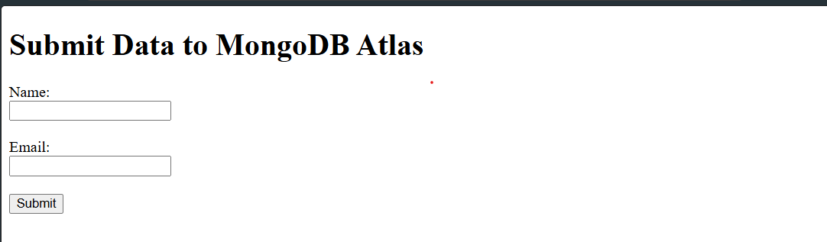
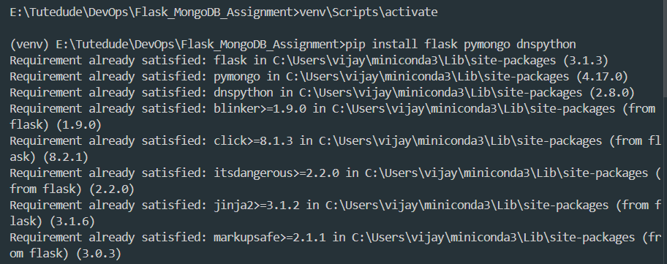
- Successful insertion
- MongoDB document

Task 5: Success & Error Handling
Explain success redirection and error handling.
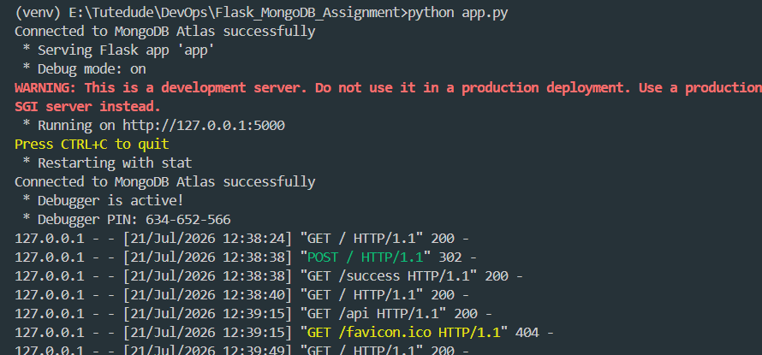
- Success page
- Error message

GitHub
Commands:
git add .
git commit -m "Completed Flask MongoDB Assignment"
git push origin main
Paste repository link and screenshots of commit history.

Conclusion
What you learned:
- Flask API
- Reading JSON files
- MongoDB Atlas integration
- Form handling
- GitHub version control

