**Transfer Learning Procedure:**

Transfer learning generally refers to a process where a model trained on one problem is used in some way on a second related problem.

In deep learning, transfer learning is a technique whereby a neural network model is first trained on a problem similar to the problem that is being solved. One or more layers from the trained model are then used in a new model trained on the problem of interest.

* Transfer learning involves using models trained on one problem as a starting point on a related problem.
* Transfer learning is flexible, allowing the use of pre-trained models directly, as feature extraction preprocessing, and integrated into entirely new models.
* Keras provides convenient access to many top performing models on the ImageNet image recognition tasks such as VGG, Inception, and ResNet.

Perhaps three of the more popular models are as follows:

* VGG (e.g. VGG16 or VGG19).
* GoogLeNet (e.g. InceptionV3).
* Residual Network (e.g. ResNet50).

**Convolutional Auto Encoder**

When CNN is used for image noise reduction or coloring, it is applied in an Autoencoder framework, i.e, the CNN is used in the encoding and decoding parts of an autoencoder. Figure (2) shows an CNN autoencoder. Each of the input image samples is an image with noises, and each of the output image samples is the corresponding image without noises. We can apply the trained model to a noisy image then output a clear image. Likewise, it can be used to train a model for image coloring. Figure (2) is an example that uses CNN Autoencoder for image coloring.

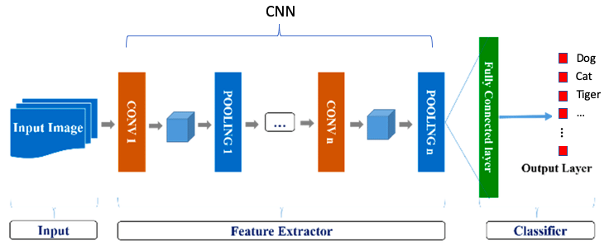

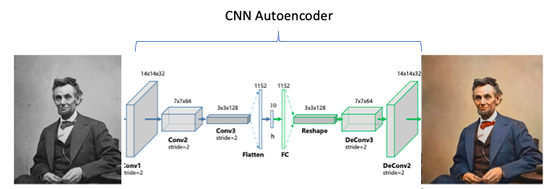

Figure (2)