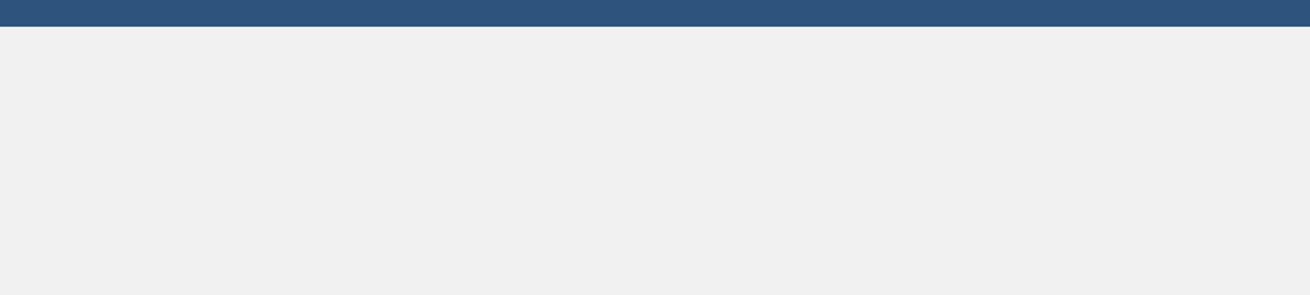

SOFTWARE ENGINEER

**Vijay R**

**Email:** [vijayro](mailto:youremail@gmail.com)cky648@gmail.com

**Phone:** 9025250494

**Portfolio:** <https://vijayrocky648.github.io/VijayPortFolio/>

**RESUME OBJECTIVE**



* A skilled and reliable software engineer seeking a position in an organization where 1.2+ years of experience in XML, ASP programming, and software development will be reflected.
* Proven ability to leverage full-stack knowledge and experience to build interactive and user-centered website designs to scale

**EXPERIENCE**



* Having 1.2 years of IT experience and currently working with Novac Technology Solutions Pvt. Ltd.
* Application Design, Development and Support.
* Gathering requirements from the client and documenting the functional specification (FS).
* Identifying & analyzing defects, questionable functions, errors and inconsistencies in the application.
* Root cause analysis (RCA) of the defects and fixing them.
* Solving production issues within the SLA (Service Level Agreement).
* Effectively communicating to the customer.

**TECHNICAL SKILL**



**Programming Languages**



JAVA

C#



SQL SERVER

**Database**

Materialize

Bootstrap

CSS

HTML

**Web Designing**

PowerShell

JQuery

JavaScript

**Scripting Languages**

**WORK EXPERIENCE**



**Title** : Patch Management System (PMS)

**Client** : Novac Technology Solutions

**Environment**: C#.NET 4.0, ASP.NET 4.0, Ajax, JQuery, Web Services

**Database** : SQL Server 2012, 2016, 2017

**OS** : Window 8, 10

**Team Size** :5

The primary object of PMS is to update day to day patch posted by Projects Development Team into Live environment as well as in UAT Environment, Achieved Using Web Application in an Automate Way, and We Generate Automate Report to Development Team regarding their SQL jobs and Window Service Details

**EDUCATIONAL QUALIFICATION**



* Pursuing bachelor of computer science degree in Guru Nanak College (GNC) affiliated with Madras University at Chennai in the year 2014-2017 with 72%
* Completed 12th in Little Flower Mat Hr Sec School at Porur in the year 2014 with 64%.
* Completed 10th in Little Flower Mat Hr Sec School at Porur in the year 2012 with 78%.

**PERSONAL STRENGTH**



* Time management.
* Positive Attitude
* Quick Learner

**PERSONAL DETAILS**



* **Father`s name** : Ramesh M H
* **Date of birth** : 03/01/1997
* **Language known**: Tamil, English

**DECLARATION**



I hereby declare that the information presented above is true to the best of my knowledge and belief.

### Chennai (Vijay)



.

signature