PROJECT REPORT

ON

**“vehicle accident detection, Reporting and safety system”**

BY

**Naresh merawat 2014/b/24**

**Shubham Sharma 2014/b/34   
vijay pal 2014/b/40**

Under Guidance of

**Mr. A.k. joshi**

NIELIT CENTER, Aurangabad.

In partial fulfilment of

**b.tech in electronics system engineering**

(2014-2018)



**NIELIT CENTRE, AURANGABAD**

(An Autonomous scientific society under the administrative control of ministry of electronics and information technology Govt. of India)

Aurangabad 431004, Maharashtra, India.

**NATIONAL INSTITUTE OF ELECTRONICS AND INFORMATION TECHNOLOGY OF INDIA(NIELIT),**



**NIELIT CENTER, AURANGABAD.**

**CERTIFICATE**

This is to certify that

**Naresh merawat 2014/b/24,**

**shubham Sharma 2014/b/34,**

**vijay pal 2014/b/40,**

Have satisfactorily completed the project titled,

***“*vehicle accident detection, Reporting and Safety System”**

In partial fulfilment of b.tech

(b.tech in Electronics system engineering)

**2014-2018**

**Mr.a.k.joshiMr.th.sunilkumarsingh**

PROJECT GUIDE PROJECT CO-ORDINATOR

NIELITCENTRE, NIELIT CENTRE,

AURANGABAD AURANGABAD

**Dr.Sanjeevkumargupta**

Director of

NIELIT CENTRE, AURANGABAD



**NIELIT CENTRE, AURANGABAD.**

(An Autonomous scientific society under the administrative control of ministry of electronics and information technology Govt. of India)

Aurangabad 431004, Maharashtra, India.

**CERTIFICATE**

This is to certify that

**Naresh merawat 2014/b/24**

**Shubham Sharma 2014/b/34,  
vijay pal 2014/b/40,**

Have satisfactorily completed the project titled,

**“vehicle accident detection, Reporting and Safety System”**

In partial fulfilment of

**b.tech**

(b.tech in electronics system engineering)

**2014-2018**

**Mr. A.k. joshi MR.th. sunilkumarsingh**

**EXAMINER**

**ACKNOWLEDGEMENT**

It gives us intense pleasure as we have privilege to submit our project on**“VEHICLE ACCIDENT DETECTION, REPORTING AND SAFETY SYSTEM”**, as a part of our final semester study of B.TECH.

We are related to express our deep sense of gratitude to our director **Dr.SanjeevKumar Gupta,**for giving us opportunity, necessary facilities and wonderful working environment.

We are greatly indebted to our project guide **Mr. A.K. Joshi,**without whose vision motivation, invaluable discussion, interaction, encouragement and supervision this project with never have taken off.

We are truly indebt to **Mr. A.K. Joshi for** welcoming all kinds of doubts and problems.

We express a deep sense of gratitude to our project coordinator**Mr. Th. Sunil Kumar Singh**for his help right from beginning to make this project successful.

We are also thankful to all teaching and non-teaching staff of NIELIT CENTRE, Aurangabad.

**Naresh Merawat 2014/B/24,**

**Shubham Sharma 2014/B/34,   
Vijay Pal 2014/B/40.**

**DEDICATION**

This Project is dedicated to our wonderful parents and Everyone else which gives us their precious time , Suggestions and Helping hands. You have been with us every step of the way, through Day and Night times of Project work. Thank you for all the unconditional love, guidance, and support that have always given us. Thank you for everything.

**ABSTRACT**

The Rapid growth of technology and infrastructure has made our lives easier. The advent of technology has also increased the traffic hazards and the road accidents take place frequently which causes huge loss of life and property because of the poor emergency facilities. Our project will provide an optimum solution to this draw back. An accelerometer can be used in a car alarm application so that dangerous driving can be detected.

Microcontroller sends the alert message through the GSM MODEM including the location to police control room or a rescue team. So the police can immediately trace the location through the GPS MODEM, after receiving the information. Then after conforming the location necessary action will be taken. If the person meets with a small accident or if there is no serious threat to anyone`s life, then the alert message can be terminated by the driver by a switch provided in order to avoid wasting the valuable time of the medical rescue team.

We are also using air quality sensor. The system to detect levels of oxygen/carbon dioxide and turn on the exhaust fan when oxygen level drops or carbon dioxide level rises, thereby preventing accidental deaths of children or pets locked inside the car.

As there is a scope for improvement and as a future implementation we can add a wireless webcam for capturing the images which will help in providing driver`s assistance.

**CONTENT**

1. INTRODUCTION
2. SURVEY REPORT
3. BLOCK DIAGRAM DESCRIPTION
4. CIRCUIT DIAGRAM & EXPLALANATION
5. APPLICATION

6. PRODUCT DESIGN

7. COSTING& ESTIMATION

8. ADVANTAGES

9. PROGRAM/CODE DESIGN

10. BIBLIOGRAPHY

**Chapter no. 1**

**INTRODUCTION**

The high demand of automobiles has also increased the traffic hazards and the road accidents. Life of the people is under high risk. This is because of the lack of best emergency facilities available in our country. An automatic alarm device for vehicle accidents is introduced in this paper. This design is a system which can detect accidents in significantly less time and sends the basic information to first aid centre within a few seconds covering geographical coordinates, the time and angle in which a vehicle accident had occurred. This alert message is sent to the rescue team in a short time, which will help in saving the valuable lives. A Switch is also provided in order to terminate the sending of a message in rare case where there is no casualty, this can save the precious time of the medical rescue team. When the accident occurs the alert message is sent automatically to the rescue team, police station and insurance company .In some cases we found that, there are so many deaths occurred dued to locked car. So we are using air quality sensor to detect the drop in level of oxygen.The message is sent through the GSM module and the location of the accident is detected with the help of the GPS module. The accident can be detected precisely with the help of IR sensor and vibration sensor. The Angle of the rolls over of the car can also be known by the message through the IR sensor. This application provides the optimum solution to poor emergency facilities provided to the roads accidents in the most feasible way.

**BASIC CONCEPTS**

The technique of accident detection system concentrated with some basic parts which are softly aggregated together in our proposed method.

**A. Oxygen level detection**

For oxygen level detection we are using an air quality sensor. Whenever the level of oxygen decreases it turns on the exhaust fan to maintain the level.

**B. Obstacle Avoidance sensor**

For this purpose we are using IR sensor**.** This sensor is analogous to human’s visionary senses, which can be used to detect obstacles.

**C. GSM Module**

A GSM modem is a device which can be either a mobile phone or a modem device which can be used to make a computer or any other processor communicate over a network. When the accident occurs, GSM sent the alert message automatically.

**D. Microcontroller**

Microcontroller is a computer on a chip that is programmed to perform almost any control, sequencing &monitoring the function. We are using MEGA2560 Arduino board. It controls all the sensors.

**E. GPS module**

We are using GPS here for locating the coordinates of vehicle, which we are going to sent through GSM.

The Bureau of Energy Efficiency, based on Central Electricity Authority statistics, has estimated gross energy consumpon for public lighting to be 6,131 million kWh in India for the years 2007-

**Chapter no. 2**

**SURVEY REPORT**

According to the Global status report on road safety 2015 , the total number of deaths caused due to road accidents has levelled out at 1.25 million a year. India faces the highest number of accidents and accidental fatalities in the world. In India, there are many kind of places like hilly area plateaus, and due to improper road facilities accidents are more and death rate due to this accidents are more.

The maximum number of accidents is reported in the transport sector, that is, on road as well as railways. Some approximations claim that Indian roads alone accounted for approximately 105,000 accidental fatalities in 2010. This is almost 15 percent of the global road fatalities when India has just 1% of the total global vehicles. The incidents of accidental deaths have shown increasing trend during the year 2000-2015 with an increase of 50 percent in the year 2010 as compared to the year 2000. According to Planning Commission of India, the total annual economic loss is 2.5% of India’s GDP due to rising number of road fatalities.

According to National Crime Records Bureau, Ministry of Road Transport & Highway, Law commission of India, one serious road accident in the country occurs every minute and 16 die on Indian roads every hour. According to the “WHO Report 2015: Data Tables” the total number of fatalities in India in 2013 is 238,562 and reported number of road traffic deaths is 137,572 with the estimated road traffic death rate per 100,000 population being 16.6. The leading cause of death is road traffic injuries especially among young people and it costs countries about 1-3% of the gross domestic product .One of the major factors that is increasing this number is the delay in reporting of the crashes to emergency centres like near-by police stations and health care centres. According to, in 2015 the 2030 Agenda for Sustainable development was launched which aims at reducing the number of deaths and injuries arising due to road crashed to half its number by the year 2020. In regard to this, authors provide a review on the existing technologies that aim to detect accidents automatically and alert the emergency centres without much delay.

The proposed system in deals with an automatic accident detection system involving vehicles which sends information about the accident including the location, the time and angle of the accident to a rescue team like a first aid centre and the police station. This information is sent in the form of an alert message. But in the cases where there are no casualties a switch is provided which can be turned off by the driver to terminate sending the alert message. A GSM module is used to send the alert message and a GPS module is used to detect the location of the accident. The GPS and GSM module are interfaced to the control unit using serial communication .The accident for which it makes use of an Accident Detection Algorithm.

The two impactful events in an accident are Roll over events and strong impacts. Roll over is captured by sudden strong horizontal tilt. ApplusandIDIADA provides a lot of historical data, thus information on collision. The average tilt from the current vehicle taken periodically is integrated using the rectangle rule and with the help of old data, and by setting threshold, they are classified as accidents.

The internal structure of CU unit receives notification from the vehicle; it classifies the accident based on the severity and decides on the needed resources for the particular event. The various actions include storing the accident information in the database, notifying the police and emergency services with the help of information in database.

The accident severity is estimated using Data Mining classification algorithms like Bayesian Network and K2 algorithm which is run on Weka platform for historical data from The National Highway Traffic Safety Administration which maintains the General Estimates System (GES), a database with information about traffic accidents that began its operation in 1988 in the US. Based on number of attributes like time, causalities and damage, the classification is done.The improvements in this work is using this system at high speed

The system in detects an accident by utilizing GPS and a Map Matching (MM) algorithm. The GPS is used to send the position and speed of the vehicle every 0.1 second to a Micro Controller Unit (MCU) which compares the current speed to the previous speed every o.1 seconds and if the speed has fallen below a threshold an accident is said to have occurred and it then checks for the location of the vehicle using the map matching module and sends an alarm to an emergency centre is the vehicle is found outside the road network. The location of the accident is sent using GSM.

The braking distance is dependent on speed and is proportional to its square and hence the faster a vehicle is going the more bleak are the chances of avoiding a crash. The forces that help in bringing the vehicle to a stand-still after the brakes are applied are frictional force and gravitational force. The maximum speed that would be achieved after applying the break and when only these two forces are in play is calculated. If the speed sent by the GSM to the microcontroller is however lesser than this maximum speed it is inferred as an accident in which additional forces have played a role in decreasing the speed. These additional forces come from the kinetic energy that is associated with a body while in motion that gets converted into destructive forces during the collision.

The MM algorithm is used to find the location of the vehicle on the road network. A Geographical Information System (GIS) software is used for MM using which the vehicle is continuously positioned on a digital map. Finally, when an accident is detected a flag is raised and the MCU waits for 5 seconds before sending an alarm out to the emergency centre. In these 5 seconds the driver can press a button to cancel the alarm and help reduce the number of false alarms. The speed, location, time and the contact details of a relative of the vehicle occupant will be sent as GPRS data using the GPRS module of the MCU and in cases where there is no GPRS coverage an SMS is sent with the same information. After this, a voice call is initiated to the emergency centre if the occupant is in a position to describe the accident.

**REFERNCES:**

[1] "Global status report on road safety 2015", *World Health Organization*, 2016.[Online].

Available:http://www.who.int/violence\_injury\_prevention/road\_safety\_status/2015/en/. (Accessed: 22- Mar- 2016)

[2] "Data", *World Health Organization*, 2016. [Online].

Available:http://www.who.int/violence\_injury\_prevention/road\_safety\_status/2015/GSRRS2015\_data/en/. (Accessed: 22- Mar- 2016).

[3] M. Ruikar, "National statistics of road traffic accidents in India", *Journal of Orthopedics, Traumatology and Rehabilitation*, vol. 6, no. 1, p. 1, 2013.

[4] V. Goud, "Vehicle Accident Automatic Detection and Remote Alarm Device", International Journal of Reconfigurable and Embedded Systems (IJRES), Vol. 1, no. 2, 2012.

[5] GSM User Manual, SIMCOM Ltd, August 2006.

[6] GPS Beginner`s Guide, Garmin Ltd, 2008.

[7] G. Liang, "Automatic Traffic Accident Detection Based on the Internet of Things and Support Vector Machine", IJSH, Vol. 9, no. 4, pp. 97-106, 2015.

[8] S.L. Lin and Z. Liu, “Parameter selections in SVM with RBF kernel function”, Journal-Zhejiang University of Technology, vol. 35, no. 2, pp. 163, 2007

[9] B. Prachi, D. Kasturi and C. Priyanka, "Intelligent Accident-Detection and Ambulance- Rescue System", International Journal Of Scientific & Technology Research, Vol. 3, No. 6, 2016.

[10] AmneshGoel, Sukanya Ray, Nidhi Chandra, “Intelligent Traffic Light System to Prioritized Emergency Purpose Vehicles based on Wireless Sensor Network”, International Journal of Computer Applications, Volume 40– No.12, February 2012.

[11] K. Patel, "Utilizing the Emergence of Android Smartphone for Public Welfare by Providing Advance Accident Detection and Remedy by 108 Ambulances", International Journal of Engineering Research & Technology (IJERT), Vol. 2, No. 9, 2013.

[12] Xinhua Shu, Zhenjun Du and Rong Chen, “Research on Mobile Location Service Design Based on Android”, 5th International Conference On Wireless Communication Networking and Mobile Computing, Beijing, pp. 1-4, 2009.

[13] J. Whipple, W. Arensman and M.S Boler, “A Public Safety Application of GPS-Enabled Smart Phones And The Android Operating System”, IEEE International Conference on System, Man and Cybernetics, San Antonio, pp. 2059-2061, 2009.

[14] B. Fernandes, M. Alam, V. Gomes, J. Ferreira and A. Oliveira, "Automatic accident detection with multi-modal alert system implementation for ITS", Vehicular Communications, Vol. 3, pp. 1-11, 2016.

[15] Pranav Dhole, Saba Shaikh, NishadGite, Vijay Sonawane “Automatic Accident Detection: Assistance through Communication Technologies and Vehicles”, IJETST- Vol. 02, Issue 04 Pages 2285-2288 April.

**Chapter no. 3**

**BLOCK DIAGRAM**

**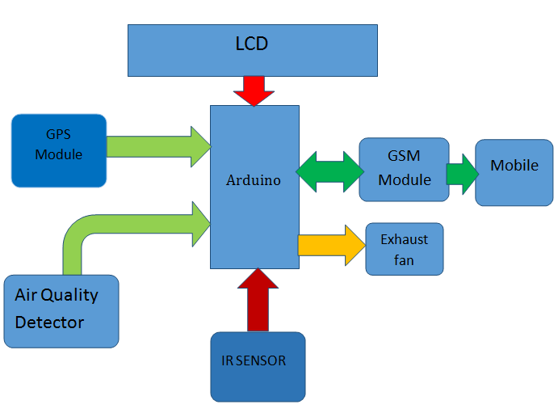**

### Main Components Required:

* Arduino Mega 2560
* GSM Module (SIM900A)
* GPS Module (SIM28ML)
* IR Sensor
* 16x2 LCD
* Air Quality Sensor
* Exhaust Fan
* DHT 22 AM2302
* Buzzer
  1. **Arduino Mega 2560:**
* The Arduino MEGA 2560 is designed for projects that require more I/O lines, more sketch memory and more RAM. With 54 digital I/O pins, 16 analog inputs and a larger space for your sketch it is the recommended board for 3D printers and robotics projects. This gives your projects plenty of room and opportunities maintaining the simplicity and effectiveness of the Arduino platform. This document explains how to connect your Mega2560 board to the computer and upload your first sketch.
* The Arduino Mega 2560 is programmed using the [Arduino Software (IDE)](https://www.arduino.cc/en/Main/Software), our Integrated Development Environment common to all our boards and running both [online](https://create.arduino.cc/editor) and offline.

#### Connect your board

Connect your Mega2560 board with an A B USB cable; sometimes this cable is called a USB printer cable. The USB connection with the PC is necessary to program the board and not just to power it up. The Mega2560 automatically draw power from either the USB or an external power supply. Connect the board to your computer using the USB cable. The green power LED (labeled **PWR**) should go on.

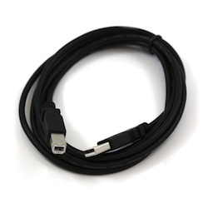

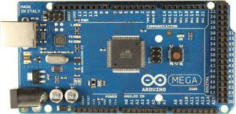.

**Arduino Mega 2560 PIN mapping table**

|  |  |  |
| --- | --- | --- |
| **Pin Number** | **Pin Name** | **Mapped Pin Name** |
| 1 | PG5 ( OC0B ) | Digital pin 4 (PWM) |
| 2 | PE0 ( RXD0/PCINT8 ) | Digital pin 0 (RX0) |
| 3 | PE1 ( TXD0 ) | Digital pin 1 (TX0) |
| 4 | PE2 ( XCK0/AIN0 ) |  |
| 5 | PE3 ( OC3A/AIN1 ) | Digital pin 5 (PWM) |
| 6 | PE4 ( OC3B/INT4 ) | Digital pin 2 (PWM) |
| 7 | PE5 ( OC3C/INT5 ) | Digital pin 3 (PWM) |
| 8 | PE6 ( T3/INT6 ) |  |
| 9 | PE7 ( CLKO/ICP3/INT7 ) |  |
| 10 | VCC | VCC |
| 11 | GND | GND |
| 12 | PH0 ( RXD2 ) | Digital pin 17 (RX2) |
| 13 | PH1 ( TXD2 ) | Digital pin 16 (TX2) |
| 14 | PH2 ( XCK2 ) |  |
| 15 | PH3 ( OC4A ) | Digital pin 6 (PWM) |
| 16 | PH4 ( OC4B ) | Digital pin 7 (PWM) |
| 17 | PH5 ( OC4C ) | Digital pin 8 (PWM) |
| 18 | PH6 ( OC2B ) | Digital pin 9 (PWM) |
| 19 | PB0 ( SS/PCINT0 ) | Digital pin 53 (SS) |
| 20 | PB1 ( SCK/PCINT1 ) | Digital pin 52 (SCK) |
| 21 | PB2 ( MOSI/PCINT2 ) | Digital pin 51 (MOSI) |
| 22 | PB3 ( MISO/PCINT3 ) | Digital pin 50 (MISO) |
| 23 | PB4 ( OC2A/PCINT4 ) | Digital pin 10 (PWM) |
| 24 | PB5 ( OC1A/PCINT5 ) | Digital pin 11 (PWM) |
| 25 | PB6 ( OC1B/PCINT6 ) | Digital pin 12 (PWM) |
| 26 | PB7 ( OC0A/OC1C/PCINT7 ) | Digital pin 13 (PWM) |
| 27 | PH7 ( T4 ) |  |
| 28 | PG3 ( TOSC2 ) |  |
| 29 | PG4 ( TOSC1 ) |  |
| 30 | RESET | RESET |
| 31 | VCC | VCC |
| 32 | GND | GND |
| 33 | XTAL2 | XTAL2 |
| 34 | XTAL1 | XTAL1 |
| 35 | PL0 ( ICP4 ) | Digital pin 49 |
| 36 | PL1 ( ICP5 ) | Digital pin 48 |
| 37 | PL2 ( T5 ) | Digital pin 47 |
| 38 | PL3 ( OC5A ) | Digital pin 46 (PWM) |
| 39 | PL4 ( OC5B ) | Digital pin 45 (PWM) |
| 40 | PL5 ( OC5C ) | Digital pin 44 (PWM) |
| 41 | PL6 | Digital pin 43 |
| 42 | PL7 | Digital pin 42 |
| 43 | PD0 ( SCL/INT0 ) | Digital pin 21 (SCL) |
| 44 | PD1 ( SDA/INT1 ) | Digital pin 20 (SDA) |
| 45 | PD2 ( RXDI/INT2 ) | Digital pin 19 (RX1) |
| 46 | PD3 ( TXD1/INT3 ) | Digital pin 18 (TX1) |
| 47 | PD4 ( ICP1 ) |  |
| 48 | PD5 ( XCK1 ) |  |
| 49 | PD6 ( T1 ) |  |
| 50 | PD7 ( T0 ) | Digital pin 38 |
| 51 | PG0 ( WR ) | Digital pin 41 |
| 52 | PG1 ( RD ) | Digital pin 40 |
| 53 | PC0 ( A8 ) | Digital pin 37 |
| 54 | PC1 ( A9 ) | Digital pin 36 |
| 55 | PC2 ( A10 ) | Digital pin 35 |
| 56 | PC3 ( A11 ) | Digital pin 34 |
| 57 | PC4 ( A12 ) | Digital pin 33 |
| 58 | PC5 ( A13 ) | Digital pin 32 |
| 59 | PC6 ( A14 ) | Digital pin 31 |
| 60 | PC7 ( A15 ) | Digital pin 30 |
| 61 | VCC | VCC |
| 62 | GND | GND |
| 63 | PJ0 ( RXD3/PCINT9 ) | Digital pin 15 (RX3) |
| 64 | PJ1 ( TXD3/PCINT10 ) | Digital pin 14 (TX3) |
| 65 | PJ2 ( XCK3/PCINT11 ) |  |
| 66 | PJ3 ( PCINT12 ) |  |
| 67 | PJ4 ( PCINT13 ) |  |
| 68 | PJ5 ( PCINT14 ) |  |
| 69 | PJ6 ( PCINT 15 ) |  |
| 70 | PG2 ( ALE ) | Digital pin 39 |
| 71 | PA7 ( AD7 ) | Digital pin 29 |
| 72 | PA6 ( AD6 ) | Digital pin 28 |
| 73 | PA5 ( AD5 ) | Digital pin 27 |
| 74 | PA4 ( AD4 ) | Digital pin 26 |
| 75 | PA3 ( AD3 ) | Digital pin 25 |
| 76 | PA2 ( AD2 ) | Digital pin 24 |
| 77 | PA1 ( AD1 ) | Digital pin 23 |
| 78 | PA0 ( AD0 ) | Digital pin 22 |
| 79 | PJ7 |  |
| 80 | VCC | VCC |
| 81 | GND | GND |
| 82 | PK7 ( ADC15/PCINT23 ) | Analog pin 15 |
| 83 | PK6 ( ADC14/PCINT22 ) | Analog pin 14 |
| 84 | PK5 ( ADC13/PCINT21 ) | Analog pin 13 |
| 85 | PK4 ( ADC12/PCINT20 ) | Analog pin 12 |
| 86 | PK3 ( ADC11/PCINT19 ) | Analog pin 11 |
| 87 | PK2 ( ADC10/PCINT18 ) | Analog pin 10 |
| 88 | PK1 ( ADC9/PCINT17 ) | Analog pin 9 |
| 89 | PK0 ( ADC8/PCINT16 ) | Analog pin 8 |
| 90 | PF7 ( ADC7 ) | Analog pin 7 |
| 91 | PF6 ( ADC6 ) | Analog pin 6 |
| 92 | PF5 ( ADC5/TMS ) | Analog pin 5 |
| 93 | PF4 ( ADC4/TMK ) | Analog pin 4 |
| 94 | PF3 ( ADC3 ) | Analog pin 3 |
| 95 | PF2 ( ADC2 ) | Analog pin 2 |
| 96 | PF1 ( ADC1 ) | Analog pin 1 |
| 97 | PF0 ( ADC0 ) | Analog pin 0 |
| 98 | AREF | Analog Reference |
| 99 | GND | GND |
| 100 | AVCC | VCC |

**Arduino Mega 2560 PIN Diagram**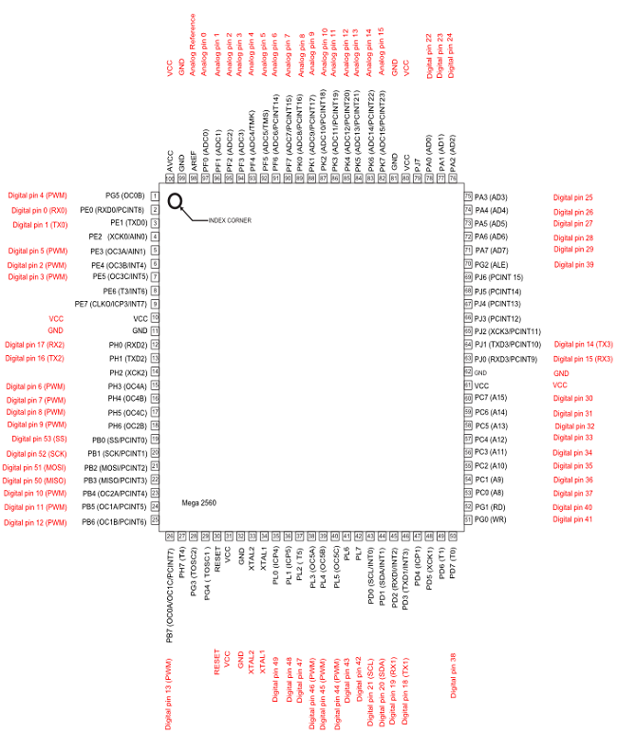

2. GSM MODULE (SIM 900A):

The SIM900 is a complete Quad-band GSM/GPRS Module which can be embedded easily used by customer or hobbyist. SIM900 GSM Module provides an industry-standard interface. SIM900 delivers GSM/GPRS 850/900/1800/1900MHz performance for voice, SMS, Data with low power consumption. It is easily available in the market.

* SIM900 designed by using single-chip processor integrating AMR926EJ-S core
* Quad - band GSM/GPRS module in small size.
* GPRS Enabled

A circuit board

Description generated with very high confidence

3. GPS Module (SIM28ML):

GPS stands for Global Positioning System and used to detect the Latitude and Longitude of any location on the Earth, with exact UTC time (Universal Time Coordinated). GPS module is used to track the location of accident in our project. This device receives the coordinates from the satellite for each and every second, with time and date. We have previously extracted **$GPGGA** string in Vehicle Tracking System to find the Latitude and Longitude Coordinates.

**GPS module** sends the data related to tracking position in real time, and it sends so many data in NMEA format. NMEA format consists several sentences, in which we only need one sentence. This sentence starts from **$GPGGA** and contains the coordinates, time and other useful information.

A circuit board

Description generated with very high confidence

4. Infrared sensor:

An [infraredsensor](https://www.elprocus.com/ir-remote-control-basics-operation-application/" \t "_blank) is an electronic device that emits in order to sense some aspects of the surroundings. An IR sensor can measure the heat of an object as well as detects the motion. These types of sensors measures only infrared radiation, rather than emitting it that is called as a [passive IR sensor](https://www.elprocus.com/passive-infrared-pir-sensor-with-applications/). Usually in the infrared spectrum, all the objects radiate some form of thermal radiations. These types of radiations are  invisible to our eyes, that can be detected by an infrared sensor.The emitter is simply an IR LED ([Light Emitting Diode](http://www.elprocus.com/explain-different-types-leds-working-applications-engineering-students/)) and the detector is simply an IR photodiode which is sensitive to IR light of the same wavelength as that emitted by the IR LED. When IR light falls on the photodiode, the resistances and these output voltages, change in proportion to the magnitude of the IR light received.

[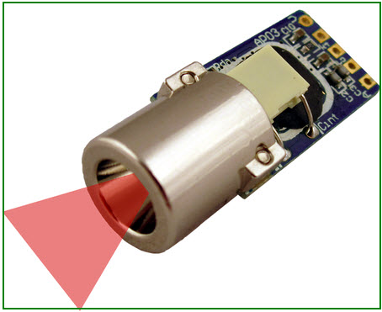](http://www.elprocus.com/wp-content/uploads/2015/01/ir-sensor.jpg)

IR Sensor

## IR Sensor Circuit Diagram and Working Principle

An infrared sensor circuit is one of the basic and popular sensor modules in an [electronic device](http://www.elprocus.com/basic-components-used-electronics-electrical/). This sensor is analogous to human’s visionary senses, which can be used to detect obstacles and it is one of the common applications in real time. This circuit comprises of the following components

* [LM358 IC](http://www.elprocus.com/op-amp-ics-pin-configuration-features-working/) 2 IR transmitter and receiver pair
* Resistors of the range of kilo ohms.
* Variable resistors.
* LED (Light Emitting Diode).

[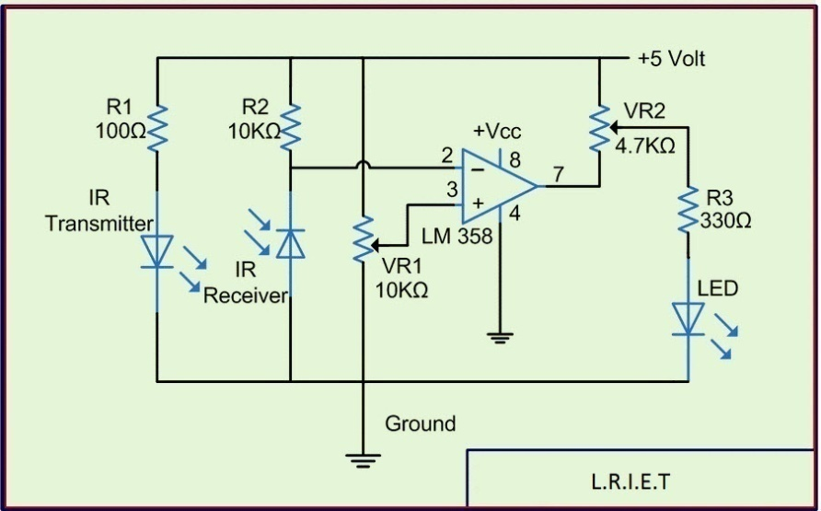](http://www.elprocus.com/wp-content/uploads/2015/01/IR-sensor-circuit-diagram.jpg)IR Sensor Circuit

In this project, the transmitter section includes an IR sensor, which transmits continuous IR rays to be received by an IR receiver module. An IR output terminal of the receiver varies depending upon its receiving of IR rays. Since this variation cannot be analyzed as such,therefore this output can be fed to a comparator circuit. Here an [operational amplifier](https://www.elprocus.com/op-amp-ics-pin-configuration-features-working/) (op-amp) of LM 339 is used as comparator circuit.

When the IR receiver does not receive a signal, the potential at the inverting input goes higher than that non-inverting input of the comparator IC (LM339). Thus the output of the comparator goes low, but the LED does not glow. When the IR receiver module receives signal to the potential at the inverting input goes low. Thus the output of the comparator (LM 339) goes high and the LED starts glowing. Resistor R1 (100 ), R2 (10k ) and R3 (330) are used to ensure that minimum 10 mA current passes through the IR LED Devices like Photodiode and normal LEDs respectively. Resistor VR2 (preset=5k) is used to adjust the output terminals. Resistor VR1 (preset=10k) is used to set the sensitivity of the circuit Diagram. Read more about IR sensors.

5. 16x2LCD:

* LCD (Liquid Crystal Display) screen is an electronic display module and find a wide range of applications. A 16x2 LCD display is very basic module and is very commonly used in various devices and circuits. These modules are preferred over [seven segments](http://www.engineersgarage.com/content/seven-segment-display) and other multi segment [LED](http://www.engineersgarage.com/content/led)s. The reasons being: LCDs are economical; easily programmable; have no limitation of displaying special & even [custom characters](http://www.engineersgarage.com/microcontroller/8051projects/create-custom-characters-LCD-AT89C51) (unlike in seven segments), [animations](http://www.engineersgarage.com/microcontroller/8051projects/display-custom-animations-LCD-AT89C51) and so on.
* A **16x2 LCD** means it can display 16 characters per line and there are 2 such lines. In this LCD each character is displayed in 5x7 pixel matrix. This LCD has two registers, namely, Command and Data.
* The command register stores the command instructions given to the LCD. A command is an instruction given to LCD to do a predefined task like initializing it, clearing its screen, setting the cursor position, controlling display etc. The data register stores the data to be displayed on the LCD. The data is the ASCII value of the character to be displayed on the LCD. Click to learn more about internal structure of a [LCD](http://www.engineersgarage.com/insight/how-lcd-works).

### Pin Diagram:

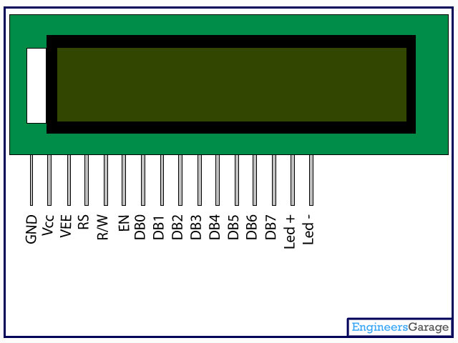

### Pin Description:

|  |  |  |
| --- | --- | --- |
| **Pin No** | **Function** | **Name** |
| 1 | Ground (0V) | Ground |
| 2 | Supply voltage; 5V (4.7V – 5.3V) | Vcc |
| 3 | Contrast adjustment; through a variable resistor | VEE |
| 4 | Selects command register when low; and data register when high | Register Select |
| 5 | Low to write to the register; High to read from the register | Read/write |
| 6 | Sends data to data pins when a high to low pulse is given | Enable |
| 7 | 8-bit data pins | DB0 |
| 8 | DB1 |
| 9 | DB2 |
| 10 | DB3 |
| 11 | DB4 |
| 12 | DB5 |
| 13 | DB6 |
| 14 | DB7 |
| 15 | Backlight VCC (5V) | Led+ |
| 16 | Backlight Ground (0V) | Led- |

1. **Air Quality detector:**

 Air quality sensor for detecting a wide range of gases, including NH3, NOx, alcohol, benzene, smoke and CO2. Ideal for use in office or factory. MQ135 gas sensor has high sensitivity to Ammonia, Sulfide and Benze steam, also sensitive to smoke and other harmful gases. It is with low cost and particularly suitable for Air quality monitoring application.  
  
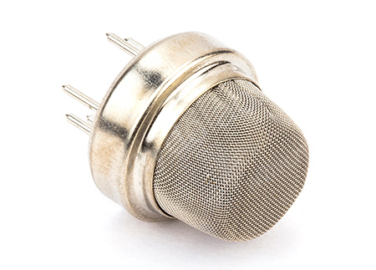

**Features:**

* High Sensitivity
* High sensitivity to Ammonia, Sulfide and Benze
* Stable and Long Life
* Detection Range: 10 - 300 ppm NH3, 10 - 1000 ppm Benzene, 10 - 300 Alcohol
* Heater Voltage: 5.0V
* Dimensions: 18mm Diameter, 17mm High excluding pins, Pins - 6mm High
* Long life and low cost

7. Exhaust Fan:

*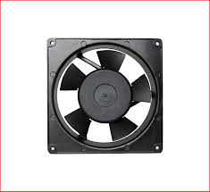*

1. DHT 22AM2302:

The AM2302 is a wired version of the [DHT22](http://www.adafruit.com/products/385), in a large plastic body. It is a basic, low-cost digital temperature and humidity sensor. It uses a capacitive humidity sensor and a thermistor to measure the surrounding air, and spits out a digital signal on the data pin (no analog input pins needed). It’s fairly simple to use, but requires careful timing to grab data. The only real downside of this sensor is you can only get new data from it once every 2 seconds, so when using our library, sensor readings can be up to 2 seconds old.

TECHNICAL DETAILS

* Low cost
* 3 to 5V power and I/O
* 2.5mA max current use during conversion (while requesting data)
* Good for 0-100% humidity readings with 2-5% accuracy
* Good for -40 to 80°C temperature readings ±0.5°C accuracy
* No more than 0.5 Hz sampling rate (once every 2 seconds)
* Body size 27mm x 59mm x 13.5mm (1.05" x 2.32" x 0.53")
* 3 wires 23cm long (9")
* 27mm wide x 58.75mm tall x 13.30mm deep

*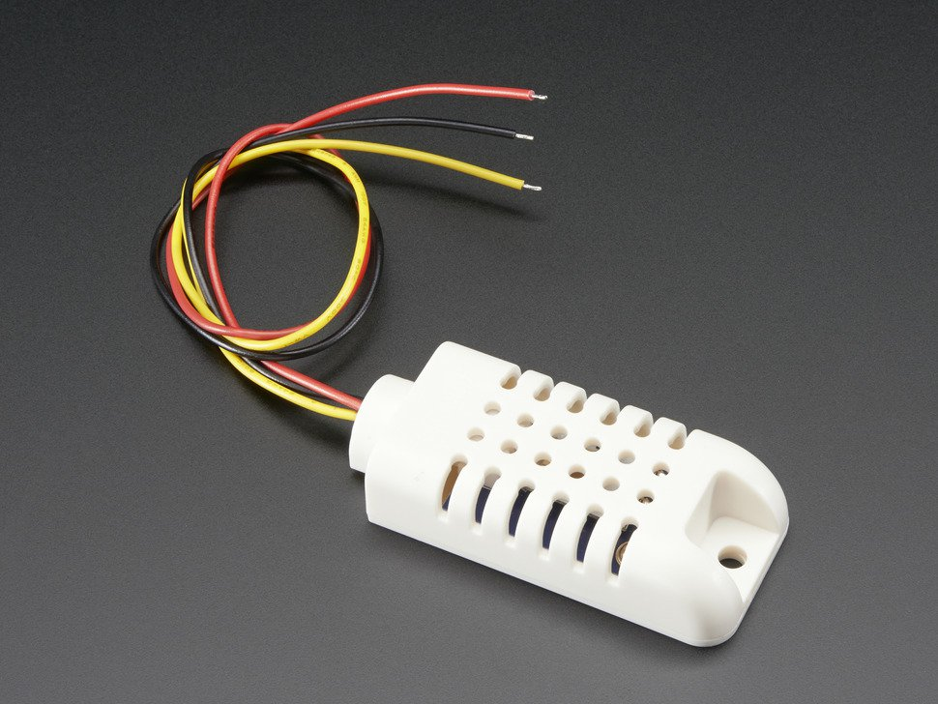*

9. Buzzer:

**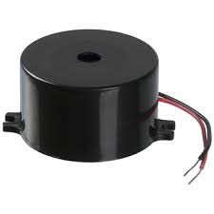**

**Chapter no. 4**

**CIRCUIT DIAGRAM**

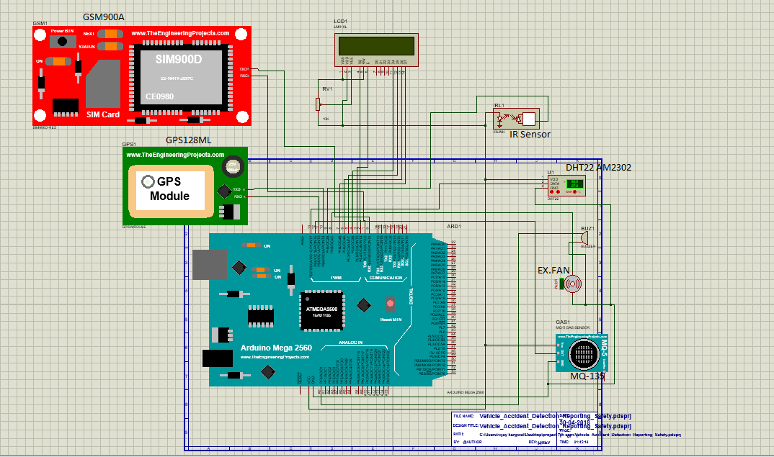

**CIRCUIT DIAGRAM EXPLANATION**

**HARDWARE REQUIREMENTS** Power Adapter (230vAC-12vDC) Arduino Mega 2560 (Atmega16U2 processor), GSM128ML,GPS900A, Resistor, variable resistor, Transistor, IR (Sensor), MQ135(sensor), DHT22 AM2302 Exhaust Fan, Connectors, Switch, Wires

**SOFTWARE REQUIREMENTS** IDE (Integrated Development environment) ProjectManager Simulator, Debugger C Cross Compiler, Cross Assembler, Locator/Linker, Altium/Proteous (PCB Design)

**DC power supply circuit**

It comprises of a step down transformer (230v-12v AC), bridge rectifier circuit, a voltage regulator with filter capacitors and a power indicating LED. The step down transformer directly converts 230v AC to 12v AC supply. This 12vAC is given as input to a bridge rectifier circuit which converts it to 12v pulsating DC. The pulsating DC obtained as output from the rectifier is given to voltage regulator through a filter capacitor. The main function of voltage regulator is to provide a constant voltage of 5v.The capacitor1 (470microf) filters out the pulsating DC to ripple less DC. The second capacitor eliminates any other ripples in the output. Thus, we get a steady supply of pure 5v DC. This is indicated by the LED which is present in the power supply circuit. For Ease of Access we are using power adapter here , which converts 230v Ac supply into 12v DC using above mentioned process as its internal circuit.

**Arduino Mega 2560 and connections**

The microcontroller used is Arduino mega 2560.Connections are mentioned below:-

GSM 900A :- for connection, RXD pin of GSM to Pin1 (TX0) of Arduino. TXD pin of GSM to pin0(RX0) of Arduino and GND of gsm to GND pin of Arduino.

GPS 128ML:- for connection, 5v pin of gps to 5v pin of Arduino. Gnd pin to Gnd pin of Arduino . TX pin of gps to pin 10 of Arduino and RX pin of gps to pin 11 of Arduino.

LCD(16\*2) :- for connection, RS pin of LCD to pin 2 of Arduino. Enable pin of LCD to pin 3 of Arduino. Then data pins(D4-D7) of LCD to pins(4-7) of Arduino. VDD and Anode pin of LCD connected to Vcc (+5v). VSS and K pin of LCD connected to GND.

IR Sensor:- for Connection, VCC and GND of IR to +5v and GND. OUT pin of IR to pin 9 of Arduino.

MQ-135 Sensor:- for connection, VCC and GND of Sensor to +5v and GND. D0 pin of Sensor to pin 12 of Arduino.

DHT22AM2302:- for connection, Pin 1 and Pin 4 of Sensor to VCC and GND respectively. Pin 2 of sensor to Pin 13 of Arduino. Pin 3 of sensor will not be connected.

Exhaust Fan:- Anode of fan connected to pin 8 of Arduino through Relay circuit ( using transistor and resistor). K pin of Fan connected to GND.

Buzzer :- Anode pin of buzzer connected to A0 pin of Arduino and K pin of buzzer Connected to GND.

Thus , We have made all the required connection for this circuit. Now we have to operate it.

**Working Explanation :-** Here is the working explanation of desired circuit given below-

**BASIC MODES OF OPERATION**

There are three basic modes of operation, 1. Detection of Vehicle Accident using IR Sensor. 2. Reporting of Accident at Various place like Nearest hospital, police station, family members, insurance company etc. using GSM and GPS. 3.Safety of people inside car during accident or Suffocation using temperature and Humidity sensor , Air quality sensor , Exhaust Fan and Alarm system.

**Accident Detection**

* First , we have to power up all the system. IR sensor placed at specific places of vehicle. IR sensor detects object in his path till the range of 2~30 cm. This sensor Module adaptable to ambient light , having a pair of infrared emitting and receiving tube, transmitting tube emit infrared frequency, when the direction of an obstacle is detected (reflection Surface), the infrared reflected is received by the reception tube.
* When Accident happens , IR sensor Detect object in his path and send the reflected infrared to reception tube. It will raise an alarm as well as GSM and GPS system will be ON for Reporting System.

**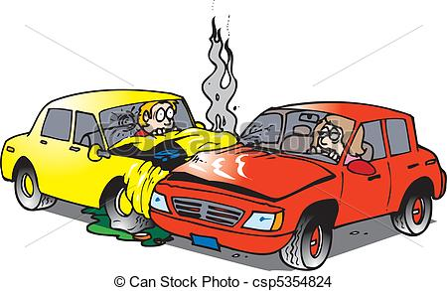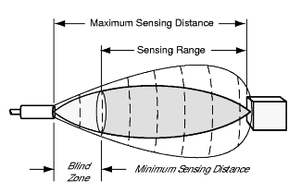**

**Reporting Procedure**

* When a flag is raised for accident, the Arduino will initiate an emergency situation automatically. The Arduino will wait for 5 seconds for the driver to press a button to cancel the accident reporting procedure. This will enable to reduce the false alarm to the Alert Service Centre. Once the 5 seconds waiting time is over, the accident information containing the location, time and the speed along with the contact number of five various places of the occupant will be sent as a GPRS data to the Alert Service Centre through the GPRS modem by the Arduino. However, GPRS coverage is not always available in every place. As such, simultaneously an SMS will also be initiated containing the same information. This will enable the vehicle occupant to describe the emergency situation if they are in a condition to describe. Besides automatic accident detection system, pressing the Manual Detection Switch, the vehicle occupant will also be able to initiate an emergency situation and it will report like the automatic accident detection system.

**Safety Procedure**

Air Quality level measurements are essential in preventing injury or death in situations where safe levels may be compromised. Oxygen gas detection instruments will typically trigger an alarm when the oxygen level drops below 19.5% volume, the OSHA-mandated level. But here we use it to start the exhaust fan using Arduino command The most common use of oxygen gas detection is in confined spaces – totally or partially closed areas generally not designed to be permanently occupied. It is essential that an O2 gas sample be drawn prior to entering these spaces, and continuing to monitor oxygen levels, as well as the presence of harmful gases, after entry.

DHT 22 AM2302 monitor the temperature and humidity inside the vehicle

When temperature or humidity goes out of specific range (T>50\*C or H<10) then it will automatically ON Exhaust fan and Maintain level of Environment inside vehicle.

**Chapter no. 5**

**APPLICATION**

* 1. **Reducing Road Accident :this is the main purpose of this project , using this whole system we can reduce many road accidents. Which will help to prevent injury and death of people inside vehicles.**
  2. **Reducing death Due to Suffocation :this system help to reduce death due to suffocation while any child or people during accident stuck in vehicle. It automatically maintain Environment inside vehicle.**
  3. **Prevent Drink and Drive : this system monitor the Alcohol inside vehicle. When someone enter as drunken condition. It will Automatically Raise an alarm.**
  4. **Maintain Environment of Vehicle : this system contain Humidity and Temperature sensor which maintain Environment of vehicle. If Environment of vehicle disturbed , it will automatically start fan.**
  5. **Stolen Vehicle Recovery:** Both consumer and commercial vehicles can be outfitted with RF or GPS units to allow police to do tracking and recovery. In the case of LoJack, the police can activate the tracking unit in the vehicle directly and follow tracking signals
  6. **Fleet Management:** When managing a fleet of vehicles, knowing the real-time location of all drivers allows management to meet customer needs more efficiently. Whether it is delivery, service or other multi-vehicle enterprises, drivers now only need a mobile phone with telephony or Internet connection to be inexpensively tracked by and dispatched efficiently.
  7. **Asset Tracking:** Companies needing to track valuable assets for insurance or other monitoring purposes can now plot the real-time asset location on a map and closely monitor movement and operating status.
  8. **Field Sales:**Mobile sales professionals can access real-time locations. For example, in unfamiliar areas, they can locate themselves as well as customers and prospects, get driving directions and add nearby last-minute appointments to itineraries. Benefits include increased productivity, reduced driving time and increased time spent with customers and prospects.
  9. **Transit Tracking:** This is the temporary tracking of assets or cargoes from one point to another. Users will ensure that the assets do not stop on route or do a U-Turn in order to ensure the security of the assets.

**Chapter no. 6**

**Product design**

**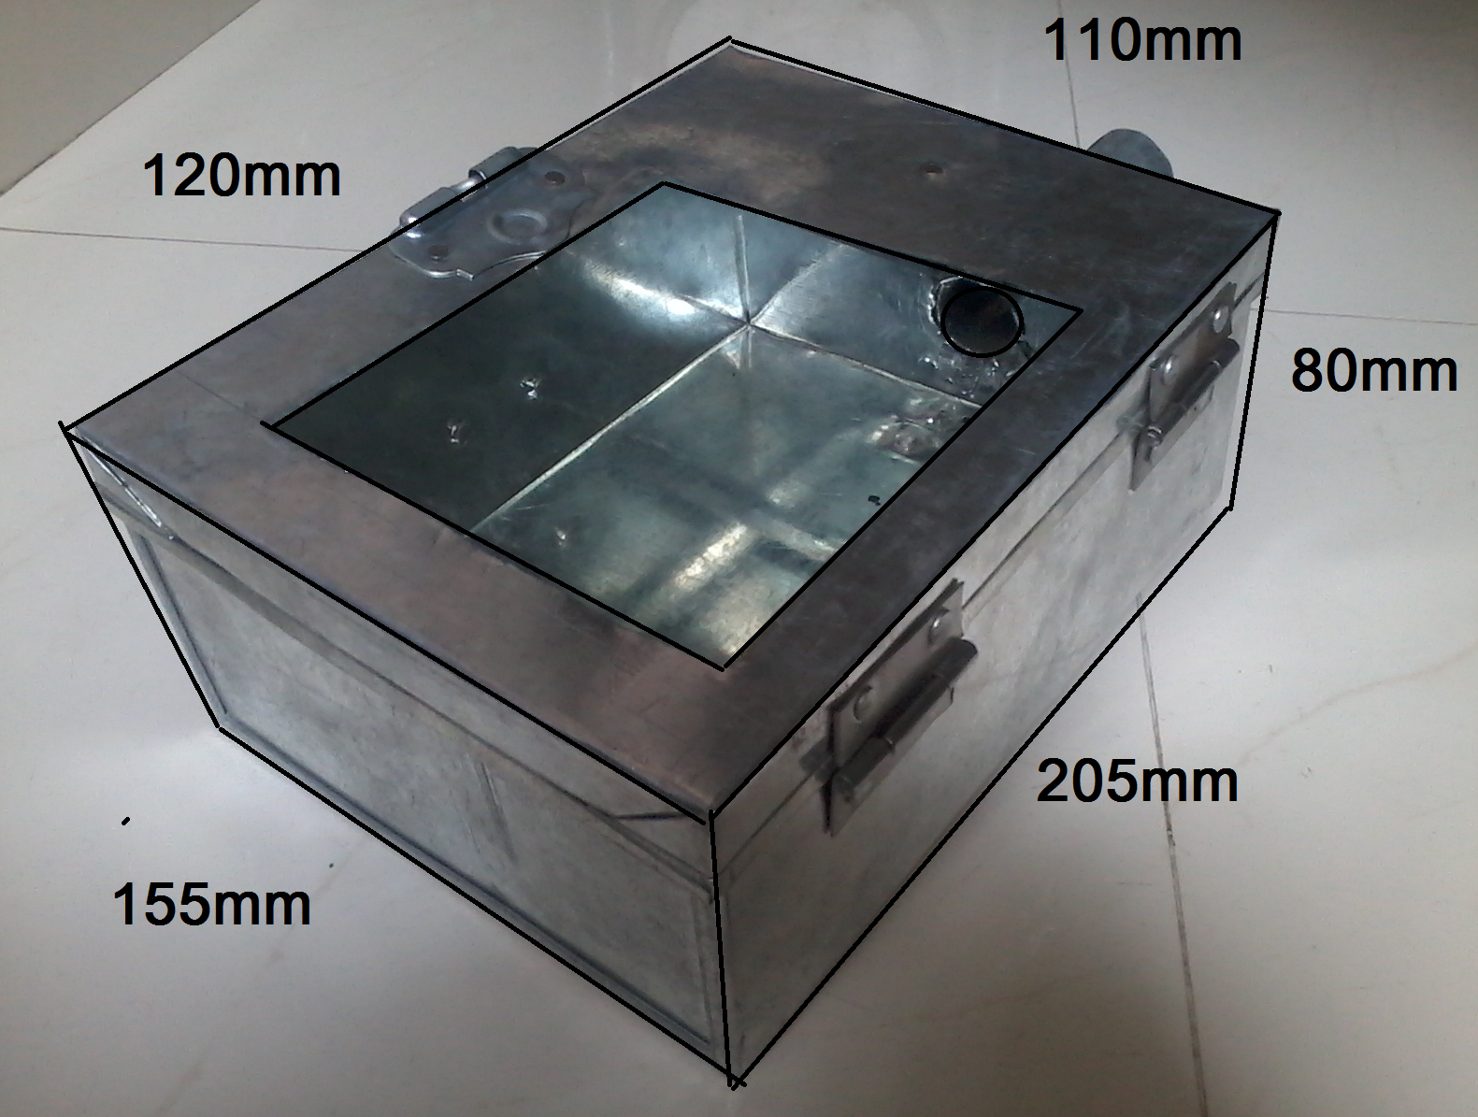**

The product design is basically an engineering technique with a flavour of art. The objective of product design is to optimize the Product for the purpose, based on the market requirement s & criteria for the quality, performance & effectiveness.

The product design of a robot has special considerations to be taken into account. These include productivity, job satisfaction, and safety.

This planning must begin at the early stage of product design where the choice of manufacturing method must be scrutinized to achieve an optimal allocation. An analysis of accidents shows that most facilities have occurred with the robot approaching unseen from behind or above. This has implications for the design of the workstation and the choice of safety equipment. The most critical aspect is the moving robot arm. Further research is needed to understand the perceptibility of arm movements. Research on sensors that can shut off the equipment in hazardous situations is summarized.

**Chapter no. 7**

**COST AND ESTIMATION**

Costing and estimation is necessary to know the capability of our product with the existing product in the market.

**METHODOLOGY**

There are three steps of costing and estimation those are:-

* **Initial estimation**

This estimation is done before producing the product. It is guide to get rough idea of the product cost.

* **Half Potential Project method**

This estimation is done after completing some part of product to check whether estimation is correct or wrong. The errors produced will be eliminated during this estimation. It also keeps track with economic feasibility of the manufacturing process.

* **Estimation after completion of product**

A prototype is made before actual mass production to get as idea feasibility of the product, hence some modification in circuit or enclosure is possible. So as to get the exact costing and estimation is done after the prototype is made.

In costing and estimation the cost compromises of the following elements:-

**1.** Development cost

**2.** Direct material cost

**3.** Technology and Production cost

**4.** Overheads.

The product execution at NIELIT is done at prototype level and not on prototype level and not on the production level, hence we can take only material cost into account. For estimation it is necessary to generate process routine, process routine is generated because it gives idea to producer about sequence of operation, so that product can be produced according to process routines.

The process routine contains following information:-

**1.** The sequence operations necessary to produce the product.

**2.** Department in which the operation takes place.

**3.** The machine on which the operation to be completed.

**4.** A brief description of operation to be completed.

**5.** The shop order corresponding to the operation.

Cost &Estimation

|  |  |  |  |  |
| --- | --- | --- | --- | --- |
| Sr. No. | Component name | Quantity | Price (Single) | Total price |
|  | Power Adapter | 2 | 150 | 300 |
|  | LCD | 1 | 378 | 378 |
|  | Humidity and temperature sensor | 1 | 442 | 442 |
|  | GY-521 Mpu6050 module | 1 | 245 | 245 |
|  | GSM MODEM | 1 | 1425 | 1425 |
|  | Arduino mega 2560 | 1 | 1299 | 1299 |
|  | GPS MODEM | 1 | 1298 | 1298 |
|  | 10KΩ (Resistor Bank Pull Up Resistor) | 4 | 10 | 40 |
|  | MQ-135 Air Quality Sensor | 1 | 260 | 260 |
|  | Buzzer | 1 | 100 | 100 |
|  | Wire Strip | 3 | 70 | 210 |
|  | RoboChesis | 1 | 160 | 160 |
|  | Wheels | 4 | 30 | 120 |
|  | Variable Resistor | 1 | 10 | 10 |
|  | IR Sensor | 1 | 250 | 250 |
|  | Exhaust Fan | 1 | 100 | 100 |
|  | 1725222CP-SPST-4A-60VDC (Relay) | 1 | 40 | 40 |
|  | Product Design | 1 | 500 | 500 |
|  | TOTAL | - | - | 2654 |

**Chapter no. 8**

**Advantages**

The system uses a GPS module which is now present in almost all vehicles and is also cheap. The system also allows the emergency centre to gauge the severity of the accident by sending the previous speeds of the vehicle and moreover allows the vehicle occupant to manually turn off the alarm and hence reduce false alarms.

The technologies used in project are GPS, GPRS and Android. The main modules and their functionalities include the hardware module for accident detection which is used to limit the switches and Arduino. Then the Web basedprevious speeds of the vehicle and moreover allows the vehicle occupant to manually turn off the alarm and hence reduce false alarms.

The technologies used in project are GPS, GPRS and Android. The main modules and their functionalities include the hardware module for accident detection which is used to limit the switches and Arduino. Then the Web based Central Registration System registers these services. An Android Application is used for controlling the circuit and User Interaction in the vehicle will raise alarm and ask the user for the conduction of further outcomes. A Webbased Service for the Central Assistance Centre will receive notifications.

Working of the module includes registering of a new vehicle and downloading the android app in smart phone. Registering all the services such as ambulance and insurances services .When the vehicle collides with another object or vehicle, the limit switch gets pressed and it establishes a circuit and the signal passes to the Arduino.The Arduino is connected to the limit switches and the Bluetooth module which is further connected to the driver’s Android Smart Phone.The application determines the GPS co-ordinates and transfers them to the central server from where the location is sent as an alert to all services registered.

The different technologies used include GPS, accelerometers and Kalman filters. The major need for this algorithm aremore accuracy in GPS systems as they suffer from the line of sight and poor update rate and as such, the acceleration data derived from the GPS lacks in instantaneous acceleration which is very important in determining a sudden deceleration due to accident. High and instantaneous data can be acquired from the IMU (Inertial Measurement Unit) as opposed to GPS.

The proposed system ismonitors the deceleration data from the GPS and IMU accelerometer sensors. These two types of data are integrated by the Kalmanfilter. Whenever the deceleration from the GPS is available, IMU deceleration is updated by this filter. The deceleration data from the IMU is considered only in the GPS outage scenario. The Razor INS can fill the gaps in case of GPS outage and the IMU data are updated through the integration of valid GPS data. The IMU provides accelerometer, gyroscope and magnetometer reading in all three axes. The orientation of the vehicle relative to gravity can be predicted by integrating gyroscope with the accelerometer and the direction of the vehicle can be determined from the magnetometer. Byintegrating these sensors in three axes, the Attitude Heading Reference System (AHRS) is built. The Direction Cosine Matrix (DCM) is used as a basis to integrate the accelerometer, gyroscope and magnetometer. This matrix is a form to represent a rotation through a 3X3 R matrix. The DCM matrix described in [28] has been used as a model for the IMU sensors to build the AHRS. The ARHS data gets corrupted, which is fused with GPS data using the Kalman filter. Vehicle decelerates when the brake is applied. Any deceleration more than 5Gs as obtained, is considered as an accident situation by the proposed algorithm. In this situation, the system would raise an alarmthe results from the paper are based on the thresholdmaintained which is 5Gs, which when the deceleration is below it, an alert is sent.

**Chapter no. 9**

PROGRAM/CODE DESIGN

#include <dht.h>

#define dataPin 13 // Defines pin number to which the sensor is connected

dht DHT;

#include <LiquidCrystal.h>

// initialize the library with the numbers of the interface pins

LiquidCrystallcd(2, 3, 4, 5, 6, 7);

#include <SoftwareSerial.h>

#include <TinyGPS.h>

TinyGPSgps;

SoftwareSerialss(10, 11);

static void smartdelay(unsigned long ms);

static void print\_float(float val, float invalid, intlen, intprec);

static void print\_int(unsigned long val, unsigned long invalid, intlen);

static void print\_date(TinyGPS&gps);

static void print\_str(const char \*str, intlen);

int fan = 8;

intir = 9;

intirs = 0;

intmq = 12;

intmqs = 0;

int buzz = A0;

void setup()

{

  pinMode(fan, OUTPUT);

  pinMode(buzz, OUTPUT);

  pinMode(ir, INPUT);

  pinMode(mq, INPUT);

  Serial.begin(9600);///gsm

  ss.begin(9600);//gps

  lcd.begin(16, 2);

  lcd.clear();

  lcd.setCursor(0, 0);

  lcd.print("WELCOME TO");

  lcd.setCursor(0, 1);

  lcd.print("NIELIT");

  delay(2000);

  lcd.clear();

  lcd.clear();

  lcd.setCursor(0, 0);

  lcd.print("ACCIDENT DETE.");

  lcd.setCursor(0, 1);

  lcd.print("& SAFTY SYSTEM");

  delay(2000);

  lcd.clear();

  lcd.setCursor(0, 0);

  lcd.print("GUIDED BY:-");

  lcd.setCursor(0, 1);

  lcd.print("PROF.A.K. JOSHI");

  delay(4000);

  lcd.clear();

}

Void loop()

{

  IntreadData = DHT.read22(dataPin); // Reads the data from the sensor

  float t = DHT.temperature; // Gets the values of the temperature

  float h = DHT.humidity; // Gets the values of the humidity

  intfrc = digitalRead(ir);

  intmqs = digitalRead(mq);

  lcd.clear();

  lcd.setCursor(0, 0);

  lcd.print("TEMP   HUMI   O2L");

  lcd.setCursor(0, 1);

  lcd.print(t);

  lcd.setCursor(7, 1);

  lcd.print(h);

  lcd.setCursor(15, 1);

  lcd.print(mqs);

  delay(400);

  if (t >= 50.0)

  {

    digitalWrite (fan, HIGH);

    lcd.clear();

    lcd.setCursor(0, 0);

    lcd.print("TEMP CROSSED");

    lcd.setCursor(0, 1);

    lcd.print("THE LIMIT");

    delay(400);

  }

  else

  {

    digitalWrite(fan, LOW);

  }

  if (mqs == LOW)

  {

    digitalWrite(fan, HIGH);

    digitalWrite(buzz, HIGH);

    lcd.clear();

    lcd.setCursor(0, 0);

    lcd.print("O2 CROSSED");

    lcd.setCursor(0, 1);

    lcd.print("THE LIMIT");

    delay(400);

  }

  else

  {

    digitalWrite(fan, LOW);

    digitalWrite(buzz, LOW);

  }

  float flat, flon;

  unsigned long age, date, time, chars = 0;

  unsigned short sentences = 0, failed = 0;

  static const double LONDON\_LAT = 51.508131, LONDON\_LON = -0.128002;

  gps.satellites();

  gps.hdop();

  gps.f\_get\_position(&flat, &flon, &age);

  if (frc == LOW)

  {

    digitalWrite(buzz, HIGH);

    /////////////////////////////////////////////////////////////

    Serial.println();

    delay(1000);

    Serial.println("AT+CMGF=1");

    delay(200);        // delay in between reads for stability

    Serial.println("AT+CMGF=1");

    delay(200);

    Serial.println("AT+CMGF=1");

    delay(200);

    Serial.println("AT+CMGS=\"+917972288506\""); //set the phone number

    delay(200);

    Serial.println("Attention!!!!!! Accident OF MH 20 BS 7777 ");

    print\_float(flat, TinyGPS::GPS\_INVALID\_F\_ANGLE, 10, 6);

    print\_float(flon, TinyGPS::GPS\_INVALID\_F\_ANGLE, 11, 6);

    delay(500);

    Serial.print("Location");

    //Serial.print("GudedBy:S.M.Badave Mam");

    delay(50);

    delay(500);

    Serial.write(26);

    ////////////////////////////////////////////////////////

    digitalWrite(buzz, LOW);

  }

  smartdelay(1000);

}

static void smartdelay(unsigned long ms)

{

  unsigned long start = millis();

  do

  {

    while (ss.available())

      gps.encode(ss.read());

  }

  while (millis() - start <ms);

}

static void print\_float(float val, float invalid, intlen, intprec)

{

  if (val == invalid)

  {

    while (len-- > 1)

      Serial.print('\*');

    Serial.print(' ');

  }

  else

  {

    Serial.print(val, prec);

    int vi = abs((int)val);

    intflen = prec + (val< 0.0 ? 2 : 1); // . and -

    flen += vi >= 1000 ? 4 : vi >= 100 ? 3 : vi >= 10 ? 2 : 1;

    for (inti = flen; i<len; ++i)

      Serial.print(' ');

  }

  smartdelay(0);

}

static void print\_int(unsigned long val, unsigned long invalid, intlen)

{

  char sz[32];

  if (val == invalid)

    strcpy(sz, "\*\*\*\*\*\*\*");

  else

    sprintf(sz, "%ld", val);

  sz[len] = 0;

  for (inti = strlen(sz); i<len; ++i)

    sz[i] = ' ';

  if (len> 0)

    sz[len - 1] = ' ';

  Serial.print(sz);

  smartdelay(0);

}

static void print\_date(TinyGPS&gps)

{

  int year;

  byte month, day, hour, minute, second, hundredths;

  unsigned long age;

  gps.crack\_datetime(&year, &month, &day, &hour, &minute, &second, &hundredths, &age);

  if (age == TinyGPS::GPS\_INVALID\_AGE)

    Serial.print("\*\*\*\*\*\*\*\*\*\* \*\*\*\*\*\*\*\* ");

  else

  {

    char sz[32];

    sprintf(sz, "%02d/%02d/%02d %02d:%02d:%02d ",

            month, day, year, hour, minute, second);

    Serial.print(sz);

  }

  print\_int(age, TinyGPS::GPS\_INVALID\_AGE, 5);

  smartdelay(0);

}

static void print\_str(const char \*str, intlen)

{

  intslen = strlen(str);

  for (inti = 0; i<len; ++i)

    Serial.print(i<slen ? str[i] : ' ');

  smartdelay(0);

}

**Chapter no. 10**

**BIBLIOGRAPHY**

* Internet :

<https://www.onlinejournal.in/IJIRV3I4/394.pdf>

<https://electronicsforu.com/>

<http://www.circuitstoday.com/interfacing-lcd-to-arduino>

<https://www.arduino.cc/en/Tutorial/HelloWorld>

<https://www.robomart.com/blog/working-of-hc-sr04-ultrasonic-sensor-with-arduino-mega2560/>

<https://www.introtoarduino.com/downloads/IntroArduinoBook.pdf>

* Book

Programming Arduino getting started with sketches “McGraw-hill