# HEALTH CARE ORGANIZATION :

**Technologies used :-**

* PHP
* Mysql

**Software Requirements:-**

* Xampp Server
* PHP
* Windows 7 or above

**Hardware Requirements:-**

* RAM – 1 GB.(Minimum)
* Processor – Dual Core or Above.

**LOGIN PAGE:**

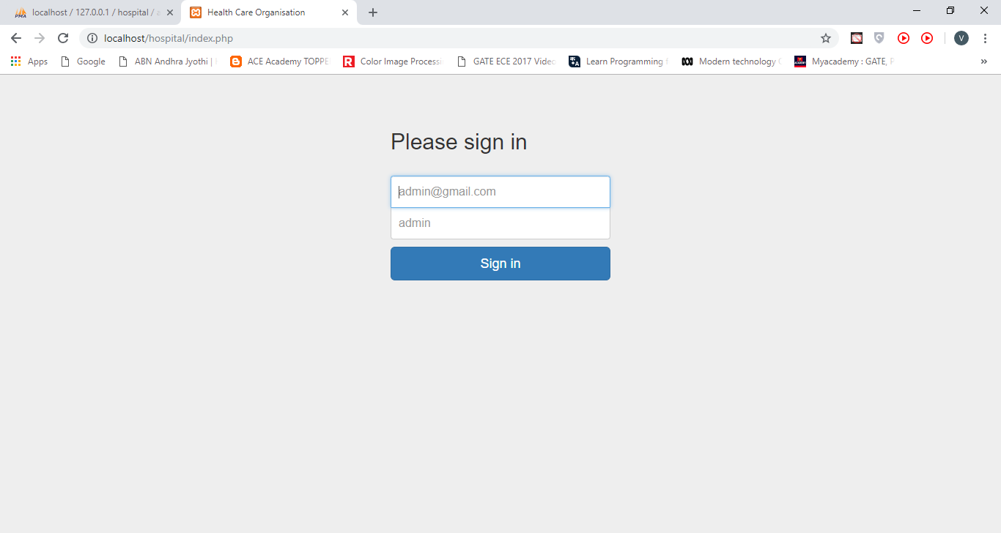

CODE:

<!DOCTYPE html>

<html lang="en">

<head>

<meta charset="utf-8">

<meta http-equiv="X-UA-Compatible" content="IE=edge">

<meta name="viewport" content="width=device-width, initial-scale=1">

<!-- The above 3 meta tags *must* come first in the head; any other head content must come *after* these tags -->

<meta name="description" content="">

<meta name="author" content="">

<title>Health Care Organisation</title>

<!-- Bootstrap core CSS -->

<link href="css/bootstrap.min.css" rel="stylesheet">

<!-- IE10 viewport hack for Surface/desktop Windows 8 bug -->

<link href="css/ie10-viewport-bug-workaround.css" rel="stylesheet">

<!-- Custom styles for this template -->

<link href="css/signIn.css" rel="stylesheet">

<!-- Just for debugging purposes. Don't actually copy these 2 lines! -->

<!--[if lt IE 9]><script src="../../assets/js/ie8-responsive-file-warning.js"></script><![endif]-->

<script src="../../assets/js/ie-emulation-modes-warning.js"></script>

<!-- HTML5 shim and Respond.js for IE8 support of HTML5 elements and media queries -->

<!--[if lt IE 9]>

<script src="https://oss.maxcdn.com/html5shiv/3.7.3/html5shiv.min.js"></script>

<script src="https://oss.maxcdn.com/respond/1.4.2/respond.min.js"></script>

<![endif]-->

</head>

<body>

<div class="container">

<form method="post" class="form-signin">

<h2 class="form-signin-heading">Please sign in</h2>

<label></label>

<label for="inputEmail" class="sr-only">Email address</label>

<input type="email" id="inputEmail" name="user" class="form-control" placeholder="admin@gmail.com" required autofocus>

<label for="inputPassword" class="sr-only">Password</label>

<input type="password" name="pass" id="inputPassword" class="form-control" placeholder="admin" required>

<button class="btn btn-lg btn-primary btn-block" name="signIn" type="submit">Sign in</button>

</form>

</div> <!-- /container -->

<!-- IE10 viewport hack for Surface/desktop Windows 8 bug -->

<script src="../../assets/js/ie10-viewport-bug-workaround.js"></script>

</body>

</html>

**Doctor List:**

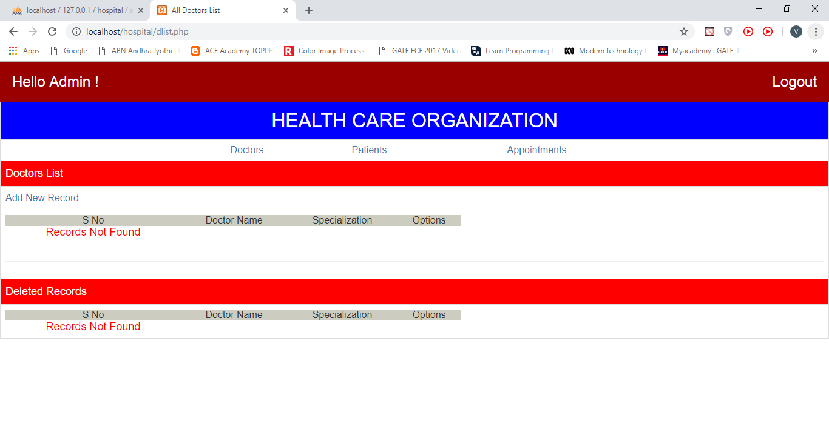

**CODE:**

<?php require('connection.php');?>

<html>

<head>

<title>All Doctors List</title>

<link rel="stylesheet" href="css/bootstrap.css"/>

</head>

<body>

<table class="table table-bordered">

<tr bgcolor=blue><td align=center><font SIZE=6 color=white>HEALTH CARE ORGANIZATION</font></td></tr>

<tr><td><table align=center width=750 cellspacing=0 cellpadding=5>

<tr><td align=center><a href=dlist.php>Doctors</td><td align=center><a

href=plist.php>Patients</td><td align=center><a

href=alist.php>Appointments</td>

</table></td></tr>

<tr bgcolor=red><td ><font size=4 color=white>Doctors

List</font></td></tr>

<tr><td><a href=dadd.php>Add New Record</a></td></tr>

<tr><td><table width=750 cellspacing=0 cellpadding=5>

<tr bgcolor=#ccccc><td align=center>S No</td><td align=center>Doctor

Name</td><td align=center>Specialization</td><td

align=center>Options</td></tr>

<?php

$rs1=mysqli_query("SELECT * from doct where dshow='Y' order by

dname;");

$sno=1;

while( $row=mysqli_fetch_array($rs1)) {

echo "<tr><td>$sno</td><td>$row[1]</td><td>$row[2]</td><td><a

href=dmod.php?rno=".$row[0].">Modify</a> | <a

href=ddel.php?rno=".$row[0].">Delete</a></td></tr>";

$sno++;

}

if ($sno==1) echo "<tr><td align=center><font size=4 color=red>Records

Not Found</font></td></tr>";

?>

</table></td></tr>

<tr><td align=center><hr></td></tr>

<tr bgcolor=red><td><font size=4 color=white>Deleted

Records</font></td></tr>

<tr><td><table width=750 cellspacing=0 cellpadding=5>

<tr bgcolor=#ccccc><td align=center>S No</td><td align=center>Doctor

Name</td><td align=center>Specialization</td><td

align=center>Options</td></tr>

<?php

$rs2=mysqli_query("SELECT * from doct where dshow='N' order by

dname;");

$sno=1;

while( $row=mysqli_fetch_array($rs2)) {

echo "<tr><td>$sno</td><td>$row[1]</td><td>$row[2]</td><td><a

href=dundel.php?rno=".$row[0].">Undelete</a></td></tr>";

$sno++;

}

if ($sno==1) echo "<tr><td align=center><font size=4 color=red>Records

Not Found</font></td></tr>";

?>

</table></td></tr>

</table>

</body>

</html> <?php require('connection.php');?>

<html>

<head>

<title>All Doctors List</title>

<link rel="stylesheet" href="css/bootstrap.css"/>

</head>

<body>

<table class="table table-bordered">

<tr bgcolor=blue><td align=center><font SIZE=6 color=white>HEALTH CARE ORGANIZATION</font></td></tr>

<tr><td><table align=center width=750 cellspacing=0 cellpadding=5>

<tr><td align=center><a href=dlist.php>Doctors</td><td align=center><a

href=plist.php>Patients</td><td align=center><a

href=alist.php>Appointments</td>

</table></td></tr>

<tr bgcolor=red><td ><font size=4 color=white>Doctors

List</font></td></tr>

<tr><td><a href=dadd.php>Add New Record</a></td></tr>

<tr><td><table width=750 cellspacing=0 cellpadding=5>

<tr bgcolor=#ccccc><td align=center>S No</td><td align=center>Doctor

Name</td><td align=center>Specialization</td><td

align=center>Options</td></tr>

<?php

$rs1=mysqli_query("SELECT * from doct where dshow='Y' order by

dname;");

$sno=1;

while( $row=mysqli_fetch_array($rs1)) {

echo "<tr><td>$sno</td><td>$row[1]</td><td>$row[2]</td><td><a

href=dmod.php?rno=".$row[0].">Modify</a> | <a

href=ddel.php?rno=".$row[0].">Delete</a></td></tr>";

$sno++;

}

if ($sno==1) echo "<tr><td align=center><font size=4 color=red>Records

Not Found</font></td></tr>";

?>

</table></td></tr>

<tr><td align=center><hr></td></tr>

<tr bgcolor=red><td><font size=4 color=white>Deleted

Records</font></td></tr>

<tr><td><table width=750 cellspacing=0 cellpadding=5>

<tr bgcolor=#ccccc><td align=center>S No</td><td align=center>Doctor

Name</td><td align=center>Specialization</td><td

align=center>Options</td></tr>

<?php

$rs2=mysqli_query("SELECT * from doct where dshow='N' order by

dname;");

$sno=1;

while( $row=mysqli_fetch_array($rs2)) {

echo "<tr><td>$sno</td><td>$row[1]</td><td>$row[2]</td><td><a

href=dundel.php?rno=".$row[0].">Undelete</a></td></tr>";

$sno++;

}

if ($sno==1) echo "<tr><td align=center><font size=4 color=red>Records

Not Found</font></td></tr>";

?>

</table></td></tr>

</table>

</body>

</html>

**Patient List:**

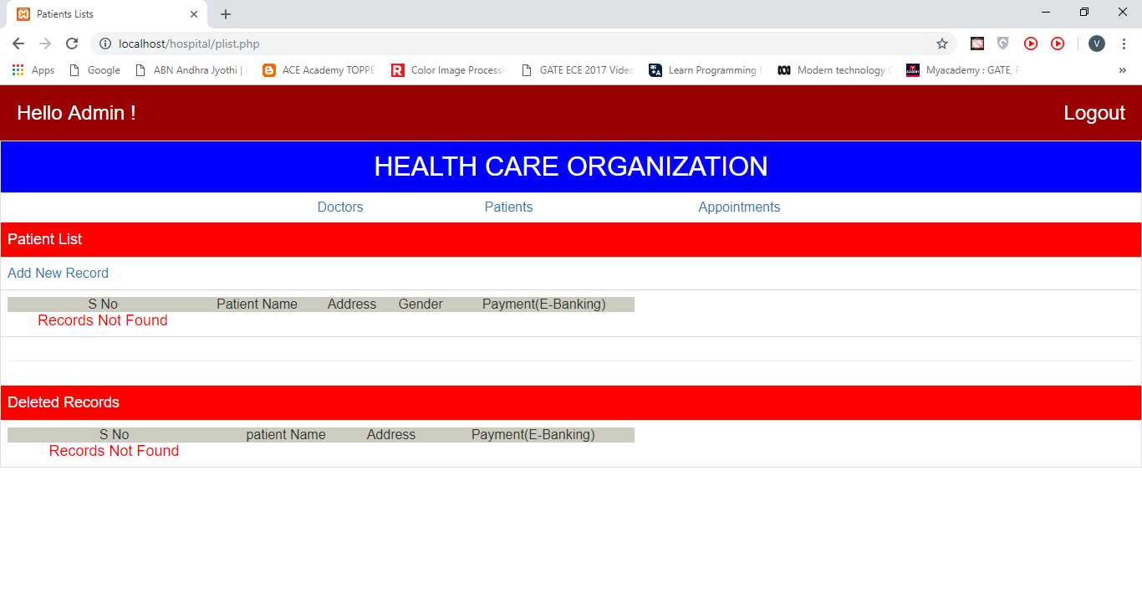

**CODE:**

<h3 style="background:#990000;padding:20px;color:#FFFFFF;margin:0px">

<span>Hello Admin !</span>

<span style="float:right"><a style="color:#FFFFFF" href="logout.php">Logout</a></span>

</h3><html>

<head>

<title>Patients Lists</title>

<link rel="stylesheet" href="css/bootstrap.css"/>

</head>

<body>

<table class="table table-bordered">

<tr bgcolor=blue><td align=center><font SIZE=6 color=white>HEALTH CARE ORGANIZATION</font></td></tr>

<tr><td><table align=center width=750 cellspacing=0 cellpadding=5>

<tr><td align=center><a href=dlist.php>Doctors</td><td align=center><a

href=plist.php>Patients</td><td align=center><a

href=alist.php>Appointments</td>

</table></td></tr>

<tr bgcolor=red><td ><font size=4 color=white>Patient

List</font></td></tr>

<tr><td><a href=padd.php>Add New Record</a></td></tr>

<tr><td><table width=750 cellspacing=0 cellpadding=5>

<tr bgcolor=#ccccc><td align=center>S No</td><td align=center>Patient

Name</td><td align=center>Address</td><td align=center>sex</td><td

align=center>Options</td></tr>

<tr><td align=center><font size=4 color=red>Records

Not Found</font></td></tr></table></td></tr>

<tr><td align=center><hr></td></tr>

<tr bgcolor=red><td><font size=4 color=white>Deleted

Records</font></td></tr>

<tr><td><table width=750 cellspacing=0 cellpadding=5>

<tr bgcolor=#ccccc><td align=center>S No</td><td align=center>patient

Name</td><td align=center>Address</td><td

align=center>Options</td></tr>

<tr><td align=center><font size=4 color=red>Records

Not Found</font></td></tr></table></td></tr>

</table>

</body>

</html>

**Appointment List:**

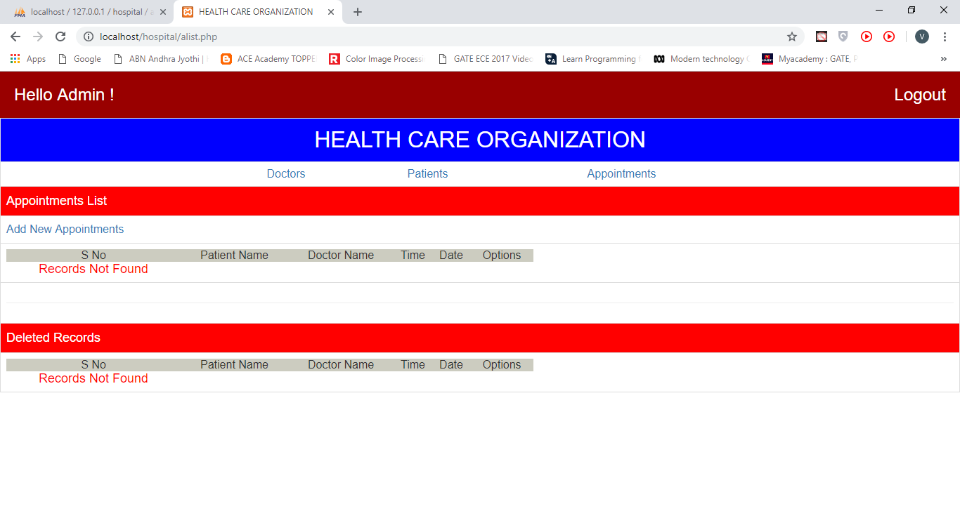

**CODE:**

<?php

require('connection.php');

error_reporting(1);

?>

<html>

<head>

<title>HEALTH CARE ORGANIZATION</title>

<link rel="stylesheet" href="css/bootstrap.css"/>

</head>

<body>

<table class="table table-bordered">

<tr bgcolor=blue><td align=center><font SIZE=6 color=white>HEALTH CARE ORGANIZATION</font></td></tr>

<tr><td><table align=center width=750 cellspacing=0 cellpadding=5>

<tr><td align=center><a href=dlist.php>Doctors</td><td align=center><a

href=plist.php>Patients</td><td align=center><a

href=alist.php>Appointments</td>

</table></td></tr>

<tr bgcolor=red><td ><font size=4 color=white>Appointments

List</font></td></tr>

<tr><td><a href=app.php>Add New Appointments</a></td></tr>

<tr><td><table width=750 cellspacing=0 cellpadding=5>

<tr bgcolor=#ccccc><td align=center>S No</td><td align=center>Patient

Name</td><td align=center>Doctor

Name</td><td align=center>Time</td>

<td align=center>Date</td><td

align=center>Options</td></tr>

<?php

if($_GET['rno']!=null)

{

$todel=$_GET['rno'];

mysqli_query("update appt SET ashow='N' where ano='$todel' ;");

}

$rs1=mysqli_query("SELECT * from appt where ashow='Y'");

$sno=1;

while( $row=mysqli_fetch_array($rs1)) {

$rs2=mysqli_query("SELECT pname from patient where pno='$row[2]'");

$rs3=mysqli_query("SELECT dname from doct where dno='$row[1]'");

$rs22=mysqli_fetch_assoc($rs2);

$rs33=mysqli_fetch_assoc($rs3);

echo "<tr><td>$sno</td><td>$rs22[pname]</td><td>$rs33[dname]</td><td>$row[3]</td><td>$row[5]</td><td><a

href=alist.php?rno=".$row[0].">Delete</a></td></tr>";

$sno++;

}

if ($sno==1) echo "<tr><td align=center><font size=4 color=red>Records

Not Found</font></td></tr>";?>

</table></td></tr>

<tr><td align=center><hr></td></tr>

<tr bgcolor=red><td><font size=4 color=white>Deleted

Records</font></td></tr>

<tr><td><table width=750 cellspacing=0 cellpadding=5>

<tr bgcolor=#ccccc><td align=center>S No</td><td align=center>Patient

Name</td><td align=center>Doctor

Name</td><td align=center>Time</td>

<td align=center>Date</td><td

align=center>Options</td></tr>

<?php

$rs1=mysqli_query("SELECT * from appt where ashow='N'");

$sno=1;

while( $row=mysqli_fetch_array($rs1)) {

$rs2=mysqli_query("SELECT pname from patient where pno='$row[2]'");

$rs3=mysqli_query("SELECT dname from doct where dno='$row[1]'");

$rs22=mysqli_fetch_assoc($rs2);

$rs33=mysqli_fetch_assoc($rs3);

echo "<tr><td>$sno</td><td>$rs22[pname]</td><td>$rs33[dname]</td><td>$row[3]</td><td>$row[5]</td><td><a

href=aundel.php?rno=".$row[0].">Undelete</a></td></tr>";

$sno++;

}

if ($sno==1) echo "<tr><td align=center><font size=4 color=red>Records

Not Found</font></td></tr>";

?>

</table></td></tr>

</table>

</body>

</html>