**Terraform Backend Using S3 and Dynamodb With State Locking :**

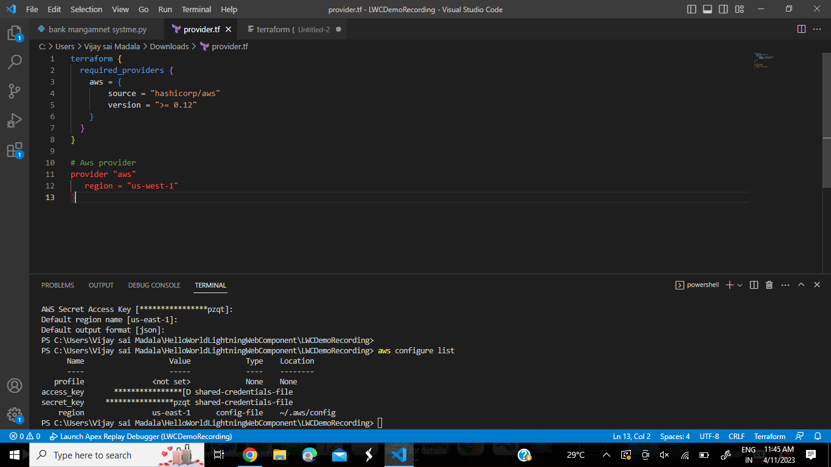

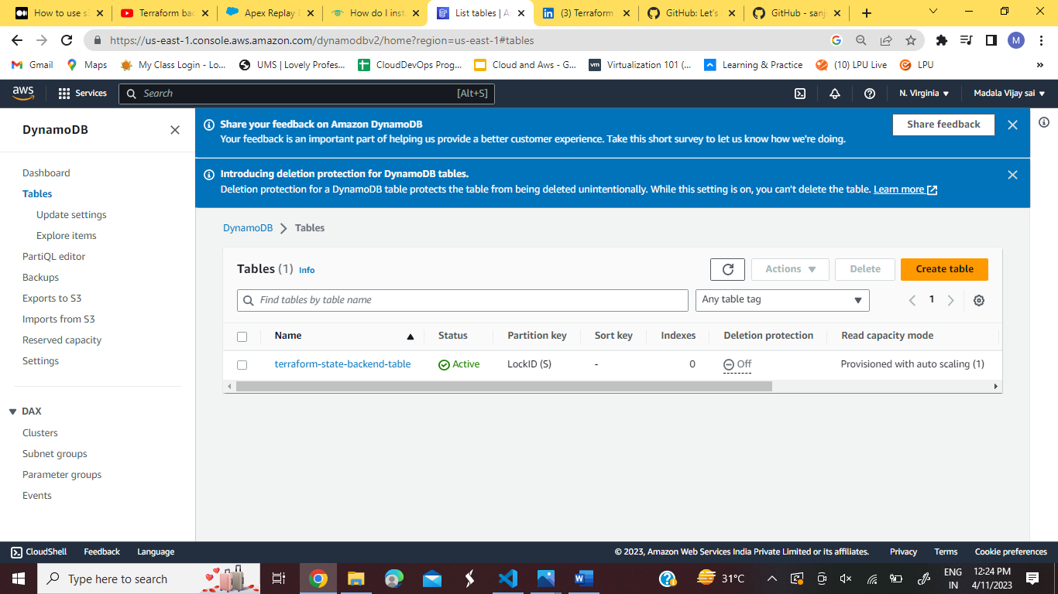

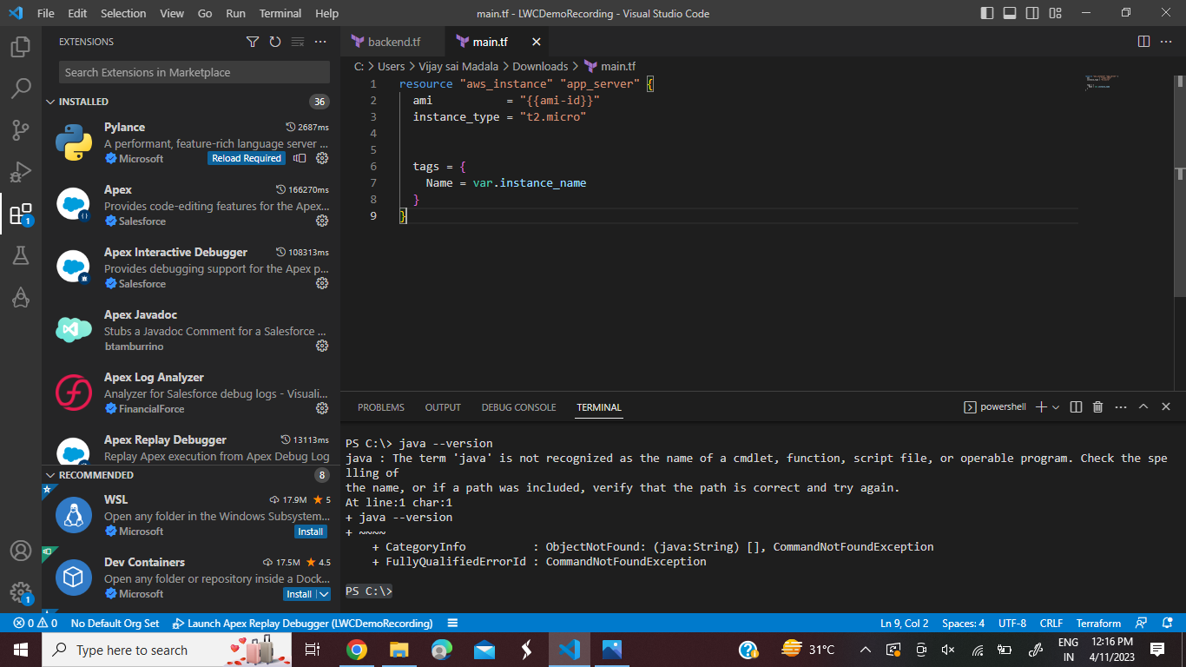

Next :- Terraform init



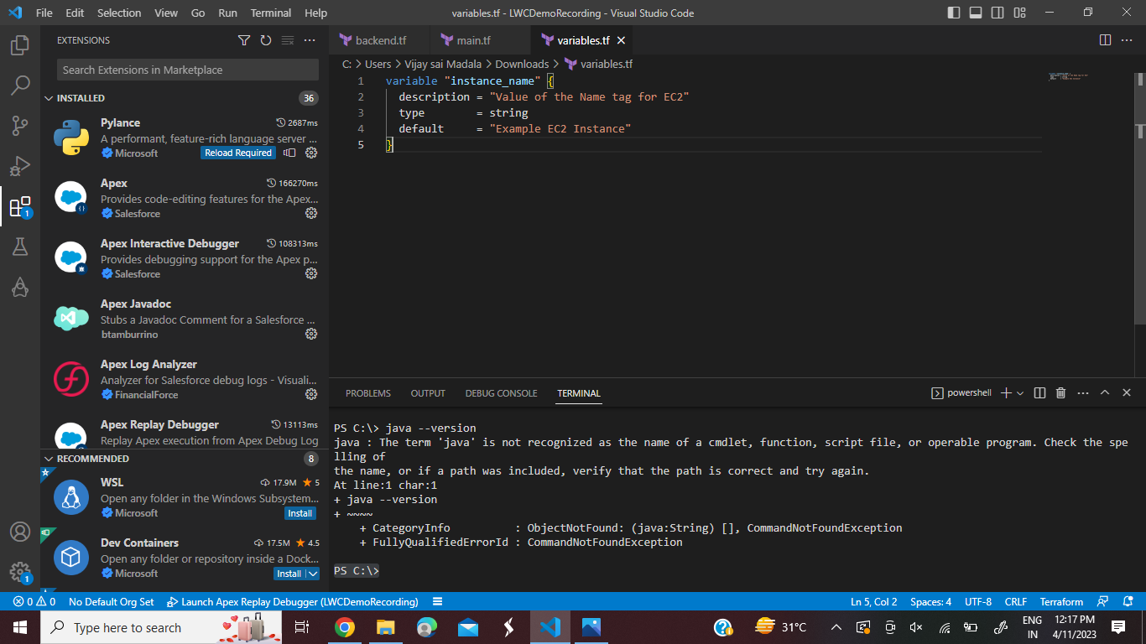

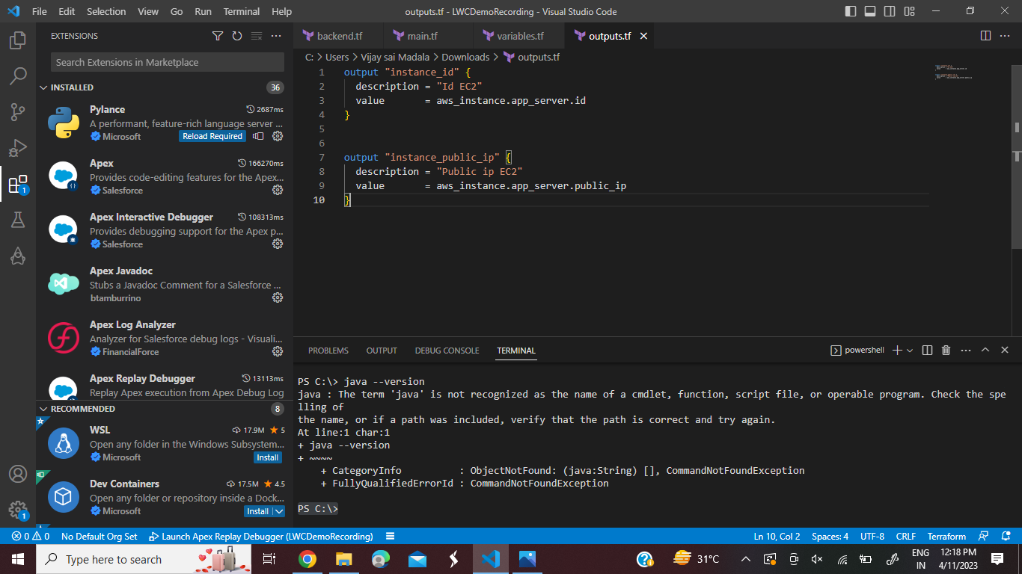

Outputs:

instance_id = "i-0d382c73cc72c3888"

instance_public_ip "13.59.146.204"

dyamoDB table Not Changed

Run **terraform destroy** command to remove all created resources