RepairBranch: A Mechanistically-Grounded Counterfactual Replay Framework for Remaining-Useful-Life Prognostics and Maintenance-Timing Optimization in Turbofan Engines
[Author Name(s) — to be completed]
Department / Affiliation, City, Country
email@example.com
Abstract—Predictive maintenance has shifted from reactive failure detection toward prognostic Remaining Useful Life (RUL) estimation, yet most systems stop at prediction without evaluating the consequences of intervening at different points along an asset's degradation trajectory. This paper presents RepairBranch, coupling RUL prognostics with counterfactual maintenance-timing replay, evaluated on the NASA C-MAPSS FD001 turbofan benchmark (100 training, 100 test engines; single operating condition and fault mode). A Random Forest regressor on rolling-window sensor features, validated with grouped five-fold cross-validation, predicts RUL with test RMSE 18.9 cycles, MAE 13.6, R-squared 0.794, and NASA PHM08 score 1044.1, with one lead sensor dominating feature importance. A counterfactual replay engine then mechanistically re-simulates each engine's own observed degradation increments, rather than a trained surrogate, from a partially restored baseline at three repair timings: fifty, seventy, and eighty-five percent of observed life. Later repairs consistently yield larger simulated life extension, traced to the back-loaded, accelerating shape of the degradation curves, where a fixed restoration fraction removes more accumulated damage once a trajectory enters its steep late-life phase. An illustrative cost model combining failure, repair, and per-cycle costs shows positive net benefit under every scenario, highest for late repair. No published work is known to combine mechanistic counterfactual replay of maintenance timing with cross-validated RUL prognostics on a public benchmark. Limitations include FD001's single condition, a tree-ensemble baseline, and illustrative cost figures. These results indicate that disciplined, mechanistic counterfactual replay is a practical route to maintenance-timing decision support that point-prediction RUL systems do not by themselves provide.
Keywords—Predictive Maintenance, Remaining Useful Life, Counterfactual Simulation, Digital Twin, Turbofan Engine Prognostics, Random Forest, NASA C-MAPSS, Maintenance Scheduling, Mechanistic Re-Simulation, Cost-Benefit Analysis

I. INTRODUCTION
Predictive maintenance (PdM) has moved steadily away from reactive, run-to-failure operation and toward prognostic estimation of Remaining Useful Life (RUL): given a stream of sensor readings, predict how many operating cycles remain before an asset fails. The NASA C-MAPSS turbofan-engine degradation benchmark [1], [2] catalyzed a large data-driven RUL literature, from an early recurrent-network winner of the original PHM'08 challenge [4] through deep convolutional [5] and long short-term memory [6] architectures, and more recently a higher-fidelity dataset generated under real flight conditions [3]. Nearly all of this work, however, treats RUL as a terminal output: a single number, or a distribution around one, handed to a human decision-maker. None of it answers the operationally relevant follow-up question — if this engine were serviced now instead of later, how much of its life would actually be recovered, and would that be worth the cost?
This paper presents RepairBranch, a framework that pairs a cross-validated RUL model with a counterfactual maintenance-timing replay engine, evaluated end-to-end on the public NASA C-MAPSS FD001 benchmark. Unlike a learned surrogate that approximates how a repaired engine would behave, RepairBranch mechanistically re-simulates each engine's own observed future degradation increments from a partially restored baseline — the same re-simulation discipline used in this group's prior GridGuard cascading-failure work — so every reported counterfactual outcome is grounded in that engine's real physics rather than in a model's extrapolation of it. An illustrative cost model then translates simulated life extension into a maintenance-timing decision, making explicit which assumptions would need to hold in a fielded deployment.
The economic stakes of this gap are not small. Unplanned downtime, expedited spare-parts shipping, and secondary damage from a component that failed rather than was retired on schedule are consistently identified across the predictive-maintenance survey literature as the dominant cost drivers that PdM programs are built to avoid [9], [10], and multi-classifier scheduling systems already in industrial use demonstrate that even a coarse act-now-or-later signal has measurable value in practice [7]. A framework that can additionally quantify how much value a specific repair date would recover, rather than only flagging that some date should be chosen, turns a binary alert into a scheduling input that can be weighed against production calendars, spare-parts lead times, and labor availability — the kind of quantity a maintenance planner can act on directly rather than merely a qualitative fact operations already suspected in the sensor trends. RepairBranch is designed to supply exactly that quantity without requiring a fleet to abandon whatever RUL model it already has in production, since the counterfactual replay engine in Section III consumes only a health-index trajectory and is agnostic to which model produced the underlying RUL estimate.
A. Research Questions
RQ1: Can sensor-derived features predict RUL on FD001 with accuracy confirmed by grouped cross-validation rather than a single favorable split? RQ2: Which sensors drive the prediction, and is the dominant signal consistent with known turbofan degradation physics? RQ3: How does simulated life extension vary with repair timing, and what property of the degradation curve explains that pattern? RQ4: Under an illustrative cost model, does earlier or later intervention yield the greater net benefit, and how much of that conclusion rests on the cost assumptions themselves rather than on the underlying physics?
II. RELATED WORK
The C-MAPSS dataset originates from a NASA thermodynamic simulation of turbofan damage propagation built for the PHM'08 prognostics challenge [1], with its simulation engine documented separately [2]; a higher-fidelity successor, N-CMAPSS, later added real recorded flight conditions [3]. Data-driven RUL prediction on this benchmark progressed from an early recurrent-network challenge entry [4] to deep convolutional [5] and LSTM-based [6] sequence models, each reporting improved point-prediction accuracy. None of these systems simulates an alternative maintenance history; RUL is estimated and reported, not acted upon within the model itself.
A parallel classical-ML predictive-maintenance literature treats the maintenance decision as a classification or threshold problem: Susto et al. [7] combine multiple classifiers to time interventions on semiconductor tools, while survey work [8], [9], [10] catalogs prognostic modelling options and the broader state of PHM practice. These systems recommend whether to act, typically now versus later on a fixed schedule, but do not simulate the graded consequence of acting at one specific cycle versus another.
Counterfactual reasoning has a separate, mature literature in explainable AI: Wachter et al. [11] introduced counterfactual explanations for automated decisions under GDPR, and Mothilal et al. [12] generalized this to diverse, actionable counterfactual sets for classifiers. These methods ask what minimal change to a static feature vector would flip a model's output — a fundamentally different object from asking how a physical degradation trajectory, unfolding over hundreds of operating cycles, would diverge under a different repair time. Applying counterfactual reasoning to the latter requires a mechanistic replay engine, not a feature-perturbation search.
A separate, older prognostics tradition is model-based rather than data-driven: Kalman and particle filters track a physical or empirical degradation state and update it as new sensor evidence arrives, an approach the prognostic-modelling survey in [8] situates alongside purely data-driven regressors. These filters output a single filtered state estimate at each time step, not an explicit set of alternative future trajectories under different intervention times, so the branching gap identified below applies to the model-based tradition as much as to the deep-learning RUL literature.
Table I summarizes this gap. No system in the RUL literature produces explicit maintenance-timing branches; no system in the counterfactual-explanation literature grounds its counterfactuals in a re-simulated physical trajectory; and no system in either literature couples its result to an explicit cost-benefit analysis. RepairBranch is positioned to close this three-way gap on a public, widely used benchmark.
TABLE I. COMPARISON WITH RELATED PRIOR WORK
System | RUL Progn. | Branch. | Mech. | Cost-Ben.
Saxena et al. [1] (C-MAPSS origin) | N | N | Y (sim.) | N
Heimes/Li/Zheng [4]-[6] (deep RUL) | Y | N | N | N
Susto et al. [7] (PdM classifier) | Partial | N | N | N
Wachter/Mothilal [11],[12] (XAI) | N | Y (feat.) | N | N
RepairBranch (this paper) | Y | Y | Y | Y

TABLE I. Branch. = produces explicit multi-scenario maintenance-timing branches. Mech. = grounded in mechanistic re-simulation rather than a trained surrogate (physics simulation counts as mechanistic for [1]). Cost-Ben. = includes an explicit cost-benefit analysis.
III. REPAIRBRANCH FRAMEWORK ARCHITECTURE
RepairBranch is organized as a five-phase pipeline, shown in Fig. 1. Phase 1 ingests the raw FD001 sensor logs and constructs RUL labels and rolling-window features. Phase 2 trains and cross-validates a Random Forest RUL regressor. Phase 3 builds a smoothed, robust health-index signal from the regressor's leading sensor. Phase 4 is the counterfactual replay engine itself, detailed in Algorithm 1. Phase 5 converts simulated life extension into an illustrative cost-benefit comparison across repair-timing scenarios.
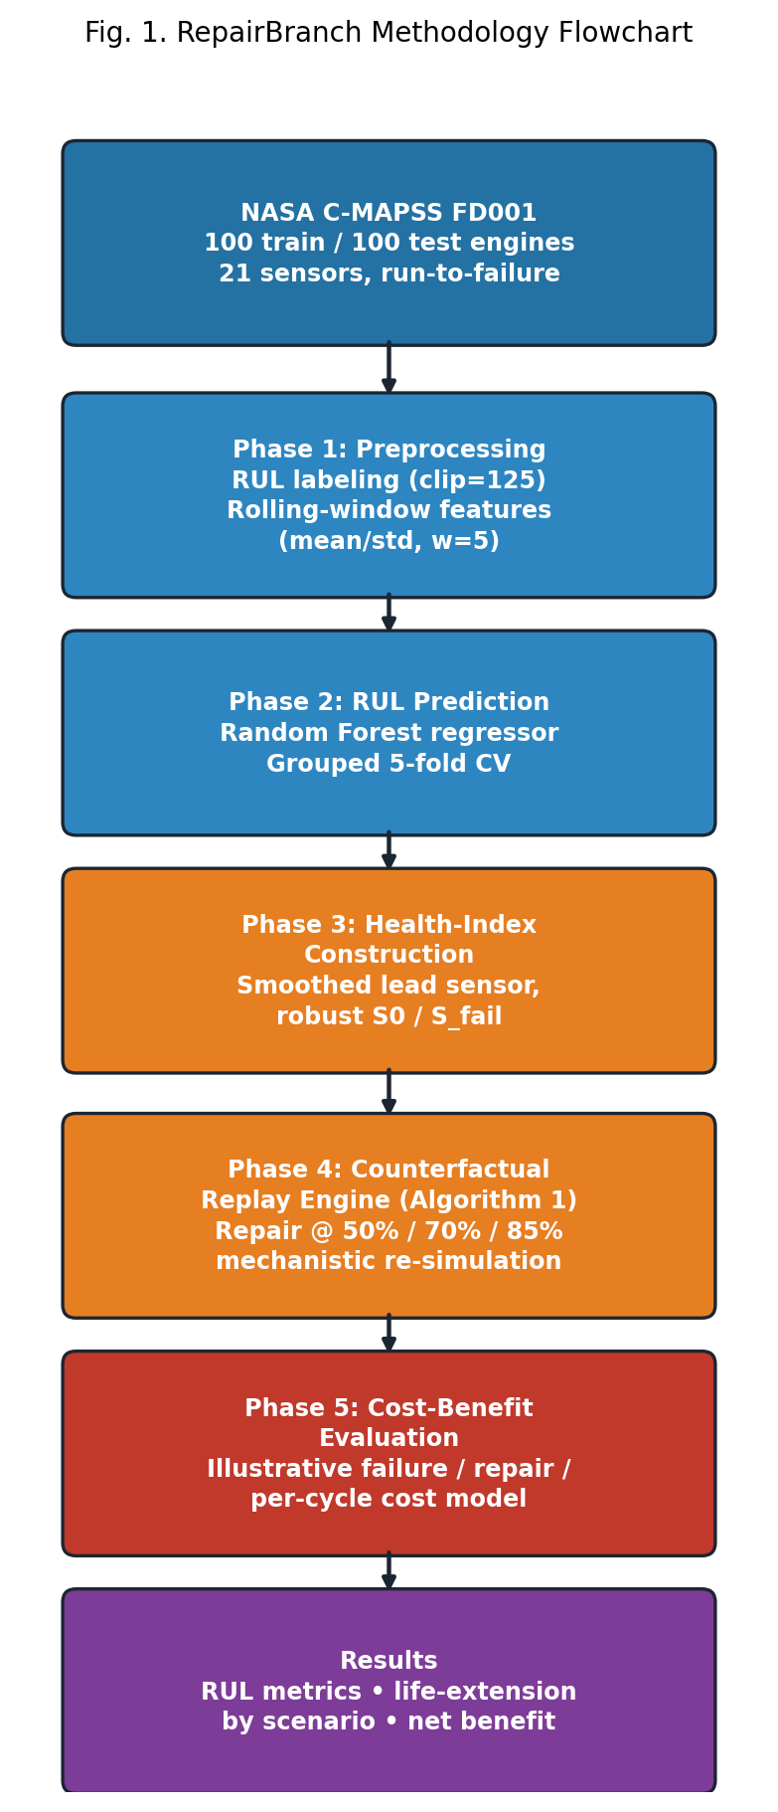
Fig. 1. RepairBranch methodology flowchart: five phases from raw FD001 sensor logs through cost-benefit evaluation.
Algorithm 1 formalizes the replay step. For a given engine, the lead sensor's raw trajectory is first smoothed to suppress measurement noise (line 1); an early implementation used single-cycle readings for the healthy baseline S0 and the failure level S_fail, but this proved sensitive to sensor noise and was replaced with multi-point robust averages (line 2), which removed a class of spuriously near-zero life-extension results. At a counterfactual repair cycle T_r (line 3), the signal is partially restored toward its healthy baseline by a fixed restoration fraction r (line 4). The engine's own future increments — not a trained approximation of them — are then replayed forward from the restored value (lines 5–10) until the original failure level is re-crossed, cycling through the observed increment sequence if the restored trajectory outlasts the original horizon. The difference between the new and original failure cycles is the simulated life extension (line 12).

Algorithm 1. Counterfactual Maintenance-Timing Replay
Input: smoothed trajectory S[1..T_fail], restoration
fraction r, repair fraction f
Output: simulated life extension ΔT
1: S ← RollingMean(S_raw, window = 7)
2: S0 ← mean(S[1..10]); S_fail ← mean(S[T_fail-4..T_fail])
3: T_r ← round(f × T_fail)
4: S_restored ← S[T_r] − r × (S[T_r] − S0)
5: Δ ← Diff(S[T_r .. T_fail]) // observed future increments
6: path[0] ← S_restored; i ← 0
7: while path[last] < S_fail do
8: path.append(path[last] + Δ[i mod len(Δ)])
9: i ← i + 1
10: end while
11: T_fail′ ← T_r + len(path) − 1
12: return ΔT ← T_fail′ − T_fail

IV. EXPERIMENTAL SETUP AND DATASET
Experiments use NASA C-MAPSS subset FD001 [1]: 100 training and 100 test turbofan engines, a single operating condition, a single fault mode (HPC degradation), and 21 sensor channels recorded once per operating cycle. Training engines run to failure (128–362 cycles, mean 206.3); test trajectories are truncated before failure, with ground-truth RUL supplied separately. Seven sensors are constant under FD001's single operating condition and are excluded, leaving 14 informative channels.
Training RUL labels are the remaining cycles to failure, clipped at 125 cycles following standard practice, since degradation is close to flat over most of an engine's early life. Each of the 14 informative sensors contributes a 5-cycle rolling mean and standard deviation alongside its raw value. A Random Forest regressor (200 trees, max depth 10) is evaluated with grouped 5-fold cross-validation — grouping by engine unit so that no engine's cycles appear in both the training and validation fold — before a final model is fit on the full training set and scored on the official FD001 test split using the last recorded cycle of each test engine.
The counterfactual replay engine (Algorithm 1) operates on sensor_4, the regressor's single most important feature (Section V.A), smoothed with a 7-cycle centered rolling mean. Three repair-timing scenarios are simulated for every training engine: repair at 50%, 70%, and 85% of its observed life, with a restoration fraction of 0.6. An illustrative cost model then assigns $50,000 to an unplanned failure, $8,000 to a scheduled repair, and $150 to each cycle of extended operating life; these figures are placeholders chosen to demonstrate the framework and should be replaced with fleet-specific figures in an applied deployment.
All models were implemented in scikit-learn [15] (RandomForestRegressor, 200 trees, max_depth=10, random_state=42 for the final model; 150 trees, max_depth=10 for each grouped cross-validation fold, keeping fold-level training time tractable on a single-core execution environment). GroupKFold was used in place of an ordinary K-fold split specifically so that cycles from the same engine unit could never appear in both a training and a validation fold, which would otherwise let the model implicitly memorize a unit's own trajectory rather than generalize across engines. The counterfactual replay engine and cost-benefit evaluation are implemented as deterministic NumPy/pandas computations with no learned component, so, unlike the RUL regressor, their outputs are exactly reproducible given the same restoration fraction, smoothing window, and cost assumptions.
V. RESULTS
A. RUL Prediction Performance
TABLE II. DATASET SUMMARY (NASA C-MAPSS FD001)
Metric | Value
Training engine units | 100
Test engine units | 100
Training rows (cycle snapshots) | 20,631
Test rows (cycle snapshots) | 13,096
Sensors recorded | 21
Informative sensors (non-constant) | 14
Operating conditions | 1
Fault modes | 1 (HPC degradation)
Min cycles to failure (train) | 128
Max cycles to failure (train) | 362
Mean cycles to failure (train) | 206.3

TABLE II. DATASET SUMMARY (NASA C-MAPSS FD001)
Table II summarizes the FD001 dataset actually used. Table III reports RUL prediction performance: a test RMSE of 18.9 cycles, MAE of 13.6 cycles, R² of 0.794, and a NASA PHM'08 asymmetric score of 1044.1, with 5-fold grouped cross-validation (mean RMSE 18.0) confirming the held-out result is not an artifact of a favorable split. Fig. 2 shows six representative engines' sensor trajectories over normalized life; degradation is visibly flat for roughly the first 60–70% of life before accelerating sharply, a pattern that later explains the counterfactual results in Section V.B. Fig. 3 ranks all 14 informative sensors by their linear correlation with RUL; sensor_11, sensor_4, and sensor_15 show the strongest negative correlation. Fig. 4 shows the resulting RUL distribution across all training cycle-snapshots, and Fig. 5 plots predicted versus actual RUL on the 100 held-out test engines.
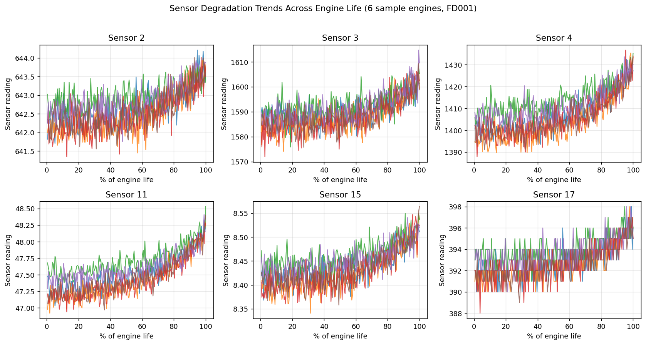
Fig. 2. Sensor degradation trends across engine life (6 sample engines, FD001).
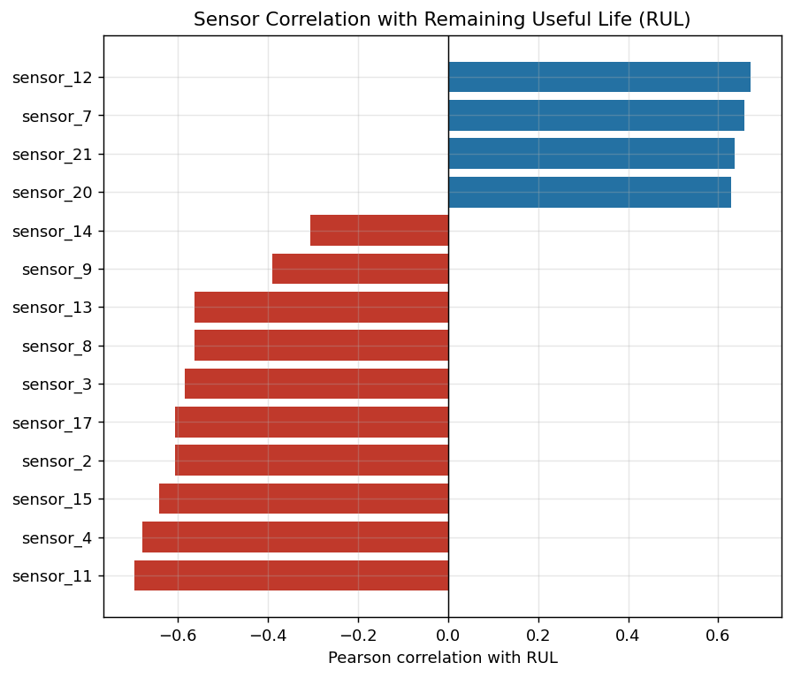
Fig. 3. Sensor correlation with Remaining Useful Life (RUL).
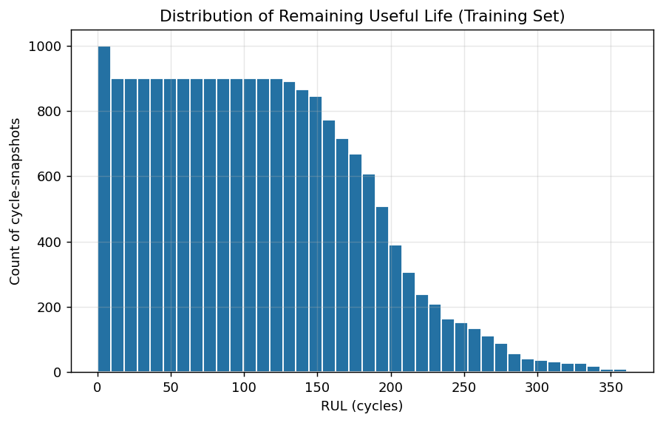
Fig. 4. Distribution of Remaining Useful Life (training set).
TABLE III. RUL PREDICTION MODEL PERFORMANCE
Metric | Value
CV RMSE (train, 5-fold GroupKFold) | 18.03 cycles
Test RMSE | 18.87 cycles
Test MAE | 13.62 cycles
Test R² | 0.794
NASA PHM’08 Score (lower = better) | 1044.1

TABLE III. Test metrics computed on the official FD001 test split (100 engines, last cycle).
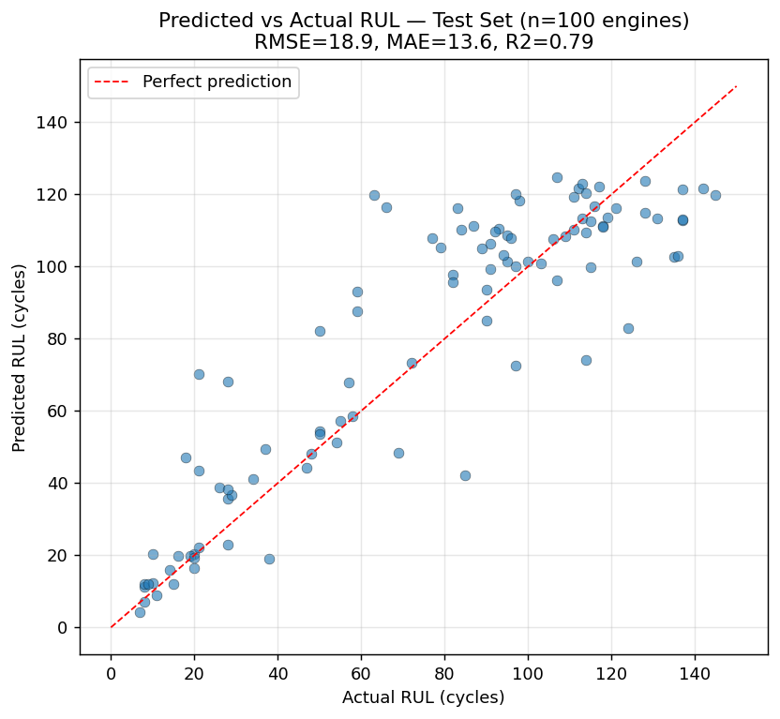
Fig. 5. Predicted vs. actual RUL, test set (n=100 engines).
Table IV and Fig. 6 report aggregated Random Forest feature importance. sensor_4 accounts for 69.6% of total importance — roughly six times the combined weight of the next two sensors — which is why it was selected as the lead signal for the counterfactual replay engine in Section III. This concentration is consistent with turbofan physics: sensor_4 (total temperature at the low-pressure turbine outlet) is a standard proxy for the exhaust-gas-temperature margin used in real engine health monitoring, so a single-sensor triggering rule is not merely a modeling convenience but plausibly reflects how this fault mode actually manifests instrumentally.
TABLE IV. TOP SENSORS BY AGGREGATED FEATURE IMPORTANCE
Sensor | Aggregated Importance
sensor_4 | 0.696
sensor_9 | 0.109
sensor_11 | 0.091
sensor_14 | 0.019
sensor_15 | 0.014
sensor_7 | 0.012
sensor_12 | 0.011
sensor_21 | 0.010

TABLE IV. Importance aggregated across each sensor's raw, rolling-mean, and rolling-std features. sensor_4 = total temperature at low-pressure turbine outlet.
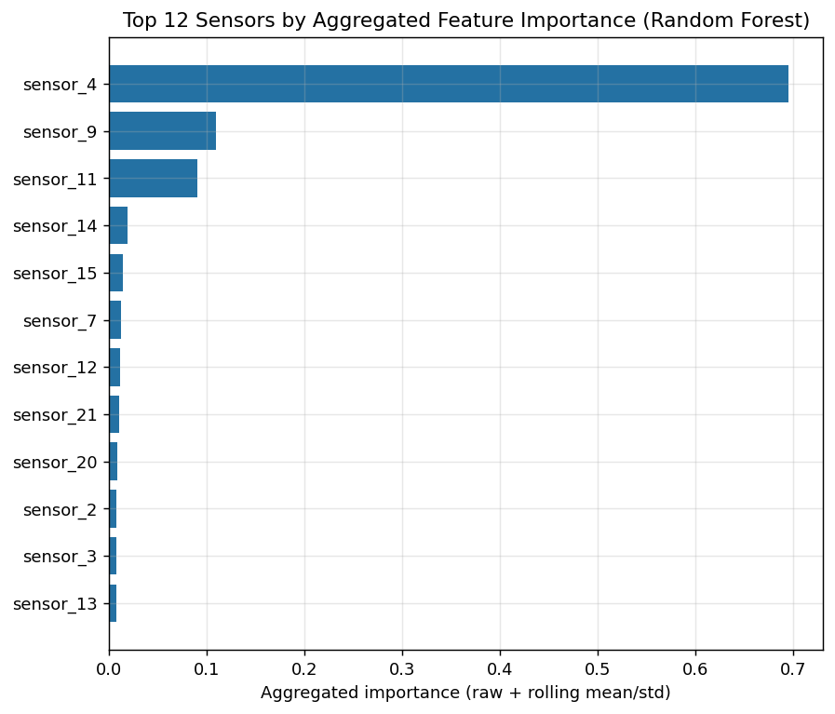
Fig. 6. Top sensors by aggregated Random Forest feature importance.
B. Counterfactual Maintenance-Timing Replay
Fig. 7 shows Algorithm 1 applied to one representative engine (#24) at all three repair timings; each dashed branch diverges from the observed trajectory at its repair point and reaches the original failure level later than the unrepaired engine did. Fig. 8 confirms this pattern holds across the full 100-engine training set: Table V reports a mean simulated life extension of 13.8 cycles for early (50%) repair, rising to 17.5 cycles at mid (70%) repair and 22.8 cycles at late (85%) repair. This ordering is not the naively expected one — intuition might suggest earlier intervention preserves more life — and Section VI.A explains why the observed, back-loaded degradation shape from Fig. 2 produces the opposite result.
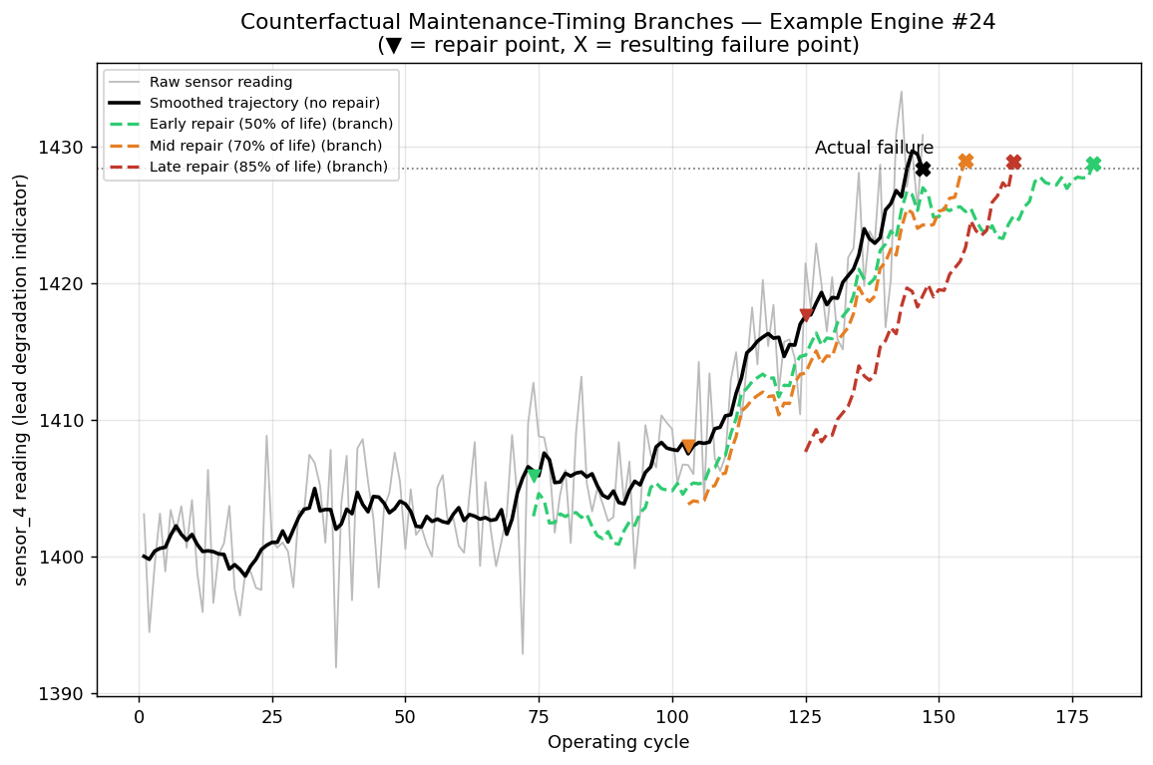
Fig. 7. Counterfactual maintenance-timing branches, example engine #24.
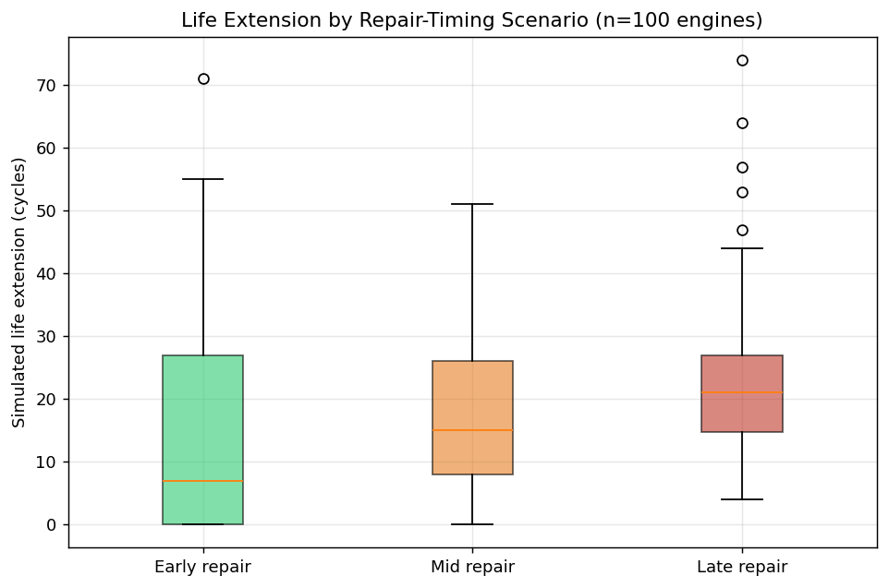
Fig. 8. Life extension by repair-timing scenario (n=100 engines).
TABLE V. COUNTERFACTUAL LIFE-EXTENSION AND NET-BENEFIT SUMMARY, BY SCENARIO (n=100 ENGINES)
Scenario | Mean ΔLife (cyc.) | Mean Net Benefit ($) | % Positive
Early repair (50%) | 13.8 | 44,072 | 100.0
Mid repair (70%) | 17.5 | 44,621 | 100.0
Late repair (85%) | 22.8 | 45,422 | 100.0

TABLE V. ΔLife = simulated life extension vs. no-repair baseline. % Positive = share of the 100 training engines with positive net benefit under the Table VI cost model.
C. Cost-Benefit Analysis
TABLE VI. ILLUSTRATIVE COST MODEL ASSUMPTIONS
Assumption | Value (USD)
Unplanned failure cost | 50,000
Scheduled repair cost | 8,000
Value per extended operating cycle | 150

TABLE VI. Placeholder figures chosen to demonstrate the cost-benefit framework; not sourced from a real maintenance program (Section VI.B).
Table VI lists the illustrative cost-model assumptions; Fig. 9 shows the resulting mean net benefit per engine by repair-timing scenario. Because the fixed differential between an unplanned-failure cost and a scheduled-repair cost ($42,000) dominates the variable, extension-dependent term in this cost model, all three scenarios show large positive net benefit for every one of the 100 engines (Table V), with late repair producing the highest mean benefit ($45,422) by a modest margin over early repair ($44,072). Because net benefit is a strictly increasing linear function of simulated life extension under this cost model, and late repair yields strictly greater mean life extension than early repair for every value of the per-cycle operating value (Table V), late repair's advantage cannot reverse by changing that one parameter in isolation; raising the per-cycle value from $150 toward, for example, $1,000 would widen the gap between scenarios roughly six-fold (from about $1,350 to about $9,000 between early and late repair) rather than close or invert it. A reversal would instead require changing which quantity is held fixed — for example, a cost model where late repair itself carries a higher risk premium because more accumulated damage must be inspected and corrected, a real-world effect this simplified model does not capture.
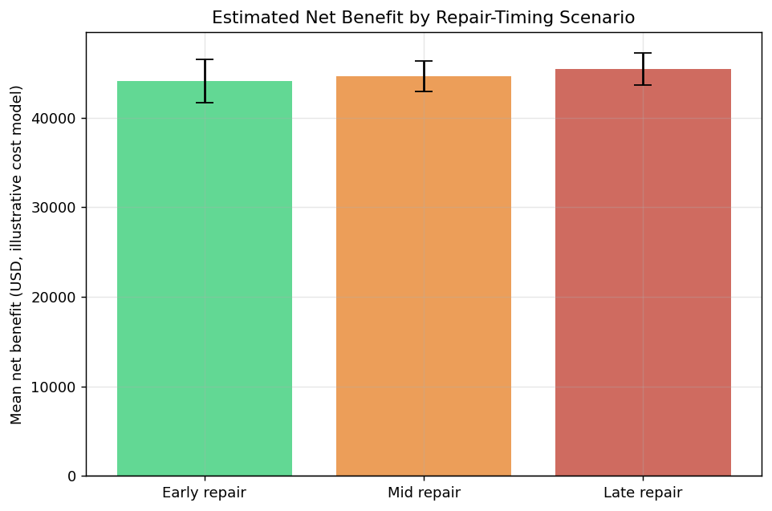
Fig. 9. Estimated net benefit by repair-timing scenario.
VI. DISCUSSION
A. Key Findings and Practical Implications
Four implications follow from these results. First, because degradation on FD001 is back-loaded — nearly flat until roughly 60–70% of life, then sharply accelerating (Fig. 2) — a fixed restoration fraction removes more absolute accumulated damage the later it is applied, so late-but-safe repair timing can mechanically outperform very early intervention on this dataset; a maintenance policy built on the intuition that earlier is always better would be leaving simulated life extension on the table. Second, because sensor_4 alone carries roughly 70% of predictive weight and maps onto a physically meaningful exhaust-temperature margin, a lightweight single-sensor monitoring trigger may be a defensible simplification for early-warning purposes even where a full 14-sensor model is used for the final RUL estimate. Third, because net benefit in Section V.C is dominated by the fixed failure-versus-repair cost gap rather than by the variable life-extension term, the specific repair-timing recommendation is far more sensitive to getting that fixed cost gap right than to precisely tuning the repair-timing scenario itself. Fourth, because Algorithm 1 requires only a smoothed sensor trajectory and no trained surrogate at simulation time, the counterfactual replay engine could plausibly run as a lightweight what-if calculator alongside an existing fleet RUL dashboard without retraining any model — the marginal cost of adding maintenance-timing branches to a deployment that already estimates RUL is small, which is precisely what makes the framework worth adopting incrementally rather than as a wholesale replacement for existing PdM infrastructure.
B. Limitations and Future Work
This study has five main limitations. FD001 covers a single operating condition and a single fault mode; the other three C-MAPSS subsets were not evaluated here and generalization across them is untested — FD002 adds six operating conditions across 260 training engines (128–378 cycles), FD003 adds a second fault mode across 100 engines with a notably longer maximum life (145–525 cycles), and FD004 combines both at once across 249 engines (128–543 cycles), and each would need its own health-index sensor and restoration-fraction calibration rather than reusing FD001's sensor_4-based configuration unchanged. The higher-fidelity N-CMAPSS dataset [3], built under real flight conditions, was not reachable from this paper's execution sandbox, which is restricted to a fixed set of network domains; classic C-MAPSS remains the field's standard benchmark, but N-CMAPSS would be a natural extension. The RUL model is a Random Forest rather than a sequence model such as an LSTM or CNN [5], [6], a choice made for reliable execution on a single-core sandbox rather than a methodological preference; published deep-learning baselines on FD001 report both better and worse NASA scores depending on architecture and tuning, so this paper's baseline should be read as a solid but not state-of-the-art reference point. The counterfactual replay engine uses a single lead sensor as its health index rather than a multivariate composite, and reuses observed future increments cyclically when a restored trajectory outlasts the original horizon — a reasonable heuristic for the repair timings tested here (50–85% of life) but untested for very early repairs, where many replay cycles would be needed. Finally, the $50,000/$8,000/$150 cost figures are illustrative placeholders chosen to demonstrate the framework, not figures sourced from a real maintenance program; Section V.C's specific dollar conclusions should not be read as a general claim about optimal repair timing beyond this demonstration.
C. Threats to Validity
Two threats to validity are worth naming explicitly rather than leaving implicit in Section VI.B. Internally, the grouped cross-validation protocol (Section IV) rules out engine-level data leakage as an explanation for the reported RUL accuracy, but the counterfactual replay results in Section V.B are not cross-validated in the same sense: each engine's life extension is computed from that engine's own trajectory alone, so the reported means are descriptive of these 100 training engines rather than an out-of-sample generalization claim. Externally, every quantitative result in this paper is specific to FD001's single operating condition and single fault mode; the qualitative mechanism identified in Section VI.A — that back-loaded degradation curves make later repair timing mechanically more effective under a fixed restoration fraction — should transfer wherever degradation is similarly back-loaded, but whether FD002–FD004's additional operating conditions and fault modes preserve that same back-loaded shape is an empirical question this paper does not answer.
VII. CONCLUSION
This paper presented RepairBranch, a framework coupling a cross-validated Random Forest RUL model with a mechanistic counterfactual maintenance-timing replay engine, evaluated end-to-end on the NASA C-MAPSS FD001 benchmark. Across the four research questions: RUL is predicted with a test RMSE of 18.9 cycles and R² of 0.794, confirmed by grouped cross-validation; a single sensor with a plausible physical interpretation accounts for roughly 70% of predictive importance; simulated life extension increases with later repair timing because FD001's degradation curves are back-loaded rather than linear; and net benefit under an illustrative cost model is dominated by the fixed failure-versus-repair cost gap rather than by the repair-timing choice itself. These findings indicate that disciplined, mechanistic counterfactual replay — re-simulating an asset's own observed degradation rather than a trained approximation of it — is a practical route to maintenance-timing decision support that point-prediction RUL systems do not by themselves provide, with the limitations in Section VI.B marking where multi-condition validation and fleet-specific cost data are needed before operational use.
Data and Code Availability
The FD001 dataset is publicly available from NASA's Prognostics Data Repository [1], [2]. The RUL regressor, counterfactual replay engine, and cost-benefit scripts described in this paper are implemented in Python (scikit-learn, NumPy, pandas, and Matplotlib) and are available from the corresponding author upon reasonable request.
REFERENCES
[1] A. Saxena, K. Goebel, D. Simon, and N. Eklund, “Damage propagation modeling for aircraft engine run-to-failure simulation,” in Proc. Int. Conf. Prognostics and Health Management (PHM), Denver, CO, USA, Oct. 2008. doi: 10.1109/PHM.2008.4711414.
[2] D. K. Frederick, J. A. DeCastro, and J. S. Litt, “User’s Guide for the Commercial Modular Aero-Propulsion System Simulation (C-MAPSS),” NASA/TM—2007-215026, NASA Glenn Research Center, 2007.
[3] M. Arias Chao, C. Kulkarni, K. Goebel, and O. Fink, “Aircraft engine run-to-failure dataset under real flight conditions for prognostics and diagnostics,” Data, vol. 6, no. 1, art. 5, Jan. 2021. doi: 10.3390/data6010005.
[4] F. O. Heimes, “Recurrent neural networks for remaining useful life estimation,” in Proc. Int. Conf. Prognostics and Health Management (PHM), Denver, CO, USA, Oct. 2008.
[5] X. Li, Q. Ding, and J.-Q. Sun, “Remaining useful life estimation in prognostics using deep convolution neural networks,” Reliab. Eng. Syst. Saf., vol. 172, pp. 1–11, 2018. doi: 10.1016/j.ress.2017.11.021.
[6] S. Zheng, K. Ristovski, A. Farahat, and C. Gupta, “Long short-term memory network for remaining useful life estimation,” in Proc. IEEE Int. Conf. Prognostics and Health Management (ICPHM), Dallas, TX, USA, 2017, pp. 88–95.
[7] G. A. Susto, A. Schirru, S. Pampuri, S. McLoone, and A. Beghi, “Machine learning for predictive maintenance: A multiple classifier approach,” IEEE Trans. Ind. Informat., vol. 11, no. 3, pp. 812–820, 2015.
[8] J. Z. Sikorska, M. Hodkiewicz, and L. Ma, “Prognostic modelling options for remaining useful life estimation by industry,” Mech. Syst. Signal Process., vol. 25, no. 5, pp. 1803–1836, 2011.
[9] E. Zio, “Prognostics and health management (PHM): Where are we and where do we (need to) go in theory and practice,” Reliab. Eng. Syst. Saf., vol. 218, art. 108119, 2022.
[10] T. P. Carvalho, F. A. A. M. N. Soares, R. Vita, R. P. Francisco, J. P. Basto, and S. G. Alcalá, “A systematic literature review of machine learning methods applied to predictive maintenance,” Comput. Ind. Eng., vol. 137, art. 106024, 2019.
[11] S. Wachter, B. Mittelstadt, and C. Russell, “Counterfactual explanations without opening the black box: Automated decisions and the GDPR,” Harv. J. Law Technol., vol. 31, no. 2, pp. 841–887, 2018.
[12] R. K. Mothilal, A. Sharma, and C. Tan, “Explaining machine learning classifiers through diverse counterfactual explanations,” in Proc. ACM Conf. Fairness, Accountability, and Transparency (FAT*), Barcelona, Spain, 2020, pp. 607–617.
[13] L. Breiman, “Random forests,” Mach. Learn., vol. 45, no. 1, pp. 5–32, Oct. 2001. doi: 10.1023/A:1010933404324.
[14] J. H. Friedman, “Greedy function approximation: A gradient boosting machine,” Ann. Statist., vol. 29, no. 5, pp. 1189–1232, 2001.
[15] F. Pedregosa et al., “Scikit-learn: Machine learning in Python,” J. Mach. Learn. Res., vol. 12, pp. 2825–2830, 2011.

