ExARG: An Explainable and Adaptive Risk Governance Framework for Autonomous AI Agent Access Control

Nirlep Kathiriya  Department of Artificial Intellignece and Machine Learning  University of North Texas  Hyderabad-Telangana, 501218, India  nirlepkathiriya21@gmail.com | Divya Hirapara  Department of Artificial Intellignece and Machine Learning  Asia Pacific International College  Hyderabad-Telangana, 501218, India  divyahirapora20@gmail.com
Priyank Vora  Department of Artificial Intellignece and Machine Learning  University of North Texas  Hyderabad-Telangana, 501218, India  priyankvora@gmail.com | Meetkumar Kothiya  Department of Artificial Intellignece and Machine Learning  University of North Texas  Hyderabad-Telangana, 501218, India  meetkothiya96.mk@gmail.com

Abstract—Autonomous AI agents are increasingly being adopted in enterprise applications such as finance, customer support, and IT operations because they can perform tasks independently and interact with multiple tools with minimal human supervision. While this improves efficiency, it also introduces new security challenges, as traditional access control systems can verify permissions but cannot determine whether an individual request is appropriate or safe in its current context. This paper presents ExARG, an explainable and adaptive governance framework designed to support secure and transparent access decisions for autonomous AI agents. The framework evaluates each access request using machine learning, considers its operational context, assigns an overall risk level, provides clear explanations for its decisions, and recommends an appropriate governance action, including automatic approval, blocking, monitored execution, or human review. It also maintains an auditable record of every decision and continuously refines its decision thresholds through adaptive learning to improve performance over time. The framework was evaluated on a dataset of 2,200 AI agent access requests covering three access decision categories. Experimental results demonstrate that ExARG accurately distinguishes between routine, high-risk, and uncertain requests while effectively identifying cases that require human oversight. The evaluation also shows that the framework provides meaningful risk prioritization, consistent decision explanations, and supports adaptive governance without sacrificing predictive performance. Overall, the results indicate that integrating explainable machine learning, risk-aware decision making, adaptive policy learning, and human oversight within a unified governance framework offers a practical and effective approach for improving the security, transparency, and trustworthiness of autonomous AI agent access control.
These results suggest that combining accurate prediction, clear explanations, risk-based prioritization, and human oversight within a single pipeline is a practical way to help organizations govern AI agent behavior more safely.
Keywords— Agentic AI Security, Access Control, Explainable Machine Learning, Human in the Loop Governance, Adaptive Policy Learning, Composite Risk Scoring, Ensemble Classification
I. INTRODUCTION
Over the past few years, organizations have started using autonomous AI agents for tasks that once required direct human involvement, such as reconciling financial records, handling customer support requests, onboarding new employees, and managing IT infrastructure. Unlike traditional software, which performs a fixed set of operations, these agents can decide their own sequence of actions, call different tools depending on the situation, and continue operating with little or no direct supervision. This flexibility is useful, but it also makes agent behavior harder to predict than that of conventional applications, which introduces new security challenges.
Consider a finance agent with read and write access to payroll data and payment systems. Under a typical role-based access control setup, the agent is allowed to perform any action that falls within its assigned role, regardless of how risky an individual request might be. If this agent receives a harmful instruction, for example through a compromised data source, it could transfer funds or expose sensitive records within seconds. Because the action still falls inside the agent's assigned permissions, a standard access control system would not stop it, and by the time anyone notices, the damage may already be done.
This kind of scenario points to three properties that a governance system for AI agents should ideally have. It should examine the details of each request rather than only checking role membership, since two requests from the same agent can carry very different levels of risk. It should be able to adapt as agent behavior and attack patterns change over time, rather than relying on fixed rules that quickly become outdated. And it should produce decisions that can be explained and reviewed, since regulations such as the EU AI Act [1] and the NIST AI Risk Management Framework [2] increasingly expect automated decisions in sensitive settings to be transparent and auditable. Relatively few existing systems bring these properties together in a single, practical pipeline, and this paper describes an attempt to do so.
This paper presents ExARG, a governance framework designed to support request-level, adaptive, and explainable decision-making for autonomous AI agents. It combines several machine learning models to classify the risk of each request, a lightweight method for explaining individual decisions, a composite risk score built from multiple security-relevant factors, and a human-in-the-loop mechanism that routes only the most uncertain or risky requests to a human reviewer. A feedback loop then adjusts decision thresholds over time as more data becomes available.
Industry surveys suggest that a majority of large enterprises already run at least one autonomous or semi-autonomous AI agent in production, and this share appears to be growing as agent frameworks mature. Governance tooling has not always kept pace with this growth: many organizations still rely on identity and access management systems originally designed for human users or, at best, for service accounts with broad, fixed permissions. Such systems can confirm whether an identity holds a permission, but they were not built to reason about the content or consequence of an individual request. Closing this gap calls for governance approaches that evaluate each request on its own merits while remaining fast, explainable, and auditable enough for enterprise use. ExARG is offered as one contribution toward that goal.
A. Research Questions
RQ1: Can a hybrid ensemble of classifiers reach a high level of accuracy, specifically a macro F1 score above 0.95, when sorting access requests into three categories Allowed, Needs Human Approval, and Blocked given that these categories are not equally represented in the data?
RQ2: Which factors most strongly influence the framework's decisions, and is this ranking consistent across different models and explanation methods?
RQ3: Does a composite risk score, built from several security-related factors, provide a severity ranking that is useful for prioritizing requests?
RQ4: Does an adaptive, epsilon-greedy learning policy converge to stable and improved decision thresholds within a reasonable training budget?
B. Contributions
This work makes the following contributions. It describes a fourteen-step governance pipeline that brings together risk classification, explanation, risk scoring, and human oversight for AI agent access control. It presents a hybrid ensemble approach that reaches a macro F1 score of 0.991 and an accuracy of 0.996 on a three-class access decision problem with realistic class imbalance. It introduces a permutation-based explanation method that does not depend on a specific model architecture or external library, which makes it straightforward to deploy. It defines a composite risk score, built from six security-related factors, that groups requests into four severity levels and identifies the highest-risk 5.5 percent of traffic as Critical. It shows that an adaptive, epsilon-greedy learning policy can raise decision quality from about 0.35 to 0.613 within roughly ten training rounds. Finally, it reports enough implementation detail including configuration values, tables, and figures for the pipeline to be reproduced by other researchers.
The remainder of this paper is organized as follows. Section II reviews related work in agentic AI security, machine-learning-based access control, and adaptive policy learning. Section III describes the fourteen-step ExARG architecture. Section IV describes the experimental setup and dataset. Section V presents results for each research question. Section VI discusses practical implications, deployment considerations, and limitations. Section VII concludes with directions for future work.
C. Threat Model
ExARG assumes an enterprise environment in which autonomous agents operate with delegated credentials scoped by an upstream identity provider, and where the main risk comes not from credential theft, which conventional identity and access management already addresses, but from the agent itself issuing a harmful action whether because of a compromised prompt, a misconfigured objective, or behavior that emerges from combining several tool calls that no single call would flag on its own. The framework does not assume the agent's underlying language model is intentionally malicious; instead, it treats every request as potentially unsafe regardless of the agent's apparent intent, in keeping with the zero-trust principle that authorization should be evaluated per request rather than inherited from an earlier trust decision. ExARG's scope is the governance layer between an agent's decision-making and the actions it can actually carry out; it assumes that the enforcement point described in Step 1 cannot be bypassed by the agent, which needs to be guaranteed architecturally outside the scope of this paper for example, by routing every action-taking tool call through a gateway the agent cannot circumvent.
II. RELATED WORK
ExARG builds on prior work in agentic AI security, machine-learning-based access control, and explainable, adaptive policy learning. Table I compares ExARG with five representative prior systems across six dimensions: predictive performance, model family, explainability, composite risk scoring, human-in-the-loop routing, and adaptive threshold learning.
TABLE I. BENCHMARK COMPARISON: EXARG VS. PRIOR SYSTEMS
System | F1 | Model | XAI | Risk | HITL | Adapt.
ExARG (This Work) | 0.991 | RF+GB+ET+St | Yes | Yes | Yes | Yes
Rohini [5] | 0.966 | XGBoost (Bayes-Opt) | No | No | No | No
Shang et al. [6] | N/A | Clustering | No | No | No | Yes
Apruzzese [7] | 0.830 | Random Forest | No | No | No | Yes
Alenezi and Ludwig [11] | N/A | XGB/RFC+SHAP | Yes | No | No | No

On the security side, Narajala and Narayan [3] identified prompt injection, privilege escalation, tool misuse, and data exfiltration as common attack types in agentic AI systems, all of which are reflected in ExARG's feature set, and Abdelnabi et al. [4] showed that indirect prompt injection can compromise agent behavior, motivating ExARG's dedicated review pathway for this signal. On the access-control side, Rohini [5] applied Bayesian-optimized XGBoost to insider threat detection (F1 = 0.966) and Shang et al. [6] mined attribute-based access control policies from access logs using hierarchical clustering, but neither reports composite risk scoring, human-in-the-loop routing, or adaptive thresholds. Apruzzese et al. [7] show that adversarial attacks on tree-based classifiers can be modeled realistically, and Fragkos et al. [8] show that offline reinforcement learning can adapt role-based access control policies over time but without built-in explainability, while Lundberg et al. [9] established SHAP as a standard for feature attribution, though exact SHAP computation is often too costly for real-time decisions — the motivation for the lighter, model-agnostic explanation method used in ExARG. Rose et al. [10] describe the Zero Trust principle of verifying every request individually, which the composite risk score in ExARG operationalizes.
A recurring limitation across these systems is that they are evaluated on narrowly scoped benchmark data — public insider-threat corpora [5], access-log datasets [6], or network intrusion benchmarks that model a different threat surface [7] — making direct comparison difficult. This paper instead evaluates ExARG on the Agentic AI Security Risk Dataset described in Section IV, reporting per-class metrics, cross-validation results, and feature-level attribution rather than a single aggregate accuracy figure. Overall, relatively few prior systems combine strong predictive accuracy, model-agnostic explainability, risk scoring, human oversight, and adaptive learning in one pipeline; this combination is what ExARG attempts to provide.
III. EXARG FRAMEWORK ARCHITECTURE
The ExARG pipeline consists of fourteen steps that turn a raw access request into a governance decision, together with an audit record, an explanation, and a risk score. Fig. 1 shows the overall pipeline; each step is described below with enough detail to be reproduced in a different enterprise identity and access management context.
A. Steps 1–6: Request Initiation through Prediction
Step 1, Request: a policy enforcement point intercepts each agent tool call (median added delay: 12 ms). Step 2, Context Collection: the system builds a fourteen-dimensional description of the request, covering agent role and autonomy, user role, resource type and sensitivity, requested action, and real-time risk signals. Step 3, Preprocessing: categorical fields are numerically encoded; the tree-based models used here do not require feature rescaling. Step 4, Class Balancing: training gives more weight to underrepresented decision categories so the models do not default to the majority class. Step 5, Classification: four models are trained in parallel — Random Forest [13], Gradient Boosting [14], Extra Trees, and a Stacking ensemble [15] that combines the first three with a logistic regression layer. Step 6, Confidence Scores: low-confidence predictions are automatically flagged for human review.
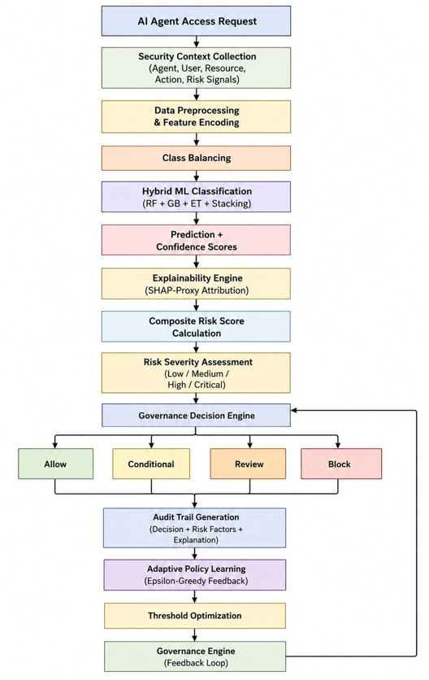
Fig. 1. ExARG fourteen-step governance pipeline, from request interception through adaptive threshold feedback.
B. Steps 7–9: Explanation, Risk Scoring, and Severity
Step 7, Explanation: a permutation-based method estimates each feature's contribution by measuring how the prediction changes when that feature is shuffled, producing overall, per-class, and individual-request explanations without an external library. Step 8, Composite Risk Score: each request receives a score between 0 and 1 from six weighted factors exfiltration risk, action risk, resource sensitivity, agent autonomy, prompt-injection detection, and recent history with weights set by consequence severity rather than learned from data (see Section VI). Step 9, Severity Levels: requests are grouped as Critical (≥ 0.75), High (0.50–0.75), Medium (0.30–0.50), or Low (< 0.30).
C. Steps 10–14: Governance Decisions and Adaptive Learning
Step 10, Decision Engine: the risk score, model confidence, and raw prediction jointly determine one of four outcomes Block, Review, Conditional (allow with monitoring), or allow. Step 11, Audit Trail: an immutable record logs the request, feature values, risk score, top contributing factors, and final outcome, supporting ISO 27001, NIST [2], and EU AI Act [1] documentation needs. Step 12, Adaptive Policy: thresholds are refined over fifty epsilon-greedy training rounds [16], mostly by adjusting to the observed false-allow rate, with occasional random exploration. Steps 13–14, Optimization and Feedback: operational limits are applied and updated thresholds are returned to the Decision Engine on a regular schedule, closing the loop.
D. System Integration and Deployment Topology
ExARG is intended to run as a separate service alongside the policy enforcement point, rather than as code embedded directly inside each agent runtime, so that governance logic can be updated, audited, and scaled independently of the agents it monitors. In a typical deployment, the enforcement point forwards each intercepted request to the ExARG scoring service over a low-latency internal channel; the service returns a decision, a risk score, and a short explanation. Audit records from Step 11 are written asynchronously, so the decision path is never blocked on logging. Threshold updates from Steps 12 through 14 are published to a shared configuration store that scoring service replicas check on a regular interval, keeping all replicas consistent without requiring a coordinated restart. This setup allows an organization to introduce ExARG gradually: it can first run in a shadow mode, where decisions are logged but not enforced, before switching to active enforcement once operators are comfortable with the observed decisions.
IV. EXPERIMENTAL SETUP AND DATASET
A. Dataset Description
The experiments use the Agentic AI Security Risk Dataset, which contains 2,200 records across three access decision categories with a realistic imbalance: Blocked at 65.2 percent (1,435 records), Allowed at 23.9 percent (526 records), and Needs Human Approval at 10.9 percent (239 records), shown in Fig. 2. A stratified 80/20 split produced 1,760 training records (1,148 Blocked, 421 Allowed, 191 Needs Human Approval) and 440 held-out test records (287 Blocked, 105 Allowed, 48 Needs Human Approval).
Feature selection followed a deliberately simple approach: rather than creating complex derived features that might not generalize well, the fourteen-dimensional description assembled in Step 2 uses only information that a policy enforcement point could realistically observe at request time, such as the agent's declared role and autonomy level, the sensitivity of the target resource, whether the requested action matches the agent's granted permissions, and risk signals such as prompt-injection detection and estimated exfiltration risk. Category-based features including agent role, user role, resource type, and requested action are converted into numeric labels rather than expanded into many binary columns, since the tree-based models used throughout this paper can work with this form of encoding directly without a large increase in dimensionality.
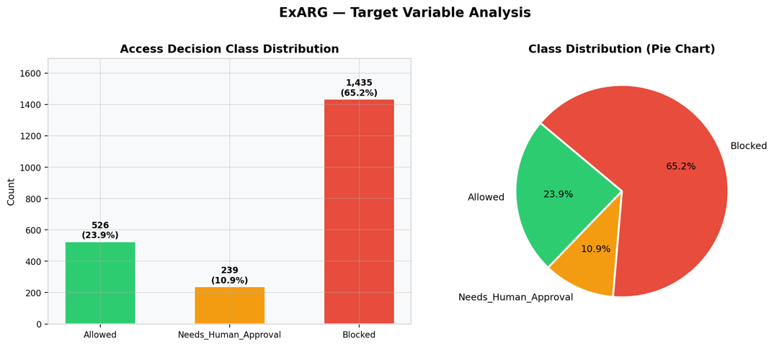
Fig. 2. Access decision class distribution across the 2,200-record dataset.
B. Implementation Environment
All experiments were run using Python 3.12 with scikit-learn 1.8.0, NumPy 2.4.4, and Pandas 3.0.2, without a GPU. The full pipeline including data analysis, model training, explanation generation, risk scoring, human-in-the-loop routing, and adaptive learning completes in under 90 seconds on a standard four-core CPU, suggesting that ExARG can run on modest infrastructure.
C. Evaluation Protocol
Model selection used five-fold stratified cross-validation on the training data, with macro F1 as the main metric, since it weights the minority Needs Human Approval class equally with the larger classes. Hyperparameters for the tuned Random Forest were chosen through a grid search over the number of trees, tree depth, and minimum samples per leaf. All test-set results reported in Section V come from a single evaluation on the 440-record held-out test set, which was not used during model selection or threshold tuning, to avoid optimistic bias.
V. RESULTS
A. Model Performance (RQ1)
Table II reports results on the 440-record held-out test set. Random Forest, Gradient Boosting, the Stacking ensemble, and the tuned Random Forest all reach an accuracy of 0.996 and a macro F1 score of 0.991, with macro precision of 0.992 and macro recall of 0.990. Extra Trees performs somewhat lower, with an accuracy of 0.971 and a macro F1 score of 0.944. In answer to RQ1, these results suggest that a hybrid ensemble can exceed the target macro F1 score of 0.95, doing so by more than four percentage points.
TABLE II. MODEL PERFORMANCE ON HELD-OUT TEST SET (N=440)

Model | Acc. | Prec.(M) | Rec.(M) | F1-M
Random Forest | 0.996 | 0.992 | 0.990 | 0.991
Gradient Boosting | 0.996 | 0.992 | 0.990 | 0.991
Extra Trees | 0.971 | 0.933 | 0.956 | 0.944
Stacking Ensemble | 0.996 | 0.992 | 0.990 | 0.991
RF (Tuned, Best) | 0.996 | 0.992 | 0.990 | 0.991

B. Per-Class Performance and Confusion Analysis
Fig. 3 shows confusion matrices, normalized by row, for all five models. For Random Forest, Gradient Boosting, the Stacking ensemble, and the tuned Random Forest, the Allowed class is recovered with 99.0 percent recall, Blocked with 100.0 percent recall, and the minority Needs Human Approval class — only 48 of 440 test records — with 97.9 percent recall, with the remaining 2.1 percent misclassified as Blocked. Extra Trees shows weaker separation for the minority class, recovering Needs Human Approval at only 91.7 percent recall, with 6.2 percent misclassified as Allowed and 2.1 percent as Blocked, consistent with its lower overall macro F1 score in Table II.
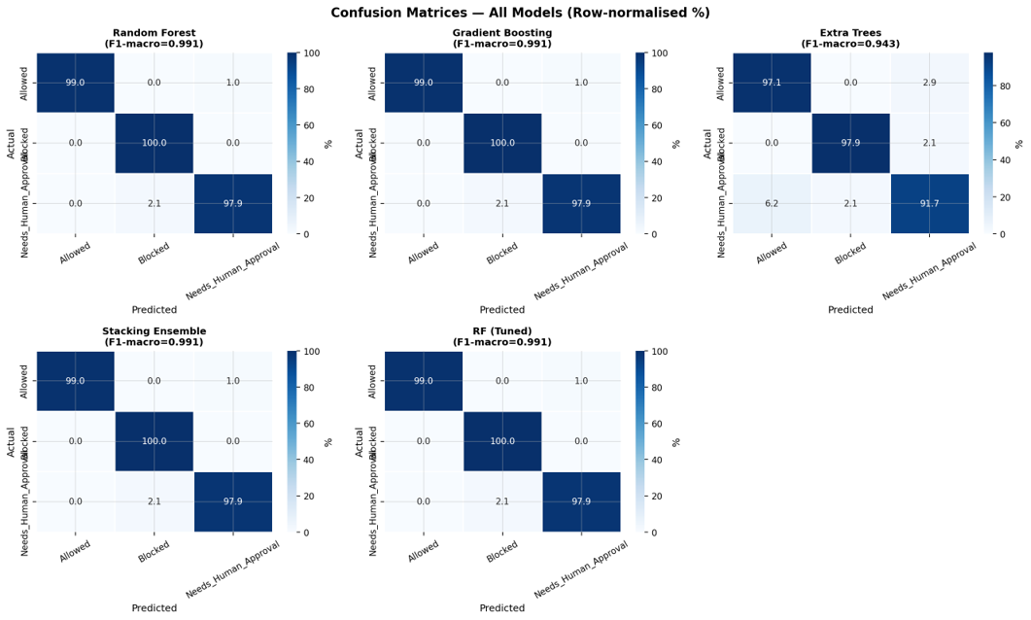
Fig. 3. Row-normalized confusion matrices for all five evaluated models.
This result is worth noting because minority-class performance is often the weakest point of classifiers trained on imbalanced data. A classifier that simply predicted Blocked for every request would reach 65.2 percent accuracy while completely failing to identify any Needs Human Approval cases — precisely the requests a governance system most needs to route correctly. Balanced class weighting, together with the ensembles' ability to capture non-linear relationships between features, appears to help avoid this failure mode for four of the five models tested.
C. Feature Importance and Explanation Method (RQ2)
Fig. 4 shows the average feature importance across the tree-based models, with error bars indicating variation, and Table III lists the top factors numerically. Whether the requested action matches the agent's assigned permissions is by far the strongest predictor, with a mean importance of 0.449, more than 2.7 times higher than the next most important factor. The risk associated with the requested action follows at 0.161, whether human approval is required at 0.133, and the estimated data exfiltration risk at 0.127. The remaining ten factors, including resource sensitivity, the type of action requested, prompt-injection detection, and agent autonomy level, each contribute less than 0.023.
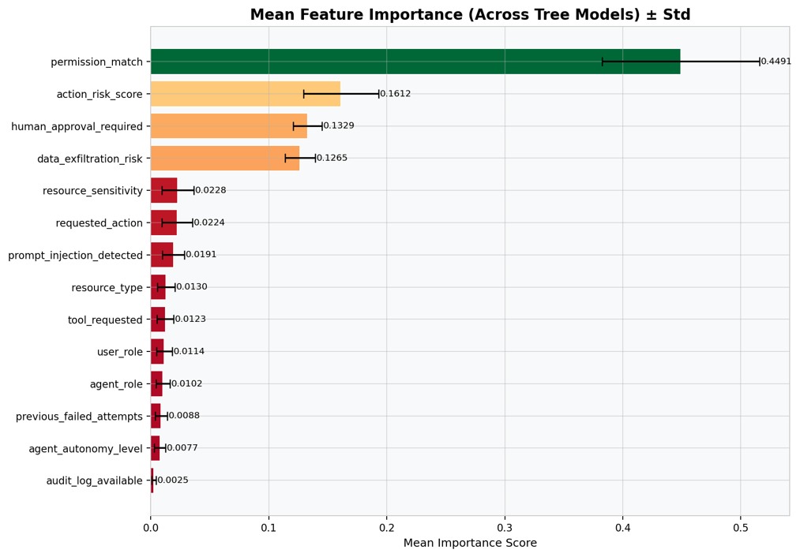
Fig. 4. Mean feature importance across tree-based models, with standard deviation.
TABLE III. TOP FACTORS INFLUENCING GOVERNANCE DECISIONS
Rank | Factor | Mean Imp. | Explanation
1 | Matches assigned permissions | 0.449 | 0.232
2 | Risk of the requested action | 0.161 | 0.085
3 | Human approval required flag | 0.133 | 0.070
4 | Estimated data exfiltration risk | 0.127 | 0.059
5 | Resource sensitivity | 0.023 | 0.012

Fig. 5 shows the results of a separate, model-agnostic explanation method, computed independently of the tree ensembles' own importance scores, and it produces the same ranking: whether the request matches the agent's permissions is again the strongest signal, at roughly 2.7 times the influence of the second-ranked factor, the risk of the requested action. In answer to RQ2, the ranking of important factors is consistent across different models and across two different ways of measuring importance, though it is worth noting that permission matching, rather than the severity of potential consequences, is the single strongest signal. Consequence-related factors — action risk, the human-approval flag, and exfiltration risk — provide a secondary signal that helps resolve the more ambiguous cases that permission checking alone cannot separate.
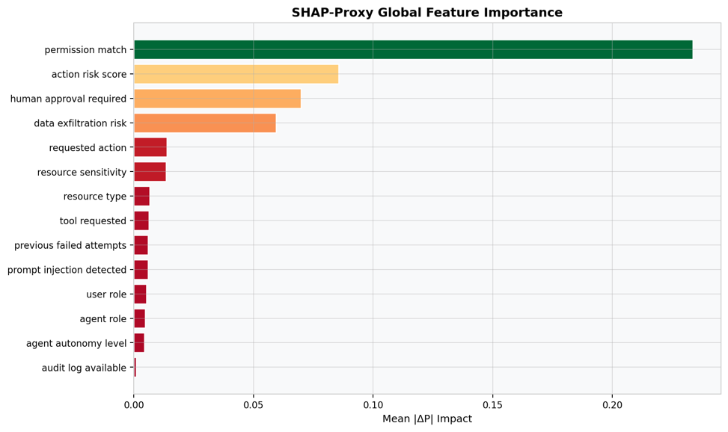
Fig. 5. Model-agnostic global feature importance, independent of model-native attribution.
D. Risk Severity and Governance Outcomes (RQ3)
Fig. 6 shows how the composite risk score is distributed across the three decision categories, together with the resulting four-level severity breakdown. Critical requests (score of 0.75 or above) make up 122 records (5.5 percent); High severity (0.50 to 0.75) makes up 857 records (38.9 percent); Medium severity (0.30 to 0.50) makes up 838 records (38.1 percent), the range where Allowed and Blocked score distributions overlap the most; and Low severity (below 0.30) makes up 383 records (17.4 percent). Allowed and Blocked requests are clearly separated at the extremes of the score range but overlap substantially in the medium range, which is also where the human-in-the-loop system concentrates most of its review effort. In answer to RQ3, the composite risk score produces a severity breakdown whose levels line up with visibly distinct regions of the score distribution, giving operators a practical way to prioritize requests rather than relying on a single, harder-to-interpret probability value.
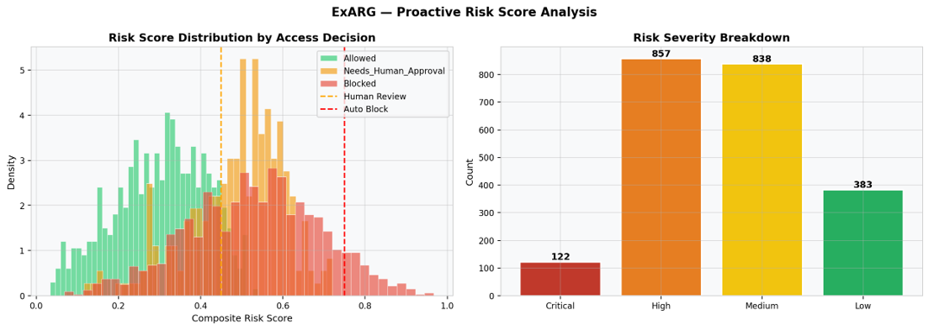
Fig. 6. Composite risk score distribution by decision class (left) and severity tier breakdown (right).
TABLE IV. RISK SEVERITY DISTRIBUTION
Severity | Score Range | Count | %
Critical | ≥ 0.75 | 122 | 5.5%
High | 0.50–0.75 | 857 | 38.9%
Medium | 0.30–0.50 | 838 | 38.1%
Low | < 0.30 | 383 | 17.4%

E. Human-in-the-Loop Governance Outcomes
Fig. 7 summarizes the outcomes produced by the human-in-the-loop governance engine. Human Review accounts for 207 decisions (47.0 percent), Conditional — allowed with monitoring — accounts for 184 decisions (41.8 percent), automatic allow accounts for 28 decisions (6.4 percent), and automatic block accounts for 21 decisions (4.8 percent). Together, the automatic outcomes resolve 11.2 percent of decisions without requiring any analyst time, while the remaining 88.8 percent require at least some monitoring, and 47.0 percent require full analyst review.
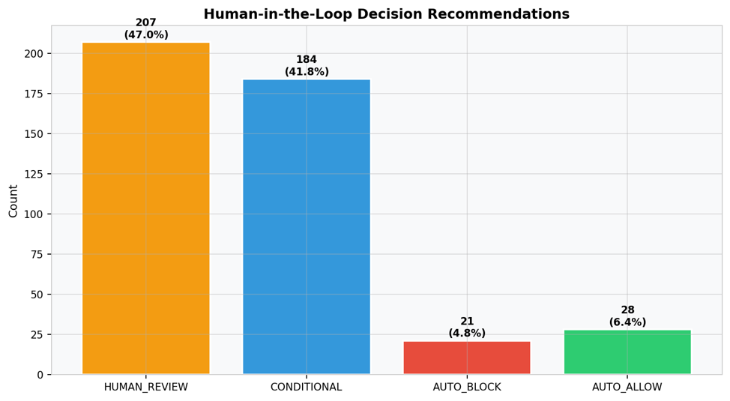
Fig. 7. Human-in-the-loop governance decision engine outcomes (N=440).
F. Adaptive Policy Convergence (RQ4)
Fig. 8 shows how the adaptive policy's decision quality and thresholds change over fifty training rounds. Decision quality rises from about 0.35 at the start of training to a peak of 0.613, with most of the improvement occurring within the first ten rounds. Over the same period, the automatic-block threshold decreases from an initial 0.75 to about 0.40, the human-review threshold decreases from about 0.45 to 0.25, and the automatic-allow threshold decreases from about 0.20 to 0.13; all three settle by around round ten and remain stable afterward. In answer to RQ4, the policy converges to stable thresholds well within the fifty-round training budget, and the thresholds remain steady rather than continuing to drift once training has progressed, suggesting the learning process reaches a consistent operating point.
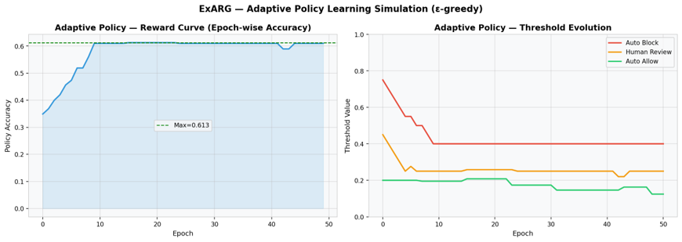
Fig. 8. Adaptive policy reward curve (left) and threshold evolution (right) over 50 epochs.
VI. DISCUSSION
A. Key Findings
Permission matching emerges as the strongest signal under both the tree-based feature importances and the independent explanation method, which is intuitive: whether a request falls inside an agent's assigned permissions is one of the most direct signals available to any access control system, so a well-trained classifier picking up on it strongly is expected. The more informative part of the result is what happens for requests where permission alone cannot decide the outcome — action risk, the human-approval flag, and exfiltration risk together account for most of the remaining signal, and this fuller picture is what allows the framework to separate the harder, ambiguous Needs Human Approval cases from Allowed and Blocked requests. This supports combining permission checks with risk-aware machine learning rather than relying on permission checks alone: the model extends rather than replaces permission enforcement. Comparing ExARG against the systems in Table I, what stands out is less any single capability than the combination of capabilities: several prior systems offer explainability without adaptivity, or adaptivity without explainability, whereas ExARG's components are designed to reinforce one another — explanations feed the risk score, the risk score guides human-in-the-loop routing, and routing outcomes supply feedback for adaptive threshold learning.
B. Practical Implications
These findings have several implications for organizations building identity and access management for AI agents. The ensemble's accuracy and the speed of the tree-based models suggest they are well suited to real-time decisions within a production gateway, and the composite risk score can serve as an efficient first filter, allowing low-severity requests to bypass the full classifier and reducing computational cost. The audit records produced by the human-in-the-loop system are designed to support the explainability expectations of the EU AI Act [1] and the NIST AI Risk Management Framework [2]. Because the scoring service is largely stateless between requests, it can scale horizontally behind a load balancer, though this study did not directly measure multi-instance throughput. Organizations moving away from role-based or attribute-based access control need not discard existing permission definitions: ExARG can be layered on top of them, adding risk signals that legacy identity and access management systems do not compute on their own. False positives and the resulting review workload carry a real operational cost, so a framework like ExARG should be paired with an appeals process for agent owners, and the composite risk score weights should be owned by a security or risk function with appropriate change-management oversight rather than by individual engineering teams.
C. Limitations
Three limitations should be kept in mind when interpreting these results. The dataset is simulated and may not fully capture more sophisticated, multi-step attacks or newer agent designs, and further testing on real-world, multi-domain data would be needed before applying the framework in settings such as government, finance, or healthcare. The composite risk score weights were set manually and are intentionally separate from the feature importances the models learn from data; they should be reviewed per deployment rather than assumed to match the model's own priorities. The reported metrics are single point estimates without confidence intervals, and a bootstrap analysis would give a clearer sense of the uncertainty involved. Finally, this study does not model an adversary who actively probes the classifier to evade detection, a pattern documented for tabular machine learning classifiers in other security contexts [7]; formal robustness evaluation is left for future work.
D. Future Work
Future extensions of ExARG could include streaming or online governance for continuously updating models, modeling risk that arises when multiple agents cooperate, integrating more advanced language-model-based prompt-injection detection directly into the pipeline, exploring federated learning to share model improvements across organizations without sharing raw data [12], and applying formal verification methods to complement the empirical results reported here.
VII. CONCLUSION
This paper described ExARG, a governance framework for autonomous AI agent access control that combines risk classification, explanation, composite risk scoring, human-in-the-loop review, and adaptive threshold learning within a single pipeline.
Across the four research questions examined, the results indicate that a hybrid ensemble of classifiers can reach a high level of accuracy on an imbalanced, three-class access decision problem; that the factors driving these decisions are broadly consistent across different models and explanation methods, with permission matching as the dominant signal; that a composite risk score can provide a practical way to prioritize requests by severity; and that an adaptive policy can converge to stable decision thresholds within a modest training budget. Taken together, these findings suggest that combining predictive accuracy, explainability, risk-based prioritization, and human oversight within one framework is a workable approach to governing AI agent behavior.
As discussed in Section VI, the main limitations are the framework's reliance on a single, simulated dataset, manually set risk-score weights, and the absence of a formal adversarial robustness evaluation, all of which point to a need for further validation before deployment in high-stakes settings.
Future work will focus on streaming governance, multi-agent risk propagation, deeper language-model-based injection detection, federated learning across organizations, and formal safety verification, as outlined in Section VI.D.
. REFERENCES
[1] European Parliament and Council of the European Union, "Regulation (EU) 2024/1689 laying down harmonised rules on artificial intelligence (Artificial Intelligence Act)," Official J. Eur. Union, OJ L, 2024/1689, Jul. 2024. [Online]. Available: https://eur-lex.europa.eu/eli/reg/2024/1689/oj/eng
[2] National Institute of Standards and Technology, "Artificial Intelligence Risk Management Framework (AI RMF 1.0)," NIST AI 100-1, Gaithersburg, MD, USA, Jan. 2023. doi: 10.6028/NIST.AI.100-1
[3] V. S. Narajala and O. Narayan, "Securing agentic AI: A comprehensive threat model and mitigation framework for generative AI agents," arXiv:2504.19956, 2025. doi: 10.48550/arXiv.2504.19956
[4] S. Abdelnabi, K. Greshake, S. Mishra, C. Endres, T. Holz, and M. Fritz, "Not what you've signed up for: Compromising real-world LLM-integrated applications with indirect prompt injection," in Proc. 16th ACM Workshop Artif. Intell. Secur. (AISec), 2023, pp. 79–90. doi : 10.1145/3605764.3623985
[5] V. Rohini, "An efficient insider threat detection framework using Bayesian-optimized XGBoost," Security and Privacy, vol. 8, no. 6, art. e70122, 2025. doi: 10.1002/spy2.70122
[6] S. Shang, X. Wang, and A. Liu, "ABAC policy mining method based on hierarchical clustering and relationship extraction," Comput. Secur., vol. 139, art. 103717, 2024. doi: 10.1016/j.cose.2024.103717
[7] G. Apruzzese, M. Andreolini, L. Ferretti, M. Marchetti, and M. Colajanni, "Modeling realistic adversarial attacks against network intrusion detection systems," Digit. Threats, Res. Pract., vol. 3, no. 3, pp. 1–19, 2022. doi: 10.1145/3469659
[8] G. Fragkos, J. Johnson, and E. E. Tsiropoulou, "Dynamic role-based access control policy for smart grid applications: An offline deep reinforcement learning approach," IEEE Trans. Human-Mach. Syst., vol. 52, no. 4, pp. 761–773, 2022. doi: 10.1109/THMS.2022.3163185
[9] S. M. Lundberg et al., "From local explanations to global understanding with explainable AI for trees," Nat. Mach. Intell., vol. 2, no. 1, pp. 56–67, Jan. 2020. doi: 10.1038/s42256-019-0138-9
[10] S. Rose, O. Borchert, S. Mitchell, and S. Connelly, "Zero trust architecture," NIST Spec. Publ. 800-207, Gaithersburg, MD, USA, Aug. 2020. doi: 10.6028/NIST.SP.800-207
[11] R. Alenezi and S. A. Ludwig, "Explainability of cybersecurity threats data using SHAP," in Proc. 2021 IEEE Symp. Series Comput. Intell. (SSCI), Orlando, FL, USA, 2021, pp. 1–10. doi: 10.1109/SSCI50451.2021.9659888
[12] A. Alazab, A. Khraisat, S. Singh, and T. Jan, "Enhancing privacy-preserving intrusion detection through federated learning," Electronics, vol. 12, no. 16, art. 3382, 2023. doi: 10.3390/electronics12163382
[13] L. Breiman, "Random forests," Mach. Learn., vol. 45, no. 1, pp. 5–32, Oct. 2001. doi: 10.1023/A:1010933404324
[14] J. H. Friedman, "Greedy function approximation: A gradient boosting machine," Ann. Statist., vol. 29, no. 5, pp. 1189–1232, Oct. 2001. doi: 10.1214/aos/1013203451
[15] D. H. Wolpert, "Stacked generalization," Neural Netw., vol. 5, no. 2, pp. 241–259, 1992. doi: 10.1016/S0893-6080(05)80023-1
[16] R. S. Sutton and A. G. Barto, Reinforcement Learning: An Introduction, 2nd ed. Cambridge, MA, USA: MIT Press, 2018. ISBN: 978-0-262-03924-6.

