Report

1. Data Collection and Formatting:

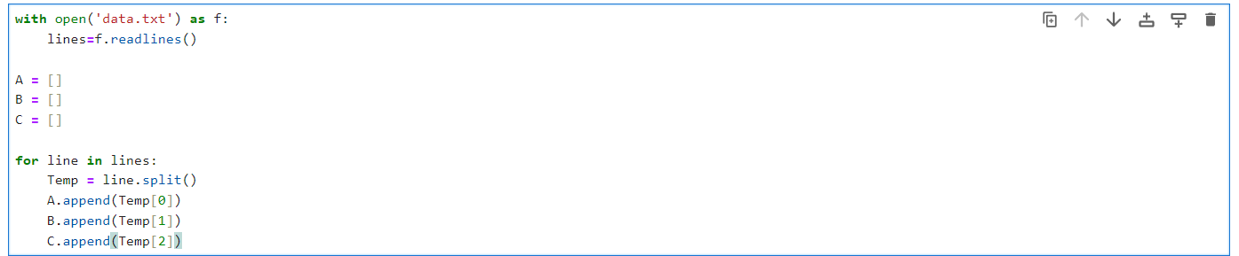

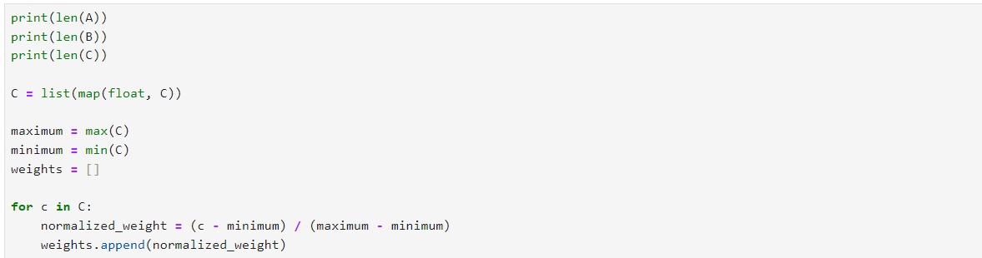

1. . Community Detection:

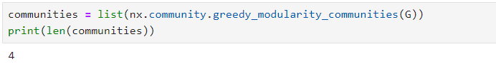

greedy_modularity_communities measure based on the density of edges. So strong connections node 🡪 one community

1. Identifying Key Businesses:

I use degree_centrality 🡪 to know the influence of a person and who done more transactions

Picking top 10 person who influence more

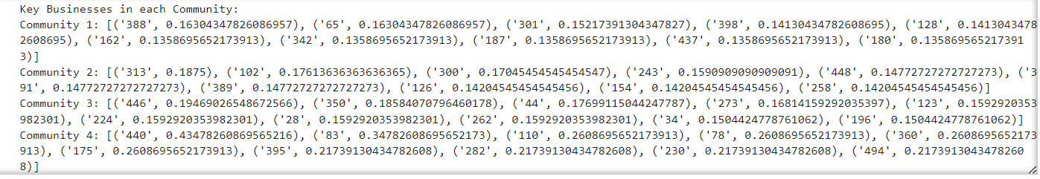

1. Anomaly Detection:

Threshold value



