In Memory File System
Vijay 24CS60R40
Command.cpp
---------------------------------------------------------------------------------------------------------------------
Data Structures:
- Superblock:
  - Stores metadata about the file system, including the total number of inodes and the number of free inodes.
- Inode:
  - Represents a file or directory.
  - Stores metadata like filename, size, type, permissions, and a pointer to the data block.
- File Table:
  - Keeps track of open files, including the file pointer, mode of access, and a reference to the corresponding inode.
- UFDT (User File Descriptor Table):
  - An array of file table pointers, used to map file descriptors to file table entries.
Functions:
- CreateDILB:
  - Initializes the inode list (DILB) with a fixed number of inodes.
- InitaliseSuperBlock:
  - Initializes the superblock and UFDT.
- CreateFile:
  - Allocates a free inode.
  - Initializes the inode's metadata.
  - Adds an entry to the UFDT.
- rm_File:
  - Decrements the link count of the inode.
  - If the link count reaches zero, the inode and its data block are freed.
- ReadFile:
  - Reads data from the file's data block.
  - Updates the file pointer.
- WriteFile:
  - Writes data to the file's data block.
  - Updates the file size and modification time.
- CloseFileByName:
  - Decrements the reference count of the file table entry.
- ls_file_in_detail:
  - Lists files with detailed information.
- ls_file:
  - Lists file names.

Shell.cpp
---------------------------------------------------------------------------------------------------------------------
Functions:
- sigintHandler:
  - Handles the SIGINT signal (Ctrl+C) to prevent termination.
- threadCreateFile, threadWriteFile, threadReadFile, threadDeleteFile:
  - Helper functions for multi-threaded execution of file operations.
- Test:
  - Creates, writes to, reads from, and deletes multiple files in a multi-threaded manner.
  - Measures the execution time of each operation.
- WrapperTest:
  - Calls the Test function multiple times with different numbers of files.
  - Calculates the average latency for each operation.
Logic Explanation:
- File System Initialization:
  - The InitaliseSuperBlock and CreateDILB functions initialize the basic data structures of the file system.
- File Creation:
  - The CreateFile function allocates a free inode from the inode list and initializes its metadata.
  - An entry is added to the UFDT to track the open file.
- File Deletion:
  - The rm_File function decrements the link count of the inode.
  - If the link count reaches zero, the inode and its data block are freed.
- File Access:
  - The ReadFile and WriteFile functions access the file's data block through the inode and file table.
- File Listing:
  - The ls_file and ls_file_in_detail functions iterate through the inode list to display file information.
- Multi-Threaded Testing:
  - The Test function creates multiple threads to perform file operations concurrently.
  - This helps evaluate the performance and scalability of the file system.
Key Points:
- The file system uses a simple inode-based structure to manage files.
- The UFDT is used to track open files and their corresponding inodes.
- The multi-threaded testing framework allows for performance evaluation under different workloads.
- The code includes basic error handling and synchronization mechanisms.

GenerateReport.cpp
---------------------------------------------------------------------------------------------------------------------
Functions:
- getMemoryUtilization():
  - Purpose: Calculates the current memory utilization of the system.
  - Steps:
    - Retrieves system memory information using sysinfo().
    - Calculates the total memory, free memory, and used memory.
    - Returns the used memory as a percentage of the total memory.
- getCpuUtilization():
  - Purpose: Calculates the CPU utilization over a short interval.
  - Steps:
    - Reads CPU usage statistics from /proc/stat.
    - Calculates the difference in idle and total CPU time between two consecutive readings.
    - Returns the CPU utilization as a percentage.
Main Function:
- Loop:
  - Continuously runs in a loop.
- Memory Utilization:
  - Calls getMemoryUtilization() to get the current memory utilization.
  - Prints the result to the console.
- CPU Utilization:
  - Calls getCpuUtilization() to get the current CPU utilization.
  - Prints the result to the console.
- Pause:
  - Pauses the execution for 100 seconds using std::this_thread::sleep_for().

Screen Shots
Basic Options and commands

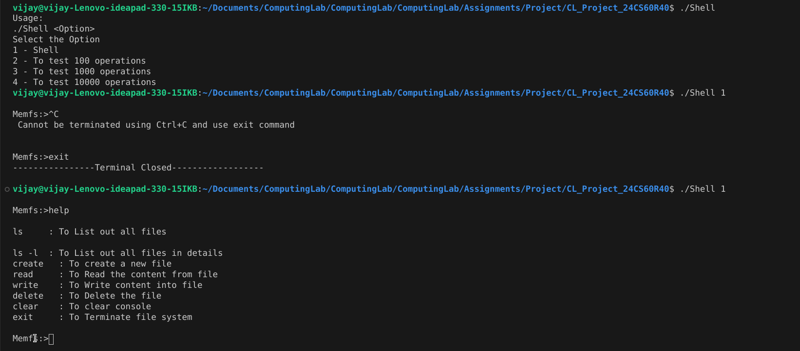
Examples on basic commands

