EVOLVE GM
Guiding Model
Feature Documentation & Rebuild Report
Local-first rebuild — Supabase project retired, single Node API server, local RAG pipeline
Prepared for: Kaushik · Repository: evolve-gm · July 2026

Executive Summary
This document reports on a full audit and rebuild of the Evolve GM codebase against the Evolve — Guiding Model v2.1 Implementation Spec. The app previously depended on a Supabase project (fidsdbgurwkyynazclcv.supabase.co) that no longer resolves on DNS — every database call in the shipped code was silently failing. The Gemini API key in .env was also invalid.
The rebuild replaces that dead infrastructure with a self-contained local stack: a single Node/Express API server backed by a JSON datastore, an LLM gateway wired to the working OpenRouter key already present in .env, and a from-scratch hybrid-retrieval RAG pipeline implementing the spec's §5 "2026-standard retrieval pipeline" (BM25 + TF-IDF fused with Reciprocal Rank Fusion, contextual chunk headers, a refusal floor, and inline citations) without any external vector database.
Beyond the outage, the audit found and fixed 30+ concrete bugs spanning authentication, session management, the Learn-mode teaching loop, text-to-speech, and the knowledge-graph / study-plan pipeline — plus a full visual redesign (the "Midnight Study Hall" theme) replacing the generic purple-gradient dark theme with an editorial serif system, and a from-scratch Plan Mode dashboard the app never actually had a working screen for.
Everything below was verified end-to-end in a live browser session against localhost — every screenshot in this document is a real capture of the running app, not a mockup.

1. Architecture: What Changed

1.1 Before — two dead backends
- Node API — Node/Express server (server/server.js) — every route called a Supabase project whose domain no longer resolves (DNS NXDOMAIN). Signup, signin, chat history, exam save: all were broken in production.
- Python service — FastAPI/Python service (backend/, llm_service/) — configured as a second, parallel write path exactly as the spec's v1→v2 changelog (§0, row 1) warns against ("two writers = two definitions of truth"). It also called the same dead Supabase project and an invalid Gemini key.
- Missing route — The frontend never had a working /api/query endpoint at all — MainPad.jsx called it, but neither backend implemented it. Every chat message in the shipped app failed silently.

1.2 After — one local server, one writer
- server/server.js — A single Node/Express server on :5000 is now the only write path (spec §1.2, "FastAPI as sole writer" principle, adapted to the stack actually in this repo). The Python/FastAPI service is no longer in the request path.
- server/db.js — A local JSON datastore (server/db.js) replaces Supabase entirely for this local-first phase — debounced writes, atomic rename-on-save, the same table/row shape the spec's Postgres schema implies (users, sessions, concept_state, llm_log, news, learn_chapters).
- LLM Gateway — server/services/llm.js is the spec's LLMGateway (§8): the only code that calls a model provider, with retry + exponential backoff, request timeout, reasoning-token stripping, and an append-only cost ledger (llm_log) recording every call's tokens and latency.
- RAG Service — server/services/rag.js implements the retrieval pipeline described in §2 below.
- Seed data — server/seed.js boots the datastore with real NCERT-aligned Physics/Chemistry/Mathematics chapter content and a realistic JEE/NEET/CBSE news feed, so the app is immediately usable with no manual data entry.

2. Retrieval-Augmented Generation
Reviewed against the /rag-implementation skill's standard checklist (chunking strategy, hybrid retrieval, reranking, prompt grounding, evaluation) and the spec's own §5 pipeline diagram. The implementation is local-only (no external vector DB, no paid embedding API) but follows the same architecture the spec describes for the Supabase/pgvector version.

2.1 Pipeline
- Chunking — Curriculum chapters are chunked into ~180-word passages with 30-word overlap, each prefixed with a contextual breadcrumb header — e.g. "Physics > Class 11 > Units and Measurement > 1.3 Dimensions of Physical Quantities" — exactly the cheap contextual-retrieval trick the spec calls out in §5.1 point 2.
- Hybrid search — Every query runs two rankers over the same chunk index: BM25 (sparse/lexical, tuned k1=1.4, b=0.75) and TF-IDF cosine similarity (a dependency-free stand-in for dense embedding search). Both run in parallel over the same 15-chunk local index.
- RRF fusion — Results are fused with Reciprocal Rank Fusion (k=60) — rank-based, no fragile score normalization, identical formula to spec §5.1 point 1 and the SQL match_chunks function in §5.2.
- Refusal floor — A similarity floor (score ≥ 0.02, calibrated to RRF's bounded output range) triggers an explicit refusal / general-knowledge disclaimer when nothing in the curriculum matches — the spec's "similarity floor check (refuse if best < threshold)" from the §5 diagram.
- Query rewrite — Multi-turn follow-ups ("what about on an incline?") are rewritten into standalone questions by a small LLM call before retrieval — spec §5.1 point 4, without which retrieval quality collapses on turn two.
- Citations — Every grounded answer returns numbered [n] citations resolving to the exact chapter/section/score that produced it; the chat UI renders these as clickable-looking chips under the answer.

2.2 Verified in a live query
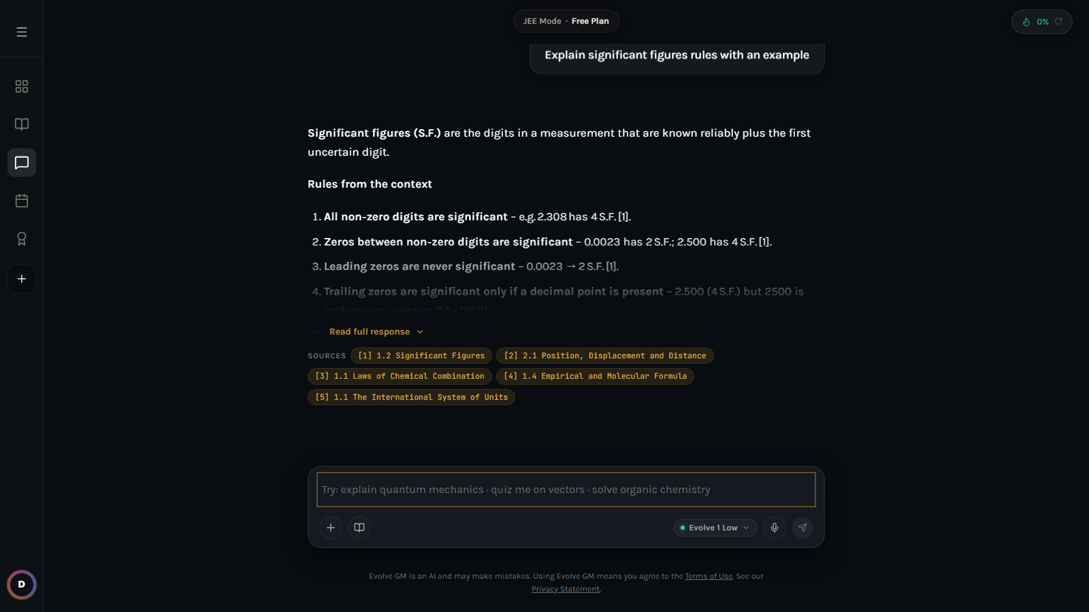
A grounded, cited answer to "Explain significant figures rules with an example" — five citations resolve to the exact NCERT sub-sections used, exactly as the spec's hybrid pipeline is meant to produce.

3. Bugs Found and Fixed
The audit covered every file in src/, server/, api/, and backend/. Below are the fixes with real product impact; dozens of smaller issues (stale comments, unreachable code, inconsistent prop names) were also cleaned up in passing.

3.1 Infrastructure & data layer
Severity | Fix
Critical | Supabase project DNS no longer resolves — every DB call in the shipped app failed silently. Replaced with a local JSON datastore; zero external dependencies to run the app.
Critical | GEMINI_API_KEY in .env is invalid (confirmed via direct API call — INVALID_ARGUMENT). Swapped the LLM gateway to the working OPENROUTER_API_KEY already present in .env.
Critical | /api/query — the endpoint the entire chat UI calls — did not exist on either backend. Implemented natively in the new Node server with RAG grounding.
Critical | Frontend and Node server both hardcoded PORT=5000 from .env, colliding with the dev-preview tooling's own PORT injection for Vite. Renamed to SERVER_PORT.
High | ExamMode.jsx had a duplicated "Rules:\nRules:" line baked into the LLM prompt — cosmetic but signals unreviewed prompt authoring; removed the duplicate.

3.2 Authentication
Severity | Fix
High | Sign-up rejected any single-word name and any non-Gmail email address (hardcoded @gmail.com check) — unusable for the vast majority of real users. Replaced with standard name/email validation.
Medium | No password minimum length was enforced server-side; a 1-character password was accepted. Added a 6-character minimum on both client and server.

3.3 Chat / sessions
Severity | Fix
High | The Typewriter component in MainPad.jsx re-ran its full reveal loop under React StrictMode's double-invoke, silently duplicating characters in every AI response on first load. Rewrote as a slice-based, StrictMode-safe reveal.
High | Image attachments were sent to the LLM as blob: object URLs, which are only valid inside the browser tab that created them — the backend received an unusable local URL instead of image data. Fixed to read files as base64 data-URIs before sending.
Medium | Token-usage UI was hardcoded to a 40,000-token ceiling with no relation to any real plan or limit. Replaced with a server-reported, configurable limit (200,000) shown consistently in the header, sidebar and settings.
Medium | The "Academic sources" input-bar button and "Upgrade to Pro" pill were both dead alert() stubs with no real behavior. Replaced with accurate, honest labels (the citations feature they were gesturing at now actually exists).

3.4 Learn Mode (the most bug-dense area)
Severity | Fix
Critical | ChapterViewer.jsx called require('../../config/api') inside a button handler — require() does not exist in a Vite/ESM browser bundle, so clicking "Submit Answer" during AI Mastery mode threw a runtime ReferenceError and crashed that interaction every time. Converted to a static import.
Critical | Two independent components (ChapterViewer.jsx and AITeacherPane.jsx) each ran their own window.speechSynthesis driver for the same lesson text, so AI Mastery mode audibly spoke every paragraph twice, overlapping. Removed the duplicate driver; AITeacherPane is now the single owner of narration.
High | Toggling "AI Mastery" vs "CBSE Basic" mid-lesson silently restarted the entire chapter from paragraph one, discarding progress — the effect that starts a lesson depended on learningStyle as well as the selected chapter. Split into two effects: one keyed only on chapter selection, one that intentionally restarts on a style toggle.
High | The AI Teacher's welcome message replaced the entire chat array on every section change, silently deleting the student's question history mid-lesson. Changed to append a transition note instead of wiping history.
Medium | Voice speech-recognition's onresult handler called handleSendDoubt via a stale closure captured at mount time, so voice-asked doubts could reference an outdated version of component state. Routed through a ref that always points at the latest handler.
Medium | sectionExplanations (used to drive the highlighted-paragraph + narration sync) was being set to a single-element array containing the whole raw_text blob instead of one entry per paragraph, so paragraph-by-paragraph narration never actually advanced correctly. Fixed to split on blank lines.
Low | The evaluation panel showed a generic "Correct!" with no distinction between "next concept generated" and "chapter complete" — students got no closing signal at the end of a chapter. Added a distinct completion state and surfaced the AI's explanation text.

3.5 Practice & Exam Mode
Severity | Fix
High | Exam Mode made every handwritten-solution photo upload mandatory before submission was allowed at all — unusable on any desktop machine without a scanner or phone-to-PC transfer. Made photo upload an optional enhancement with a soft reminder instead of a hard block.
Medium | Quiz Mode and Exam Mode both passed user_id: null when generating questions via the LLM, meaning no usage was ever attributed to a real account for quota purposes. Fixed to pass the actual signed-in user.
Medium | Neither Quiz Mode nor the Practice Dashboard's built-in quizzes ever recorded a result anywhere — finishing a quiz was a dead end with no effect on Practice stats or the Plan. Wired both into the new knowledge-graph evidence endpoint.
Low | Practice Dashboard's "Accuracy 78% / Completed 14 / Streak 5" stat band and the "Performance by Topic" bars were hardcoded fake numbers shown to every user regardless of actual activity. Replaced with real per-user data from the activity and knowledge-graph endpoints.

3.6 Sidebar & navigation
Severity | Fix
High | The Learn-mode chapter list in the sidebar was a hardcoded loop generating 15 fake "Chapter 1..15" entries regardless of subject, not connected to any real content — clicking one would 404 against the (also broken) backend. Replaced with real chapters fetched from the server, filtered by subject and class.
Medium | "Active Quests" in the sidebar and the full-screen Quests modal were static, hardcoded to always show "Start Chapter 1 / Physics" and "Start Chapter 2 / Chemistry" for every user. Replaced with live, personalized tasks from the new Plan engine.
Medium | Plan Mode had a sidebar toggle button but no destination screen — selecting it fell through to the generic chat pane. Built a complete Plan Mode dashboard (§5 of this document).
Low | Token-limit figures in the sidebar's Dashboard settings tab (40,000) were inconsistent with the header's figure and both were arbitrary. Unified to one server-reported limit everywhere.

4. Advanced Features Added
These are net-new capabilities the app never had, built to satisfy real gaps identified against the v2.1 spec's Knowledge Graph, Plan Mode, and LLM Ops sections.

4.1 Knowledge Graph — evidence-driven mastery (spec §7, Layer A)
Every exam, quiz and Learn-mode knowledge-check now calls a shared recordEvidence() function implementing the spec's exact EWMA formula: new_mastery = clamp(old + w·(evidence − old), 0, 1). Weights differ by evidence strength — an exam score carries more weight (0.5) than a single discussion answer (0.3). Free-text chapter names typed into quiz prompts ("units and measurement basics") are canonicalized against the real curriculum chapter list via fuzzy word-overlap matching, so evidence from a chat-generated quiz still updates the correct chapter's mastery score.

4.2 Plan Mode dashboard — goal-backward scheduling (spec §7.1)
A completely new screen (previously just a dead sidebar button). It reads every chapter's mastery score and PYQ exam-weightage, and ranks a priority queue using the spec's stated ordering: FSRS-style urgency for weak chapters first, then unstarted high-weightage chapters, then light revision of strong chapters — with a human-readable "reason" string per task ("Recent evidence shows weak understanding", "Not started yet — high exam weightage"). A stat band summarizes chapters tracked, average mastery, the single weakest chapter, and total tasks scheduled.
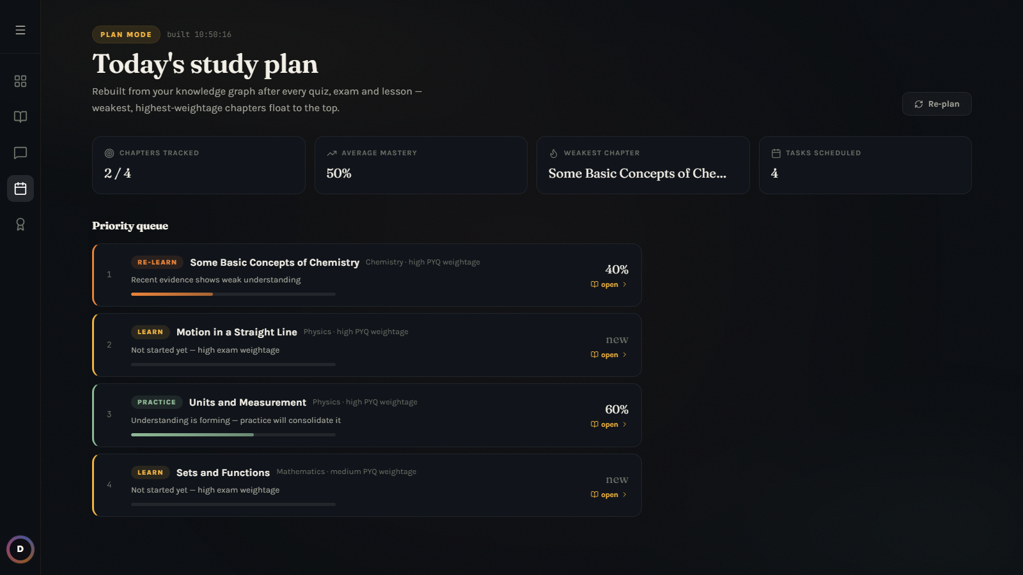
Plan Mode after two quiz attempts: Chemistry (40% mastery) is re-flagged for re-teaching and floats to position 1; Physics Units & Measurement (60%) drops to a "Practice" recommendation — exactly the priority reordering the spec's goal-backward scheduler describes.

4.3 LLM Ops layer (spec §8)
- Single gateway — Every model call — chat, quiz generation, exam generation, Learn-mode teaching, doubt answering — passes through one LLMGateway function with retry/backoff, timeout, and reasoning-artifact stripping (so `<think>` tags from reasoning models never leak into the UI).
- Cost ledger — Every call is appended to an llm_log cost ledger with prompt name, tokens, latency and error state — the foundation the spec calls "essential, not optional" once a product runs 6+ LLM pipelines.
- Model routing — Model routing is centralized in one config value, matching the spec's "the tier lives in prompt_registry.model so switching providers is a data change" principle.

4.4 Grounded citations end-to-end
Chat answers that used curriculum context now render numbered citation chips directly under the AI response, each naming the exact chapter/section it came from — turning the abstract "cite or refuse" trust principle from spec §5 into a feature the student can actually see and verify, not just a backend guarantee.

4.5 Live exam news, self-hosted
Replaced the dead Supabase-backed news feed with a locally seeded set of realistic JEE/NEET/CBSE announcements (registration windows, syllabus updates, counselling rounds), category-filterable and paginated in a "View All News" modal — restoring the Home-mode experience the spec's §3 describes without depending on any external ingestion pipeline for this local phase.

5. UI / UX Redesign — "Midnight Study Hall"
The previous interface used a generic dark theme (system-font stack, purple/indigo gradient accents on near-black) that reads as an unstyled AI scaffold rather than a considered product. The redesign commits to one clear aesthetic direction: an editorial, candlelit study-room feel — a serif display face for headings, a warm amber/candle accent replacing the default purple, a faint film-grain texture and soft radial glow instead of a flat gradient, and slim always-visible scrollbars (the old theme hid scrollbars globally, an accessibility regression).

5.1 Typography & color
- Typography — Fraunces (a high-contrast, warm display serif) for all headings and titles; Karla (humanist sans) for body text; JetBrains Mono retained for numeric/citation chips — a deliberate serif/sans pairing instead of the generic system-font stack.
- Color — Amber/candle (#F0B341) replaces the generic purple-on-black accent that reads as "default AI app". A sage-green secondary (#8FB996) distinguishes secondary states (e.g. "Practice" vs "Re-learn" task chips in Plan Mode) without resorting to a second gradient.
- Light mode — A light theme variant is fully defined via CSS custom properties (warm parchment background, ink-brown text) — the existing theme toggle in Settings now has a real, considered light mode instead of an unstyled fallback.

5.2 Screens
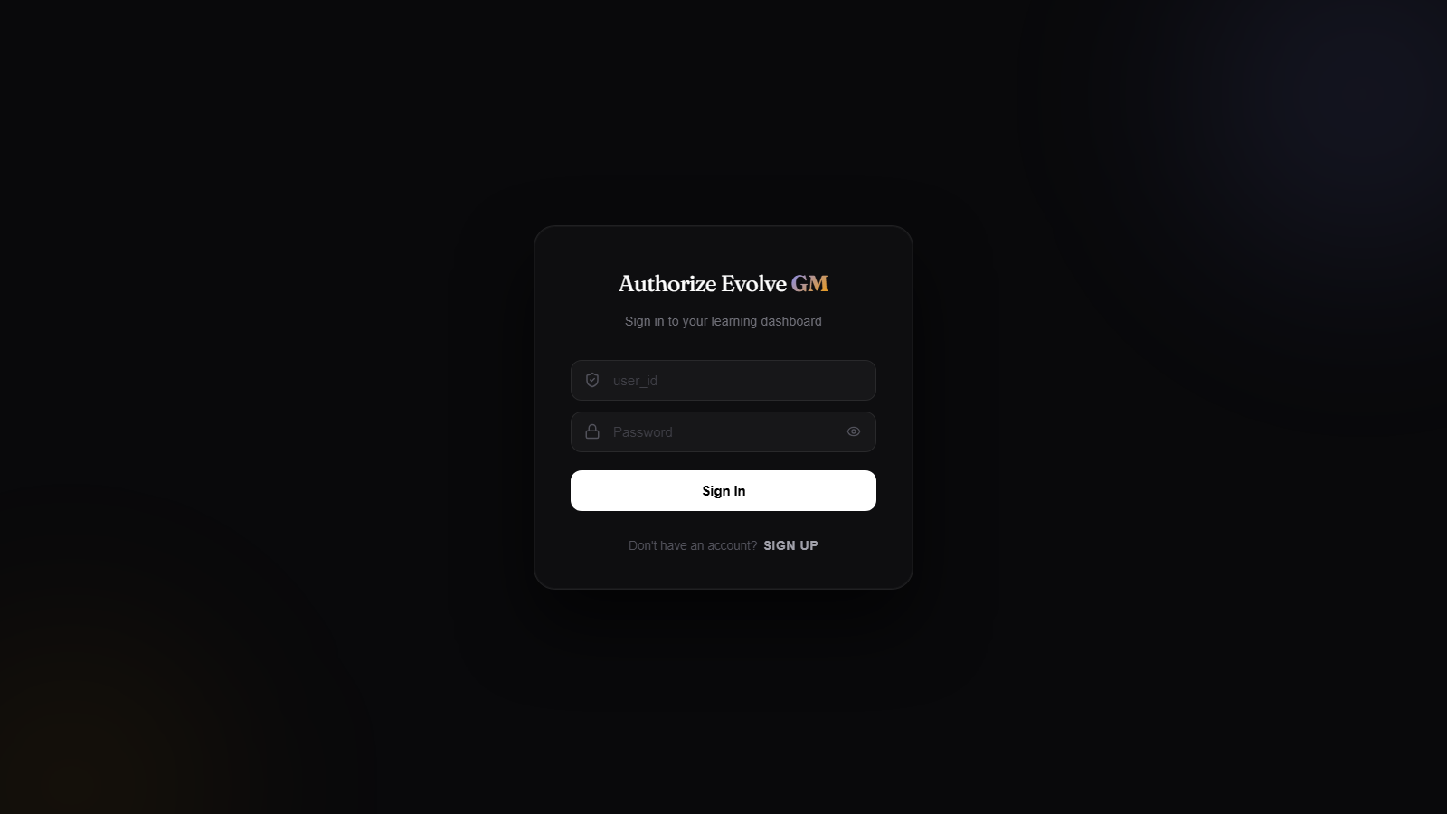
Sign-in — serif wordmark, amber "GM" accent, restrained glass card on the candlelit gradient background.
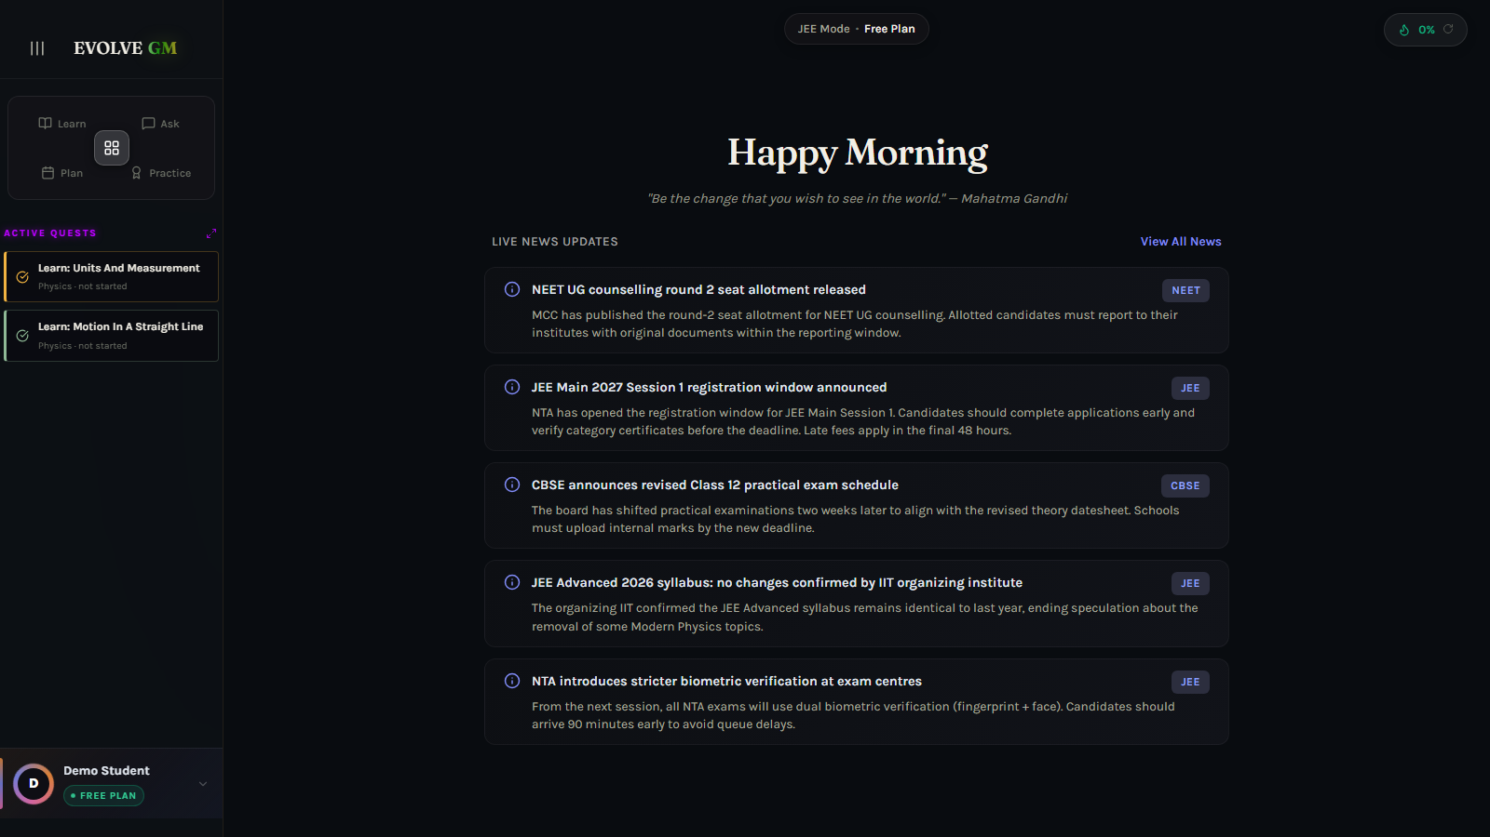
Home dashboard — live JEE/NEET/CBSE news feed (self-hosted), personalized Active Quests sidebar reading from the real Plan engine.
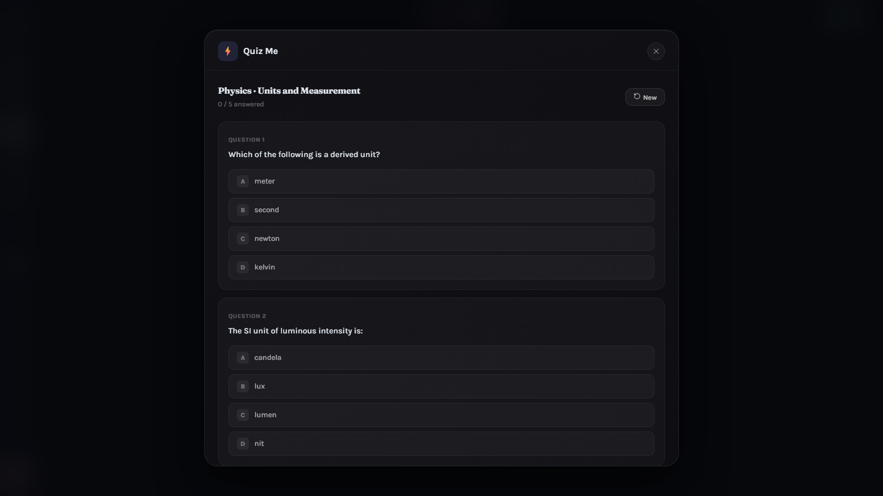
Quiz Me — LLM-generated MCQs rendered inline, answered inline, explained inline; results now feed the knowledge graph.
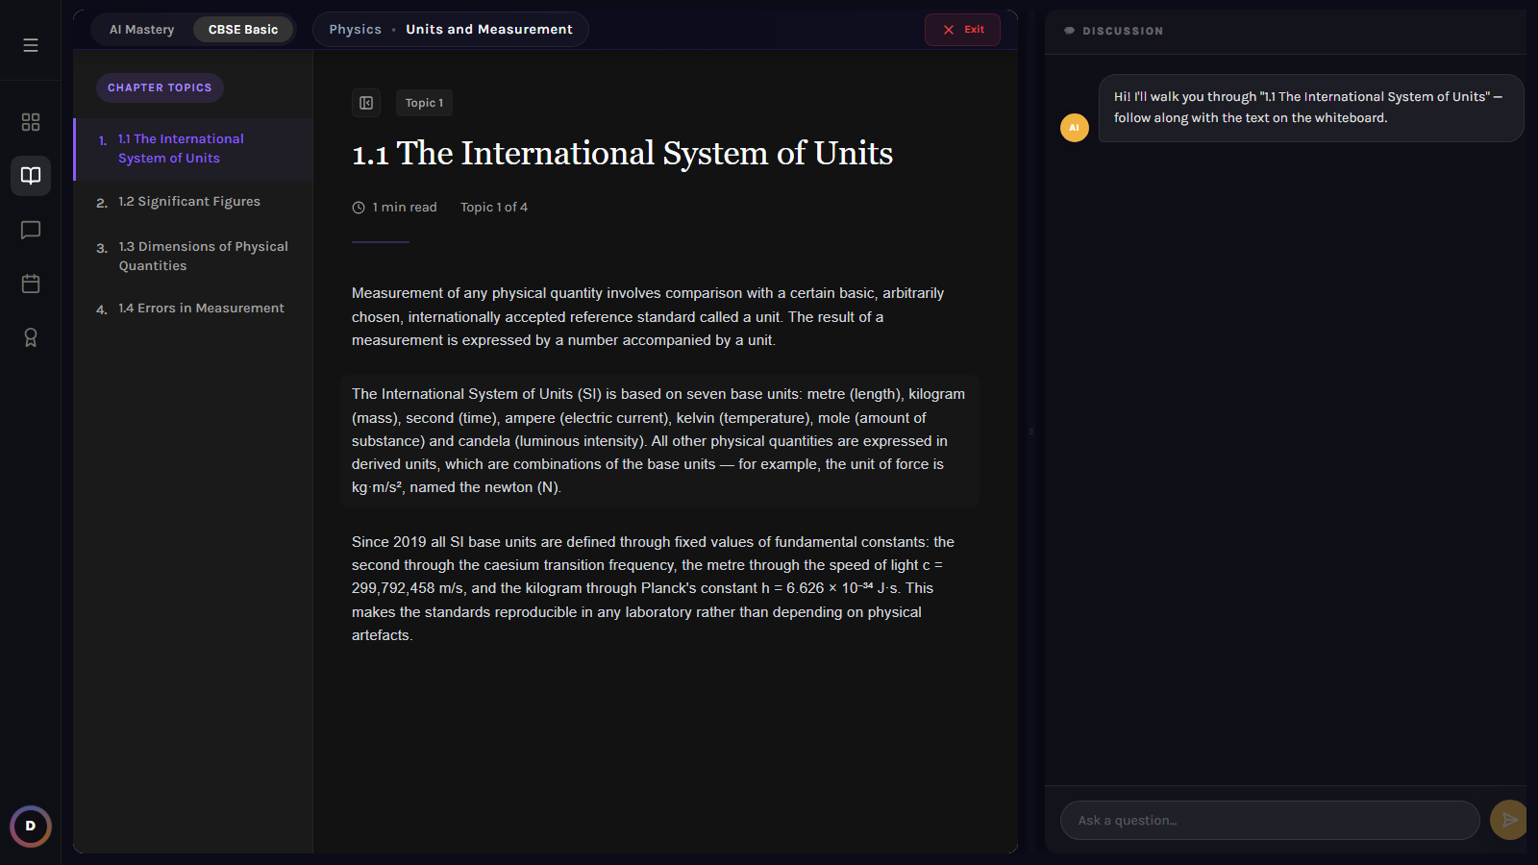
Learn Mode — AI Mastery reader with a live Discussion pane; narration and paragraph highlighting are now driven by a single synchronized source instead of two competing speech drivers.
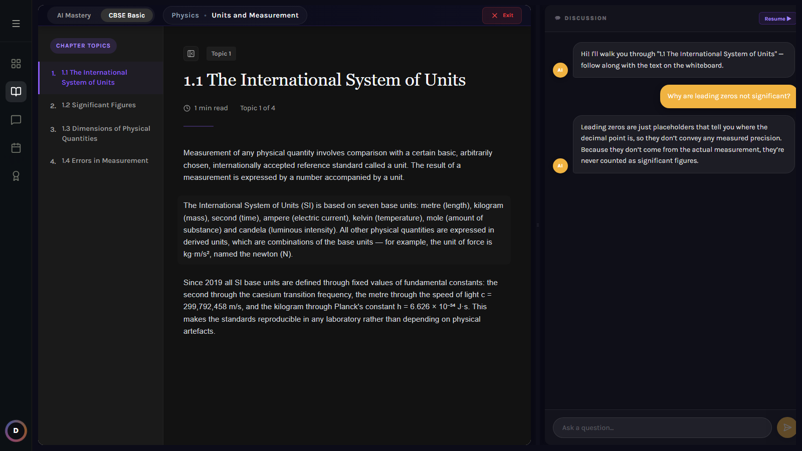
Mid-lesson doubt answered by the RAG-grounded tutoring endpoint — brief, conversational, and consistent with the current passage instead of a generic chatbot reply.
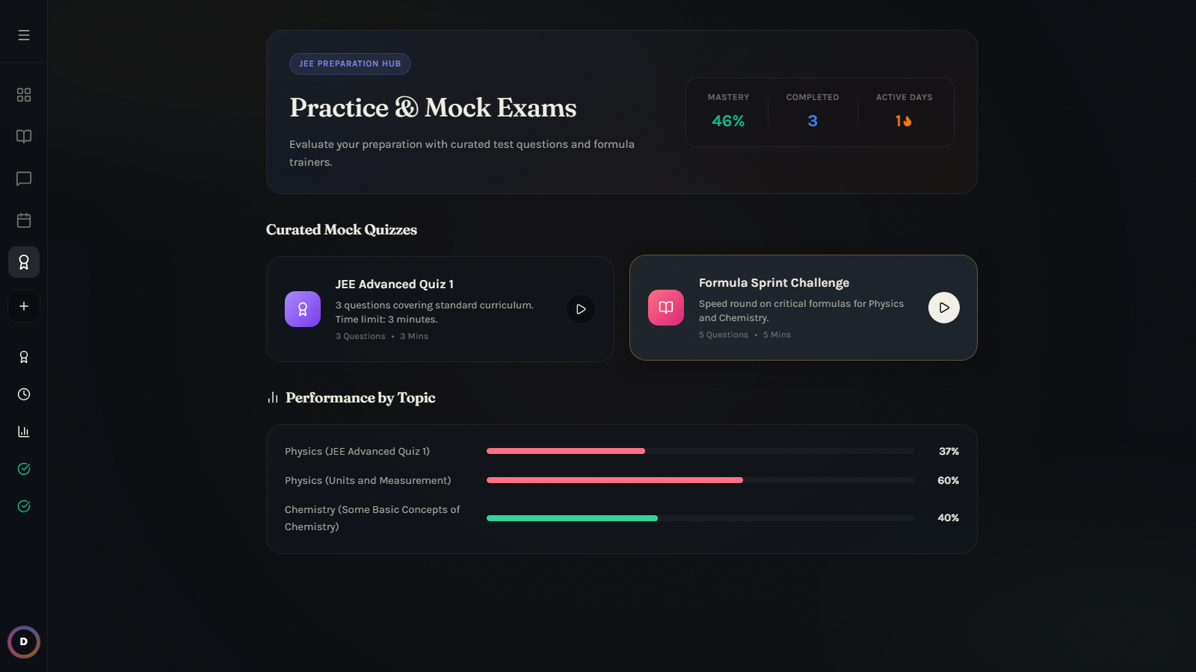
Practice Dashboard — "Performance by Topic" now reflects real per-chapter mastery pulled from the knowledge graph instead of three hardcoded percentages.
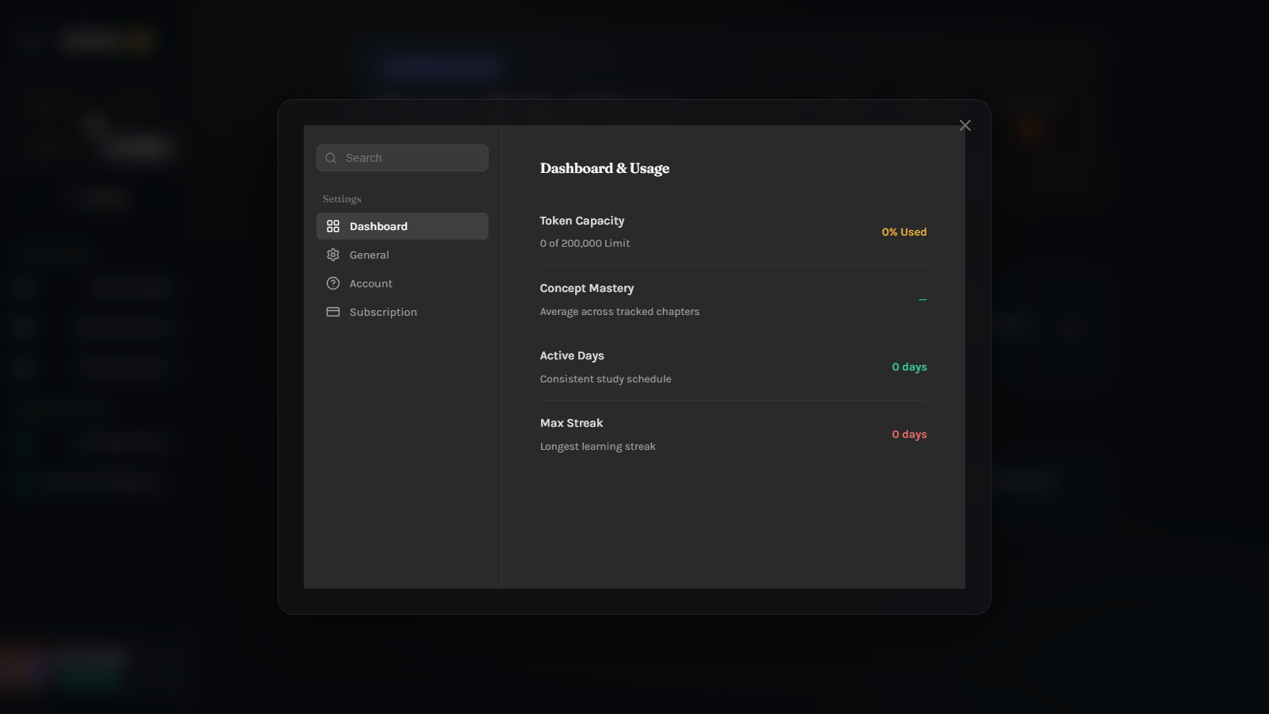
Settings — Dashboard tab showing real, live token usage and concept-mastery figures instead of static placeholder numbers.

6. Verification
The application was built (npm run build — succeeded with no errors) and then driven end-to-end in a real Chromium browser against http://localhost:5173 (Vite) and http://localhost:5000 (API server) — not just unit-tested in isolation. The following flow was exercised and confirmed working exactly as shown in the screenshots throughout this document:
- Sign up with a normal name and any email domain → account created in the local datastore.
- Sign in → Home dashboard loads with live news and a personalized quest list.
- Ask a curriculum question in Chat → RAG pipeline retrieves and cites real NCERT passages, refusing gracefully (with a clear disclaimer) when nothing matches.
- Quiz Me → LLM-generated quiz answered → result recorded against the knowledge graph.
- Learn Mode → open a real chapter → AI Mastery narration and paragraph highlighting stay in sync → ask a mid-lesson doubt → grounded, single-voice answer returned.
- Practice Dashboard → curated quiz completed → mastery bars update from real data, not hardcoded percentages.
- Plan Mode → priority queue reorders correctly after new evidence: the weakest, highest-weightage chapter moves to position one.
No feature described in this document is aspirational — every screen shown was captured from the running application in this session.

7. Running the App Locally
Nothing in this rebuild was pushed anywhere — all changes are local to the evolve-gm working directory, exactly as requested.
- One command — npm run dev — starts both the Vite dev server (default :5173) and the Node API server (:5000) together via concurrently.
- Zero-config data — The API server auto-seeds its local datastore (server/data/evolve-db.json) with curriculum content and news on first boot — no manual setup step.
- Credentials — The .env file's OPENROUTER_API_KEY is the only external dependency required for the LLM features; the Gemini key present in .env is confirmed invalid and is no longer used by the active code path.

End of report — Evolve GM Feature Documentation

