TECHNICAL ARCHITECTURE

EUC Inventory and
Grounded AI Integration
  - Why it was built, what was implemented, how the code works, and how verified EUC evidence should connect to AI
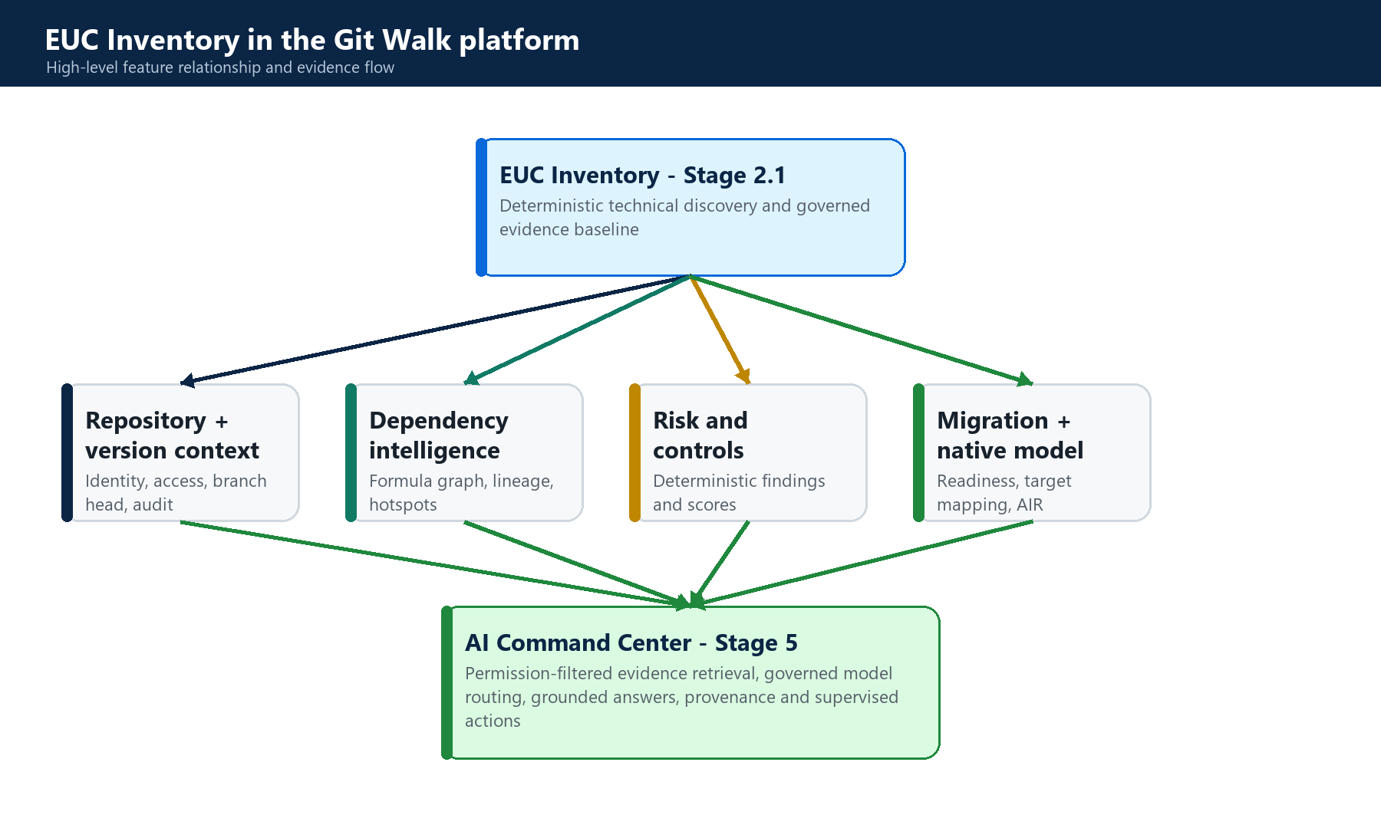
Git Walk technical feature documentation | Current implementation and controlled target state

Document type | Technical architecture and implementation guide
Scope | EUC Inventory Stage 2.1 and its direct AI integration
Code baseline | Repository branch ver2, reviewed 26-27 August 2026
Status | Code-grounded documentation; target-state items explicitly labeled

Document purpose and reading guide
This document explains the EUC Inventory capability implemented in Git Walk, beginning with the business and engineering rationale and then tracing the feature from the React user interface through FastAPI, validation, immutable storage, static analyzers, normalized persistence, downstream intelligence, and AI grounding.
ACCURACY CONVENTION
Implemented means directly present in the reviewed code. Downstream integration means implemented elsewhere in the repository and dependent on Stage 2.1. Recommended target state identifies a documented extension that is not yet wired end to end.

Contents
- 1. EUC Inventory feature overview
- 2. Scope, terminology and architectural principles
- 3. High-level platform architecture
- 4. Detailed Stage 2.1 architecture
- 5. Feature block specifications
- 6. Data model and persistence
- 7. API and user-interface contracts
- 8. EUC Inventory and AI Command Center
- 9. Security, governance and non-functional behavior
- 10. Testing and acceptance strategy
- 11. Advantages, limitations and recommended improvements
- 12. Codebase traceability and dependencies
- Appendices: operational runbook, glossary and acceptance checklist

1. EUC Inventory feature overview

1.1 Why the feature was built
Enterprise spreadsheets frequently operate as applications: they implement calculations, approvals, forecasts, data transformations, reports and integrations. Conventional file repositories can identify a workbook by name and binary content, but they cannot explain its internal logic, dependencies or operational risk. This creates an inventory problem before it creates an AI problem.
Git Walk therefore introduces EUC Inventory as the technical-discovery entry point for spreadsheet intelligence. The feature establishes a deterministic, versioned and permission-controlled record of what exists inside a workbook. This baseline is necessary before dependency analysis, risk scoring, migration planning or AI explanation can be trusted.
FEATURE DEFINITION
EUC Inventory is a static-analysis pipeline for .xlsx, .xlsm and UTF-8 .csv assets. It fingerprints and preserves the source, extracts supported technical structures without executing workbook code, normalizes the results, and seals an immutable inventory manifest.

1.2 What was built
- A repository-scoped EUC registration and portfolio experience in React.
- Authenticated FastAPI endpoints for upload, analysis, status, inventory retrieval and JSON export.
- Hostile-file-aware validation for OpenXML and CSV inputs.
- Content and structure fingerprints for identity, deduplication and provenance.
- Immutable storage of original source bytes in the semantic object ledger.
- Three static analyzers covering workbook structure, formula patterns and OpenXML package metadata.
- Normalized SQLite tables for sheets, formulas, occurrences, objects, external links, connections and warnings.
- A versioned immutable analysis manifest associated with the repository head commit and analyzer version.
- Downstream consumption by dependency, risk/control, migration and application-model features.
- An AI evidence path that currently retrieves deterministic EUC findings and repository evidence for grounded explanation.

1.3 How it was built
The implementation follows a compiler-like pipeline. Input bytes pass through validation and identity gates, are preserved as immutable source evidence, and are loaded into a controlled analysis context. Independent analyzers emit metrics, normalized records and warnings. A service layer persists those records transactionally and creates a canonical manifest. The UI then queries the latest inventory by section.
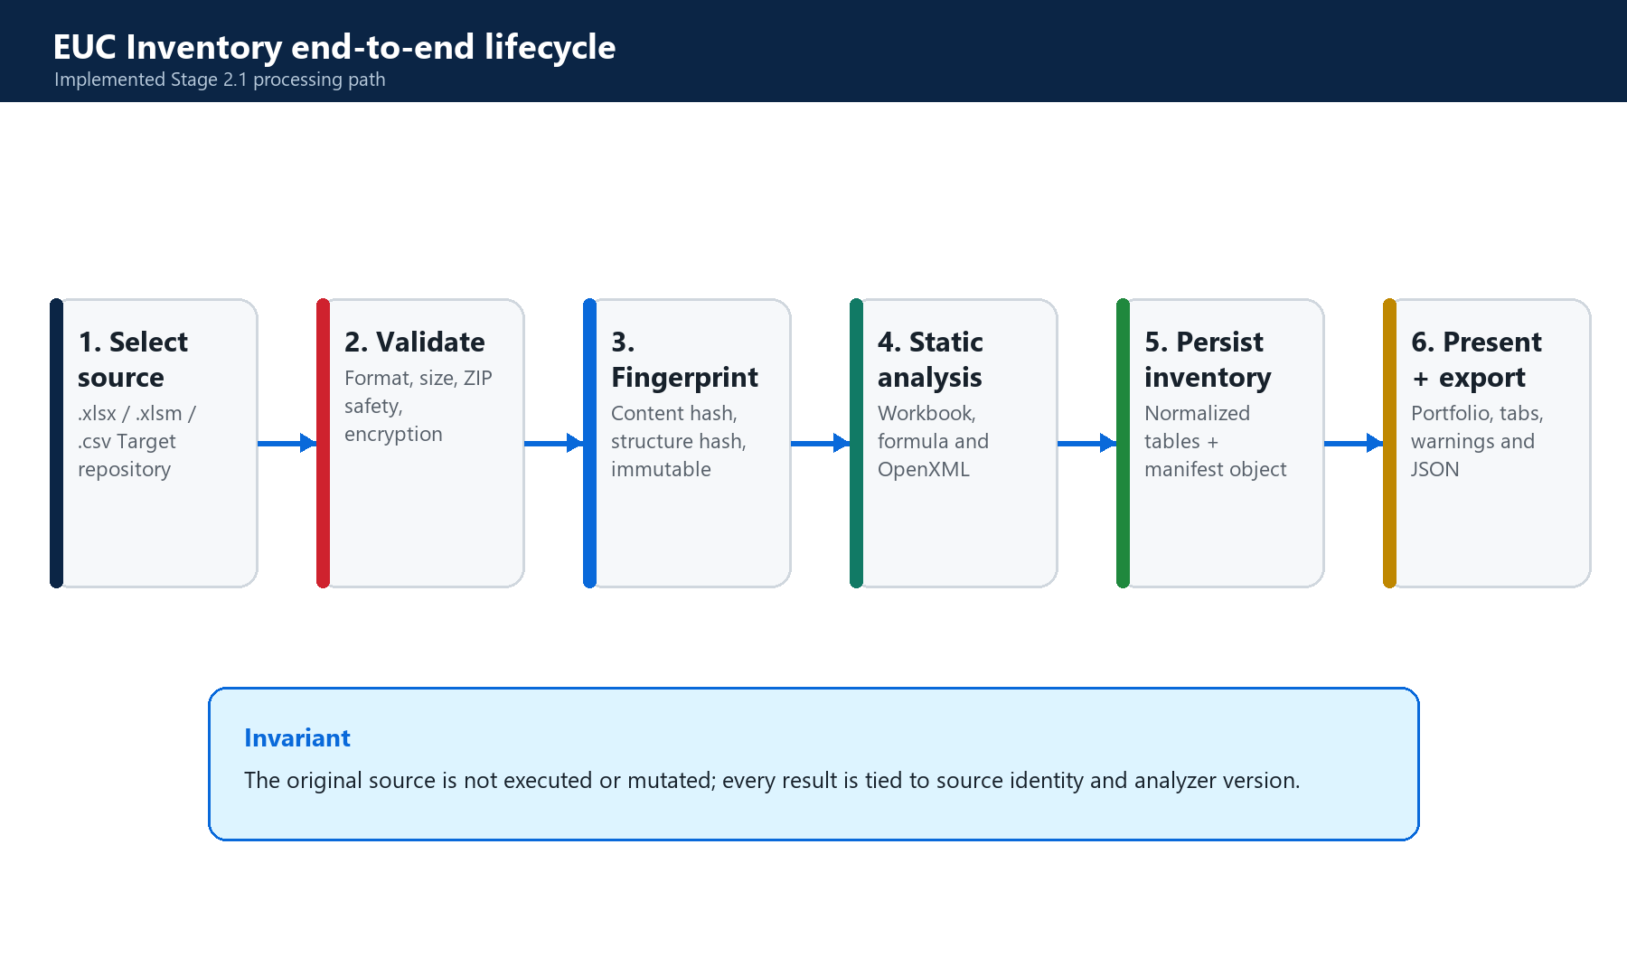
Figure 1. Implemented end-to-end EUC Inventory lifecycle.

1.4 User-visible capability
The EUC Inventory page allows an authorized user to select a target repository, register a workbook or CSV, view analysis status, search the governed portfolio, inspect workbook-map and formula/object details, re-run analysis, and export the current manifest as JSON. The page also exposes downstream tabs; those tabs depend on Stage 2.1 but are separate feature stages.

2. Scope, terminology and architectural principles

2.1 Scope boundary
Included in this document | Excluded except as a dependency
Stage 2.1 upload, validation, fingerprints, source storage, analyzers, inventory persistence, portfolio, export | General repository version control implementation
Direct internal dependencies needed by Stage 2.1 | Full dependency-engine algorithms
Current and recommended EUC-to-AI evidence connection | General integrations, digital-thread and merge workflows
Testing and operating the EUC feature | Unrelated frontend and backend features

2.2 Core terms
Term | Technical meaning
EUC asset | A registered .xlsx, .xlsm or .csv source associated with a Git Walk repository.
Content fingerprint | SHA-256 of the exact source bytes; used for identity and repository-scoped deduplication.
Structure fingerprint | SHA-256 of a canonical representation of workbook package structure or CSV header.
Analysis run | A versioned execution of analyzer version 2.1.0 against an immutable source.
Inventory | Normalized queryable records describing sheets, formulas, objects, links, connections and warnings.
Manifest | Immutable JSON evidence object containing the summary and extracted records for an analysis run.
Grounded AI | AI output constrained to authorized evidence references, structured response validation and provenance.

2.3 Architectural principles
- Deterministic extraction is authoritative. Workbook counts and structures come from parsers, not an LLM.
- No workbook code is executed during inventory. VBA and connections are inspected as metadata only.
- Every analysis is tied to exact source identity, repository context, analyzer version and a manifest hash.
- Authorization is applied before repository data or EUC evidence is read or changed.
- AI explains verified evidence; it must not invent inventory facts or override deterministic controls.
- Target-state capabilities are documented separately from current implementation.

3. High-level platform architecture
Stage 2.1 sits between repository governance and higher-order intelligence. Repository context supplies identity, access, branch-head provenance and audit. EUC Inventory supplies the normalized technical baseline. Dependency and intelligence stages derive relationships and findings. Migration and application-model stages consume those facts. Stage 5 AI retrieves authorized evidence and produces explanations with provenance.
Figure 2. High-level relationship between EUC Inventory and direct downstream platform features.
Connected feature | Connection to EUC Inventory | Status
Repository governance | Repository ID, membership, organization, default-branch head and audit events | Implemented direct dependency
Semantic storage | Immutable original source and immutable analysis manifest | Implemented direct dependency
Dependency intelligence | Consumes formula occurrences, sheet identities, external links and connections | Implemented downstream stage
Risk and controls | Consumes inventory and graph-derived features to generate deterministic findings | Implemented downstream stage
Migration / native model | Uses technical facts, findings and dependencies for readiness and target models | Implemented downstream stage
AI Command Center | Currently retrieves repository evidence and open EUC findings; direct raw inventory adapter is recommended | Partial direct integration

4. Detailed Stage 2.1 architecture

4.1 Runtime components
Layer | Primary components | Responsibility
Presentation | frontend/src/App.jsx; styles.css | Portfolio, upload, selection, inventory tabs, warnings, re-analysis and export.
Client API | frontend/src/services/api.js | Multipart upload and authenticated REST calls under /api/v1/euc.
HTTP boundary | backend/app/api/euc.py | FastAPI routing, request constraints, principal dependency and typed HTTP errors.
Application service | backend/app/euc/service.py | Access checks, deduplication, orchestration, persistence, status, retrieval and export.
Analysis | validation.py; fingerprint.py; analyzers.py | Safety gates, identity and static extraction.
Persistence | database.py; semantic_ledger_service.py | Normalized SQLite records, object storage, references and immutable evidence.
Governance | access_control; security; observability | Permissions, principal, audit events and metrics.

4.2 Synchronous processing sequence
The current frontend performs registration and analysis as two sequential HTTP requests and waits for analysis completion. Although analysis-run status fields exist, POST /analysis executes synchronously in the current API. Large workbooks can therefore hold an HTTP request until completion or the configured timeout.
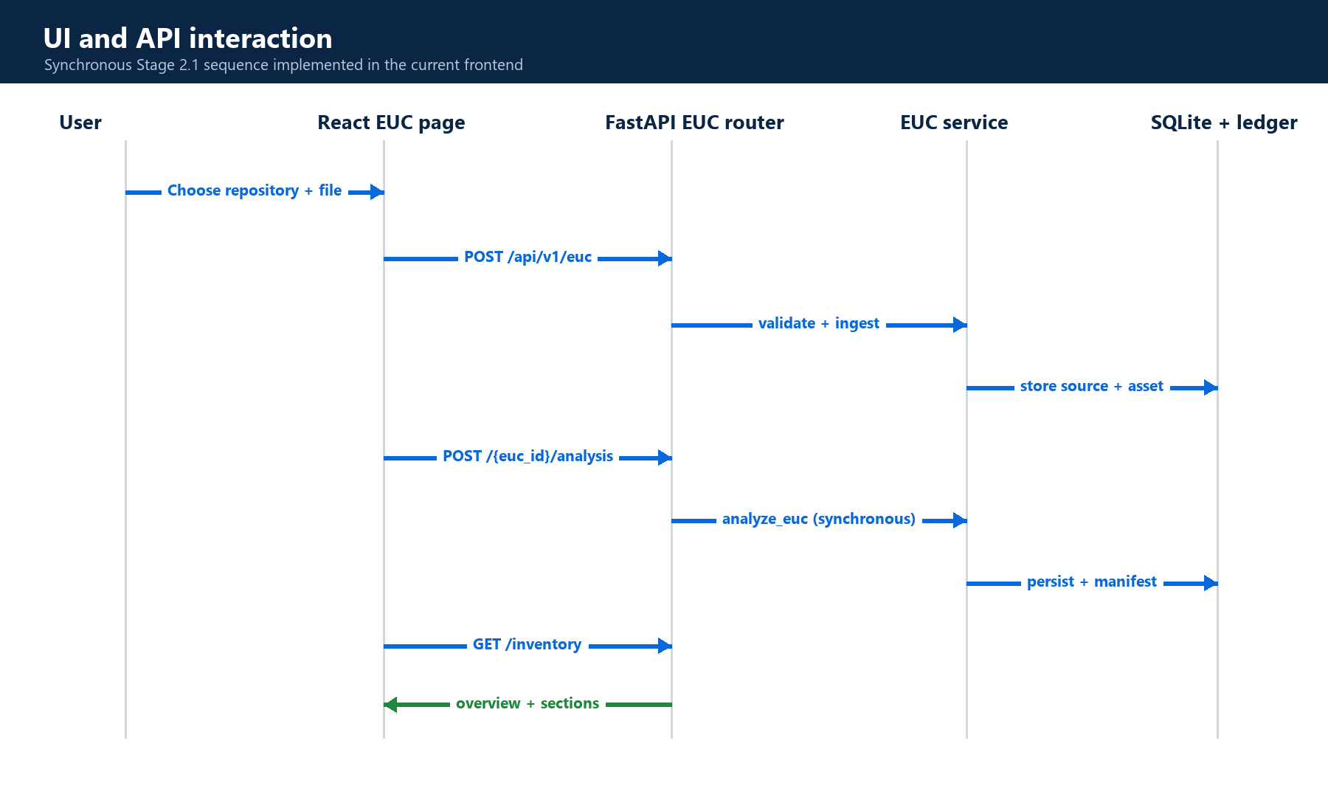
Figure 3. Current user-interface and API sequence.

5. Feature block specifications

5.1 Block A - repository selection and EUC registration
The React page obtains editable repositories from the existing dataset/repository foundation. A user selects a repository and file. The client sends multipart form data containing repository_id and file to POST /api/v1/euc. The backend reads no more than the configured maximum plus one byte, resolves the authenticated principal and passes the request to ingest_euc.
Input | Processing | Output
Authenticated user; repository ID; filename; source bytes | Repository edit permission, validation, hashes, deduplication and ledger storage | EUC asset with PENDING status or existing deduplicated asset

5.2 Block B - hostile-file-aware validation
Validation occurs both during registration and immediately before analysis. CSV files must be non-empty UTF-8 text. OpenXML files must be valid ZIP packages with required workbook parts. Package paths, entry counts, decompressed size, XML part size, encryption and macro/container consistency are checked before parsing.
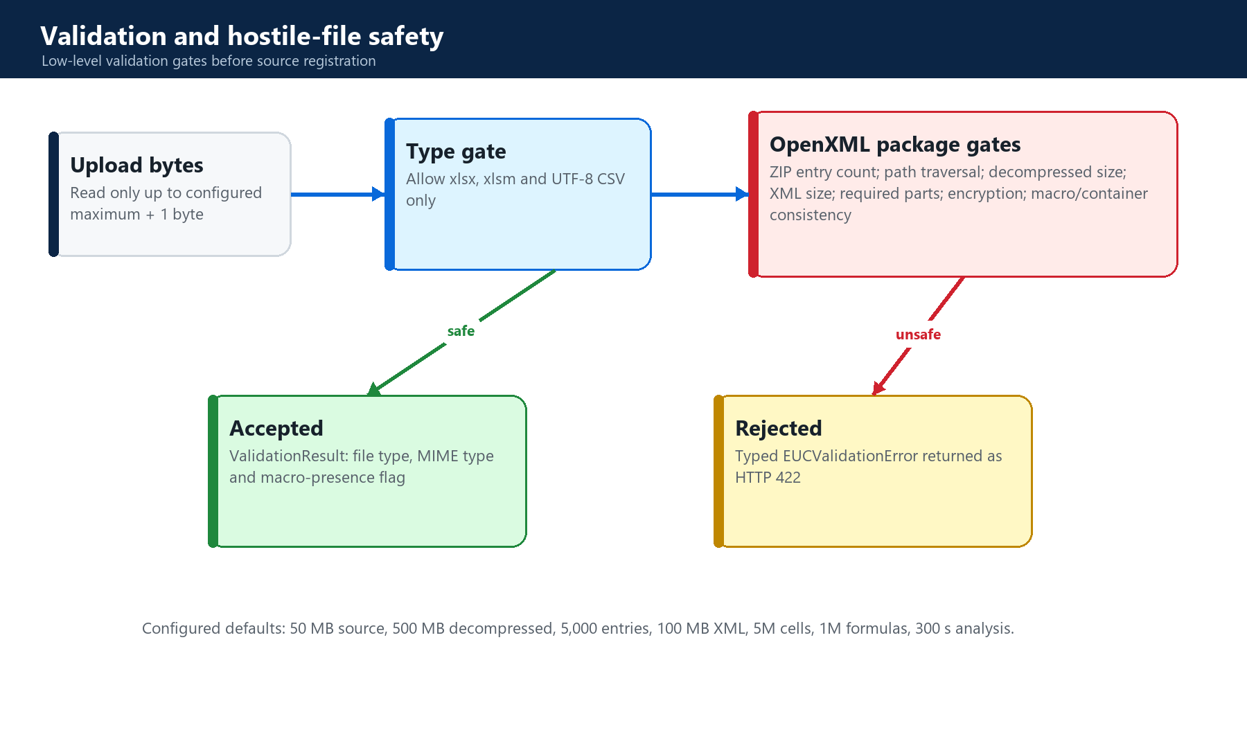
Figure 4. Validation gates and typed rejection path.
Condition | Error code | Default behavior
Unsupported extension | UNSUPPORTED_FORMAT | Reject anything except xlsx, xlsm and csv.
Invalid or missing OpenXML parts | CORRUPT_OPENXML | Reject malformed packages.
Unsafe path | PATH_TRAVERSAL | Reject absolute or parent-traversing package entries.
Excessive entries or expansion | ZIP_BOMB | Reject package expansion beyond limits.
Encrypted workbook | PASSWORD_PROTECTED | Reject because structure cannot be safely inventoried.
Macro payload in xlsx | INVALID_FILE | Reject inconsistent container; require xlsm.

5.3 Block C - fingerprinting, deduplication and immutable source
content_fingerprint computes SHA-256 over exact bytes. structure_fingerprint computes a canonical package-part signature excluding media and calcChain, or a CSV signature based on the first line. Repository-scoped content deduplication prevents duplicate EUC_ASSETS records for identical bytes. The original is stored in the semantic ledger as EUC_SOURCE_FILE, linked through object references, and retained as a garbage-collection root.
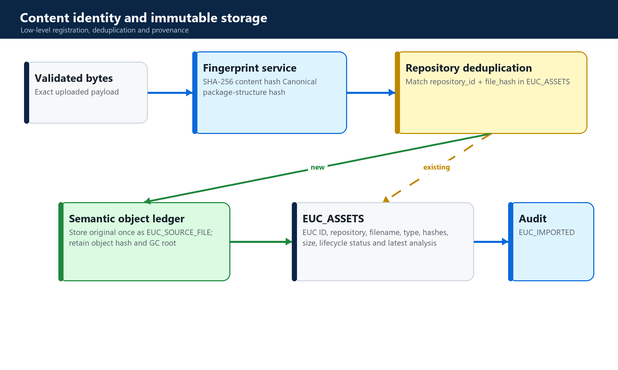
Figure 5. Source identity, object storage and deduplication.

5.4 Block D - analysis orchestration
analyze_euc creates a unique analysis run, associates it with the repository default branch head, records status transitions, reloads and revalidates the immutable source, writes a temporary file, and creates AnalysisContext. It then invokes the three analyzers, aggregates warnings and metrics, persists normalized records, stores the immutable manifest, updates the asset's latest-analysis pointer, records duration and audit events, and deletes the temporary file.
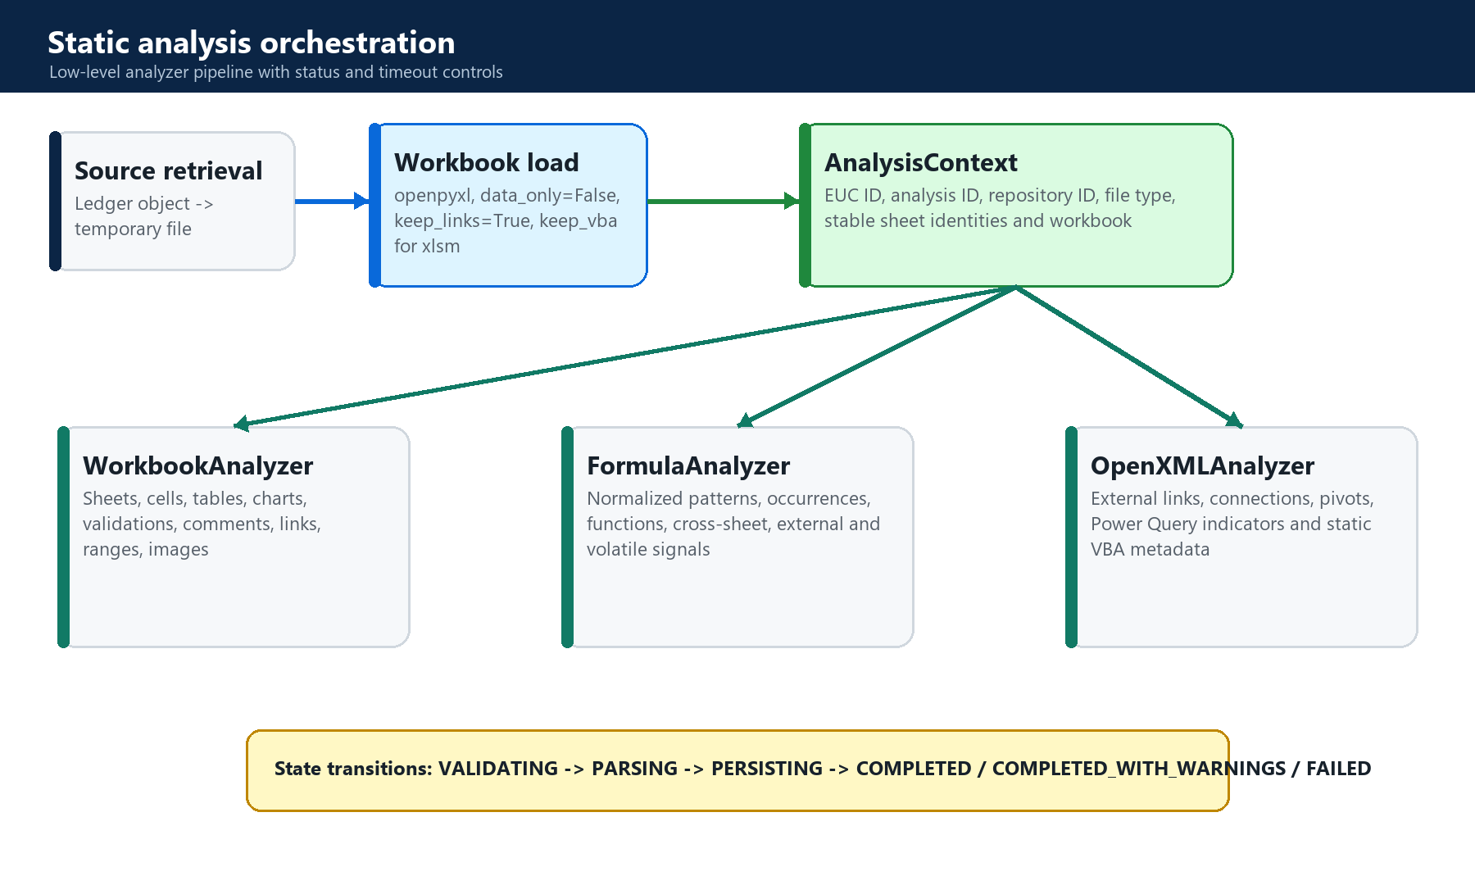
Figure 6. Analysis orchestration and result aggregation.
State | Meaning
PENDING | Source registered; no analysis started.
VALIDATING | Source retrieval and validation in progress.
PARSING | Workbook and package analyzers running.
PERSISTING | Normalized records and manifest being written.
COMPLETED | Analysis completed without warnings.
COMPLETED_WITH_WARNINGS | Usable inventory completed with static-analysis warnings.
FAILED | Analysis failed; errors are recorded against the run and asset.

5.5 Block E - workbook structural analyzer
WorkbookAnalyzer iterates every worksheet and cell through openpyxl. It counts used, formula, constant and styled-blank cells; captures comments and hyperlinks; records sheet visibility and hidden axes; inventories tables, validations, merged ranges, charts and images; and creates workbook-level metrics. Stable sheet IDs are reused from repository semantics where available, otherwise derived deterministically from the sheet name.
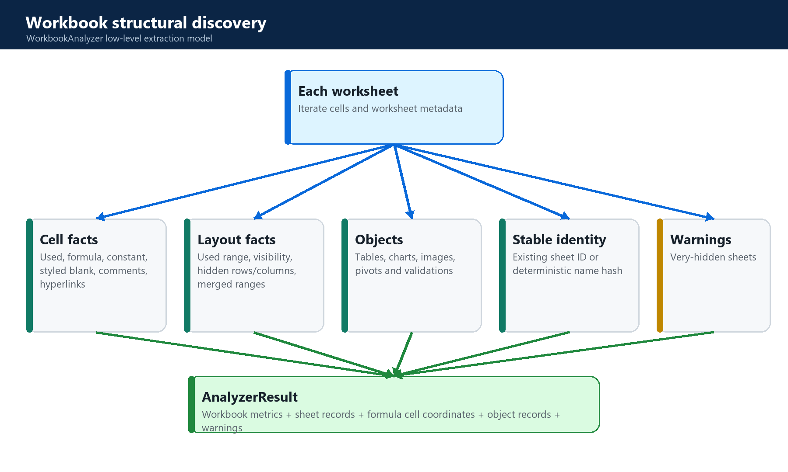
Figure 7. WorkbookAnalyzer extraction model.

5.6 Block F - formula pattern analyzer
FormulaAnalyzer consumes formula-cell records from WorkbookAnalyzer. It normalizes formulas so repeated relative-row logic groups into the same pattern, hashes each normalized expression, records every occurrence, extracts function names, and flags cross-sheet, external-workbook and volatile behavior. This produces a compact semantic view of repeated business logic while retaining raw formulas for traceability.
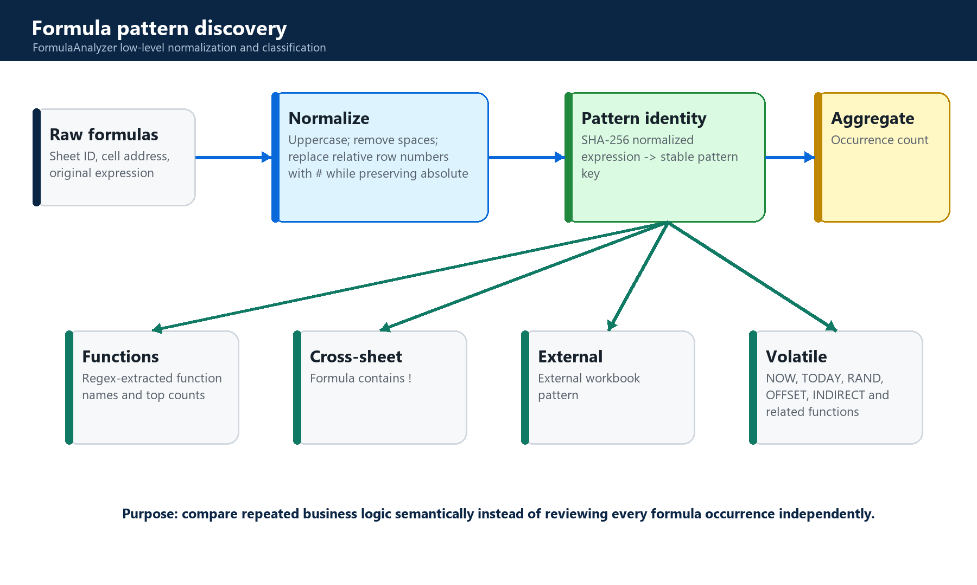
Figure 8. Formula normalization, identity and classification.
TECHNICAL BOUNDARY
Formula normalization is regex-based and intentionally lightweight. It groups common A1-style patterns but is not a complete Excel grammar or calculation engine.

5.7 Block G - OpenXML, external connection and VBA metadata analyzer
OpenXMLAnalyzer opens the validated workbook as a ZIP package. It detects external-link parts, packaged connection attributes, pivot definitions, Power Query indicators and vbaProject.bin. Credential-like connection attributes are redacted. VBA discovery records binary size and hash plus token-derived candidate module names and auto-execution event names. It does not execute VBA or fully decompile procedures.
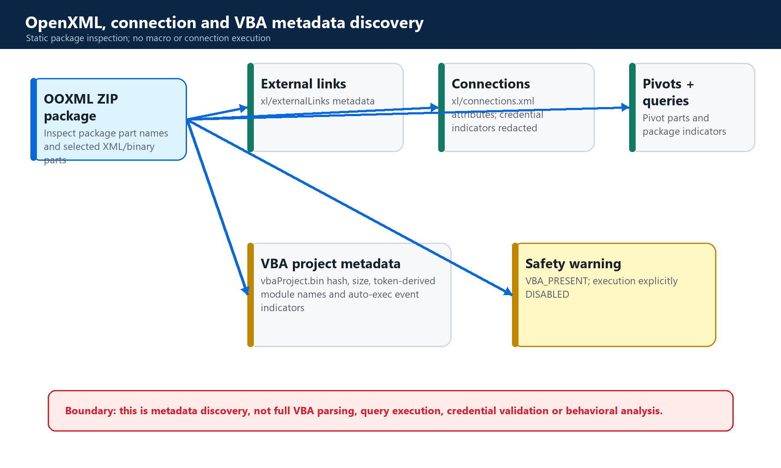
Figure 9. Static OpenXML and VBA metadata inspection.

5.8 Block H - normalized persistence and manifest
The service persists each analyzer result into purpose-specific tables. Formula occurrences are inserted in batches of 2,000. A summary merges workbook, formula and package metrics. The manifest records analyzer version, EUC ID, source commit, structure hash, summary, sheets, formula patterns, external links, connections, objects and warnings. The manifest is stored in the semantic ledger and references the immutable source object.
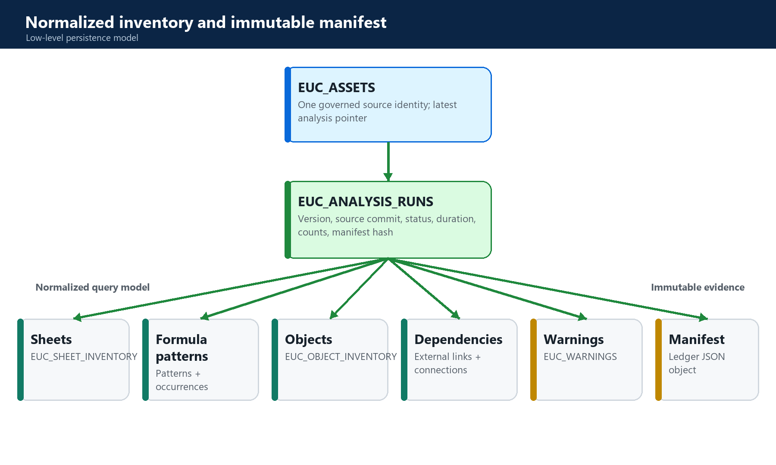
Figure 10. Normalized query model and immutable evidence model.

5.9 Portfolio, inventory views and export
GET /api/v1/euc lists accessible assets with repository metadata, latest status, analyzer version, warnings and summary. GET /inventory supports overview, sheets, formulas, objects and dependencies sections with limit/cursor pagination. The React page requests up to 250 records per section, renders summaries and lists, and exposes re-analysis and JSON export.
View | Primary evidence shown
Registered assets | Filename, repository, size, sheets, formulas and analysis status.
Workbook map | Sheet visibility, ranges, cell counts, formulas, tables, charts, validations and hidden axes.
Formula patterns | Normalized expression, functions, occurrence count and behavioral signals.
Objects | Grouped tables, named ranges, comments, hyperlinks, validations, charts, images, VBA and query indicators.
Dependency sources | External workbook references and packaged data connections.
Export JSON | The latest immutable manifest payload.

6. Data model and persistence

6.1 Core entities
Table | Key relationship | Purpose
EUC_ASSETS | EUC_ID; repository ID; latest analysis ID | Persistent source identity and lifecycle.
EUC_ANALYSIS_RUNS | ANALYSIS_ID -> EUC_ID | Versioned run status, provenance, metrics, manifest and errors.
EUC_SHEET_INVENTORY | ANALYSIS_ID + SHEET_ID | Worksheet structure and counts.
EUC_FORMULA_PATTERNS | ANALYSIS_ID + normalized hash | Grouped formula logic and classification.
EUC_FORMULA_OCCURRENCES | ANALYSIS_ID + pattern + cell | Raw formula evidence at cell level.
EUC_OBJECT_INVENTORY | ANALYSIS_ID + optional sheet | Workbook and worksheet object metadata.
EUC_EXTERNAL_LINKS | ANALYSIS_ID | External workbook relationships.
EUC_CONNECTIONS | ANALYSIS_ID | Packaged data-connection metadata.
EUC_WARNINGS | ANALYSIS_ID | Non-fatal analysis warnings.

6.2 Provenance chain
The provenance chain is: repository -> EUC asset -> immutable source object -> analysis run -> normalized records -> immutable manifest. The analysis run also records the repository source commit and analyzer version. The manifest object references the original source object, ensuring both remain storage roots.
WHY TWO STORAGE MODELS
Normalized SQL supports filtering, ordering and UI pagination. Immutable ledger objects support stable evidence, content addressing, audit and reproducibility. Both are required for an operational inventory platform.

7. API and user-interface contracts

7.1 Stage 2.1 endpoints
Method and path | Permission / input | Result
POST /api/v1/euc | Authenticated principal; euc.analyze; multipart repository_id + file | 201 asset record; may be deduplicated.
GET /api/v1/euc | Accessible repositories; optional repository_id and search | Portfolio assets with latest summary.
POST /api/v1/euc/{euc_id}/analysis | euc.analyze | Synchronous completed or failed analysis response.
GET /api/v1/euc/{euc_id}/analysis/{analysis_id} | euc.read | Status, progress, freshness, summary, warnings and errors.
GET /api/v1/euc/{euc_id}/inventory | euc.read; include, limit and cursor | Selected normalized inventory sections.
GET /api/v1/euc/{euc_id}/export | euc.read; completed analysis required | JSON manifest attachment.

7.2 Error mapping
The router converts repository permission failures to HTTP 403, missing assets or analyses to 404, EUC validation failures to 422 with a typed code, invalid requests and timeouts to 400, and unexpected analysis failures to 500. This gives the client a stable distinction between user-correctable input and server failure.

7.3 Pagination and response behavior
The inventory API applies the same limit and cursor to each requested section. next_cursor is returned if any selected list reaches the limit. The current UI requests 250 records per section once and does not follow next_cursor. Large inventories can therefore be partially displayed even though additional records remain available through the API.

8. EUC Inventory and AI Command Center

8.1 Architectural responsibility split
Deterministic EUC layer | AI layer
Counts sheets, cells, formulas, objects and connections | Explains why those facts matter.
Builds formula and dependency structures | Summarizes impact and recommends review.
Generates rules, scores and findings | Communicates findings in user language.
Stores source and manifest hashes | Cites evidence IDs and provenance.
Enforces deterministic control states | Must not replace PASS/FAIL authority.

CORE AI PRINCIPLE
The parser determines the facts. Graph and control engines determine relationships and deterministic findings. The LLM explains, compares and recommends using those authorized facts.

8.2 Implemented connection
The current EvidenceRetriever enforces ai.use and repository.read, adds deterministic repository KPIs and relevant audit events, then queries open EUC_FINDINGS for assets in the selected repository. Each evidence item carries type, ID, title, summary, classification, freshness and a source hash. Evidence text is explicitly labeled untrusted evidence rather than instructions, and injection-like content is isolated with warnings.
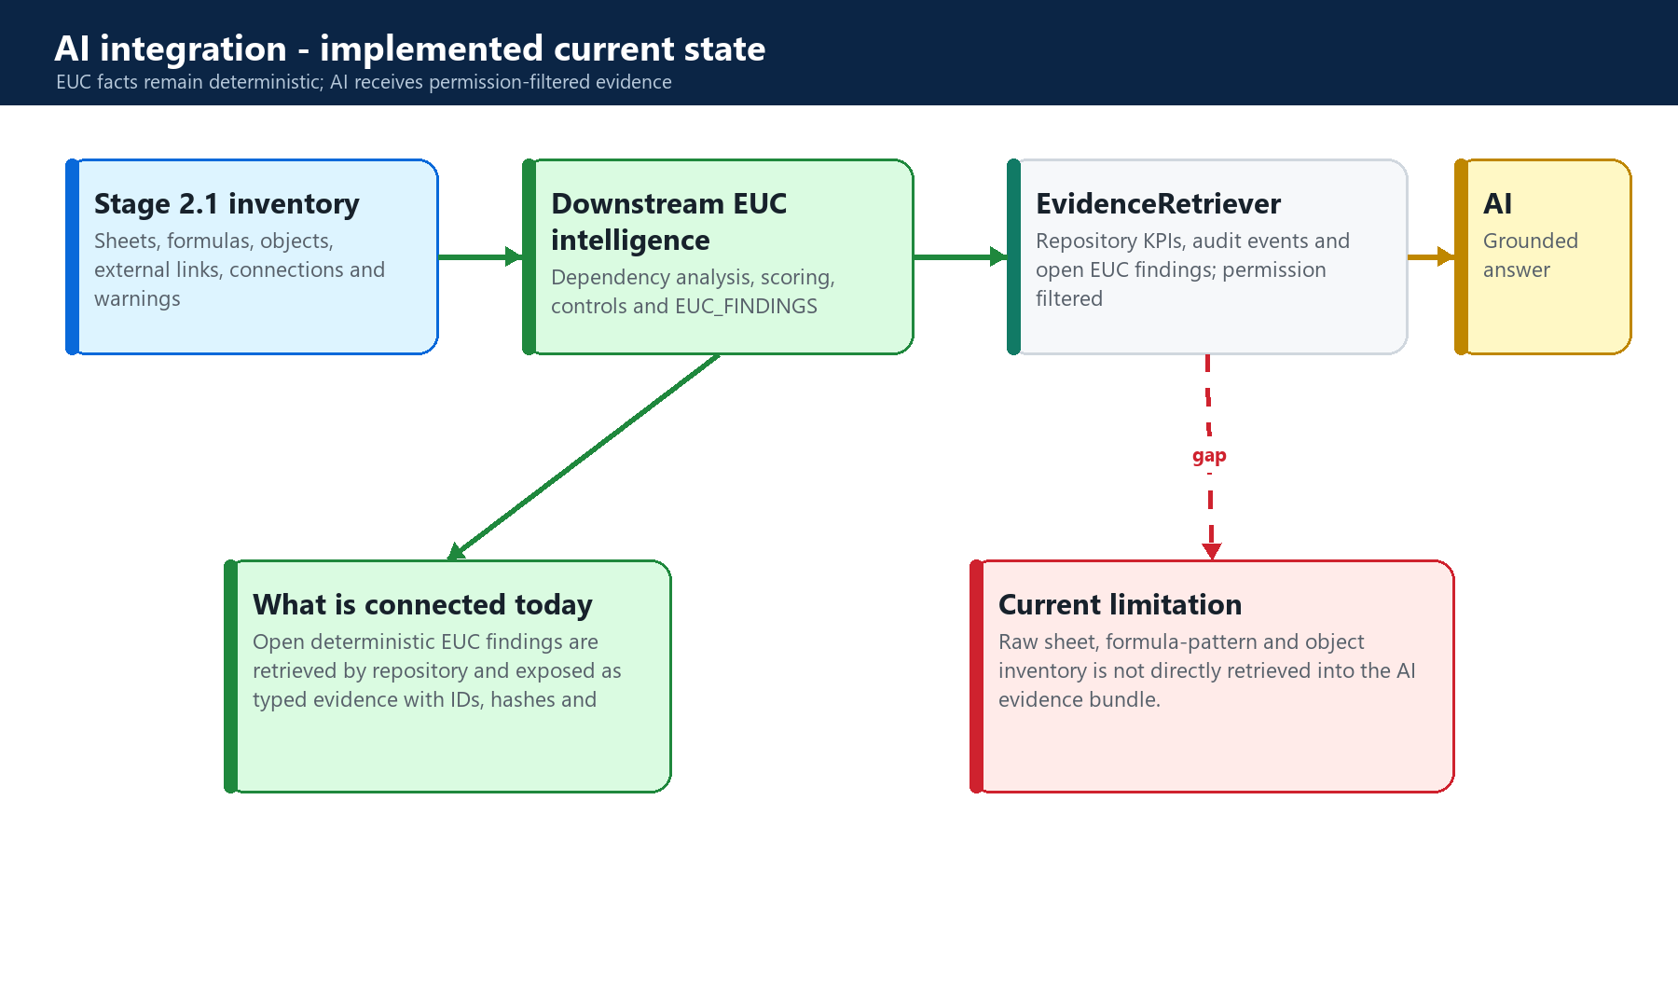
Figure 11. Implemented EUC-to-AI evidence path and present raw-inventory gap.

8.3 AI gateway controls
- Organization and feature policies determine whether AI and external providers are allowed for the evidence classification.
- Model routing selects an enabled governed model and active prompt version.
- Organization and per-user token quotas are enforced before provider execution.
- Evidence context receives a stable context hash and request-to-evidence references are persisted.
- Model output must validate against the GroundedAnswer schema; malformed output is repaired up to three attempts.
- Citations not present in the retrieved evidence allow-list are removed.
- A grounding score combines retrieval quantity and citation coverage; low evidence sets insufficient_evidence.
- Responses, conversations, token usage, latency and audit events are persisted.

8.4 Recommended direct EUC evidence adapter
To answer detailed questions such as 'Which sheets contain volatile formulas?' or 'Summarize the external connections in this workbook,' the AI layer should retrieve Stage 2.1 inventory sections directly rather than relying only on downstream findings. The adapter should accept repository and optional EUC scope, invoke existing authorized service methods or read-only tools, limit and summarize large occurrence sets deterministically, and emit typed evidence records with analysis ID, manifest hash, source commit and freshness.
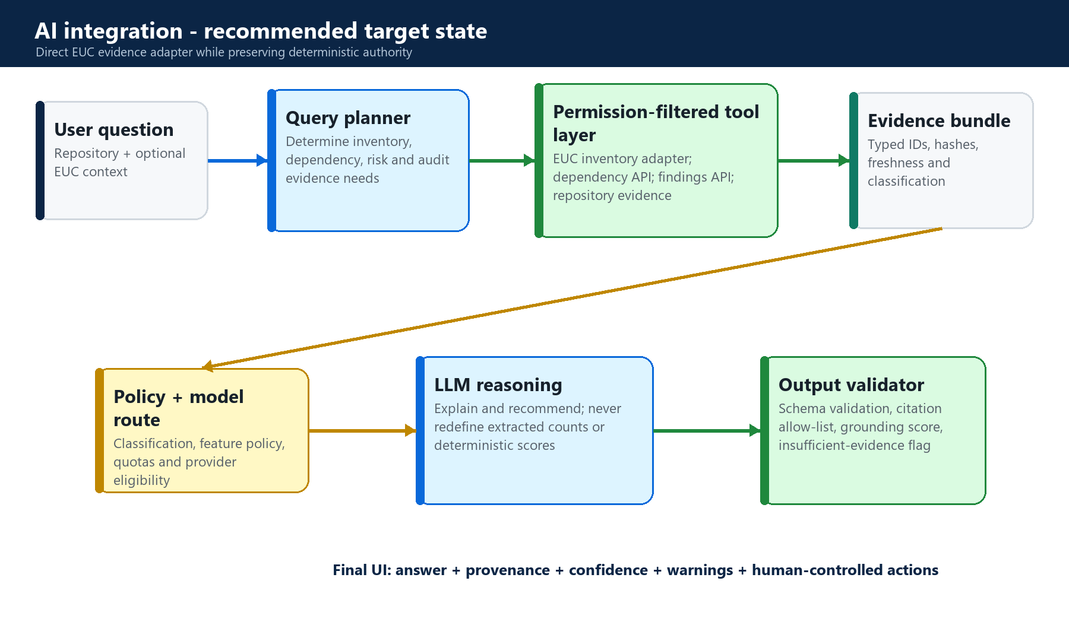
Figure 12. Recommended direct inventory grounding architecture.
Recommended evidence type | Source | Use
EUC_OVERVIEW | Latest analysis summary | Workbook-scale explanation and high-level risk context.
EUC_SHEET | EUC_SHEET_INVENTORY | Sheet map, visibility and structural questions.
EUC_FORMULA_PATTERN | EUC_FORMULA_PATTERNS | Business-logic and volatile/external formula questions.
EUC_OBJECT_SUMMARY | EUC_OBJECT_INVENTORY | Tables, named ranges, VBA, Power Query and validation questions.
EUC_CONNECTION | EUC_CONNECTIONS / EUC_EXTERNAL_LINKS | External system and workbook dependency explanation.
EUC_MANIFEST | Immutable manifest hash | Provenance and reproducibility reference.

9. Security, governance and non-functional behavior
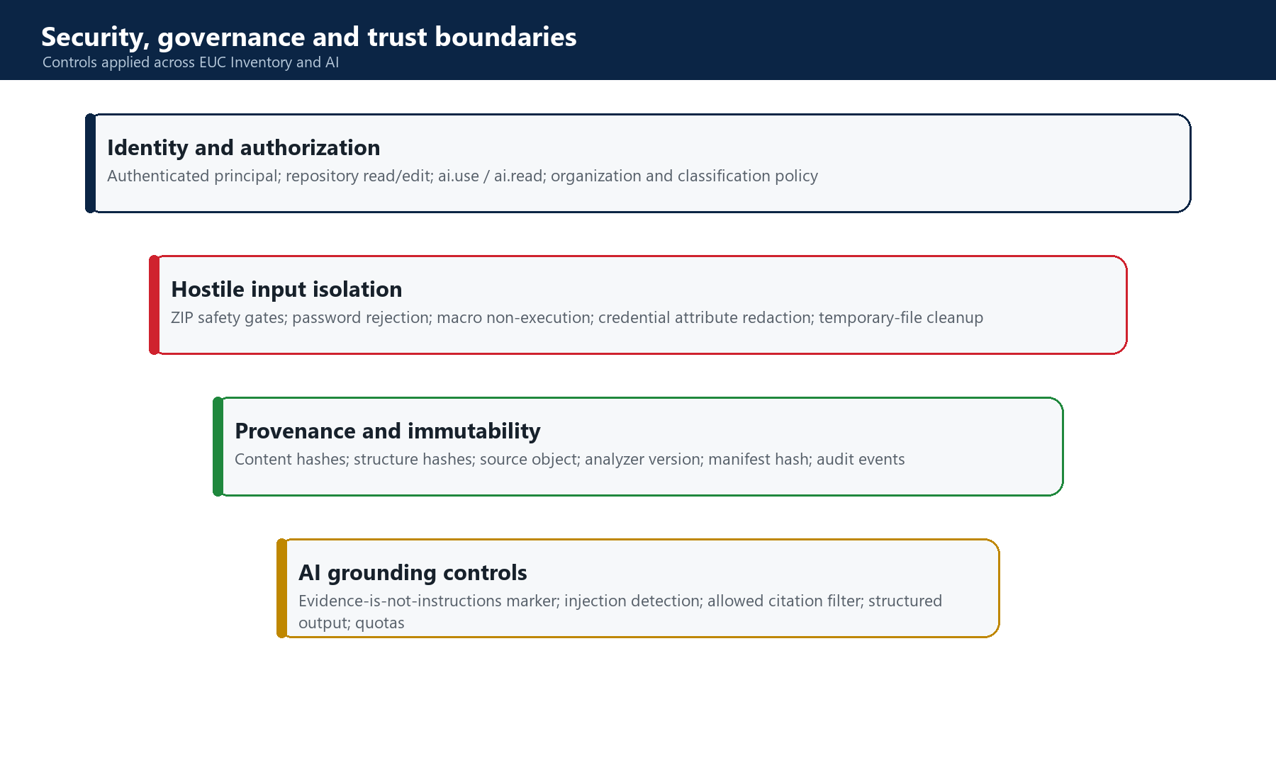
Figure 13. Security and trust controls spanning EUC Inventory and AI.

9.1 Access control
Repository access is resolved through active repository ownership or membership, followed by authorization_engine checks for euc.analyze or euc.read. AI applies organization-level ai.use or ai.read plus repository.read. The AI gateway additionally enforces classification and feature model policy.

9.2 Non-execution safety
openpyxl loads formulas without calculating them because data_only=False. keep_vba preserves VBA binary content for metadata inspection when the file is xlsm. The code does not launch Excel, invoke VBA, refresh connections or submit workbook content to an execution runtime. Temporary source files are removed in a finally block.

9.3 Limits and defaults
Control | Default
Maximum source file | 50 MB
Maximum decompressed package | 500 MB
Maximum ZIP entries | 5,000
Maximum XML part | 100 MB
Maximum cells | 5,000,000
Maximum formulas | 1,000,000
Analysis timeout | 300 seconds
Inventory API limit | 1-500 rows per requested section

9.4 Observability and audit
Registration, analysis start, completion and failure generate audit events. Completed analysis records duration metrics and result status. AI requests record model, prompt, context references, latency, token usage, output validity, grounding confidence and cache behavior. These records enable technical support, governance review and cost control.

10. Testing and acceptance strategy
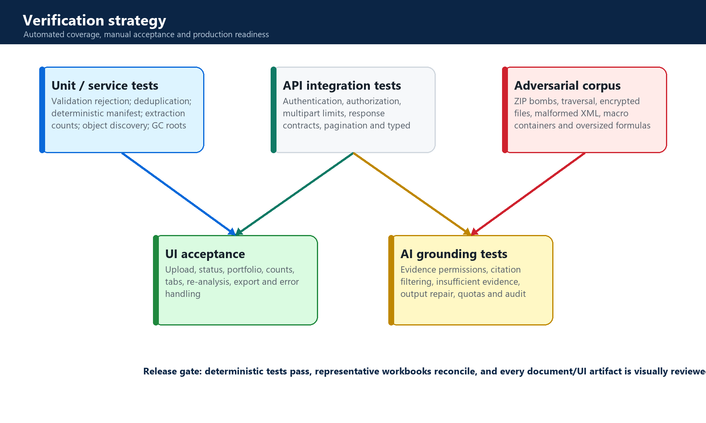
Figure 14. Recommended layered verification strategy.

10.1 Existing automated tests
backend/tests/test_stage21_euc_inventory.py creates a temporary product database and a representative workbook containing formulas, a very-hidden sheet, a table, data validation and a named range. It verifies invalid input rejection, repository-scoped deduplication, deterministic manifest hashes across re-analysis, expected formula counts, extracted sheets and objects, JSON export and storage garbage-collection roots.
VERIFIED BASELINE
The dedicated Stage 2.1 suite was executed during this documentation task: 3 tests passed. The frontend production build also completed successfully, with only webpack bundle-size warnings.

10.2 How to run the automated tests
Backend Stage 2.1:
cd C:\Projects\board-walk-clone-1\backend
python -m pytest tests\test_stage21_euc_inventory.py -q
Frontend production build:
cd C:\Projects\board-walk-clone-1\frontend
npm.cmd run build

10.3 Manual acceptance procedure
- Start the backend on http://localhost:8000 and the frontend on https://localhost:3000.
- Authenticate, create or select an editable repository, and open EUC Inventory.
- Upload a representative xlsx containing formulas, a table, validation, named ranges and a hidden sheet.
- Confirm source registration, completed status and workbook-map counts against Excel inspection.
- Confirm formula-pattern grouping and the cross-sheet, external and volatile indicators.
- Upload a representative xlsm and verify VBA_PRESENT while confirming that no macro side effect occurs.
- Export the JSON manifest and reconcile its analysis version, summary, objects and warnings.
- Upload the identical bytes again and verify the same EUC ID is returned as deduplicated.
- Modify one formula, upload again and verify a new content hash plus changed formula evidence.
- Validate a user without repository access receives 403 and an invalid package receives typed 422 detail.

10.4 Recommended missing tests
- Direct API tests for multipart byte limits, authentication, repository authorization and every error mapping.
- Dedicated CSV behavior, UTF-8 rejection, empty header and maximum-cell tests.
- Adversarial OpenXML fixtures for path traversal, high compression ratio, excessive entries, oversized XML and encryption.
- Real xlsm fixtures validating macro-container handling, warning content and no-execution guarantees.
- Inventory pagination tests where multiple sections independently cross the same cursor boundary.
- Failure-injection tests proving transaction rollback and temporary-file cleanup.
- Direct EUC-to-AI retrieval tests once the recommended raw-inventory adapter is implemented.
- UI tests for asynchronous error states, re-analysis and large portfolio/search behavior.

11. Advantages, limitations and recommended improvements

11.1 Advantages
- Transforms opaque workbook binaries into queryable technical evidence.
- Creates a safer discovery process by avoiding VBA and connection execution.
- Reduces duplicate storage and analysis ambiguity through cryptographic identity.
- Supports repeatable analysis and audit through versioned manifest hashes.
- Compresses repeated spreadsheet logic into formula patterns while retaining raw occurrences.
- Provides a reusable foundation for dependency, risk, control and migration features.
- Enables AI explanation over governed findings instead of allowing an LLM to guess workbook structure.

11.2 Current limitations
Limitation | Engineering impact
Only xlsx, xlsm and UTF-8 csv | Legacy xls and xlsb require additional parsers or conversion.
Synchronous analysis endpoint | Large files can hold requests for up to the configured timeout.
Regex formula normalization | Not a complete Excel grammar; structured references and dynamic constructs may be imperfectly grouped.
VBA token discovery | Does not produce a complete module/procedure/call graph.
Power Query package indicator | Does not fully parse M expressions or execute queries.
UI requests first 250 rows | Large sections require pagination support in the client.
AI retrieves findings, not raw inventory | Detailed workbook questions lack direct Stage 2.1 grounding today.
Structure hash uses names and sizes | It is useful for comparison but is not a semantic workbook-equivalence proof.

11.3 Prioritized improvements
- Add a direct, permission-filtered EUC evidence adapter to the AI retrieval layer.
- Move analysis to a background worker and expose polling or server-sent progress while retaining analysis-run state.
- Implement frontend cursor pagination and section-specific limits.
- Adopt a full Excel formula parser for richer normalization and structured-reference handling.
- Add deeper VBA and Power Query parsers in isolated static-analysis components.
- Build an adversarial workbook corpus and performance baseline for configured limits.
- Expose manifest/source freshness and repository-head staleness directly in the EUC UI.

12. Codebase traceability and dependencies

12.1 Primary implementation files
Path | Responsibility
frontend/src/App.jsx | EUC state, lifecycle calls and inventory rendering.
frontend/src/services/api.js | EUC REST client functions.
frontend/src/styles.css | EUC page visual system and responsive layout.
backend/app/api/euc.py | Authenticated API boundary and error mapping.
backend/app/euc/service.py | Registration, orchestration, persistence, retrieval and export.
backend/app/euc/validation.py | Hostile-file-aware source validation.
backend/app/euc/fingerprint.py | Content and structure fingerprints.
backend/app/euc/analyzers.py | Workbook, formula and OpenXML analyzers.
backend/app/euc/models.py | Shared analyzer contracts.
backend/app/database.py | Core EUC and downstream database schema.
backend/app/ai/retrieval.py | Permission-filtered evidence retrieval including EUC findings.
backend/app/ai/gateway.py | AI policy, routing, quota, structured output and citation controls.
backend/app/ai/service.py | Conversation, evidence and AI request orchestration.
backend/tests/test_stage21_euc_inventory.py | Dedicated Stage 2.1 automated tests.
backend/tests/test_stage5_ai_platform.py | AI grounding, citation filtering, quota and agent audit tests.

12.2 Direct technology dependencies
Dependency | Use in this feature
Python 3 | Backend services, static analysis and persistence orchestration.
FastAPI | Authenticated upload, inventory and export HTTP endpoints.
Pydantic | AI structured output and request validation; API request models.
openpyxl | Workbook structure and formula access without Excel execution.
python-multipart | Multipart file upload support.
SQLite | Normalized inventory and operational metadata.
React 18 | EUC Inventory and AI Command Center user interfaces.
Web APIs | FormData, authenticated fetch and JSON download.
Python standard library | ZIP/XML/CSV parsing, hashing, JSON, temporary files and timing.

Appendix A - Operational runbook

A.1 Local startup
- Install backend requirements from backend/requirements.txt.
- From backend, start uvicorn app.main:app --reload --port 8000.
- From frontend, run npm install if dependencies are absent, then npm.cmd start.
- Open https://localhost:3000 and accept the local development certificate if required.
- Use http://localhost:8000/docs for authenticated API contract inspection.

A.2 Failure triage
Symptom | Check
Upload rejected | HTTP detail code, extension, size, ZIP structure, encryption and repository edit permission.
Analysis failed | EUC_ANALYSIS_RUNS errors_json, asset status, audit event and configured limits.
Counts differ from Excel | Merged/styled blanks, formula data type, hidden axes, unsupported objects and analyzer version.
Inventory appears incomplete | API include list, limit/cursor and frontend 250-row request limit.
AI answer lacks workbook detail | Current retriever exposes EUC findings, not raw inventory; inspect evidence_bundle.
AI citation removed | Citation ID/type was not in the authorized retrieved evidence allow-list.

Appendix B - Acceptance checklist
- Supported files register only within authorized repositories.
- Unsafe, encrypted and malformed sources are rejected with typed errors.
- Identical source bytes deduplicate within the repository.
- Original source and manifest remain immutable storage roots.
- No VBA, formula calculation or external connection execution occurs.
- Sheet, formula, object, link and connection evidence reconciles with representative workbooks.
- Re-analysis produces deterministic manifest identity for unchanged inputs and analyzer version.
- Inventory export includes source and analysis provenance.
- AI responses cite only authorized evidence and signal insufficient grounding.
- Target-state direct raw-inventory AI retrieval is not claimed until implemented and tested.

Appendix C - Glossary
Term | Definition
AIR | Application Intermediate Representation used by the downstream native-model feature.
EUC | End-User Computing asset, typically a spreadsheet used to implement business logic or operations.
GC root | An object-store reference that prevents immutable source or manifest evidence from garbage collection.
Grounding | Constraining AI output to retrieved evidence and validating cited evidence references.
OOXML | Office Open XML package format used by xlsx and xlsm workbooks.
Semantic inventory | Normalized technical representation of workbook structures and logic.
Static analysis | Inspection without executing workbook formulas, macros, queries or external connections.
Volatile formula | A formula using functions that may recalculate frequently or create difficult dependency behavior.

Conclusion
EUC Inventory is not merely a file-upload page. It is the deterministic discovery and provenance layer that converts a governed workbook source into technical evidence. Its design separates extraction from interpretation: parsers and graph/control engines establish facts, while AI provides authorized explanation and recommendations. The current code already grounds AI in repository evidence and open EUC findings. Adding a direct Stage 2.1 evidence adapter is the clearest next step for detailed workbook-aware AI without weakening the deterministic source of truth.

