RSERC_CHK — Unit Test Document

Field | Value
Script | rserc_chk.sh
VMS Original | RSERC_CHK.COM
Test Platform | Linux / Bash 4+
Oracle Version | (as deployed)
Tester | ____________________________
Test Date | ____________________________

How to Source the Script for Testing
The script contains an entry-point guard that prevents main() from executing when sourced. This allows individual functions to be tested in isolation:
# Source the script (does NOT execute main)
# The script uses its default configuration paths:
# TAP_LOG_DIR=/data/tap/R53_TAPLIVE/TAP/LOG
# LOG_FILE=/data/tap/R53_TAPLIVE/TAP/LOG/rserc_chk.log
# WORK_DIR=/tmp/rserc_chk_$$ (created automatically)
source /path/to/rserc_chk.sh
All functions are now available to call directly.

Test Prerequisites (Global)
Prerequisite | Required For | How to Verify
Bash 4+ | All functions | bash –version
mailx installed | send_alert, send_report | which mailx
MTA running | send_alert, send_report | systemctl status postfix
Oracle sqlplus | generate_spid_list, generate_hourly_reports, check_rserc_failures | which sqlplus
OS Oracle auth | Above + DB queries | sqlplus -s / <<< "SELECT 1 FROM DUAL; EXIT;"
at daemon running | schedule_next_run | systemctl status atd
tee, find, wc | Multiple functions | Available in coreutils (standard)

1.1 Test: Basic Message Logging
Purpose:
Verify that log_msg writes a timestamped message to both stdout and the log file.
Test Steps:
- Source the script (see "How to Source" above)
- Run: log_msg "Test message from UT"
- Check stdout for the message
- Check the log file: tail -1 "${LOG_FILE}"
Inputs Required:
Input | Value
$1 (msg) | "Test message from UT"
LOG_FILE | ${TAP_LOG_DIR}/rserc_chk.log
Expected Output:
- stdout: DD-Mon-YYYY HH:MM:SS - Test message from UT (current timestamp)
- Log file last line: same as stdout
Actual Output:
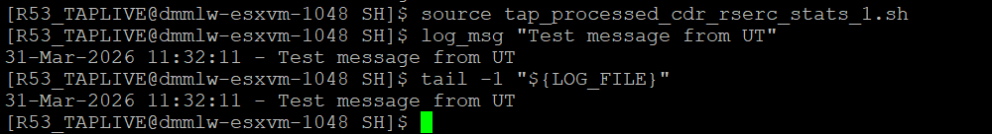

2.1 Test: Email Alert Dispatch
Purpose:
Verify that send_alert sends an email with an empty body and logs the subject.
Test Steps:
- Source the script
- Set EMAIL_L2 to a test mailbox you can check (or use a local user)
- Run: send_alert "UT - Test alert subject"
- Check the log file for the subject line
- Check the recipient mailbox for the email
Inputs Required:
Input | Value
$1 (subject) | "UT - Test alert subject"
EMAIL_L2 | Test email address
Expected Output:
- Email received with subject UT - Test alert subject and empty body
- Log file contains: DD-Mon-YYYY HH:MM:SS - UT - Test alert subject
Actual Output:
Kindly Ignore. It can be tested once email is configured.

2.2 Test: Graceful Handling When mailx is Unavailable
Purpose:
Verify that send_alert does not crash when mailx is not installed or MTA is down.
Test Steps:
- Source the script
- Temporarily rename mailx: sudo mv /usr/bin/mailx /usr/bin/mailx.bak
- Run: send_alert "UT - No mailx test"
- Check that the log line still appears
- Restore: sudo mv /usr/bin/mailx.bak /usr/bin/mailx
Inputs Required:
Input | Value
$1 (subject) | "UT - No mailx test"
Expected Output:
- No crash/termination
- Log file contains the message (even though email failed silently)
Actual Output:
Kindly Ignore. It can be tested once email is configured.

3.1 Test: Email with File Body
Purpose:
Verify that send_report sends an email containing the file's contents as the body.
Test Steps:
- Source the script
- Create a test file: echo "Line 1 of report" > ${WORK_DIR}/test_report.lis
- Run: send_report "UT - Report Subject" "${WORK_DIR}/test_report.lis" "youremail@example.com"
- Check the recipient mailbox for the email body content
Inputs Required:
Input | Value
$1 (subject) | "UT - Report Subject"
$2 (file) | ${WORK_DIR}/test_report.lis
$3 (recipient) | Your test email address
Expected Output:
- Email received with subject UT - Report Subject
- Email body contains: Line 1 of report
Actual Output:
Kindly Ignore. It can be tested once email is configured.

3.2 Test: Multiple Recipients
Purpose:
Verify that send_report sends the email to all specified recipients.
Test Steps:
- Source the script
- Create a test file: echo "Multi-recipient test" > ${WORK_DIR}/test_multi.lis
- Run: send_report "UT Multi" "${WORK_DIR}/test_multi.lis" "user1@test.com" "user2@test.com"
- Check both mailboxes
Inputs Required:
Input | Value
$1 (subject) | "UT Multi"
$2 (file) | ${WORK_DIR}/test_multi.lis
$3, $4 (recipients) | Two test addresses
Expected Output:
- Both recipients receive the email with the same subject and body
Actual Output:
Kindly Ignore. It can be tested once email is configured.

4.1 Test: Job Scheduled with at
Purpose:
Verify that the script schedules itself for 06:00 tomorrow using at.
Test Steps:
- Ensure atd is running: systemctl status atd
- Source the script
- Run: schedule_next_run
- Check the at queue: atq
- Inspect the job: at -c <job_id> (use job ID from atq)
Inputs Required:
Input | Value
atd | Must be running
$0 | Path to the script
Expected Output:
- atq shows a new job scheduled for 06:00 tomorrow
- The job command contains the script path
Actual Output:
Kindly test the scheduling through cron.

5.1 Test: SPID List Population from Oracle
Purpose:
Verify that the function queries Oracle and writes SP_IDs to a file.
Test Steps:
- Ensure Oracle sqlplus is available and OS-authenticated
- Source the script
- Run: generate_spid_list
- Check the output file: cat "${SPID_LIST}"
- Verify each line contains a numeric SP_ID
Inputs Required:
Input | Value
Oracle access | OS-authenticated
WORK_DIR | Must exist (writable)
service_providers table | Must contain data
Expected Output:
- File ${WORK_DIR}/spid_list.lis exists
- Contains one SP_ID per line (numeric values)
- No SQL*Plus banner text in the file
Actual Output:
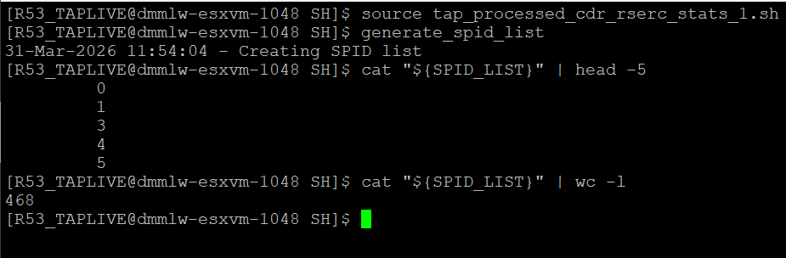

6.1 Test: Archive Check — Files Present (No Alert)
Purpose:
Verify no alert is sent when recent archive files exist.
Test Steps:
- Verify recent files exist: find /data/tap/R53_TAPLIVE/TAP/ARCHIVE -maxdepth 1 -iname 'cd*.dat' -mmin -240 | head -5
- Source the script
- Run: check_tap_directories
- Verify NO "No Call files processed" alert in log
Inputs Required:
Input | Value
TAP_ARCHIVE_DIR | /data/tap/R53_TAPLIVE/TAP/ARCHIVE
Files in dir | At least one cd*.dat < 4hr old
Expected Output:
- Log shows directory checks but NO archive alert
Actual Output:

6.3 Test: Collect Directory — Over Threshold (Alert)
Purpose:
Verify alert when collect directory has more files than MAX threshold.
Test Steps:
- Check current file count: find /data/tap/R53_TAPLIVE/TAP/COLLECT -maxdepth 1 -iname 'CD?????GBRCN*.dat' | wc -l
- Lower threshold below current count: export MAX=2
- If fewer than 3 files exist, create test files: touch ... CD00001GBRCN_ut_a.dat etc.
- Source the script
- Run: check_tap_directories
- Check log for "There are N files in tap collection" (where N > MAX)
- Cleanup test files: rm -f /data/tap/R53_TAPLIVE/TAP/COLLECT/CD*GBRCN_ut_*.dat
Inputs Required:
Input | Value
TAP_COLLECT_DIR | /data/tap/R53_TAPLIVE/TAP/COLLECT
MAX | 2 (lowered for testing)
Files | 3+ files matching CD?????GBRCN*
Expected Output:
- Log contains: There are 3 files in tap collection
Actual Output:
Kindly test as part of system testing.

6.4 Test: Collect Directory — Under Threshold (No Alert)
Purpose:
Verify no alert when file count is within threshold.
Test Steps:
- Use actual collect directory: /data/tap/R53_TAPLIVE/TAP/COLLECT
- Set threshold to default: export MAX=400
- Source and run: check_tap_directories
- Verify NO "files in tap collection" alert in log
Inputs Required:
Input | Value
MAX | 400
Files | Below threshold
Expected Output:
- No alert for collect directory
Actual Output:
Kindly test as part of system testing.

6.5 Test: Per-SPID Split Directory Check
Purpose:
Verify per-SPID split directory threshold alerting using SPID_LIST.
Test Steps:
- Ensure SPID list exists: cat "${SPID_LIST}" (generated by generate_spid_list)
- Pick a valid SPID from the list (e.g., 7 → 007)
- Check existing files: ls /data/tap/R53_TAPLIVE/TAP/SPLIT/007/ | wc -l
- Create test files exceeding threshold: for i in $(seq 1 5); do touch "/data/tap/R53_TAPLIVE/TAP/SPLIT/007/CD_ut_test_${i}.SPLIT"; done
- Lower threshold: export SPLIT_MAX=2
- Source the script and run: check_tap_directories
- Check log for: "There are N files in TAP Distribute for spid 007"
- Cleanup test files: rm -f /data/tap/R53_TAPLIVE/TAP/SPLIT/007/CD_ut_test_*.SPLIT
Inputs Required:
Input | Value
TAP_OB_SPLIT | /data/tap/R53_TAPLIVE/TAP/SPLIT
SPLIT_MAX | 2 (lowered for testing)
SPID_LIST | ${WORK_DIR}/spid_list.lis (from Oracle)
Expected Output:
- Log contains: There are 5 files in TAP Distribute for spid 007
Actual Output:
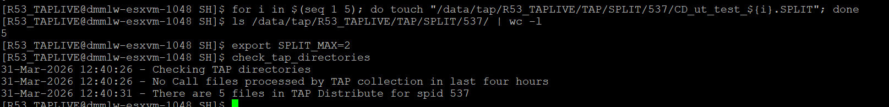

7.1 Test: Report Files Generated and Emailed
Purpose:
Verify that Oracle spool files are generated, emailed, and cleaned up.
Test Steps:
- Ensure Oracle sqlplus is available
- Source the script
- Set run_count=2 (to enable zero-RSERC check)
- Run: generate_hourly_reports
- Check log for listed report messages
- Verify spool files were cleaned up: ls ${WORK_DIR}/files_created* (should fail)
- Check email delivery
Inputs Required:
Input | Value
Oracle connection | OS-authenticated, DB accessible
run_count | 2
EMAIL_L2 | Test address
EMAIL_APOLLO | Test address
Expected Output:
- Three emails sent (files_created, recs_created ×2)
- Temp files deleted after sending
- Log messages as listed above
Actual Output:
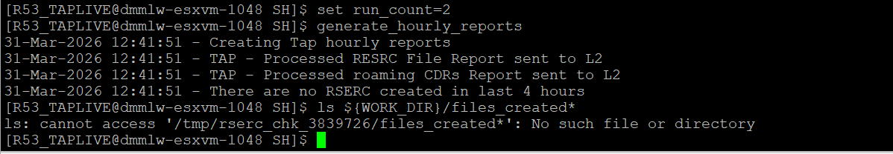

7.2 Test: Zero-RSERC Alert (run_count > 1)
Purpose:
Verify that a zero-RSERC alert fires when no files were created in last 4 hours.
Test Steps:
- Source the script
- Set run_count=3
- Run: generate_hourly_reports
- If Oracle returns FILE_COUNT=0, check log for: "There are no RSERC created in last 4 hours"
- If data exists, create mock files_created1.lis with FILE_COUNT=0 and call the checking portion manually
Inputs Required:
Input | Value
run_count | > 1
FILE_COUNT | 0 (from Oracle or mock file)
Expected Output:
- Alert: There are no RSERC created in last 4 hours
Actual Output:
Kindly test as part of system testing.

7.3 Test: Zero-RSERC — First Run (No Alert)
Purpose:
Verify that the zero-RSERC alert is suppressed on the first hourly run (run_count=1).
Test Steps:
- Source the script
- Set run_count=1
- Create mock file: echo "FILE_COUNT= 0" > "${WORK_DIR}/files_created1.lis"
- Observe that NO alert is sent (check log)
Inputs Required:
Input | Value
run_count | 1
FILE_COUNT | 0
Expected Output:
- NO alert is sent (first run is excluded)
Actual Output:
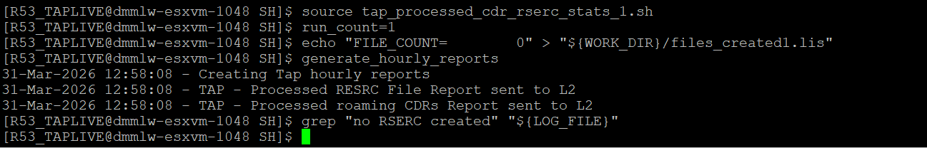

8.1 Test: Assembly/Dist Process Running (Skip Check)
Purpose:
Verify that failure checks are skipped when assembly/distribution processes are active.
Test Steps:
- Start a dummy process matching dist (example): bash -c "exec -a dist_test sleep 600" &
- Capture PID: DIST_PID=$!
- Source the script, run: check_rserc_failures
- Verify returns immediately (no .don/.tmp checks)
- Kill dummy: kill $DIST_PID
Inputs Required:
Input | Value
Running process | Process with "dist" in name/args
Expected Output:
- Function returns without .don or .tmp checking
- Log shows only "Checking for RSERC failures"
Actual Output:
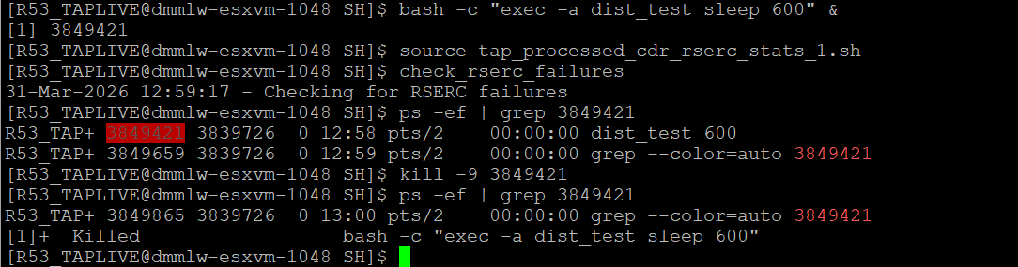

8.2 Test: .don Files Detected (Alert)
Purpose:
Verify that .don files trigger an alert email.
Test Steps:
- Create a test .don file: touch /data/tap/R53_TAPLIVE/TAP/OG_SP/ut_test_file.don
- Ensure no dist/assemb processes running: ps -ef | grep -i 'assemb\|dist' | grep -v grep
- Source the script, run: check_rserc_failures
- Check log for: "RSERC Failure - Procedure 841 - *.DON files left out"
- Cleanup test file: rm -f /data/tap/R53_TAPLIVE/TAP/OG_SP/ut_test_file.don
Inputs Required:
Input | Value
TAP_OUTGOING_SP | /data/tap/R53_TAPLIVE/TAP/OG_SP
.don files | At least one present
Expected Output:
- Alert email sent to TAP Support and L2
- Log contains: RSERC Failure - Procedure 841 - *.DON files left out
Actual Output:
Kindly test as part of system testing.

8.3 Test: .tmp Files Detected (Alert + Recovery)
Purpose:
Verify that .tmp files trigger an alert AND automatic RSERC recovery.
Test Steps:
- Create test files: touch /data/tap/R53_TAPLIVE/TAP/OG_SP/mrlog_test_...0007_file.tmp and touch /data/tap/R53_TAPLIVE/TAP/OG_SP/ut_other_file.tmp
- Ensure no dist/assemb processes running: ps -ef | grep -i 'assemb\|dist' | grep -v grep
- Source the script, run: check_rserc_failures
- Check log for: "RSERC Failure - Procudure 841" and "Re-running RSERC for SP_ID: ..."
- Verify .tmp deleted: ls /data/tap/R53_TAPLIVE/TAP/OG_SP/*.tmp (should fail)
Inputs Required:
Input | Value
TAP_OUTGOING_SP | /data/tap/R53_TAPLIVE/TAP/OG_SP
TAP_PERIOD_DIR | /data/tap/R53_TAPLIVE/TAP/PERIOD
RERUN_RSERC_SQL | Path to valid SQL or mock script
Expected Output:
- Alert email with "Procudure 841" (typo preserved)
- tmp files deleted from both directories
- SP_ID extracted and RSERC re-run triggered
- Log: Re-running RSERC for SP_ID: <extracted_id>
Actual Output:
Kindly test as part of system testing.

8.4 Test: No .don or .tmp Files (Clean State)
Purpose:
Verify that no alerts are sent when directories are clean.
Test Steps:
- Verify no .don or .tmp files: ls /data/tap/R53_TAPLIVE/TAP/OG_SP/*.don /data/tap/R53_TAPLIVE/TAP/OG_SP/*.tmp 2>/dev/null | wc -l (should be 0)
- Source the script, run: check_rserc_failures
- Verify log shows only "Checking for RSERC failures" — no alerts
Inputs Required:
Input | Value
TAP_OUTGOING_SP | /data/tap/R53_TAPLIVE/TAP/OG_SP (clean)
Expected Output:
- No alert emails
- Log shows only "Checking for RSERC failures"
Actual Output:
Kindly test as part of system testing.

9.1 Test: Startup Sequence
Purpose:
Verify that main() calls schedule_next_run, generate_spid_list, and enters the loop correctly.
Test Steps:
- Run the full script in a controlled environment
- Override directories to test dirs (if required)
- Run: ./rserc_chk.sh (or bash rserc_chk.sh)
- Watch log output for startup sequence messages
- Let it run for one cycle, then Ctrl+C to stop
Inputs Required:
Input | Value
All env vars | Pointing to test directories
Oracle | Available
MTA | Running
Expected Output:
- Log shows the complete startup sequence listed
- Script loops every 10 minutes and checks for failures
- Hourly checks execute when the clock hour changes
Actual Output:
Kindly test as part of system testing.

9.2 Test: Exit at Hour 23
Purpose:
Verify that the script exits cleanly when the clock hour reaches 23.
Test Steps:
- Start the script close to 23:00 (or mock the time)
- Verify log shows: "RSERC_CHK completed"
- Verify temp files in WORK_DIR are cleaned up
Inputs Required:
Input | Value
System time | Approaching 23:00
Expected Output:
- Script exits with code 0
- Cleanup executed (old logs deleted, WORK_DIR removed)
- Log: RSERC_CHK completed
Actual Output:
Kindly test as part of system testing.

10.1 Test: Normal Cleanup
Purpose:
Verify that cleanup_and_exit removes temp files and old logs.
Test Steps:
- Source the script
- Create temp files in WORK_DIR (as per procedure)
- Create an old log file (>30 days)
- Run: cleanup_and_exit
- Verify WORK_DIR removed and old log deleted
- Verify log shows: "RSERC_CHK completed"
Inputs Required:
Input | Value
WORK_DIR | Directory with temp files
TAP_LOG_DIR | Directory with old log (>30 days)
Expected Output:
- WORK_DIR removed
- Old logs (>30 days) deleted
- Recent logs preserved
- Log: RSERC_CHK completed
Actual Output:
Kindly test as part of system testing.

10.2 Test: Double-Call Guard
Purpose:
Verify that calling cleanup_and_exit twice does not produce duplicate log entries.
Test Steps:
- Source the script
- Reset guard: _CLEANUP_DONE=0
- Run: cleanup_and_exit
- Run again: cleanup_and_exit
- Count completion entries: grep -c "RSERC_CHK completed" "${LOG_FILE}"
Inputs Required:
Input | Value
_CLEANUP_DONE | 0 (before first call)
Expected Output:
- "RSERC_CHK completed" appears exactly ONCE in the log
- Second call returns immediately with exit code 0
Actual Output:
Kindly test as part of system testing.

11.1 Test: Sourcing Does Not Execute Main
Purpose:
Verify that sourcing the script makes functions available without running main().
Test Steps:
- Run: source ./rserc_chk.sh
- Verify no "RSERC CHK started" in stdout
- Verify functions are available: type log_msg
Inputs Required:
Input | Value
None
Expected Output:
- No output from sourcing (main does not execute)
- type log_msg shows: log_msg is a function
Actual Output:
Kindly test as part of system testing.

11.2 Test: Direct Execution Runs Main
Purpose:
Verify that running the script directly invokes main() and sets up the EXIT trap.
Test Steps:
- Run: bash rserc_chk.sh (with appropriate env vars set)
- Verify "RSERC CHK started" appears in log
- Ctrl+C to trigger SIGINT trap
- Verify "RSERC_CHK completed" appears (cleanup triggered)
Inputs Required:
Input | Value
Env vars | All TAP_* paths, Oracle access
Expected Output:
- "RSERC CHK started" in log
- On Ctrl+C: "RSERC_CHK completed" logged, temp files cleaned
Actual Output:
Kindly test as part of system testing.

Test Summary
# | Function | Test Case | Pass/Fail | Remark
1.1 | log_msg | Basic message logging | Pass
2.1 | send_alert | Email alert dispatch | ________ | Ignore as email is not configured
2.2 | send_alert | mailx unavailable | ________ | Ignore as email is not configured
3.1 | send_report | Email with file body | ________ | need to be tested during system testing
3.2 | send_report | Multiple recipients | ________ | need to be tested during system testing
4.1 | schedule_next_run | Job scheduled with at | ________ | Test the cronjob
4.2 | schedule_next_run | Fallback when at unavailable | ________ | Test the cronjob
5.1 | generate_spid_list | SPID list from Oracle | Pass
6.1 | check_tap_directories | Archive — files present | Pass
6.3 | check_tap_directories | Collect — over threshold | ________ | need to be tested during system testing
6.4 | check_tap_directories | Collect — under threshold | ________ | need to be tested during system testing
6.5 | check_tap_directories | Per-SPID split check | Pass
7.1 | generate_hourly_reports | Reports generated & emailed | Pass
7.2 | generate_hourly_reports | Zero-RSERC alert (run > 1) | ________ | need to be tested during system testing
7.3 | generate_hourly_reports | Zero-RSERC — first run | Pass
8.1 | check_rserc_failures | Process running (skip) | Pass
8.2 | check_rserc_failures | .don files detected | ________ | need to be tested during system testing
8.3 | check_rserc_failures | .tmp files + recovery | ________ | need to be tested during system testing
8.4 | check_rserc_failures | Clean state (no alerts) | ________ | need to be tested during system testing
9.1 | main | Startup sequence | ________ | need to be tested during system testing
9.2 | main | Exit at hour 23 | ________ | need to be tested during system testing
10.1 | cleanup_and_exit | Normal cleanup | ________ | need to be tested during system testing
10.2 | cleanup_and_exit | Double-call guard | ________ | need to be tested during system testing
11.1 | Entry-point guard | Sourcing does not execute main | ________ | need to be tested during system testing
11.2 | Entry-point guard | Direct execution runs main | ________ | need to be tested during system testing

