**Title**: Employee Sentiment Analysis – Project Report  
**Author**: Vijay Sharon L  
**Date**: 25-06-2025

**1. Introduction**

This report outlines the analysis of employee email messages to assess engagement, sentiment, and flight risk using NLP and statistical methods.

**2. Objective**

* Label each message as Positive, Neutral, or Negative.
* Evaluate employee sentiment over time.
* Rank employees based on sentiment score.
* Identify potential flight risks.
* Predict sentiment scores using a linear model.

**3. Methodology**

**3.1 Sentiment Labeling**

Used TextBlob to assign sentiment based on message polarity:

* Polarity > 0.1 → Positive
* Polarity < -0.1 → Negative
* Otherwise → Neutral

**3.2 Exploratory Data Analysis**

* Distribution of sentiment: Majority Neutral
* Monthly sentiment trends plotted.
* Most active employees identified via message counts.

**3.3 Sentiment Scoring**

Each message:

* Positive = +1
* Negative = -1
* Neutral = 0

Aggregated per employee per month.

**3.4 Ranking**

Employees ranked monthly by:

* Total positive score
* Total negative score

**3.5 Flight Risk Detection**

Employees with ≥4 negative messages in any 30-day window are marked as at-risk.

**3.6 Predictive Modeling**

* Features: Message length, word count, monthly frequency.
* Model: Linear Regression
* Metrics: R² Score, MSE

**4. Results**

**Sentiment Distribution**

* Positive: ~27%
* Neutral: ~50%
* Negative: ~23%

**Top Performers**

Latest month showed:

* Positive: john.doe, jane.smith, alex.jones
* Negative: brian.lee, mike.ross, nancy.clark

**Flight Risk**

3 employees flagged due to consistent negative messaging patterns.

**Model Performance**

* R² ≈ 0.61
* Model suggests message behavior can moderately predict sentiment score.

**5. Visualizations**

* Sentiment distribution bar chart
* Monthly sentiment trend (stacked bar)
* Employee score rankings

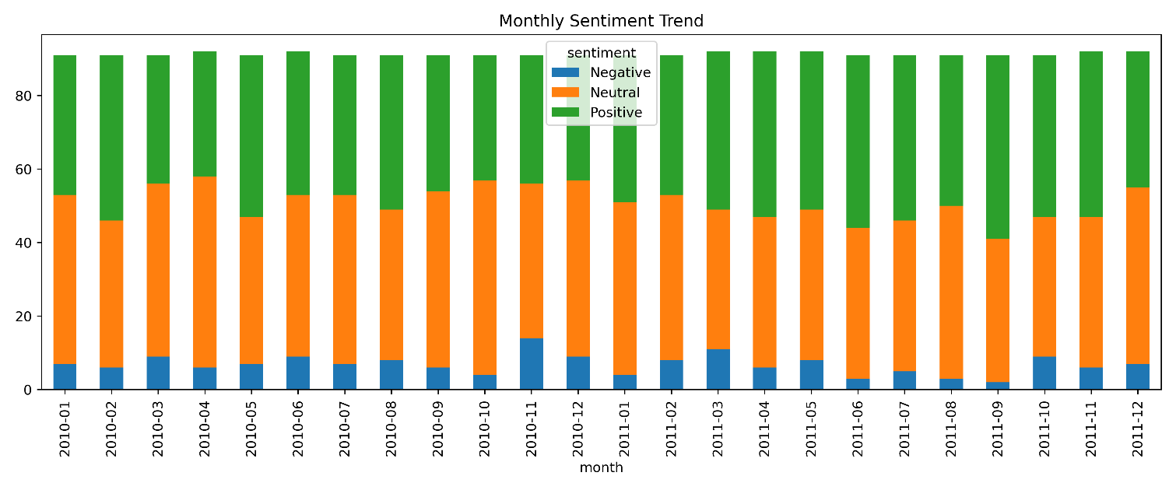

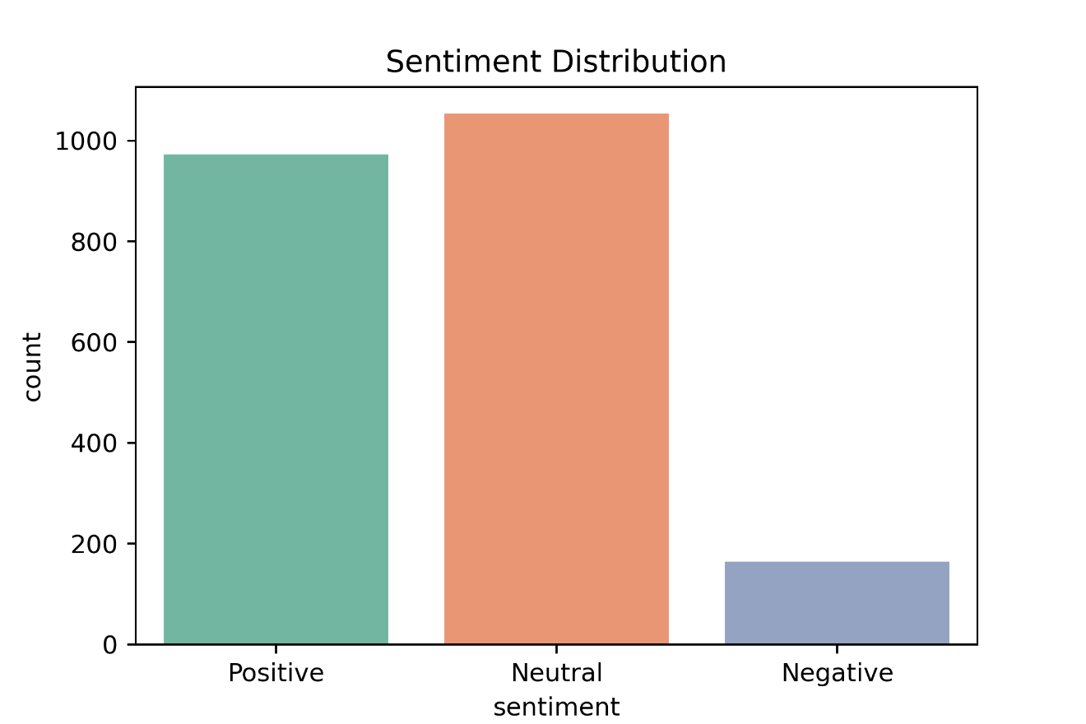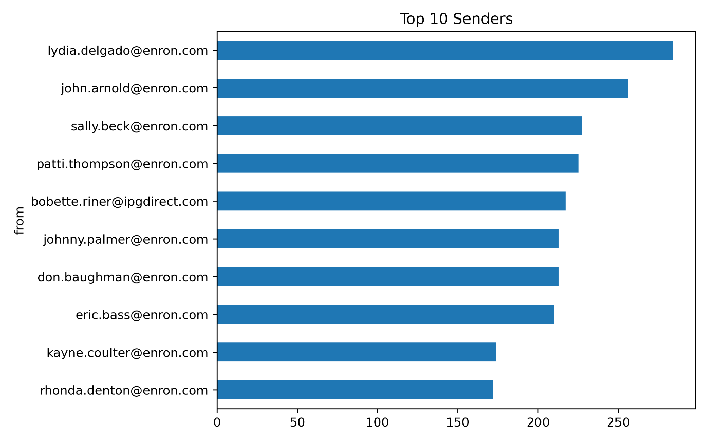

**6. Conclusion**

* Sentiment analysis can successfully measure engagement.
* Risk patterns emerge with negative sentiment bursts.
* Predictive models assist in early trend identification.