**Understanding Principle Component Analysis(PCA) step by step.**

**Introduction**

**Principal component analysis** (**PCA**) is a statistical procedure that is used to reduce the dimensionality.

**Steps Involved in the PCA**

***Step 1:*** Standardize the dataset.

***Step 2:***Calculate the covariance matrix for the features in the dataset.

***Step 3:***Calculate the eigenvalues and eigenvectors for the covariance matrix.

***Step 4:***Sort eigenvalues and their corresponding eigenvectors.

***Step 5:***Pick k eigenvalues and form a matrix of eigenvectors.

**Step 6:** Transform the original matrix.

Let's go to each step one by one.

**1. Standardize the Dataset**

Assume we have the below dataset which has 4 features and a total of 5 training examples.

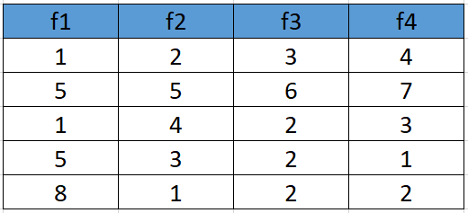

Dataset matrix

First, we need to standardize the dataset and for that, we need to calculate the mean and standard deviation for each feature.

Standardization formula

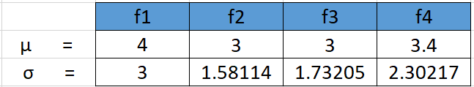

Mean and standard deviation before standardization

After applying the formula for each feature in the dataset is transformed as below:

Standardized Dataset

**2. Calculate the covariance matrix for the whole dataset**

Covariance indicates **the relationship of two variables whenever one variable changes**. If an increase in one variable results in an increase in the other variable, both variables are said to have a positive covariance.

The formula to calculate the covariance matrix:

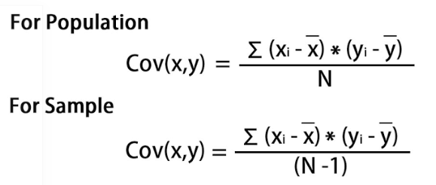

Covariance Formula

The covariance matrix for the given dataset will be calculated as below

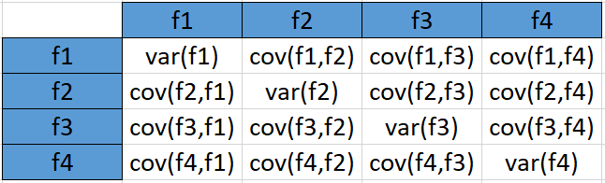

Since we have standardized the dataset, so the **mean for each feature is 0** and the standard deviation is 1.

var(f1) = ((-1.0-0)² + (0.33-0)² + (-1.0-0)² +(0.33–0)² +(1.33–0)²)/5  
**var (f1) = 0.8**

cov(f1,f2) =  
((-1.0–0)*(-0.632456-0) +  
(0.33–0)*(1.264911-0) +  
(-1.0–0)* (0.632456-0)+  
(0.33–0)*(0.000000 -0)+  
(1.33–0)*(-1.264911–0))/5  
**cov(f1,f2 = -0.25298**

In the similar way we can calculate the other covariances and which will result in the below covariance matrix

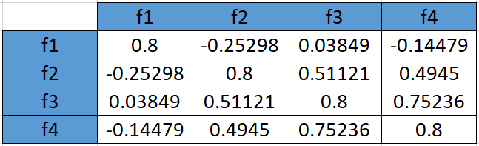

covariance matrix (population formula)

**3. Calculate eigenvalues and eigen vectors.**

An **eigenvector** is a nonzero vector that changes at most by a scalar factor when that linear transformation is applied to it. The corresponding **eigenvalue** is the factor by which the eigenvector is scaled.

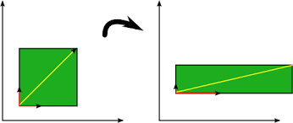

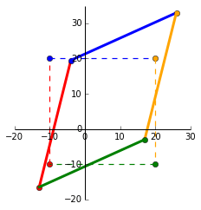

Eigenvectors **make understanding linear transformations easy**. They are the "axes" (directions) along which a linear transformation acts simply by "stretching/compressing" and/or "flipping"; eigenvalues give you the factors by which this compression occurs

Let A be a square matrix (in our case the covariance matrix), ν a vector and λ a scalar that satisfies Aν = λν, then λ is called eigenvalue associated with eigenvector ν of A.  
Rearranging the above equation,

Aν-λν =0 ; (A-λI)ν = 0

Since we have already know ν is a non- zero vector, only way this equation can be equal to zero, if

det(A-λI) = 0

A-λI = 0

Solving the above equation = 0

***λ = 2.51579324 , 1.0652885 , 0.39388704 , 0.02503121***

**Eigenvectors:**

Solving the (A-λI)ν = 0 equation for ν vector with different λ values:

For λ = *2.51579324, solving the above equation using Cramer's rule, the values for v vector are*

*v1 = 0.16195986  
v2 = -0.52404813  
v3 = -0.58589647  
v4 = -0.59654663*

Going by the same approach, we can calculate the eigen vectors for the other eigen values. We can from a matrix using the eigen vectors.

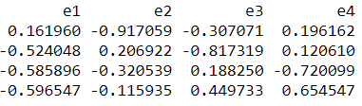

eigenvectors(4 * 4 matrix)

***4.*Sort eigenvalues and their corresponding eigenvectors.**

Since eigenvalues are already sorted in this case so no need to sort them again.

***5.*Pick k eigenvalues and form a matrix of eigenvectors**

If we choose the top 2 eigenvectors, the matrix will look like this:

Top 2 eigenvectors(4*2 matrix)

**6. Transform the original matrix.**

Feature matrix * top k eigenvectors = Transformed Data

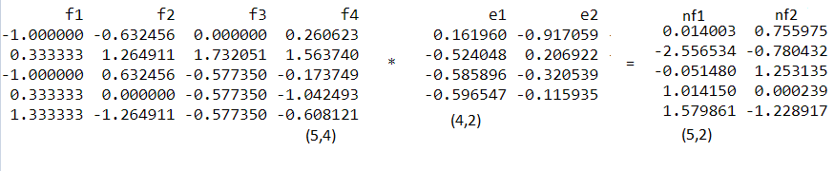

Data Transformation