Data Mining and Analytics (CSDC - 0337)
Report

Title:
Comprehensive Analysis of Student Academic and Behavioral Dataset using Python and Data Visualization Techniques

Abstract:
This project presents a comprehensive analysis of student academic and behavioral data using Python-based data analytics and visualization tools.
- The main aim of the study is to identify the key factors influencing students’ CGPA, academic progress, and satisfaction levels with their college experience. By analyzing data related to school activities, stream selection, reasons affecting performance, and personal interests, the project provides deep insights into how various academic and non-academic elements shape student outcomes.

- The analysis was conducted using a combination of Python libraries, including Pandas for data cleaning and manipulation, Matplotlib and Seaborn for data visualization, and NumPy for numerical processing. The dataset underwent multiple stages of preprocessing—such as removal of irrelevant or inconsistent entries, renaming and standardizing column names, imputing missing values, and categorizing numerical data into meaningful ranges.

Through step-by-step visual exploration, the study examined correlations between academic grades (10th, 12th, CGPA), participation in extracurricular activities, stream choice motivation, and overall college satisfaction.
- Key insights revealed that students who selected their academic streams based on personal interest and actively engaged in academic or technical activities showed higher CGPA scores and greater satisfaction with college life. Conversely, time-management issues, peer influence, and lack of interest in the chosen branch were identified as major reasons behind declining academic performance.

- The outcome of the project is a detailed visual report that not only highlights patterns and relationships within the dataset but also serves as a decision-support resource for educators and institutions. The findings can help colleges develop targeted strategies to improve student engagement, performance, and well-being.

Github link - https://github.com/vijaysolanki9079/DMA-SEM-5-MiniProject/

Introduction:
The primary goal of this project is to analyze and understand student performance trends and behavioral patterns using real academic data. The dataset used for this study was obtained from a CSV file containing detailed responses from students regarding their academic records, extracurricular activities, stream selection choices, motivations, satisfaction levels, and other influencing factors such as time management, health, and interest in studies.

The project focuses on uncovering how various personal, academic, and social elements contribute to a student’s overall performance and satisfaction in college. Through step-by-step analysis, it aims to answer key questions such as — How do school activities influence CGPA? Does choosing a stream based on personal interest lead to better results? What are the most common reasons behind academic improvement or decline?

This type of analysis is extremely valuable for educational institutions, as it provides data-driven insights into student behavior and academic trends. Administrators and faculty can use the findings to develop better mentoring programs, enhance learning environments, and design interventions that address specific challenges faced by students. Additionally, understanding the relationship between satisfaction levels and academic outcomes can help improve the overall student experience and institutional reputation.

The project also emphasizes data preprocessing and cleaning, as the dataset initially contained inconsistencies, missing values, and unstandardized text entries. By performing transformations such as renaming columns, imputing categorical variables, and filtering irrelevant rows, a refined and accurate dataset was achieved for reliable analysis. Subsequently, multiple visualizations—such as pie charts, bar graphs, scatter plots, and heatmaps—were generated to uncover patterns and correlations between academic and behavioral variables.

In summary, this study provides a comprehensive analytical journey, starting from raw data cleaning to generating actionable insights, thus bridging the gap between raw information and educational decision-making.

Tools and Libraries Used:
The analysis was performed using the Python programming language, with a focus on powerful data analysis and visualization libraries. The key tools used in this project are as follows:

- Pandas – Used for data manipulation and cleaning. It helped in reading the CSV file, handling missing values, transforming data into usable formats, and performing aggregations like grouping and summing categorical data.

- NumPy – Provided numerical operations and efficient handling of arrays, particularly when categorizing CGPA ranges or computing derived numerical values.

- Matplotlib – Used for creating basic visualizations such as pie charts and bar plots that display categorical data distributions clearly.

- Seaborn – A statistical visualization library built on top of Matplotlib, used for advanced visualizations such as boxplots, scatter plots, and heatmaps to show relationships between multiple variables with appealing aesthetics.

- Warnings – Utilized to suppress unnecessary warning messages during execution to ensure clean output during iterative testing and visualization.

- Jupyter Notebook / Google Colab – These served as the execution environments for running Python code interactively, displaying data outputs, and visualizations in real-time, which enhanced the exploratory data analysis process.

Data Import and Initial Exploration:
Steps covered:
- Imported the CSV using pd.read_csv()
- Displayed first few rows using df.head()
- Used df.info() and df.describe() to understand structure and data types
- Checked missing values with df.isnull().sum()

import pandas as pd
import numpy as np

df = pd.read_csv('/content/Acad-Data.csv', encoding='latin-1')
display(df.head())

df.info()
df.describe()
df.isnull().sum()

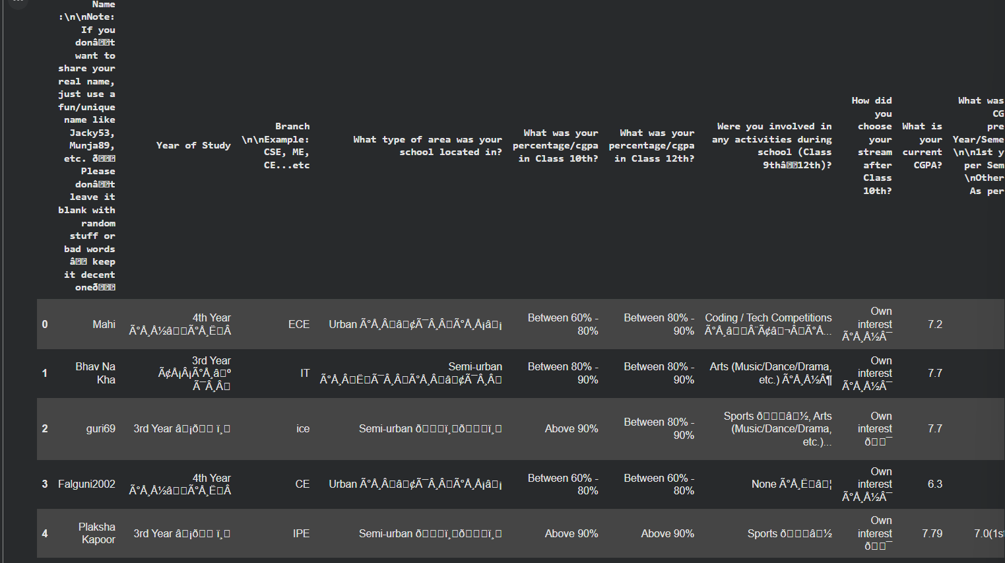

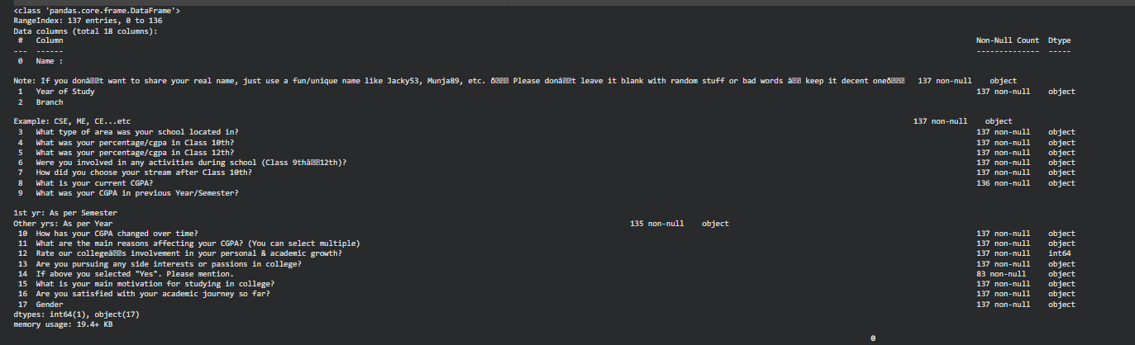

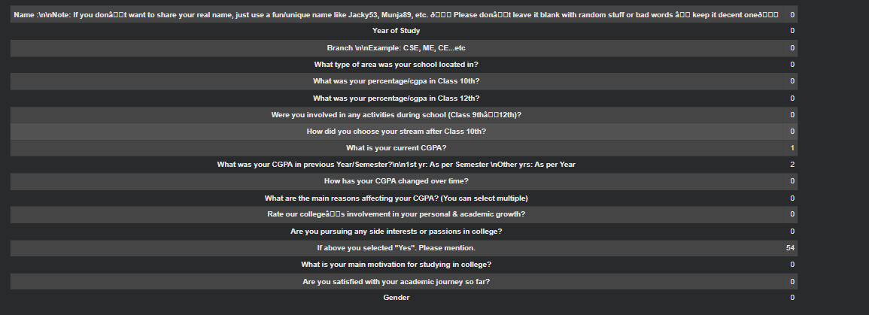

Data Cleaning and Preprocessing:

(a) Removing Bad / Irrelevant Text

import pandas as pd

bad_words = ['backshot', "haven't given exams", 'hale', "i'm", 'papers', 'fresher']
df = df[~df.apply(lambda row: row.astype(str)
.str.lower()
.apply(lambda x: any(bad_word.lower() in x for bad_word in bad_words))
.any(), axis=1)]

df.reset_index(drop=True, inplace=True)

df.head()

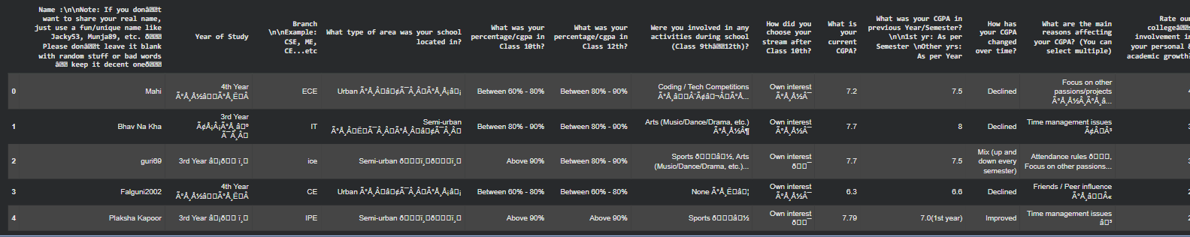

- Renaminng Columns

new_column_names = {
'Name :\n\nNote: If you donât want to share your real name, just use a fun/unique name like Jacky53, Munja89, etc. ð Please donât leave it blank with random stuff or bad words â keep it decent oneð': 'Name',
'Year of Study ': 'Year',
'Branch \n\nExample: CSE, ME, CE...etc': 'Branch',
'What type of area was your school located in? ': 'School_Area',
'What was your percentage/cgpa in Class 10th?': '10th',
'What was your percentage/cgpa in Class 12th?': '12th',
'Were you involved in any activities during school (Class 9th12th)?': 'School_Activities',
'How did you choose your stream after Class 10th?': 'Stream_Choice',
'What is your current CGPA?': 'Current_CGPA',
'What was your CGPA in previous Year/Semester?\n\n1st yr: As per Semester \nOther yrs: As per Year ': 'Previous_CGPA',
'How has your CGPA changed over time?': 'CGPA_Change',
'What are the main reasons affecting your CGPA? (You can select multiple)': 'CGPA_Reasons',
'Rate our colleges involvement in your personal & academic growth? ': 'College_Support',
'Are you pursuing any side interests or passions in college? ': 'Side_Interests',
'If above you selected "Yes". Please mention.': 'Side_Interests_Details',
'What is your main motivation for studying in college?': 'College_Motivation',
'Are you satisfied with your academic journey so far?': 'Academic_Satisfaction',
'Gender ': 'Gender'
}

df.columns.values[0] = 'Name'
df.columns.values[6] = 'School_Activities'
df.columns.values[12] = 'Rate our College'

df = df.rename(columns=new_column_names)
display(df.head())

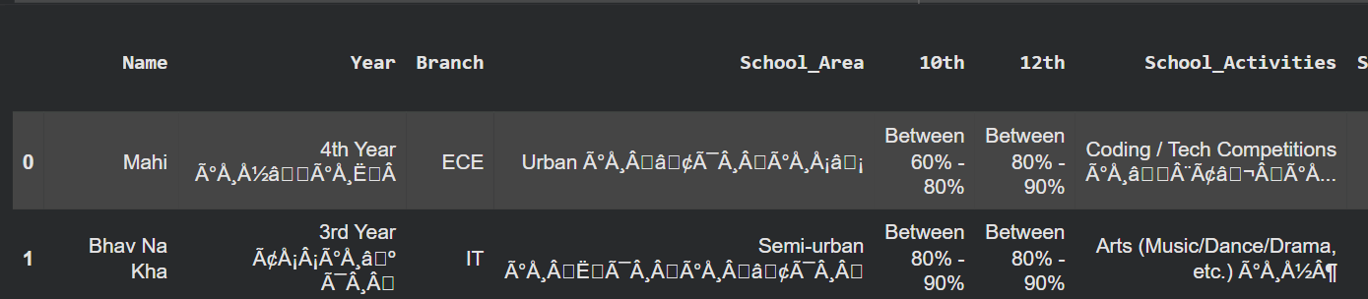

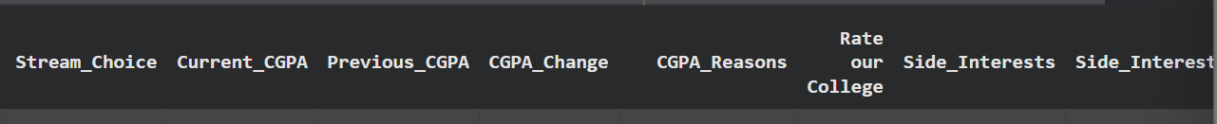

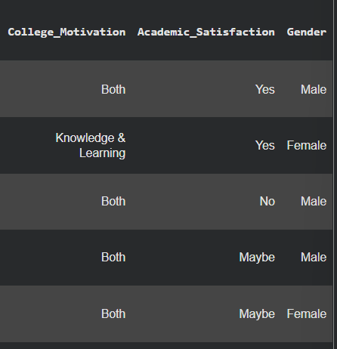

- Columns Processing

df['Year'] = df['Year'].astype(str).str.extract(r'(\d+)').astype(float).astype('Int64')
display(df.head())

Explanation
- Converts the ‘Year’ column to string to ensure text processing works correctly.
- Uses regular expression (\d+) to extract only the numeric part (year) from the text.
- Converts the extracted values to float, then to integer (Int64) for numerical consistency.
- Displays the first few cleaned rows to confirm successful conversion.

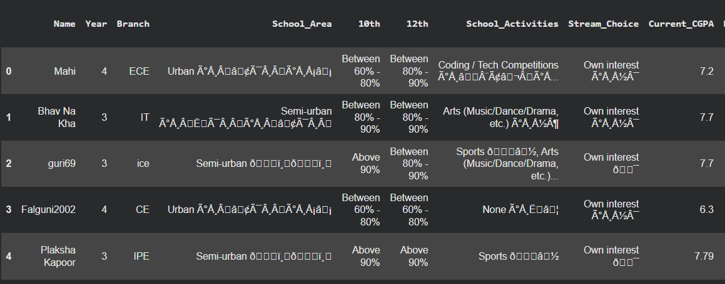

df['School_Area'] = df['School_Area'].str.replace(r'[^a-zA-Z\s-]', '', regex=True).str.strip()
display(df.head())

Explanation:
- Removes all unwanted symbols, numbers, or punctuation from the ‘School_Area’ column using a regular expression.
- Keeps only alphabets, spaces, and hyphens (a-zA-Z\s-).
- str.strip() removes extra spaces from the beginning and end of the text.
- Displays the cleaned output for verification.

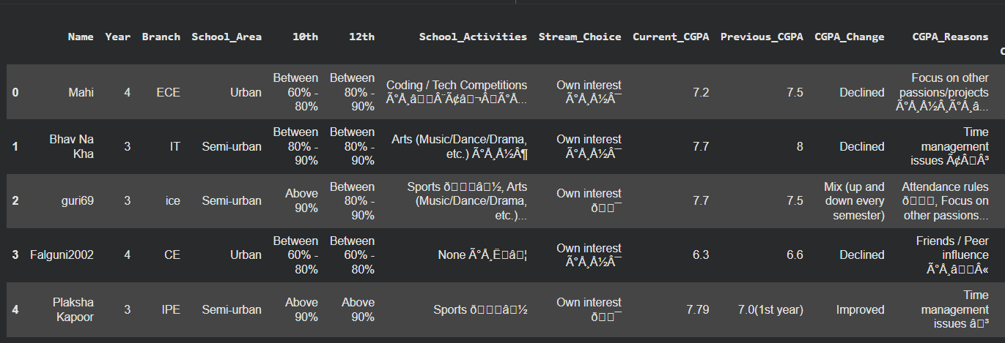

df = df.dropna(how='all')
display(df.head())

Explanation:
- Drops rows where all columns are NaN (completely empty rows).
- This ensures the dataset only contains meaningful data.
- Displays the resulting DataFrame after removing empty rows.

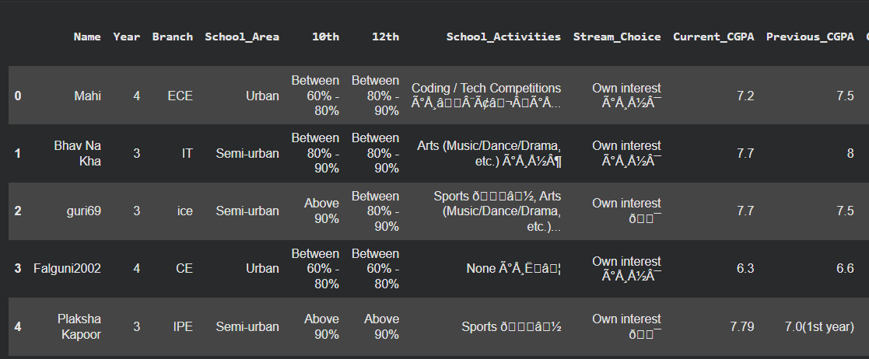

- Branch Column

df['Branch'] = df['Branch'].astype(str).str.strip().str.upper().replace('DSE', 'DS')
unique_branch_values = df['Branch'].unique()
print("Unique values in the 'Branch' column:")
for branch in unique_branch_values:
print(branch)

df['Branch'] = df['Branch'].astype(str).str.strip().str.upper().replace('DSE', 'DS')

valid_branches = ['CSE', 'ECE', 'IT', 'ME', 'EE', 'CE', 'CH', 'BT', 'IPE', 'ICE', 'DS', 'MNC', 'MCE']

manual_corrections = {
'YOUR FATHERS BRANCH': 'CSE',
'MCE OR MNC': 'MNC',
'': None,
}
a
df['Branch'] = df['Branch'].replace(manual_corrections)

df.loc[~df['Branch'].isin(valid_branches), 'Branch'] = 'UNKNOWN'

unique_branch_values = df['Branch'].unique()
print("✅ Cleaned unique values in the 'Branch' column:")
for branch in unique_branch_values:
print(branch)

Explanation
- This code focuses on cleaning and standardizing the ‘Branch’ column in the dataset.
- First, all entries are converted to uppercase and extra spaces removed using str.strip() and str.upper() to ensure uniform formatting.
- The abbreviation 'DSE' is replaced with 'DS' for consistency.
- Next, a list of valid branch names is defined to serve as a reference for data validation.
- Some specific wrong or unclear entries like "YOUR FATHERS BRANCH" or "MCE OR MNC" are manually corrected using a dictionary called manual_corrections.
- Any branch names not in the valid list are replaced with 'UNKNOWN' to maintain dataset consistency.
- Finally, unique values are printed both before and after cleaning to verify that all invalid or inconsistent entries were successfully handled.

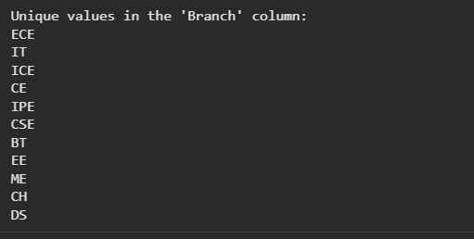

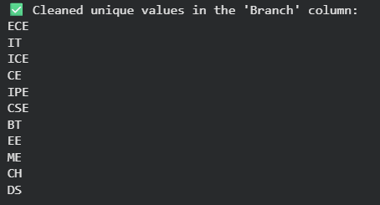

- Data Categorization:
Categorize the '10th' and '12th' columns into grades based on percentage ranges and visualize the distribution of these grades.

percentage_ranges = {
'Above 90%': '>90%',
'Between 80% - 90%': '80-90%',
'Between 60% - 80%': '60-80%',
'Under 60%': '<60%'
}

print("Percentage/CGPA ranges for categorization:")
for key, value in percentage_ranges.items():
print(f"- {key}: {value}")

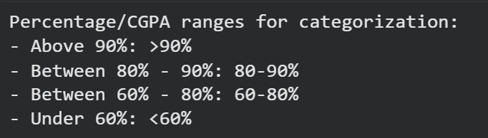

df['10th_grade'] = df['10th'].map(percentage_ranges).fillna('Unknown')
df['12th_grade'] = df['12th'].map(percentage_ranges).fillna('Unknown')
display(df.head())

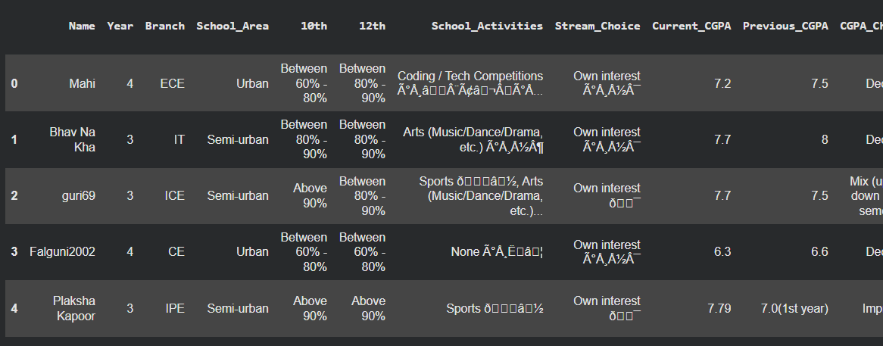

Explanation
- In this step, the dataset’s 10th and 12th-grade percentage columns are standardized into categories for easier analysis and visualization.
- A dictionary named percentage_ranges is created to map various textual representations of marks into four defined categories:
  - >90% → Excellent performers
  - 80–90% → Very good performers
  - 60–80% → Average to good performers
  - <60% → Below-average performers
- The .map() function is used to transform the raw textual data in '10th' and '12th' columns according to the mapping dictionary.
- Any entry not matching the dictionary (e.g., missing or unexpected values) is replaced with 'Unknown' using .fillna('Unknown').
- Finally, the cleaned and categorized columns '10th_grade' and '12th_grade' are displayed to verify successful transformation.

Purpose / Outcome:
This process ensures that all academic performance data is grouped into consistent, interpretable categories.
Such categorization helps in:
- Creating clear visualizations of performance distribution.
- Identifying patterns between school-level performance and later academic or behavioral factors.
- Simplifying statistical and correlation analysis by reducing text variation.

tenth_grade_distribution = df['10th_grade'].value_counts(normalize=True)
twelfth_grade_distribution = df['12th_grade'].value_counts(normalize=True)

print("Distribution of 10th Grade:")
display(tenth_grade_distribution)

print("\nDistribution of 12th Grade:")
display(twelfth_grade_distribution)

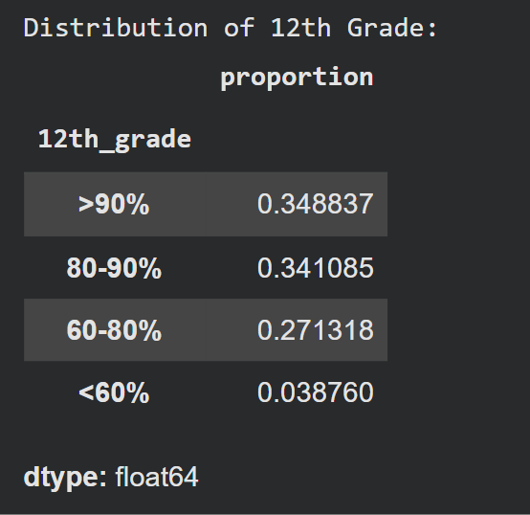
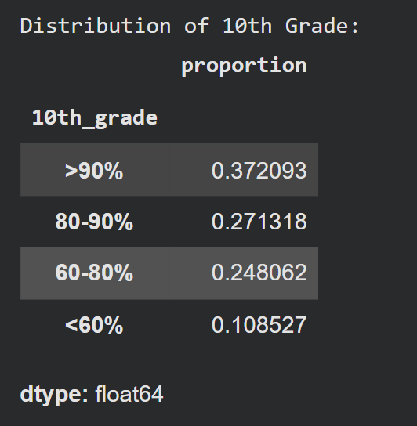

Explanation
- After categorizing students based on their 10th and 12th grade performance, the next step is to analyze the distribution of these categories.
- The .value_counts(normalize=True) method is used here:
  - It counts the frequency of each grade category.
  - By setting normalize=True, it converts those counts into percentages (proportional values).
- This helps to understand what percentage of students fall into each performance range (e.g., >90%, 80–90%, etc.).
- Two separate variables are created:
  - tenth_grade_distribution — stores the distribution for 10th-grade categories.
  - twelfth_grade_distribution — stores the distribution for 12th-grade categories.
- The display() function is used to show these results clearly in a tabular form, especially useful in Jupyter Notebook or Google Colab environments.

Visualize it

import matplotlib.pyplot as plt
import seaborn as sns

plt.figure(figsize=(8, 5))
sns.barplot(x=tenth_grade_distribution.index, y=tenth_grade_distribution.values)
plt.xlabel('10th Grade')
plt.ylabel('Proportion')
plt.title('Distribution of 10th Grades')
plt.show()

plt.figure(figsize=(8, 5))
sns.barplot(x=twelfth_grade_distribution.index, y=twelfth_grade_distribution.values)
plt.xlabel('12th Grade')
plt.ylabel('Proportion')
plt.title('Distribution of 12th Grades')
plt.show()

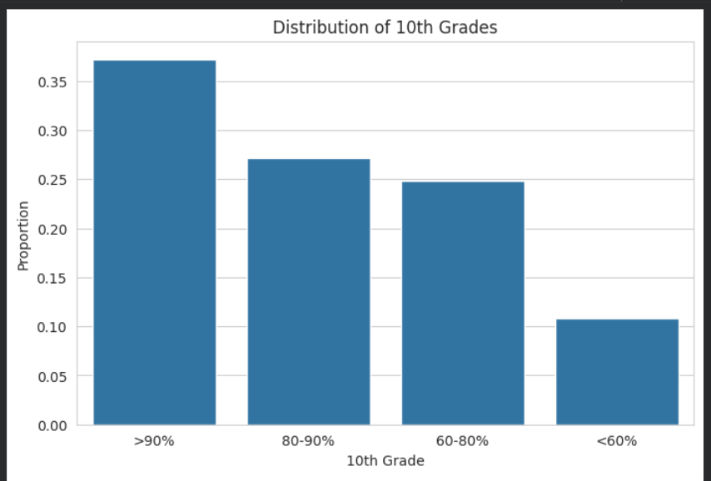

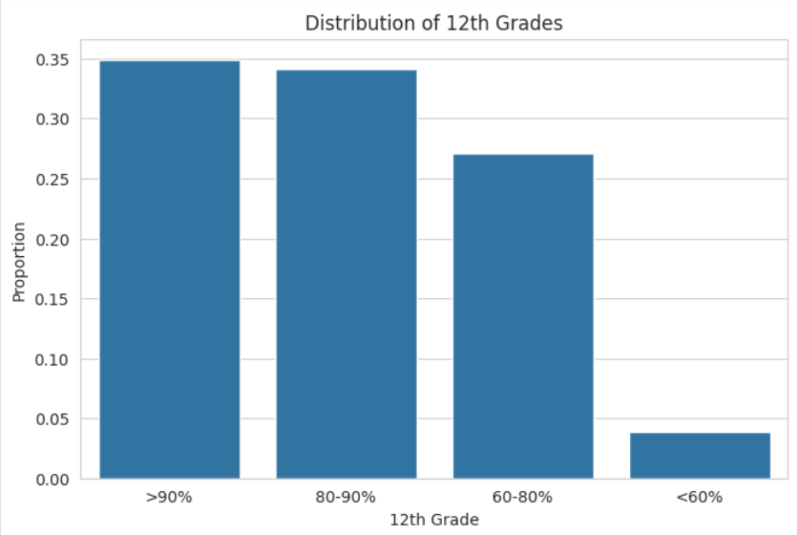

- School Activities Cleaning and Categorization

# Step 1: Checking unique values in the column
unique_school_activities = df['School_Activities'].unique()
print("Unique values in the 'School_Activities' column:")
for activity in unique_school_activities:
print(activity)

# Step 2: Cleaning function
def clean_activity(text):
text = str(text).lower()
text = unidecode.unidecode(text)
text = re.sub(r'[^\w\s,]', '', text)
text = re.sub(r'\s+', ' ', text).strip()
return text

# Step 3: Apply cleaning
df['School_Activities'] = df['School_Activities'].apply(clean_activity)

# Step 4: Categorize into activity types
options = {
'Sports': ['sports'],
'Arts': ['arts', 'arts music/dance/drama etc'],
'Tech': ['coding / tech competitions', 'tech'],
'Academics': ['olympiads / quiz / other academics', 'academics'],
'None': ['none']
}

for col, keywords in options.items():
df[col] = df['School_Activities'].apply(lambda x: 1 if any(k in x for k in keywords) else 0)

# Step 5: Drop original text column
df.drop(columns=['School_Activities'], inplace=True)

df.head(20)

Explanation
This section focuses on extracting and structuring student co-curricular activity data from the dataset.
The goal is to identify each student’s participation area (e.g., sports, arts, technology, academics, or none) to study how these factors relate to their academic and satisfaction metrics later.

Here’s how the process works step by step:
- Identify Unique Entries:
  - We first print out all unique values in the 'School_Activities' column.
  - This helps us understand the variety and inconsistency in how students entered their activity information (e.g., “sports”, “Sports”, “coding / tech competitions”, “arts music/dance/drama etc”).

- Clean the Text Data:
  - A function clean_activity() was created to make entries uniform by:
    - Converting all text to lowercase.
    - Removing accents or special characters using unidecode.
    - Deleting punctuations and extra spaces with regular expressions (re).
  - This ensures all entries are clean and standardized before categorization.

- Categorization into Defined Groups:
  - We created a dictionary options that maps each broad activity category to a list of keywords that identify it.
    - Example:
      - “sports” → Sports category
      - “coding / tech competitions” → Tech category
      - “arts music/dance/drama etc” → Arts category

  - Then, using apply() with a lambda function, a new binary column (0 or 1) is created for each activity type.
    - 1 means the student participated in that category.
    - 0 means they didn’t.

- Drop Redundant Column:
  - After categorization, the original 'School_Activities' column is dropped to keep the dataset clean and structured.

Visualise it:

import matplotlib.pyplot as plt
import seaborn as sns

activity_counts = df[['Sports','Arts','Tech','Academics','None']].sum()

plt.figure(figsize=(8,5))
sns.barplot(x=activity_counts.index, y=activity_counts.values, palette='Set2')
plt.title('Number of Students per School Activity')
plt.ylabel('Number of Students')
plt.xlabel('Activity')
plt.show()

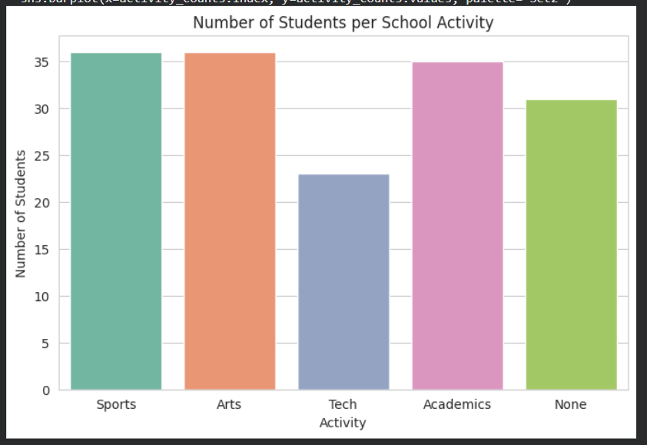

plt.figure(figsize=(7,7))
plt.pie(activity_counts.values, labels=activity_counts.index, autopct='%1.1f%%', colors=sns.color_palette('Set2'))
plt.title('Percentage of Students in Each Activity')
plt.show()

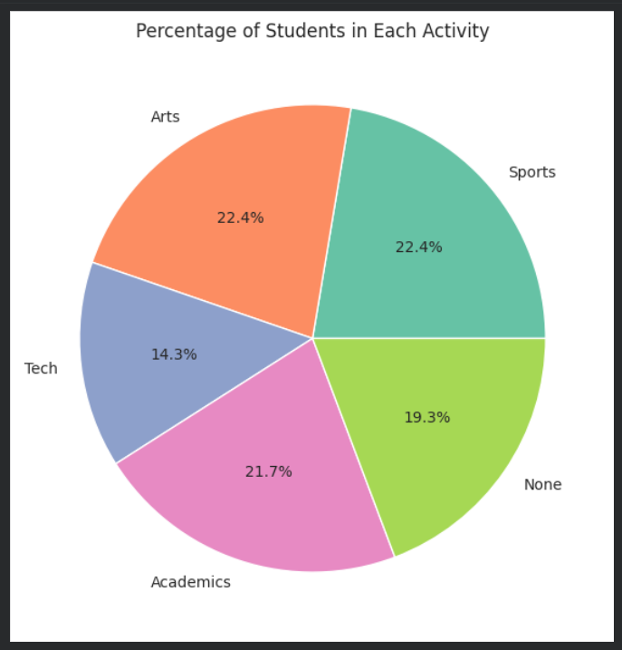

# Correlation between activities
corr = df[['Sports','Arts','Tech','Academics']].corr()

plt.figure(figsize=(6,5))
sns.heatmap(corr, annot=True, cmap='coolwarm', fmt=".2f")
plt.title('Correlation Between Activities')
plt.show()

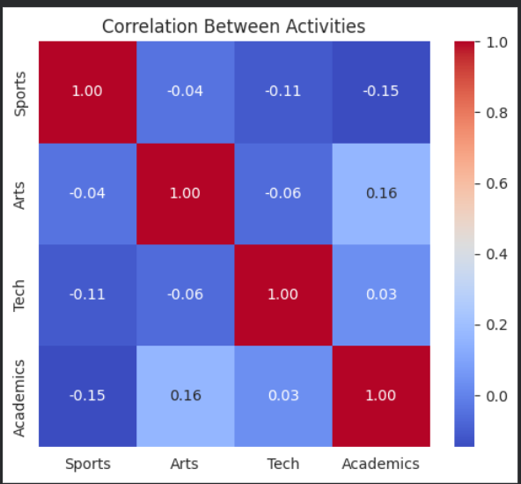

Relating the activities with other columns

# Group by Branch and sum activities
branch_activity = df.groupby('Branch')[['Sports','Arts','Tech','Academics','None']].sum().reset_index()

branch_activity.set_index('Branch').plot(kind='bar', figsize=(10,6), stacked=False, colormap='Set2')
plt.title('Activities per Branch')
plt.ylabel('Number of Students')
plt.xlabel('Branch')
plt.xticks(rotation=45)
plt.legend(title='Activity')
plt

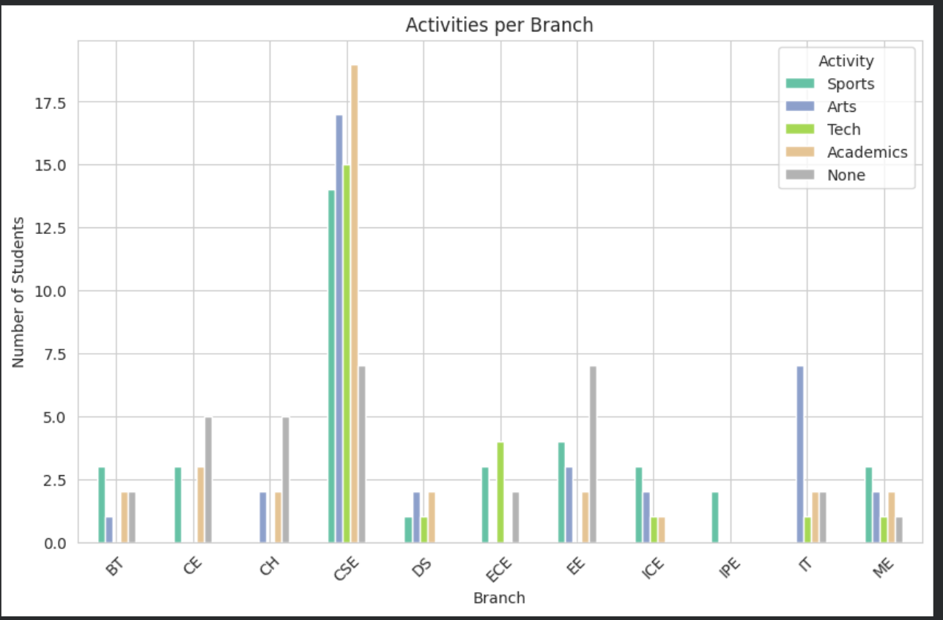

# Group by Year
year_activity = df.groupby('Year')[['Sports','Arts','Tech','Academics','None']].sum()

# Plot stacked bars
year_activity.plot(kind='bar', stacked=True, figsize=(10,6), colormap='Set3')
plt.title('Activity Participation by Year')
plt.ylabel('Number of Students')
plt.xlabel('Year of Study')
plt.xticks(rotation=0)
plt.legend(title='Activity')
plt.show()

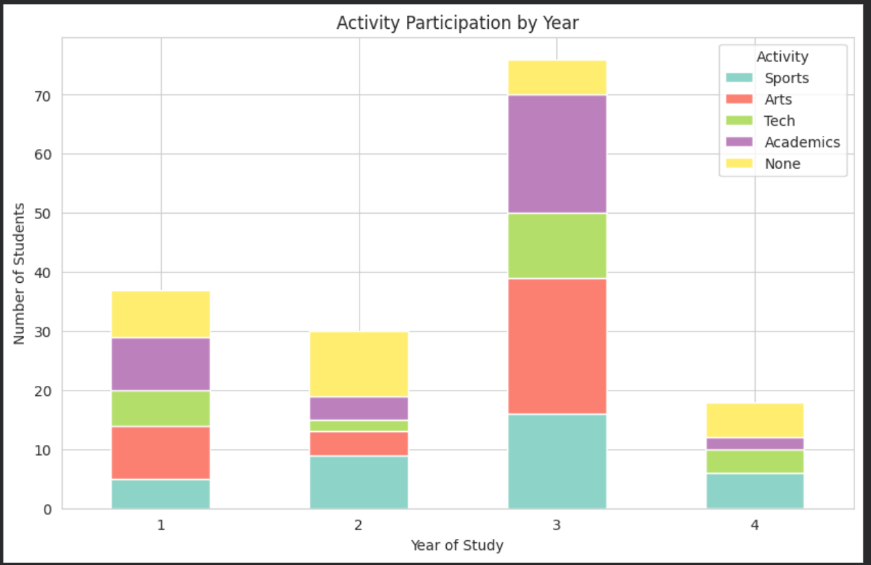

pivot = df.pivot_table(index='Branch', columns='Year', values='Sports', aggfunc='sum', fill_value=0)
sns.heatmap(pivot, annot=True, fmt='d', cmap='coolwarm')
plt.title('Sports Participation by Branch and Year')
plt.show()

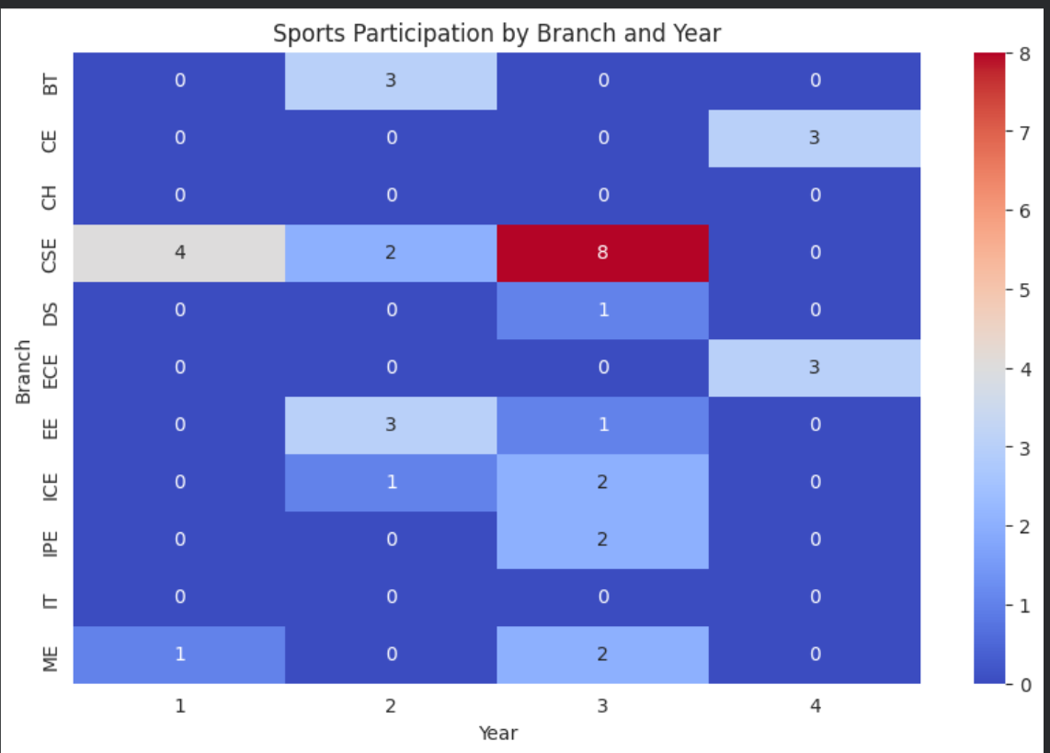

import seaborn as sns

# Correlation/participation per branch
branch_heat = df.groupby('Branch')[['Sports','Arts','Tech','Academics']].sum()

plt.figure(figsize=(8,6))
sns.heatmap(branch_heat, annot=True, cmap='YlGnBu', fmt='d')
plt.title('Activity Participation Heatmap by Branch')
plt.xlabel('Activity')
plt.ylabel('Branch')
plt.show()

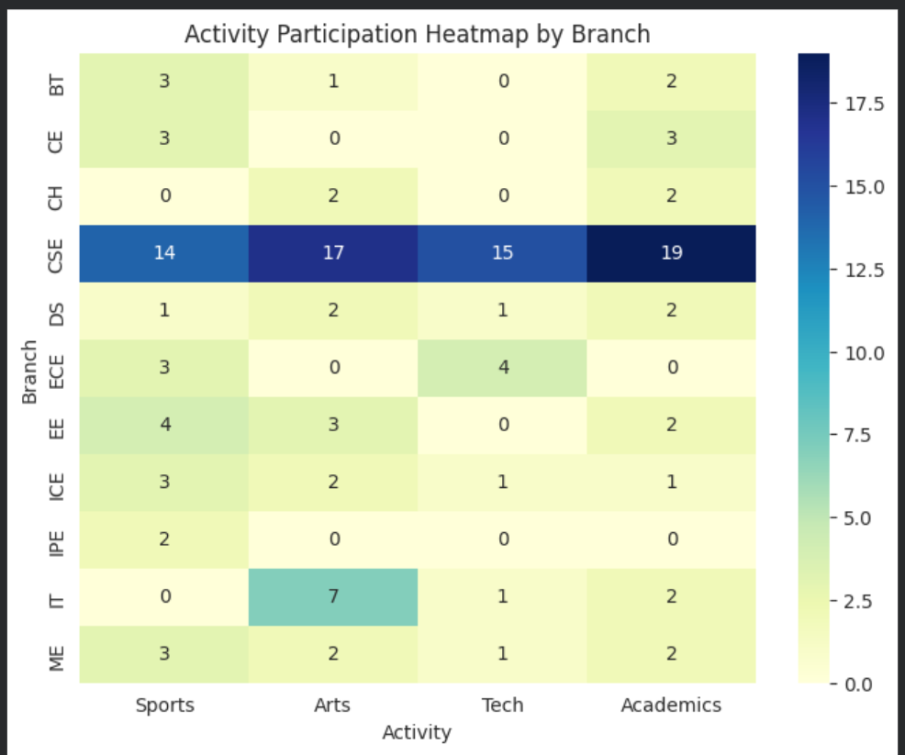

- Stream_Choice

# Clean column names
df.columns = df.columns.str.strip().str.replace('\n', '_')

# Cleaning function for Stream_Choice
def clean_stream(text):
text = str(text).lower()
text = unidecode.unidecode(text)
text = re.sub(r'[^\w\s,()/]', '', text)
text = re.sub(r'\s+', ' ', text).strip()
return text

df['Stream_Choice'] = df['Stream_Choice'].apply(clean_stream)

# Categorizing stream choices
stream_options = {
'Own_Interest': ['own interest', 'interest', 'own'],
'Parents_Suggestion': ['parents', 'relatives', 'sharma ji'],
'Peer_Pressure': ['peer pressure', 'peer'],
'No_Choice': ['no choice', 'fixed']
}

for col, keywords in stream_options.items():
df[col] = df['Stream_Choice'].apply(lambda x: 1 if any(k in x for k in keywords) else 0)

df.drop(columns=['Stream_Choice'], inplace=True)

Explanation

The dataset contained an open-ended column named “Stream_Choice”, where students mentioned why they chose their current engineering stream (e.g., “own interest”, “parents told me”, “peer pressure”).
However, the text responses were inconsistent in wording and casing — for example, some wrote “OWN INTEREST”, others “my interest” or “parents suggested”.

To standardize this:
- All text was converted to lowercase and cleaned using regex to remove unwanted symbols or punctuation.

- We then defined key categories:
  - Own_Interest: Students who selected their stream by personal choice.
  - Parents_Suggestion: Streams influenced by parents or relatives.
  - Peer_Pressure: Choices made under friends’ or social pressure.
  - No_Choice: Students who had no option and were assigned by circumstances.
- Each of these was encoded into binary columns (1 for “Yes”, 0 for “No”), creating a clean, analyzable structure.

- The original text column was dropped for clarity.

This cleaning process allows us to quantify student decision-making patterns and later correlate them with CGPA trends, motivation, and satisfaction.

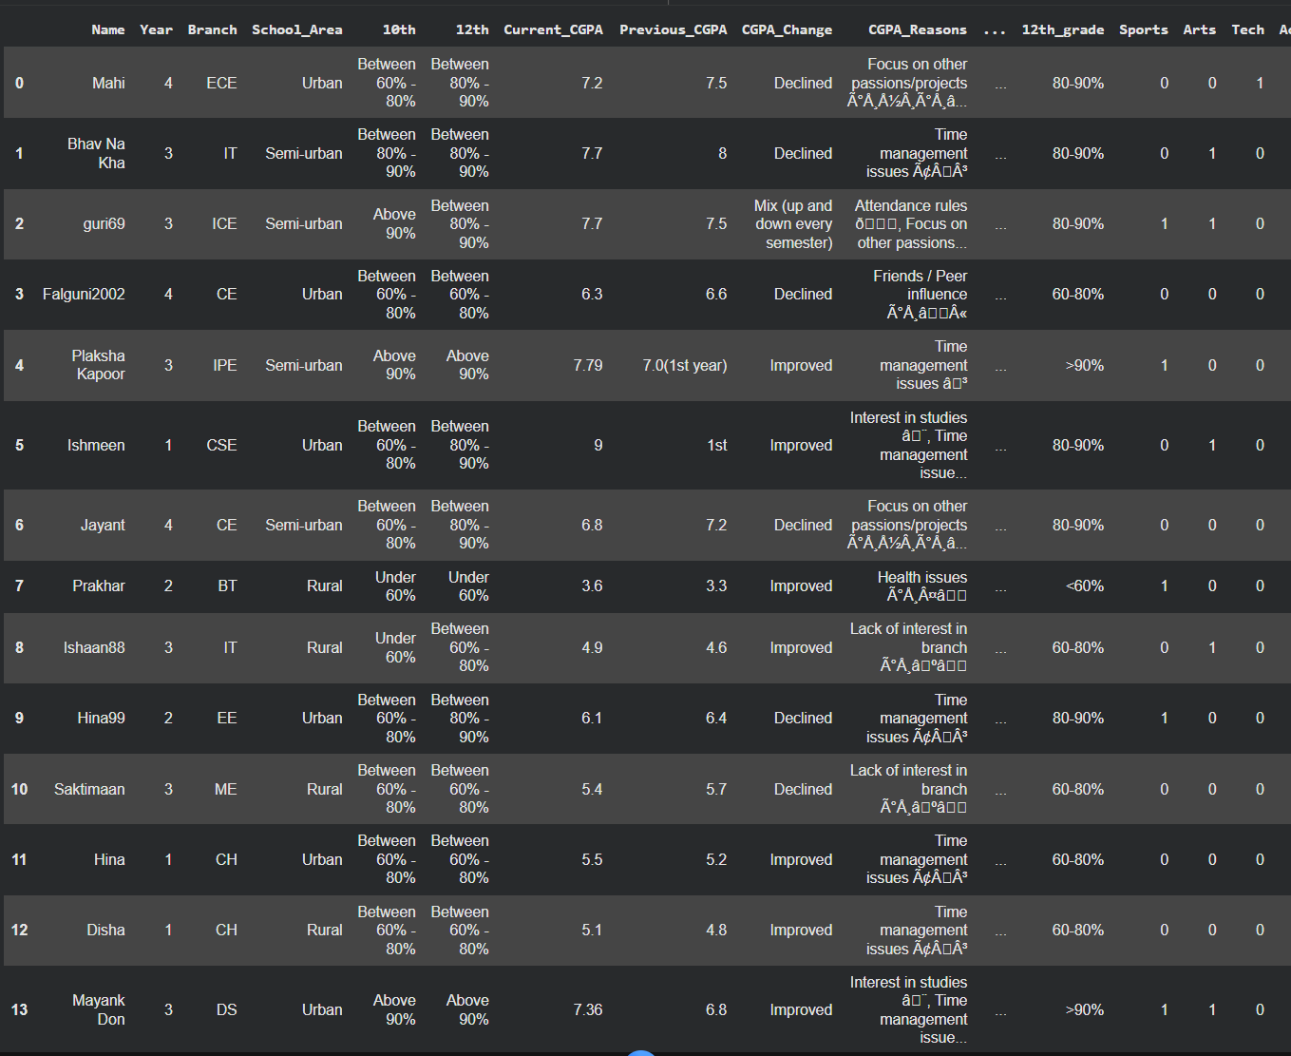

Cleaning CGPA Reasons and Categorization

# Clean column names
df.columns = df.columns.str.strip().str.replace('\n', '_')

def clean_reason(text):
text = str(text).lower()
text = unidecode.unidecode(text)
text = re.sub(r'[^\w\s,()]', '', text)
text = re.sub(r'\s+', ' ', text).strip()
return text

df['CGPA_Reasons'] = df['CGPA_Reasons'].apply(clean_reason)

cgpa_reasons_options = {
'Interest_in_studies': ['interest in studies', 'interest'],
'Time_management': ['time management', 'time management issues'],
'Attendance': ['attendance rules', 'attendance'],
'Peer_influence': ['friends', 'peer influence', 'peer'],
'Health_issues': ['health issues', 'health'],
'Lack_of_interest_in_branch': ['lack of interest in branch', 'lack of interest'],
'Other_passions': ['focus on other passions', 'projects', 'other passions']
}

for col, keywords in cgpa_reasons_options.items():
df[col] = df['CGPA_Reasons'].apply(lambda x: 1 if any(k in x for k in keywords) else 0)

df.drop(columns=['CGPA_Reasons'], inplace=True)

df.head(20)

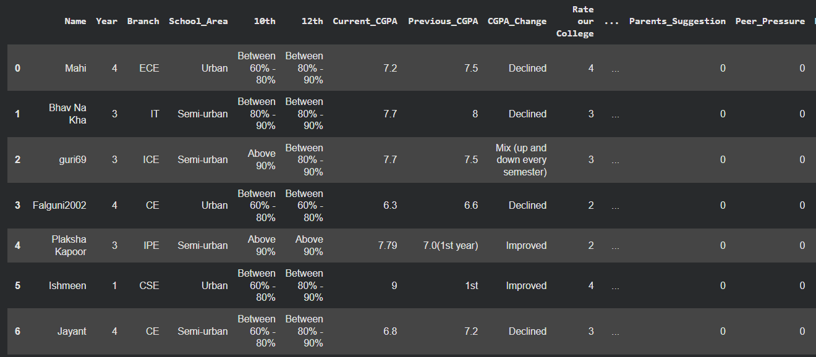

Explanation
Similarly, the “CGPA_Reasons” column collected student feedback about what factors influenced their academic performance.
Students mentioned multiple causes such as “health issues”, “peer distraction”, “focus on projects”, or “attendance problems”.

To structure this information:
- The text was cleaned using clean_reason() to normalize casing and remove noise.
- We defined 7 main influencing categories — Interest in studies, Time management, Attendance, Peer influence, Health issues, Lack of interest in branch, and Focus on other passions/projects.
- Each response was analyzed for keywords and categorized under these columns.
- The result was a binary dataset clearly showing the proportion of students affected by each factor.

This transformation helps in identifying root causes of low or fluctuating CGPA, and later correlating them with other attributes like stream choice and motivation levels.

Visualize it:

import pandas as pd
import matplotlib.pyplot as plt
import seaborn as sns

sns.set_style("whitegrid")
plt.rcParams['figure.figsize'] = (10,6)

# 1️ Pie Charts for School Activities
activity_cols = ['Sports','Arts','Tech','Academics','None']
activity_counts = df[activity_cols].sum()

plt.figure(figsize=(8,8))
plt.pie(activity_counts.values, labels=activity_counts.index, autopct='%1.1f%%', colors=sns.color_palette('Set2'))
plt.title('Distribution of School Activities')
plt.show()

# 2️ Pie Chart for Stream Choice
stream_cols = ['Own_Interest','Parents_Suggestion','Peer_Pressure','No_Choice']
stream_counts = df[stream_cols].sum()

plt.figure(figsize=(8,8))
plt.pie(stream_counts.values, labels=stream_counts.index, autopct='%1.1f%%', colors=sns.color_palette('Set1'))
plt.title('Distribution of Stream Choice')
plt.show()

# 3️ Bar Charts: Activities by Branch
branch_activity = df.groupby('Branch')[activity_cols].sum()
branch_activity.plot(kind='bar', stacked=False, colormap='Set2', figsize=(12,6))
plt.title('School Activities by Branch')
plt.ylabel('Number of Students')
plt.xlabel('Branch')
plt.xticks(rotation=45)
plt.show()

# 4️ Bar Charts: Stream Choice by Branch
branch_stream = df.groupby('Branch')[stream_cols].sum()
branch_stream.plot(kind='bar', stacked=True, colormap='Set1', figsize=(12,6))
plt.title('Stream Choice by Branch')
plt.ylabel('Number of Students')
plt.xlabel('Branch')
plt.xticks(rotation=45)
plt.show()

# 5️ CGPA Distribution by Activities
df_melt_activity = df.melt(id_vars=['Current_CGPA'], value_vars=activity_cols,
var_name='Activity', value_name='Participated')
df_melt_activity = df_melt_activity[df_melt_activity['Participated']==1]

plt.figure(figsize=(10,6))
sns.boxplot(x='Activity', y='Current_CGPA', data=df_melt_activity, palette='Set2')
plt.title('CGPA Distribution by School Activities')
plt.show()

# 6️ CGPA Distribution by Stream Choice
df_melt_stream = df.melt(id_vars=['Current_CGPA'], value_vars=stream_cols,
var_name='StreamChoice', value_name='Selected')
df_melt_stream = df_melt_stream[df_melt_stream['Selected']==1]

plt.figure(figsize=(10,6))
sns.boxplot(x='StreamChoice', y='Current_CGPA', data=df_melt_stream, palette='Set1')
plt.title('CGPA Distribution by Stream Choice')
plt.show()

# 7️ Academic Scores vs Stream Choice (Scatter + Box)
plt.figure(figsize=(12,6))
sns.scatterplot(x='12th', y='Current_CGPA', hue='Own_Interest', data=df, palette={1:'green',0:'red'})
plt.title('12th Percentage vs CGPA (Own Interest)')
plt.xlabel('12th Percentage / CGPA Equivalent')
plt.ylabel('Current CGPA')
plt.show()

plt.figure(figsize=(12,6))
sns.boxplot(x='Own_Interest', y='Current_CGPA', data=df, palette='Set2')
plt.title('CGPA Distribution by Own Interest Stream Choice')
plt.xticks([0,1], ['No', 'Yes'])
plt.show()

# 8️ Heatmap: Correlation of Academic Scores
numeric_cols = ['10th','12th','Current_CGPA','Previous_CGPA','CGPA_Change']
plt.figure(figsize=(8,6))
sns.heatmap(df[numeric_cols].corr(), annot=True, cmap='coolwarm', fmt=".2f")
plt.title('Correlation Between Academic Scores')
plt.show()

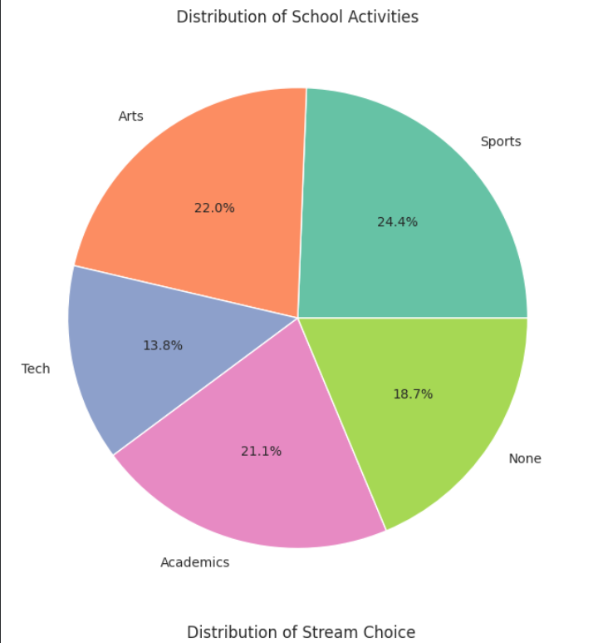

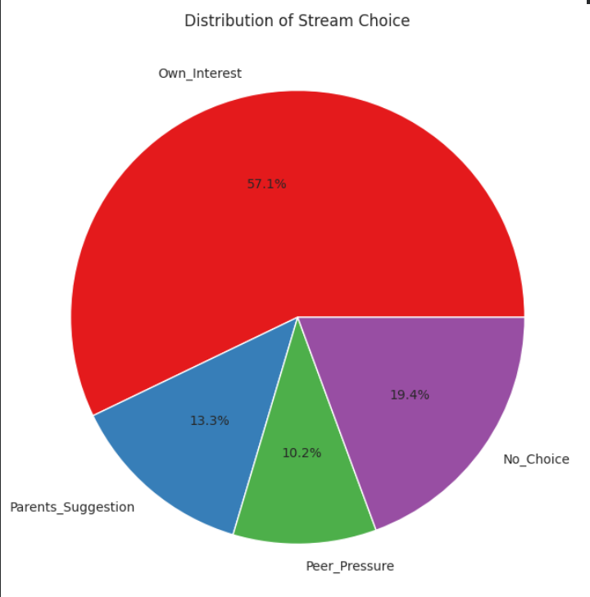

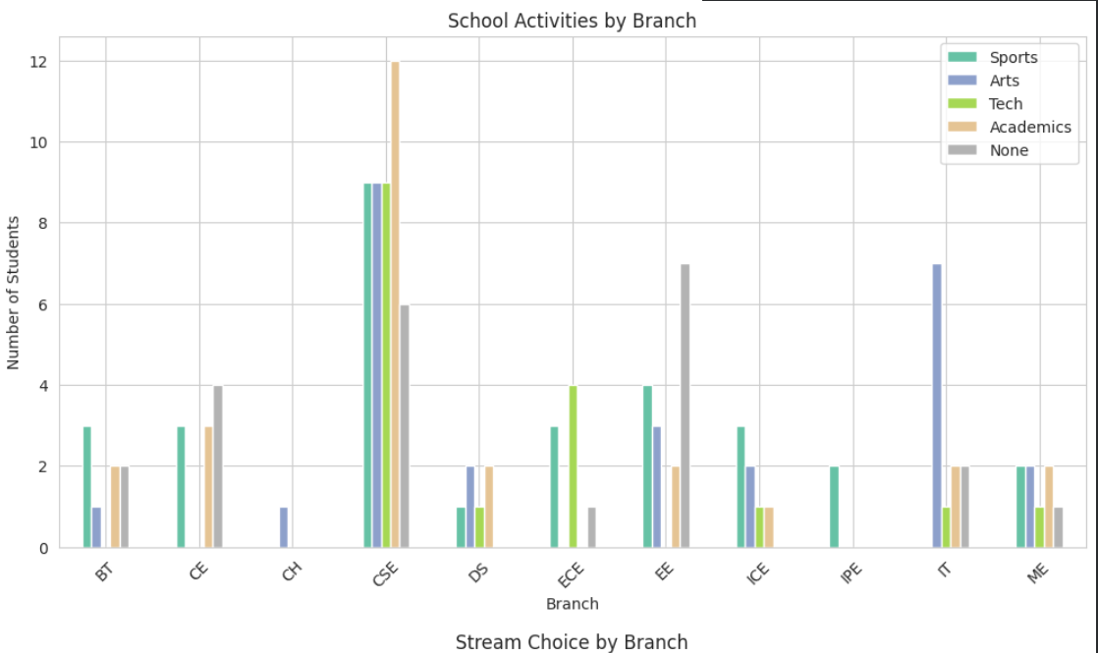

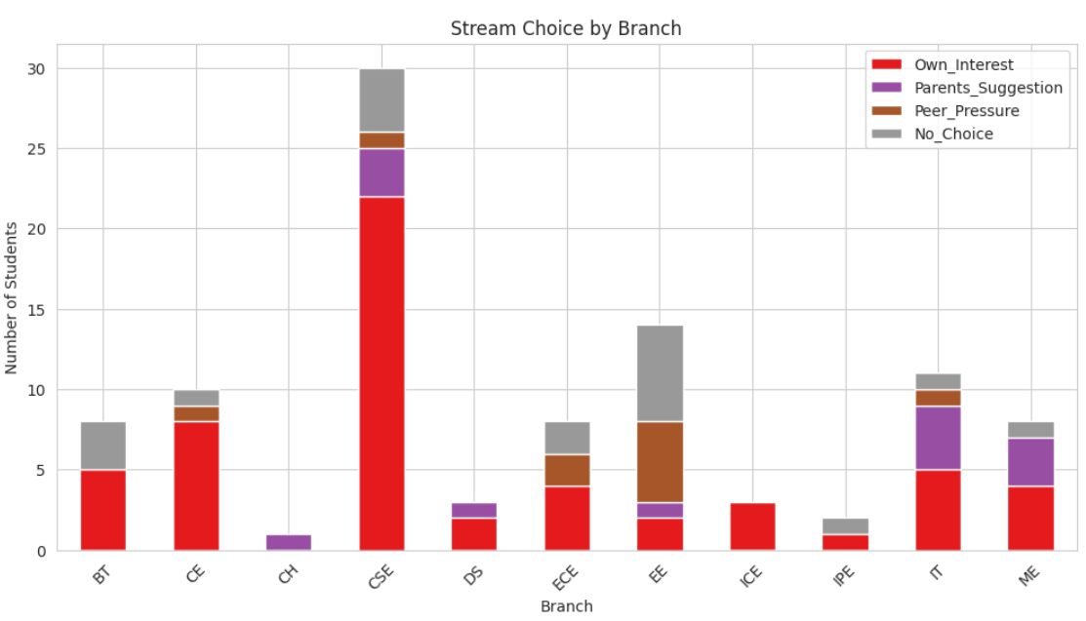

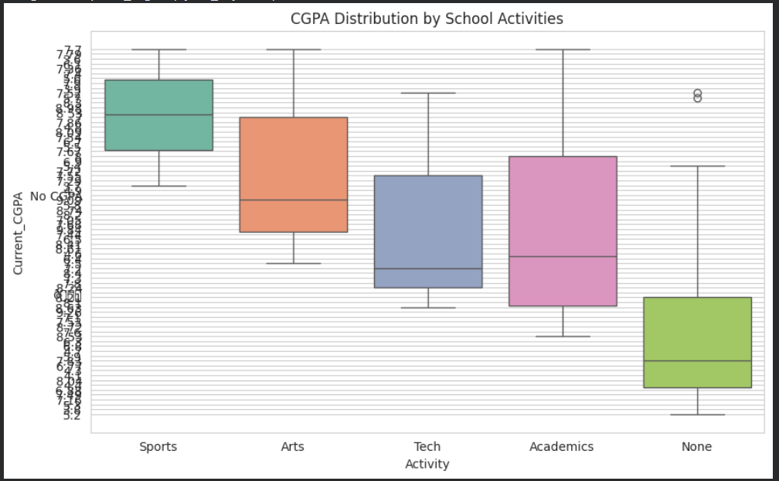

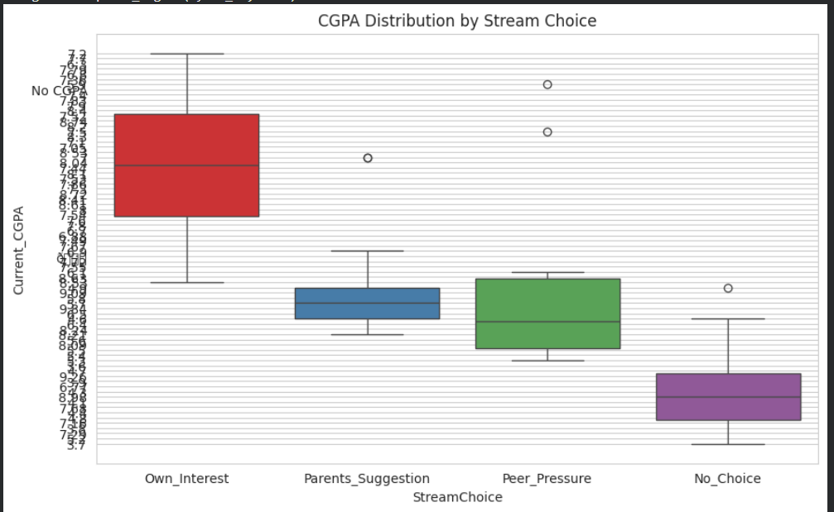

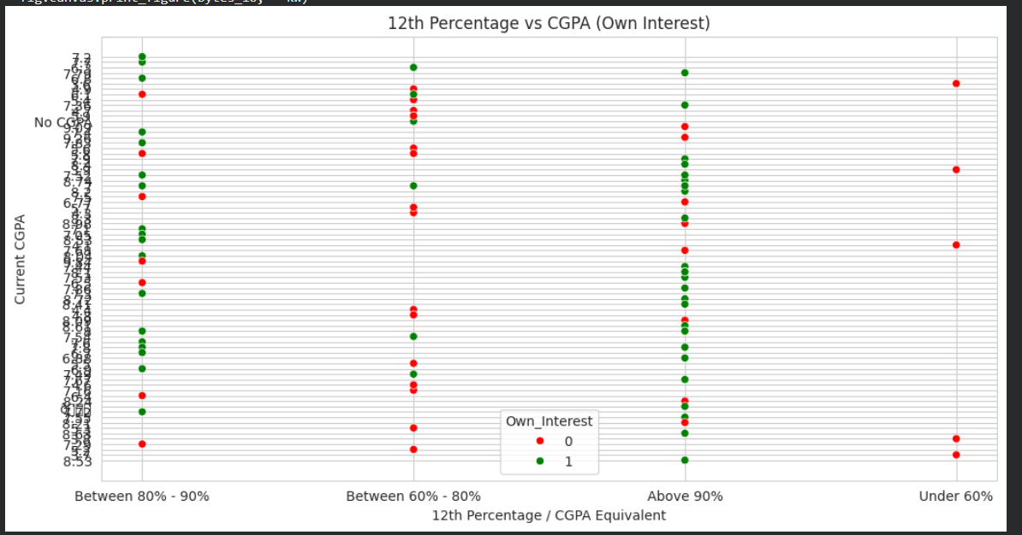

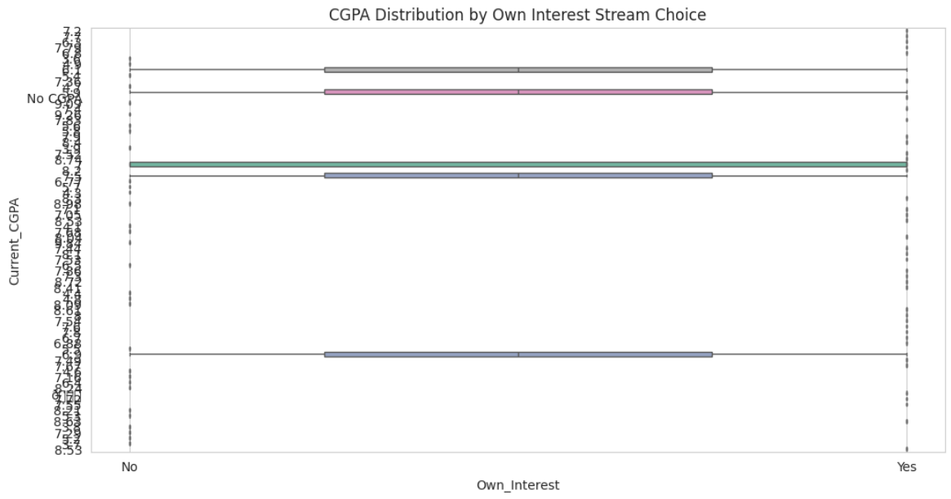

- Current_CGPA

# Convert Current_CGPA to numeric
df['Current_CGPA'] = pd.to_numeric(df['Current_CGPA'], errors='coerce')

df = df.dropna(subset=['Current_CGPA']).reset_index(drop=True)

bins = [0, 6, 7, 8, 9, 10]
labels = ['<6', '6-7', '7-8', '8-9', '>9']
df['CGPA_Range'] = pd.cut(df['Current_CGPA'], bins=bins, labels=labels, include_lowest=True)

df[['Current_CGPA', 'CGPA_Range']].head(10)

Visualize it:

# Convert Current_CGPA to numeric
df['Current_CGPA'] = pd.to_numeric(df['Current_CGPA'], errors='coerce')

df = df.dropna(subset=['Current_CGPA']).reset_index(drop=True)

bins = [0, 6, 7, 8, 9, 10]
labels = ['<6', '6-7', '7-8', '8-9', '>9']
df['CGPA_Range'] = pd.cut(df['Current_CGPA'], bins=bins, labels=labels, include_lowest=True)

df[['Current_CGPA', 'CGPA_Range']].head(10)

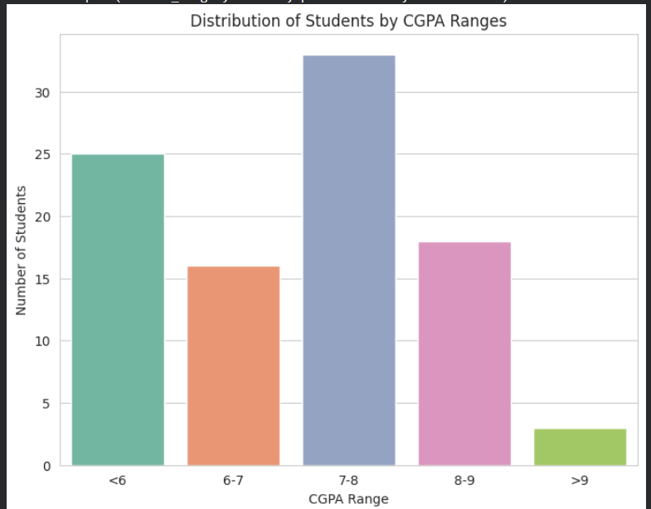

# CGPA Range vs Activities
activity_cols = ['Sports','Arts','Tech','Academics','None']

for act in activity_cols:
plt.figure(figsize=(8,6))
sns.countplot(x='CGPA_Range', hue=act, data=df, palette='Set2', order=labels)
plt.title(f'{act} Participation across CGPA Ranges')
plt.ylabel('Number of Students')
plt.xlabel('CGPA Range')
plt.legend(title=act)
plt.show()
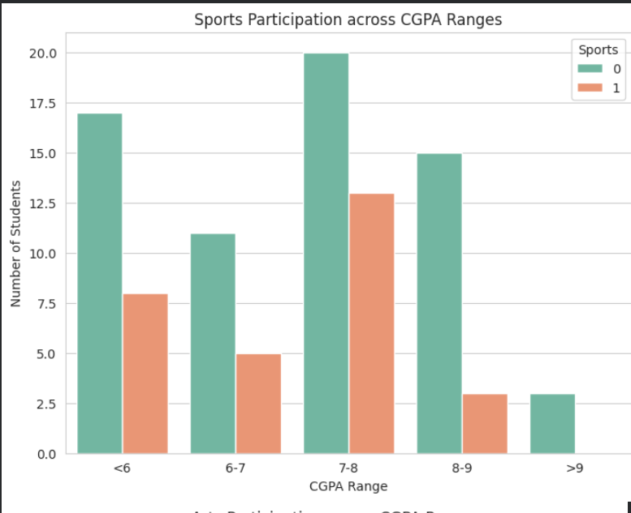

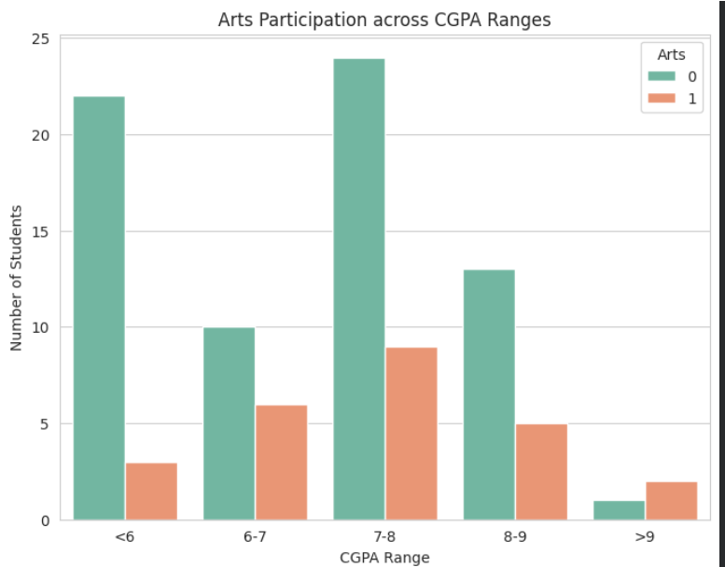

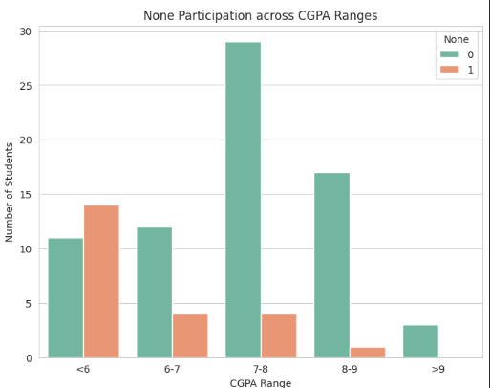

#CGPA Range vs Stream Choice
stream_cols = ['Own_Interest','Parents_Suggestion','Peer_Pressure','No_Choice']
for sc in stream_cols:
plt.figure(figsize=(8,6))
sns.countplot(x='CGPA_Range', hue=sc, data=df, palette='Set1', order=labels)
plt.title(f'{sc} Distribution across CGPA Ranges')
plt.ylabel('Number of Students')
plt.xlabel('CGPA Range')
plt.legend(title=sc)
plt.show()

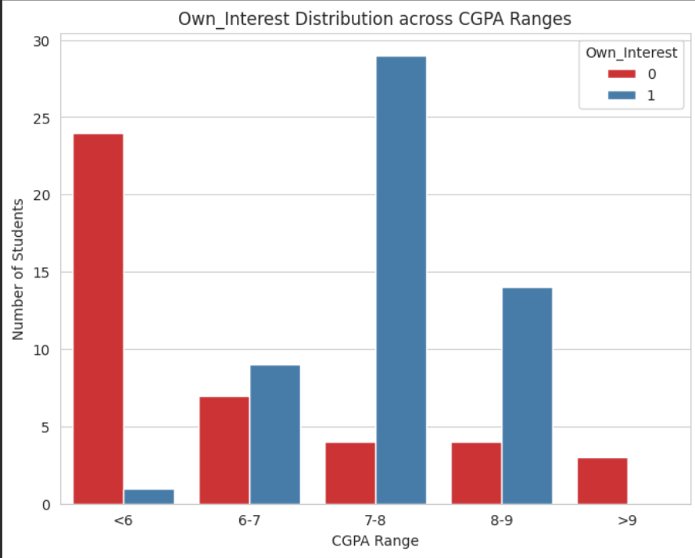

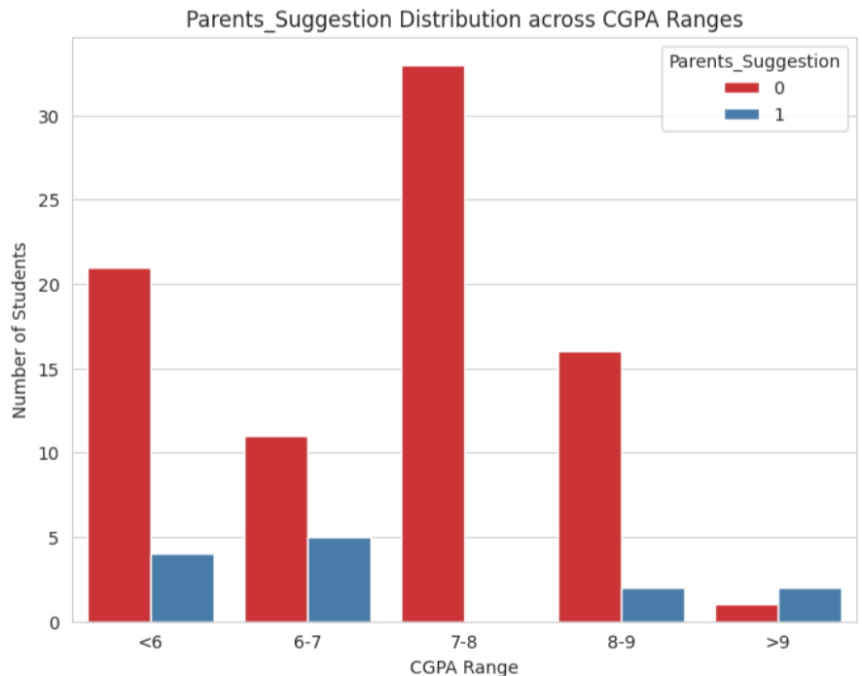

- CGPA Change

import pandas as pd
import re
import unidecode

def clean_change(text):
text = str(text).lower()
text = unidecode.unidecode(text)
text = re.sub(r'[^a-z\s]', '', text)
text = text.strip()

if 'mix' in text:
return 'Mix'
elif 'improved' in text:
return 'Improved'
elif 'declined' in text:
return 'Declined'
else:
return 'Other'

df['CGPA_Change'] = df['CGPA_Change'].apply(clean_change)
df.head(10)

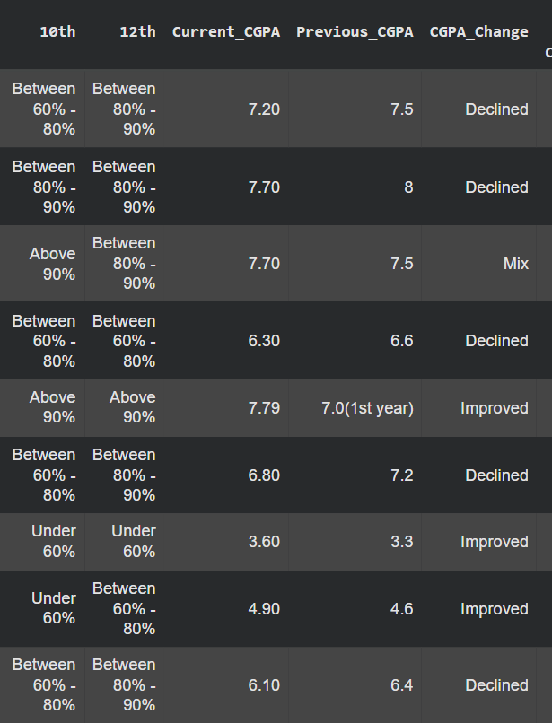

import matplotlib.pyplot as plt
import seaborn as sns

sns.set_style("whitegrid")

# Pie Chart
plt.figure(figsize=(7,7))
df['CGPA_Change'].value_counts().plot.pie(autopct='%1.1f%%', colors=sns.color_palette('Set2'), startangle=90)
plt.title('Distribution of CGPA Change')
plt.ylabel('')
plt.show()

# Bar Chart
plt.figure(figsize=(8,6))
sns.countplot(x='CGPA_Change', data=df, palette='Set2', order=['Improved','Declined','Mix','Other'])
plt.title('CGPA Change Distribution')
plt.ylabel('Number of Students')
plt.xlabel('CGPA Change')
plt.show()

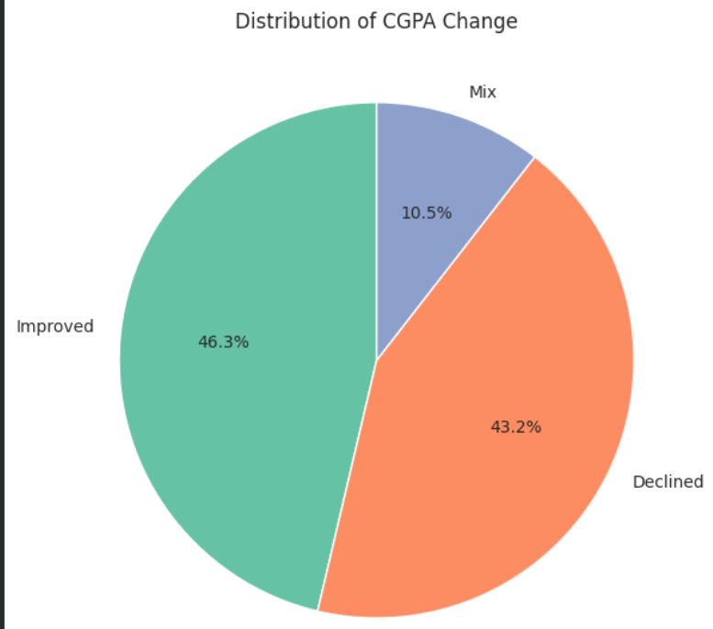

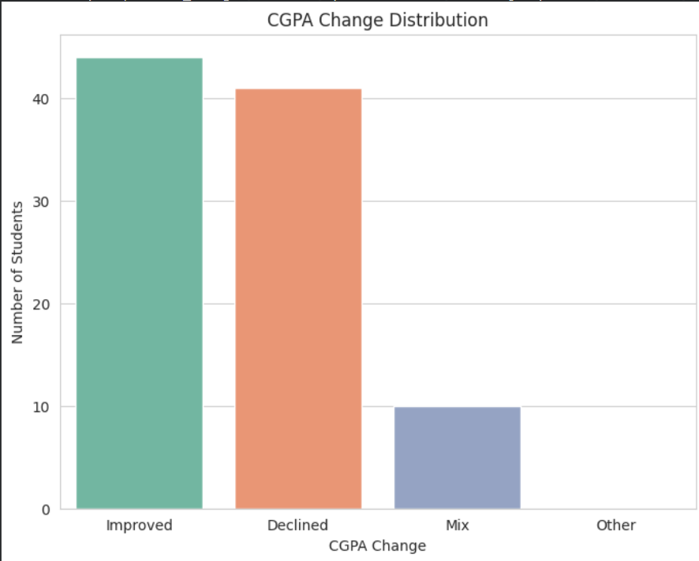

# CGPA_Change vs CGPA_Range

plt.figure(figsize=(10,6))
sns.countplot(x='CGPA_Range', hue='CGPA_Change', data=df, palette='Set2', order=['<6','6-7','7-8','8-9','>9'])
plt.title('CGPA Change across CGPA Ranges')
plt.ylabel('Number of Students')
plt.xlabel('CGPA Range')
plt.show()

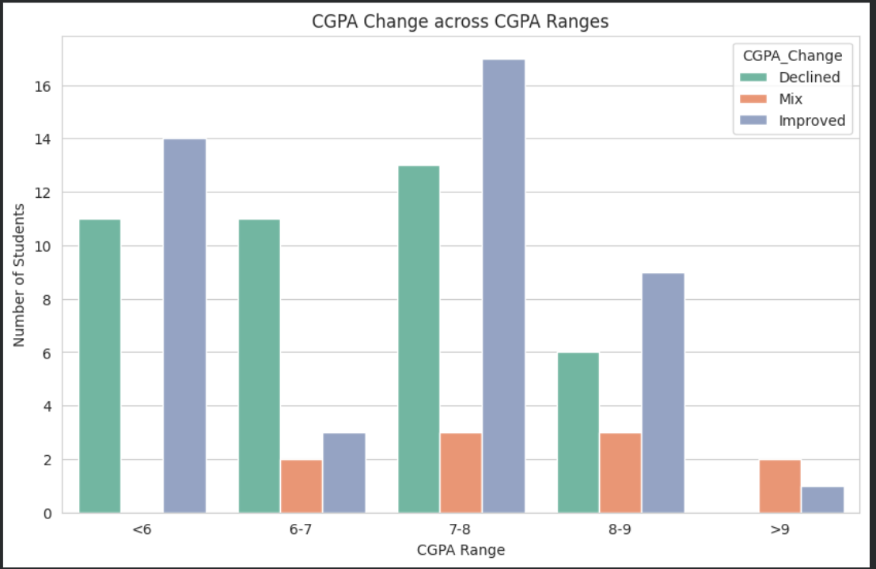

# CGPA_Change vs Branch
plt.figure(figsize=(12,6))
sns.countplot(x='Branch', hue='CGPA_Change', data=df, palette='Set2')
plt.title('CGPA Change Distribution by Branch')
plt.ylabel('Number of Students')
plt.xlabel('Branch')
plt.xticks(rotation=45)
plt.show()

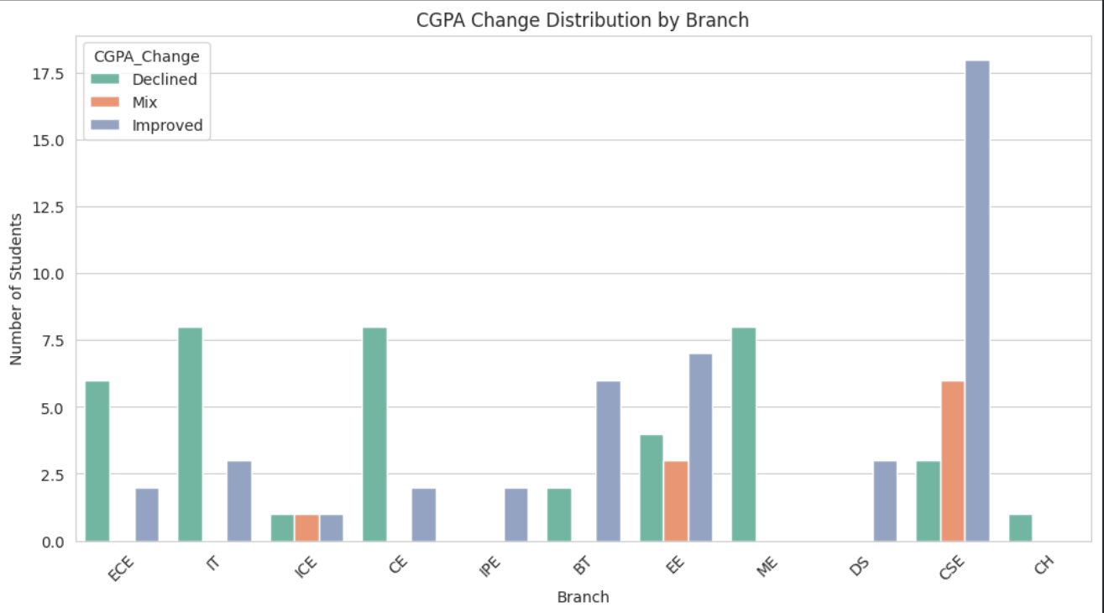

# CGPA_Change vs Activities / Stream Choice

plt.figure(figsize=(8,6))
sns.countplot(x='Own_Interest', hue='CGPA_Change', data=df, palette='Set1')
plt.title('CGPA Change vs Own Interest Stream Choice')
plt.ylabel('Number of Students')
plt.xlabel('Own Interest')
plt.xticks([0,1], ['No','Yes'])
plt.show()

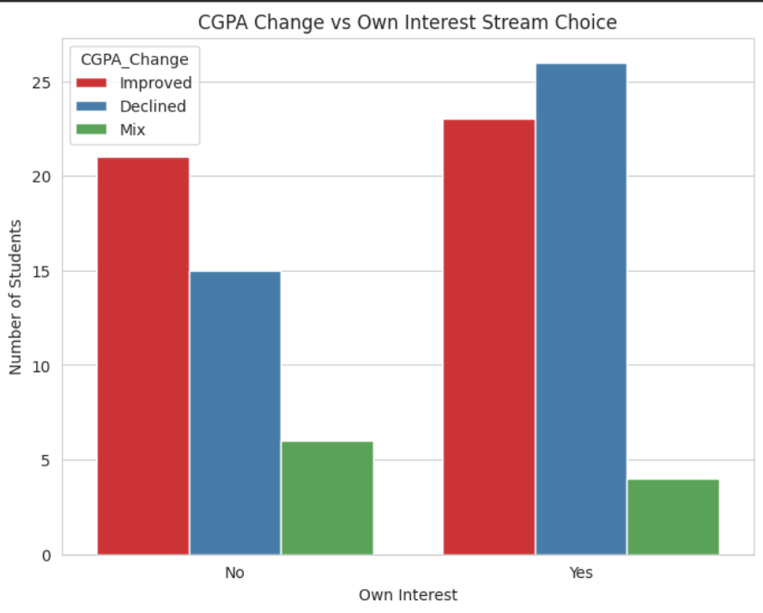

- Rate Our Clg

# Check if the column exists
if 'Rate our College' not in df.columns:
raise ValueError("Column 'Rate our College' not found in the dataframe!")

print("Column Info:")
print(df['Rate our College'].describe())
print("\nValue Counts:")
print(df['Rate our College'].value_counts())

# 1: Bar Plot ---
plt.figure(figsize=(8,6))
sns.countplot(x='Rate our College', data=df, palette='viridis')
plt.title('Distribution of College Ratings (1-5)')
plt.xlabel('Rating')
plt.ylabel('Number of Responses')
plt.show()

# 2: Pie Chart ---
rating_counts = df['Rate our College'].value_counts().sort_index()
plt.figure(figsize=(8,8))
plt.pie(rating_counts, labels=rating_counts.index, autopct='%1.1f%%', startangle=90, colors=sns.color_palette('viridis', 5))
plt.title('College Ratings Distribution (Pie Chart)')
plt.show()

# 3: Histogram ---
plt.figure(figsize=(8,6))
plt.hist(df['Rate our College'], bins=5, color='skyblue', edgecolor='black', rwidth=0.8)
plt.title('Histogram of College Ratings')
plt.xlabel('Rating')
plt.ylabel('Frequency')
plt.xticks(range(1,6))
plt.show()

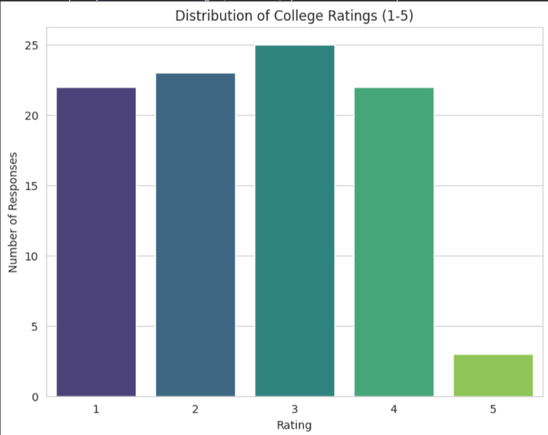

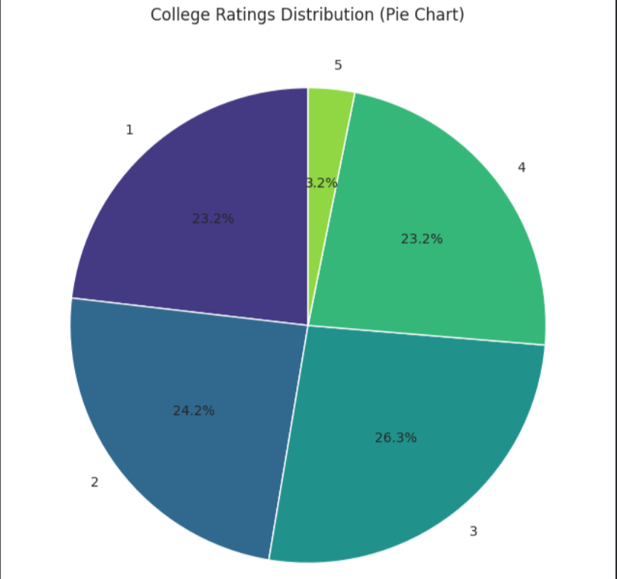

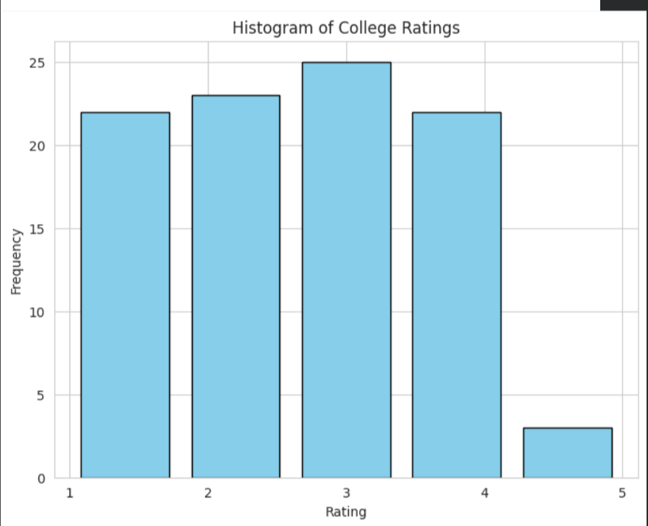

- Side Interests

import pandas as pd
import matplotlib.pyplot as plt
import seaborn as sns

if 'Side_Interests' not in df.columns or 'Side_Interests_Details' not in df.columns:
raise ValueError("Columns 'Side_Interests' and/or 'Side_Interests_Details' not found!")
print("Value Counts for Side_Interests:")
print(df['Side_Interests'].value_counts())

# 1: Bar Plot ---
plt.figure(figsize=(6,5))
sns.countplot(x='Side_Interests', data=df, palette='pastel')
plt.title('Students Pursuing Side Interests')
plt.xlabel('Side Interests?')
plt.ylabel('Number of Students')
plt.show()

# 2: Pie Chart ---
side_counts = df['Side_Interests'].value_counts()
plt.figure(figsize=(6,6))
plt.pie(side_counts, labels=side_counts.index, autopct='%1.1f%%', startangle=90, colors=sns.color_palette('pastel'))
plt.title('Side Interests Distribution')
plt.show()

# Show some Side_Interests_Details entries ---
yes_details = df[df['Side_Interests'] == 'Yes']['Side_Interests_Details'].dropna()
print("\nExample entries for Side_Interests_Details (students who said Yes):")
print(yes_details.head(10).to_list()) # show first 10 examples

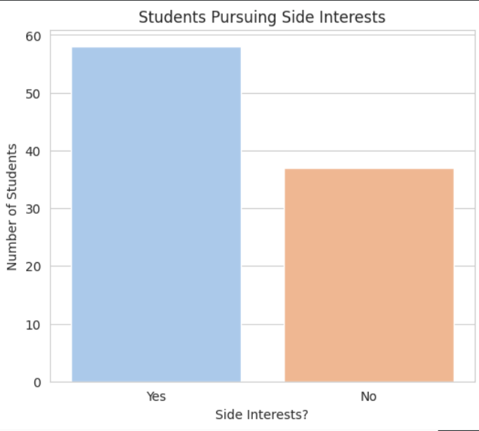
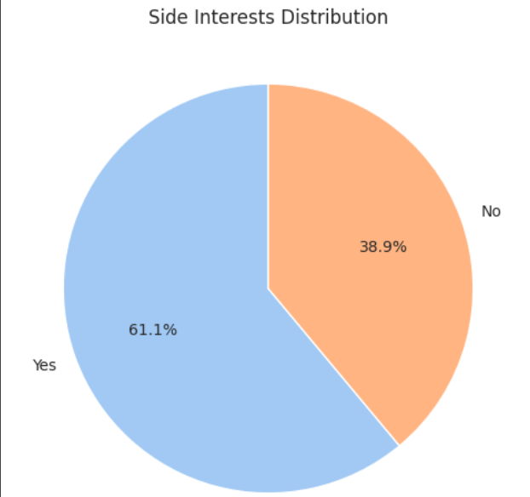

if 'Rate our College' in df.columns:
df.rename(columns={'Rate our College': 'Rate_College'}, inplace=True)

print("Columns in df:")
print(df.columns.tolist())

# 1. Basic Side Interests Distribution ---
plt.figure(figsize=(6,5))
sns.countplot(x='Side_Interests', data=df, palette='pastel')
plt.title('Students Pursuing Side Interests')
plt.xlabel('Side Interests?')
plt.ylabel('Number of Students')
plt.show()

# 2. Side Interests vs Current CGPA ---
plt.figure(figsize=(8,6))
sns.boxplot(x='Side_Interests', y='Current_CGPA', data=df, palette='Set2')
plt.title('Current CGPA vs Side Interests')
plt.xlabel('Side Interests?')
plt.ylabel('Current CGPA')
plt.show()

#3. Side Interests vs Extra Activities ---
activity_cols = ['Sports', 'Arts', 'Tech', 'Academics']
for col in activity_cols:
plt.figure(figsize=(6,4))
sns.countplot(x=col, hue='Side_Interests', data=df, palette='pastel')
plt.title(f'{col} Participation vs Side Interests')
plt.xlabel(col)
plt.ylabel('Number of Students')
plt.show()

# 4. Side Interests vs Academic Challenges ---
challenge_cols = ['Interest_in_studies', 'Time_management', 'Attendance',
'Peer_influence', 'Health_issues', 'Lack_of_interest_in_branch', 'Other_passions']
for col in challenge_cols:
plt.figure(figsize=(6,4))
sns.countplot(x=col, hue='Side_Interests', data=df, palette='pastel')
plt.title(f'{col} vs Side Interests')
plt.xlabel(col)
plt.ylabel('Number of Students')
plt.xticks(rotation=45)
plt.show()

# 5. Optional: CGPA Range vs Side Interests ---
if 'CGPA_Range' in df.columns:
plt.figure(figsize=(8,5))
sns.countplot(x='CGPA_Range', hue='Side_Interests', data=df, palette='Set2')
plt.title('CGPA Range vs Side Interests')
plt.xlabel('CGPA Range')
plt.ylabel('Number of Students')
plt.show()

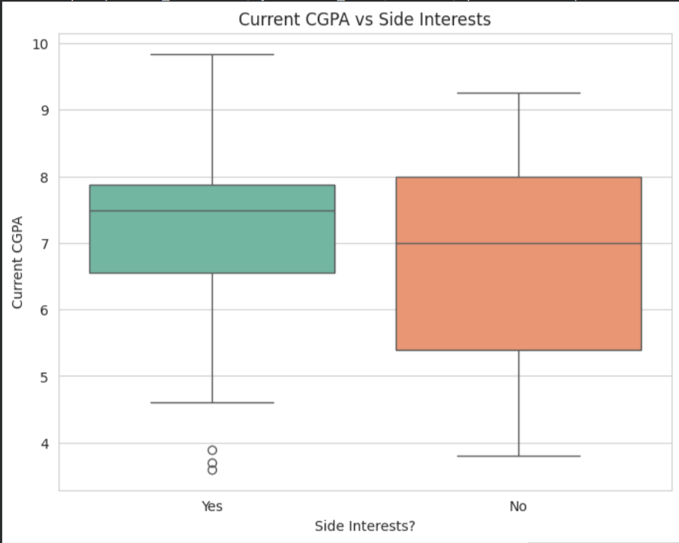
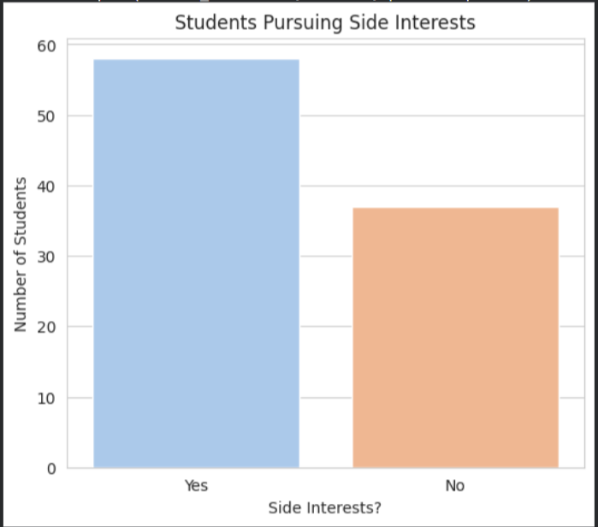

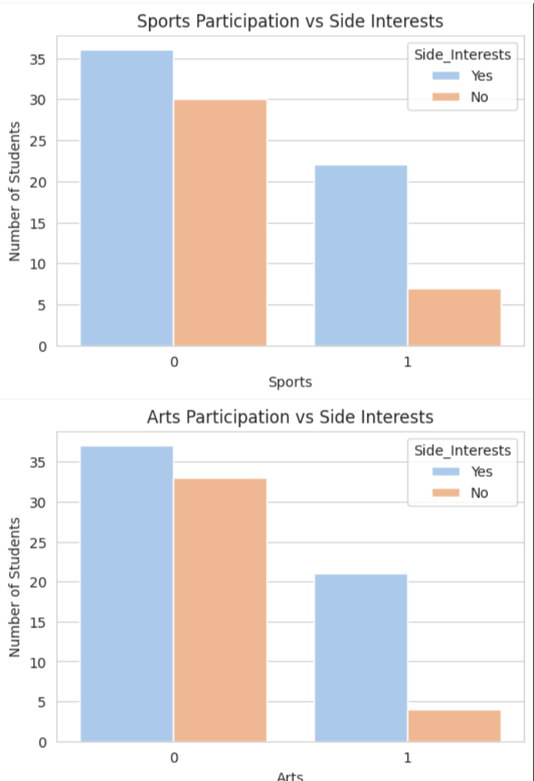

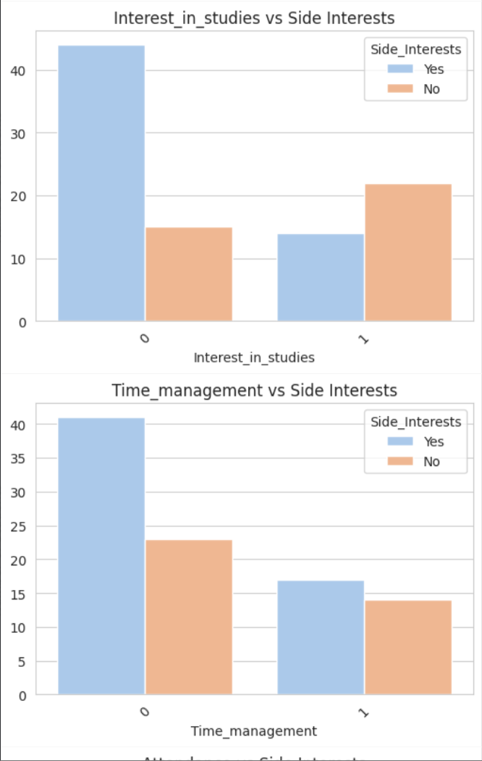
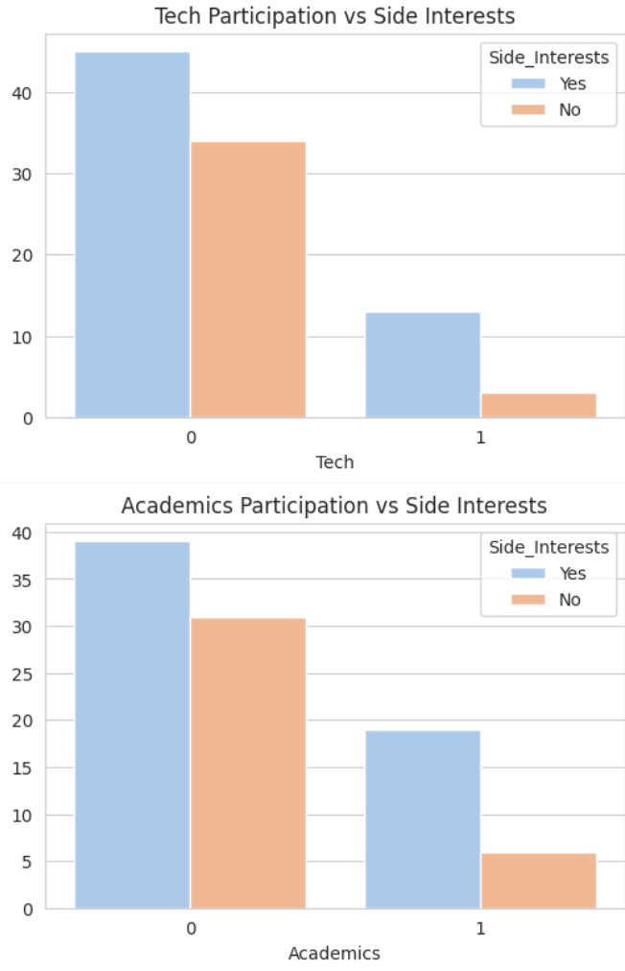

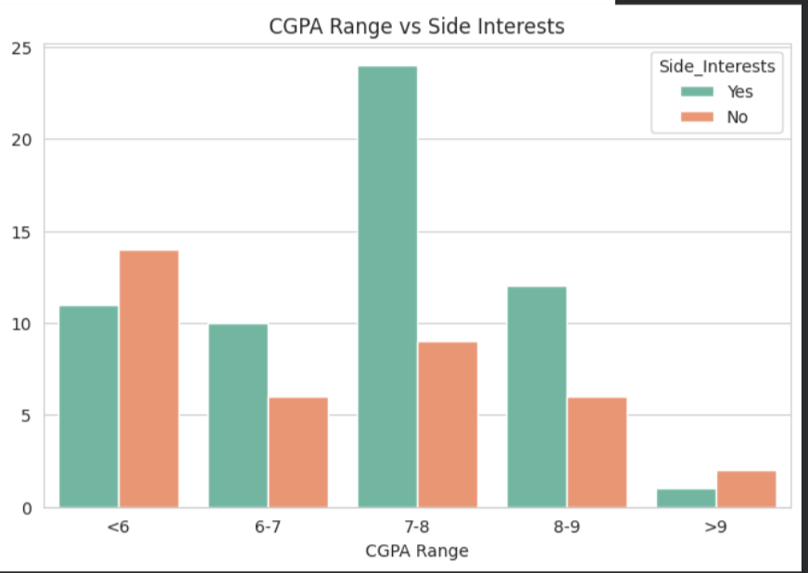

- College Motivation

# motivation_satisfaction_visualization.py

import pandas as pd
import matplotlib.pyplot as plt
import seaborn as sns

print("Columns in df:")
print(df.columns.tolist())

# 1. College Motivation Distribution ---
plt.figure(figsize=(7,5))
sns.countplot(x='College_Motivation', data=df, palette='Set2')
plt.title('Distribution of College Motivation')
plt.xlabel('Main Motivation for Studying')
plt.ylabel('Number of Students')
plt.xticks(rotation=30)
plt.show()

# 2. College Motivation vs Gender ---
plt.figure(figsize=(8,5))
sns.countplot(x='College_Motivation', hue='Gender', data=df, palette='pastel')
plt.title('College Motivation by Gender')
plt.xlabel('Main Motivation')
plt.ylabel('Number of Students')
plt.xticks(rotation=30)
plt.show()
# 3. Academic Satisfaction Distribution ---
plt.figure(figsize=(6,5))
sns.countplot(x='Academic_Satisfaction', data=df, palette='Set3')
plt.title('Academic Satisfaction Distribution')
plt.xlabel('Are you satisfied with your academic journey?')
plt.ylabel('Number of Students')
plt.show()

# 4. Academic Satisfaction vs Gender ---
plt.figure(figsize=(6,5))
sns.countplot(x='Academic_Satisfaction', hue='Gender', data=df, palette='pastel')
plt.title('Academic Satisfaction by Gender')
plt.xlabel('Academic Satisfaction')
plt.ylabel('Number of Students')
plt.show()

# 5. Academic Satisfaction vs College Motivation ---
plt.figure(figsize=(8,6))
sns.countplot(x='College_Motivation', hue='Academic_Satisfaction', data=df, palette='Set2')
plt.title('Academic Satisfaction vs College Motivation')
plt.xlabel('Main Motivation')
plt.ylabel('Number of Students')
plt.xticks(rotation=30)
plt.show()

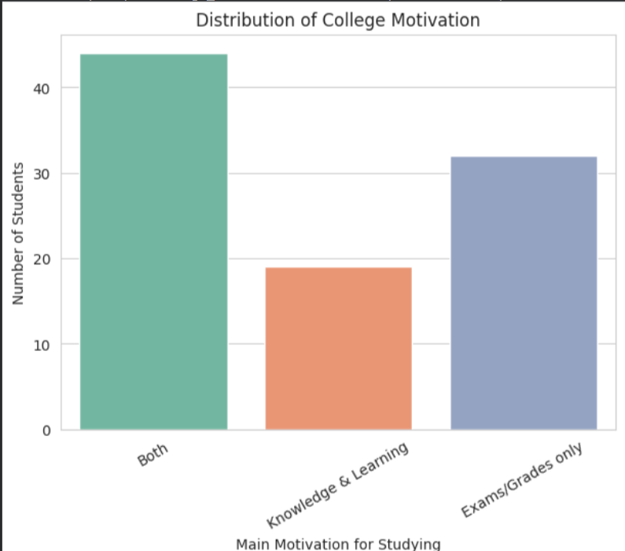

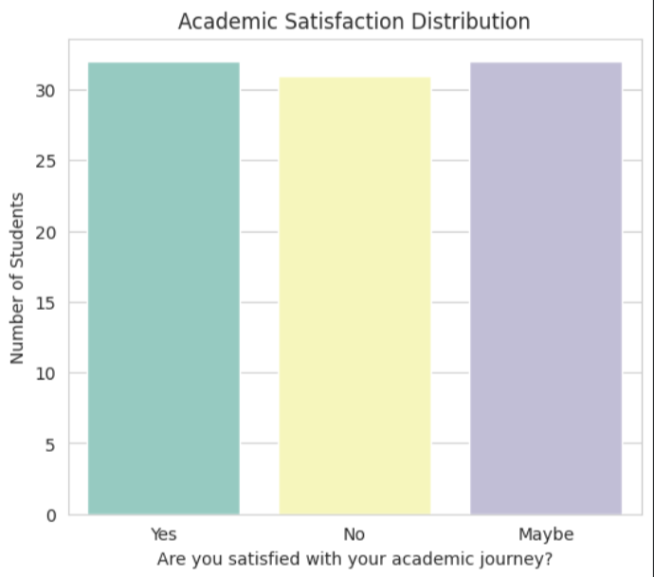

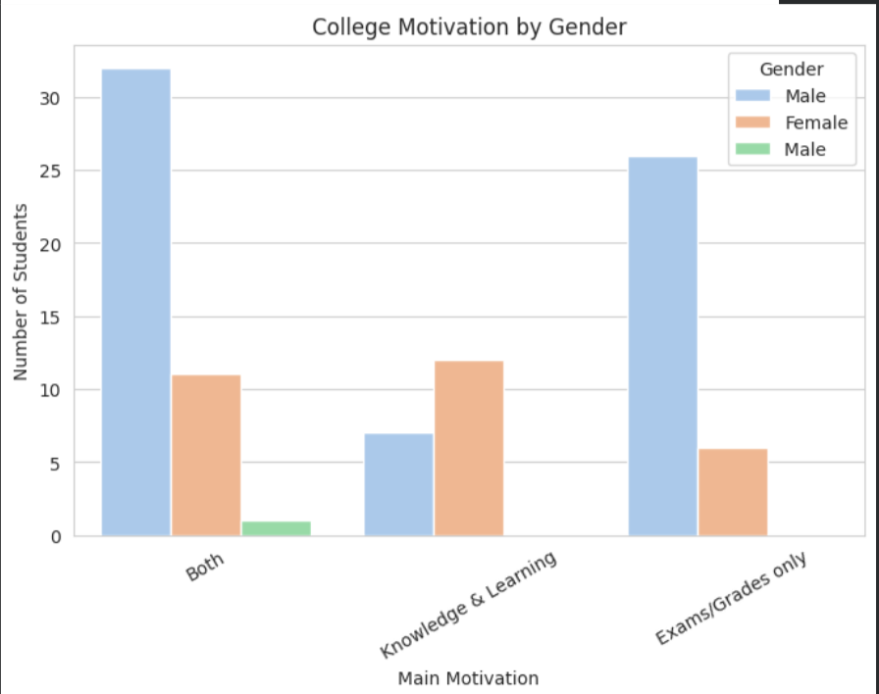

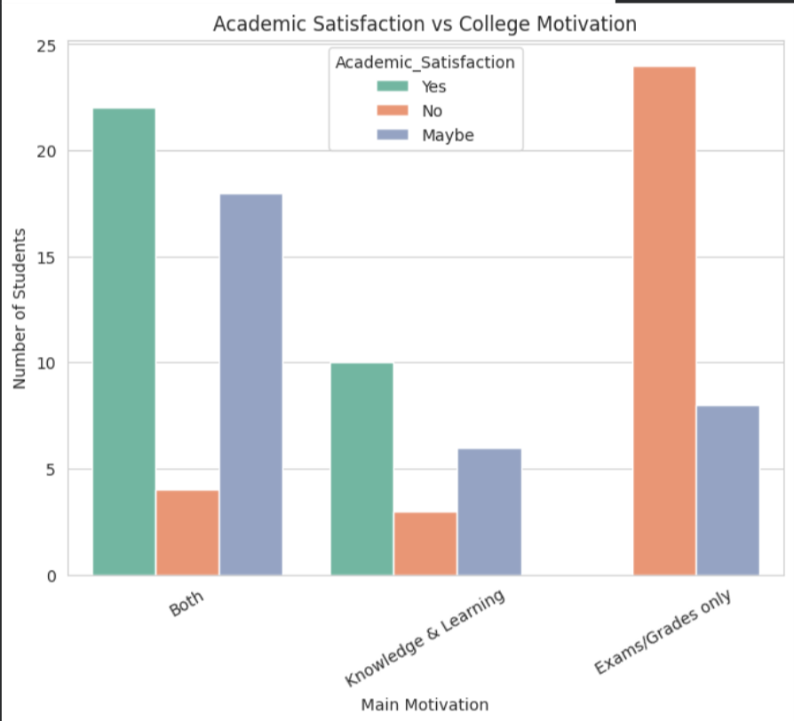

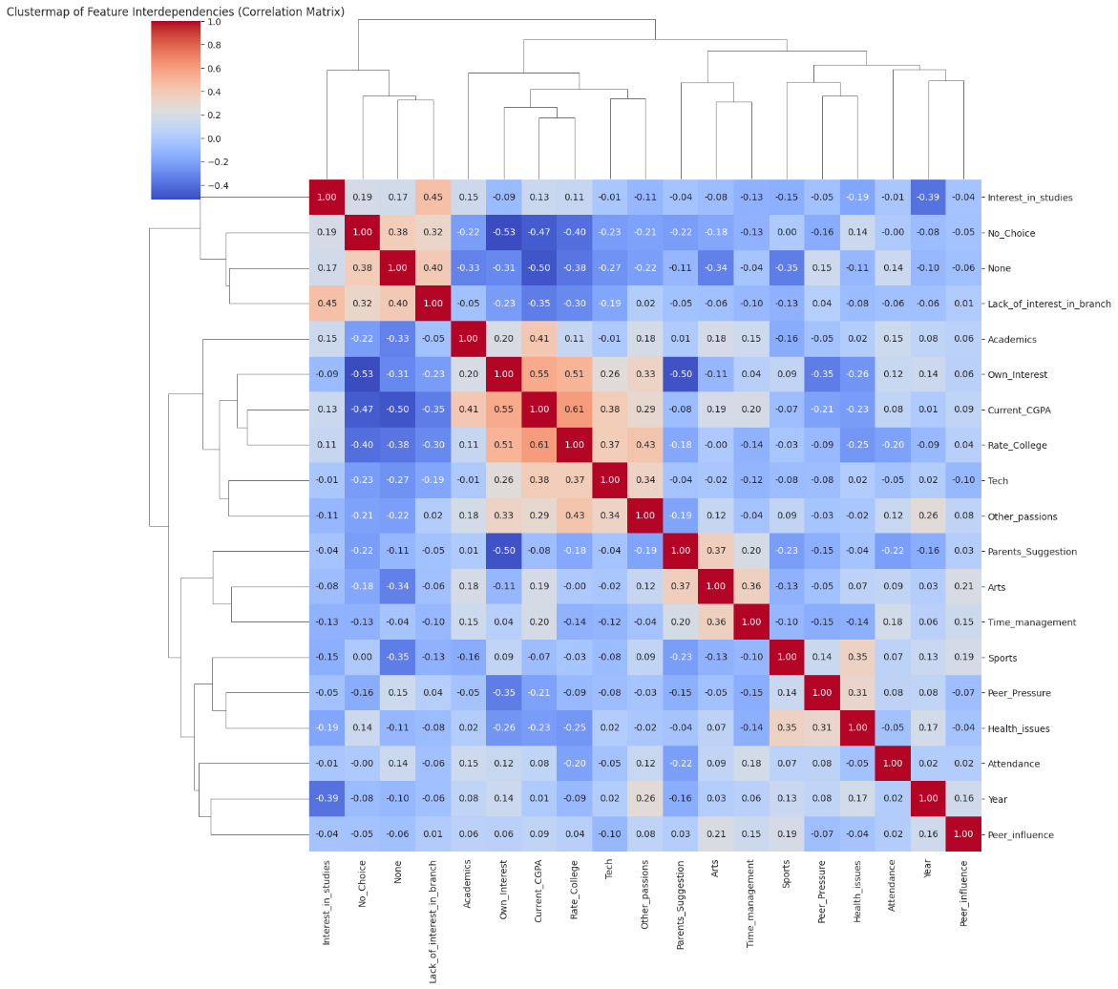

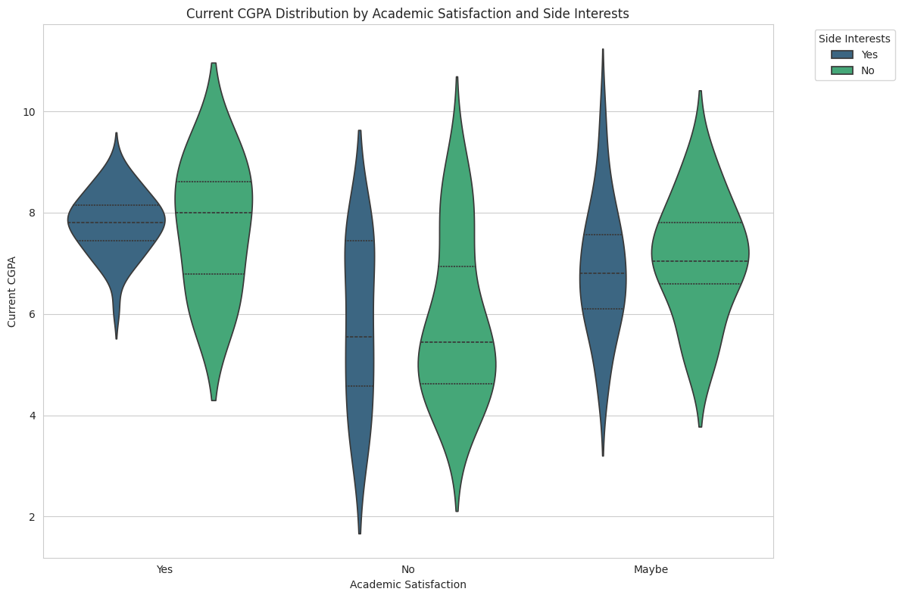

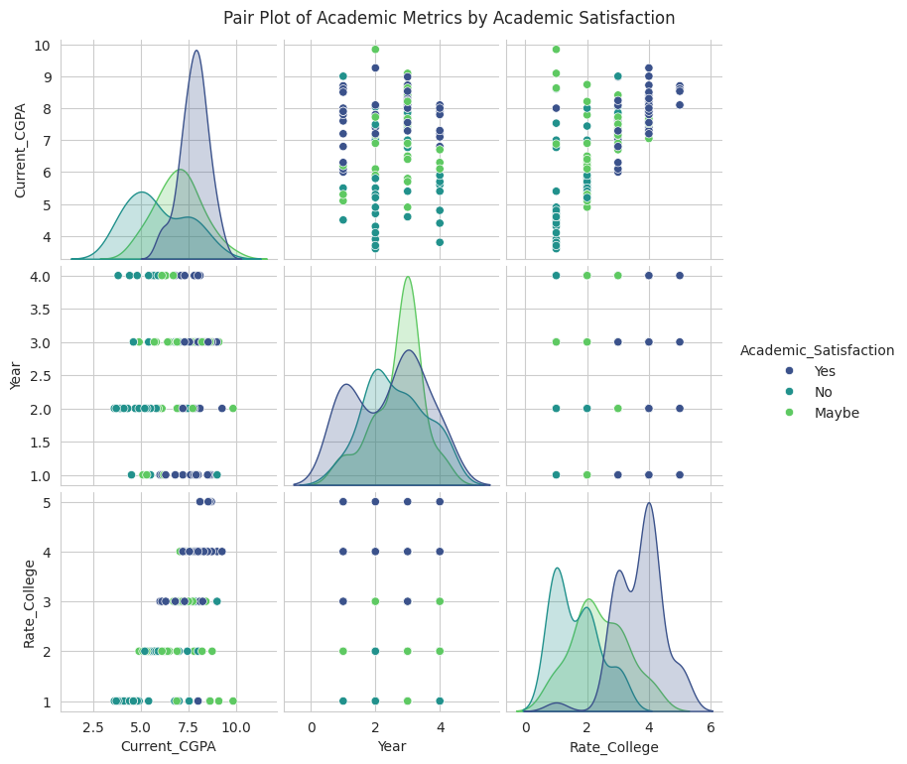

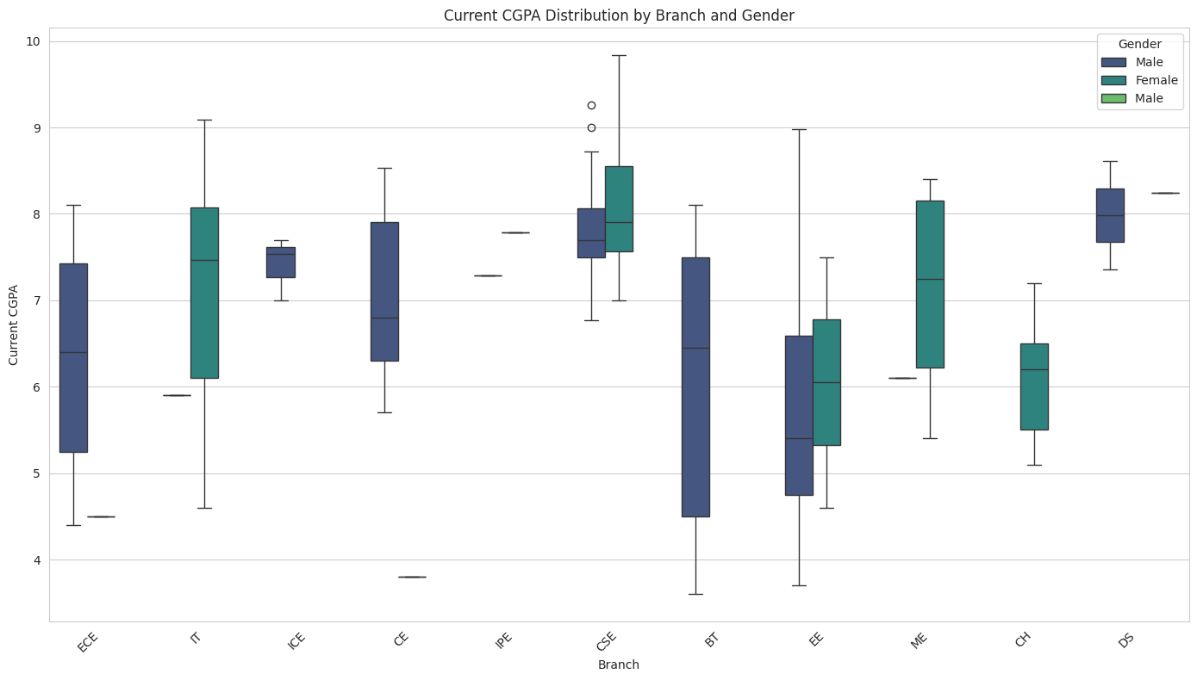

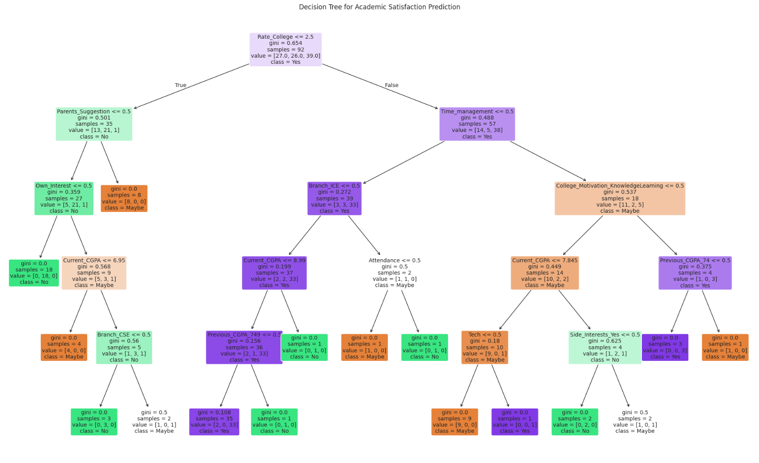

***END***

