[Home] - [Personal] - [Sudoku Solver] - Basic Strategies
Basic Strategies on this page  - Naked Pairs  - Naked Triples  - Naked Quads  - Hidden Pairs  - Hidden Triples  - Hidden Quads  - Intersection Removal | Goto Fishy Strategies  - X-Wing  - Sword-Fish  - Jelly-Fish  - Multivalue-X-Wing  - Finned X-Wing  - Sashimi Finned X-Wing | Goto Advanced Strategies  - Singles Chains a.k.a Simple Colouring  - Multi-Colouring  - Y-Wing a.k.a XY-Wing  - Y-Wing Chain  - XY-Chains  - XYZ-Wing  - WXYZ-Wing  - Aligned Pair Exclusion  - Remote Pairs  - Unique Rectangles  - Guardian/Broken Wings  - Death Blossom

Glossary: Unit: Any row, box or column, there being 27 units on a 9x9 Sudoku.
Naked Pairs
A Naked Pair (also known as a Conjugate Pair) is a set of two candidate numbers sited in two cells that belong to at least one unit in common. That is they reside in the same row, box or column.
It is clear that the solution will contain those values in those two cells and all other candidates with those numbers can be removed from whatever unit(s) they have in common.
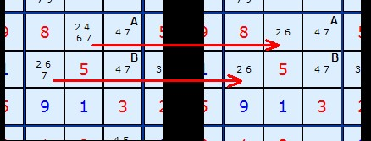
Figure 1
Consider this center box in Figure 1. There are two 4/7s at A and B. Two other cells contain 4s and 7s. We remove those to produce the right hand picture.
Figure 2 to the right is the same example but we're looking down the column at our two 4/7s at A and B. In the box below are two cells C and D which also contain 4s and 7s. We can safely remove the 4 from C and the 4 and 7 from D. | 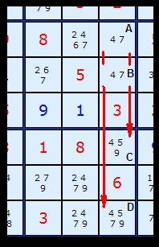  Figure 2
Naked Triples
A Naked Triple is slightly more complicated because it does not always imply three numbers each in three cells.
Any group of three cells in the same unit that contain IN TOTAL three candidates is a Naked Triple. Each cell can have two or three numbers, as long as in combination all three cells have only three numbers. When this happens, the three candidates can be removed from all other cells in the same unit.

The combinations of candidates for a Naked Triple will be one of the following:  The last case is interesting and the advanced strategy XY-Wings uses this formation. | (123) (123) (123)  (123) (123) (12)  (123) (12) (23)  (12) (23) (13)
To see a Naked Triple in action look at this center strip from an example board: | 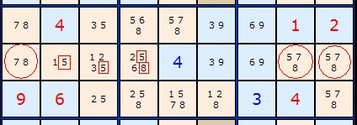
We have a triple in columns 1, 8 and 9. There are three other squares with 5,7 and 8 so we can clear them off leaving: | 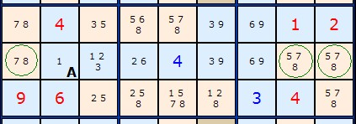
Naked Quads
A Naked Quad is rarer, especially in its full form but still useful if they can be spotted. The same logic from Naked Triples applies.
We have a Naked Quad arranged nicely together in the top row. Because we have 2/4/7/8 in columns 3, 4, 5 and 6 (marked in green circles) we can clear all other occurrences from the row (marked in red squares).  Load a different Example From the start or at the required point | 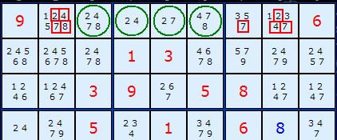
Hidden Pairs
Looking for Hidden pairs is a great way to open the board up to the other tests. Consider this top centre box below. There are two 5/8s hidden in in the squares at the top of the 3 x 3 box. They are marked by the green squares. We know these are the only possible positions for 5 and 8 since the rest of the board excludes the other squares in the box.
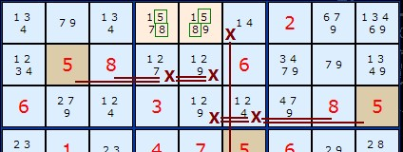
Since 5 AND 8 must exist in those two squares the two 1s, the 7 and the 9 cannot exist there. So we remove them. This reveals the hidden pair.
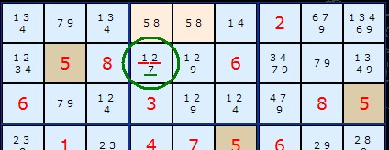
The knock on effect of this is to leave just one 7 in the box. We can make that the solution of that square and probably complete the rest of the board:
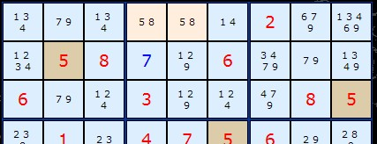
Exposing the pairs like this is essential for the Box/Line Reduction and the Remote Pairs - or at least makes them identifiable as appropriate strategies.

Naked Triples
A Naked Triple is slightly more complicated because it does not always imply three numbers each in three cells.
Any group of three cells in the same unit that contain IN TOTAL three candidates is a Naked Triple. Each cell can have two or three numbers, as long as in combination all three cells have only three numbers. When this happens, the three candidates can be removed from all other cells in the same unit.

The combinations of candidates for a Naked Triple will be one of the following:  The last case is interesting and the advanced strategy XY-Wings uses this formation. | (123) (123) (123)  (123) (123) (12)  (123) (12) (23)  (12) (23) (13)
To see a Naked Triple in action look at this center strip from an example board:
We have a triple in columns 1, 8 and 9. There are three other squares with 5,7 and 8 so we can clear them off leaving:
Naked Quads
A Naked Quad is rarer, especially in its full form but still useful if they can be spotted. The same logic from Naked Triples applies.
We have a Naked Quad arranged nicely together in the top row. Because we have 2/4/7/8 in columns 3, 4, 5 and 6 (marked in green circles) we can clear all other occurrences from the row (marked in red squares).
Load a different Example From the start or at the required point
Hidden Pairs
Looking for Hidden pairs is a great way to open the board up to the other tests. Consider this top centre box below. There are two 5/8s hidden in in the squares at the top of the 3 x 3 box. They are marked by the green squares. We know these are the only possible positions for 5 and 8 since the rest of the board excludes the other squares in the box.
Since 5 AND 8 must exist in those two squares the two 1s, the 7 and the 9 cannot exist there. So we remove them. This reveals the hidden pair.
The knock on effect of this is to leave just one 7 in the box. We can make that the solution of that square and probably complete the rest of the board:
Exposing the pairs like this is essential for the Box/Line Reduction and the Remote Pairs - or at least makes them identifiable as appropriate strategies.

Hidden Triples
We can extend Hidden Pairs to Hidden Triples or even Hidden Quads. A Triple will consist of three pairs of numbers lying in three cells in the same ROW, COLUMN or BOX, Such as 4/8/9, 4/8/9 and 4/8/9. However, we don't need exactly three pairs of numbers in three cells for the rules to apply. In the example below we have 4/8/9, 4/8 and 8/9 in three cells.
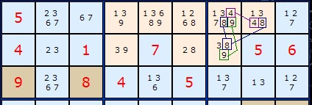
Since 4 AND 8 AND 9 must exist in those three squares the other numbers cannot exist there. So we remove them. This reveals the hidden triple:
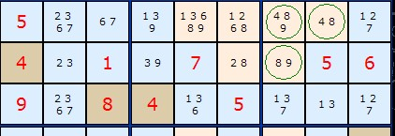
The minimum number of numbers for Hidden Triples will be three pairs of numbers, for example, 4/8, 4/9 and 8/9. It is clear they are bonded together and if they lie on three cells within the same ROW, COLUMN or BOX then any other numbers on those cells can be removed.

Hidden Quads
Here is the one example of a Hidden Quad found in a library of 18,000. Four numbers 3/5/6/7 on four cells are hidden by all of one number - 4 in R2C8. Barely qualifies as 'hidden' but it is legitimate. Note how none of the cells need to have all four numbers as long as only four cells contain all four numbers and are intermingled.  Note: the Solver program does not look for Hidden Quads since they are so rare and can normally be by-passed by other strategies. Loading the example will get you to the quad point but not remove the 4. | 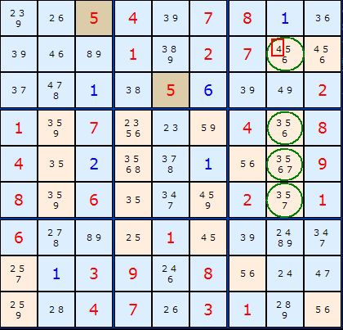  Figure 1  Load This Example From the start or at the required point
Intersection Removal
If any one number occurs twice or three times in just one unit (any row, column or box) then we can remove that number from the intersection of another unit. There are four types of intersection:
- A Pair or Triple in a box - if they are aligned on a row, n can be removed from the rest of the row.
- A Pair or Triple in a box - if they are aligned on a column, n can be removed from the rest of the column.
- A Pair or Triple on a row - if they are all in the same box, n can be removed from the rest of the box.
- A Pair or Triple on a column - if they are all in the same box, n can be removed from the rest of the box.
Rules 1 and 2 are also called Pointing Pairs/Triples Rules 3 and 4 are also called Box/Line Reduction
Type 1 - Pointing Pairs/Triples Strategy (a.k.a. Intersection Removal)
Looking at each box in turn there may be two or three occurrences of a particular number.
If these numbers are aligned on a single row or column (as a pair or a triple) then we know that number MUST occur on that line. Therefore, if the number occurs anywhere else on the row or column outside the box WHICH THEY ARE ALIGNED ON then it can be removed. The pair or triple points along the line at any numbers which can be removed.
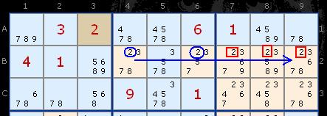
Consider the top third of the puzzle board above. We are looking at the number 2 in the center box and using the solver all the cells with 2 remaining have been highlighted. 2 can only be found in the centre row at B4 and B6. The 2's in the rest of the row can be removed (red squares).
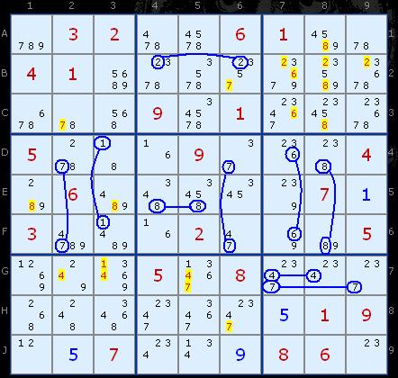
Load This Example
Now this is a rather special puzzle and a little extreme, but if we look at the whole board you can see I have highlighted a whole cluster of Pointing Pairs. It is obviously not necessary to spot everyone to progress the board but there are so many good examples it is worth looking at. The eliminations are highlighted in yellow. You should be able to see which eliminations belong to which Pointing Pair.
Credits
Phil Jackson from Tynemouth, UK, pointed out this strategy and coined 'pointing pairs' (27 May 05). New example added 26th April 2007.
Type 2 - Box Line Reduction Strategy (a.k.a. Intersection Removal)
This strategy involves careful comparison of rows and columns against the content of boxes (3 x 3 squares). If we find numbers in any row or column that are grouped together in just one box, we can exclude those numbers from the rest of the box. For example:
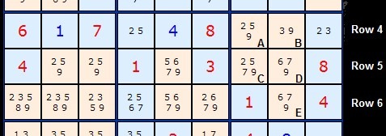
Consider the right hand box in this center row of the board. We can see five squares with 9s marked as possible numbers. The 9s that exist in cells A and B are the only 9s in that whole row. Either A or B MUST contains a 9 in the final solution. We can therefore safely remove the 9s from C, D and E.
Credits
I'd like to thank Andrew Pepperdine from Bath, UK for highlighting this strategy and sending me an example game board. (31 May 05). There is a counterpoint to Intersection Removal thats discussed under Generalizing X-Wings

The Law of Leftovers
Coming very soon. (Sorry! out of time tonight)
See also Fishy Strategies and Advanced Strategies
If anyone wishes to comment, correct or contribute to these pages please feel free to contact me at andrew@scanraid.com. I'm always interested to hear from other sudoku fanatics.
Andrew Stuart
Copyright
Scanraid Ltd
2005

Hidden Triples
We can extend Hidden Pairs to Hidden Triples or even Hidden Quads. A Triple will consist of three pairs of numbers lying in three cells in the same ROW, COLUMN or BOX, Such as 4/8/9, 4/8/9 and 4/8/9. However, we don't need exactly three pairs of numbers in three cells for the rules to appl

