How to set up Google Cloud Services

Go to <https://cloud.google.com/>

Fill out information such as country and select “Class Project/ Assignment”:

You can choose any payment method you like; your information will be used for verification only. Keep in mind that you will receive $300 free credit and this the credit you will use to perform your assignments (It is more than enough for assignment purpose). You can disable the service to save the remaining free credit after you finish with the assignments.

It is your responsibility to disable Google Cloud Platform after finishing the assignment to avoid any charge from Google



Create a project:

Enable Cloud Spanner API:

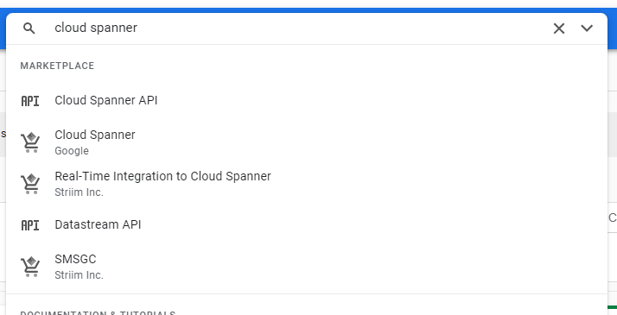

Creating a Spanner Instance:

Hit Create.

Now you should create a Database:

Creating a Credential File; you need to have credentials to connect to the databases/services from your applications, in our case, Jupyter notebook. On the menu, select “APIS & Services” and then “Credentials”:

Choose “Service Account”:

Copy service accounts for permission later

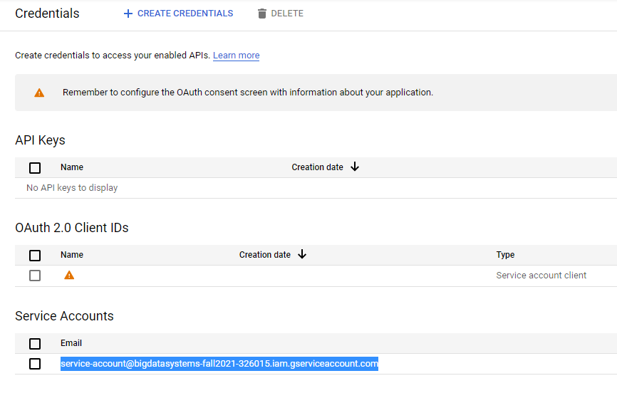

Click on service-account@bigdata...

Click on Grant Access

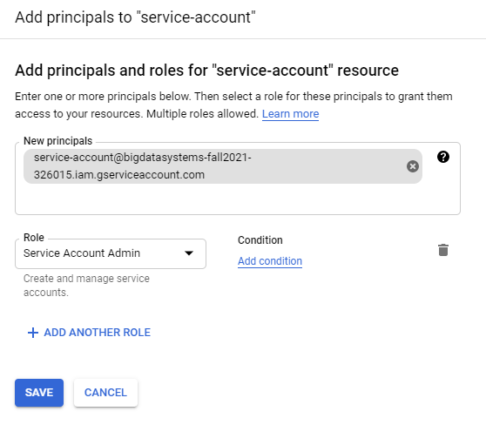

Click on Keys tab then Create New Key

Make sure your service account will be added to Spanner under Permission tab

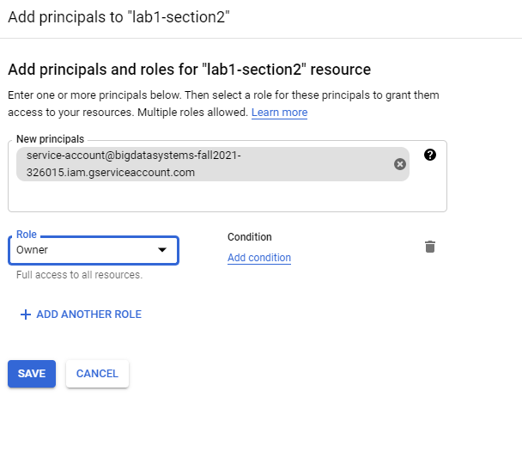

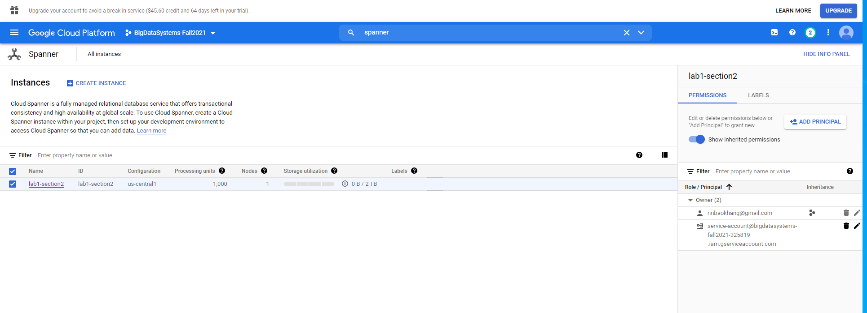

You should see a new download file name bigdatasystems-fall2021…json. Please keep this file, so later you can utilize this credential json file to access to Google Cloud API.

Enable Big Table:

Navigate to this page

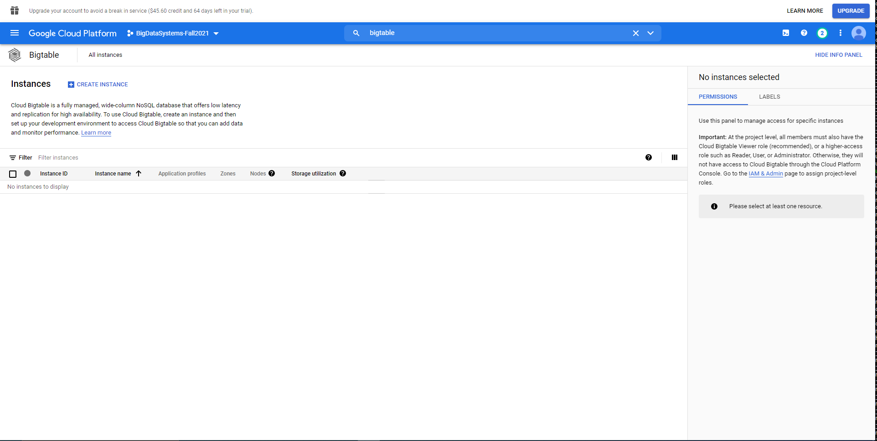

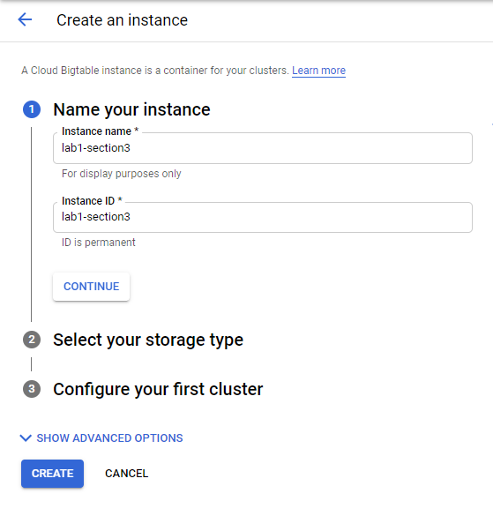

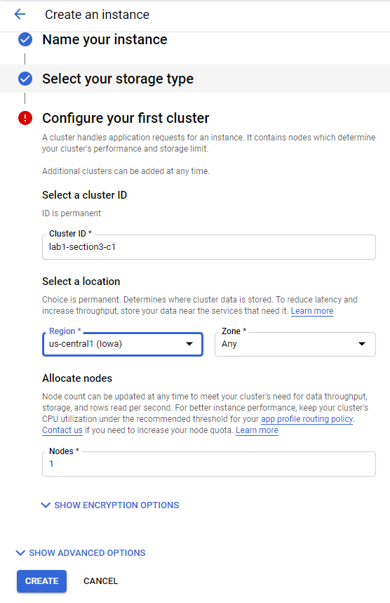

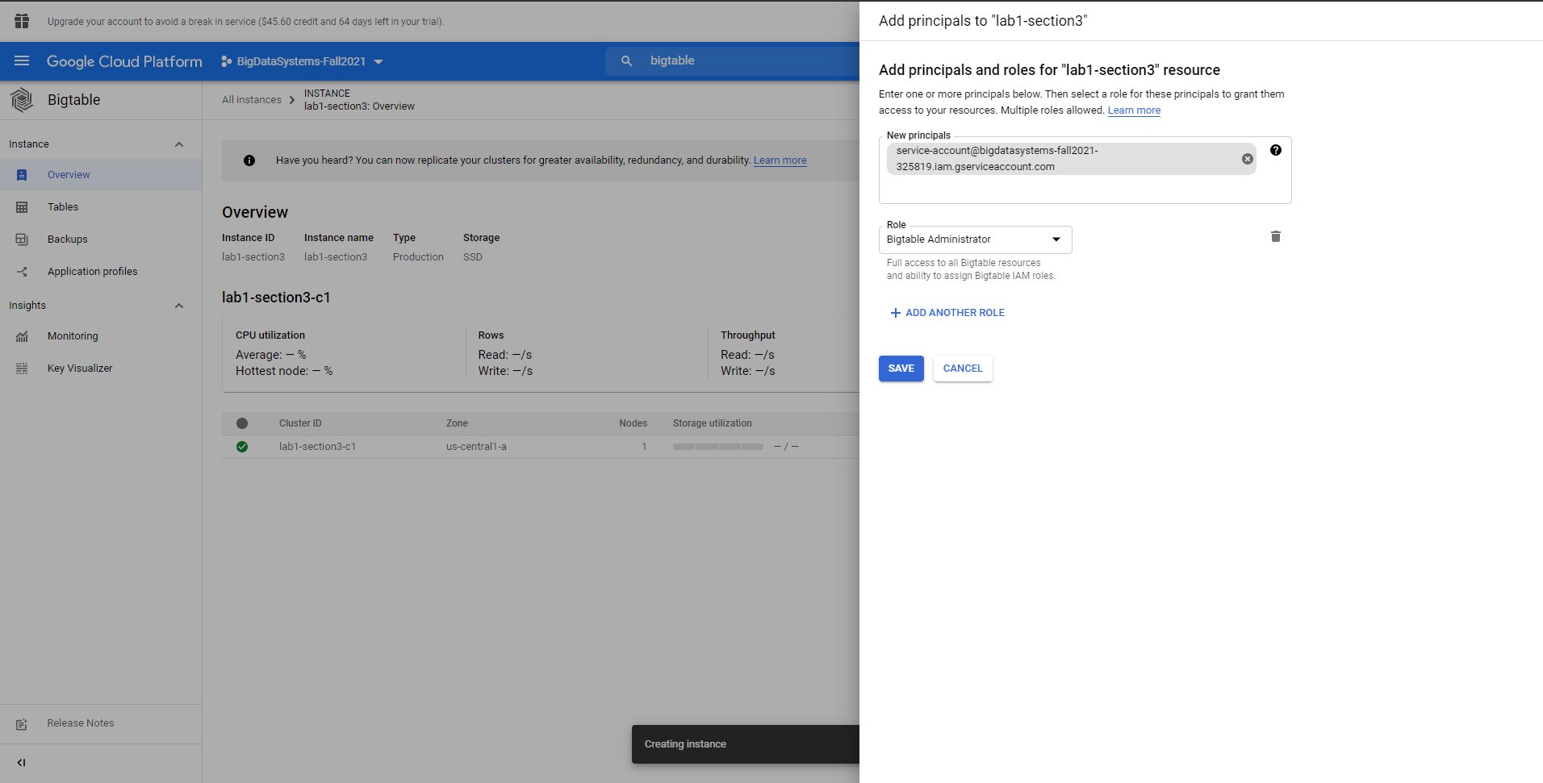

Noted:

You need to make sure that you are authorized to access Google Service API by adding service-account to Permission tab under Google Service API. Otherwise, you will not able to connect to Google Cloud API

For example:

To check if service-account has access to Big Data API, you need navigate to Big Table, choose an instance, check permission tab.

