Table of Contents

**1.** **Introduction** 2

1.1. Purpose 2

1.2. Scope of this document 2

**2.** **SAP Landscape Details** 2

2.1. CMO Data Center Locations 2

2.2 Systems Involved in migration 3

2.3 CMO Vs FMO Version comparison 3

2.4 Version supportability in Azure 3

2.5 CMO Network Details 4

2.6 CMO Sizing 5

**3.** **System Architecture and Design Principles** 6

3.1. High Level Architecture diagram 6

3.2. Key Architecture Principal 6

3.3. Azure components explained 7

3.3.1. Region 7

3.3.2. Availability Zone 7

3.3.3. Virtual Machines (VM) 7

3.3.4. Proximity Placement Group 7

3.3.5. Accelerated networking 8

3.3.6. Storage 9

3.4. Azure Data Center Strategy in FMO 11

3.5. HA/DR Solution 11

3.5.1. Service Level Agreement (SLA) 11

3.5.2. High Availability 11

3.5.3. Disaster Recovery 13

3.6. DNS Solution 13

3.7. HANA database encryption 13

3.8. Backup Solution 14

**4.** **Migration Strategy** 14

4.1 Lift and shift migration with replatform 14

# **Introduction**

## Purpose

This document provides a comprehensive architectural overview of the Siemens x56 SAP landscape, which are planned to be migrated into the Azure public cloud.

There are three systems ( DEV, QA and Production ) in this landscape and x56 hosts EWM application.

## Scope of this document

The document depicts the technical aspects of the SAP System, Azure Components involved & migration strategy and is intended to capture and convey the significant architectural design decisions which have been made in preparation for the migration to cloud.

This document merges knowledge from past meeting with Siemens, Microsoft & SAP and from ATOS expertise to formulate a plan for developing SAP architecture in Azure and SAP migration strategy.

# **SAP Landscape Details**

## CMO Data Center Locations

**Texas / USA**

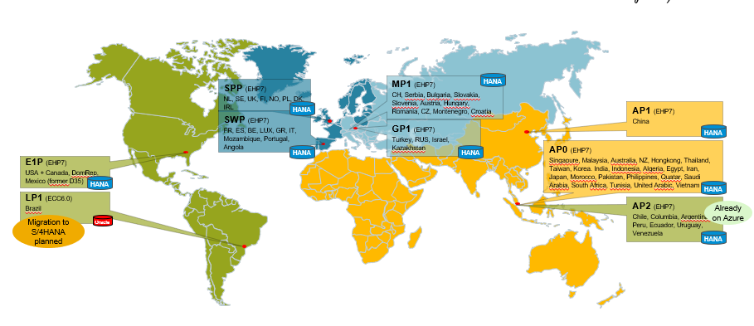

## 2.2 Systems Involved in migration

|  |  |  |
| --- | --- | --- |
| Dev | Test | Production |
| D56 | Q56 | P56 |

## 2.3 CMO Vs FMO Version comparison

|  |  |  |  |  |  |  |  |
| --- | --- | --- | --- | --- | --- | --- | --- |
|  | | **DMO Versions** | | | **FMO Versions** | | |
| **SAP** | **OS** | **DB** | **SAP** | **OS** | **DB** |
| **P56** | **DB** | **N/A** | **RHEL 7.9** | **SAP HANA 2.0 SPS 5** | **N/A** | **RHEL 8.4** | **SAP HANA 2.0 SPS 5** |
| **App Server** | **SAP NW 7.5/EWM 9.5** | **SLES 12 SP5** | **N/A** | **SAP NW 7.5/EWM 9.5** | **RHEL 8.4** | **N/A** |

**Note :**

## 2.4 Version supportability in Azure

From the above table we can see that CMO systems are hosted on multiple OS platforms e.g., SLES12, RHEL 7.x, AIX 7.1 but FMO systems will be hosted on RHEL 8.4.

The RHEL 8.4 systems will use the Siemens hardened golden image to ensure that they comply with the security guidelines/requirements. Monitoring against any defects against the agreed standards are identified using the Alcatraz scripts, which are scheduled and managed via Bladelogic.

Patching of the RHEL systems will be managed by Bladelogic, using the patching schedule agreed with Siemens. Bladelogic manages the updates of the available repos, which are then used when the system patching is initiated by Bladelogic.

SAP version in FMO remains same as CMO except LP1 where EHP upgrade will be performed from EHP7 SPS14 to SPS19.

DB version on all systems after migration will be HANA 2.0 SP5.

Hence, it needs to be checked if RHEL 8.4, HANA 2.0 SP5 & EHP7/8 FOR SAP ERP 6.0 is supported in Azure. The SAP Product Availability Matrix (PAM) and SAP OSS Notes: 1928533 - SAP Applications on Azure: Supported Products and Azure VM types, 2015553 - SAP on Microsoft Azure: Support prerequisites and 2235581 - SAP HANA: Supported Operating Systems provide details of supported operating systems, VM Azure types and pre-requisites.

**OS**

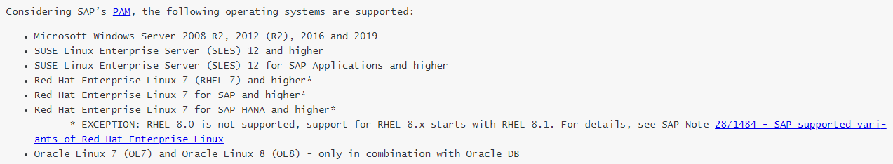

**SAP**

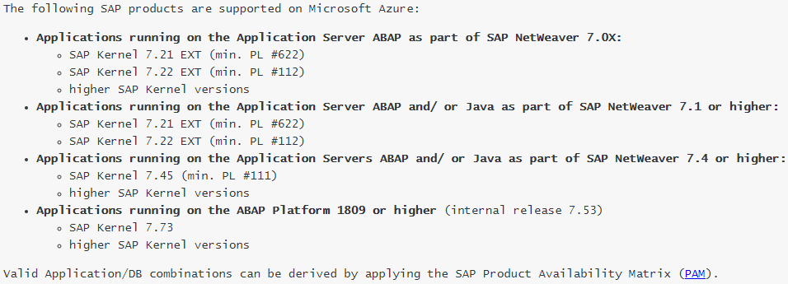

**DB**



**Conclusion** – All the component versions i.e. SAP/DB/OS are supported in Azure.

## 2.5 CMO Network Details

From the below data it can be seen that the network bandwidth used in CMO environment is 150 MB.

**Fuerth**

Te0/0/1/0.448 up up FTH | 150000 | SIEMENS PROXY VLAN 448 (AVZ1) | Project D4539-043

**Munich**

Te0/0/2/2.84 up up MCH | 150000 | Siemens-Proxy VLAN 84 (AVZ1)

## 

## 2.6 CMO Sizing

|  |  |  |  |  |  |  |  |  |  |  |  |  |  |  |  |  |  |  |  |  |  |  |  |  |  |  |  |  |  |  |  |  |  |  |  |  |  |  |  |  |  |  |  |  |  |  |  |  |  |  |  |  |  |  |  |  |  |  |  |  |  |  |  |  |  |  |  |  |  |  |  |  |  |  |  |  |  |
| --- | --- | --- | --- | --- | --- | --- | --- | --- | --- | --- | --- | --- | --- | --- | --- | --- | --- | --- | --- | --- | --- | --- | --- | --- | --- | --- | --- | --- | --- | --- | --- | --- | --- | --- | --- | --- | --- | --- | --- | --- | --- | --- | --- | --- | --- | --- | --- | --- | --- | --- | --- | --- | --- | --- | --- | --- | --- | --- | --- | --- | --- | --- | --- | --- | --- | --- | --- | --- | --- | --- | --- | --- | --- | --- | --- | --- | --- |
| |  |  |  |  |  |  |  | | --- | --- | --- | --- | --- | --- | --- | | **X56** |  | **Host Name** | **Instance#** | **Number of Instances** | **CPU** | **Memory** | |  | | **P56** | usirv99d1sap |  | 1 | 112 | 772 |  | | usirv99d2sap |  | 1 | 112 | 772 |  | | usirv99d3sap |  | 1 | 16 | 128 |  | | usirv99d4sap |  | 1 | 8 | 96 |  | | usirv99d5sap |  | 1 | 8 | 96 |  | | **Q56** | usirv99d6sap |  | 2 | 112 | 1.16TB |  | | usirv99d7sap |  | 1 | 4 | 32 |  | | usirv99d8sap |  | 1 | 4 | 32 |  | | **D56** | usirv99d6sap |  | 2 | 112 | 1.16TB |  | | usirv99d9sap |  | 1 | 4 | 32 |  | | usirv99dasap |  | 1 | 4 | 32 |  | |
|  |
|  |

|  |
| --- |
| **System Architecture and Design Principles**High Level Architecture diagram The following diagram outlines the high-level major components of the SAP environment in Azure cloud.   Key Architecture Principal  * All production systems will be setup in HA between two zones within same region. * Non-Prod systems will be setup in Zone 3. * High Availability for production systems to be configured and achieved using RHEL pacemaker cluster. * Azure backup will be used as a backup solution with BLOB (GRS) as storage for the backup files, which will ensure accessibility to other region in case of disaster scenario. * Azure premium file share will be used to host shared mountpoints across zones (e.g., trans, sapmnt etc.) * For the low latency, VM’s will be configured in proximity placement group with Availability Sets. * Accelerated networking will be enabled on the VM’s for better performance. * HANA database will be synced through HANA System Replication (HSR), between Zones to achieve HA. * The failover for the HANA database will also be managed by RHEL pacemaker cluster. * Azure premium disks will be used for the database storage. * As per ARI security requirements, every SAP SID and its associated components should be in separate subscription and no sharing between them. This means that per landscape we will require 3 VM’s for the Web dispatcher, 2 for Prod (due to HA) and 1 for QA. For DEV web dispatcher will be installed locally on the PAS server itself.  Azure components explainedRegion An Azure region is a set of datacentres, deployed within a latency-defined perimeter and connected through a dedicated regional low-latency network. Availability Zone Azure Availability Zones are separate data center units within Microsoft Azure, each with its own power, cooling, and networking.  Running a VM with one or more replicated copies on different Availability Zones, provides resiliency against data centre failure.   Virtual Machines (VM) An Azure virtual machine is an on-demand, scalable computer resource that is available in Azure. Virtual machines host the application or database. Proximity Placement Group A proximity placement group is a logical grouping used to make sure that Azure compute resources are physically located close to each other.   Accelerated networking Prior to proximity groups being available the main solution to reduce VM-to-VM network latency was to use Accelerated Networking aka Single Root IO Virtualisation.  Accelerated networking enables single root I/O virtualization (SR-IOV) to a VM, greatly improving its networking performance. This high-performance path bypasses the host from the Datapath, reducing latency, jitter, and CPU utilization, for use with the most demanding network workloads on supported VM types. The following  picture shows communication between two VMs with and without accelerated networking:   Storage As part of this solution, we will be using 3 types Azure storages and the details of which are as below   1. Azure Premium Disks   Azure premium SSDs deliver high-performance and low-latency disk support for virtual machines (VMs) with input/output (IO)-intensive workloads.  When you provision a premium storage disk, unlike standard storage, you are guaranteed the capacity, IOPS, and throughput of that disk.   1. Premium File Share (ZRS)   Premium file shares are backed by solid-state drives (SSDs) and provide consistent high performance and low latency, within single-digit milliseconds for most IO operations, for IO-intensive workloads.  ZRS provides high availability by synchronously writing three replicas of your data across three different Azure [Availability Zones](https://docs.microsoft.com/en-us/azure/availability-zones/az-overview), thereby protecting your data from cluster, datacenter, or entire zone outage. Zonal redundancy enables you to read and write data even if one of the availability zones is unavailable.  Region wise availability |
| <https://azure.microsoft.com/en-us/global-infrastructure/services/?products=storage&regions=europe-west,europe-north,us-east,us-central,asia-pacific-east,asia-pacific-southeast,china-north,china-east,china-east-2,china-north-2>  **Architectural Considerations**  When defining the NFS and CIFS shares within the Azure landscape you need to follow the following rules:  • The private end points for the CIF and NFS shares should be defined on the Apps network only, you shouldn’t be creating private end points on the database subnets.  • The private end points should have a DNS name defined for the endpoint in the dc.siemens.net DNS domain e.g: If storage resource name is ap0nfscloudstorage and the private end point has been created in the Q56 subscription the DNS name would be ap0nfscloudstorage_q56.dc.siemens.net.  • Filesystems defined in the /etc/fstab should not use file.core.windows.net and instead should be using the apdsap.siemens.net name i.e., azeunegp1nfs1_<sid>. dc.siemens.net:/azeunegp1nfs1/gu1sapmnt not azeunegp1nfs1.file.core.windows.net:/azeunegp1nfs1/gu1sapmnt.  • Above rule also applies to any filesystem which is getting mounted from FMO to CMO e.g: /usr/sap/trans |
|  |

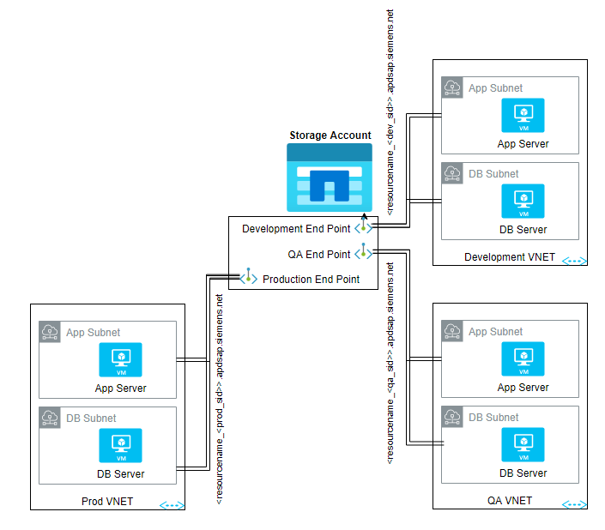

1. Azure BLOB storage (GRS)

We plan to make use of Azure BLOB storage for Azure backup solution to store the backups.

Azure Blob storage is an object storage solution for the cloud, optimized to store massive amounts of data.

Geo-redundant storage (GRS) copies the data synchronously three times within a single physical location in the primary region using LRS. It then copies your data asynchronously to a single physical location in the secondary region. Within the secondary region, your data is copied synchronously three times using LRS.

## Azure Data Center Strategy in FMO

**US-east-2– Primary, US-west-2 for DR. – Production**

**US-east-2 – DEV and QA.**

## HA/DR Solution

### Service Level Agreement (SLA)

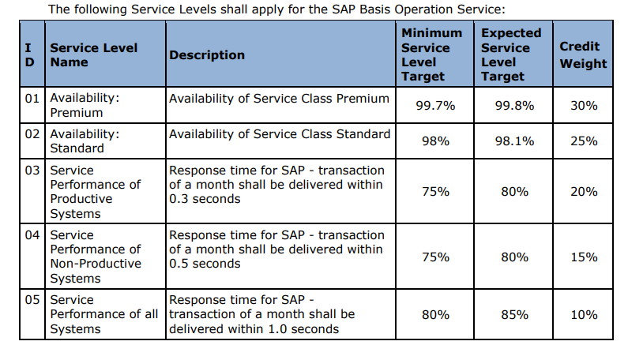

### High Availability

High availability in Azure will be achieved through RHEL pacemaker configured for failover between two availability zones. With Availability Zones, Azure offers 99.99% VM uptime SLA.

Application level high availability will be achieved by configuring ASCS in Zone-1 and ERS (Enque Replication Server) in Zone-2. All the application servers will be divided in half and distributed across both the zones. In case of failover RHEL pacemaker will move ASCS service to Zone-2. Shared filesystems like sapmnt & trans will be configured in Azure premium file shares which can span across zones providing high availability to the shared filesystem.

Database level High availability will also be configured using RHEL pacemaker between the two availability zones. HANA system replication (HSR) will be configured for syncing data between Zone-1 to Zone-2. In case of failover, Pacemaker will perform takeover on secondary node, making it primary and operation will continue.

While availability zones will be used to provide high availability, there was a concern with regards to the latency between two zones. As per discussion in SAP max attention workshop, it was agreed that the latency between zones will be measured select it based on latency within acceptable limits. The tool to measure latency is

[SAP-on-Azure-Scripts-and-Utilities/AvZone-Latency-Test at main · Azure/SAP-on-Azure-Scripts-and-Utilities · GitHub](https://github.com/Azure/SAP-on-Azure-Scripts-and-Utilities/tree/main/AvZone-Latency-Test)

SAP recommends latency values as below

* + Good value: Roundtrip time <= 0.3 ms
  + Moderate value: 0.3 ms < roundtrip time <= 0.7 ms
  + Below average value: Roundtrip time > 0.7 ms

Based on many improvements deployed by Microsoft into the Azure regions to reduce network latency within an Azure Availability Zone, the new deployment guidance for zonal deployments, looks like:

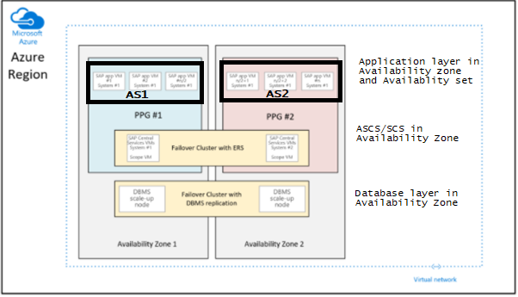

The difference to the recommendation given so far is that the database VMs in the two zones are no more a part of the proximity placement groups.

The proximity placement groups per zone are now scoped with the deployment of the VM running the SAP ASCS/SCS instances. This also means that for the regions where Availability Zones are collected by multiple datacenters, the ASCS/SCS instance, and the application tier could run under one network spine and the database VMs could run under another network spine.

### Disaster Recovery

DR solution in the selected option is an On-Demand solution. Backups will be configured in Azure Backup and target for backup storage will be BLOB’s. The solution will use Geo Redundant Storage (GRS) which will replicate across fixed region pair.

If a region is lost, Microsoft will make the backups available to customers. Customers will be able to restore to any of their configured restore points.

## DNS Solution

To use custom domain name instead of Azure provided names, we will have to use Azure Private DNS.

* Benefits
  + Removes the need for custom DNS solutions
  + Use all common DNS records types
  + Automatic hostname record management
  + Hostname resolution between virtual networks.
  + Available in all Azure regions.

A specific virtual network can be linked to only one private zone if automatic registration of VM DNS records is enabled. You can however link multiple virtual networks to a single DNS zone.

**Context and Scenario**

* **Existing Scenario**
  + Existing IT Infrastructure (On-Premise)
  + Additional Infrastructure in the Azure cloud.
  + Hybrid cloud connection via expressroute
* **Expectations**
  + Multiple VNET’s to be connected
  + Need to make use of Hub and Spoke network topology
  + DNS resolution necessary across VNET’s
  + DNS resolution necessary between on-prem and cloud.

## HANA database encryption

SAP HANA database support several levels of persistent encryption: data, backup and log encryption. SAP HANA doesn’t encrypt the data in memory, and only the persistent layer (disk) is encrypted. The databases will be encrypted using keys managed using secure store in the file system (SSFS) protection for the root keys used to encrypt information stored in the data and log volumes. Backup of these keys are essential for any future recovery of the database, and therefore the backup of these keys are included in the Azure storage backups of the HANA shared filesystem.

The encryption of the HANA backups and log will not be in forced, due to a performance issue with the encryption using 3rd Party backint solutions. SAP have confirmed that this is a known issue, and are investigating it and once a solution is identified backup and log encryption using SAP HANA encryption will be reviewed.

HANA backups will be encrypted using the Azure backup vaults platform managed keys encryption.

Client-side data encryption between the SAP and SAP HANA database will be configured, using SSL encryption.

## Backup Solution

We plan to make use of Azure backup as a backup solution for all the system lines.

Azure Backup is HANA backint certified by SAP, to provide native backup support by leveraging SAP HANA’s native APIs. This offering from Azure Backup aligns with Azure Backup’s model of zero-infrastructure backups, eliminating the need to deploy and manage backup infrastructure. SAP HANA databases can now seamlessly backup and restore running on Azure VMs (M series VMs also supported now!) and leverage enterprise management capabilities that Azure Backup provides.

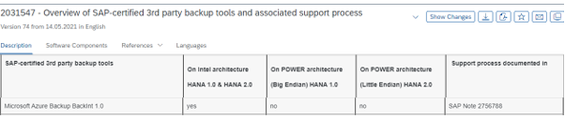

# **Migration Strategy**

The x56 landscape is a three system landscape ( Dev, QA and production). The system is already running with HANA database. The database is running on RHEL and SAP application servers are running on SUSE. During the migration, SAP application servers will be moved to RHEL and eliminate SUSE Linux in the landscape.

The migration approach will be Lift and Shift with replatform.

## Lift and shift migration with replatform

In this case, x56 running on HANA DB will have to be migrated without changing software versions. Lift and shift meaning moving applications to the cloud as-is. However, since CMO OS versions vary between SLES and RHEL for App and DB, and in FMO all of them will be hosted on RHEL 8.4 irrespective of the source OS version, in cloud terms it will be called as Replatforming.

The migration would involve, migrating HANA DB with the help of HANA System Replication (HSR) and applications configurations will be migrated using OS utilities.

Below image depicts the high-level steps involved in this migration method

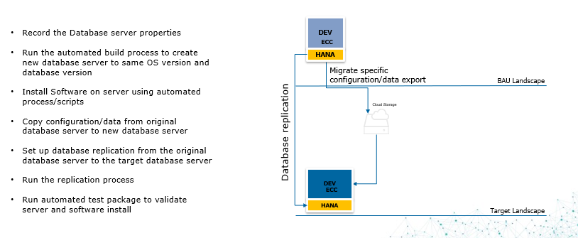

**Note**:

HSR between SUSE to RHEL is supported

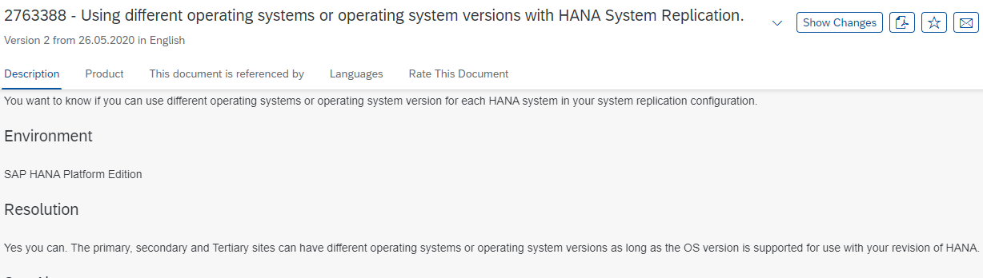

1. Siemenization

There are certain Specific tasks to be performed for Siemens other than general post installation tasks. These tasks will be performed in two phases before and after migration of x56 to cloud. Following are the list which may be updated in due course.

|  |  |  |  |  |
| --- | --- | --- | --- | --- |
| Main task | Sub task | Ownership | Co-ownership | Comments |
| **Managed system configuration - P49** |  | **Atos** | **SHS** | Needed |
| **Initial transports** |  | **Atos** |  | Check only |
|  | ADP | **Atos** | **SHS** |  |
|  | Gama | **Atos** | **SHS** |  |
| **Cert measures implementation – HANA** |  | **Atos** |  | **Needed** |
| **Cert measures implementation – SAP** |  | **Atos** |  | **Needed** |
| **Cert measures implementation – OS** |  | **Atos** |  | **Needed** |
| **ADP (tool works in development system only)** |  | **Atos** |  | **Only valid for development systems** |
|  | ER tool |  |  |  |
|  | Mue Mon (configuration required on prod only) |  |  |  |
|  | CCM Extractor |  |  |  |
|  | PUC/PAC rulesets |  |  |  |
|  | Security weaver |  |  |  |
|  | Separations enforcer |  |  |  |
|  | HANALM |  |  |  |
|  | CERT MPC |  |  |  |
| **Vforge/CTM/CodeProfiler** |  | **Atos** | **SHS** | Needed |
| **ATC (only required on DEV)** |  | **Atos** |  | Only valid for development systems |
| UC4 |  | **Atos** | **SHS** | **Confirm with customer** |
| **cleanup scripts** |  | **Atos** |  | **Needed** |
| **RFC callback** |  | **Atos** |  | **Check only** |
| **UCON** |  | **Atos** |  | **Check only** |
| **Medcompare** |  | **Atos** |  | **Check only** |
| **Gama notifications** |  | **Atos** | **SHS** | Check only |
| **/SIE/ namespace** |  | **Atos** |  | Check only |
| **Special user tool** |  | **Atos** |  | Check only |
| **USMM (prod only)** |  | **Atos** |  | Only for Prod |