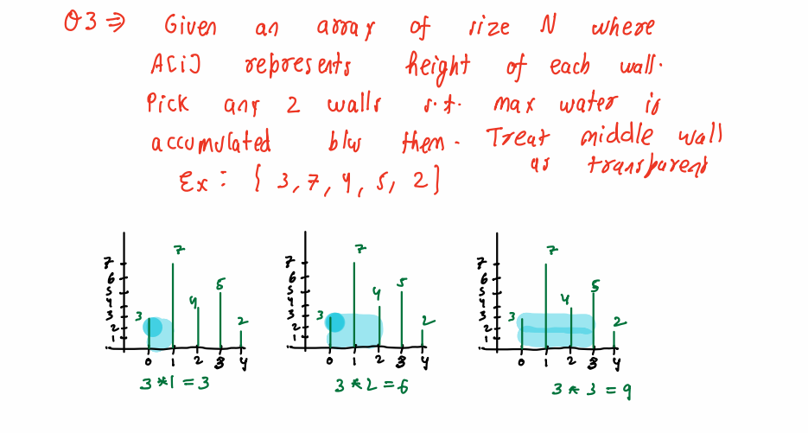

P1 = 0, p2 = n -1;

Int maxWater = int.MinValue;

While (p1 < p2)

{

Int height = min (A[p1], A[p2])

Int width = p2 –p1;

Var currentWater = height \* width;

maxWater = max(currentWater, maxWater);

if (A[p1] > A[p2]) {

p2++

}

else if (A[p1] <= A[p2]){

p1++;

}

}

Return maxWater;