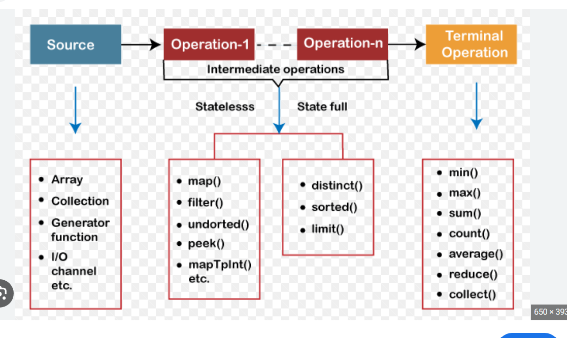
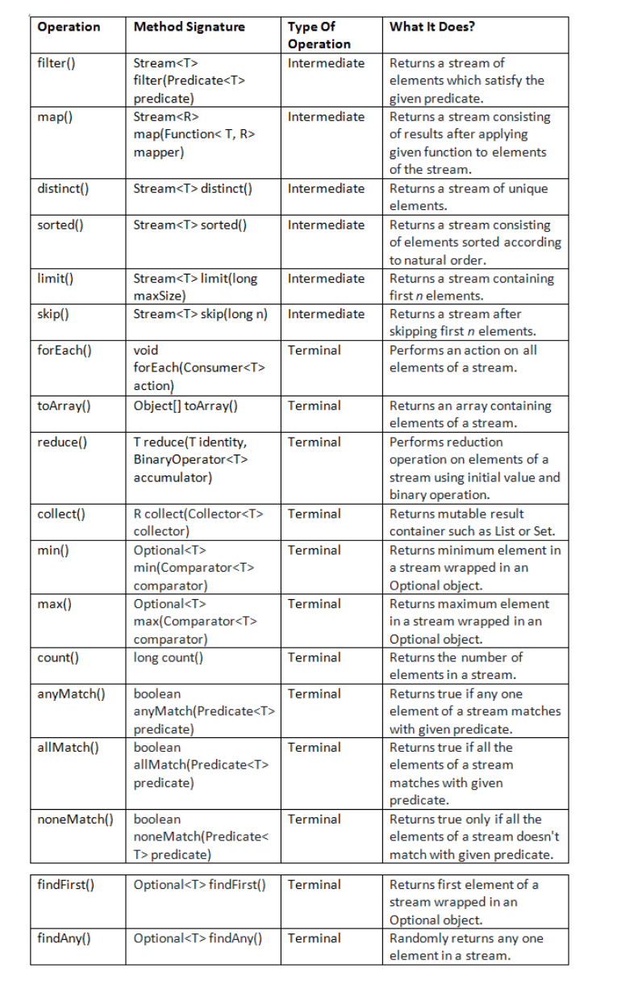
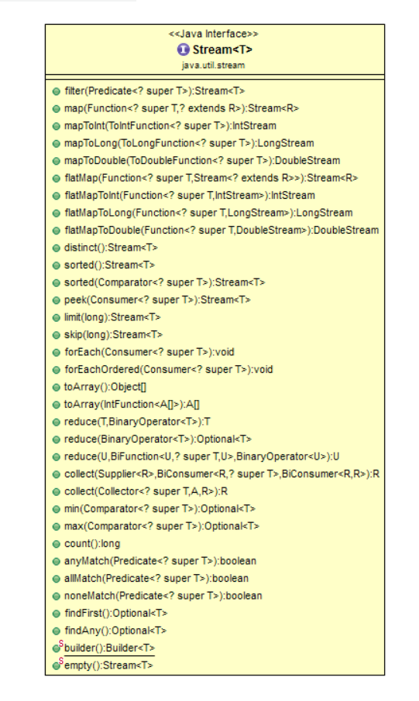

In Java 8 Streams, intermediate operations are classified into stateful and stateless based on whether they depend on previously seen elements.

🔹 1. Stateless Intermediate Operations
✅ Definition
A stateless operation processes each element independently, without relying on any past elements.
🧠 Key Idea
No memory of previous elements is needed.
📌 Examples
- filter()
- map()
- flatMap()
- peek()
💡 Example
List<Integer> list = List.of(1, 2, 3, 4, 5);
list.stream()
.filter(n -> n % 2 == 0) // stateless
.map(n -> n * 2) // stateless
.forEach(System.out::println);
🔍 Explanation
- filter() checks each number independently
- map() transforms each number independently
- No need to know previous elements
⚡ Characteristics
- Can be easily parallelized
- Fast and efficient
- No internal buffering

🔹 2. Stateful Intermediate Operations
✅ Definition
A stateful operation needs to remember previous elements to produce the result.
🧠 Key Idea
Requires memory of past elements (state).
📌 Examples
- sorted()
- distinct()
- limit() (stateful in some cases)
- skip()
💡 Example
List<Integer> list = List.of(5, 3, 1, 2, 3, 4);
list.stream()
.distinct() // stateful
.sorted() // stateful
.forEach(System.out::println);
🔍 Explanation
- distinct() needs to track seen elements
- sorted() must see all elements before sorting
⚡ Characteristics
- May require buffering the entire stream
- Slower than stateless operations
- Parallel processing is more complex

🔥 Side-by-Side Comparison
Feature | Stateless | Stateful
Depends on previous elements | ❌ No | ✅ Yes
Memory usage | Low | Higher
Performance | Faster | Slower
Parallel processing | Easy | Complex
Examples | map, filter | sorted, distinct

🎯 Simple Analogy
- Stateless 👉 Like checking each student’s age individually
- Stateful 👉 Like ranking students (you need all marks first)

⚠️ Important Interview Point
👉 In parallel streams, stateful operations can become a performance bottleneck because:
- They may require synchronization
- They may need full data before processing

If you want, I can next:
✅ Show internal working diagrams of stream pipeline
✅ Give real-world project examples (Spring Boot use cases)
✅ Provide interview tricky questions on this topic

Java 8 Streams : A Beginner's Guide
Java 8 Streams : A Beginner’s Guide
- pramodbablad
- April 24, 2019
- Java 8
- 7 Comments

Using Java 8 Streams, you can write most complex data processing queries without much difficulties. In this tutorial, I have tried to explain Java 8 stream characteristics and operations with simple examples. I hope it will be helpful for you guys.
Java 8 Streams
1) What Are Streams?
Streams can be defined as a sequences of elements from a source which support data processing operations. You can treat streams as operations on data. You will get to know as you go through this article.
2) Why Streams?
Almost every Java application use Collections API to store and process the data. Despite being the most used Java API, it is not easy to write the code for even some common data processing operations like filtering, finding, matching, sorting, mapping etc using Collections API . So, there needed Next-Gen API to process the data. So Java API designers have come with Java 8 Streams API to write more complex data processing operations with much of ease.
3) Characteristics Of Java 8 Streams
3.1) Streams are not the data structures
Streams doesn’t store the data. You can’t add or remove elements from streams. Hence, they are not the data structures. They are the just operations on data.
3.2) Stream Consumes a data source
Stream consumes a source, performs operations on it and produces the result. Source may be a collection or an array or an I/O resource. Remember, stream doesn’t modify the source.
3.3) Intermediate And Terminal Operations
Most of the stream operations return another new stream and they can be chained together to form a pipeline of operations.
The operations which return stream themselves are called intermediate operations. For example – filter(), distinct(), sorted() etc.
The operations which return other than stream are called terminal operations. count(). min(), max() are some terminal operations.
3.4) Pipeline Of Operations
A pipeline of operations consists of three things – a source, one or more intermediate operations and a terminal operation. Pipe-lining of operations let you to write database-like queries on a data source. In the below example, int array is the source, filter() and distinct() are intermediate operations and forEach() is a terminal operation.
1 | IntStream.of(new int[] {4, 7, 1, 8, 3, 9, 7}).filter((int i) -> i > 5).distinct().forEach(System.out::println);
3.5) Internal Iteration
Collections need to be iterated explicitly. i.e you have to write the code to iterate over collections. But, all stream operations do the iteration internally behind the scene for you. You need not to worry about iteration at all while writing the code using Java 8 Streams API.
3.6) Parallel Execution
To gain the performance while processing the large amount of data, you have to process it in parallel and use multi core architectures. Java 8 Streams can be processed in parallel without writing any multi threaded code. For example, to process the collections in parallel, you just use parallelStream() method instead of stream() method.
1  2  3  4  5  6  7  8  9  10  11  12  13  14  15  16  17  18  19 | List<String> names = new ArrayList<>();  names.add("David");  names.add("Johnson");  names.add("Samontika");  names.add("Brijesh");  names.add("John");  //Normal Execution  names.stream().filter((String name) -> name.length() > 5).skip(2).forEach(System.out::println);  //Parallel Execution  names.parallelStream().filter((String name) -> name.length() > 5).skip(2).forEach(System.out::println);
3.7) Streams are lazily populated
All elements of a stream are not populated at a time. They are lazily populated as per demand because intermediate operations are not evaluated until terminal operation is invoked.
3.8) Streams are traversable only once
You can’t traverse the streams more than once just like iterators. If you traverse the stream first time, it is said to be consumed.
1  2  3  4  5  6  7  8  9 | List<String> nameList = Arrays.asList("Dinesh", "Ross", "Kagiso", "Steyn");  Stream<String> stream = nameList.stream();  stream.forEach(System.out::println);  stream.forEach(System.out::println);  //Error : stream has already been operated upon or closed
3.9) Short Circuiting Operations
Short circuiting operations are the operations which don’t need the whole stream to be processed to produce a result. For example – findFirst(), findAny(), limit() etc.
4) java.util.stream.Stream
java.util.stream.Stream interface is the center of Java 8 Streams API. This interface contains all the stream operations. Below table shows frequently used Stream methods with description.
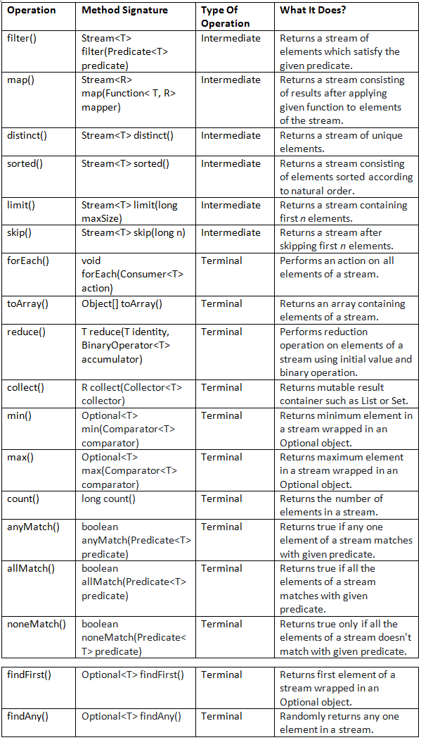
Let’s see some important stream operations with examples.
5) Java 8 Stream Operations
5.1) Stream Creation Operations
5.1.1) empty() : Creates an empty stream
Method Signature : public static<T> Stream<T> empty()
Type Of Method : Static Method
What It Does? : Returns an empty stream of type T.
1  2  3  4  5 | Stream<Student> emptyStream = Stream.empty();  System.out.println(emptyStream.count());  //Output : 0
5.1.2) of(T t) : Creates a stream of single element of type T
Method Signature : public static<T> Stream<T> of(T t)
Type Of Method : Static Method
What It Does? : Returns a single element stream of type T.
1  2  3  4  5 | Stream<Student> singleElementStream = Stream.of(new Student());  System.out.println(singleElementStream.count());  //Output : 1
5.1.3) of(T… values) : Creates a stream from values
Method Signature : public static<T> Stream<T> of(T… values)
Type Of Method : Static Method
What It does? : Returns a stream consisting of supplied values as elements.
1  2  3  4  5 | Stream<Integer> streamOfNumbers = Stream.of(7, 2, 6, 9, 4, 3, 1);  System.out.println(streamOfNumbers.count());  //Output : 7
5.1.4) Creating streams from collections
From Java 8, every collection type will have a method called stream() which returns the stream of respective collection type.
Example : Creating a stream from List
1  2  3  4  5  6  7  8  9  10  11  12  13  14  15 | List<String> listOfStrings = new ArrayList<>();  listOfStrings.add("One");  listOfStrings.add("Two");  listOfStrings.add("Three");  listOfStrings.stream().forEach(System.out::println);  // Output :  // One  // Two  // Three
5.2) Selection Operations
5.2.1) filter() : Selecting with a predicate
Method Signature : Stream<T> filter(Predicate<T> predicate)
Type Of Operation : Intermediate Operation
What it does? : Returns a stream of elements which satisfy the given predicate.
1  2  3  4  5  6  7  8  9  10  11  12  13  14  15  16  17  18  19  20  21 | List<String> names = new ArrayList<>();  names.add("David");  names.add("Johnson");  names.add("Samontika");  names.add("Brijesh");  names.add("John");  //Selecting names containing more than 5 characters  names.stream().filter((String name) -> name.length() > 5).forEach(System.out::println);  // Output :  // Johnson  // Samontika  // Brijesh
5.2.2) distinct() : Selects only unique elements
Method Signature : Stream<T> distinct()
Type Of Operation : Intermediate Operation
What It Does? : Returns a stream of unique elements.
1  2  3  4  5  6  7  8  9  10  11  12  13  14  15  16  17  18  19  20  21  22  23  24  25  26  27 | List<String> names = new ArrayList<>();  names.add("David");  names.add("Johnson");  names.add("Samontika");  names.add("Brijesh");  names.add("John");  names.add("David");  names.add("Brijesh");  //Selecting only unique names  names.stream().distinct().forEach(System.out::println);  // Output :  // David  // Johnson  // Samontika  // Brijesh  // John
5.2.3) limit() : Selects first n elements
Method Signature : Stream<T> limit(long maxSize)
Type Of Operation : Intermediate Operation
What It Does? : Returns a stream containing first n elements.
1  2  3  4  5  6  7  8  9  10  11  12  13  14  15  16  17  18  19  20  21  22  23  24  25  26 | List<String> names = new ArrayList<>();  names.add("David");  names.add("Johnson");  names.add("Samontika");  names.add("Brijesh");  names.add("John");  names.add("David");  names.add("Brijesh");  //Selecting first 4 names  names.stream().limit(4).forEach(System.out::println);  // Output :  // David  // Johnson  // Samontika  // Brijesh
5.2.4) skip() : Skips first n elements
Method Signature : Stream<T> skip(long n)
Type Of Operation : Intermediate Operation
What It Does? : Returns a stream after skipping first n elements.
1  2  3  4  5  6  7  8  9  10  11  12  13  14  15  16  17  18  19  20  21  22  23  24  25 | List<String> names = new ArrayList<>();  names.add("David");  names.add("Johnson");  names.add("Samontika");  names.add("Brijesh");  names.add("John");  names.add("David");  names.add("Brijesh");  //Skipping first 4 names  names.stream().skip(4).forEach(System.out::println);  // Output :  // John  // David  // Brijesh
5.3) Mapping Operations
5.3.1) map() : Applies a function
Method Signature : Stream<R> map(Function<T, R> mapper);
Type Of Operation : Intermediate Operation
What It Does? : Returns a stream consisting of results after applying given function to elements of the stream.
1  2  3  4  5  6  7  8  9  10  11  12  13  14  15  16  17  18  19  20  21  22 | List<String> names = new ArrayList<>();  names.add("David");  names.add("Johnson");  names.add("Samontika");  names.add("Brijesh");  names.add("John");  //Returns length of each name  names.stream().map(String::length).forEach(System.out::println);  // Output :  // 5  // 7  // 9  // 7  // 4
Other versions of map() method : mapToInt(), mapToLong() and mapToDouble().
5.4) Sorting Operations
5.4.1) sorted() : Sorting according to natural order
Method Signature : Stream<T> sorted()
Type Of Operation : Intermediate Operation
What It Does? : Returns a stream consisting of elements sorted according to natural order.
1  2  3  4  5  6  7  8  9  10  11  12  13  14  15  16  17  18  19  20  21  22  23 | List<String> names = new ArrayList<>();  names.add("David");  names.add("Johnson");  names.add("Samontika");  names.add("Brijesh");  names.add("John");  //Sorting the names according to natural order  names.stream().sorted().forEach(System.out::println);  // Output :  // Brijesh  // David  // John  // Johnson  // Samontika
5.4.2) sorted(Comparator) : Sorting according to supplied comparator
Method Signature : Stream<T> sorted(Comparator<T> comparator)
Type Of Operation : Intermediate Operation
What It Does? : Returns a stream consisting of elements sorted according to supplied Comparator.
1  2  3  4  5  6  7  8  9  10  11  12  13  14  15  16  17  18  19  20  21  22  23 | List<String> names = new ArrayList<>();  names.add("David");  names.add("Johnson");  names.add("Samontika");  names.add("Brijesh");  names.add("John");  //Sorting the names according to their length  names.stream().sorted((String name1, String name2) -> name1.length() - name2.length()).forEach(System.out::println);  // Output :  // John  // David  // Johnson  // Brijesh  // Samontika
5.5) Reducing Operations
Reducing operations are the operations which combine all the elements of a stream repeatedly to produce a single value. For example, counting number of elements, calculating average of elements, finding maximum or minimum of elements etc.
5.5.1) reduce() : Produces a single value
Method Signature : T reduce(T identity, BinaryOperator<T> accumulator);
Type Of Operation : Terminal Operation
What It Does? : This method performs reduction operation on elements of a stream using initial value and binary operation.
1  2  3 | int sum = Arrays.stream(new int[] {7, 5, 9, 2, 8, 1}).reduce(0, (a, b) -> a+b);  //Output : 32
There is another form of reduce() method which takes no initial value. But returns an Optional object.
1  2  3 | OptionalInt sum = Arrays.stream(new int[] {7, 5, 9, 2, 8, 1}).reduce((a, b) -> a+b);  //Output : OptionalInt[32]
Methods min(), max(), count() and collect() are special cases of reduction operation.
5.5.2) min() : Finding the minimum
Method Signature : Optional<T> min(Comparator<T> comparator)
Type Of Operation : Terminal Operation
What It Does? : It returns minimum element in a stream wrapped in an Optional object.
1  2  3  4  5 | OptionalInt min = Arrays.stream(new int[] {7, 5, 9, 2, 8, 1}).min();  //Output : OptionalInt[1]  //Here, min() of IntStream will be used as we are passing an array of ints
5.5.3) max() : Finding the maximum
Method Signature : Optional<T> max(Comparator<T> comparator)
Type Of Operation : Terminal Operation
What It Does? : It returns maximum element in a stream wrapped in an Optional object.
1  2  3  4  5 | OptionalInt max = Arrays.stream(new int[] {7, 5, 9, 2, 8, 1}).max();  //Output : OptionalInt[9]  //Here, max() of IntStream will be used as we are passing an array of ints
5.5.4) count() : Counting the elements
Method Signature : long count()
Type Of Operation : Terminal Operation
What It Does? : Returns the number of elements in a stream.
1  2  3  4  5  6  7  8  9  10  11  12  13  14  15  16  17  18  19 | List<String> names = new ArrayList<>();  names.add("David");  names.add("Johnson");  names.add("Samontika");  names.add("Brijesh");  names.add("John");  //Counting the names with length > 5  long noOfBigNames = names.stream().filter((String name) -> name.length() > 5).count();  System.out.println(noOfBigNames);  // Output : 3
5.5.5) collect() : Returns mutable container
Method Signature : R collect(Collector<T> collector)
Type Of Operation : Terminal Operation
What It Does? : collect() method is a special case of reduction operation called mutable reduction operation because it returns mutable result container such as List or Set.
1  2  3  4  5  6  7  8  9  10  11  12  13  14  15  16  17  18  19 | List<String> names = new ArrayList<>();  names.add("David");  names.add("Johnson");  names.add("Samontika");  names.add("Brijesh");  names.add("John");  //Storing first 3 names in a mutable container  List<String> first3Names = names.stream().limit(3).collect(Collectors.toList());  System.out.println(first3Names);  // Output : [David, Johnson, Samontika]
5.6) Finding And Matching Operations
5.6.1) anyMatch() : Any one element matches
Method Signature : boolean anyMatch(Predicate<T> predicate)
Type Of Operation : Short-circuiting Terminal Operation
What It Does? : Returns true if any one element of a stream matches with given predicate. This method may not evaluate all the elements of a stream. Even if the first element matches with given predicate, it ends the operation.
1  2  3  4  5  6  7  8  9  10  11  12  13  14  15  16 | List<String> names = new ArrayList<>();  names.add("David");  names.add("Johnson");  names.add("Samontika");  names.add("Brijesh");  names.add("John");  if(names.stream().anyMatch((String name) -> name.length() == 5))  {  System.out.println("Yes... There is a name exist with 5 letters");  }
5.6.2) allMatch() : All elements matches
Method Signature : boolean allMatch(Predicate<T> predicate)
Type Of Operation : Terminal Operation
What It Does? : This method returns true if all the elements of a stream matches with given predicate. Otherwise returns false.
1  2  3  4  5  6  7  8  9  10  11  12  13  14 | List<String> names = new ArrayList<>();  names.add("Sampada");  names.add("Johnson");  names.add("Samontika");  names.add("Brijesh");  if(names.stream().allMatch((String name) -> name.length() > 5))  {  System.out.println("All are big names");  }
5.6.3) noneMatch() : No element matches
Method Signature : boolean noneMatch(Predicate<T> predicate)
Type Of Operation : Terminal Operation
What It Does? : Returns true only if all the elements of a stream doesn’t match with given predicate.
1  2  3  4  5  6  7  8  9  10  11  12  13  14  15  16 | List<String> names = new ArrayList<>();  names.add("David");  names.add("Johnson");  names.add("Samontika");  names.add("Brijesh");  names.add("John");  if(names.stream().noneMatch((String name) -> name.length() == 2))  {  System.out.println("There is no two letter name");  }
5.6.4) findFirst() : Finding first element
Method Signature : Optional<T> findFirst()
Type Of Operation : Short-circuiting Terminal Operation
What It Does? : Returns first element of a stream wrapped in an Optional object.
1  2  3 | Optional<String> firstElement = Stream.of("First", "Second", "Third", "Fourth").findFirst();  //Output : Optional[First]
5.6.5) findAny() : Finding any element
Method Signature : Optional<T> findAny()
Type Of Operation : Short-circuiting Terminal operation
What It Does? : Randomly returns any one element in a stream. The result of this operation is unpredictable. It may select any element in a stream. Multiple invocations on the same source may not return same result.
1 | Optional<String> anyElement = Stream.of("First", "Second", "Third", "Fourth").findAny();
5.7) Other Operations
5.7.1) forEach() :
Method Signature : void forEach(Consumer<T> action)
Type Of Operation : Terminal Operation
What It Does? : Performs an action on all elements of a stream.
1  2  3  4  5  6 | Stream.of("First", "Second", "Second", "Third", "Fourth").limit(3).distinct().forEach(System.out::println);  // Output  // First  // Second
5.7.2) toArray() : Stream to array
Method Signature : Object[] toArray()
Type Of Operation : Terminal Operation
What It Does? : Returns an array containing elements of a stream.
1  2  3  4  5  6  7  8  9  10  11  12  13  14  15  16  17  18  19  20  21 | List<String> names = new ArrayList<>();  names.add("David");  names.add("Johnson");  names.add("Samontika");  names.add("Brijesh");  names.add("John");  //Storing first 3 names in an array  Object[] streamArray = names.stream().limit(3).toArray();  System.out.println(Arrays.toString(streamArray));  // Output  // [David, Johnson, Samontika]
5.7.3) peek() :
Method Signature : Stream<T> peek(Consumer<T> action)
Type Of Operation : Intermediate Operation
What It Does? : Performs an additional action on each element of a stream. This method is only to support debugging where you want to see the elements as you pass in a pipeline.
1  2  3  4  5  6  7  8  9  10  11  12  13  14  15  16  17  18  19  20  21  22  23  24  25  26  27  28  29 | List<String> names = new ArrayList<>();  names.add("David");  names.add("Johnson");  names.add("Samontika");  names.add("Brijesh");  names.add("John");  names.add("David");  names.stream()  .filter(name -> name.length() > 5)  .peek(e -> System.out.println("Filtered Name :"+e))  .map(String::toUpperCase)  .peek(e -> System.out.println("Mapped Name :"+e))  .toArray();  //Output :  //Filtered Name :Johnson  //Mapped Name :JOHNSON  //Filtered Name :Samontika  //Mapped Name :SAMONTIKA  //Filtered Name :Brijesh  //Mapped Name :BRIJESH
Also Read :

