🔓 Mastering CORS: How to Securely Enable Cross-Origin Requests
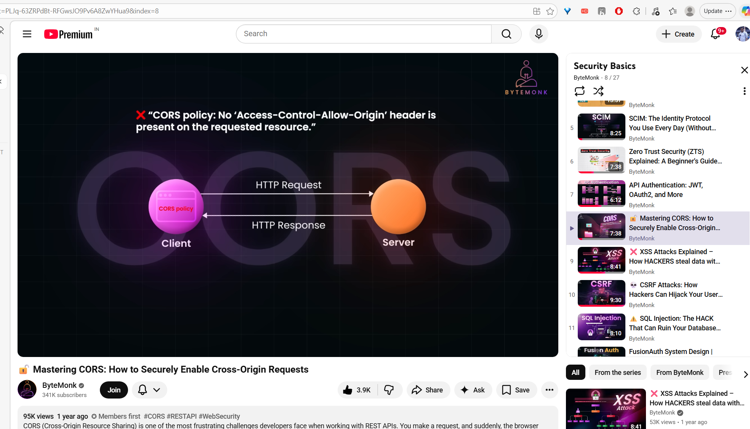

what is CORS? Please explain with simple and easy understanding? How does spring and angular avoid this CORS issue?
🌐 What is CORS? (Simple Explanation)
CORS = Cross-Origin Resource Sharing
Let’s break it down in a very simple way 👇

🧠 Simple Analogy (House Security 🏠)
Think of your backend (server) as a house.
- Your frontend (Angular app) is a person trying to enter the house
- If the person is from the same place (same origin) → allowed ✅
- If the person is from a different place (different origin) → blocked ❌ (by default)
👉 This blocking is done by the browser, not the server.

🔍 What is "Origin"?
An origin = combination of:
- Protocol (http/https)
- Domain
- Port
Example:
URL | Origin
http://localhost:4200 | Origin A
http://localhost:8080 | Origin B
👉 These are different origins → CORS problem occurs

⚠️ What is the CORS Issue?
When your Angular app tries to call a Spring Boot API:
Angular → http://localhost:4200
Spring Boot → http://localhost:8080
Browser says:
❌ "Wait! Different origin → I will block this request unless server allows it."

🧪 Example Error
Access to fetch at 'http://localhost:8080/api/data'
from origin 'http://localhost:4200'
has been blocked by CORS policy

⚙️ How Spring Boot Handles CORS
Spring Boot must explicitly say:
👉 "I trust this frontend origin"
✅ Option 1: Using @CrossOrigin
@CrossOrigin(origins = "http://localhost:4200")
@RestController
public class MyController {
@GetMapping("/data")
public String getData() {
return "Hello";
}
}

✅ Option 2: Global CORS Configuration (Recommended)
@Configuration
public class WebConfig implements WebMvcConfigurer {
@Override
public void addCorsMappings(CorsRegistry registry) {
registry.addMapping("/**")
.allowedOrigins("http://localhost:4200")
.allowedMethods("GET", "POST", "PUT", "DELETE")
.allowedHeaders("*");
}
}

✅ Option 3: Spring Security CORS Config
@Bean
public SecurityFilterChain securityFilterChain(HttpSecurity http) throws Exception {
http.cors().and().csrf().disable();
return http.build();
}

⚙️ How Angular Handles CORS
👉 Important: Angular itself does NOT fix CORS
Because:
- CORS is enforced by browser security
- Only server (Spring Boot) can allow it

🛠️ What Angular Can Do (During Development)
✅ Option: Proxy Configuration
Create proxy.conf.json
{
"/api": {
"target": "http://localhost:8080",
"secure": false,
"changeOrigin": true
}
}
Run Angular:
ng serve --proxy-config proxy.conf.json
👉 Now Angular calls:
http://localhost:4200/api/data
👉 Proxy forwards to:
http://localhost:8080/api/data
✅ Browser thinks it's same origin → no CORS issue

🧠 Key Takeaways
- CORS is a browser security feature
- It prevents unauthorized cross-origin requests
- Fix must be done in backend (Spring Boot)

💡 Simple Summary
Component | Role
Browser | Blocks cross-origin requests
Spring Boot | Allows trusted origins
Angular | Uses proxy (only for dev)

If you want, I can also explain:
- 🔥 What is preflight request (OPTIONS) in CORS
- 🔥 Common interview questions on CORS
- 🔥 Real-time production configuration (very important for interviews)
yes. How does this configuration in production to make it work?
Great question — this is where many people get confused, especially in interviews 👍
Let’s walk through how CORS is handled in production in a clean, real-world way.

🚀 1. First Understand: Production is Different
In development:
- Angular → http://localhost:4200
- Spring Boot → http://localhost:8080
👉 Different origins → CORS issue

✅ In Production (Best Case)
Usually, both apps are hosted under the same domain:
https://myapp.com → Angular (frontend)
https://myapp.com/api → Spring Boot (backend)
👉 Same origin → ❌ NO CORS issue at all

🏗️ 2. How This is Achieved in Real Projects
🔹 Option 1: Serve Angular from Spring Boot
- Build Angular app:
ng build
- Copy files into Spring Boot:
src/main/resources/static/
👉 Now Spring Boot serves:
- UI + APIs from same domain
✅ No CORS needed
✅ Simplest production setup

🔹 Option 2: Use Reverse Proxy (Most Common 🔥)
Use tools like:
- Nginx
- Apache HTTP Server

🧠 How it works:
Browser → Nginx → routes internally
Example:
https://myapp.com → Angular files
https://myapp.com/api → Spring Boot

🔧 Sample Nginx Config
server {
listen 80;
location / {
root /var/www/angular;
index index.html;
try_files $uri /index.html;
}
location /api/ {
proxy_pass http://localhost:8080/;
}
}
👉 Browser sees same origin
👉 Internally routed to backend
✅ No CORS problem
✅ Industry standard approach

⚠️ 3. When CORS is STILL Needed in Production
Sometimes frontend & backend are on different domains:
https://app.mycompany.com (Angular)
https://api.mycompany.com (Spring Boot)
👉 Now CORS is required

🔐 4. Secure CORS Configuration (VERY IMPORTANT)
❌ Bad Practice (Never in Production)
.allowedOrigins("*")
👉 Anyone can access your API → security risk 🚨

✅ Good Practice
registry.addMapping("/api/**")
.allowedOrigins("https://app.mycompany.com")
.allowedMethods("GET", "POST", "PUT", "DELETE")
.allowCredentials(true);

🔐 With Spring Security
@Bean
public CorsConfigurationSource corsConfigurationSource() {
CorsConfiguration config = new CorsConfiguration();
config.setAllowedOrigins(List.of("https://app.mycompany.com"));
config.setAllowedMethods(List.of("GET","POST","PUT","DELETE"));
config.setAllowCredentials(true);
config.setAllowedHeaders(List.of("*"));
UrlBasedCorsConfigurationSource source = new UrlBasedCorsConfigurationSource();
source.registerCorsConfiguration("/**", config);
return source;
}

🌐 5. What Happens Internally (Preflight Request)
Before actual request:
Browser sends:
OPTIONS /api/data
Origin: https://app.mycompany.com
Server responds:
Access-Control-Allow-Origin: https://app.mycompany.com
Access-Control-Allow-Methods: GET, POST
👉 Then actual request is sent

🧠 Interview-Ready Summary
👉 You can answer like this:
"In production, we usually avoid CORS by hosting frontend and backend under the same domain using reverse proxy like Nginx.
If they are on different domains, we configure Spring Boot with specific allowed origins instead of wildcard (*) to ensure security.
Angular itself doesn’t handle CORS — it's controlled by the backend and browser."

🔥 Real-World Tips
- Prefer same domain deployment (no CORS headaches)
- Use Nginx reverse proxy in most architectures
- Never use "*" in production
- Handle preflight requests properly
- If using cookies → enable allowCredentials(true)

If you want next, I can explain:
- 🔥 CORS + JWT authentication issues (very common interview trap)
- 🔥 Difference between allowedOrigins vs allowedOriginPatterns
- 🔥 Debugging CORS errors step-by-step (real scenarios)

Web Security Part I: Cross-origin requests (Spring Boot & Angular Example) | by Amir Abdallah | Medium

Web Security Part I: Cross-origin requests (Spring Boot & Angular Example)



Amir Abdallah
Follow
4 min read
·
Sep 5, 2024
11

Press enter or click to view image in full size

Introduction
Web applications follow a client-server model, where server-side code responds to HTTP requests initiated by client-side code. This model governs how a web page interacts with the server.
Web pages typically communicate with the server that initially served them. However, they can also interact with other domains (e.g., third-party services). This communication requires careful definition and control to mitigate security risks. This is where Cross-Origin Resource Sharing (CORS) comes into play.
Types of Cross-origin Communication
We have three main types of cross-origin communication:
- Cross-origin navigation: Occurs when clicking a link to access a web page on a different domain (e.g., www.google.com).
- Cross-origin embeds: Happens when a web page loads resources like images from a third-party service.
- Cross-origin reads: Involves fetching data from a different domain using JavaScript (e.g., through XMLHttpRequest or Fetch API).
The first two types are generally allowed by default. However, cross-origin reads are forbidden by default in the browser for security reasons.
Example of Cross-origin Read:
fetch("http://example.com/movies.json")
.then((response) => response.json())
.then((data) => console.log(data));
Overcoming Restrictions of Cross-Origin Reads
Initially, cross-origin reads were only accessible by the service that loaded the web page. This restriction helped mitigate security risks. However, the demand for dynamic web pages has made this restriction a bottleneck. It hinders user experience improvements that rely on third-party functionalities like AI chatbots, analytics, or geospatial services.
To enable these features, you need to configure cross-origin resource sharing (CORS) on the web server hosting the target resource. CORS allows you to define exceptions to the same-origin policy, enabling controlled access to your resources from other domains.
What Is Cross-Origin Resource Sharing (CORS)?
CORS is a browser security feature that allows or restricts web pages from making requests to a domain different from the one that served the page. For example, if a page on example.com tries to request data from api.example2.com, the browser checks the CORS policy of api.example2.com to see if the request is allowed.
Implementing CORS with HTTP Headers
Implementing CORS involves setting specific HTTP headers in the server’s response to cross-origin requests. These headers, prefixed with Access-Control, dictate the allowed origins, methods, and other aspects of the cross-origin interaction.
Accepting All Cross-Origin Requests (Least Secure):
The simplest, but least secure, approach is to allow all cross-origin requests using the wildcard character:
Access-Control-Allow-Origin: *
Restricting to Specific Domains:
For enhanced security, restrict access to specific domains:
Access-Control-Allow-Origin: https://trusted.com
Limiting Allowed HTTP Methods:
You can further refine control by specifying the allowed HTTP methods:
Access-Control-Allow-Methods: POST, GET, OPTIONS
By carefully configuring these and other Access-Control headers, you can tailor the CORS policy to your application’s specific security and functionality requirements.
Hands-On Demo

Let’s build a simple application using Spring Boot (backend) and Angular (frontend) to demonstrate CORS implementation and configuration.
Step 1: Set Up the Spring Boot Backend
Create a new Spring Boot project using Spring Initializr (https://start.spring.io/) with the following dependencies:
- Spring Web
- Spring Boot DevTools
Create a simple REST controller:
// src/main/java/com/example/demo/DemoController.java
package com.example.demo;
import org.springframework.web.bind.annotation.CrossOrigin;
import org.springframework.web.bind.annotation.GetMapping;
import org.springframework.web.bind.annotation.RestController;
@RestController
public class DemoController {
@CrossOrigin(origins = "http://localhost:4200")
@GetMapping("/data")
public String getData() {
return "Hello from Spring Boot!";
}
}
Configure CORS globally (optional):
// src/main/java/com/example/demo/CorsConfig.java
package com.example.demo;
import org.springframework.context.annotation.Bean;
import org.springframework.context.annotation.Configuration;
import org.springframework.web.servlet.config.annotation.CorsRegistry;
import org.springframework.web.servlet.config.annotation.WebMvcConfigurer;
@Configuration
public class CorsConfig {
@Bean
public WebMvcConfigurer corsConfigurer() {
return new WebMvcConfigurer() {
@Override
public void addCorsMappings(CorsRegistry registry) {
registry.addMapping("/**")
.allowedOrigins("http://localhost:4200")
.allowedMethods("GET", "POST", "PUT", "DELETE", "OPTIONS");
}
};
}
}
Run the Spring Boot application.
Step 2: Set Up the Angular Frontend
Create a new Angular project:
ng new angular-cors-demo
cd angular-cors-demo
Generate a service to fetch data:
ng generate service data
Implement the service:
// src/app/data.service.ts
import { Injectable } from '@angular/core';
import { HttpClient } from '@angular/common/http';
import { Observable } from 'rxjs';
@Injectable({
providedIn: 'root'
})
export class DataService {
private apiUrl = 'http://localhost:8080/data';
constructor(private http: HttpClient) { }
getData(): Observable<string> {
return this.http.get<string>(this.apiUrl);
}
}
Generate a component to display data:
ng generate component data-display
Implement the component:
// src/app/data-display/data-display.component.ts
import { Component, OnInit } from '@angular/core';
import { DataService } from '../data.service';
@Component({
selector: 'app-data-display',
templateUrl: './data-display.component.html',
styleUrls: ['./data-display.component.css']
})
export class DataDisplayComponent implements OnInit {
data: string;
constructor(private dataService: DataService) { }
ngOnInit(): void {
this.dataService.getData().subscribe(response => {
this.data = response;
});
}
}
Update the component template:
<!-- src/app/data-display/data-display.component.html -->
<div>
<h1>Data from Spring Boot:</h1>
<p>{{ data }}</p>
</div>
Run the Angular application:
ng serve
Step 3: Test the Application
- Start the Spring Boot application on http://localhost:8080.
- Start the Angular application on http://localhost:4200.
- Navigate to http://localhost:4200 in your browser.
- Verify that the Angular application fetches and displays the data from the Spring Boot backend.
Conclusion
in this series, I will document web security principles with hands-on demos. I hope you enjoy it.

Cross-Origin Resource Sharing (CORS) in Spring Boot Applications | by Salman Mohamed | Medium
Cross-Origin Resource Sharing (CORS) in Spring Boot Applications



Salman Mohamed
Follow
5 min read
·
Jun 23, 2024
174
3

In this article, we will explore CORS, what it is, how it works, and how to implement it in a Spring Boot application with the help of Spring Security.
Press enter or click to view image in full size

What is CORS?
CORS stands for Cross-Origin Resource Sharing. To understand CORS, we must first know how browsers behave in this context. Normally, browsers don’t allow front-end client applications to make requests to backend servers that are not hosted in the same domain as the site.
To understand this better, let’s look at an example. Say your client application is hosted on the domain “carrot.com”. If your application makes any requests to other domains, such as “tomato.com”, the browser will block the action. The browser will allow the client app to make requests only to applications hosted on “carrot.com”.
Shocking, right? Then how do modern applications work? We know that most front-end applications are built using frameworks like ReactJS, Angular, etc. These are hosted separately from the backend servers and make REST calls to these servers. This wouldn’t be possible if the browser behaved as discussed above, right?
This is where CORS comes into the picture to make this possible.
How CORS Works?
When the client app (hosted on “carrot.com”) makes a request to a backend server (hosted on “tomato.com”), the server will attach a header called Access-Control-Allow-Origin with "carrot.com" as its value in the response.
When the browser receives the response, it checks for the presence of the Access-Control-Allow-Origin header with the appropriate value. If this header is present and allows "carrot.com", the browser relaxes its strict origin policy and permits the client app to process the response.
The server maintains a list of domains for which it intends the browser to permit client applications to access its resources.
💡Did you notice?
The browser’s strict origin policy doesn’t prevent the client application from making requests to cross-origin sites. Instead, it blocks the client application from accessing the response sent by cross-origin applications if the appropriate headers are not present. Therefore, CORS is not a typical API endpoint security mechanism.
Implementing CORS in Spring boot applications
With an understanding of how CORS works, let’s proceed to implement it in a Spring Boot application.
Before we do that, let’s first observe how the browser blocks cross-origin requests in practice. To demonstrate this, we will create a Spring MVC project with just two endpoints: one to serve an HTML page, and another that the JavaScript in the HTML page will call.

But the trick is, we’ll call the first endpoint using the host localhost. After the page loads, we’ll attempt to call the second endpoint using the host 127.0.0.1. Despite both endpoints pointing to the same application server, the browser treats these host names as different origins and applies its CORS policy accordingly.
Press enter or click to view image in full size
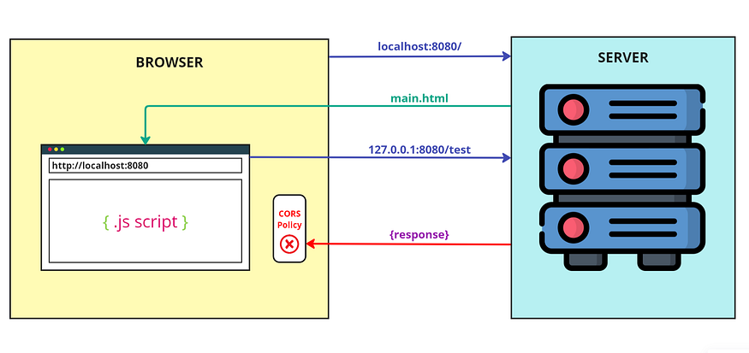
Browser blocks cross-origin requests
I have created a controller class named CorsDemo in my Spring Boot application. It includes two endpoints: /, which serves an HTML page, and /test, which is invoked by the HTML page.
@Controller
public class CorsDemo {
@GetMapping("/")
public String home() {
return "tester.html";
}
@PostMapping("/test")
@ResponseBody
public String test() {
return "Hello World!";
}
}
Additionally, I’ve developed an HTML file named tester.html located in resources/templates directory. This project utilizes Thymeleaf as the template engine.
<!DOCTYPE HTML>
<html>
<head>
<script>
const request = new XMLHttpRequest();
const url='http://127.0.0.1:8080/test';
request.open("POST", url);
request.send();
request.onreadystatechange = (e) => {
document
.getElementById("invoker")
.innerHTML = request.responseText;
}
</script>
</head>
<body>
<div id="invoker"></div>
</body>
</html>
Now, if we hit localhost:8080/ from our browser, we can see that the first call successfully fetches the HTML page. However, the second call (/test) fails with a CORS error.
Press enter or click to view image in full size
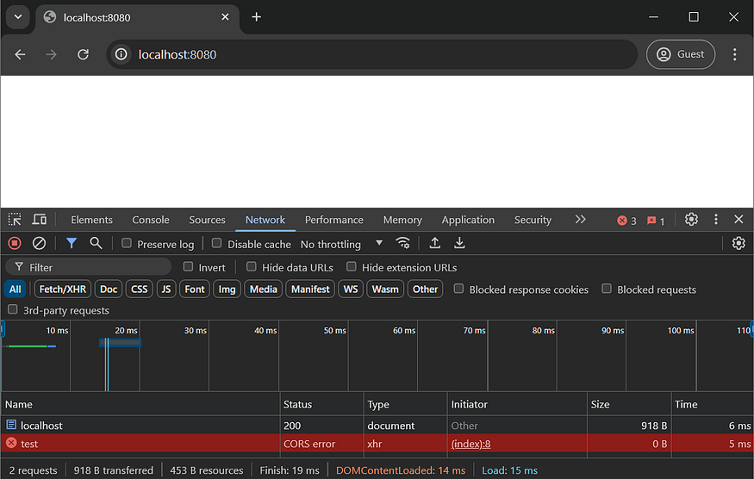
To avoid this issue, we can add the Spring Boot annotation @CrossOrigin over the /test endpoint.
@PostMapping("/test")
@ResponseBody
@CrossOrigin
public String test() {
return "Hello World!";
}
This annotation allows any domain to access the endpoint.
Press enter or click to view image in full size
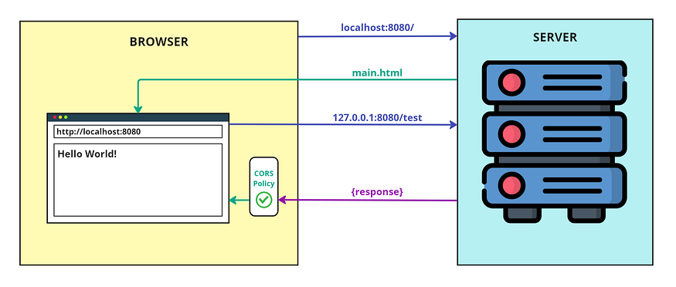
Browser allows cross-origin requests
Press enter or click to view image in full size
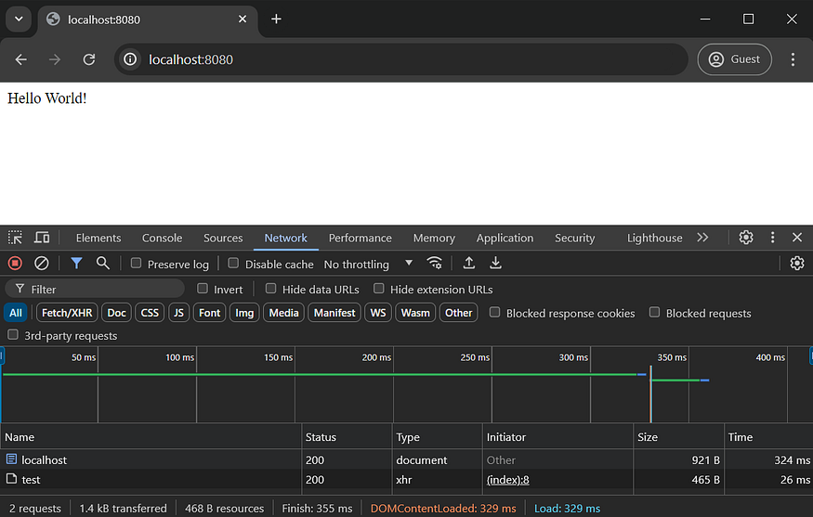
Press enter or click to view image in full size
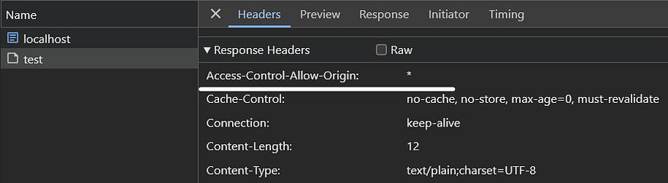
As you can see, there is an Access-Control-Allow-Origin header in the response with the value *, which means any domain can access this particular endpoint.
But it is difficult to annotate each and every endpoint in a large project. Therefore, we can use the CorsConfigurer from the Spring Security.
I have created a custom CORS configuration source class that extends the CorsConfigurationSource interface. Inside that class, I initialized a CorsConfiguration object, specifying the allowed domains, allowed HTTP methods, and allowed headers. Only requests with the specified HTTP methods and headers will receive a response with the Access-Control-Allow-Origin header.
@Component
public class CustomCorsConfiguration implements CorsConfigurationSource {
@Override
public CorsConfiguration getCorsConfiguration(HttpServletRequest request) {
CorsConfiguration config = new CorsConfiguration();
config.setAllowedOrigins(List.of("http://localhost:8080", "http://127.0.0.1:8080"));
config.setAllowedMethods(List.of("GET", "POST", "PUT", "DELETE"));
config.setAllowedHeaders(List.of("*"));
return config;
}
}
In the security filter chain, we add the custom CORS configuration source bean to the CorsConfigurer.
@Configuration
public class SecurityConfig {
@Autowired CustomCorsConfiguration customCorsConfiguration;
@Bean
public SecurityFilterChain securityFilterChain(HttpSecurity httpSecurity) throws Exception {
httpSecurity
.csrf(AbstractHttpConfigurer::disable)
.authorizeHttpRequests(req -> req.anyRequest().permitAll())
.cors(c -> c.configurationSource(customCorsConfiguration));
return httpSecurity.build();
}
}
Hope you like this article. For further exploration on Spring framework and Security-related topics, feel free to check out more articles on my profile.

“What the CORS” ft Spring Boot & Spring Security | by Rajendra Prasad Padma | Medium

“What the CORS” ft Spring Boot & Spring Security



Rajendra Prasad Padma
Follow
9 min read
·
Mar 13, 2021
145
6


Title
Ok. One fine day, I was trying to build a simple Rest API that exposed endpoints to create,read,update,delete a single resource on my server. I wanted to use React to make a small form that will submit these requests.
Beware, the following React form is so advanced. You have to be atleast a Ninja level React developer to come up with this kind of form.
Press enter or click to view image in full size
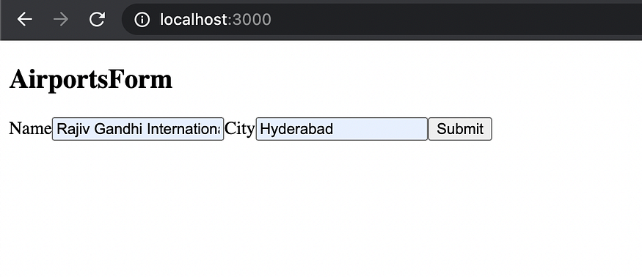
Dont be jealous guys.!
So my Rest Api (made with spring boot) was running on ‘http://localhost:8080’ & my React App was running on ‘http://localhost:3000’
Press enter or click to view image in full size

Wife Overthinking meme
Code was all ready and prepped to make that first ever post request to create the resource on server. I was waiting eagerly as the folks at JPL during perseverance touch down.
Then I saw this on my console
Press enter or click to view image in full size
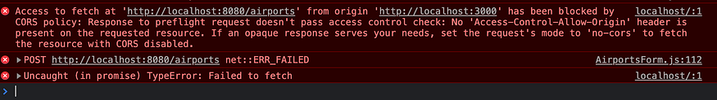
What the CORS!!!
And when I went to my network tab in ‘developer console’ to dig further. I saw these two requests lying around
Press enter or click to view image in full size
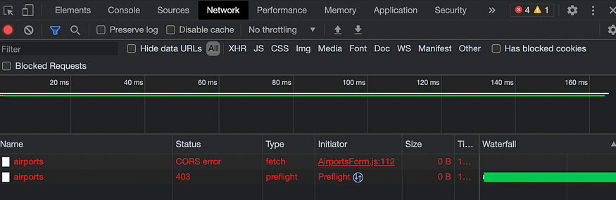
Developer Tools — Network Tab
I was using the fetch api to make the below POST request from my react code.
Press enter or click to view image in full size
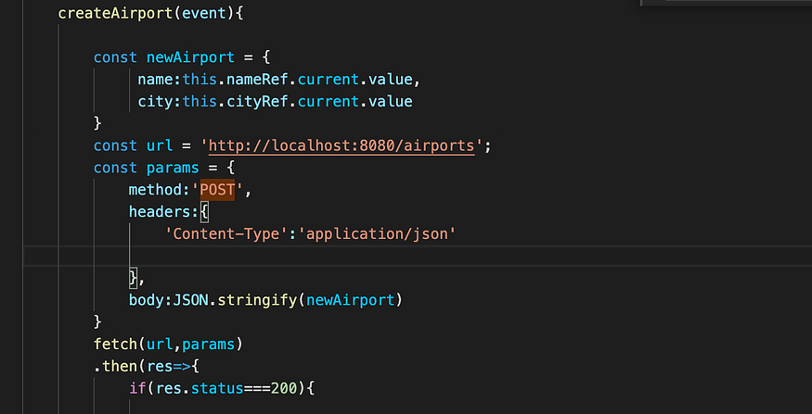
React Code
After hitting that submit button from my page, i was confused of two things:
- Why did my POST fail
- Why are there two requests in network tab of my server as shown in the developer console screenshot
Introducing CORS
CORS is a way for browsers to understand if a particular javascript code running on it(Ex: My React Code — http://localhost:3000)is allowed to request a resource from the server(My Spring Boot Rest Api running on the server — http://localhost:8000) . If they are not allowed by servers, then browsers simply throw a CORS exception.
Lets try to understand this with error message i received in the console:
Access to fetch at ‘http://localhost:8080/airports' from origin ‘http://localhost:3000' has been blocked by CORS policy: Response to preflight request doesn’t pass access control check: No ‘Access-Control-Allow-Origin’ header is present on the requested resource. If an opaque response serves your needs, set the request’s mode to ‘no-cors’ to fetch the resource with CORS disabled.
Here the key word to understand is ‘origin’. ‘origin’ is the combination of ‘protocol://host:port’. So the request is being made from an origin called ‘http://localhost:3000’ and the request is sent to origin ‘http://localhost:8080’. So these are two different origins trying to communicate. So in these cases , the browsers verify if the requestor (http://localhost:3000) is allowed to request a resource from requestee (http://localhost:8080). If requestor is not allowed to , then we see this nasty CORS error while making requests.
But why do we see two requests happening in network tab?
If you notice carefully , one request is having the Type = preflight and another one (i.e., the actual fetch making POST) request has type = ‘CORS error’ from screenshot above. So Browsers don’t immediately send the POST request first, they try to check which “origin” is whitelisted/allowed by server first. In order to do this check, they send out an OPTIONS request to the server. This is often referred to “preflight” request.
So what is the browser actually expecting from this preflight request?
Browser is expecting to receive a response header back from the server which tells it that “am cool with having this request”.
And which response header is that exactly?
“access-control-allow-origin” — This is the header where the whitelisted origins are mentioned. If localhost:3000 is present on the whitelisted header then we are open for business.
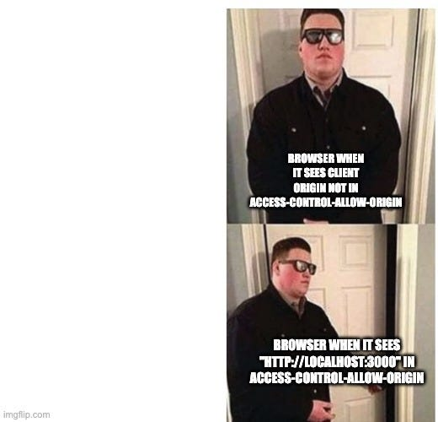
Bouncer Meme
Lets see what is in the failed preflight request.
The Request Method is ‘OPTIONS’ and its forbidden (403) to make that request on the server. And my Response headers don’t have anything mentioned as ‘Access-Control-Allow-Origin’. So Basically, The preflight request itself failed because “OPTIONS” request method was not defined on the server side.
Press enter or click to view image in full size
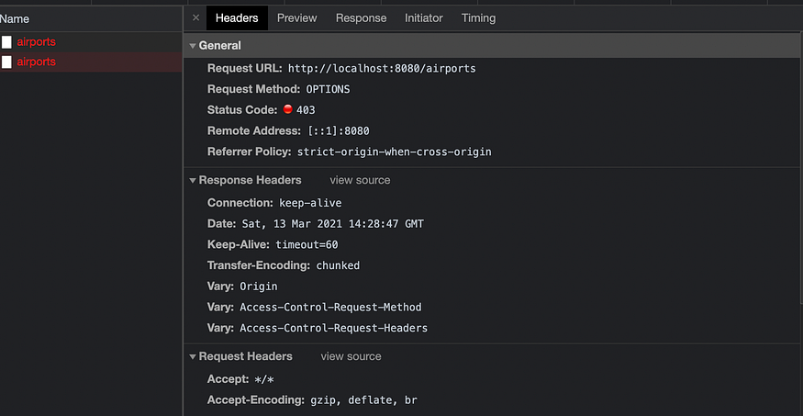
Developer Tools — Headers
All I have at my controller are these basic CRUD request mappings (GET,POST,PUT,DELETE)
Press enter or click to view image in full size
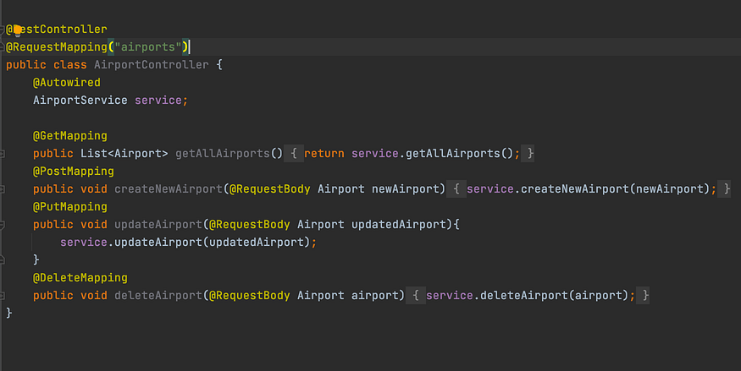
Rest Controller Code
So now the original question? How do i allow preflight to check which origin is allowed and how do i whitelist “http://localhost:3000” as a qualified origin.
Spring Boot offers a simple solution through its annotation @CrossOrigin. Simply put it on top of your controller class like this
Press enter or click to view image in full size
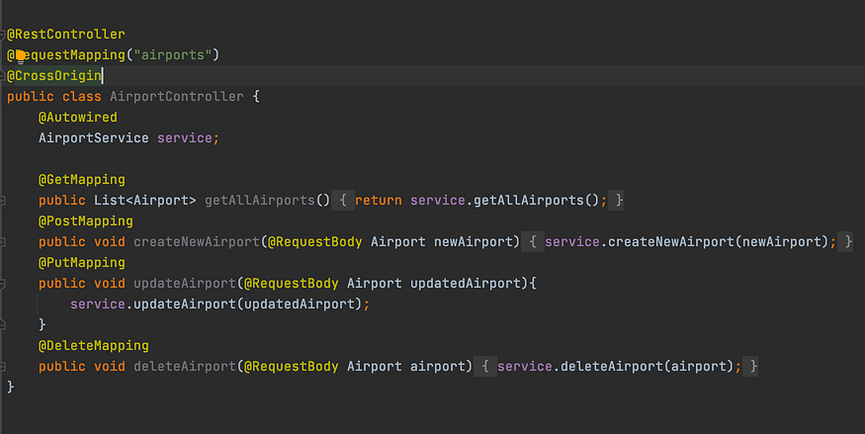
Rest Controller Code
Now I restarted my spring boot application and retried posting the resource.
And it worked
Press enter or click to view image in full size
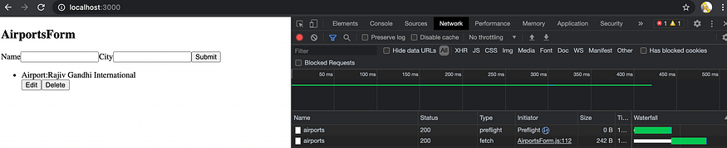
Full Screenshot Of Form And Developer Tools
You will see now that both preflight and the post request made it out with ‘200 — A Ok ;)’
Lets examine the preflight request and response headers now.
In the request headers of preflight, the request method is ‘OPTIONS’ and in response headers, you will notice that
‘Access-Control-Allow-Origin’ : * (This indicates that any origin can make a request to resource on the server, so my react application also qualifies to send the request)
‘Access-Control-Allow-Methods’ : POST (preflight confirmed that POST that is about to be made is qualified)
‘Allow’ : GET,HEAD,POST,PUT,DELETE,OPTIONS,PATCH.
Before making the @CrossOrigins change on the server, preflight request got 403 status since OPTIONS was not allowed on the server. But now you can see that all the request methods are being allowed by the server. So preflight which is “OPTIONS” request goes through fine even if it doesn’t have any endpoint declared on the server.
Press enter or click to view image in full size
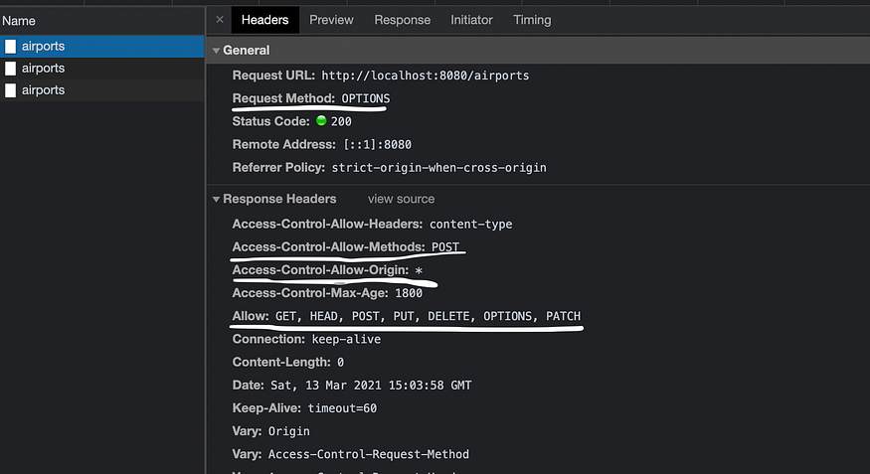
Developer Tools — Headers
Just declaring @CrossOrigins on the controller opens the gates for all the origins and methods to come and hit your server. But in a serious application, we wouldn’t want that. So you can customize the origins and methods that you want to filter at server by using these attributes in @CrossOrigins
- origins = “http://localhost:3000”
(This will only allow my react app to request)
2. methods={RequestMethod.GET,RequestMethod.POST,RequestMethod.PUT,RequestMethod.DELETE}
(You can define what methods are allowed from requests)

There are others to declare what headers are allows, and if credentials are allowed or not etc.., You can explore them on your own
Press enter or click to view image in full size
Rest Controller
Phase II — Attach Basic Authentication to my requests using spring security
Ok. After this confidence boost, i wanted to try attaching spring security to my rest api. Wanted to allow basic authentication as a way to authenticate the requests
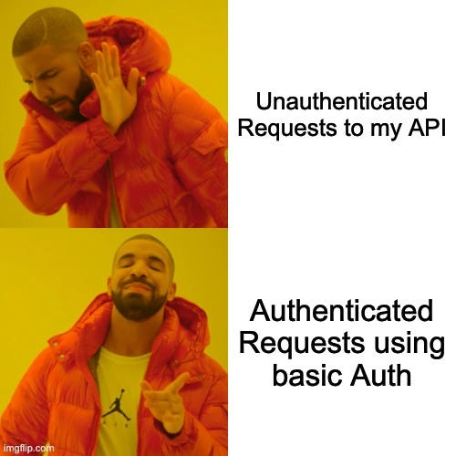
Drake meme
Being a Ninja that i am , Went and added Spring security starter dependencies to my pom.xml and udpated maven dependencies and started up my server. Once server restarts, spring security puts in a layer of authentication to the application with default username as ‘user’ and password is some hash that spring security generates randomly everytime.
Now, I made the same post request from react application.
And once again, the dreaded CORS exception was back
Press enter or click to view image in full size
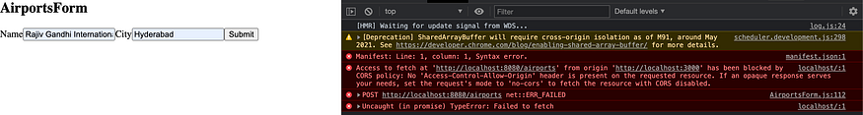
Full Screenshot of Page and Console
Went into network to debug further.
There was only one post request and no preflight request.The response to the post request doesn’t have the ‘Access-Control-Allow-Origin’ set. Also we see new WWW-Authenticate:Basic realm=”Realm” header.
Press enter or click to view image in full size
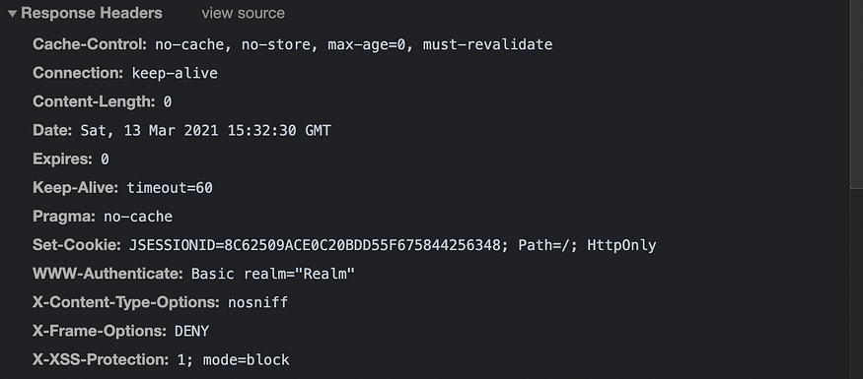
Response Headers
So basically after enabling the spring security, we are expected to do two things:
- Send the basic authentication request from our client while making request
- Make our server send the Access-Control-Allow-Origin Flag indicating that the react application is qualified origin.
But wait, we already mentioned @CrossOrigins at our controller didn’t we?
Yeah, But they aren’t being considered when spring security is enabled, we need a way through this.
Lets, attack this one step at a time.
- Send the basic authentication request from our client while making request
Since am using fetch, in the parameters i send while making the POST call from React, I need to attach the below header information:
“Authorization”:”Basic Base64encoded(username:password)”
lets say my user name is — user
password is — harambe
I can use a function in react called btoa and pass username and password to it like — btoa(user:harambe). The btoa method returns the base64 encoded string. So this looks something like this
Press enter or click to view image in full size
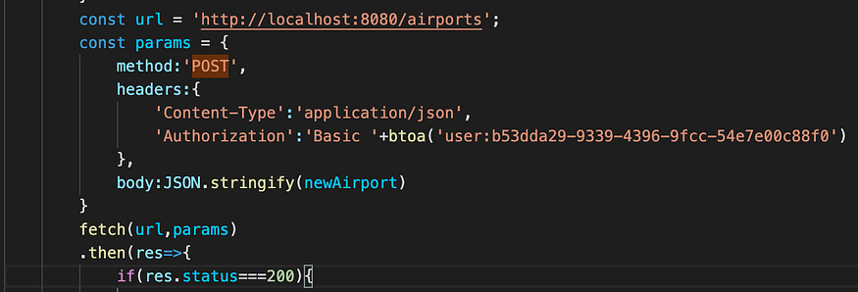
React with authorization
Don’t forget to keep <space> between Basic and btoa(username:password) method. This helps with authentication.
Now lets try that post call again
Press enter or click to view image in full size
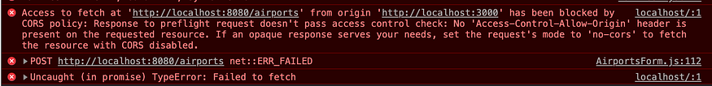
What the cors!! part 2
Well, well , well — who we have here. Went to network to see both preflight and post request
Press enter or click to view image in full size
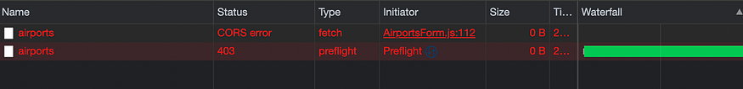
Preflight + POST
The pattern feels the same like what we have encountered before adding spring security to the project. One preflight(OPTIONS) request that is unauthorized and another CORS exception in fetch POST call(the actual call).
Digging into the preflight request and response , i see that no allow-access-control-origin returned by server and it was expecting authentication even on the OPTIONS request
Press enter or click to view image in full size
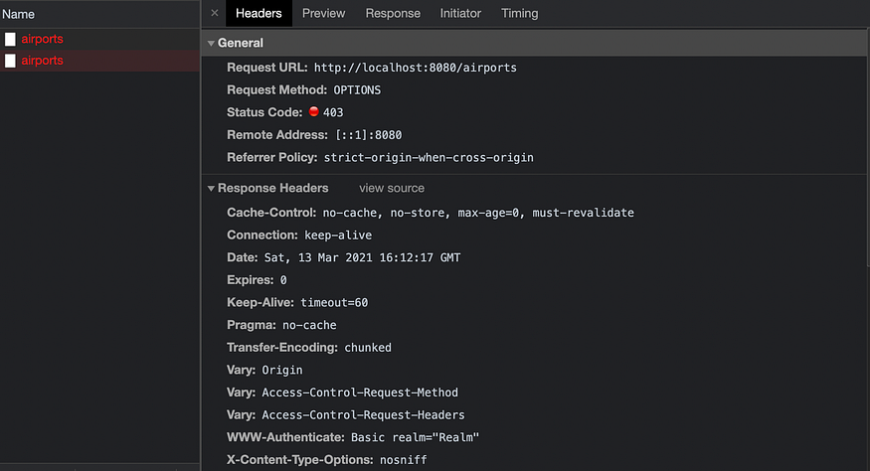
Developer Tools — Headers

Contemplating pablo meme
After spending a good half of my weekend into looking for a way to configure spring security to allow cross origin request, i stumbled upon this piece of code
Press enter or click to view image in full size
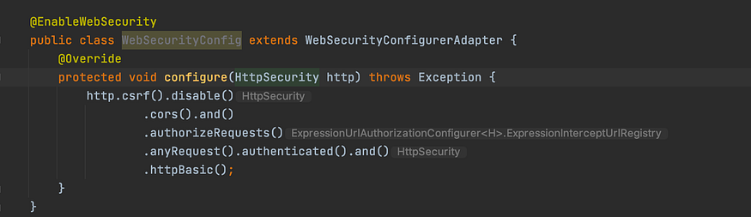
Web Security Config
Configure the spring security config by calling these methods that come out of the box in your main Spring Application that hosts this Rest API.
here the method
- cors() -> tells spring security to enable cors. So Now server is ready to whitelist/filter the origins. So be mindful that we are still going to set the origins list
- httpBasic() -> tells spring security that clients are going to authenticate the requests through basic authentication method. So spring security is tuned to read the ‘Authorization’:’Basic #hash’ that we are sending from client. If its a valid authentication details, spring security will let us through
For the rest of the methods you see on the code, i will plan another blog post.
Now, cors() is just enabled, but we still have to configure which origins are whitelisted.
Press enter or click to view image in full size
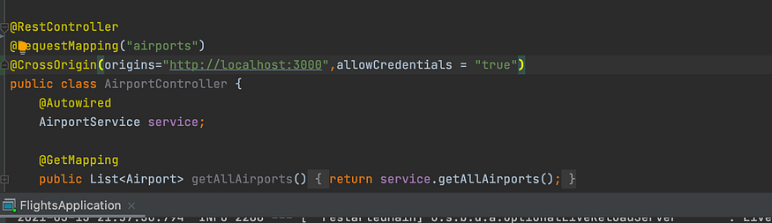
Rest Controller
So, here you see in the controller, I have added my
- origins = “http://localhost:3000” .which is my react code
- allowCredentials = true. This is important if you are using any form of authentication
By default, the @CrossOrigin allows all the request methods and headers. So
preflight request wouldn’t be having a problem now.
Now, let us hit that post button again

Button stress meme
Press enter or click to view image in full size
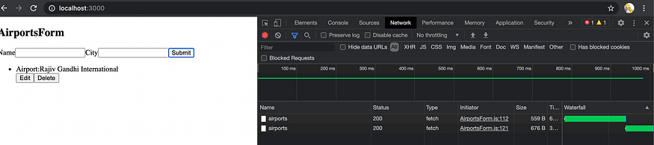
Final Glory
Finally, The sweetness of Glory.
Please ignore the second request here , its not from preflight. I wrote a logic to do ‘Get’ after posting something to list the items as u see in screenshot.
Lets check the POST request and response headers affected with our configuration.
Press enter or click to view image in full size
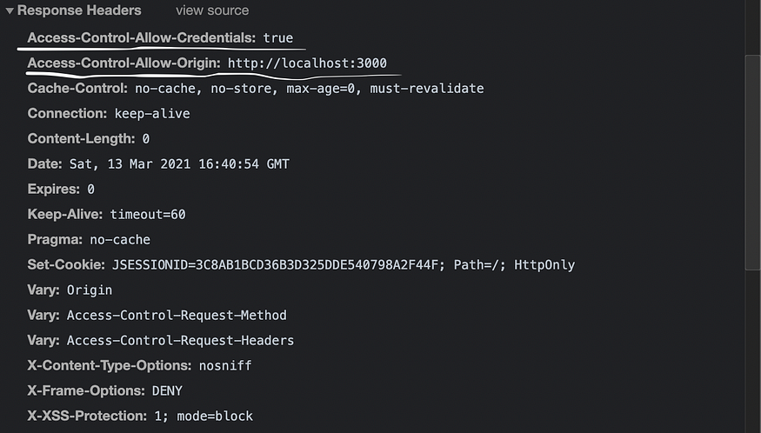
Developer Tools — Response Headers
You can see that ‘Access-Control-Allow-Credentials’ flag is set to true & also allow-origin shows the react application origin.
Hope this makes your day !

