💀 CSRF Attacks: How Hackers Can Hijack Your Users’ Accounts!
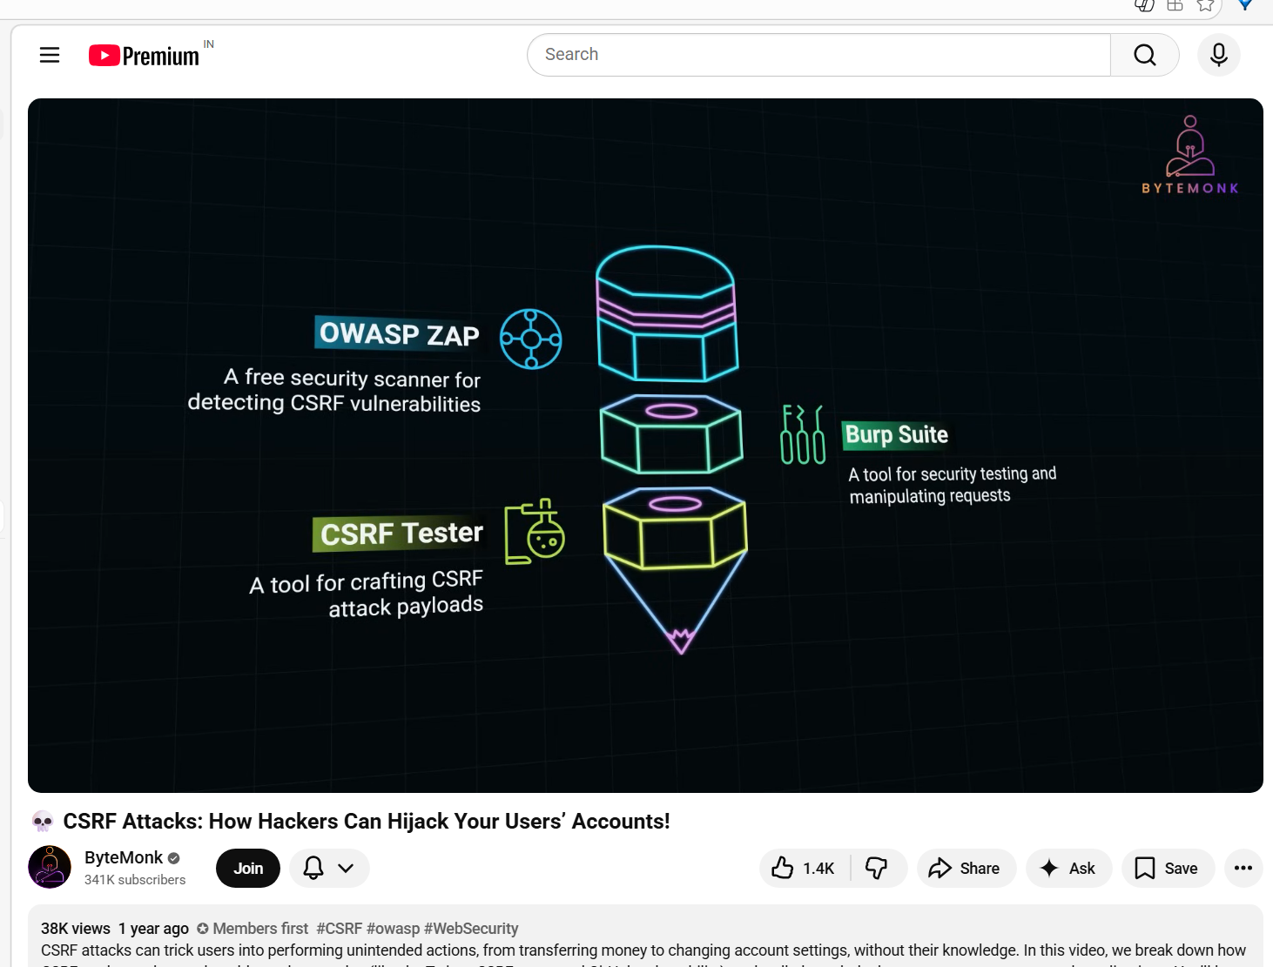

Cross-Site Request Forgery (CSRF) Explained And Demonstrated By A Pro Hacker!
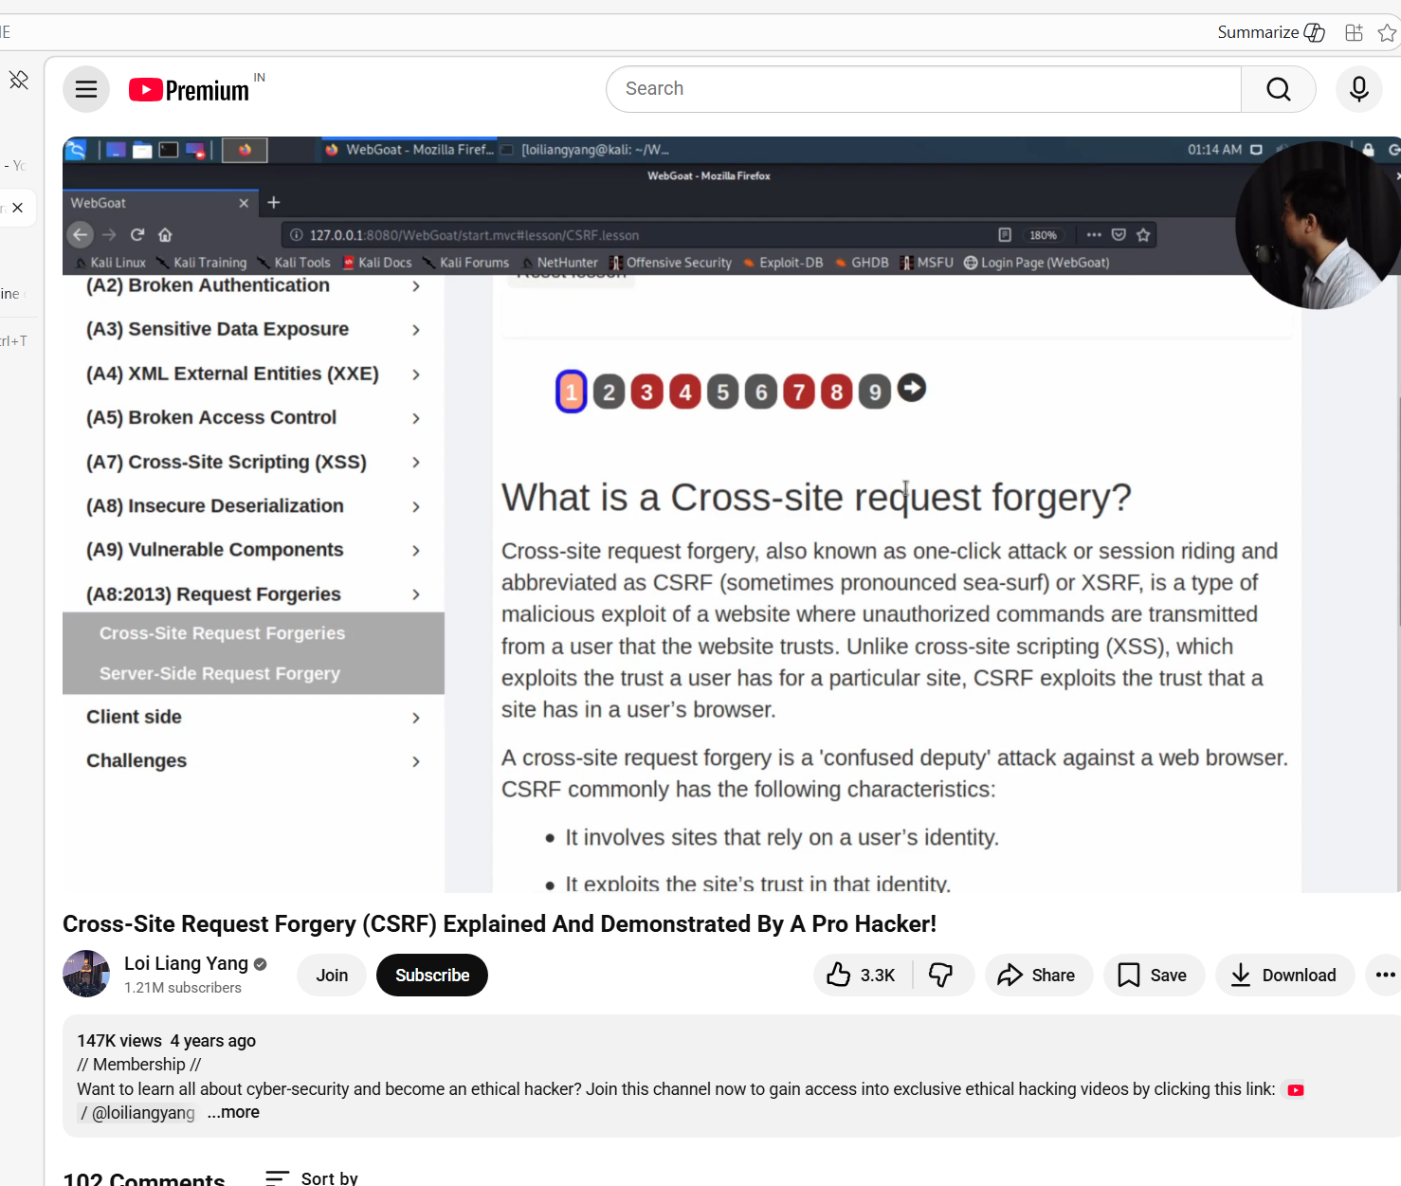

Cross Site Request Forgery (CSRF or XSRF)
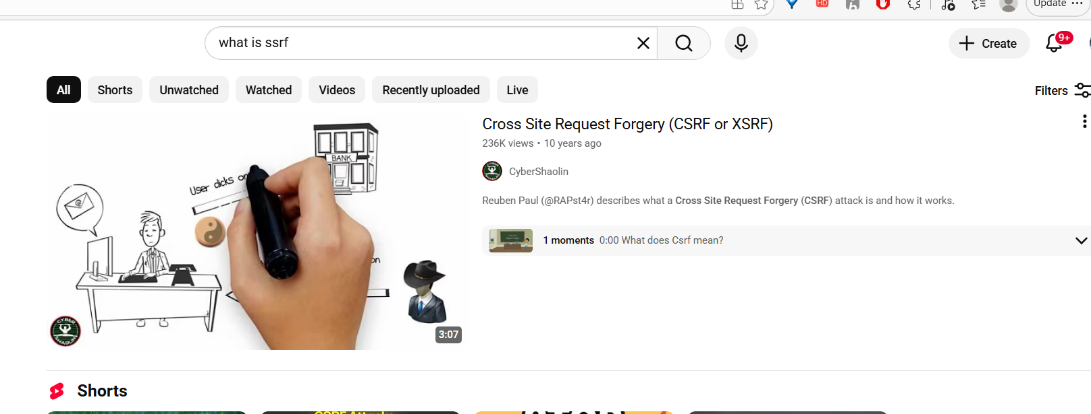

what is cross site request forgery. Please explain with simple and easy understanding examples
Cross-Site Request Forgery (CSRF) is a type of web security vulnerability where a malicious website tricks a user’s browser into performing an unwanted action on another website where the user is already logged in.

🔹 Simple Definition
CSRF = “Doing something on a website without the user’s intention, but using their logged-in session.”

🔹 Real-Life Analogy
Imagine:
- You are logged into your bank account
- In another tab, you open a malicious website
That malicious site secretly sends a request like:
“Transfer ₹10,000 to attacker”
Since your browser is already logged into the bank, it automatically sends your session cookies, and the bank thinks:
👉 “This is a valid user request”
So the transfer happens — without your knowledge

🔹 Simple Web Example
🟢 Normal Request (Safe)
You click a button:
POST /transfer
amount=1000&toAccount=12345

🔴 CSRF Attack
Attacker creates a hidden request like:
<img src="https://bank.com/transfer?amount=10000&toAccount=attacker123">
When you visit the attacker’s page:
- Your browser automatically sends request to bank.com
- Your session cookie is included
- Bank processes it as a legitimate request

🔹 Why CSRF Happens
CSRF works because:
- Browser automatically sends cookies/session
- Server trusts the request without verifying intent
- No extra validation like tokens

🔹 Key Point to Remember
👉 CSRF attacks exploit trust between:
- Browser → Website

🔹 Common Actions Targeted
- Money transfers 💸
- Changing passwords 🔑
- Updating email 📧
- Placing orders 🛒

🔹 How to Prevent CSRF
✅ 1. CSRF Tokens (Most Important)
- Server sends a unique token
- Client must send it back with request
<input type="hidden" name="csrf_token" value="abc123">

✅ 2. SameSite Cookies
- Restrict cookies from being sent in cross-site requests

✅ 3. Use POST instead of GET
- Avoid sensitive operations via GET

✅ 4. Re-authentication / OTP
- For critical operations (like payments)

✅ 5. Check Referer / Origin Header
- Validate request source

🔹 Easy One-Line Summary
👉 CSRF = Forcing a logged-in user to perform unwanted actions without their consent

If you want, I can also:
- Show Java/Spring Boot CSRF protection example
- Explain difference between CSRF vs XSS (very important interview question)

ation.”

🔹 5. Secure REST Approach (Better)
Instead of disabling blindly:
http
.csrf(csrf -> csrf
.csrfTokenRepository(CookieCsrfTokenRepository.withHttpOnlyFalse())
);

🔥 Common Interview Questions (with Answers)

❓ 1. What is CSRF in one sentence?
👉 CSRF is an attack where a logged-in user is tricked into performing unintended actions on a trusted website.

❓ 2. Why does CSRF happen?
👉 Because browsers automatically send cookies, and the server does not verify whether the request is intentional.

❓ 3. Why is CSRF not applicable to JWT?
👉 JWT is sent in headers manually, not automatically like cookies.

❓ 4. Difference between CSRF token and JWT?
Feature | CSRF Token | JWT
Purpose | Prevent CSRF | Authentication
Stored | Server + Client | Client-side
Auto sent by browser | ❌ | ❌

❓ 5. Can GET requests be CSRF attacked?
👉 Yes (if server allows sensitive operations via GET)

❓ 6. How does Spring Security prevent CSRF?
👉 By generating a unique token per session and validating it for every state-changing request.

❓ 7. What happens if CSRF token is missing?
👉 Server returns:
➡️ 403 Forbidden

❓ 8. How does XSS break CSRF protection?
👉 XSS can read CSRF token from page and send valid malicious requests.

❓ 9. When should you disable CSRF?
👉 Only when:
- Using stateless APIs
- Using JWT/OAuth
- No session cookies involved

❓ 10. Best practices to prevent CSRF?
- Use CSRF tokens ✅
- Use SameSite cookies ✅
- Avoid GET for sensitive actions ✅
- Re-authenticate for critical actions ✅

🧠 Quick Interview Summary
👉 CSRF
- Uses cookies
- Exploits trust
- Prevented using tokens
👉 Spring Boot
- CSRF enabled by default
- Disable only for stateless APIs

🚀 Pro Tip (High-Level Answer)
If interviewer asks advanced:
👉 Say this:
“In modern applications using JWT or OAuth2, CSRF risk is reduced because authentication tokens are not automatically sent by the browser. However, in session-based applications, CSRF protection is critical and handled via synchronizer tokens or SameSite cookies.”

If you want next:
- I can give real-world attack scenarios (step-by-step hacker flow)
- Or hands-on mini project showing CSRF attack + fix

Explain XSS and its types? How does spring implemented to avoid these types of xss attacks?
Let’s break this down in a simple + interview-ready + practical way 👇

🔐 What is XSS (Cross-Site Scripting)?
XSS (Cross-Site Scripting) is a security vulnerability where an attacker injects malicious JavaScript into a trusted website.
👉 When another user opens that page, the script runs in their browser.

🧠 Simple Analogy
Think of your website as a notice board in your house 🏠
- Normal user → writes a message 📝
- Attacker → secretly adds a spy note with instructions 🕵️‍♂️
When someone reads it:
- Instead of just reading → they unknowingly execute attacker’s script 😨

💥 Example
<input type="text" name="comment">
User enters:
<script>alert('Hacked!')</script>
If your app directly displays it:
<p><script>alert('Hacked!')</script></p>
👉 Script executes → XSS attack successful

🚨 Types of XSS
There are 3 main types:

1️⃣ Stored XSS (Persistent XSS)
📌 What happens?
- Malicious script is stored in DB
- Runs every time someone loads that data
💥 Example
Comment section:
<script>stealCookies()</script>
Saved in DB → shown to all users → attack spreads
🧠 Analogy
Someone sticks a permanent spy note on your wall

2️⃣ Reflected XSS
📌 What happens?
- Script comes from request (URL / query param)
- Immediately reflected in response
💥 Example
URL:
https://site.com/search?q=<script>alert(1)</script>
If backend prints it:
Results for: <script>alert(1)</script>
👉 Script executes instantly
🧠 Analogy
Someone tricks you into reading a malicious message instantly

3️⃣ DOM-Based XSS
📌 What happens?
- Happens entirely in browser (JavaScript)
- Backend is not involved
💥 Example
document.getElementById("msg").innerHTML = location.hash;
URL:
site.com/#<script>alert(1)</script>
👉 JS injects script → executed
🧠 Analogy
Your own house system processes a message without checking it

🛡️ How Spring Boot Prevents XSS
Spring itself doesn’t magically stop XSS—you must use it correctly.
Let’s see how protection is implemented 👇

✅ 1. Output Escaping (MOST IMPORTANT)
Spring (especially with Thymeleaf) automatically escapes HTML.
✔ Safe Example (Thymeleaf)
<p th:text="${userInput}"></p>
👉 Converts:
<script>alert(1)</script>
➡ into:
&lt;script&gt;alert(1)&lt;/script&gt;
👉 Script will NOT execute

❌ Dangerous
<p th:utext="${userInput}"></p>
👉 This does NOT escape HTML → XSS risk

✅ 2. Spring Security Headers
Using Spring Security, you can enable browser protections:
http
.headers(headers -> headers
.contentSecurityPolicy("script-src 'self'")
);
Important Headers:
- Content-Security-Policy (CSP) → restrict scripts
- X-XSS-Protection → browser XSS filter
- X-Content-Type-Options
👉 These reduce attack impact

✅ 3. Input Validation
Always validate user input:
@Size(max = 100)
@NotNull
private String comment;
👉 Prevents large/malicious payloads

✅ 4. Avoid innerHTML in JavaScript
Instead of:
element.innerHTML = userInput; ❌
Use:
element.innerText = userInput; ✅

✅ 5. Encoding (Manual if needed)
String safe = HtmlUtils.htmlEscape(userInput);

✅ 6. Use DTO + Sanitization Libraries
Libraries like:
- OWASP Java HTML Sanitizer
Example:
PolicyFactory policy = Sanitizers.FORMATTING;
String safeHTML = policy.sanitize(userInput);

✅ 7. Disable Inline Scripts via CSP
Content-Security-Policy: script-src 'self'
👉 Prevents injected scripts from running

🎯 Interview Summary (Quick Answer)
👉 XSS is a vulnerability where attackers inject malicious scripts into web pages executed in user browsers.
Types:
- Stored XSS → saved in DB
- Reflected XSS → comes via request
- DOM-based XSS → client-side JS issue
Prevention in Spring:
- Output escaping (Thymeleaf auto-escaping)
- Avoid th:utext
- Use Spring Security headers (CSP)
- Validate inputs
- Encode output (HtmlUtils)
- Avoid innerHTML
- Use sanitization libraries

If you want, I can also give you:
✅ Real Spring Boot code example (end-to-end)
✅ Interview tricky questions on XSS
✅ Comparison: XSS vs CSRF (very commonly asked)
could you elaborate on the following, Using Spring Security, you can enable browser protections: http .headers(headers -> headers .contentSecurityPolicy("script-src 'self'") ); Important Headers: Content-Security-Policy (CSP) → restrict scripts X-XSS-Protection → browser XSS filter X-Content-Type-Options
Great question—this is exactly the level of detail interviewers expect 👍
Let’s break down what these headers actually do, why they matter, and how Spring Security applies them.

🔐 Why Security Headers Matter
Even if your backend is secure, the browser is the final execution environment.
👉 Security headers = instructions sent by your server to the browser
👉 They tell the browser:
“Only behave in a safe way when rendering this page.”

🛡️ 1. Content-Security-Policy (CSP)
📌 What it does
CSP controls what resources (scripts, styles, images) the browser is allowed to load.
👉 This is the MOST powerful defense against XSS

💥 Without CSP
<script>alert('Hacked')</script>
👉 Browser executes it 😨

✅ With CSP
http
.headers(headers -> headers
.contentSecurityPolicy("script-src 'self'")
);
Meaning:
Directive | Meaning
'self' | Only allow scripts from your own domain
👉 Now browser says:
❌ “I will NOT run this inline or external unknown script”

🧠 Simple Analogy
Your house 🏠 allows only known guests (your domain)
Unknown people (injected scripts) are blocked at the door 🚫

🔍 Common CSP Rules
Content-Security-Policy:
default-src 'self';
script-src 'self';
style-src 'self' 'unsafe-inline';
img-src 'self' data:;
Explanation:
- default-src 'self' → everything from your domain
- script-src 'self' → only trusted JS
- img-src data: → allow base64 images

⚠️ Important Note
❌ Avoid:
script-src 'unsafe-inline'
👉 This allows inline scripts → weakens XSS protection

🛡️ 2. X-XSS-Protection
📌 What it does
This header enables browser’s built-in XSS filter.
http.headers(headers -> headers
.xssProtection(xss -> xss
.headerValue("1; mode=block")
)
);

🔍 Values
Value | Meaning
0 | Disable protection
1 | Enable filter
1; mode=block | Block page if attack detected

🧠 Simple Analogy
Browser acts like a security guard:
- Detects suspicious script
- Stops page from loading

⚠️ Reality Check (Important for interviews)
👉 Modern browsers (Chrome, Edge) have deprecated this header
👉 Why?
- CSP is much stronger
- This filter was inconsistent
👉 So today:
✔ Use CSP
❌ Don’t rely only on X-XSS-Protection

🛡️ 3. X-Content-Type-Options
📌 What it does
Prevents MIME-type sniffing
http.headers(headers -> headers
.contentTypeOptions()
);

💥 Problem Without It
Browser may guess content type:
Content-Type: text/plain
But browser thinks:
👉 “Looks like JavaScript… I’ll execute it”
😨 Dangerous!

✅ With Header
X-Content-Type-Options: nosniff
👉 Browser says:
“I will ONLY trust declared content type”

🧠 Analogy
Food label says “juice 🧃”
Without header → browser tastes it and says “maybe alcohol 🍺”
With header → browser says:
“I trust label only. No guessing.”

⚙️ Full Spring Security Configuration
Here’s a real-world configuration:
@Bean
public SecurityFilterChain filterChain(HttpSecurity http) throws Exception {
http
.headers(headers -> headers
// CSP
.contentSecurityPolicy(csp -> csp
.policyDirectives("default-src 'self'; script-src 'self'")
)
// XSS Protection
.xssProtection(xss -> xss
.headerValue("1; mode=block")
)
// Content Type Options
.contentTypeOptions()
);
return http.build();
}

🎯 How These Work Together
Header | Protects Against | Strength
CSP | XSS (script injection) | ⭐⭐⭐⭐⭐
X-XSS-Protection | Reflected XSS (legacy) | ⭐⭐
X-Content-Type-Options | MIME confusion attacks | ⭐⭐⭐

🔥 Interview-Ready Summary
👉 CSP is the primary defense against XSS—it restricts script execution sources.
👉 X-XSS-Protection is legacy and mostly deprecated but still discussed.
👉 X-Content-Type-Options prevents browsers from misinterpreting content types.
👉 In Spring Security, these are configured via:
http.headers(...)

💡 Pro Tip (Very Important)
Even with all headers:
❌ They do NOT replace:
- Input validation
- Output escaping
👉 Headers = extra layer, not the only protection

If you want next level understanding, I can show:
✅ How CSP blocks a real attack step-by-step
✅ Differences between CSP vs input validation
✅ Common mistakes developers make with CSP (very important for interviews)

