what is docker java

Open source Java projects: Docker

Redefine Java virtualization with Docker
JavaWorld | NOV 3, 2015 3:42 PM PT

MORE LIKE THIS
- 
Open source Java projects: Docker Swarm
- 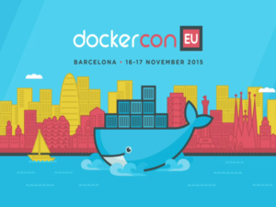
New Docker tool removes a big barrier for enterprises
- 
Jenkins-Docker pairing gathers momentum

- 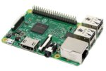
33% off Raspberry Pi 3 Model B Motherboard - Deal Alert
- 
12% off Fellowes Powershred Jam-Proof Cross-Cut Paper and Credit Card Shredder...
- 
33% off H&R Block Tax Software Deluxe Federal and State 2016 - Deal Alert
LATEST INSIDER
- 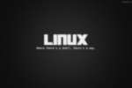
5 rock-solid Linux distros for developers
- 
Review: GitLab rocks version control
- 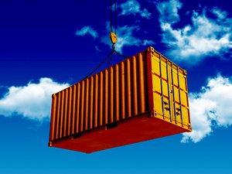
To the cloud! Real-world container migrations
See all Insider
Docker is an open platform for building, shipping, and running distributed applications. Dockerized applications can run locally on a developer's machine, and they can be deployed to production across a cloud-based infrastructure. Docker lends itself to rapid development and enables continuous integration and continuous deployment like almost no other technology does. In short, Docker is a platform that every developer should be familiar with.
This installment of Open source Java projects introduces Java developers to Docker. I'll explain why it's important to developers, walk you through setting up and deploying a Java application to Docker, and show you how to integrate Docker into your build process.

Quick guide to Docker terminology
Docker has its own terminology, which I'll be using throughout this introduction. Take a minute to familiarize yourself with these terms:
- Docker engine: The process running on your production machine that sits between your running Docker application and the underlying operating system and hardware.
- Dockerfile: A text file that contains the instructions (or commands) used to build a Docker image.
- Docker image: The result of building a Dockerfile and executing the Dockerfile's commands. It is constructed from a root operating system, installed applications, and commands executed in such a way that it can run your application. A Docker image serves as the basis for Docker containers and is the static template from which they are created.
- Docker container: A runtime instance of a Docker image. Whereas the Docker image is like a template (built from a Dockerfile that contains the correct operating system, applications, and commands used to build the image), the container is an actual running instance of that image.
- Docker host: A physical or virtual machine that runs the Docker engine to host your Docker container's DockerHub.
- DockerHub: The repository that hosts Docker images. Think of a DockerHub being to Docker images what GitHub is to Git repositories: a central location for hosting and serving up Docker images.

Introducing Docker
A little over a decade ago, software applications were large and complex things, deployed to large machines. In the Java world, we developed enterprise archives (EARs) that contained both Enterprise JavaBeans (EJB) and web components (WARs), then we deployed them to large application servers. We did everything that we could to design our applications to run optimally on large machines, maximizing all of the resources available to us.
In the early 2000s, with the advent of the cloud, developers began using virtual machines and server clusters to scale out applications to meet user demand. Applications deployed virtually had to be designed quite differently from the monoliths of years past. Lighter weight, service-oriented applications were the new standard. We learned to design software as a collection of interconnected services, with each component being as stateless as possible. The concept and implementation of scalable infrastructure transformed; rather than depend on the vertical scalability of a single large machine, developers and architects started thinking in terms of horizontal scalability: how to deploy a single application across numerous lightweight machines.
Docker takes this virtualization a step further, providing a lightweight layer that sits between the application and the underlying hardware. Docker runs the application as a process on the host operating system. Figure 1 compares a traditional virtual machine to Docker.
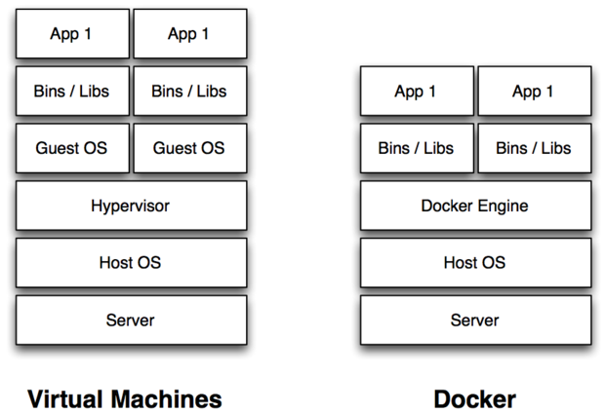
Figure 1. Comparing virtual machines to Docker
A traditional virtual machine runs a hypervisor on the host operating system. The OS, in turn, runs a full guest operating system inside the virtual machine. The guest operating system then hosts the binaries and libraries required to run an application.
Docker, on the other hand, provides a Docker engine, which is a daemon that runs on the host operating system. The Docker engine translates operating system calls in the Docker container to native calls on the host operating system. A Docker image, which is the template from which Docker containers are created, contains a bare-bones operating system layer, and only the binaries and libraries required to run an application.
The differences might seem subtle, but in practice they are profound.

Understanding process virtualization
When we look at the operating system in a virtual machine, we see the virtual machine's resources, such as its CPU and memory. When we run a Docker container, we directly see the host machine's resources. I liken Docker to a process virtualization platform rather than a machine virtualization platform. Essentially, your application is running as a self-contained and isolated process on the host machine. Docker achieves isolation by leveraging a handful of Linux constructs, such as cgroups and namespaces, to ensure that each process runs as an independent unit on the operating system.
Because Dockerized applications run similar to processes on the host machine, their design is different from applications that run on a virtual machine. To illustrate, we might normally run Tomcat and a MySQL database on a single virtual machine, but Docker would have us run the app server and database in their own, respective Docker containers. This allows Docker to better manage the individual processes as self-contained units on the host operating system. It also means that in order to effectively use Docker, we need to design our applications as finely granular services, like microservices.

Microservices in Docker
In a nutshell, microservices is a software architectural style that facilitates a modular approach to system building. In a microservices architecture, complex applications are composed of smaller, independent processes. Each process performs one or more specific tasks, communicating with other processes via language-independent APIs.
Microservices are very fine-grained, highly decoupled services that perform a single function, or a collection of related functions, very well. For example, if you are managing a user's profile and shopping cart, rather than packaging them together as a set of user services, you might opt to define them separately, as user profile services and user shopping cart services. In practical terms, building microservices means building web services, most commonly RESTful web services, and grouping them by functionality. In Java, we will package these as WAR files and deploy them to a container, such as Tomcat, then run Tomcat and our services inside a Docker container.

Setting Up Docker
Before we dive into Docker, let's get your local environment set up. It's great if you are running Linux: you can just install Docker directly and start running it. For those of us using Windows or a Mac, Docker is available through a tool called the Docker Toolbox, which installs a virtual machine (using Oracle's Virtual Box technology), which runs Linux with the Docker daemon. We can then use the Docker client to execute commands that are sent to the daemon for processing. Note that you won't be managing the virtual machine; you'll just be installing the toolbox and executing the docker command line tool.
Start by downloading Docker with the appropriate Mac, Windows, or Linux setup instructions.
I use a Mac, so I downloaded the Mac version of Docker Toolbox and ran the installation file. Once the install completed I ran the Docker Quickstart Terminal, which started the Virtual Box image and provided a command shell. The setup should be more or less the same for Windows users, but see the Windows instructions for more information.

DockerHub: The Docker image repository
Before we start using Docker, take a minute to visit DockerHub, the official repository for Docker images. Explore DockerHub and you'll find that it hosts thousands of images, both official ones and many built by independent developers. You'll find base operating systems like CentOS, Ubuntu, and Fedora as well as configured images for Java, Tomcat, Jetty, and more. You can also find almost any popular application out-of-the-box, including MySQL, MongoDB, Neo4j, Redis, Couchbase, Cassandra, Memcached, Postgres, Nginx, Node.js, WordPress, Joomla, PHP, Perl, Ruby, and so on. Before you build an image, make sure it's not already on DockerHub!
As an exercise, try running a simple CentOS image. Enter the following command in your Docker Toolbox command prompt:
$ docker run -it centos
The docker command is your primary interface to communicating with the Docker daemon. The run directive tells Docker to download and run the specified image (assuming it isn't already on your computer). Alternatively, you can download an image without running it by using the pull directive. There are two arguments: i tells Docker to run this image in interactive mode, and ttells it to create a TTY shell. Note that unofficial images are named with the convention username/image-name, while official images are run without a username, which is why we only need to specify "centos" as the image we want to run. Finally, you can specify a version of the image to run by appending a :version-number to the end of the image name, such as centos:7. Each image defines a latest version that is used by default; in the case of CentOS, the latest version is 7.
After running $ docker run -it centos you should see Docker downloading the image, after which it will present an output similar to the following:

$ docker run -it centos
[root@dcd69de89aad /]#

Because we ran this container in interactive mode, it presented us with a root command shell. Browse around the operating system for a little bit and then exit by executing the exit command.
You can see all images that you have downloaded by executing docker images:

$ docker images
REPOSITORY TAG IMAGE ID CREATED VIRTUAL SIZE
java 8 5282faca75e8 4 weeks ago 817.6 MB
tomcat latest 71093fb71661 8 weeks ago 347.7 MB
centos latest 7322fbe74aa5 11 weeks ago 172.2 MB

You can see that I have the latest versions of CentOS and Tomcat, as well as Java 8.

Running Tomcat inside Docker
Starting a Tomcat instance inside Docker is a little more complex than starting the CentOS image. Issue the command:
$ docker run -d -p 8080:8080 tomcat
In this example, we're running tomcat as a daemon process, using the -dargument. We're exposing port 8080 on our Docker container as port 8080 on our Docker host (the Virtual Box virtual machine). When you run this command you should see output similar to the following:

$ docker run -d -p 8080:8080 tomcat
bdbedc47836028b9d1fee3d4a96eee4d89838d7b6b0b4298d9e5a7d117292003

This horribly long hexidecimal number is the container ID, which we will use in a minute. You can see all the running processes by executing docker ps:

$ docker ps
CONTAINER ID IMAGE COMMAND CREATED STATUS PORTS NAMES
bdbedc478360 tomcat "catalina.sh run" 3 seconds ago Up 3 seconds 0.0.0.0:8080->8080/tcp focused_morse

You'll notice that the container ID returns the first 12 characters from the ID above. This ID is painful to type, so Docker allows you to specify enough of it in commands to uniquely identify it. For example, you could specify "bdb" and that would be enough for Docker to uniquely identify this instance. In order to see when Tomcat has finished loading, you would typically tail the catalina.outfile. The alternative in the Docker world is to view the standard output using the docker logs command. Specify the -f argument to follow the logs:

$ docker logs -f bdb
09-Sep-2015 02:15:21.611 INFO [main] org.apache.catalina.startup.VersionLoggerListener.log Server version: Apache Tomcat/8.0.24
...
09-Sep-2015 02:15:25.137 INFO [main] org.apache.catalina.startup.Catalina.start Server startup in 3188 ms

Exit the log tailing by pressing Ctrl-C.

Testing and exploring
To test Tomcat, you need to find the address of your Virtual Box host. When you started the Docker Quickstart Terminal, you should have seen a line that looked like the following:

docker is configured to use the default machine with IP 192.168.99.100
Alternatively, you can look at the DOCKER_HOST environment variable to find the machine's IP address:
DOCKER_HOST=tcp://192.168.99.100:2376
Open a browser window to port 8080 on the Docker Host:
http://192.168.99.100:8080
You should see the standard Tomcat homepage.
Before we stop our instance, use the docker command line tool to learn a little more about our processes:
- docker stats CONTAINER ID displays the CPU, memory, and network I/O for each image.
- docker inspect CONTAINER ID displays the configuration of the image.
- docker info displays information about the Docker host.
When you're finished, you can stop Tomcat by executing the docker stopcommand with your container ID: $ docker stop bdb.
You can confirm that Tomcat is no longer running by executing docker ps again to verify that it is no longer listed. You can see the history of all the images you have run by executing docker ps -a:

$ docker ps -a
CONTAINER ID IMAGE COMMAND CREATED STATUS PORTS NAMES
bdbedc478360 tomcat "catalina.sh run" 26 minutes ago Exited (143) 5 seconds ago focused_morse

At this point you should understand how to find images on DockerHub, how to download and run instances, how to view running instances, how to view an instance's runtime statistics and logs, and how to stop an instance. Now let's turn our attention to how Docker images are defined.

https://zeroturnaround.com/rebellabs/docker-for-java-developers-how-to-sandbox-your-app-in-a-clean-environment/

Docker for Java Developers: How to sandbox your app in a clean environment
- October 25, 2015

- Oleg Shelajev

- 11 Comments

- inShare138

View image on Twitter
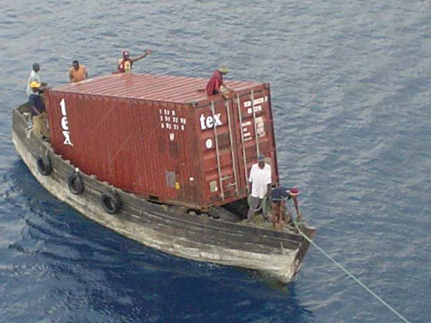

Follow
Kelsey Hightower
✔@kelseyhightower
I'm sure that container management system you wrote is going to be awesome!
12:22 AM - 8 Nov 2014

936936 Retweets

778778 likes
I’ve got a confession: I’ve been putting off looking into Docker for some time, mainly due to lack of time and the fact that ZeroTurnaround, our sponsor and parent, recently decided to get out of the Ops business altogether and focus on developer tools. As an engineer on our former release automation tool, I tend to get a slightly bad taste when I look at virtualization or giant cluster management tools.
So I’m coming to the Docker game a bit late perhaps, but today I’m going to talk about how Java developers can cut through the jungle that is the Docker phenomenon and more easily grasp the benefits of using this hot new tool for simplifying your development process.
In this post, we’ll discuss what Docker is, what you can do with it, what you can (but probably don’t want to) do with it, and how to think about the soup that is Docker.
NB! We have also created a 1 page cheat sheet with the most frequently used Docker commands which is printable and gives a great overview of when and what commands you need:
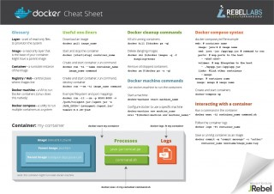
But if you like to start with an introduction first, let’s get into what Docker is.

What is Docker?
Docker is, in its own words, “an open platform for developers and sysadmins to build, ship, and run distributed applications”. In other, simpler words, Docker is a container manager. Note that it’s not a virtualization solution that abstracts away the underlying OS or hardware, like the well-known VirtualBox, but an engine to package an individual application system to run in its own particular environment.
It means that Docker can be used as a virtualenv in Python, sandboxing the application dependencies so as not to let them to get into dependency management hell.
It’s pretty clear how Docker can be interesting for operations people to deploy apps to myriads of servers at once. Or for cloud computing enablers, like Google Cloud Computing, but let’s get our hands dirty and see how we, as ordinary Java developers, can benefit from containers in development.

Installation and getting started
The instructions to install Docker are available from, surprise-surprise, its website. I don’t want to go into the exact list of activities required to obtain it, so in order to keep this post more high level than that, this chapter will be very brief.
If you’re lucky to run a operation system that supports Docker out of the box (read: some Linux distro), you’re all good to go. Install Docker using your favorite package manager and verify this commmand works:
$ sudo docker run ubuntu:14.04 /bin/echo 'Hello world'
Hello world
If you’re not that lucky and belong to a category of people running Windows or OSX, worry not. There is boot2docker project that will start a tiny lightweight Linux virtual machine for you so you can enjoy using Docker nonetheless.
Installing boot2docker comes easy, there are OS specific installers prepared for us. Running it is also trivial, and here are the instructions for Mac people.
Verify that it works using the command above, ssh into boot2docker and run it:
$ boot2docker ssh
## .
## ## ## ==
## ## ## ## ===
/""""""""""""""""\___/ ===
~~~ {~~ ~~~~ ~~~ ~~~~ ~~ ~ / ===- ~~~
\______ o __/
\ \ __/
\____\______/
_ _ ____ _ _
| |__ ___ ___ | |_|___ \ __| | ___ ___| | _____ _ __
| '_ \ / _ \ / _ \| __| __) / _` |/ _ \ / __| |/ / _ \ '__|
| |_) | (_) | (_) | |_ / __/ (_| | (_) | (__| < __/ |
|_.__/ \___/ \___/ \__|_____\__,_|\___/ \___|_|\_\___|_|
Boot2Docker version 1.3.1, build master : 9a31a68 - Fri Oct 31 03:14:34 UTC 2014
Docker version 1.3.1, build 4e9bbfa

docker@boot2docker:~$ sudo docker run ubuntu:14.04 /bin/echo 'Hello world'
Hello world
That’s it, we have run our first Docker app. It does nothing fancy, just echoes a message, but it is a crucial step in setting up the infrastructure for something useful.



Let’s get groovy with those magnificent containers
Although we like the language, we’re not exactly a Groovy shop so we’ll focus on getting Java running in the container.
The good news is that even here, everything is done for us. There’s an official repo with Docker images for Java: dockerfile/java. Well, to be very precise, these are not images, but dockerfiles that tell Docker how to create an actual image.
If you look at the Docker file for Java 8, you’ll immediately notice that the Java 8 image is based on the stock Ubuntu image and installs Java as you would do to the usual Ubuntu machine.
Additionally, it defines the JAVA_HOME and the default Docker command to execute:
# Define working directory.
WORKDIR /data
# Define commonly used JAVA_HOME variable
ENV JAVA_HOME /usr/lib/jvm/java-8-oracle
# Define default command.
CMD ["bash"]
Now, our Docker container is equipped with Java and is able to run Java commands:
docker run -it --rm dockerfile/java:oracle-java8 java -version
java version "1.8.0_25"
Java(TM) SE Runtime Environment (build 1.8.0_25-b17)
Java HotSpot(TM) 64-Bit Server VM (build 25.25-b02, mixed mode)
We can run random Java commands to be executed in our Docker environment. And it doesn’t use a proper virtual machine for that, so no VM overhead is thrown upon you.
How easy and portable is that?!

Awesome, let me personalise it even more
I know what you’re thinking: this is pretty cool, but now I have to make a dockerfile to download and install Maven, clone my project repository, then build it, downloading half of the internet in the process. Fear not, Docker can easily access your host filesystem, so you don’t have to provide much besides the access to Java.

Indeed, you can have it, cat. Linux obviously has the advantage of being the native OS of Docker, so the mapping is as seamless as it can be. A Docker command just takes a parameter, -v, which directories to map to something inside the container.
For example the command below will share my ~/repo dir with the container.
docker run -v /Users/shelajev/repo:/opt/repo ubuntu ls -la /opt/repo/zt-zip
OSX users, you’re covered too, since boot2docker 1.3.1 your home directory is shared by default with the boot2docker virtual machine, so the -v will work too:
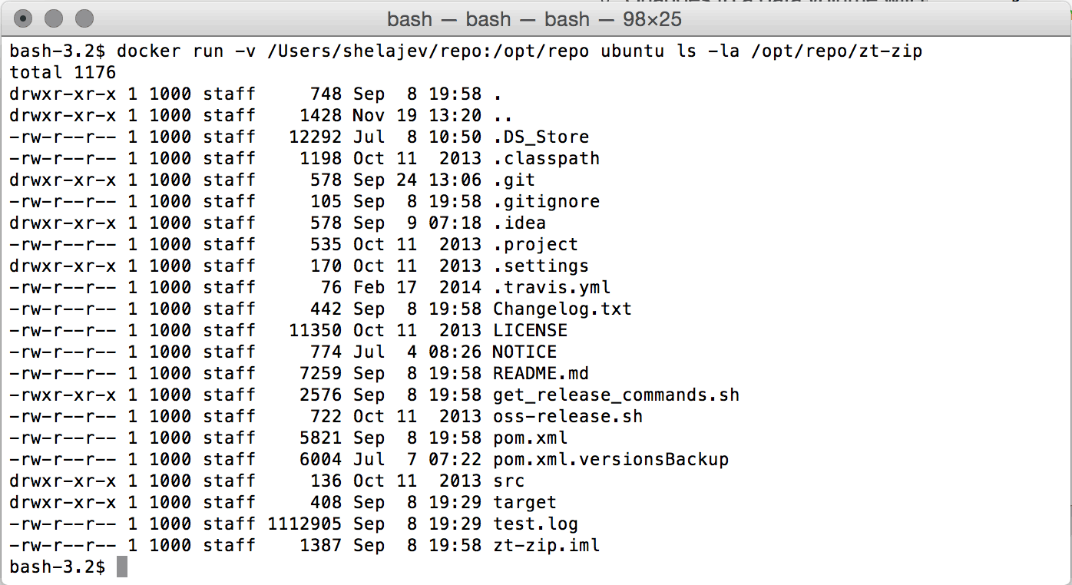
Windows people, don’t worry, there’s just an incantation for you to make it work too. In short, you’ll have to install VirtualBox Guest Additions and manually map a folder between your host and the boot2docker VM. This is pretty straightforward when you understand what you’re doing or follow a how-to, like the one linked above.
Now it’s pretty clear how to run your actual Java applications in a Docker container. Your source code sits on your host machine, and you edit it there as well. You even build it on the host machine, because operations activities don’t start with the source code, they start with a prebuilt artifact. From there it’s as simple as putting it into the correct place and using the correct command to start it.
Here’s an example of a Java project, which I’ll use Spring Boot for getting the application started. We wrote a bit about this in last week’s post, What you can build for free in 2 hours with Spring Boot, Twitter and Facebook.
So usually, on my machine I’d run it like:
shelajev@shrimp ~/repo/tmp/gs-spring-boot/complete ‹master›
$ java -jar target/gs-spring-boot-0.1.0.jar
And verify that the application is running on the port 8080. To run it in the Docker container, I just do the same, but provide a port mapping so I can access that from the host machine:
docker run -v /Users/shelajev/repo:/opt/repo -p 8080:8080 --rm dockerfile/java:oracle-java8 java -jar /opt/repo/tmp/gs-spring-boot/complete/target/gs-spring-boot-0.1.0.jar
The output of this command is very predictable, it starts the Spring Boot app and prints all the initialization things it has to. For brevity, it’s not included here, but it looks exactly like this pastebin.
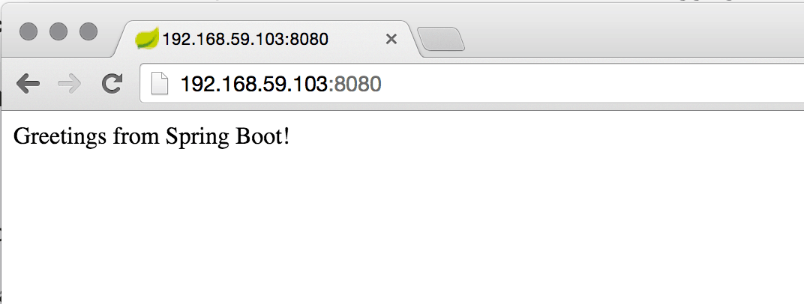
E voilà! I can access it from my host machine browser! The exact IP where boot2docker offers an interface that is mapped to docker is easily obtainable with a:
open http://$(boot2docker ip 2>/dev/null)/

Conclusion: Docker is as Dev-friendly as an Ops tool can be
I’m comfortable in asserting that Docker is a well-thought-out tool where almost everything is accessible from the command line.
In this post we looked at how to get started with Docker containers to enable a portable development environment for Java projects. This might reduce the install complexity for a new project without sacrificing the goods or performance that your usual environment provides you: your favorite IDE, automatic tests, tools like JRebel (shameless plug), and others.
For Java developers, Docker helps isolate our apps in a clean environment, so the unpredictability of “works on my machine” is a little less irritating. Isolation is important because it reduces the complexity of the software environment we’re using. Plus, to benefit from using Docker you don’t have to get into the world of containers and start deploying your application to thousands nodes. Just the isolation from your developer’s machine is a big plus.
Docker, with its intuitive user interface reduces this complexity even further, becoming a great tool for any developer. Additional benefits of using it is that it’ll make operations people life easier, and we all know how important is that. Free karma, right?
Share your opinion in the comments below or find me on Twitter: @shelajev.

Read next:
Git Commands Cheat Sheet
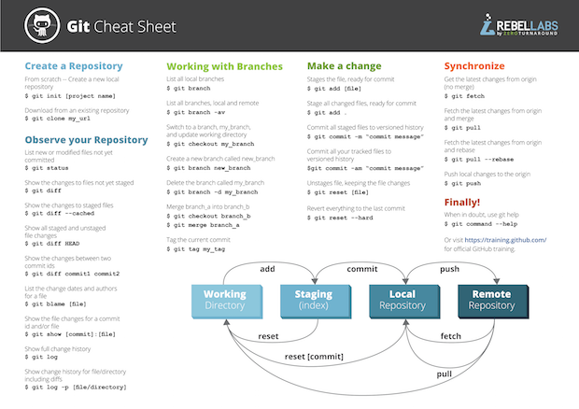
Java 8 Streams Cheat Sheet
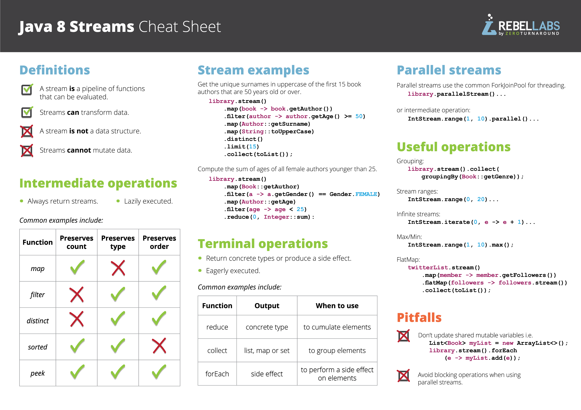

- inShare138

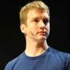

OLEG SHELAJEV
Developer Advocate
Oleg Šelajev is an engineer, author, speaker, lecturer and advocate at ZeroTurnaround. He spends his time testing, coding, writing, giving conference talks, crafting blogposts and reports. He is pursuing a PhD on Dynamic System updates and code evolution. Oleg is a part-time lecturer at the University of Tartu and enjoys speaking and participating in Java/JVM development conferences such as JavaOne, JavaZone, JFokus and others. In his free time, Oleg plays chess at a semi-grandmaster level, loves puzzles and solving all kinds of problems.
More posts http://twitter.com/shelajev https://plus.google.com/115206705377325870061/ http://ee.linkedin.com/in/shelajev/
- containercontainer managementdockerjavaJRebelJVMRebelLabsSpring Boot

spring boot docker mysql

https://spring.io/guides/gs/spring-boot-docker/

GETTING STARTED

Spring Boot with Docker
This guide walks you through the process of building a Docker image for running a Spring Boot application.

What you’ll build
Docker is a Linux container management toolkit with a "social" aspect, allowing users to publish container images and consume those published by others. A Docker image is a recipe for running a containerized process, and in this guide we will build one for a simple Spring boot application.

What you’ll need
- About 15 minutes
- A favorite text editor or IDE
- JDK 1.8 or later
- Gradle 2.3+ or Maven 3.0+
- You can also import the code from this guide as well as view the web page directly into Spring Tool Suite (STS) and work your way through it from there.
If you are NOT using a Linux machine, you will need a virtualized server. By installing VirtualBox, other tools like the Mac’s boot2docker, can seamlessly manage it for you. Visit VirtualBox’s download site and pick the version for your machine. Download and install. Don’t worry about actually running it.
You will also need Docker, which only runs on 64-bit machines. See https://docs.docker.com/installation/#installation for details on setting Docker up for your machine. Before proceeding further, verify you can run docker commands from the shell. If you are using boot2docker you need to run that first.

How to complete this guide
Like most Spring Getting Started guides, you can start from scratch and complete each step, or you can bypass basic setup steps that are already familiar to you. Either way, you end up with working code.
To start from scratch, move on to Build with Gradle.
To skip the basics, do the following:
- Download and unzip the source repository for this guide, or clone it using Git: git clone https://github.com/spring-guides/gs-spring-boot-docker.git
- cd into gs-spring-boot-docker/initial
- Jump ahead to Set up a Spring Boot app.
When you’re finished, you can check your results against the code in gs-spring-boot-docker/complete.

Build with Gradle

Build with Maven

Build with your IDE

Set up a Spring Boot app
Now you can create a simple application.
src/main/java/hello/Application.java
package hello;

import org.springframework.boot.SpringApplication;
import org.springframework.boot.autoconfigure.SpringBootApplication;
import org.springframework.web.bind.annotation.RequestMapping;
import org.springframework.web.bind.annotation.RestController;

@SpringBootApplication
@RestController
public class Application {

@RequestMapping("/")
public String home() {
return "Hello Docker World";
}

public static void main(String[] args) {
SpringApplication.run(Application.class, args);
}

}
The class is flagged as a @SpringBootApplication and as a @RestController, meaning it’s ready for use by Spring MVC to handle web requests. @RequestMapping maps / to the home() method which just sends a 'Hello World' response. The main() method uses Spring Boot’s SpringApplication.run() method to launch an application.
Now we can run the application without the Docker container (i.e. in the host OS).
If you are using Gradle, execute:
./gradlew build && java -jar build/libs/gs-spring-boot-docker-0.1.0.jar
If you are using Maven, execute:
mvn package && java -jar target/gs-spring-boot-docker-0.1.0.jar
and go to localhost:8080 to see your "Hello Docker World" message.

Containerize It
Docker has a simple Dockerfile file format that it uses to specify the "layers" of an image. So let’s go ahead and create a Dockerfile in our Spring Boot project:
src/main/docker/Dockerfile
FROM frolvlad/alpine-oraclejdk8:slim
VOLUME /tmp
ADD gs-spring-boot-docker-0.1.0.jar app.jar
RUN sh -c 'touch /app.jar'
ENV JAVA_OPTS=""
ENTRYPOINT [ "sh", "-c", "java $JAVA_OPTS -Djava.security.egd=file:/dev/./urandom -jar /app.jar" ]
This Dockerfile is very simple, but that’s all you need to run a Spring Boot app with no frills: just Java and a JAR file. The project JAR file is ADDed to the container as "app.jar" and then executed in the ENTRYPOINT.
We added a VOLUME pointing to "/tmp" because that is where a Spring Boot application creates working directories for Tomcat by default. The effect is to create a temporary file on your host under "/var/lib/docker" and link it to the container under "/tmp". This step is optional for the simple app that we wrote here, but can be necessary for other Spring Boot applications if they need to actually write in the filesystem.
You can use a RUN command to "touch" the jar file so that it has a file modification time (Docker creates all container files in an "unmodified" state by default). This actually isn’t important for the simple app that we wrote, but any static content (e.g. "index.html") would require the file to have a modification time.

To reduce Tomcat startup time we added a system property pointing to "/dev/urandom" as a source of entropy.
if you are using boot2docker you need to run it first before you do anything with the Docker command line or with the build tools (it runs a daemon process that handles the work for you in a virtual machine).
To build the image you can use some tooling for Maven or Gradle from the community (big thanks to Transmode and Spotify for making those tools available).

Build a Docker Image with Maven
In the Maven pom.xml you should add a new plugin like this (see the plugin documentation for more options): :
pom.xml
<properties>
<docker.image.prefix>springio</docker.image.prefix>
</properties>
<build>
<plugins>
<plugin>
<groupId>com.spotify</groupId>
<artifactId>docker-maven-plugin</artifactId>
<version>0.4.11</version>
<configuration>
<imageName>${docker.image.prefix}/${project.artifactId}</imageName>
<dockerDirectory>src/main/docker</dockerDirectory>
<resources>
<resource>
<targetPath>/</targetPath>
<directory>${project.build.directory}</directory>
<include>${project.build.finalName}.jar</include>
</resource>
</resources>
</configuration>
</plugin>
</plugins>
</build>
The configuration specifies 3 things:
- The image name (or tag), which will end up here as springio/gs-spring-boot-docker
- The directory in which to find the Dockerfile
- The resources (files) to copy from the target directory to the docker build (alongside the Dockerfile) - we only need the jar file in this example
Before proceeding with the following steps (which use Docker’s CLI tools), make sure Docker is properly running by typing docker ps. If you get an error message, something may not be set up correctly. Using a Mac? Add $(boot2docker shellinit 2> /dev/null) to the bottom of your .bash_profile (or similar env-setting configuration file) and refresh your shell to ensure proper environment variables are configured.
You can build a tagged docker image and then push it to a remote repository using the "docker" command line like this:
$ mvn package docker:build -DpushImage
You don’t have to push your newly minted Docker image to actually run it. Moreover the "push" command will fail if you aren’t a member of the "springio" organization on Dockerhub. Change the build configuration and the command line to your own username instead of "springio" to make it actually work.
package MUST be run before docker:build. Otherwise, it will fail.

Build a Docker Image with Gradle
If you are using Gradle you need to add a new plugin like this:
build.gradle
buildscript {
...
dependencies {
...
classpath('se.transmode.gradle:gradle-docker:1.2')
}
}

group = 'springio'

...
apply plugin: 'docker'

task buildDocker(type: Docker, dependsOn: build) {
push = true
applicationName = jar.baseName
dockerfile = file('src/main/docker/Dockerfile')
doFirst {
copy {
from jar
into stageDir
}
}
}
The configuration specifies 3 things:
- the image name (or tag) is set up from the jar file properties, which will end up here as springio/gs-spring-boot-docker
- the directory in which to find the Dockerfile
- the jar file is copied from the build directory to the docker build (alongside the Dockerfile) - we only need the jar file in this example
You can build a tagged docker image and then push it to a remote repository with Gradle in one command:
$ ./gradlew build buildDocker

After the Push
The "docker push" will fail for you (unless you are part of the "springio" organization at Dockerhub), but if you change the configuration to match your own docker ID then it should succeed, and you will have a new tagged, deployed image.
You do NOT have to register with docker or publish anything to run a docker image. You still have a locally tagged image, and you can run it like this:
$ docker run -p 8080:8080 -t springio/gs-spring-boot-docker
....
2015-03-31 13:25:48.035 INFO 1 --- [ main] s.b.c.e.t.TomcatEmbeddedServletContainer : Tomcat started on port(s): 8080 (http)
2015-03-31 13:25:48.037 INFO 1 --- [ main] hello.Application : Started Application in 5.613 seconds (JVM running for 7.293)
The application is then available on http://localhost:8080 (visit that and it says "Hello Docker World"). To make sure the whole process is really working, change the prefix from "springio" to something else (e.g. ${env.USER}) and go through it again from the build through to the docker run.
When using a Mac with boot2docker, you typically see things like this at startup:
Docker client to the Docker daemon, please set:
export DOCKER_CERT_PATH=/Users/gturnquist/.boot2docker/certs/boot2docker-vm
export DOCKER_TLS_VERIFY=1
export DOCKER_HOST=tcp://192.168.59.103:2376
To see the app, you must visit the IP address in DOCKER_HOST instead of localhost. In this case, http://192.168.59.103:8080, the public facing IP of the VM.
When it is running you can see in the list of containers, e.g:
$ docker ps
CONTAINER ID IMAGE COMMAND CREATED STATUS PORTS NAMES
81c723d22865 springio/gs-spring-boot-docker:latest "java -jar /app.jar" 34 seconds ago Up 33 seconds 0.0.0.0:8080->8080/tcp goofy_brown
and to shut it down again you can docker stop with the container ID from the listing above (yours will be different):
$ docker stop 81c723d22865
81c723d22865
If you like you can also delete the container (it is persisted in your filesystem under /var/lib/docker somewhere) when you are finished with it:
$ docker rm 81c723d22865

Using Spring Profiles
Running your freshly minted Docker image with Spring profiles is as easy as passing an environment variable to the Docker run command
$ docker run -e "SPRING_PROFILES_ACTIVE=prod" -p 8080:8080 -t springio/gs-spring-boot-docker
or
$ docker run -e "SPRING_PROFILES_ACTIVE=dev" -p 8080:8080 -t springio/gs-spring-boot-docker

Debugging the application in a Docker container
To debug the application JPDA Transport can can be used. So we’ll treat the container like a remote server. To enable this feature pass a java agent settings in JAVA_OPTS variable and map agent’s port to localhost during a container run. With the Docker for Mac there is limitation due to that we can’t access container by IP without black magic usage.
$ docker run -e "JAVA_OPTS=-agentlib:jdwp=transport=dt_socket,address=5005,server=y,suspend=n" -p 8080:8080 -p 5005:5005 -t springio/gs-spring-boot-docker

Summary
Congratulations! You’ve just created a Docker container for a Spring Boot app! Spring Boot apps run on port 8080 inside the container by default and we mapped that to the same port on the host using "-p" on the command line.
Want to write a new guide or contribute to an existing one? Check out our contribution guidelines.
All guides are released with an ASLv2 license for the code, and an Attribution, NoDerivatives creative commons license for the writing.

https://dzone.com/articles/running-spring-boot-in-a-docker-container

Running Spring Boot in a Docker Container

A brilliant from-the-start introduction to using Spring Boot on Docker. This article even takes you through what docker is so you've know excuse not to give it a whirl.
 by
John Thompson

·
Jun. 09, 16 · Java Zone
Like (3)

Comment (3)

Save

Tweet
11.71k Views
Join the DZone community and get the full member experience.
JOIN FOR FREE
What every Java engineer should know about microservices: Reactive Microservices Architecture. Brought to you in partnership with Lightbend.
Containers based deployments are rapidly gaining popularity in the enterprise. One of the more popular container solutions is Docker.
Many view containers as virtual machines. They’re not. Well, kind of not. A container is a virtual walled environment for your application. It’s literally a ‘container’ inside the host OS. Thus your application works like it is in its own self-contained environment, but it’s actually sharing operating system resources of the host computer. Because of this, containers are more resource efficient than full blown virtual machines. You get more bang for your buck running a bare metal machine with a bunch of containers than you do running a bare metal machine with a bunch of VMs. This is why massive cloud computing companies running 10’s of thousands of servers are running containers. Google, Facebook, Netflix, Amazon are all big advocates of containers.

Introducing Docker Containers
To help you visualize the difference, here are a couple images provided by Docker. Here is the bloated architecture of a traditional virtual machine environment. A popular solution you can try is Oracle’s Virtual Box which allows you run a variety of operating systems on your personal machine. I personally use VMWare Fusion to run Windows on my MBP (and I still feel a little dirty every time I do). If you’ve never used either these, I recommend you give them a try.
In this graphic, note how each stack has its own Guest OS.
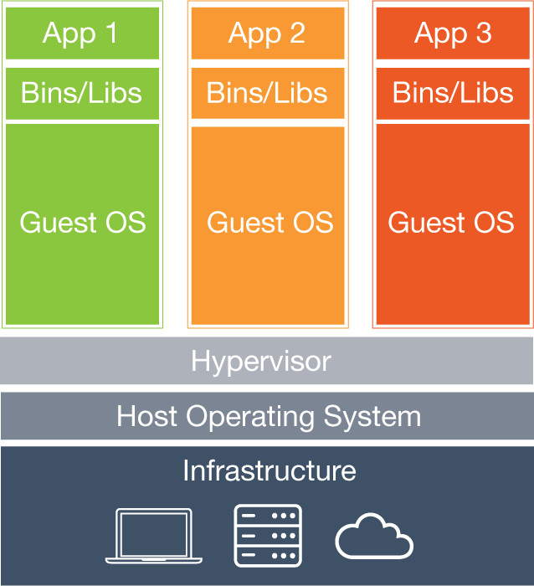
Now for comparison, here is the same stack containerized by Docker. Here you can see how each application does not get its own operating system. This is key to why Docker containers are so efficient. You’re not providing a virtual layer mimic the hardware, for the guest OS to use. And you’re not running n+1 guest hosts either.
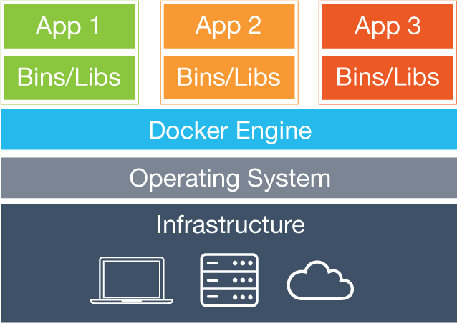
Clearly this is more efficient computing. I’ve seen estimates in the 10-25% range of improved performance. But like with everything else when it comes to computing performance – your mileage may vary. I’d expect lightweight Linux VMs to be closer to the 10% side of the scale, and Windows VMs probably closer to the 25% end of the scale – just because the Windows OS is so bloated in comparison.
This leads me to an important distinction about Docker – Linux only. Yes, you can “run” Docker on Windows and OSX – but at this time, you can only do so using a VM running in Virtual Box to run – a Linux VM.

Running Spring Boot in a Docker Container

Introduction
When I first heard about running Spring Boot in a Docker container, I personally thought – “now why would you want to run a JVM in a VM, on a VM?” At first glance, it just seemed like an absolutely terrible idea from a performance standpoint. I doubt if any of these solutions will ever match the performance of a JVM running on a bare metal installation of Linux. But, I’ve shown above, running a Spring Boot application in a Docker container should have minimal performance impact. Certainly less of an impact than running in a VM. Which is exactly what you’re doing running applications in any cloud provider (see image one above).

Installing Docker
I’m not going to get into installing Docker on your OS. There is ample documentation about installing Docker on the internet. Going forward, I’m going to assume you have Docker installed. Since Docker is Linux based, my focus will be on Linux (RHEL / CentOS).

Spring Boot Example Application
For the purposes of this tutorial, let’s start with a simple Spring Boot Application. I’m going to use the completed application from my Mastering Thymeleaf course. This is a simple Spring Boot web application which is perfect for our needs.
If you want to follow this tutorial along step by step, head over to GitHub and check out this Spring Boot project. Be sure to change to the branch “spring-boot-docker-start”.

Building a Spring Boot Docker Image
For us to run Spring Boot in a Docker container, we need to define a Docker image for it. Building Docker images is done through the use of “Dockerfile”s. Dockerfiles are basically a manifest of commands we will use to build and configure our docker container. To configure our Docker image to run our Spring Boot application, we will want to:
- Start with the latest CentOS image from Docker Hub.
- Install and configure Oracle Java.
- Install the Spring Boot artifact – our executable JAR file.
- Run the Spring Boot application.
I’m using CentOS for its compatibility with RHEL, which is probably the most popular Linux distribution used by enterprises. And Oracle’s Java, mainly for the same reason.

Create Our Dockerfile
In our Maven project, we need to create our Dockerfile. In /src/main/docker create the file Dockerfile .
NOTE: As a Java developer you may be tempted to create the file as DockerFile. Don’t do this. The Maven Plugin we cover later won’t see your file if it’s CamelCase. I learned this lesson the hard way.

CentOS
We’ll start our Docker image off by using the CentOS image from Docker hub.
FROM centos

Installing Oracle Java
The following lines in our dockerfile will install wget into the image using the yum package installer, download the Oracle Java JDK from Oracle using wget, then configure Java on the machine.

Dockerfile
ENV JAVA_VERSION 8u31
ENV BUILD_VERSION b13
# Upgrading system
RUN yum -y upgrade
RUN yum -y install wget
# Downloading & Config Java 8
RUN wget --no-cookies --no-check-certificate --header "Cookie: oraclelicense=accept-securebackup-cookie" "http://download.oracle.com/otn-pub/java/jdk/$JAVA_VERSION-$BUILD_VERSION/jdk-$JAVA_VERSION-linux-x64.rpm" -O /tmp/jdk-8-linux-x64.rpm
RUN yum -y install /tmp/jdk-8-linux-x64.rpm
RUN alternatives --install /usr/bin/java jar /usr/java/latest/bin/java 200000
RUN alternatives --install /usr/bin/javaws javaws /usr/java/latest/bin/javaws 200000
RUN alternatives --install /usr/bin/javac javac /usr/java/latest/bin/javac 200000

Installing the Spring Boot Executable Jar
In this section of the Dockerfile, we are:
- Adding a /tmp volume. Docker will map this to /var/lib/docker on the host system. This is the directory Spring Boot will configure Tomcat to use as its working directory.
- The ADD command adds the Spring Boot executable Jar into our Docker image.
- The RUN command is to ‘touch’ the JAR and give it a modified date.
- The ENTRY point is what will run the jar file when the container is started.
I learned about these configuration settings from a post from the Pivotal team here.

Dockerfile
ENV JAVA_VERSION 8u31
ENV BUILD_VERSION b13
# Upgrading system
RUN yum -y upgrade
RUN yum -y install wget
# Downloading & Config Java 8
RUN wget --no-cookies --no-check-certificate --header "Cookie: oraclelicense=accept-securebackup-cookie" "http://download.oracle.com/otn-pub/java/jdk/$JAVA_VERSION-$BUILD_VERSION/jdk-$JAVA_VERSION-linux-x64.rpm" -O /tmp/jdk-8-linux-x64.rpm
RUN yum -y install /tmp/jdk-8-linux-x64.rpm
RUN alternatives --install /usr/bin/java jar /usr/java/latest/bin/java 200000
RUN alternatives --install /usr/bin/javaws javaws /usr/java/latest/bin/javaws 200000
RUN alternatives --install /usr/bin/javac javac /usr/java/latest/bin/javac 200000

Complete Dockerfile
Here is the complete Dockerfile.

Dockerfile
FROM centos
ENV JAVA_VERSION 8u31
ENV BUILD_VERSION b13
# Upgrading system
RUN yum -y upgrade
RUN yum -y install wget
# Downloading & Config Java 8
RUN wget --no-cookies --no-check-certificate --header "Cookie: oraclelicense=accept-securebackup-cookie" "http://download.oracle.com/otn-pub/java/jdk/$JAVA_VERSION-$BUILD_VERSION/jdk-$JAVA_VERSION-linux-x64.rpm" -O /tmp/jdk-8-linux-x64.rpm
RUN yum -y install /tmp/jdk-8-linux-x64.rpm
RUN alternatives --install /usr/bin/java jar /usr/java/latest/bin/java 200000
RUN alternatives --install /usr/bin/javaws javaws /usr/java/latest/bin/javaws 200000
RUN alternatives --install /usr/bin/javac javac /usr/java/latest/bin/javac 200000
EXPOSE 8080
#install Spring Boot artifact
VOLUME /tmp
ADD /maven/sfg-thymeleaf-course-0.0.1-SNAPSHOT.jar sfg-thymeleaf-course.jar
RUN sh -c 'touch /sfg-thymeleaf-course.jar'
ENTRYPOINT ["java","-Djava.security.egd=file:/dev/./urandom","-jar","/sfg-thymeleaf-course.jar"]

Building the Docker Image Using Maven
Naturally, we could build our Docker image using docker itself. But this is not a typical use case for Spring developers. A typical use case for us would be to use Jenkins to generate the Docker image as part of a CI build. For this use case, we can use Maven to package the Spring Boot executable JAR, then have that build artifact copied into the Docker image.
There’s actually several competing Maven plugins for Docker support. The guys at Spotify have a nice Maven / Docker plugin. In this example, I’m going to show you how to use the Fabric8 Docker plugin for Maven.

Fabric8
Of the Maven plugins for Docker, at the time of writing, Fabric8 seems to be the most robust. For this post, I’m only interested in building a Docker Image for our Spring Boot artifact. This is just scratching the surface of the capabilities of the Fabric8 Maven plugin. This plugin can be used to spool up Docker Images to use for your integration tests for CI builds. How cool is that!?!? But let’s learn to walk before we run!
Here is a typical configuration for the Fabric8 Maven plugin for Docker.

Fabric8 Maven Docker Plugin Configuration
<plugin>
<groupId>io.fabric8</groupId>
<artifactId>docker-maven-plugin</artifactId>
<version>0.15.3</version>
<configuration>
<dockerHost>http://127.0.0.1:2375</dockerHost>
<verbose>true</verbose>
<images>
<image>
<name>springframeworkguru/masteringthymeleaf</name>
<build>
<dockerFile>Dockerfile</dockerFile>
<assembly>
<descriptorRef>artifact</descriptorRef>
</assembly>
</build>
</image>
</images>
</configuration>
</plugin>

If you’re following along in tutorial, the complete Maven POM now is:

pom.xml
<?xml version="1.0" encoding="UTF-8"?>
<project xmlns="http://maven.apache.org/POM/4.0.0" xmlns:xsi="http://www.w3.org/2001/XMLSchema-instance"
xsi:schemaLocation="http://maven.apache.org/POM/4.0.0 http://maven.apache.org/xsd/maven-4.0.0.xsd">
<modelVersion>4.0.0</modelVersion>
<groupId>guru.springframework</groupId>
<artifactId>sfg-thymeleaf-course</artifactId>
<version>0.0.1-SNAPSHOT</version>
<packaging>jar</packaging>
<name>sfg-thymeleaf-course</name>
<description>Thymeleaf Course</description>
<parent>
<groupId>org.springframework.boot</groupId>
<artifactId>spring-boot-starter-parent</artifactId>
<version>1.3.1.RELEASE</version>
<relativePath/> <!-- lookup parent from repository -->
</parent>
<properties>
<project.build.sourceEncoding>UTF-8</project.build.sourceEncoding>
<java.version>1.8</java.version>
</properties>
<dependencies>
<dependency>
<groupId>org.springframework.boot</groupId>
<artifactId>spring-boot-starter-thymeleaf</artifactId>
</dependency>
<dependency>
<groupId>org.springframework.boot</groupId>
<artifactId>spring-boot-starter-web</artifactId>
</dependency>
<dependency>
<groupId>org.springframework.boot</groupId>
<artifactId>spring-boot-devtools</artifactId>
</dependency>
<dependency>
<groupId>org.springframework.boot</groupId>
<artifactId>spring-boot-starter-security</artifactId>
</dependency>
<dependency>
<groupId>org.thymeleaf.extras</groupId>
<artifactId>thymeleaf-extras-springsecurity4</artifactId>
<version>2.1.2.RELEASE</version>
</dependency>
<!--testing deps-->
<dependency>
<groupId>org.springframework.boot</groupId>
<artifactId>spring-boot-starter-test</artifactId>
<scope>test</scope>
</dependency>
</dependencies>
<build>
<plugins>
<plugin>
<groupId>org.springframework.boot</groupId>
<artifactId>spring-boot-maven-plugin</artifactId>
</plugin>
<plugin>
<groupId>io.fabric8</groupId>
<artifactId>docker-maven-plugin</artifactId>
<version>0.15.3</version>
<configuration>
<dockerHost>http://127.0.0.1:2375</dockerHost>
<verbose>true</verbose>
<images>
<image>
<name>springframeworkguru/masteringthymeleaf</name>
<build>
<dockerFile>Dockerfile</dockerFile>
<assembly>
<descriptorRef>artifact</descriptorRef>
</assembly>
</build>
</image>
</images>
</configuration>
</plugin>
</plugins>
</build>
</project>

Building the Docker Image
To build the Docker image with our Spring Boot artifact run this command:
mvn clean packagedocker:build
The ‘clean’ tells Maven to delete the target directory. While this step is technically optional, if you don’t use it, sooner or later you’re going to get bit in the ass by some weird issue. Maven will always compile your classes with the package command. If you’ve done some refactoring and changed class names or packages, without the ‘clean’ the old class files are left on the disk. And in the words of IBM – “Unpredictable results may occur”.
It is very important to run the package command with the docker:build command. You’ll encounter errors if you try to run these in two separate steps.
While the Docker image is building, you will see the following output in the console:
[INFO] --- docker-maven-plugin:0.15.3:build (default-cli) @ sfg-thymeleaf-course ---
[INFO] Copying files to /home/john.thompson/src/springframework.guru/sfg-thymeleaf-course/target/docker/springframeworkguru/masteringthymeleaf/build/maven
[INFO] Building tar: /home/john.thompson/src/springframework.guru/sfg-thymeleaf-course/target/docker/springframeworkguru/masteringthymeleaf/tmp/docker-build.tar
[INFO] DOCKER> docker-build.tar: Created [springframeworkguru/masteringthymeleaf] in 686 milliseconds
[INFO] DOCKER> Step 1 : FROM centos
[INFO] DOCKER> ---> 904d6c400333
[INFO] DOCKER> Step 2 : ENV JAVA_VERSION 8u31
[INFO] DOCKER> ---> Using cache
[INFO] DOCKER> ---> 4eecb49f2d65
[INFO] DOCKER> Step 3 : ENV BUILD_VERSION b13
[INFO] DOCKER> ---> Using cache
[INFO] DOCKER> ---> 86732207b3a7
[INFO] DOCKER> Step 4 : RUN yum -y upgrade
[INFO] DOCKER> ---> Using cache
[INFO] DOCKER> ---> 3dc9f5aaaab9
[INFO] DOCKER> Step 5 : RUN yum -y install wget
[INFO] DOCKER> ---> Using cache
[INFO] DOCKER> ---> 7c6ea7db011d
[INFO] DOCKER> Step 6 : RUN wget --no-cookies --no-check-certificate --header "Cookie: oraclelicense=accept-securebackup-cookie" "http://download.oracle.com/otn-pub/java/jdk/$JAVA_VERSION-$BUILD_VERSION/jdk-$JAVA_VERSION-linux-x64.rpm" -O /tmp/jdk-8-linux-x64.rpm
[INFO] DOCKER> ---> Using cache
[INFO] DOCKER> ---> 46049829b569
[INFO] DOCKER> Step 7 : RUN yum -y install /tmp/jdk-8-linux-x64.rpm
[INFO] DOCKER> ---> Using cache
[INFO] DOCKER> ---> e41473085a2a
[INFO] DOCKER> Step 8 : RUN alternatives --install /usr/bin/java jar /usr/java/latest/bin/java 200000
[INFO] DOCKER> ---> Using cache
[INFO] DOCKER> ---> 0ea94f139d46
[INFO] DOCKER> Step 9 : RUN alternatives --install /usr/bin/javaws javaws /usr/java/latest/bin/javaws 200000
[INFO] DOCKER> ---> Using cache
[INFO] DOCKER> ---> d7297a64face
[INFO] DOCKER> Step 10 : RUN alternatives --install /usr/bin/javac javac /usr/java/latest/bin/javac 200000
[INFO] DOCKER> ---> Using cache
[INFO] DOCKER> ---> b8b1dbac3831
[INFO] DOCKER> Step 11 : EXPOSE 8080
[INFO] DOCKER> ---> Using cache
[INFO] DOCKER> ---> acbdc5e0cb38
[INFO] DOCKER> Step 12 : VOLUME /tmp
[INFO] DOCKER> ---> Using cache
[INFO] DOCKER> ---> 451ca0bd1715
[INFO] DOCKER> Step 13 : ADD /maven/sfg-thymeleaf-course-0.0.1-SNAPSHOT.jar sfg-thymeleaf-course.jar
[INFO] DOCKER> ---> 78fa04335365
[INFO] DOCKER> Removing intermediate container ee1881a8a140
[INFO] DOCKER> Step 14 : RUN sh -c 'touch /sfg-thymeleaf-course.jar'
[INFO] DOCKER> ---> Running in 1aabdb264d54
[INFO] DOCKER> ---> f8ac883ccd8c
[INFO] DOCKER> Removing intermediate container 1aabdb264d54
[INFO] DOCKER> Step 15 : ENTRYPOINT java -Djava.security.egd=file:/dev/./urandom -jar /sfg-thymeleaf-course.jar
[INFO] DOCKER> ---> Running in 6fc902be3c66
[INFO] DOCKER> ---> 03cc39512193
[INFO] DOCKER> Removing intermediate container 6fc902be3c66
[INFO] DOCKER> Successfully built 03cc39512193
[INFO] DOCKER> [springframeworkguru/masteringthymeleaf] : Built image sha256:03cc3
[INFO] ------------------------------------------------------------------------
[INFO] BUILD SUCCESS
[INFO] ------------------------------------------------------------------------
[INFO] Total time: 30.214s
[INFO] Finished at: Mon Jun 06 13:35:12 CDT 2016
[INFO] Final Memory: 34M/322M
[INFO] ------------------------------------------------------------------------
Docker images are built in layers. The CentOS image from Docker Hub is our first layer. Each command in our Dockerfile is another ‘layer’. Docker works by ‘caching’ these layers locally. I think of it as being somewhat like your local Maven repository under ~/.m2. Where Maven will bring down Java artifacts once then cache them for future use.
The first time you build this Docker image will take longer since all the layers are being downloaded / built. The next time we build this, the only layers that change are the one which adds the new Spring Boot artifact, all commands after this. The layers before the Spring Boot artifact aren’t changing, so the cached version will be used in the Docker build.

Running the Spring Boot Docker Image

Docker Run Command
So far, we have not said anything about port mapping. This is actually done at run time. When we start the Docker container, in the run command, we will tell Docker how to map the ports. In our example we want to map port 8080 of the host machine to port 8080 of the container. This is done with the ‘-p’ parameter, followed with <host port>:<container port>. We also want to use the ‘-d’ parameter. This tells Docker to start the container in the background.
Here is the complete command to run our docker container:
docker run-p8080:8080-dspringframeworkguru/masteringthymeleaf
This command will start the Docker container and echo the id of the started container.
Congratulations, your Spring Boot application is up and running!
You should now be able to access the application on port 8080 of your machine.

Working with Running Docker Containers

Viewing Running Docker Containers
To see all the containers running on your machine, use the following command:

View Log Output
Our running Docker containers are far from little black boxes. There’s a lot we can do with them. One common thing we want to do is see the log output. Easy enough. Use this command:
docker logs springframeworkguru/masteringthymeleaf

Access a Running Docker Container
Need to ssh into a Docker container? Okay, technically this really isn’t SSH, but this command will give you a bash:
sudo docker exec-it springframeworkguru/masteringthymeleaf bash

Stopping the Docker Container
Shutting down our Docker container is easy. Just run this command:
docker stop springframeworkguru/masteringthymeleaf

Ending Source Code
Just in case you’ve run into trouble, like always, I have a branch in GitHub with the complete working example. You can get the ending source code for this tutorial here on GitHub.

Conclusion
The default executable Jar artifact of Spring Boot is ideal for deploying Spring Boot applications in Docker. As I’ve shown here launching a Spring Boot application in a Docker container is easy to do.
In terms of technology, Docker is still fairly young. At the time of writing, Docker is only about three years old. Yet, it is rapidly catching on. While Docker is widely used by the web giants, it is just starting to trickle down to Fortune 500 enterprises. At the time of writing, Docker is not available natively on OSX or Windows. Yet. Microsoft has committed to releasing a native version of Docker for Windows. Which is interesting. A lot of things going on around Docker at Red Hat and Pivotal too.
Docker is a fundamental paradigm shift in the way we do things as Spring developers. I assure you, if you’re developing applications in the enterprise using the Spring Framework and have not used Docker, it’s not a matter of if, it is a when.
As a developer, Docker brings up some very cool opportunities. Need a Mongo database to work against? No problem, spool up a local Docker container. Need a virtual environment for your Jenkins CI builds. No problem.
I personally have only been working with Docker a short time. I am honestly excited about it. My thoughts on Docker – now we’re cooking with gas!
Microservices for Java, explained. Revitalize your legacy systems (and your career) with Reactive Microservices Architecture, a free O'Reilly book. Brought to you in partnership with Lightbend.

Like This Article? Read More From DZone
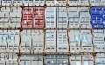Deploying Spring Boot Microservices with Containers and Kubernetes
Spring Boot Microservice Development on Kubernetes [Videos]
Docker 101 for Developers

Free Resource
Contexts and Dependency Injection for the Java EE Platform
Topics:

CONTAINER ,DOCKER CONTAINERS ,SPRING BOOT ,SPRING ,BOOT ,DOCKER HUB ,DOCKER
Like (3)

Comment (3)

Save

Tweet
11.71k Views
Published at DZone with permission of John Thompson, DZone MVB. See the original article here.
Opinions expressed by DZone contributors are their own.

Java Partner Resources
Estimate Your ROI Using the ValueStory for CA APM
CA Technologies

Modern Monitoring across Omnichannel, Microservices and Cloud
CA Technologies

How to Understand the Power of the Actor Model in Less than 1 hour (free O’Reilly eBook)
Lightbend

Easily Build Continuous Delivery Pipelines with Jenkins and Pipeline Plugin
CloudBees

8 Steps to Rocket-Powered Java Development
ZeroTurnaround

http://containertutorials.com/docker-compose/spring-boot-app.html

Container Tutorials
- ← Building Docker-Compose based MicroServices for a Flask Application
- Docker Security →
- Home

- MicroServices with Docker

Build a simple Spring Boot app with Docker
In this tutorial we will building a simple Spring Boot application which will run inside a docker container.

Required Software
- docker (1.6.0 or above)
- jdk 1.8
- Gradle 2.3+ or Maven 3.0+

Install the required software
$ sudo add-apt-repository ppa:webupd8team/java
$ sudo apt-get update
$ sudo apt-get install oracle-java8-installer
$ java -version
java version "1.8.0_45"
Java(TM) SE Runtime Environment (build 1.8.0_45-b14)
Java HotSpot(TM) 64-Bit Server VM (build 25.45-b02, mixed mode)
$ sudo apt-get install gradle
$ sudo apt-get install maven

Setup a Spring Boot App
The following project can be cloned from official git repository in order to run the basic example of spring boot application inside a container.
$git clone https://github.com/spring-guides/gs-spring-boot-docker.git

Spring Boot application
The java file can be found at following location;

src/main/java/hello/Application.java
package hello;

import org.springframework.boot.SpringApplication;
import org.springframework.boot.autoconfigure.SpringBootApplication;
import org.springframework.boot.bind.RelaxedPropertyResolver;
import org.springframework.web.bind.annotation.RequestMapping;
import org.springframework.web.bind.annotation.RestController;

@SpringBootApplication
@RestController
public class Application {

@RequestMapping("/")
public String home() {
return "Hello Docker World";
}

public static void main(String[] args) {
SpringApplication.run(Application.class, args);
}

}
The class is flagged as a @SpringBootApplication and as a @RestController, meaning it’s ready for use by Spring MVC to handle web requests. @RequestMapping maps / to the home() method which just sends a response back. The main() method uses Spring Boot’s SpringApplication.run() method to launch an application.

Containerize the Spring Boot application
We will containerize the above application using the DockerFile. The project JAR file is added to the container as “app.jar” and then executed in the ENTRYPOINT.We have added a VOLUME pointing to /tmp because it is where a Spring Boot application creates working directories for Tomcat by default.

Dockerfile
This file is needed to create a docker image;
FROM java:8
VOLUME /tmp
ADD gs-spring-boot-docker-0.1.0.jar app.jar
RUN bash -c 'touch /app.jar'
ENTRYPOINT ["java","-Djava.security.egd=file:/dev/./urandom","-jar","/app.jar"]

Build a Docker Image with Maven
The maven supports the docker plugin in order to build the docker image. The following three configurations are required in building the docker image either with maven or gradle.
- The image name (or tag)
- The directory in which to find the Dockerfile
- The resources (files) to copy from the target directory to the docker build (alongside the Dockerfile) - we only need the jar file in this example
The maven pom.xml should contain the following configuration;

pom.xml
<properties>
<docker.image.prefix>springio</docker.image.prefix>
</properties>
<build>
<plugins>
<plugin>
<groupId>com.spotify</groupId>
<artifactId>docker-maven-plugin</artifactId>
<version>0.2.3</version>
<configuration>
<imageName>${docker.image.prefix}/${project.artifactId}</imageName>
<dockerDirectory>src/main/docker</dockerDirectory>
<resources>
<resource>
<targetPath>/</targetPath>
<directory>${project.build.directory}</directory>
<include>${project.build.finalName}.jar</include>
</resource>
</resources>
</configuration>
</plugin>
</plugins>
</build>
Using the maven build the docker image
$ mvn package docker:build

Build a Dokcer image with Gradle
Even the gradle provides the plugin to build the docker image. The above mentioned 3 configurations are required to be provided in the build.gradle file

build.gradle
buildscript {
...
dependencies {
...
classpath('se.transmode.gradle:gradle-docker:1.2')
}
}

group = 'springio'

...
apply plugin: 'docker'

task buildDocker(type: Docker, dependsOn: build) {
push = true
applicationName = jar.baseName
dockerfile = file('src/main/docker/Dockerfile')
doFirst {
copy {
from jar
into stageDir
}
}
}
Using the gradle build the docker image
$ ./gradlew build buildDocker

Run the Spring Boot App container
Now just execute the following command in order to run the containerized application;
$ docker images
REPOSITORY TAG IMAGE ID CREATED VIRTUAL SIZE
gregturn/gs-spring-boot-docker latest 3e70f57df702 21 hours ago 841.4 MB
$ docker run -p 8080:8080 -t gregturn/gs-spring-boot-docker
The application is now available and can be accessed at the address http://localhost:8080.

Reference

