http://www.dineshonjava.com/2017/01/microservices-with-spring-boot.html#1

 | - Home  - Core Java  - Java Interview Questions  - Getting Started  - Java Basics  - Java Object Oriented  - Exception Handling  - Inner Classes  - Java Collections  - Java Threads  - Spring  - Spring Core  - Spring MVC  - Spring AOP  - Spring Security  - Spring Batch  - Spring 4.X.X  - Spring Mobile  - Spring HATEOAS  - Interview Questions  - Spring Boot  - Microservices  - Hibernate  - Hibernate 4  - Struts 2  - J2EE  - JSP  - Servlet  - JSTL  - JDBC  - JAXB  - Java Mail API  - Web Services  - JAX-WS (SOAP)  - JAX-RS (REST)  - WSDL  - SOAP  - WS Interview Questions  - Hadoop  - Design Patterns  - Creational Patterns  - Structural Patterns  - Behavioral Patterns  - J2EE Patterns  - Maven  - Gradle  - Ant  - MongoDB  - Training  - More  - Cloud Computing  - Thymeleaf  - AJAX  - Linux Cron Job  - Who is Who  - Computer Glossary  - Eclipse Shortcuts  - Who I AM

Microservices with Spring Boot
Posted by Dinesh Rajput
In this Microservices with Spring Boot tutorial we will discuss about to creating a microservices with spring and will see microservices architecture. Microservices allow large systems to be built up from a number of collaborating components. Microservices allows to do loose coupling between application processes in stead of loose coupling between application components as Spring does.
Table of Contents
- Introduction
  - What is Microservices Architecture?
  - Without Microservices
  - With Microservices
- Microservices Benefits
- Microservices Challenges
- Microservices Infrastructure
- Microservices Tooling Supports
  - Spring
    - Spring Boot
  - Spring Cloud
    - Eureka by Netflix
- Developing Simple Microservices Example
  - Creating Discovery Service
  - Creating MicroService (the Producer)
  - Create Microservice Consumers
- Summary
1. Introduction
Microservices is not a new term. It coined in 2005 by Dr Peter Rodgers then called micro web services based on SOAP. It became more popular since 2010. Micoservices allows us to break our large system into number of independent collaborating processes. Lets see below microservices architecture.
1.1 What is Microservices Architecture?
Microservices architecture allows to avoid monolith application for large system. It provide loose coupling between collaborating processes which running independently in different environments with tight cohesion. So lets discuss it by an example as below.
For example imagine an online shop with separate microservices for user-accounts, product-catalog order-processing and shopping carts. So these components are inevitably important for such a large online shopping portal. For online shopping system we could use following architectures.
1.2 Shopping system without Microservices (Monolith architecture)
In this architecture we are using Monolith architecture i.e. all collaborating components combine all in one application.
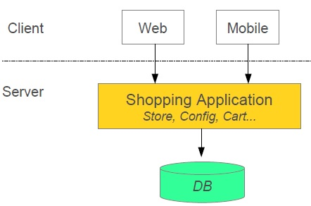
1.3 Shopping system with Microservices
In this architecture style the main application divided in a set of sub applications called microservices. One large Application divided into multiple collaborating processes as below.
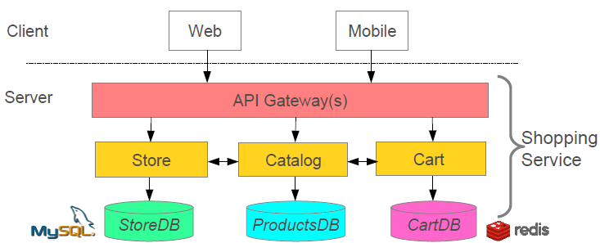
Spring enables separation-of-concerns
- Loose Coupling- Effect of changes isolated
- Tight Cohesion- Code perform a single well defined task
Microservices provide the same strength as Spring provide
- Loose Coupling- Application build from collaboration services or processes, so any process change without effecting another processes.
- Tight Cohesion-An individual service or process that deals with a single view of data.
There are a number of moving parts that you have to setup and configure to build such a system. For implementing this system is not too obvious you have to knowledge about spring boot, spring cloud and Netflix. In this post I will discuss one example for this architecture before the example lets first discuss about pros and cons of microservices architecture.
2. Microservices Benefits
- Smaller code base is easy to maintain.
- Easy to scale as individual component.
- Technology diversity i.e. we can mix libraries, databases, frameworks etc.
- Fault isolation i.e. a process failure should not bring whole system down.
- Better support for smaller and parallel team.
- Independent deployment
- Deployment time reduce
3. Microservices Challenges
- Difficult to achieve strong consistency across services
- ACID transactions do not span multiple processes.
- Distributed System so hard to debug and trace the issues
- Greater need for end to end testing
- Required cultural changes in across teams like Dev and Ops working together even in same team.
4. Microservices Infrastructure
- Platform as a Service like Pivotal Cloud Foundry help to deployment, easily run, scale, monitor etc.
- It support for continuous deployment, rolling upgrades fo new versions of code, running multiple versions of same service at same time.
5. Microservices Tooling Supports
5.1 Using Spring for creating Microservices
- Setup new service by using Spring Boot
- Expose resources via a RestController
- Consume remote services using RestTemplate
5.2 Adding Spring Cloud and Discovery server
What is Spring Cloud?
- It is building blocks for Cloud and Microservices
- It provides microservices infrastructure like provide use services such as Service Discovery, Configuration server and Monitoring.
- It provides several other open source projects like Netflix OSS.
- It provides PaaS like Cloud Foundry, AWS and Heroku.
- It uses Spring Boot style starters
There are many use-cases supported by Spring Cloud like Cloud Integration, Dynamic Reconfiguration, Service Discovery, Security,Client side Load Balancing etc. But in this post we concentrate on following microservices support
- Service Discovery (How do services find each other?)
- Client-side Load Balancing (How do we decide which service instance to use?)
Service Discovery
Problem without discovery
- How do services find each other?
- What happens if we run multiple instances for a service

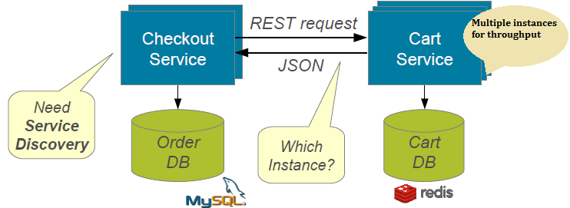
Resolution with service discovery

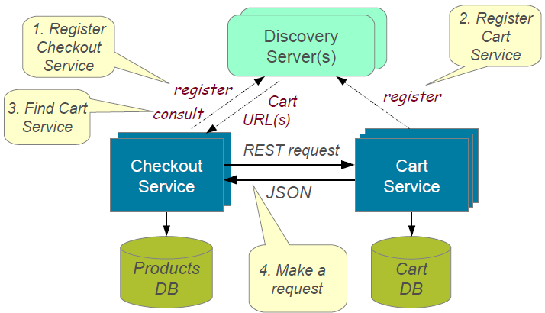
Implementing Service Discovery
Spring Cloud support several ways to implement service discovery but for this I am going to use Eureka created by Netflix. Spring Cloud provide several annotation to make it use easy and hiding lots of complexity.
Client-side Load Balancing
Each service typically deployed as multiple instances for fault tolerance and load sharing. But there is problem how to decide which instance to use?
Implementing Client-Side Load Balancing
We will use Netflix Ribbon, it provide several algorithm for Client-Side Load Balancing. Spring provide smart RestTemplate for service discovery and load balancing by using @LoadBalanced annotation with RestTemplate instance.
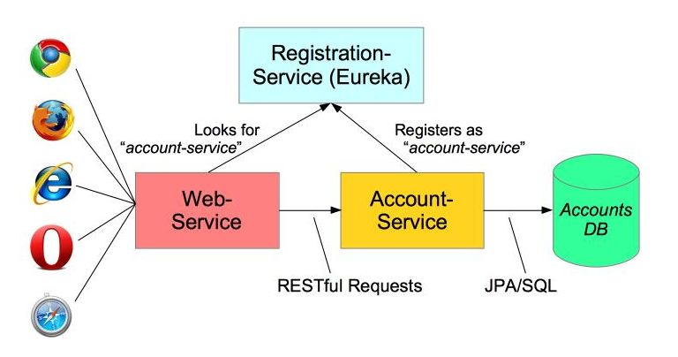
@ImageSource-Spring.io
6. Developing Simple Microservices Example
For build a simple microservices system following steps required
- Creating Discovery Service (Creating Eureka Discovery Service)
- Creating MicroService (the Producer)
  - Register itself with Discovery Service with logical service.
- Create Microservice Consumers find Service registered with Discovery Service
  - Discovery client using a smart RestTemplate to find microservice.
Maven Dependencies
- <dependencies>
- <dependency>
- <groupId>org.springframework.cloud</groupId>
- <artifactId>spring-cloud-starter</artifactId>
- </dependency>
- <dependency>
- <groupId>org.springframework.cloud</groupId>
- <artifactId>spring-cloud-starter-eureka</artifactId>
- </dependency>
- <dependency>
- <groupId>org.springframework.boot</groupId>
- <artifactId>spring-boot-starter-web</artifactId>
- </dependency>

- <dependency>
- <groupId>org.hsqldb</groupId>
- <artifactId>hsqldb</artifactId>
- <scope>runtime</scope>
- </dependency>
- <dependency>
- <groupId>org.springframework.boot</groupId>
- <artifactId>spring-boot-starter-test</artifactId>
- <scope>test</scope>
- </dependency>
- </dependencies>
Step 1: Creating Discovery Service (Creating Eureka Discovery Service)
- Eureka Server using Spring Cloud
- We need to implement our own registry service as below.

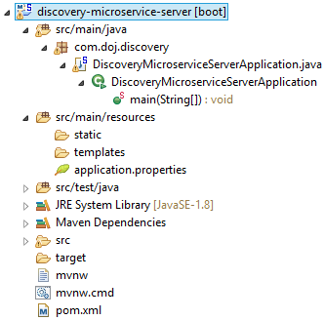
application.yml
- # Configure this Discovery Server
- eureka:
- instance:
- hostname: localhost
- client: #Not a client
- registerWithEureka: false
- fetchRegistry: false

- # HTTP (Tomcat) port
- server:
- port: 1111
DiscoveryMicroserviceServerApplication.java
- package com.doj.discovery;

- import org.springframework.boot.SpringApplication;
- import org.springframework.boot.autoconfigure.SpringBootApplication;
- import org.springframework.cloud.netflix.eureka.server.EnableEurekaServer;

- @SpringBootApplication
- @EnableEurekaServer
- public class DiscoveryMicroserviceServerApplication {

- public static void main(String[] args) {
- SpringApplication.run(DiscoveryMicroserviceServerApplication.class, args);
- }
- }
pom.xml
- <!-- Eureka registration server -->
- <dependency>
- <groupId>org.springframework.cloud</groupId>
- <artifactId>spring-cloud-starter-eureka-server</artifactId>
- </dependency>
For Whole Source Code for the Discover Server Application you could download from github as below link.
discovery-microservice-server
Run this Eureka Server application with right click and run as Spring Boot Application and open in browser http://localhost:1111/
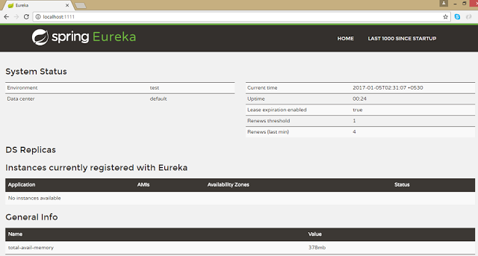
Step 2: Creating Account Producer MicroService
Microservice declares itself as an available service and register to Discovery Server created in Step 1.
- Using @EnableDiscoveryClient
- Registers using its application name
Lets see the service producer application structure as below.
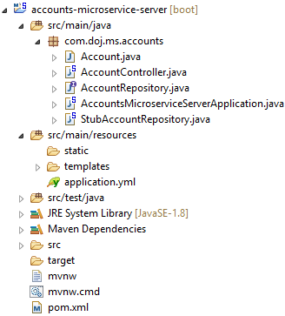
application.yml
- ### Spring properties
- # Service registers under this name
- spring:
- application:
- name: accounts-microservice

- # Discovery Server Access
- eureka:
- client:
- serviceUrl:
- defaultZone: http://localhost:1111/eureka/

- # HTTP Server (Tomcat) Port
- server:
- port: 2222

- # Disable Spring Boot's "Whitelabel" default error page, so we can use our own
- error:
- whitelabel:
- enabled: false
AccountsMicroserviceServerApplication.java
- package com.doj.ms.accounts;

- import org.springframework.boot.SpringApplication;
- import org.springframework.boot.autoconfigure.SpringBootApplication;
- import org.springframework.cloud.client.discovery.EnableDiscoveryClient;

- @SpringBootApplication
- @EnableDiscoveryClient
- public class AccountsMicroserviceServerApplication {

- public static void main(String[] args) {
- SpringApplication.run(AccountsMicroserviceServerApplication.class, args);
- }

- }
pom.xml
- <dependencies>
- <dependency>
- <groupId>org.springframework.cloud</groupId>
- <artifactId>spring-cloud-starter</artifactId>
- </dependency>
- <dependency>
- <groupId>org.springframework.cloud</groupId>
- <artifactId>spring-cloud-starter-eureka</artifactId>
- </dependency>
- <dependency>
- <groupId>org.springframework.boot</groupId>
- <artifactId>spring-boot-starter-web</artifactId>
- </dependency>

- </dependencies>
Other required source files related to this application you could download from github link as given below
accounts-microservice-server
Now run this account service application as Spring Boot application and after few seconds refresh browser to the home page of Eureka Discovery Server at http://localhost:1111/ in previous Step 1. Now one Service registered to the Eureka registered instances with Service Name "ACCOUNT-MICROSERVICE" as below
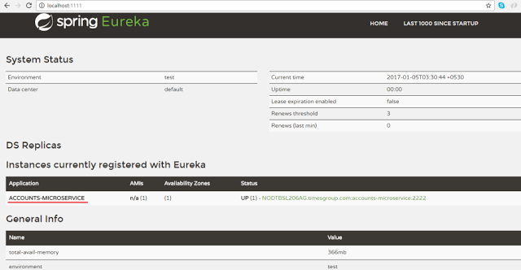
Step 3: Consumer Service
- Create Consumers to find the Producer Service registered with Discovery Service at Step 1.
- @EnableDiscoveryClient annotation also allows us to query Discovery server to find miroservices.
Lets see the consumer application structure as below.
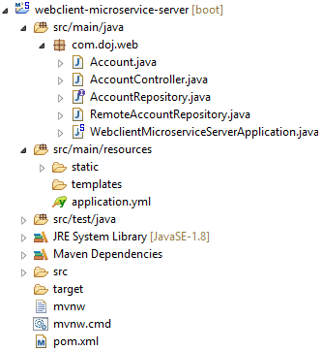
application.yml
- # Service registers under this name
- # Control the InternalResourceViewResolver:
- spring:
- application:
- name: accounts-web
- mvc:
- view:
- prefix: /WEB-INF/views/
- suffix: .jsp

- # Discovery Server Access
- eureka:
- client:
- serviceUrl:
- defaultZone: http://localhost:1111/eureka/

- # Disable Spring Boot's "Whitelabel" default error page, so we can use our own
- error:
- whitelabel:
- enabled: false
WebclientMicroserviceServerApplication.java
- package com.doj.web;

- import org.springframework.boot.SpringApplication;
- import org.springframework.boot.autoconfigure.SpringBootApplication;
- import org.springframework.cloud.client.discovery.EnableDiscoveryClient;
- import org.springframework.cloud.client.loadbalancer.LoadBalanced;
- import org.springframework.context.annotation.Bean;
- import org.springframework.web.client.RestTemplate;

- @SpringBootApplication
- @EnableDiscoveryClient
- public class WebclientMicroserviceServerApplication {

- public static final String ACCOUNTS_SERVICE_URL = "http://ACCOUNTS-MICROSERVICE";

- public static void main(String[] args) {
- SpringApplication.run(WebclientMicroserviceServerApplication.class, args);
- }

- @Bean
- @LoadBalanced
- public RestTemplate restTemplate() {
- return new RestTemplate();
- }
- @Bean
- public AccountRepository accountRepository(){
- return new RemoteAccountRepository(ACCOUNTS_SERVICE_URL);
- }
- }
pom.xml
- <dependencies>
- <dependency>
- <groupId>org.springframework.cloud</groupId>
- <artifactId>spring-cloud-starter-eureka</artifactId>
- </dependency>
- <dependency>
- <groupId>org.springframework.cloud</groupId>
- <artifactId>spring-cloud-starter-ribbon</artifactId>
- </dependency>
- <dependency>
- <groupId>org.springframework.boot</groupId>
- <artifactId>spring-boot-starter-web</artifactId>
- </dependency>
- <dependency>
- <groupId>org.springframework.boot</groupId>
- <artifactId>spring-boot-starter-actuator</artifactId>
- </dependency>
- <dependency>
- <groupId>org.springframework.boot</groupId>
- <artifactId>spring-boot-starter-test</artifactId>
- <scope>test</scope>
- </dependency>
- <!-- These dependencies enable JSP usage -->
- <dependency>
- <groupId>org.apache.tomcat.embed</groupId>
- <artifactId>tomcat-embed-jasper</artifactId>
- <scope>provided</scope>
- </dependency>
- <dependency>
- <groupId>javax.servlet</groupId>
- <artifactId>jstl</artifactId>
- </dependency>
- </dependencies>
Other required source files related to this application you could download from github link as given below
webclient-microservice-server
Now run this consumer service application as Spring Boot application and after few seconds refresh browser to the home page of Eureka Discovery Server at http://localhost:1111/ in previous Step 1. Now one more Service registered to the Eureka registered instances with Service Name "ACCOUNTS-WEB" as below
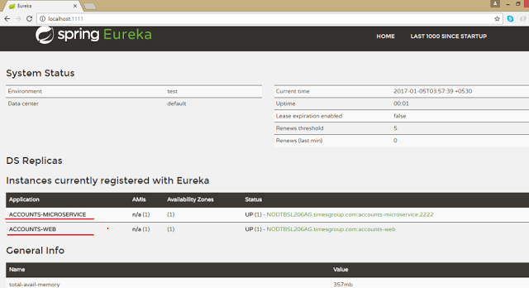
Lets our consumer consume the service of producer registered at discovery server.
- package com.doj.web;

- import java.util.Arrays;
- import java.util.List;

- import org.springframework.beans.factory.annotation.Autowired;
- import org.springframework.web.client.RestTemplate;

- /**
- * @author Dinesh.Rajput
- *
- */
- public class RemoteAccountRepository implements AccountRepository {

- @Autowired
- protected RestTemplate restTemplate;

- protected String serviceUrl;

- public RemoteAccountRepository(String serviceUrl) {
- this.serviceUrl = serviceUrl.startsWith("http") ? serviceUrl
- : "http://" + serviceUrl;
- }

- @Override
- public List<Account> getAllAccounts() {
- Account[] accounts = restTemplate.getForObject(serviceUrl+"/accounts", Account[].class);
- return Arrays.asList(accounts);
- }

- @Override
- public Account getAccount(String number) {
- return restTemplate.getForObject(serviceUrl + "/accounts/{id}",
- Account.class, number);
- }

- }
Lets open web application which is a consumer of the account microservice registered at Eureka Discovery Server.
http://localhost:8080/ as below
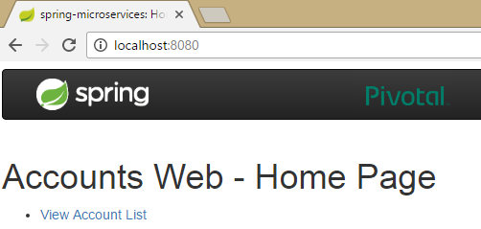
Now click on View Account List then fetch all accounts from account microservice.
http://localhost:8080/accountList
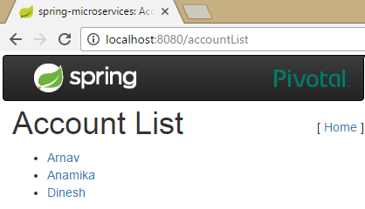
Now click on any account from the list of accounts to fetch the details of account for account number from account microservice.
http://localhost:8080/accountDetails?number=5115
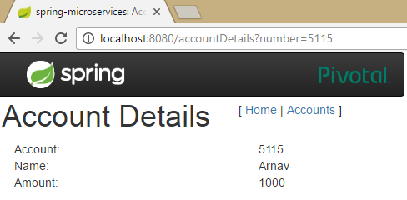
Load Balanced RestTemplate
Create using @LoadBalanced- Spring enhances it to service lookup & load balancing
- @Bean
- @LoadBalanced
- public RestTemplate restTemplate() {
- return new RestTemplate();
- }
Must inject using same qualifier-
- If there are multiple RestTemplate you get the right one.
- It can used to access multiple microservices

- @Autowired
- @LoadBalanced
- protected RestTemplate restTemplate;
Load Balancing with Ribbon
Our smart RestTemplate automatically integrates two Netflix utilities
- Eureka Service Discovery
- Ribbon Client Side Load Balancer
Eureka return the URL of all available instances
Ribbon determine the best available service too use
Just inject the load balanced RestTemplate automatic lookup by logical service-name
7. Summary
After completion of this article you should have learned:
- What is the MicroServices Architecture
- Advantages and Challenges of MicroServices
- And some information about Spring Cloud such as Eureka Discover Server by Netflix and Ribbon.
Mock Questions for Spring Certification
Spring Exam Simulator
You might also like:

Spring Boot Tutorial-Introduction to Spring Boot

Working with SQL Databases in Spring Boot Application

Spring Data JPA using Spring Boot Application

Spring Security Tutorial using Spring Boot

Developing your first Spring Boot application Hello World

Linkwithin

Newer PostOlder PostHome

LABELS
- About My Professional Life (1)
- AJAX (4)
- Ant (11)
- cloud computing (17)
- collection (18)
- Core JAVA (77)
- Core Java Interview Questions (13)
- Garbage Collection (2)
- GitHub (3)
- Gradle (3)
- Hadoop (14)
- Hibernate (14)
- hibernate4 (4)
- interview questions (33)
- Java (4)
- Java Code Best Practices (2)
- JavaMail (14)
- JAXB (4)
- JDBC (1)
- JSP (29)
- JSTL (44)
- Linux (2)
- Logging (2)
- maven (12)
- Microservices (3)
- migration (1)
- mongodb (18)
- motivational (1)
- multithreading (16)
- REST (24)
- Security (1)
- Servlet (26)
- SOAP (9)
- Spring 5 (1)
- Spring AOP (24)
- Spring Batch (17)
- Spring Batch3 (1)
- Spring Boot (22)
- Spring HATEOAS (1)
- Spring Mobile (1)
- Spring MVC (28)
- Spring MVC interview questions (8)
- Spring REST (6)
- Spring3.0 (104)
- Spring4 (36)
- SpringSecurity (17)
- String in Java (40)
- struts2 (49)
- thymeleaf (1)
- UDDI (1)
- WebService (15)
- WSDL (9)
8143938

ADS

MENU
- ▼ 2017 (65)
  - April (2)
  - March (19)
  - February (31)
  - January (13)
- ► 2016 (60)
- ► 2015 (11)
- ► 2014 (89)
- ► 2013 (352)
- ► 2012 (85)

POPULAR POSTS
- 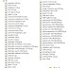
Spring MVC Hibernate Integration CRUD Example Step by Step
In this example show how to write a simple web based application with CRUD operation using Spring3 MVC Framwork with Hibernate3 using Annot...
- 
Core JAVA Tutorial - Core JAVA a Baby Step to be a Best Java ian
Hello Friends, Now we will focused on the Core Java tutorial, it is really a baby step to be a good, better and best Java ian :-) . I mean...
- 
Spring Tutorial - A Baby Step to Learn
In this series of spring tutorial, it’s provides many step by step examples and explanations on using Spring framework. The Spring framewo...
- 
Spring Security Tutorial- Learn Step to Secure Web
In this spring security tutorial we will discuss about some of the security tips about the Spring Framework. Spring Security is a powerful...
- 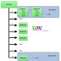
How does java Hashmap work internally
What is Hashing? Hashing in its simplest form, is a way to assigning a unique code for any variable/object after applying any formula/algor...
- REST and SOAP Web Service Interview Questions
In this interview questions tutorial we will explain most asking interviews questions on the web services like SOAP, REST etc and its protoc...
- 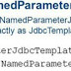
NamedParameterJdbcTemplate in Spring with Example
The NamedParameterJdbcTemplate class helps you specify the named parameters inste a d of classic placeholder('?') argument. Named pa...
- 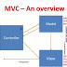
Spring MVC Tutorial with Examples
Model view controller is a software architecture design pattern. It provides solution to layer an application by separating three concerns...
- 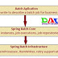
Spring Batch Tutorial - Introduction Get Best Examples
Hi In this spring batch tutorial I will discuss about one of the excellent feature of Spring Framework name Spring Batch. Spring Batch is a ...
- 
Learn with Best Hibernate Tutorial for Beginners
This hibernate tutorial provide step by step instructions on using Hibernate 3.0. Hibernate is popular open source object relational ma...
Share to Facebook
, Number of shares10
Share to TwitterShare to PrintShare to EmailMore AddThis Share options
, Number of shares257
SHARES
Follow

Follow

https://dzone.com/articles/spring-boot-creating

Spring Boot: Creating Microservices on Java

Learn all about creating a microservices architecture on Java in this great tutorial.
 by
Alexandre Lourenco
·
Dec. 29, 14 · Integration Zone
Like (11)

Comment (9)

Save

Tweet
72.93k Views
Join the DZone community and get the full member experience.
JOIN FOR FREE
Build APIs from SQL and NoSQL or Salesforce data sources in seconds. Read the Creating REST APIs white paper, brought to you in partnership with CA Technologies.
Welcome, reader. In this article, we will talk about an interesting architectural model, microservices architecture, in addition to studying one of the new features of Spring 4.0, Spring Boot. But after all, what are microservices?
Microservices
In the development of large systems, it is common to develop various components and libraries that implement various functions, ranging from the implementation of business requirements to technical tasks, such as an XML parser, for example. In these scenarios, several components are reused by different interfaces and / or systems. Imagine, for example, a component that implements a register of customers and we package this component in a java project, which generates his deliverable as a .jar.
In this scenario, we could have several interfaces to use this component, such as web applications, mobile, EJBs, etc. In the traditional form of Java implementation, we would package this jar in several other packages, such as EAR files, WAR, etc. Imagine now that a problem in the customer register is found. In this scenario, we have a considerable operational maintenance work, since as well as the correction on the component, we would have to make the redeploy of all consumer applications due to the component to be packaged inside the other deployment packages.
In order to propose a solution to this issue, was born microservices architecture model. In this architectural model, rather than package the jar files into consumer systems, the components are independently exposed in the form of remote accessible APIs, consumed using protocols such as HTTP, for example.
An important point to note in the above explanations, is that although we are exemplifying the model using the Java world, the same principles can be applied to other technologies such as C #.
Spring Boot
Among the new features in version 4.0 of the Spring Framework, a new project that has arisen is the Spring Boot.O goal of Spring Boot is to provide a way to provide Java applications quickly and simply, through an embedded server - by default it uses an embedded version of tomcat - thus eliminating the need of Java EE containers. With Spring Boot, we can expose components such as REST services independently, exactly as proposed in microservices architecture, so that in any maintenance of the components, we no longer make the redeploy of all the system.
So without further delay, let's begin our hands-on. For this lab, we will use the Eclipse Luna and Maven 3.
To illustrate the concept of microservices, we will create 3 Maven projects in this hands-on: each of them will symbolize back-end functionality, ie reusable APIs, and one of them held a composition, that is, will be a consumer of the other 2.
To begin, let's create 3 simple Maven projects without defined archetype, and let's call them Product-backend, Customer-backend and Order-backend. In the poms of the 3 projects, we will add the dependencies for the creation of our REST services and startup Spring Boot, as we can see below:
.
.
.
<parent>
<groupId>org.springframework.boot</groupId>
<artifactId>spring-boot-starter-parent</artifactId>
<version>1.2.0.RELEASE</version>
</parent>
<dependencies>
<dependency>
<groupId>org.springframework.boot</groupId>
<artifactId>spring-boot-starter-web</artifactId>
</dependency>
<dependency>
<groupId>org.springframework.boot</groupId>
<artifactId>spring-boot-starter-jersey</artifactId>
</dependency>
</dependencies>
.
.
.
With the dependencies established, we start coding. The first class that we create, that we call Application, will be identical in all three projects, because it only works as an initiator to Spring Boot - as defined by @SpringBootApplication annotation - rising a Spring context and the embedded server:
package br.com.alexandreesl.handson;
import org.springframework.boot.SpringApplication;
import org.springframework.boot.autoconfigure.SpringBootApplication;
@SpringBootApplication
public class Application {
public static void main(String[] args) {
SpringApplication.run(Aplication.class, args);
}
}
The next class we will see is the ApplicationConfig. In this class, which uses the @Configuration Spring annotation to indicate to the framework that it is a resource configuration class, we set the Jersey, which is our ResourceManager responsible for exposing REST services for the consumers.
In a real application, this class would be also creating datasources for access to databases and other resources, but in order to keep it simple enough to be able to focus on the Spring Boot, we will use mocks to represent the data access.
package br.com.alexandreesl.handson;
import javax.inject.Named;
import org.glassfish.jersey.server.ResourceConfig;
import org.springframework.context.annotation.Configuration;
@Configuration
public class ApplicationConfig {
@Named
static class JerseyConfig extends ResourceConfig {
public JerseyConfig() {
this.packages(“br.com.alexandreesl.handson.rest”);
}
}
}
The above class will be used identically in the projects relating to customers and products. For the orders, however, since it will be a consumer of other services, we will use this class with a slight difference, as we will also instantiate a RestTemplate. This class, one of the new features in the Spring Framework, is a standardized and very simple interface that facilitates the consumption of REST services. The class to use in the Order-backend project can be seen below:
package br.com.alexandreesl.handson;
import javax.inject.Named;
import org.glassfish.jersey.server.ResourceConfig;
import org.springframework.context.annotation.Bean;
import org.springframework.context.annotation.Configuration;
import org.springframework.web.client.RestTemplate;
@Configuration
public class ApplicationConfig {
@Named
static class JerseyConfig extends ResourceConfig {
public JerseyConfig() {
this.packages(“br.com.alexandreesl.handson.rest”);
}
}
@Bean
public RestTemplate restTemplate() {
RestTemplate restTemplate = new RestTemplate();
return restTemplate;
}
}
Finally, we will start the implementation of the REST services themselves. In the project responsible for customer features (Customer-backend), we create a class of DTO and a REST service. The class, which is a simple POJO:
package br.com.alexandreesl.handson.rest;
public class Customer {
private long id;
private String name;
private String email;
public long getId() {
return id;
}
public void setId(long id) {
this.id = id;
}
public String getName() {
return name;
}
public void setNome(String name) {
this.name = name;
}
public String getEmail() {
return email;
}
public void setEmail(String email) {
this.email = email;
}
}
The REST service, in turn, has only 2 capabilities, a search of all customers and other that query a customer from his id:
package br.com.alexandreesl.handson.rest;
import java.util.ArrayList;
import java.util.List;
import javax.inject.Named;
import javax.ws.rs.GET;
import javax.ws.rs.Path;
import javax.ws.rs.Produces;
import javax.ws.rs.QueryParam;
import javax.ws.rs.core.MediaType;
@Named
@Path(“/”)
public class CustomerRest {
private static List<Customer> Customers = new ArrayList<Customer>();
static {
Customer customer1 = new Customer();
customer1.setId(1);
customer1.setNome(“Customer 1″);
customer1.setEmail(“customer1@gmail.com”);
Customer customer2 = new Customer();
customer2.setId(2);
customer2.setNome(“Customer 2″);
customer2.setEmail(“Customer2@gmail.com”);
Customer customer3 = new Customer();
customer3.setId(3);
customer3.setNome(“Customer 3″);
customer3.setEmail(“Customer3@gmail.com”);
Customer customer4 = new Customer();
customer4.setId(4);
customer4.setNome(“Customer 4″);
customer4.setEmail(“Customer4@gmail.com”);
Customer customer5 = new Customer();
customer5.setId(5);
customer5.setNome(“Customer 5″);
customer5.setEmail(“Customer5@gmail.com”);
customers.add(customer1);
customers.add(customer2);
customers.add(customer3);
customers.add(customer4);
Customers.add(customer5);
}
@GET
@Produces(MediaType.APPLICATION_JSON)
public List<Customer> getCustomers() {
return customers;
}
@GET
@Path(“customer”)
@Produces(MediaType.APPLICATION_JSON)
public Customer getCustomer(@QueryParam(“id”) long id) {
Customer cli = null;
for (Customer c : customers) {
if (c.getId() == id)
cli = c;
}
return cli;
}
}
And that concludes our REST customers service. For products, analogous to customers, we have the methods to search all products or a product through one of his ids and finally we have the orders service, which through a submitOrder method gets the data of a product and a customer - whose keys are passed as parameters to the method - and returns a order header. The classes that make up our services are the following:
package br.com.alexandreesl.handson.rest;
public class Product {
private long id;
private String sku;
private String description;
public long getId() {
return id;
}
public void setId(long id) {
this.id = id;
}
public String getSku() {
return sku;
}
public void setSku(String sku) {
this.sku = sku;
}
public String getDescription() {
return description;
}
public void setDescription(String description) {
this.description = description;
}
}
package br.com.alexandreesl.handson.rest;
import java.util.ArrayList;
import java.util.List;
import javax.inject.Named;
import javax.ws.rs.GET;
import javax.ws.rs.Path;
import javax.ws.rs.Produces;
import javax.ws.rs.QueryParam;
import javax.ws.rs.core.MediaType;
@Named
@Path(“/”)
public class ProductRest {
private static List<Product> products = new ArrayList<Product>();
static {
Product product1 = new Product();
product1.setId(1);
product1.setSku(“abcd1″);
product1.setDescricao(“Product1″);
Product product2 = new Product();
product2.setId(2);
product2.setSku(“abcd2″);
product2.setDescricao(“Product2″);
Product product3 = new Product();
product3.setId(3);
product3.setSku(“abcd3″);
product3.setDescricao(“Product3″);
Product product4 = new Product();
product4.setId(4);
product4.setSku(“abcd4″);
product4.setDescricao(“Product4″);
products.add(product1);
products.add(product2);
products.add(product3);
products.add(product4);
}
@GET
@Produces(MediaType.APPLICATION_JSON)
public List<Product> getProducts() {
return products;
}
@GET
@Path(“product”)
@Produces(MediaType.APPLICATION_JSON)
public Product getProduct(@QueryParam(“id”) long id) {
Product prod = null;
for (Product p : products) {
if (p.getId() == id)
prod = p;
}
return prod;
}
}
Finally, the classes that make up our aforementioned order service in the Order-backend project are:
package br.com.alexandreesl.handson.rest;
import java.util.Date;
public class Order {
private long id;
private long amount;
private Date dateOrder;
private Customer customer;
private Product product;
public long getId() {
return id;
}
public void setId(long id) {
this.id = id;
}
public long getAmount() {
return amount;
}
public void setAmount(long amount) {
this.amount = amount;}
public Date getDateOrder() {
return dateOrder;
}
public void setDateOrder(Date dateOrder) {
this.dateOrder = dateOrder;
}
public Customer getCustomer() {
return customer;
}
public void setCustomer(Customer customer) {
this.customer = customer;
}
public Product getProduct() {
return product;
}
public void setProduct(Product product) {
this.product = product;
}
}
package br.com.alexandreesl.handson.rest;
import java.util.Date;
import javax.inject.Inject;
import javax.inject.Named;
import javax.ws.rs.GET;
import javax.ws.rs.Path;
import javax.ws.rs.Produces;
import javax.ws.rs.QueryParam;
import javax.ws.rs.core.MediaType;
import org.springframework.web.client.RestTemplate;
@Named
@Path(“/”)
public class OrderRest {
private long id = 1;
@Inject
private RestTemplate restTemplate;
@GET
@Path(“order”)
@Produces(MediaType.APPLICATION_JSON)
public Order submitOrder(@QueryParam(“idCustomer”) long idCustomer,
@QueryParam(“idProduct”) long idProduct,
@QueryParam(“amount”) long amount) {
Order order = new Order();
Customer customer = restTemplate.getForObject(
“http://localhost:8081/customer?id={id}”, Customer.class,
idCustomer);
Product product = restTemplate.getForObject(
“http://localhost:8082/product?id={id}”, Product.class,
idProduct);
order.setCustomer(customer);
order.setProduct(product);
order.setId(id);
order.setAmount(amount);
order.setDataOrder(new Date());
id++;
return order;
}
}
The reader should note the use of product and customer classes in our order service. Such classes, however, are not direct references to the ones implemented in other projects, but classes "cloned" of the original, within the order project. This apparent duplication of code in the DTO classes, sure to be a negative aspect of the solution, which can be seen as similar as the stubs classes we see in JAX-WS clients, must be measured carefully as it can be considered a small price to pay, compared to the impact we see if we make the coupling of the projects.
A half solution that can minimize this problem is to create a unique project for the domain classes, which would be imported by all other projects, as the domain classes must undergo a number of much lower maintenance than the services. I leave it to the reader to assess the best option, according to the characteristics of their projects.
Good, but after all this coding, lets get down to, which is to test our services!
To begin, let's start our REST services. For this, we create run configurations in Eclipse where we will add a system property, which specify the port where the spring boot will start the services. In my environment, I started the customer service on port 8081, the products in 8082 and the orders on port 8083, but the reader is free to use the most appropriate ports for his environment. The property to be used to configure the port is:
-Dserver.port=8081
NOTE: If the reader change the ports, it must correct the ports of the calls on the order service code.
With properly configured run configurations, we will start processing and test the calls to our REST. Simply click the icon and select to run each run configuration created, one at a time, which will generate 3 different consoles running in the Eclipse console window. As the reader can see, when we start a project, Spring Boot generates a boot log, where you can see the embedded tomcat and its associated resources, such as Jersey, being initialized:
. ____ _ __ _ _
/\\ / ___'_ __ _ _(_)_ __ __ _ \ \ \ \
( ( )\___ | '_ | '_| | '_ \/ _` | \ \ \ \
\\/ ___)| |_)| | | | | || (_| | ) ) ) )
' |____| .__|_| |_|_| |_\__, | / / / /
=========|_|==============|___/=/_/_/_/
:: Spring Boot :: (v1.2.0.RELEASE)
2014-12-23 21:59:34.567 INFO 8088 --- [ main] br.com.alexandreesl.handson.Application : Starting Application on alexandre-pc with PID 8088 (C:\Users\alexa_000\workspace19122014\Cliente-backend\target\classes started by alexandre in C:\Users\alexa_000\workspace19122014\Cliente-backend)
2014-12-23 21:59:34.613 INFO 8088 --- [ main] ationConfigEmbeddedWebApplicationContext : Refreshing org.springframework.boot.context.embedded.AnnotationConfigEmbeddedWebApplicationContext@4b1aeb38: startup date [Tue Dec 23 21:59:34 BRST 2014]; root of context hierarchy
2014-12-23 21:59:35.347 INFO 8088 --- [ main] o.s.b.f.s.DefaultListableBeanFactory : Overriding bean definition for bean 'beanNameViewResolver': replacing [Root bean: class [null]; scope=; abstract=false; lazyInit=false; autowireMode=3; dependencyCheck=0; autowireCandidate=true; primary=false; factoryBeanName=org.springframework.boot.autoconfigure.web.ErrorMvcAutoConfiguration$WhitelabelErrorViewConfiguration; factoryMethodName=beanNameViewResolver; initMethodName=null; destroyMethodName=(inferred); defined in class path resource [org/springframework/boot/autoconfigure/web/ErrorMvcAutoConfiguration$WhitelabelErrorViewConfiguration.class]] with [Root bean: class [null]; scope=; abstract=false; lazyInit=false; autowireMode=3; dependencyCheck=0; autowireCandidate=true; primary=false; factoryBeanName=org.springframework.boot.autoconfigure.web.WebMvcAutoConfiguration$WebMvcAutoConfigurationAdapter; factoryMethodName=beanNameViewResolver; initMethodName=null; destroyMethodName=(inferred); defined in class path resource [org/springframework/boot/autoconfigure/web/WebMvcAutoConfiguration$WebMvcAutoConfigurationAdapter.class]]
2014-12-23 21:59:35.590 INFO 8088 --- [ main] f.a.AutowiredAnnotationBeanPostProcessor : JSR-330 'javax.inject.Inject' annotation found and supported for autowiring
2014-12-23 21:59:36.146 INFO 8088 --- [ main] s.b.c.e.t.TomcatEmbeddedServletContainer : Tomcat initialized with port(s): 8081/http
2014-12-23 21:59:36.374 INFO 8088 --- [ main] o.apache.catalina.core.StandardService : Starting service Tomcat
2014-12-23 21:59:36.375 INFO 8088 --- [ main] org.apache.catalina.core.StandardEngine : Starting Servlet Engine: Apache Tomcat/8.0.15
2014-12-23 21:59:36.480 INFO 8088 --- [ost-startStop-1] o.a.c.c.C.[Tomcat].[localhost].[/] : Initializing Spring embedded WebApplicationContext
2014-12-23 21:59:36.481 INFO 8088 --- [ost-startStop-1] o.s.web.context.ContextLoader : Root WebApplicationContext: initialization completed in 1871 ms
2014-12-23 21:59:37.258 INFO 8088 --- [ost-startStop-1] o.s.b.c.embedded.FilterRegistrationBean : Mapping filter: 'requestContextFilter' to: [/*]
2014-12-23 21:59:37.274 INFO 8088 --- [ost-startStop-1] o.s.b.c.embedded.FilterRegistrationBean : Mapping filter: 'hiddenHttpMethodFilter' to: [/*]
2014-12-23 21:59:37.274 INFO 8088 --- [ost-startStop-1] o.s.b.c.embedded.FilterRegistrationBean : Mapping filter: 'characterEncodingFilter' to: [/*]
2014-12-23 21:59:37.274 INFO 8088 --- [ost-startStop-1] o.s.b.c.e.ServletRegistrationBean : Mapping servlet: 'jerseyServlet' to [/*]
2014-12-23 21:59:37.274 INFO 8088 --- [ost-startStop-1] o.s.b.c.e.ServletRegistrationBean : Mapping servlet: 'dispatcherServlet' to [/]
2014-12-23 21:59:37.430 INFO 8088 --- [ main] s.w.s.m.m.a.RequestMappingHandlerAdapter : Looking for @ControllerAdvice: org.springframework.boot.context.embedded.AnnotationConfigEmbeddedWebApplicationContext@4b1aeb38: startup date [Tue Dec 23 21:59:34 BRST 2014]; root of context hierarchy
2014-12-23 21:59:37.493 INFO 8088 --- [ main] s.w.s.m.m.a.RequestMappingHandlerMapping : Mapped "{[/error],methods=[],params=[],headers=[],consumes=[],produces=[],custom=[]}" onto public org.springframework.http.ResponseEntity<java.util.Map<java.lang.String, java.lang.Object>> org.springframework.boot.autoconfigure.web.BasicErrorController.error(javax.servlet.http.HttpServletRequest)
2014-12-23 21:59:37.493 INFO 8088 --- [ main] s.w.s.m.m.a.RequestMappingHandlerMapping : Mapped "{[/error],methods=[],params=[],headers=[],consumes=[],produces=[text/html],custom=[]}" onto public org.springframework.web.servlet.ModelAndView org.springframework.boot.autoconfigure.web.BasicErrorController.errorHtml(javax.servlet.http.HttpServletRequest)
2014-12-23 21:59:37.524 INFO 8088 --- [ main] o.s.w.s.handler.SimpleUrlHandlerMapping : Mapped URL path [/**] onto handler of type [class org.springframework.web.servlet.resource.ResourceHttpRequestHandler]
2014-12-23 21:59:37.524 INFO 8088 --- [ main] o.s.w.s.handler.SimpleUrlHandlerMapping : Mapped URL path [/webjars/**] onto handler of type [class org.springframework.web.servlet.resource.ResourceHttpRequestHandler]
2014-12-23 21:59:37.571 INFO 8088 --- [ main] o.s.w.s.handler.SimpleUrlHandlerMapping : Mapped URL path [/**/favicon.ico] onto handler of type [class org.springframework.web.servlet.resource.ResourceHttpRequestHandler]
2014-12-23 21:59:37.634 INFO 8088 --- [ main] o.s.j.e.a.AnnotationMBeanExporter : Registering beans for JMX exposure on startup
2014-12-23 21:59:37.689 INFO 8088 --- [ main] s.b.c.e.t.TomcatEmbeddedServletContainer : Tomcat started on port(s): 8081/http
2014-12-23 21:59:37.690 INFO 8088 --- [ main] br.com.alexandreesl.handson.Application : Started Application in 3.398 seconds (JVM running for 3.815)
To make just one example, lets call the Order Service. If we call the following URL:
http://localhost:8083/order?idCustomer=2&idProduct=3&amount=4
We produce the following JSON, representing the header of a order:
{"id":1,"amount":4,"dateOrder":1419187358576,"customer":{"id":2,"name":"Customer 2","email":"customer2@gmail.com"},"product":{"id":3,"sku":"abcd3","description":"Product3"}}
At this point, the reader may notice a bug in our order service: subsequent calls will generate the same ID order! This is due to our mock variable that generates the ids be declared as a global variable that is recreated every new instance of the class. As REST services have request scope, every request generates a new instance, which means that the variable is never incremented through the calls. One of the simplest ways of fixing this bug is declaring the variable as static, but before we do that, let's take a moment to think about the fact that we have implemented our projects as microservices - yes, they are microservices! - Can help us in our maintenance:
- If we were in a traditional implementation, each of these components would be a jar file encapsulated within a client application such as a web application (WAR);
- Thus, for fixing this bug, not only we would have to correct the order project, but we would also redeploy the product project, the customer project and the web application itself! The advantages become even more apparent if we consider that the application would have many more features in addition to the problematic feature, so to correct one feature, we would have to perform the redeploy of all others, causing a complete unavailability of our system during reimplantation;
So, having realized the advantages of our construction format, we will initiate the maintenance. During the procedure, we will make the restart of our order service in order to demonstrate how microservices do not affect each other's availability.
To begin our maintenance, we will terminate the Spring Boot of the order process. To do this, we simply select the corresponding console window and terminate. After the stop, if we call the URL of the order service, we have the following error message, indicating the unavailability.
However, if we try to make the product and customer service calls, we see that both are operational, proving the independence.
Then we make the maintenance, changing the variable to the static type:
.
.
.
private static long id = 1;
.
.
.
Finally, we perform a restart of the order service with the implemented correction. If we run several calls to the URL, we see that the service is generating orders with different IDs, proving that the fix was a success:
{"id":9,"amount":4,"dateOrder":1419187358576,"customer":{"id":2,"name":"Customer 2","email":"customer2@gmail.com"},"product":{"id":3,"sku":"abcd3","description":"Product3"}}
We realize, with this simple example, that the independence of such implementations with microservices brought us a powerful architecture: you can undeploy, correct / evolve and deploy new versions of parts of a system, without thereby requiring the redeployment of the whole system and its totally unfeasibility.
Conclusion
And so we conclude our hands-on. With a simple implementation, but powerful, Spring Boot is a good option to implement a microservices architecture and it must be evaluated throughout java architects or developers who wants to promote this model in their demands. Thanks to everyone who supported me in this hands-on, until next time.
The Integration Zone is brought to you in partnership with CA Technologies. Use CA Live API Creator to quickly create complete application backends, with secure APIs and robust application logic, in an easy to use interface.

Like This Article? Read More From DZone
First Step with Spring Boot and Elasticsearch
Dropwizard vs Spring Boot—A Comparison Matrix
Spring Integration - Building a Sample Application

Free DZone Refcard
.NET on Linux
Topics:

JAVA ,ENTERPRISE-INTEGRATION ,SPRING ,TUTORIAL ,INTEGRATION ,BOOT ,SPRING BOOT ,MICROSERVICES ,MICROSERVICES ARCHITECTURE
Like (11)

Comment (9)

Save

Tweet
72.93k Views
Opinions expressed by DZone contributors are their own.

https://www.3pillarglobal.com/insights/building-a-microservice-architecture-with-spring-boot-and-docker-part-iii


- WHAT WE DO
- HOW WE DO IT
- WHO WE DO IT FOR
- INSIGHTS
- NEWS
- ABOUT
- CONTACT
- CAREERS
HOME / INSIGHTS / BLOGS / BUILDING A MICROSERVICE ARCHITECTURE WITH SPRING BOOT AND DOCKER, PART III

BUILDING A MICROSERVICE ARCHITECTURE WITH SPRING BOOT AND DOCKER, PART III
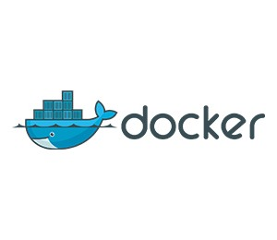

PART III: BUILDING YOUR FIRST MICROSERVICE, ITS CONTAINER, AND LINKING CONTAINERS
We’re about ready to actually get started with building a microservice. We’ll start with creating a service to handle our employee object. The high-level steps we’ll follow are:
- Set up a new Spring Boot project
- Define our employee object
- Wire up persistence
- Expose web services
- Define a Docker container to run our microservice, including linking to the Mongo container that we created in Part II
- Run our container in our Docker Machine that we set up earlier

SETTING UP OUR SPRING BOOT PROJECT
We’ll be creating a folder under our project root (in a separate repository in production) to hold our service, and in this folder, we’ll create our build.gradle file. What’s nice about Spring Boot is that purely by defining the dependencies, it wires up a great deal of interoperability auto-magically. Our build.grade file looks like:
1  2  3  4  5  6  7  8  9  10  11  12  13  14  15  16 | buildscript {  repositories {  jcenter()  }  dependencies {  classpath 'org.springframework.boot:spring-boot-gradle-plugin:1.2.0.RELEASE'  }  }  apply plugin: 'spring-boot'  repositories { jcenter()  }  dependencies {  compile "org.springframework.boot:spring-boot-starter-actuator"  compile "org.springframework.boot:spring-boot-starter-web"  }
Now, as we mentioned, we’ll be using an IDE for some of this, specifically Spring Tool Suite (STS), so we’ll have to add Gradle support. First, open STS, and on the dashboard page that opens, click the “IDE Extensions” link:
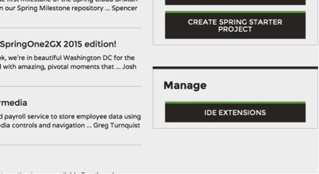
From that screen, select “Grade Support,” and click “Install.” Follow the prompts to completion, which will include restarting STS:
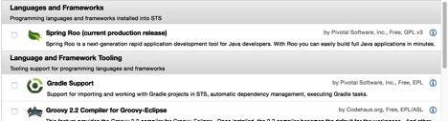
One restarted, select “Import project…,” select the (now available) Gradle project, point to your folder, and click “Build Model” — this will populate the list of projects with “Employee” — select it and click “Finish.” This will import the simple build.gradle we started the project with. Once the project is imported, the first thing is a Spring Boot configuration class. In this scenario, we’ll name them according to their service, so in this case: EmployeeBoot. Spring heavily leverages annotations and scanning, so minimal configuration is needed (imports omitted):
1  2  3  4  5  6  7  8  9  10 | @Configuration  @EnableAutoConfiguration  @ComponentScan  public class EmployeeBoot {  public static void main(String[] args) {  SpringApplication.run(EmployeeBoot.class);  }  }

OUR EMPLOYEE CLASS
Next, we’ll make our POJO class to hold employee information. We’ll keep it to the bare minimum fields for now and we’ll add more as necessary:
Employee.Class:
1  2  3  4  5  6  7  8  9  10  11  12 | @Document(collection=”employees”)  public class Employee {  @Id  private String id;  private String email;  private String fullName;  private String managerEmail;  // getters and setters omitted for brevity  }
Note the @Document annotation — this is what ties this object to be a Mongo document, and specifies the collection name for where the employee “document” should be stored.
Next we’ll define a Spring persistence repository to read and write these Employees:
EmployeeRepository.class:
1  2  3  4 | public interface EmployeeRepository extends  MongoRepository<Employee, String> {  }
The beauty of Spring is that’s all you need to write — just the interface that extends MongoRepository — not even an implementation. The two generic parameters indicate the type of the objects to persist (Employee), and the type of the unique identifier (String). Spring will wire up an implementation that handles 95% of all activities just from this declaration. The question that then follows is, how does Spring know where the database is? Spring will default to looking at localhost:27017. This obviously isn’t going to work, so we’ll need to set this straight. We could implement our own MongoTemplate bean, but fortunately Spring allows us to pass in the connection information via Java Properties. We can define a properties file or pass them in on the command line. We’ll go with the latter as it’s pretty easy to pass it in when building our container later on. The last file we’ll need to create is a REST endpoint or two to make sure that this works. We’ll make a quick Spring Controller, then we’ll be able to test this out.
EmployeeController.java:
1  2  3  4  5  6  7  8  9  10  11  12  13  14  15  16  17  18  19  20  21 | @RestController  @RequestMapping("/employee")  public class EmployeeController {  @Autowired  EmployeeRepository employeeRepository;  @RequestMapping(method = RequestMethod.POST)  public Employee create(@RequestBody Employee employee){  Employee result = employeeRepository.save(employee);  return result;  }  @RequestMapping(method = RequestMethod.GET, value="/{employeeId}")  public Employee get(@PathVariable String employeeId){  return employeeRepository.findOne(employeeId);  }  }
The RestController and RequestMapping class-level annotation tell Spring to expose this as a REST service accepting JSON, and expose it at the /employee URI path. The @Autowired annotation tells Spring to use its auto-generated implementation of the repository interface we defined above, and inject it into this controller.Now onto the specific operations — the @RequestMapping, when applied at the method level, indicate what method is to be used based on the HTTP verb used (POST vs GET in this case). Additionally, for GET, we indicate an {employeeId} in the URL path, such as using /employee/abcd1234 to look up the employee and return it.
No we have enough to test! First, we need to build and run our Spring Boot application. There are a number of ways to do this from within Eclipse, but we’ll start in the command line and work our way up. From your Employee folder, type (reference the part 3/step 2 branch from Git to skip to here): gradle build. This should compile the Spring Boot application into build/libs/Employee.jar. This jar includes everything needed to run the app, including an embedded servlet container (Tomcat by default).
Before we run this and test it, we need to back up a bit — where was our Mongo again? Looking at our “Docker PS” output, we remember that port 32777 on our VM was forwarded to our Mongo container 27017, and our VM IP was 192.168.99.100. As mentioned previously, we can pass this connection information to Spring by passing an environment property, so the command to run our app is:
1 | java -Dspring.data.mongodb.uri=mongodb://192.168.99.100:32777/micros -jar build/libs/Employee.jar
Once the app starts (which should be within 1-4 seconds), you can hit the web service with your REST tool of choice
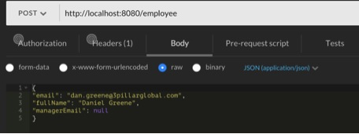
Don’t forget to include the HTTP header “Content-Type” with a value of “application/json.” You should receive a response of (your ID will differ):
1  2  3  4  5  6 | {  "id": "55fb2f1930e07c6c844b02ff",  "email": "dan.greene@3pillarglobal.com",  "fullName": "Daniel Greene",  "managerEmail": null  }
We can test our GET method by calling:
1 | http://localhost:8080/employee/55fb2f1930e07c6c844b02ff
You should get the same document back. Huzzah! Our service works!

TURNING A BOOT INTO A CONTAINER
Now we need to build our first customer container, which will run our Employee microservice. WE do this by defining a Dockerfile. This Dockerfile will define what it takes to take a “bare” image and turn it into our lean, mean, microservice machine. Let’s look at the file and then go through it step by step (reference part 3/ step 3 to jump to here):
1  2  3  4  5  6 | FROM java:8  VOLUME /tmp  ADD build/libs/Employee.jar app.jar  EXPOSE 8080  RUN bash -c 'touch /app.jar'  ENTRYPOINT ["java","-Dspring.data.mongodb.uri=mongodb://mongodb/micros", "-Djava.security.egd=file:/dev/./urandom","-jar","/app.jar"]
- We start with a “standard” image that already includes Java 8 installed (called “Java” and tagged “8”)
- We then define that a volume named /tmp should exist
- We then add a file from the local filesystem, naming it “app.jar.” The re-naming isn’t necessary, just an option available
- We state that we want to open port 8080 on the container
- We run a command on the system to “touch” the file. This ensures a file modification date on the app.jar file
- The ENTRYPOINT command is the “what to run to ‘start'” command — we run Java, setting our Spring Mongo property and a quick additional property to speed up the Tomcat startup time, and then point it at our jar
Now, we build the container image by running docker build -t microservicedemo/employee .
We can see the results by typing docker images
1  2 | REPOSITORY TAG IMAGE ID CREATED VIRTUAL SIZE  microservicedemo/employee latest 364ffd8162b9 15 minutes ago 846.6 MB
The question that follows is “how does our service container talk to the Mongo container?” For that, we get into container linking. When you run a container, you can pass an optional –link parameter, specifying the running container name that the new container needs to be able to communicate with. So with our command docker run -P -d --name employee --link mongodb microservicedemo/employee we fire up our new container image, exposing its ports (-P) in the background (-d), naming it employee (–name), and telling it to link to the container named “mongodb” (–link). Linking these does the following:
- Creates a hosts file entry in the employee container pointing at the running location of the MongoDB container
- Inserts a number of environment variables in the employee container to assist with any other programmatic access needed. To see them run: docker exec employee bash -c 'env |grep MONGODB'
- Allows containers to communicate directly over ports exposed, so there is no need to worry about the hose machine part mapping. If you remember above, we set the Spring Mongo URL to MongoDB as the hostname (mongodb://mongodb/micros), so with the hostfile entries and Mongo running on the default port, the boot container can see the database
With our container running, we can now exercise the same web service running as a container this time (for me, port 8080 of the container was proxied to 32772 of the VM host):
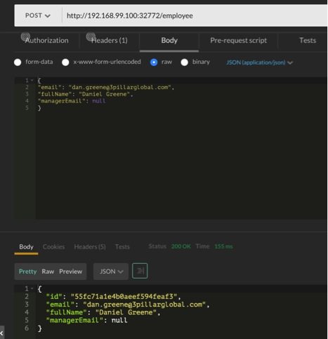
We’ve made a lot of progress in this part of the series. We have two containers that work and can talk to each other. Next, we’ll add in some additional services/containers and look at the process for making updates and working with CI.
This blog is the third of four parts:
- Read Part IV
- Start from the beginning with Part I & Part II


DAN GREENE

DIRECTOR OF ARCHITECTURE
Dan Greene is the Director of Architecture at 3Pillar Global. Dan has 18 years of software design and development experience, with software and product architecture experience in areas including eCommerce, B2B integration, Geospatial Analysis, SOA architecture, Big Data, and Cloud Computing. He is an AWS Certified Solution Architect who worked at Oracle, ChoicePoint, and Booz Allen Hamilton prior to 3Pillar. Dan is a graduate of George Washington University. He is also a father, amateur carpenter, and runs obstacle races including Tough Mudder.

4 RESPONSES TO “BUILDING A MICROSERVICE ARCHITECTURE WITH SPRING BOOT AND DOCKER, PART III”
- Thisadee P on December 12th, 2015 - 3:43am
Are you using “mongo” or “mongodb” as container name? in 2nd part you create it with ” docker run -P -d –name mongo mongo”
Reply
  - Dan Greene on December 13th, 2015 - 12:00pm
Good catch! I’m using it as ‘mongodb’ in later sections (end even later in part 2), so I’ll update part 2 with the correct name.
Thanks!
Reply
- Pepster on May 22nd, 2016 - 9:09am
Nooby question: If you want to scale out the Employee service and the MongoDB service to different hosts (what you probably want to do in production), do you still link them like this?
Reply
- Jorge on January 12th, 2017 - 5:31am
Just one point: When you say “build.grade file” in the Setting up paragraph I guess you mean “build.gradle” ( typo)
Great post anyway and very well explained
Reply

LEAVE A REPLY
Top of Form
- Name (required)
- Mail (required)
Comment
Bottom of Form
LEARN MORE
- ARTICLES
- AWARDS
- EVENTS
- PRESS RELEASES
- BLOGS
- PODCASTS
- VIDEOS
Free product development tips delivered right to your inbox
LET'S WORK TOGETHER
- CONTACT
- SITEMAP
- LEGAL

Focus Retriever
Share to FacebookShare to TwitterShare to LinkedIn

