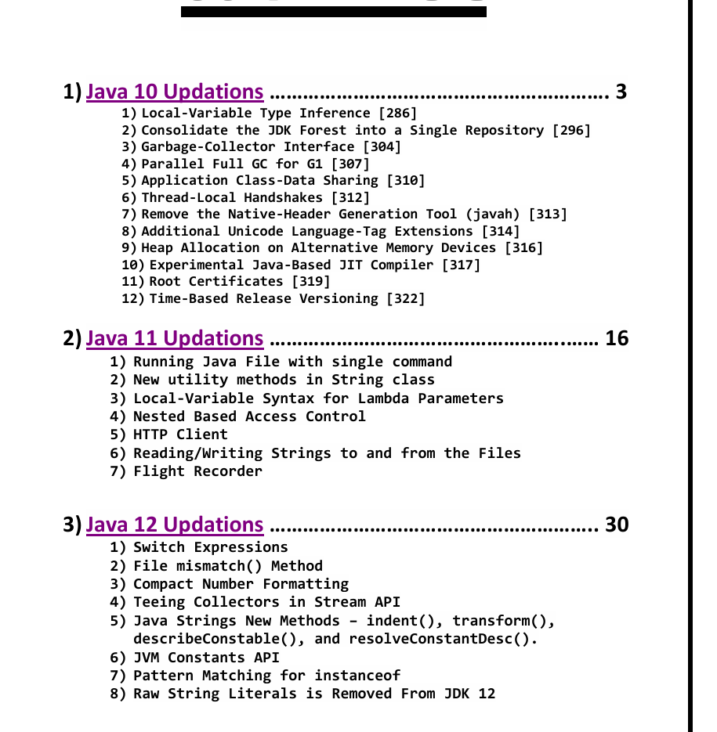

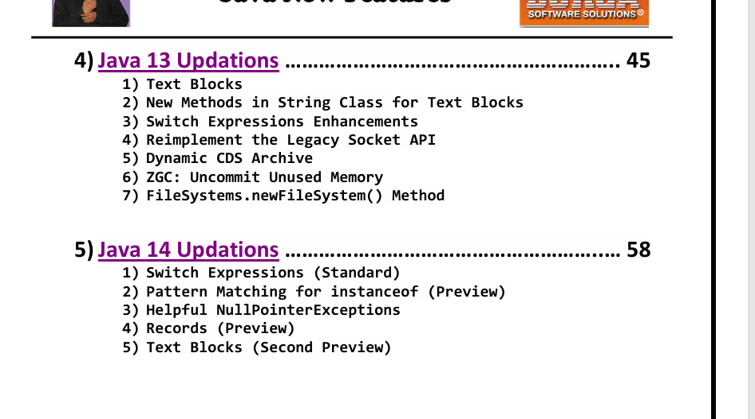Java 15 Features)
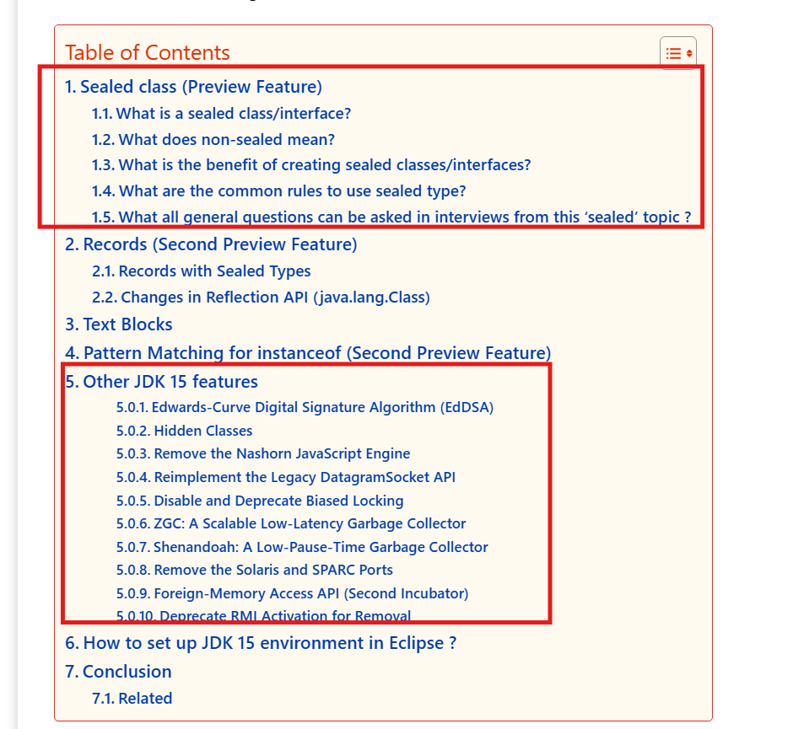

Java 17 Features)
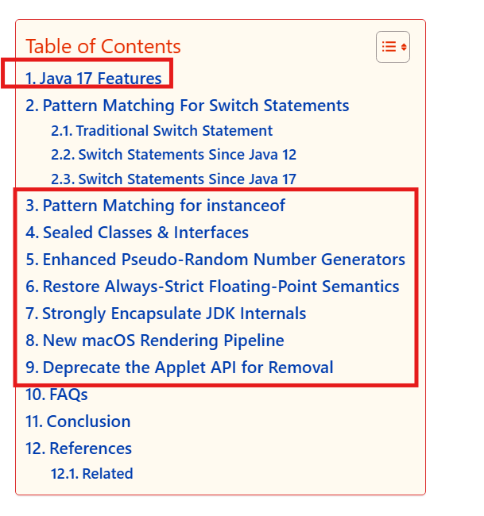

Java 21 Features)
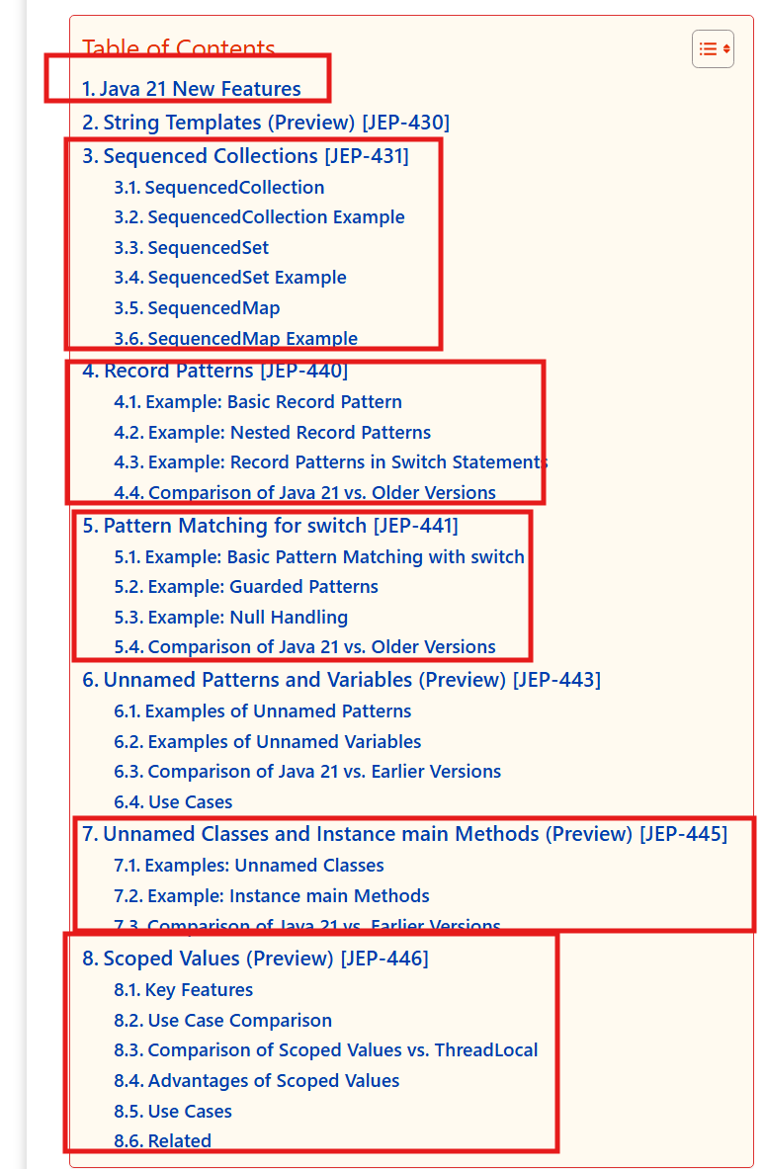

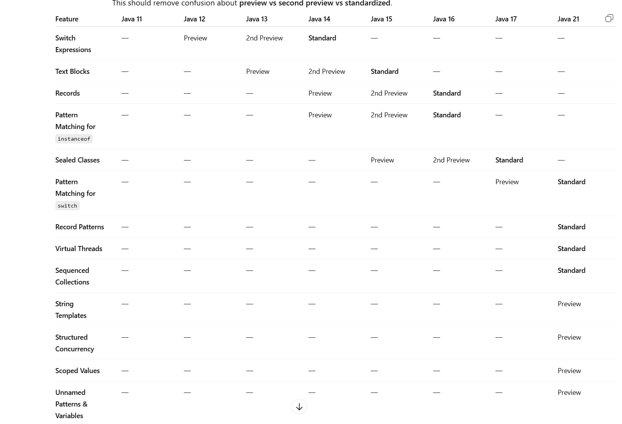

✅ How to remember this easily for interviews
Java 14 standardized
- Switch Expressions
Java 15 standardized
- Text Blocks
Java 16 standardized
- Records
- Pattern Matching for instanceof
Java 17 standardized
- Sealed Classes
Java 21 standardized
- Virtual Threads
- Pattern Matching for Switch
- Record Patterns
- Sequenced Collections

💡 Quick rule (very useful in interviews):
Most Java language features follow this lifecycle:
Preview → Second Preview (sometimes) → Standard (final release)
Example:
Records
Java 14 → Preview
Java 15 → Second Preview
Java 16 → Standard

If you want, I can also show a very powerful “Java Feature Timeline (Java 8 → Java 21)” diagram that many senior developer interviews expect you to know.

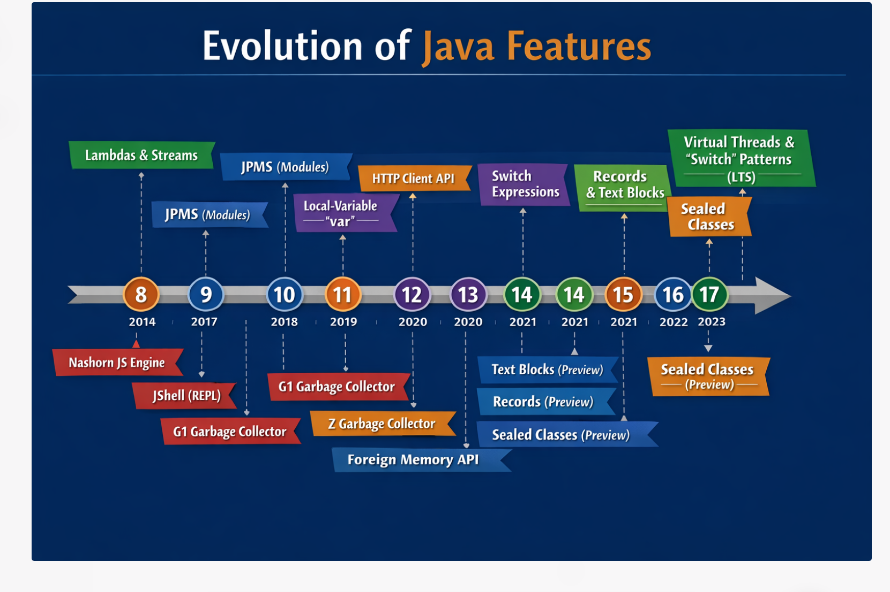

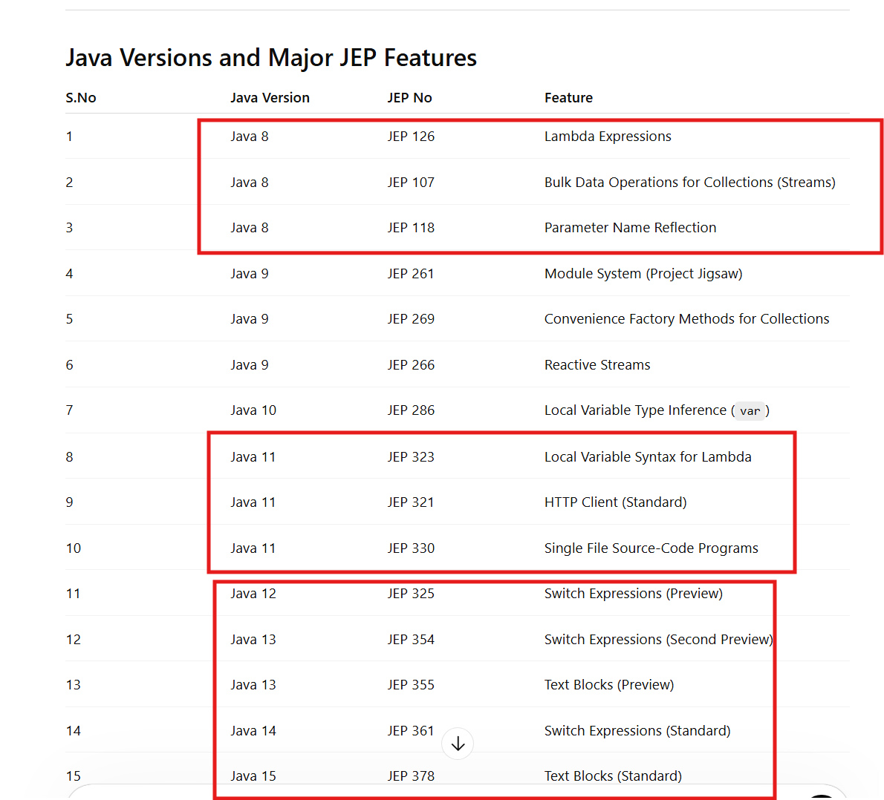

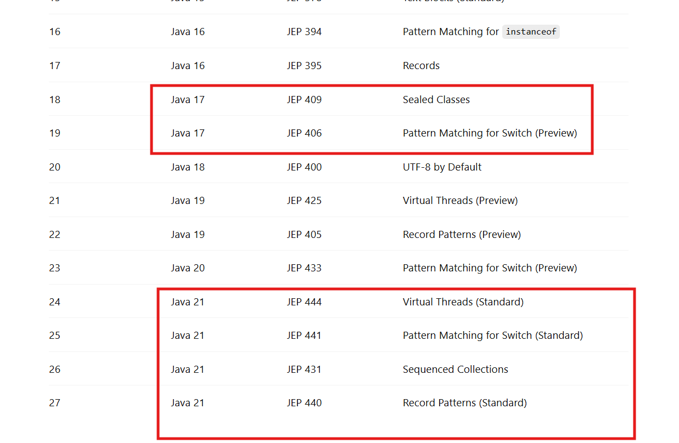

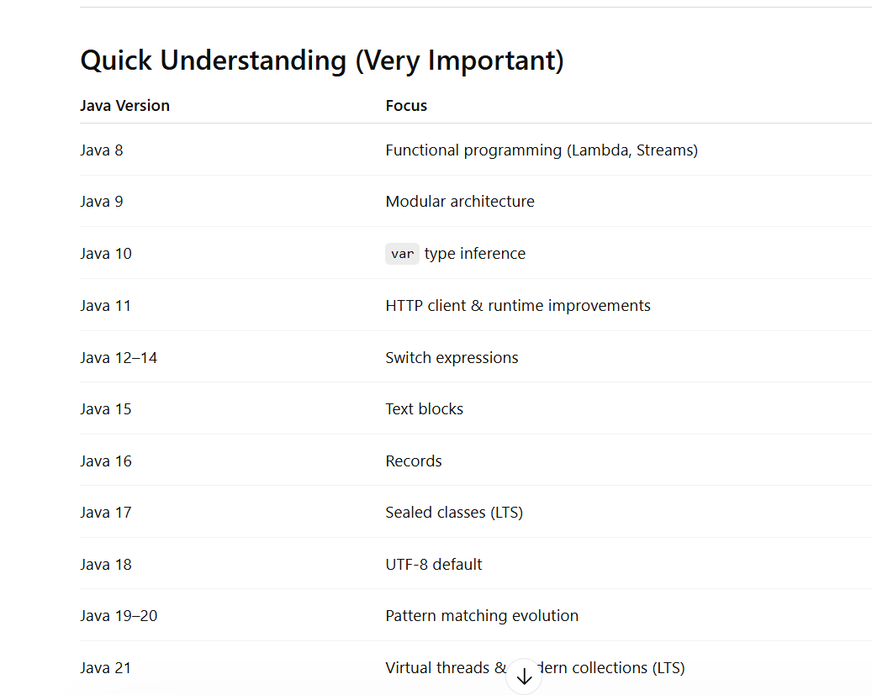

Here are the main features introduced in

Java 11, each in one single statement:
- HTTP Client API (Standard) – Introduces a modern HTTP client supporting HTTP/1.1, HTTP/2, and WebSockets.
- Local-Variable Syntax for Lambda Parameters – Allows the use of var in lambda parameters for improved readability and annotations.
- Launch Single-File Source-Code Programs – Enables running a Java program directly from a .java file without compiling it first.
- Z Garbage Collector (Experimental) – Introduces a scalable low-latency garbage collector designed for large heaps.
- Epsilon Garbage Collector – Adds a no-operation garbage collector used for performance testing and memory benchmarking.
- Dynamic Class-File Constants – Extends the class-file format to support dynamically computed constants.
- New String Methods – Adds useful methods like isBlank(), lines(), strip(), and repeat() to the String class.
- New File Methods – Introduces methods such as readString() and writeString() in the Files API.
- Nest-Based Access Control – Allows nested classes to access each other's private members more efficiently.
- Remove Java EE and CORBA Modules – Removes deprecated Java EE and CORBA modules from the JDK.

Java 12, each in one single statement:
- Switch Expressions (Preview) – Enhances the switch statement to return values and use the arrow (->) syntax.
- Shenandoah Garbage Collector (Experimental) – Introduces a low-pause-time garbage collector designed to reduce GC pause times.
- JVM Constants API – Provides an API to model nominal descriptions of key class-file and runtime artifacts.
- One AArch64 Port (ARM64) – Unifies the two existing ARM64 ports into a single supported implementation.
- Default CDS Archives – Improves application startup time by including default class data sharing archives.
- Abortable Mixed Collections for G1 – Improves the G1 Garbage Collector by allowing mixed collections to be aborted if they exceed pause time targets.
- Promptly Return Unused Committed Memory from G1 – Enables G1 to release unused memory back to the operating system more quickly.

Java 13, each in one single statement:
- Text Blocks (Preview) – Introduces multi-line string literals using triple quotes (""") for improved readability.
- Switch Expressions (Second Preview) – Enhances the switch statement to return values and use the arrow (->) syntax.
- Dynamic CDS Archives – Improves application startup time by automatically generating class data sharing archives.
- ZGC: Uncommit Unused Memory – Allows the Z Garbage Collector to return unused heap memory to the operating system.
- Reimplement the Legacy Socket API – Rewrites the old socket implementation with a simpler and more maintainable design.

Java 14, each in one single statement:
- Switch Expressions (Standard) – Allows switch to return values using a concise arrow (->) syntax.
- Records (Preview) – Introduces a compact syntax for declaring immutable data carrier classes.
- Pattern Matching for instanceof (Preview) – Simplifies type checking and casting into a single expression.
- Helpful NullPointerExceptions – Provides detailed messages explaining exactly which variable was null.
- Text Blocks (Second Preview) – Enables writing multi-line string literals using triple quotes.
- Foreign-Memory Access API (Incubator) – Allows safe and efficient access to memory outside the Java heap.
- Packaging Tool (Incubator) – Introduces jpackage to create native installers for Java applications.
- NUMA-Aware Memory Allocation for G1 – Improves performance by optimizing memory allocation on NUMA architectures.
- ZGC on macOS and Windows – Extends support for the Z Garbage Collector to macOS and Windows.
- Remove the CMS Garbage Collector – Removes the deprecated Concurrent Mark Sweep (CMS) garbage collector.

Java 15, each in one single statement:
- Text Blocks (Standard) – Provides a multi-line string syntax using triple quotes to write readable string literals.
- Sealed Classes (Preview) – Restricts which classes can extend or implement a class or interface.
- Hidden Classes – Introduces classes that are not discoverable and are mainly used by frameworks that generate classes dynamically.
- Pattern Matching for instanceof (Second Preview) – Simplifies type checking and casting into a single concise expression.
- Records (Second Preview) – Provides a concise syntax for defining immutable data carrier classes.
- Foreign-Memory Access API (Second Incubator) – Allows Java programs to safely access memory outside the Java heap.

- Edwards-Curve Digital Signature Algorithm (EdDSA) – Adds support for modern cryptographic digital signature algorithms.
- ZGC Improvements – Enhances the Z Garbage Collector to support production use with better performance.
- Shenandoah Garbage Collector (Production) – Introduces a low-pause-time garbage collector for improved application responsiveness.
- Remove Nashorn JavaScript Engine – Removes the deprecated Nashorn JavaScript engine from the JDK.

Java 16, each in one single statement:
- Records – Introduces a compact syntax for declaring immutable data carrier classes.
- Pattern Matching for instanceof – Simplifies type checking and casting in a single operation.
- Sealed Classes (Preview) – Allows restricting which classes can extend or implement a class or interface.
- Vector API (Incubator) – Provides an API for performing vector computations that utilize modern CPU SIMD instructions.
- Foreign Linker API (Incubator) – Enables Java programs to call native libraries outside the JVM.
- Foreign Memory Access API (Incubator) – Allows safe and efficient access to memory outside the Java heap.
- JEP 338: Vector API (Second Incubator) – Improves support for vectorized computations for better performance.
- Unix-Domain Socket Channels – Adds support for Unix-domain sockets in the NIO channel API for inter-process communication.
- Strongly Encapsulate JDK Internals by Default – Restricts access to internal JDK APIs to improve security and maintainability.
- Packaging Tool – Provides a standard tool (jpackage) for packaging Java applications into platform-specific installers.

Java 17, each explained in one short statement:
- Sealed Classes – Restrict which classes can extend or implement a class or interface.
- Pattern Matching for instanceof – Combines type checking and casting in a single concise expression.
- Foreign Function & Memory API (Incubator) – Allows Java programs to interact safely with native code and memory outside the JVM.
- Vector API (Second Incubator) – Enables developers to perform vector computations that can leverage modern CPU SIMD instructions.
- Enhanced Pseudo-Random Number Generators – Introduces new interfaces and algorithms for flexible and better random number generation.
- Strongly Encapsulate JDK Internals – Prevents access to internal JDK APIs by default for better security and maintainability.
- Context-Specific Deserialization Filters – Provides better control over deserialization to improve security.
- Restore Always-Strict Floating-Point Semantics – Ensures floating-point calculations always follow strict IEEE 754 rules.
- Deprecate the Security Manager for Removal – Marks the Security Manager for future removal as it is rarely used now.
- Remove the Experimental AOT and JIT Compiler – Eliminates the previously experimental ahead-of-time and JIT compilers from the JDK.
If you want, I can also show Java 17 features grouped into three categories (Language, JVM, Security) which is very useful for interviews.

Java 21, each explained in one short statement:
- Virtual Threads – Introduces lightweight threads that enable high-concurrency applications with simpler thread management.
- Sequenced Collections – Adds new interfaces that provide a well-defined encounter order for collections like List, Set, and Map.
- Pattern Matching for Switch – Allows pattern matching directly inside switch statements for more expressive conditional logic.
- Record Patterns – Enables destructuring of record objects to easily extract their components in pattern matching.
- Unnamed Patterns and Variables (Preview) – Allows the use of _ to ignore variables or patterns that are not needed.
- String Templates (Preview) – Provides a safer and more flexible way to embed expressions inside strings.
- Scoped Values (Preview) – Offers a safer and more efficient alternative to thread-local variables for sharing immutable data.
- Structured Concurrency (Preview) – Simplifies concurrent programming by treating multiple tasks as a single unit of work.
- Foreign Function & Memory API (Preview) – Enables Java programs to interact efficiently with native libraries and off-heap memory.
- Vector API (Sixth Incubator) – Provides APIs for writing vector computations that leverage modern CPU SIMD instructions.
- Generational ZGC – Enhances the Z Garbage Collector by separating young and old generations for better performance.
- Key Encapsulation Mechanism API – Introduces a standard API for encryption key encapsulation used in secure communications.

