Sequenced Collections API - Sip of Java – Inside.java

Sequenced Collections API - Sip of Java
Billy Korando on October 2, 2023
Annoyed by the boilerplate needed to find the last element in a collection, or to step through a collection in reverse order? The good news, those actions have become a lot easier to accomplish with the release of Java 21 and the Sequenced Collections API! Let’s take a look.
New Interfaces Same Hierarchy
The new Sequenced Collections API has been added as a series of new interfaces to the existing Collections Hierarchy for collections with a defined encounter order. In several cases the methods added to the new interfaces are actually existing methods that have been promoted from lower-level classes.
On the collections side, two new interfaces were added, SequencedCollection and SequencedSet:
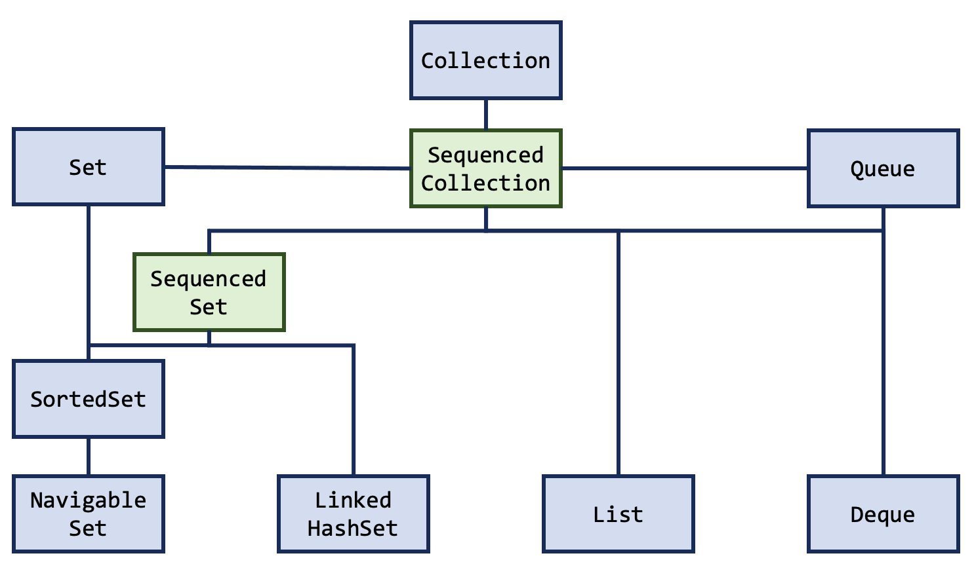
java.util.SequencedCollection contains the below methods:
interface SequencedCollection<E>
extends Collection<E> {
// New method
SequencedCollection<E> reversed();
// Methods promoted from Deque
void addFirst(E);
void addLast(E);
E getFirst();
E getLast();
E removeFirst();
E removeLast();
}
java.util.SequenceSet contains a single method, an override of reversed() which returns a SequencedSet instead:
interface SequencedSet<E> extends Set<E>,
SequencedCollection<E> {
// covariant override
SequencedSet<E> reversed();
}
On the Map side of the Collections Hierarchy a single interface was added SequencedMap:
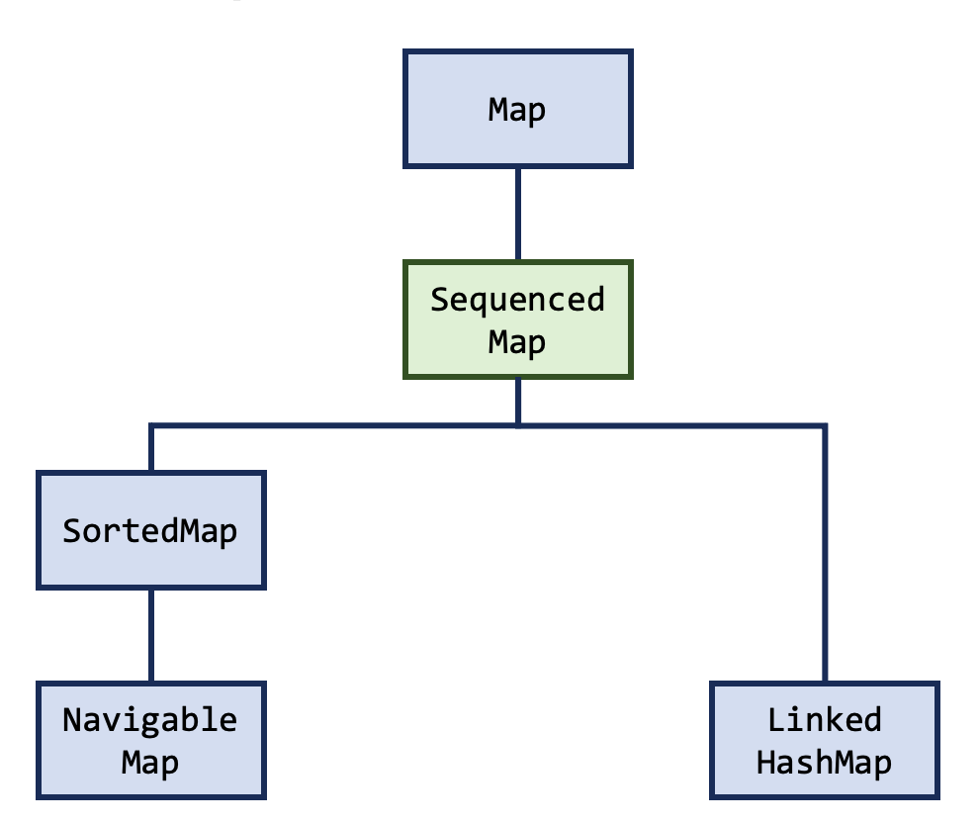
Here is a closer look at the contents of java.util.SequencedMap:
interface SequencedMap<K,V> extends Map<K,V> {
// new methods
SequencedMap<K,V> reversed();
SequencedSet<K> sequencedKeySet();
SequencedCollection<V> sequencedValues();
SequencedSet<Entry<K,V>> sequencedEntrySet();
V putFirst(K, V);
V putLast(K, V);
// methods promoted from NavigableMap
Entry<K, V> firstEntry();
Entry<K, V> lastEntry();
Entry<K, V> pollFirstEntry();
Entry<K, V> pollLastEntry();
}
Defined Encounter Order
As mentioned earlier the Sequenced Collections API updates collections with a defined encounter order. On the Collection tree this covers most of the popular and commonly used collections like ArrayList and SortedSet, though would exclude HashSet, which doesn’t have a defined encounter order.
For the Map tree the oft-used HashMap does not benefit from the Sequenced Collections API changes, as it does not have a defined encounter order. If you want to use the new methods defined in SequencedMap, you will need to use an alternative Map implementation like TreeMap, LinkedHashMap, or a Map implementing SortedMap.
Additional Reading

Sequenced Collections in Java | Baeldung
1. Overview
Java 21 introduced an update of Java’s collections framework called Sequenced Collections.
The Sequenced Collections proposal stands out as a game-changing enhancement that promises to redefine how developers interact with collections. This feature injects new interfaces into the existing hierarchy, offering a seamless mechanism to access the first and last elements of a collection using built-in default methods. Moreover, it provides support to obtain a reversed view of the collection.
In this article, we will explore this new enhancement, its potential risks, and the advantages it brings.
2. Motivation
The absence of a universal supertype for collections with a defined encounter order has been a repeated source of problems and complaints. Additionally, the lack of uniform methods for accessing first and last elements and iterating in reverse order has been a persistent limitation of Java’s collections framework.
We can take as an example List and Deque: both define an encounter order, but their common supertype, Collection, does not. Similarly, Set does not define an encounter order, but some subtypes, such as SortedSet and LinkedHashSet, do. Support for encounter order is thus spread across the type hierarchy, and operations related to encounter order are either inconsistent or missing.
In order to demonstrate the inconsistency, let’s make a comparison of accessing the first and last elements of different collection types:
 | Accessing the first element | Accessing the last element
List | list.get(0) | list.get(list.size() – 1)
Deque | deque.getFirst() | deque.getLast()
SortedSet | sortedSet.first() | sortedSet.last()
LinkedHashSet | linkedHashSet.iterator().next() | // missing
The same thing happens when trying to get a reversed view of a collection. While iterating the elements of a collection from the first to the last element follows a clear and consistent pattern, doing so in the opposite direction presents challenges.
To illustrate, when dealing with a NavigableSet, we can use the descendingSet() method. For a Deque, the descendingIterator() method proves useful. Similarly, when dealing with a List, the listIterator() method works well. However, this is not the case for LinkedHashSet, as it doesn’t provide any support for reverse iteration.
All these differences led to fragmented codebases and complexity, making it challenging to express certain useful concepts in APIs.
3. The New Java Collection Hierarchy
This new feature introduces three new interfaces for sequenced collections, sequenced sets, and sequenced maps, which are added to the existing hierarchy of collections:
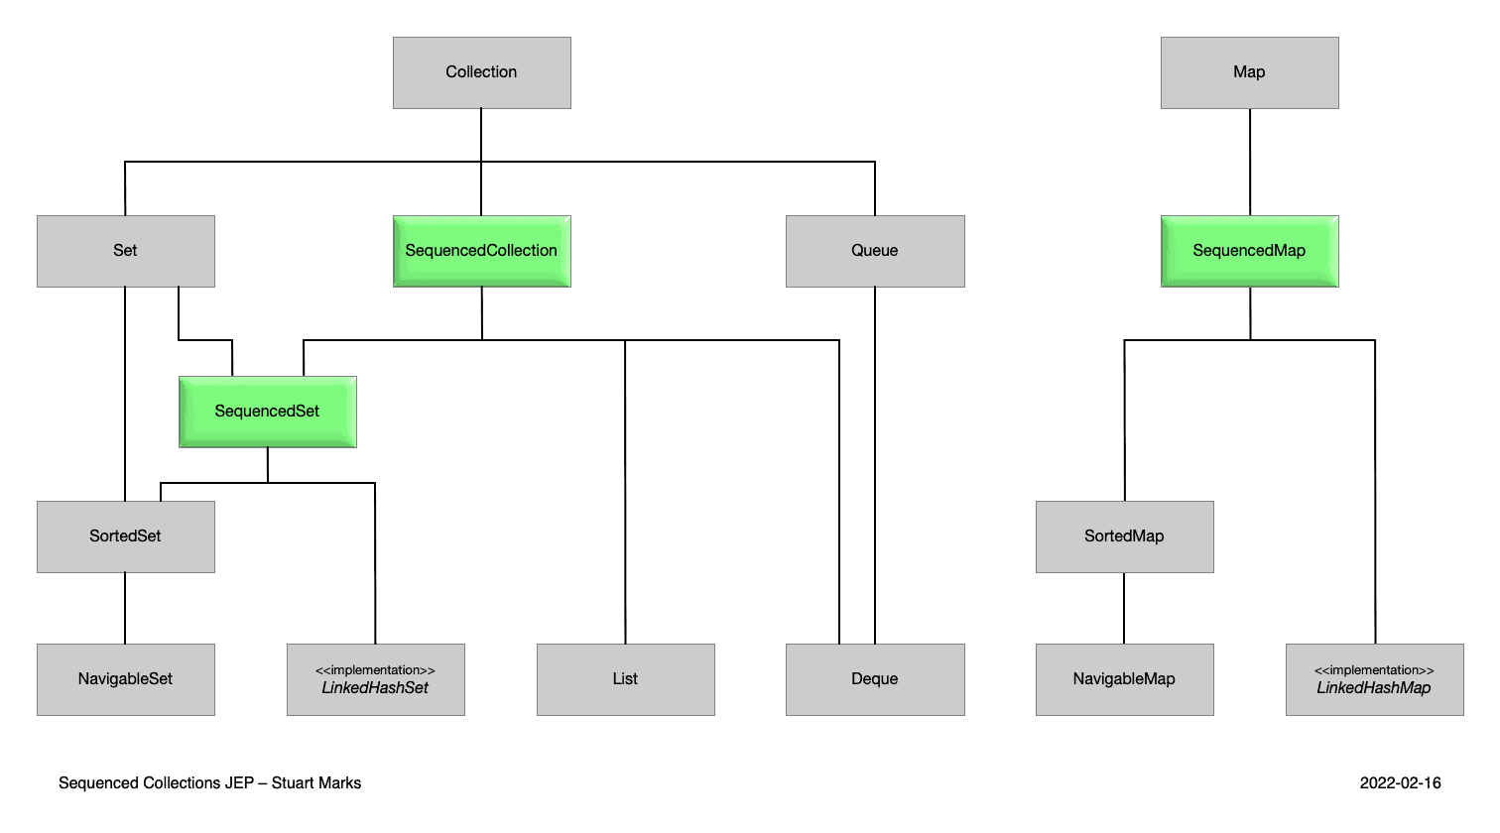
This image is part of the official documentation for JEP 431: Sequenced Collections (source).
3.1. SequencedCollection
A sequenced collection is a Collection whose elements have a defined encounter order. The new SequencedCollection interface provides methods to add, retrieve, or remove elements at both ends of the collection, along with a method to get a reverse-ordered view of the collection.
interface SequencedCollection<E> extends Collection<E> {

// new method
SequencedCollection<E> reversed();

// methods promoted from Deque
void addFirst(E);
void addLast(E);

E getFirst();
E getLast();

E removeFirst();
E removeLast();
}Copy
All methods, except reversed(), are default methods, provide a default implementation, and are promoted from Deque. The reversed() method provides a reversed-order view of the original collection. Also, any modifications to the original collection are visible in the reversed view.
The add*() and remove*() methods are optional and throw an UnsupportedOperationException in their default implementation, primarily to support the case of unmodifiable collections and collections with an already defined sorting order. The get*() and remove*() methods throw NoSuchElementException if the collection is empty.
3.2. SequencedSet
A sequenced set can be defined as a specialized Set which functions as a SequencedCollection, ensuring the absence of duplicate elements. The SequencedSet interface extends SequencedCollection and overrides its reversed() method. The only difference is that the return type of SequencedSet.reversed() is SequencedSet.
interface SequencedSet<E> extends Set<E>, SequencedCollection<E> {

// covariant override
SequencedSet<E> reversed();
}Copy
3.3. SequencedMap
A sequenced map is a Map whose entries have a defined encounter order. The SequencedMap does not extend SequencedCollection and provides its own methods to manipulate elements at either end of the collection.
interface SequencedMap<K, V> extends Map<K, V> {

// new methods
SequencedMap<K, V> reversed();
SequencedSet<K> sequencedKeySet();
SequencedCollection<V> sequencedValues();
SequencedSet<Entry<K, V>> sequencedEntrySet();

V putFirst(K, V);
V putLast(K, V);

// methods promoted from NavigableMap
Entry<K, V> firstEntry();
Entry<K, V> lastEntry();
Entry<K, V> pollFirstEntry();
Entry<K, V> pollLastEntry();
}
Copy
Similar to SequencedCollection, put*() methods throw UnsupportedOperationException for unmodifiable maps or maps with an already defined sorting order. Also, calling one of the methods promoted from NavigableMap on an empty map leads to throwing a NoSuchElementException.
4. Risks
The introduction of the new interfaces is supposed not to affect code that simply uses collections implementations. However, there are several kinds of conflicts that may appear if custom collection types would be defined in our codebases:
- method naming: new methods introduced might clash with methods on existing classes. For example, if we have a custom implementation of the List interface that already defines a getFirst() method but with a different return type than getFirst() defined in SequencedCollection, it will create a source incompatibility when upgrading to Java 21.
- covariant overrides: both List and Deque provide covariant overrides of the reversed() method, one returning List and the other one returning Deque. Therefore, any custom collection that implements both interfaces will lead to a compile-time error when upgrading to Java 21 because the compiler can’t choose one over the other.
The report JDK-8266572 contains a full analysis of the incompatibility risk.
5. Conclusion
In conclusion, Sequenced Collections marks a significant leap forward for the Java Collections. By addressing the long-standing need for a unified way to handle collections with a defined encounter order, Java empowers developers to work more efficiently and intuitively. The new interfaces establish a clearer structure and consistent behavior, resulting in more robust and readable code.

Java 21 Collections Framework — Complete Guide | by Lalit Chaturvedi | Medium
Java 21 Collections Framework — Complete Guide



Lalit Chaturvedi
Follow
9 min read
·
Jul 6, 2025
2


Overview
The Java Collections Framework is a unified architecture for representing and manipulating collections of objects. It provides a set of interfaces, implementations, and algorithms to work with groups of objects efficiently.
Class Hierarchy
Complete Collections Hierarchy
Press enter or click to view image in full size
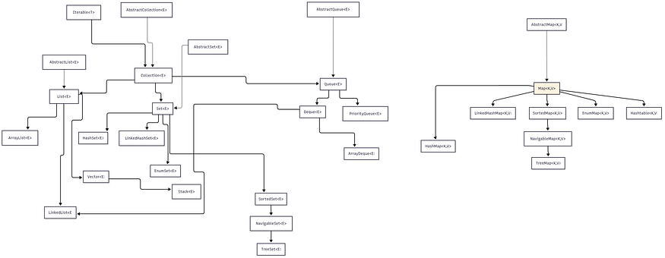
Main Collection Types
1. List Interface
- Purpose: Ordered collection that allows duplicates
- Key Implementations:
- ArrayList - Resizable array implementation
- LinkedList - Doubly-linked list implementation
- Vector - Synchronized resizable array (legacy)
- Stack - LIFO stack (legacy)
Example Usage:
List<String> arrayList = new ArrayList<>();
arrayList.add("Java");
arrayList.add("Python");
arrayList.add("Java"); // Duplicates allowed
List<String> linkedList = new LinkedList<>();
linkedList.addFirst("First");
linkedList.addLast("Last");
2. Set Interface
- Purpose: Collection that doesn’t allow duplicates
- Key Implementations:
- HashSet - Hash table based, no ordering
- LinkedHashSet - Hash table with insertion order
- TreeSet - Red-black tree, sorted order
- EnumSet - Specialized for enum types
Example Usage:
Set<String> hashSet = new HashSet<>();
hashSet.add("Java");
hashSet.add("Python");
hashSet.add("Java"); // Duplicate ignored
Set<String> treeSet = new TreeSet<>();
treeSet.add("Zebra");
treeSet.add("Apple"); // Will be sorted automatically
3. Queue Interface
- Purpose: Collection for holding elements before processing
- Key Implementations:
- PriorityQueue - Priority heap
- ArrayDeque - Resizable array deque
- LinkedList - Also implements Queue
Example Usage:
Queue<String> queue = new ArrayDeque<>();
queue.offer("First");
queue.offer("Second");
String first = queue.poll(); // Returns "First"
PriorityQueue<Integer> priorityQueue = new PriorityQueue<>();
priorityQueue.offer(3);
priorityQueue.offer(1);
priorityQueue.offer(2);
// Poll will return 1, 2, 3 in order
4. Deque Interface
- Purpose: Double-ended queue (both ends insertion/removal)
- Key Implementations:
- ArrayDeque - Resizable array implementation
- LinkedList - Also implements Deque
Example Usage:
Deque<String> deque = new ArrayDeque<>();
deque.addFirst("Middle");
deque.addFirst("First");
deque.addLast("Last");
// Order: First, Middle, Last
5. Map Interface
- Purpose: Key-value pair mappings
- Key Implementations:
- HashMap - Hash table based
- LinkedHashMap - Hash table with insertion/access order
- TreeMap - Red-black tree, sorted by keys
- EnumMap - Specialized for enum keys
- Hashtable - Synchronized hash table (legacy)
Example Usage:
Map<String, Integer> hashMap = new HashMap<>();
hashMap.put("Java", 25);
hashMap.put("Python", 30);
Map<String, Integer> treeMap = new TreeMap<>();
treeMap.put("Zebra", 1);
treeMap.put("Apple", 2); // Keys will be sorted
Concurrent Collections
Java provides thread-safe collections in the java.util.concurrent package for multi-threaded applications. These collections are designed for high concurrency and performance.
1. Concurrent Maps
ConcurrentHashMap
- Purpose: Thread-safe hash table with high concurrency
- Key Features:
- Segment-based locking (Java 8+: CAS operations)
- Better performance than synchronized HashMap
- Null keys/values not allowed
Example Usage:
ConcurrentMap<String, Integer> concurrentMap = new ConcurrentHashMap<>();
concurrentMap.put("key1", 1);
concurrentMap.putIfAbsent("key2", 2);
concurrentMap.compute("key1", (k, v) -> v + 1);
ConcurrentSkipListMap
- Purpose: Thread-safe sorted map
- Key Features:
- Sorted order maintained
- O(log n) operations
- NavigableMap implementation
Example Usage:
ConcurrentNavigableMap<String, Integer> skipListMap = new ConcurrentSkipListMap<>();
skipListMap.put("zebra", 1);
skipListMap.put("apple", 2);
// Keys automatically sorted
2. Concurrent Sets
ConcurrentSkipListSet
- Purpose: Thread-safe sorted set
- Key Features:
- Based on ConcurrentSkipListMap
- Sorted order maintained
- NavigableSet implementation
Example Usage:
ConcurrentSkipListSet<String> concurrentSet = new ConcurrentSkipListSet<>();
concurrentSet.add("zebra");
concurrentSet.add("apple");
// Elements automatically sorted
3. Concurrent Queues
ConcurrentLinkedQueue
- Purpose: Thread-safe unbounded queue
- Key Features:
- Lock-free implementation
- FIFO ordering
- Unbounded capacity
Example Usage:
ConcurrentLinkedQueue<String> queue = new ConcurrentLinkedQueue<>();
queue.offer("first");
queue.offer("second");
String head = queue.poll(); // Returns "first"
ConcurrentLinkedDeque
- Purpose: Thread-safe unbounded deque
- Key Features:
- Lock-free implementation
- Double-ended operations
- Unbounded capacity
Example Usage:
ConcurrentLinkedDeque<String> deque = new ConcurrentLinkedDeque<>();
deque.addFirst("middle");
deque.addFirst("first");
deque.addLast("last");
4. Blocking Queues
Blocking queues are thread-safe queues that block when attempting to retrieve from an empty queue or add to a full queue.
ArrayBlockingQueue
- Purpose: Bounded blocking queue backed by array
- Key Features:
- Fixed capacity
- FIFO ordering
- Optional fairness policy
Example Usage:
BlockingQueue<String> blockingQueue = new ArrayBlockingQueue<>(10);
blockingQueue.put("item1"); // Blocks if full
String item = blockingQueue.take(); // Blocks if empty
LinkedBlockingQueue
- Purpose: Optionally bounded blocking queue
- Key Features:
- Linked node structure
- Optional capacity limit
- Higher throughput than ArrayBlockingQueue
Example Usage:
BlockingQueue<String> linkedQueue = new LinkedBlockingQueue<>(100);
linkedQueue.offer("item", 1, TimeUnit.SECONDS); // Timeout version
PriorityBlockingQueue
- Purpose: Unbounded blocking priority queue
- Key Features:
- Priority-based ordering
- Unbounded capacity
- Thread-safe
Example Usage:
PriorityBlockingQueue<Integer> priorityQueue = new PriorityBlockingQueue<>();
priorityQueue.put(3);
priorityQueue.put(1);
priorityQueue.put(2);
// Takes in priority order: 1, 2, 3
DelayQueue
- Purpose: Blocking queue of delayed elements
- Key Features:
- Elements available only after delay expires
- Unbounded capacity
- Used for scheduling
Example Usage:
DelayQueue<DelayedTask> delayQueue = new DelayQueue<>();
delayQueue.put(new DelayedTask("task1", 1000)); // 1 second delay
DelayedTask task = delayQueue.take(); // Blocks until delay expires
SynchronousQueue
- Purpose: Blocking queue with no storage capacity
- Key Features:
- Each put must wait for take
- No storage capacity
- Direct handoff between threads
Example Usage:
SynchronousQueue<String> syncQueue = new SynchronousQueue<>();
// Producer thread
syncQueue.put("item"); // Blocks until consumer takes
// Consumer thread
String item = syncQueue.take(); // Blocks until producer puts
5. Transfer Queue
LinkedTransferQueue
- Purpose: Unbounded transfer queue
- Key Features:
- Combines queue and blocking operations
- Transfer method for direct handoff
- Implements TransferQueue interface
Example Usage:
TransferQueue<String> transferQueue = new LinkedTransferQueue<>();
transferQueue.transfer("item"); // Waits for consumer
// Or
transferQueue.put("item"); // Doesn't wait
Concurrent Collections Hierarchy
Press enter or click to view image in full size
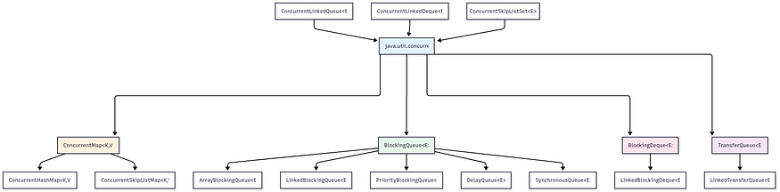
Thread Safety Comparison
Collection Type Thread-Safe Locking Strategy Performance
-----------------------------------------------------------------------------------------------
HashMap No None High (single-threaded)
Hashtable Yes Synchronized methods Low
Collections.synchronizedMap() Yes Synchronized wrapper Low
ConcurrentHashMap Yes Segments / CAS High
TreeMap No None Medium (single-threaded)
ConcurrentSkipListMap Yes Lock-free High
Java 21 New Features
Sequenced Collections (JEP 431)
Java 21 introduces new interfaces for collections with a defined encounter order:
- SequencedCollection<E> - Base interface for ordered collections
- SequencedSet<E> - Ordered set interface
- SequencedMap<K,V> - Ordered map interface
Sequenced Collections Hierarchy
Press enter or click to view image in full size
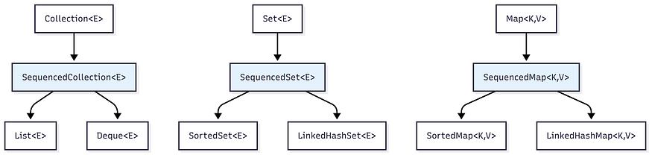
New Methods in Sequenced Collections
MethodDescriptionExamplegetFirst()Get first elementlist.getFirst()getLast()Get last elementlist.getLast()addFirst(E)Add to beginninglist.addFirst("item")addLast(E)Add to endlist.addLast("item")removeFirst()Remove first elementlist.removeFirst()removeLast()Remove last elementlist.removeLast()reversed()Get reversed viewlist.reversed()

Example Usage:
// Java 21 Sequenced Collections
List<String> list = new ArrayList<>();
list.addFirst("First"); // New in Java 21
list.addLast("Last"); // New in Java 21
String first = list.getFirst(); // New in Java 21
String last = list.getLast(); // New in Java 21// Get reversed view
SequencedCollection<String> reversed = list.reversed();
Best Practices
When to Use Each Collection
Lists
- ArrayList:
- ✅ Default choice for lists
- ✅ Random access needed
- ✅ More reads than writes
- ❌ Frequent insertions/deletions in middle
- LinkedList:
- ✅ Frequent insertions/deletions in middle
- ✅ Queue operations
- ✅ Unknown size, frequent modifications
- ❌ Random access needed
Sets
- HashSet:
- ✅ Fast lookups
- ✅ No duplicates
- ✅ Order not important
- ❌ Need sorted data
- LinkedHashSet
- ✅ No duplicates
- ✅ Insertion order matters
- ✅ Predictable iteration order
- TreeSet:
- ✅ No duplicates
- ✅ Sorted order required
- ✅ Range operations needed
Maps
- HashMap:
- ✅ Key-value pairs
- ✅ Fast access
- ✅ Order not important
- ❌ Need sorted keys
- LinkedHashMap:
- ✅ Key-value pairs
- ✅ Insertion/access order matters
- ✅ LRU cache implementation
- TreeMap:
- ✅ Key-value pairs
- ✅ Sorted by keys
- ✅ Range operations on keys
Queues
- ArrayDeque:
- ✅ Stack or queue operations
- ✅ Better than Stack/Vector
- ✅ No capacity restrictions
- PriorityQueue:
- ✅ Elements processed by priority
- ✅ Heap operations needed
Concurrent Collections
- ConcurrentHashMap:
- ✅ High-performance thread-safe map
- ✅ Better than synchronized HashMap
- ✅ High concurrency scenarios
- ❌ Null keys/values not allowed
- ConcurrentSkipListMap:
- ✅ Thread-safe sorted map
- ✅ NavigableMap operations needed
- ✅ Concurrent range queries
- ConcurrentLinkedQueue:
- ✅ Lock-free unbounded queue
- ✅ High-throughput producer-consumer
- ✅ Non-blocking operations
- ArrayBlockingQueue:
- ✅ Bounded producer-consumer scenarios
- ✅ Back-pressure control needed
- ✅ Fair scheduling required
- LinkedBlockingQueue:
- ✅ Higher throughput than ArrayBlockingQueue
- ✅ Optionally bounded
- ✅ Separate locks for put/take
- PriorityBlockingQueue:
- ✅ Priority-based task scheduling
- ✅ Thread-safe priority operations
- ✅ Unbounded capacity acceptable
Code Examples
Working with Java 21 Sequenced Collections
import java.util.*;
public class SequencedCollectionsExample {
public static void main(String[] args) {
// List as SequencedCollection
List<String> list = new ArrayList<>();
list.addFirst("First");
list.addLast("Last");
list.add(1, "Middle");
System.out.println("List: " + list);
System.out.println("First: " + list.getFirst());
System.out.println("Last: " + list.getLast());
System.out.println("Reversed: " + list.reversed());
// LinkedHashSet as SequencedSet
SequencedSet<String> sequencedSet = new LinkedHashSet<>();
sequencedSet.addFirst("A");
sequencedSet.addLast("C");
sequencedSet.add("B");
System.out.println("SequencedSet: " + sequencedSet);
// LinkedHashMap as SequencedMap
SequencedMap<String, Integer> sequencedMap = new LinkedHashMap<>();
sequencedMap.put("first", 1);
sequencedMap.put("last", 3);
sequencedMap.put("middle", 2);
System.out.println("SequencedMap: " + sequencedMap);
System.out.println("First Entry: " + sequencedMap.firstEntry());
System.out.println("Last Entry: " + sequencedMap.lastEntry());
}
}
Performance Comparison Example
import java.util.*;
import java.util.concurrent.*;
public class PerformanceComparison {
public static void main(String[] args) {
int size = 100000;
// ArrayList vs LinkedList for random access
List<Integer> arrayList = new ArrayList<>();
List<Integer> linkedList = new LinkedList<>();
// Fill both lists
for (int i = 0; i < size; i++) {
arrayList.add(i);
linkedList.add(i);
}
// Random access performance
long start = System.nanoTime();
for (int i = 0; i < 1000; i++) {
arrayList.get(size / 2);
}
long arrayListTime = System.nanoTime() - start;
start = System.nanoTime();
for (int i = 0; i < 1000; i++) {
linkedList.get(size / 2);
}
long linkedListTime = System.nanoTime() - start;
System.out.println("ArrayList random access: " + arrayListTime + " ns");
System.out.println("LinkedList random access: " + linkedListTime + " ns");
}
}
Concurrent Collections Example
import java.util.concurrent.*;
import java.util.*;
public class ConcurrentCollectionsExample {
public static void main(String[] args) throws InterruptedException {
// ConcurrentHashMap example
ConcurrentHashMap<String, Integer> concurrentMap = new ConcurrentHashMap<>();
// Multiple threads can safely modify the map
ExecutorService executor = Executors.newFixedThreadPool(4);
for (int i = 0; i < 4; i++) {
final int threadId = i;
executor.submit(() -> {
for (int j = 0; j < 1000; j++) {
concurrentMap.put("thread" + threadId + "_key" + j, j);
}
});
}
executor.shutdown();
executor.awaitTermination(1, TimeUnit.MINUTES);
System.out.println("ConcurrentHashMap size: " + concurrentMap.size());
// BlockingQueue example
BlockingQueue<String> queue = new ArrayBlockingQueue<>(10);
// Producer thread
Thread producer = new Thread(() -> {
try {
for (int i = 0; i < 5; i++) {
queue.put("Item " + i);
System.out.println("Produced: Item " + i);
Thread.sleep(100);
}
} catch (InterruptedException e) {
Thread.currentThread().interrupt();
}
});
// Consumer thread
Thread consumer = new Thread(() -> {
try {
for (int i = 0; i < 5; i++) {
String item = queue.take();
System.out.println("Consumed: " + item);
Thread.sleep(150);
}
} catch (InterruptedException e) {
Thread.currentThread().interrupt();
}
});
producer.start();
consumer.start();
producer.join();
consumer.join();
}
}
Memory Management Tips
- Initialize with appropriate capacity:
List<String> list = new ArrayList<>(1000); // If you know the size
Map<String, String> map = new HashMap<>(16, 0.75f); // Custom load factor
2. Use appropriate collection for your use case:
// For small collections, ArrayList is often faster than LinkedList
List<String> small = new ArrayList<>(); // Better for < 100 elements
// For large collections with frequent insertions
List<String> large = new LinkedList<>(); // Better for frequent modifications
3. Consider thread safety requirements:
// Thread-safe alternatives
List<String> syncList = Collections.synchronizedList(new ArrayList<>());
Map<String, String> concurrentMap = new ConcurrentHashMap<>(); // For high-concurrency scenarios
ConcurrentSkipListMap<String, String> sortedConcurrentMap = new ConcurrentSkipListMap<>();
BlockingQueue<String> blockingQueue = new LinkedBlockingQueue<>();
4. Choose appropriate concurrent collection:
// For high-throughput scenarios
ConcurrentLinkedQueue<String> lockFreeQueue = new ConcurrentLinkedQueue<>(); // For producer-consumer with backpressure
ArrayBlockingQueue<String> boundedQueue = new ArrayBlockingQueue<>(1000); // For priority-based processing
PriorityBlockingQueue<Task> priorityQueue = new PriorityBlockingQueue<>();
5. Avoid common concurrent collection pitfalls:
ConcurrentHashMap<String, Integer> map = new ConcurrentHashMap<>(); // ❌ Wrong: Not atomic
if (!map.containsKey("key")) { map.put("key", 1); } // ✅ Correct: Atomic operation
map.putIfAbsent("key", 1); // ✅ Better: Use compute methods
map.compute("key", (k, v) -> v == null ? 1 : v + 1);
Conclusion
The Java 21 Collections Framework provides a comprehensive set of data structures for different use cases. The new Sequenced Collections feature adds valuable functionality for working with ordered data, making common operations more intuitive and efficient.
Key Takeaways:
- Standard Collections: Use ArrayList, HashMap, and HashSet for most general-purpose scenarios
- Concurrent Collections: Essential for multi-threaded applications — ConcurrentHashMap, BlockingQueues, etc.
- Java 21 Sequenced Collections: Provide consistent APIs for ordered collections with new convenience methods
- Performance Matters: Choose collections based on your access patterns and performance requirements
- Thread Safety: Always consider concurrency requirements when selecting collections
Decision Matrix:
Java Collections Decision Matrix
Press enter or click to view image in full size
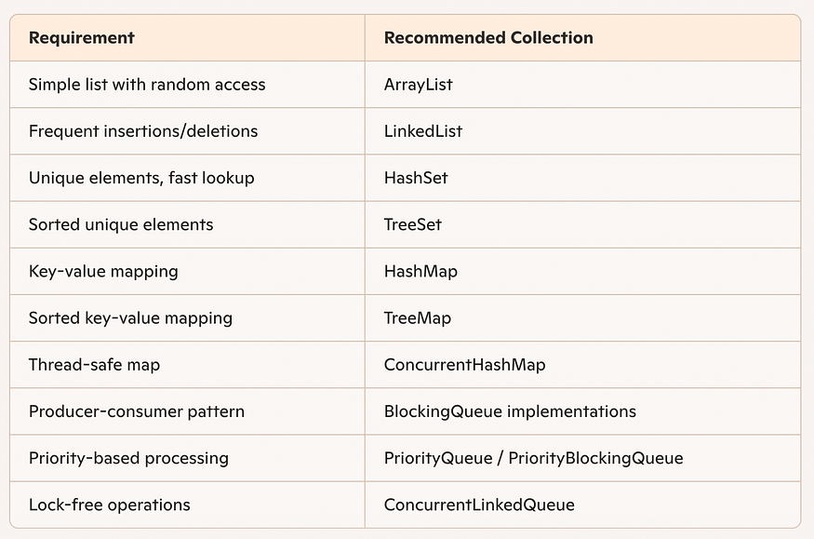
Choose your collections based on:
- Performance requirements (time/space complexity)
- Thread safety needs
- Ordering requirements
- Duplicate handling
- Access patterns (random vs sequential)
- Concurrency level (single-threaded vs multi-threaded)
Understanding these characteristics and the new Java 21 features will help you write more efficient, maintainable, and robust Java applications.

