https://creately.com/blog/diagrams/deployment-diagram-tutorial/

The Easy Guide to UML Deployment Diagrams
Updated on: 27 September 2021
Deployment diagrams are used to visualize the hardware processors/ nodes/ devices of a system, the links of communication between them and the placement of software files on that hardware.
In this UML deployment diagram tutorial, we will cover what is a deployment diagram, deployment diagram notations and how to draw one. You can use one of the editable deployment diagram examples to start right away.
If you are deploying to the cloud, you may skip UML altogether and use something like our AWS architecture templates to achieve the same purpose.

What is Deployment Diagram
A deployment diagram is a UML diagram type that shows the execution architecture of a system, including nodes such as hardware or software execution environments, and the middleware connecting them.
Deployment diagrams are typically used to visualize the physical hardware and software of a system. Using it you can understand how the system will be physically deployed on the hardware.
Deployment diagrams help model the hardware topology of a system compared to other UML diagram types which mostly outline the logical components of a system.

Deployment Diagram Notations
In order to draw a deployment diagram, you need to first become familiar with the following deployment diagram notations and deployment diagram elements.

Nodes
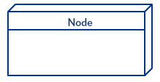
A node, represented as a cube, is a physical entity that executes one or more components, subsystems or executables. A node could be a hardware or software element.

Artifacts

Artifacts are concrete elements that are caused by a development process. Examples of artifacts are libraries, archives, configuration files, executable files etc.

Communication Association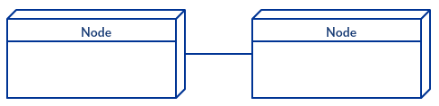
This is represented by a solid line between two nodes. It shows the path of communication between nodes.

Devices
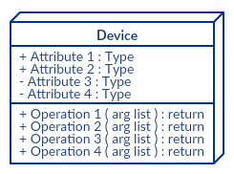
A device is a node that is used to represent a physical computational resource in a system. An example of a device is an application server.

Deployment Specifications
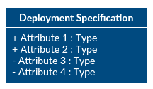
Deployment specifications is a configuration file, such as a text file or an XML document. It describes how an artifact is deployed on a node.

How to Draw a Deployment Diagram
Follow the simple steps below to draw a deployment diagram. You can either use the deployment diagram examples below to get a head start or use our UML diagram tool to start from the beginning.
Step 1: Identify the purpose of your deployment diagram. And to do so, you need to identify the nodes and devices within the system you’ll be visualizing with the diagram.
Step 2: Figure out the relationships between the nodes and devices. Once you know how they are connected, proceed to add the communication associations to the diagram.
Step 3: Identify what other elements like components, active objects you need to add to complete the diagram.
Step 4: Add dependencies between components and objects as required.

Deployment Diagram Examples

Deployment Diagram for Online Shopping System
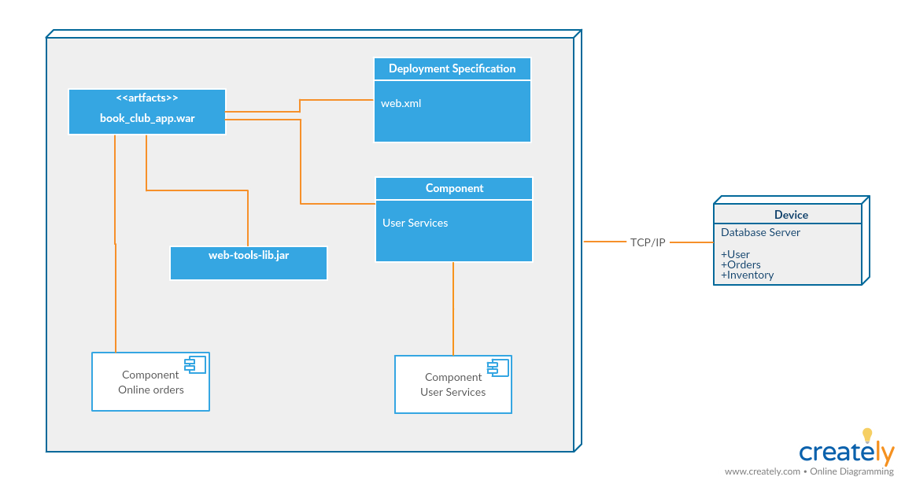
Deployment Diagram for Online Shopping System (Click on the template to edit online)

Deployment Diagram for Library Management System
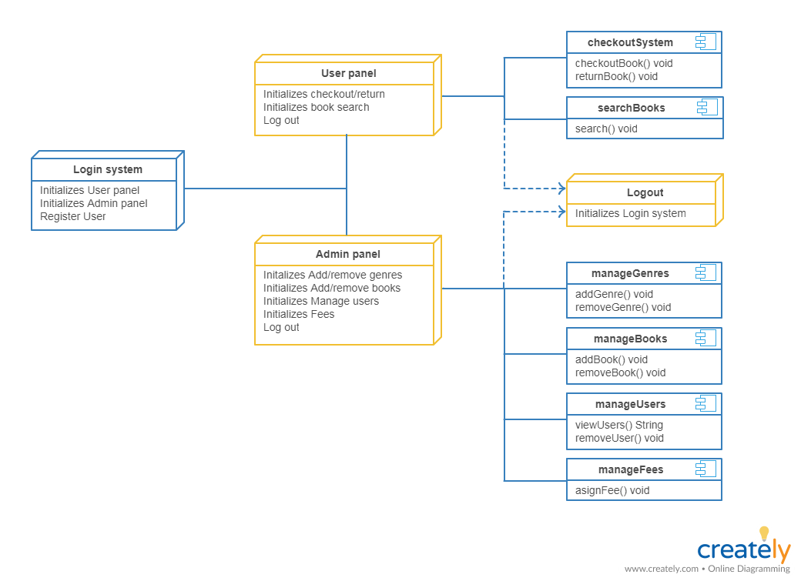
Deployment Diagram for Library Management System (Click on the template to edit online)

Deployment Diagram for Hospital Management System
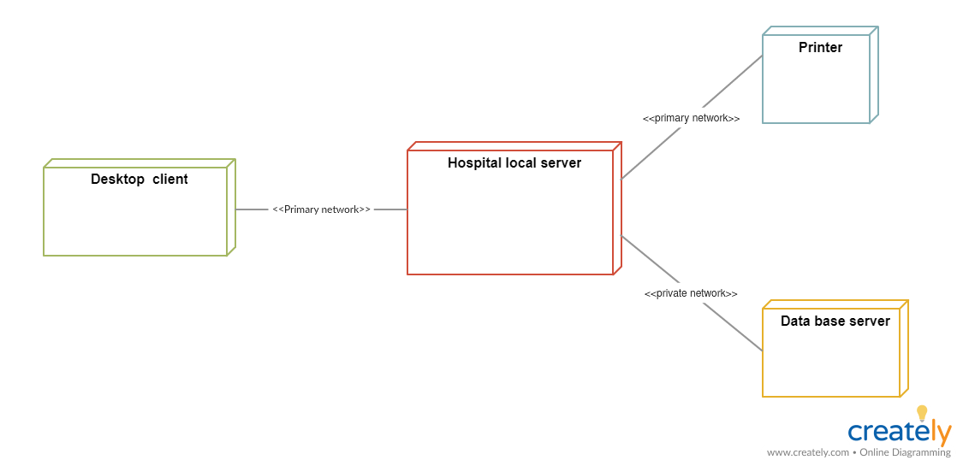
Deployment Diagram for Hospital Management System (Click on the template to edit online)

Deployment Diagram for Hotel Management System
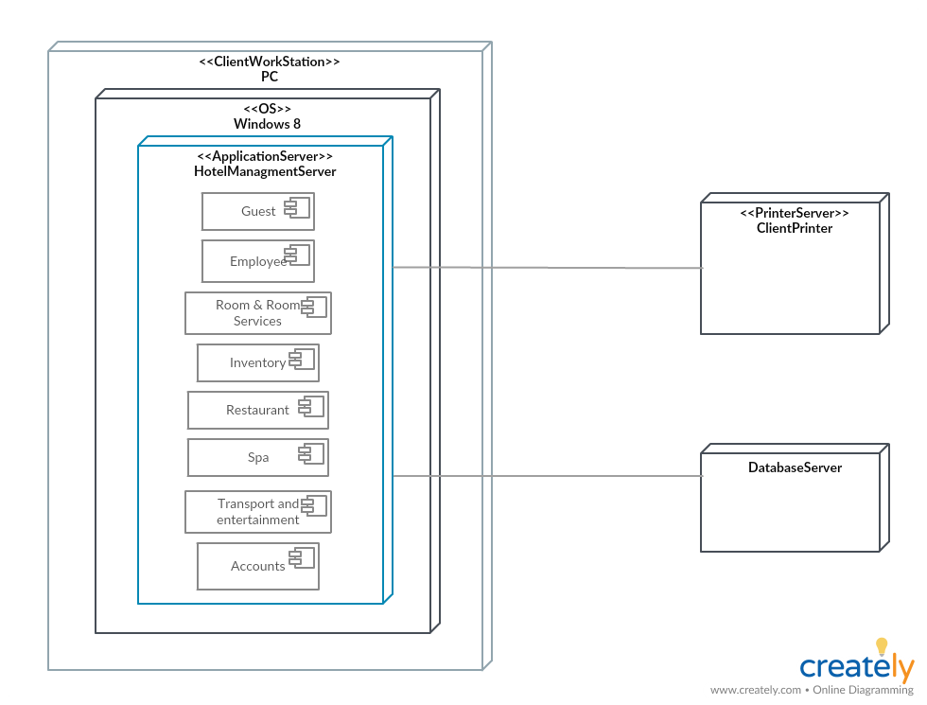
Deployment Diagram for Hotel Management System (Click on the template to edit online)

Share the Deployment Diagram Tutorial
In this deployment diagram tutorial, we have covered everything you need to know – from what is a deployment diagram to deployment diagram elements – to draw a deployment diagram yourself. Use our UML diagram tool for powerful features that’ll make drawing UML diagrams easier.
Last week we published a comprehensive tutorial on component diagrams and if you missed it, do check it out below with our other UML diagram tutorials.
The Easy Guide to Component Diagrams
The Easy Guide to Activity Diagrams
The Easy Guide to Class Diagrams
The Ultimate Guide to Sequence Diagram Tutorials
And don’t forget to leave your thoughts in the comment section below.

https://dev.mysql.com/doc/refman/8.0/en/table-scan-avoidance.html

8.2.1.23 Avoiding Full Table Scans
The output from EXPLAIN shows ALL in the type column when MySQL uses a full table scan to resolve a query. This usually happens under the following conditions:
- The table is so small that it is faster to perform a table scan than to bother with a key lookup. This is common for tables with fewer than 10 rows and a short row length.
- There are no usable restrictions in the ON or WHERE clause for indexed columns.
- You are comparing indexed columns with constant values and MySQL has calculated (based on the index tree) that the constants cover too large a part of the table and that a table scan would be faster. See Section 8.2.1.1, “WHERE Clause Optimization”.
- You are using a key with low cardinality (many rows match the key value) through another column. In this case, MySQL assumes that by using the key probably requires many key lookups and that a table scan would be faster.
For small tables, a table scan often is appropriate and the performance impact is negligible. For large tables, try the following techniques to avoid having the optimizer incorrectly choose a table scan:
- Use ANALYZE TABLE tbl_name to update the key distributions for the scanned table. See Section 13.7.3.1, “ANALYZE TABLE Statement”.
- Use FORCE INDEX for the scanned table to tell MySQL that table scans are very expensive compared to using the given index:
- SELECT * FROM t1, t2 FORCE INDEX (index_for_column)
WHERE t1.col_name=t2.col_name;
See Section 8.9.4, “Index Hints”.
- Start mysqld with the --max-seeks-for-key=1000 option or use SET max_seeks_for_key=1000 to tell the optimizer to assume that no key scan causes more than 1,000 key seeks. See Section 5.1.8, “Server System Variables”.

https://dev.mysql.com/doc/refman/5.7/en/scalar-subqueries.html

13.2.10.1 The Subquery as Scalar Operand
In its simplest form, a subquery is a scalar subquery that returns a single value. A scalar subquery is a simple operand, and you can use it almost anywhere a single column value or literal is legal, and you can expect it to have those characteristics that all operands have: a data type, a length, an indication that it can be NULL, and so on. For example:
CREATE TABLE t1 (s1 INT, s2 CHAR(5) NOT NULL);
INSERT INTO t1 VALUES(100, 'abcde');
SELECT (SELECT s2 FROM t1);
The subquery in this SELECT returns a single value ('abcde') that has a data type of CHAR, a length of 5, a character set and collation equal to the defaults in effect at CREATE TABLE time, and an indication that the value in the column can be NULL. Nullability of the value selected by a scalar subquery is not copied because if the subquery result is empty, the result is NULL. For the subquery just shown, if t1 were empty, the result would be NULL even though s2 is NOT NULL.
There are a few contexts in which a scalar subquery cannot be used. If a statement permits only a literal value, you cannot use a subquery. For example, LIMIT requires literal integer arguments, and LOAD DATA requires a literal string file name. You cannot use subqueries to supply these values.
When you see examples in the following sections that contain the rather spartan construct (SELECT column1 FROM t1), imagine that your own code contains much more diverse and complex constructions.
Suppose that we make two tables:
CREATE TABLE t1 (s1 INT);
INSERT INTO t1 VALUES (1);
CREATE TABLE t2 (s1 INT);
INSERT INTO t2 VALUES (2);
Then perform a SELECT:
SELECT (SELECT s1 FROM t2) FROM t1;
The result is 2 because there is a row in t2 containing a column s1 that has a value of 2.
A scalar subquery can be part of an expression, but remember the parentheses, even if the subquery is an operand that provides an argument for a function. For example:
SELECT UPPER((SELECT s1 FROM t1)) FROM t2;

https://www.w3resource.com/mysql/subqueries/index.php

MySQL Subqueries
Last update on April 04 2022 13:07:19 (UTC/GMT +8 hours)

Subqueries
A subquery is a SQL query nested inside a larger query.
- A subquery may occur in:
  - - A SELECT clause
  - - A FROM clause
  - - A WHERE clause
- In MySQL subquery can be nested inside a SELECT, INSERT, UPDATE, DELETE, SET, or DO statement or inside another subquery.
- A subquery is usually added within the WHERE Clause of another SQL SELECT statement.
- You can use the comparison operators, such as >, <, or =. The comparison operator can also be a multiple-row operator, such as IN, ANY, SOME, or ALL.
- A subquery can be treated as an inner query, which is a SQL query placed as a part of another query called as outer query.
- The inner query executes first before its parent query so that the results of the inner query can be passed to the outer query.
Contents:
- Subquery Syntax
- MySQL Subquery Example
- Subqueries : Guidelines and Types of Subqueries
- MySQL Subquery as Scalar Operand
- MySQL Subqueries : Using Comparisons
- MySQL Subqueries with ALL, ANY, IN, or SOME
- MySQL Row Subqueries
MySQL Subqueries with EXISTS or NOT EXISTS
MySQL Correlated Subqueries
MySQL Subqueries in the FROM Clause
Subquery Syntax :
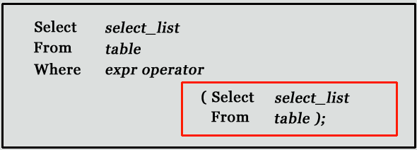
- The subquery (inner query) executes once before the main query (outer query) executes.
- The main query (outer query) use the subquery result.
Subquery syntax as specified by the SQL standard and supported in MySQL
DELETE FROM t1
WHERE s11 > ANY
(SELECT COUNT(*) /* no hint */ FROM t2
WHERE NOT EXISTS
(SELECT * FROM t3
WHERE ROW(5*t2.s1,77)=
(SELECT 50,11*s1 FROM t4 UNION SELECT 50,77 FROM
(SELECT * FROM t5) AS t5)));
A subquery can return a scalar (a single value), a single row, a single column, or a table (one or more rows of one or more columns). These are called scalar, column, row, and table subqueries.
MySQL Subquery Example:
Using a subquery, list the name of the employees, paid more than 'Alexander' from emp_details .
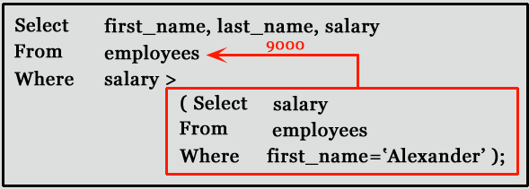
mysql> SELECT first_name,last_name, salary FROM emp_details
WHERE salary >(SELECT salary FROM emp_details
WHERE first_name='Alexander');
+------------+-----------+----------+
| first_name | last_name | salary |
+------------+-----------+----------+
| Steven | King | 24000.00 |
| Neena | Kochhar | 17000.00 |
| Lex | De Haan | 17000.00 |
| RABI | CHANDRA | 15000.00 |
| Ana | King | 17000.00 |
+------------+-----------+----------+
5 rows in set (0.00 sec)
Subqueries: Guidelines
There are some guidelines to consider when using subqueries :
- A subquery must be enclosed in parentheses.
- Use single-row operators with single-row subqueries, and use multiple-row operators with multiple-row subqueries.
- If a subquery (inner query) returns a null value to the outer query, the outer query will not return any rows when using certain comparison operators in a WHERE clause.
Types of Subqueries
- The Subquery as Scalar Operand
- Comparisons using Subqueries
- Subqueries with ALL, ANY, IN, or SOME
- Row Subqueries
- Subqueries with EXISTS or NOT EXISTS
- Correlated Subqueries
- Subqueries in the FROM Clause
MySQL Subquery as Scalar Operand
A scalar subquery is a subquery that returns exactly one column value from one row. A scalar subquery is a simple operand, and you can use it almost anywhere a single column value or literal is legal. If the subquery returns 0 rows then the value of scalar subquery expression in NULL and if the subquery returns more than one row then MySQL returns an error.
There is some situation where a scalar subquery cannot be used. If a statement permits only a literal value, you cannot use a subquery. For example, LIMIT requires literal integer arguments, and LOAD DATA INFILE requires a literal string file name. You cannot use subqueries to supply these values.
Example: MySQL Subquery as Scalar Operand
mysql> SELECT employee_id, last_name,
(CASE WHEN department_id=(
SELECT department_id from departments WHERE location_id=2500)
THEN 'Canada' ELSE 'USA' END)
location FROM employees;
+-------------+-------------+----------+
| employee_id | last_name | location |
+-------------+-------------+----------+
| 100 | King | USA |
| 101 | Kochhar | USA |
| 102 | De Haan | USA |
| 103 | Hunold | USA |
| 104 | Ernst | USA |
| 105 | Austin | USA |
| - - - - - - - - - - - - - - - - - - -|
| - - - - - - - - - - - - - - - - - - -|
107 rows in set (0.00 sec)
MySQL Subqueries: Using Comparisons
A subquery can be used before or after any of the comparison operators. The subquery can return at most one value. The value can be the result of an arithmetic expression or a column function. SQL then compares the value that results from the subquery with the value on the other side of the comparison operator. You can use the following comparison operators:
Operator | Description
= | Equal to
> | Greater than
>= | Greater than or equal to
< | Less than
<= | Less than or equal to
!= | Not equal to
<> | Not equal to
<=> | NULL-safe equal to operator
For example, suppose you want to find the employee id, first_name, last_name, and salaries for employees whose average salary is higher than the average salary throughout the company.
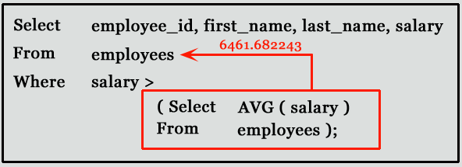
mysql> SELECT employee_id,first_name,last_name,salary
FROM employees WHERE salary >
(SELECT AVG(SALARY) FROM employees);
+-------------+-------------+------------+----------+
| employee_id | first_name | last_name | salary |
+-------------+-------------+------------+----------+
| 100 | Steven | King | 24000.00 |
| 101 | Neena | Kochhar | 17000.00 |
| 102 | Lex | De Haan | 17000.00 |
| 103 | Alexander | Hunold | 9000.00 |
| 108 | Nancy | Greenberg | 12000.00 |
| 109 | Daniel | Faviet | 9000.00 |
| 120 | Matthew | Weiss | 8000.00 |
| 121 | Adam | Fripp | 8200.00 |
| 122 | Payam | Kaufling | 7900.00 |
|- - - - - - - - - - - - - - - - - - - - - - - - - -|
|- - - - - - - - - - - - - - - - - - - - - - - - - -|
+-------------+-------------+------------+----------+
51 rows in set (0.00 sec)
MySQL Subqueries with ALL, ANY, IN, or SOME
You can use a subquery after a comparison operator, followed by the keyword ALL, ANY, or SOME.
The ALL operator compares value to every value returned by the subquery. Therefore ALL operator (which must follow a comparison operator) returns TRUE if the comparison is TRUE for ALL of the values in the column that the subquery returns.
Syntax:
operand comparison_operator ALL (subquery)
NOT IN is an alias for <> ALL. Thus, these two statements are the same:
Code:
SELECT c1 FROM t1 WHERE c1 <> ALL (SELECT c1 FROM t2);
SELECT c1 FROM t1 WHERE c1 NOT IN (SELECT c1 FROM t2);

Copy
Example: MySQL Subquery, ALL operator
The following query selects the department with the highest average salary. The subquery finds the average salary for each department, and then the main query selects the department with the highest average salary.
mysql> SELECT department_id, AVG(SALARY)
FROM EMPLOYEES GROUP BY department_id
HAVING AVG(SALARY)>=ALL
(SELECT AVG(SALARY) FROM EMPLOYEES GROUP BY department_id);
+---------------+--------------+
| department_id | AVG(SALARY) |
+---------------+--------------+
| 90 | 19333.333333 |
+---------------+--------------+
1 row in set (0.00 sec)
Note: Here we have used ALL keyword for this subquery as the department selected by the query must have an average salary greater than or equal to all the average salaries of the other departments.
The ANY operator compares the value to each value returned by the subquery. Therefore ANY keyword (which must follow a comparison operator) returns TRUE if the comparison is TRUE for ANY of the values in the column that the subquery returns.
Syntax:
operand comparison_operator ANY (subquery)
Example: MySQL Subquery, ANY operator
The following query selects any employee who works in the location 1800. The subquery finds the department id in the 1800 location, and then the main query selects the employees who work in any of these departments.
employees table:

departments table:
mysql> SELECT first_name, last_name,department_id
FROM employees WHERE department_id= ANY
(SELECT DEPARTMENT_ID FROM departments WHERE location_id=1800);
+------------+-----------+---------------+
| first_name | last_name | department_id |
+------------+-----------+---------------+
| Michael | Hartstein | 20 |
| Pat | Fay | 20 |
+------------+-----------+---------------+
2 rows in set (0.00 sec)
Note: We have used ANY keyword in this query because it is likely that the subquery will find more than one departments in 1800 location. If you use the ALL keyword instead of the ANY keyword, no data is selected because no employee works in all departments of 1800 location
When used with a subquery, the word IN (equal to any member of the list) is an alias for = ANY. Thus, the following two statements are the same:
Code:
SELECT c1 FROM t1 WHERE c1 = ANY (SELECT c1 FROM t2);
SELECT c1 FROM t1 WHERE c1 IN (SELECT c1 FROM t2);

Copy
The word SOME is an alias for ANY. Thus, these two statements are the same:
Code:
SELECT c1 FROM t1 WHERE c1 <> ANY (SELECT c1 FROM t2);
SELECT c1 FROM t1 WHERE c1 <> SOME (SELECT c1 FROM t2);

Copy
MySQL Row Subqueries
A row subquery is a subquery that returns a single row and more than one column value. You can use = , >, <, >=, <=, <>, !=, <=> comparison operators. See the following examples:
Code:
SELECT * FROM table1 WHERE (col1,col2) = (SELECT col3, col4 FROM table2 WHERE id = 10);
SELECT * FROM table1 WHERE ROW(col1,col2) = (SELECT col3, col4 FROM table2 WHERE id = 10);

Copy
For both queries,
- if the table table2 contains a single row with id = 10, the subquery returns a single row. If this row has col3 and col4 values equal to the col1 and col2 values of any rows in table1, the WHERE expression is TRUE and each query returns those table1 rows.
- If the table2 row col3 and col4 values are not equal the col1 and col2 values of any table1 row, the expression is FALSE and the query returns an empty result set. The expression is unknown (that is, NULL) if the subquery produces no rows.
- An error occurs if the subquery produces multiple rows because a row subquery can return at most one row.
Example: MySQL Row Subqueries
In the following examples, queries shows differentr result according to above conditions :
departments table:

employees table:
mysql> SELECT first_name
FROM employees
WHERE ROW(department_id, manager_id) = (SELECT department_id, manager_id FROM departments WHERE location_id = 1800);
+------------+
| first_name |
+------------+
| Pat |
+------------+
1 row in set (0.00 sec)
Code:
mysql>SELECT first_name
FROM employees
WHERE ROW(department_id, manager_id) = (SELECT department_id, manager_id FROM departments WHERE location_id = 2800);
Empty set (0.00 sec)

Copy
Code:
mysql>SELECT first_name
FROM employees
WHERE ROW(department_id, manager_id) = (SELECT department_id, manager_id FROM departments WHERE location_id = 1700);
ERROR 1242 (21000): Subquery returns more than 1 row

Copy
MySQL Subqueries with EXISTS or NOT EXISTS
The EXISTS operator tests for the existence of rows in the results set of the subquery. If a subquery row value is found, EXISTS subquery is TRUE and in this case NOT EXISTS subquery is FALSE.
Syntax:
SELECT column1 FROM table1 WHERE EXISTS (SELECT * FROM table2);
In the above statement, if table2 contains any rows, even rows with NULL values, the EXISTS condition is TRUE. Generally, an EXISTS subquery starts with SELECT *, but it could begin with SELECT 'X', SELECT 5, or SELECT column1 or anything at all. MySQL ignores the SELECT list in such a subquery, so it makes no difference.
Example: MySQL Subqueries with EXISTS
From the following tables (employees) find employees (employee_id, first_name, last_name, job_id, department_id) who have at least one person reporting to them.
employees table:
SELECT employee_id, first_name, last_name, job_id, department_id
FROM employees E
WHERE EXISTS (SELECT * FROM employees WHERE manager_id = E.employee_id);
+-------------+------------+-----------+---------+---------------+
| employee_id | first_name | last_name | job_id | department_id |
+-------------+------------+-----------+---------+---------------+
| 100 | Steven | King | AD_PRES | 90 |
| 101 | Neena | Kochhar | AD_VP | 90 |
| 102 | Lex | De Haan | AD_VP | 90 |
| 103 | Alexander | Hunold | IT_PROG | 60 |
| 108 | Nancy | Greenberg | FI_MGR | 100 |
| 114 | Den | Raphaely | PU_MAN | 30 |
| 120 | Matthew | Weiss | ST_MAN | 50 |
| 121 | Adam | Fripp | ST_MAN | 50 |
| ---------- | ---------- | --------- | ------- | ------------- |
+-------------+------------+-----------+---------+---------------+
18 rows in set (0.02 sec)
Example: MySQL Subqueries with NOT EXISTS
NOT EXISTS subquery almost always contains correlations. Here is an example :
From the following table (departments and employees) find all departments (department_id, department_name) that do not have any employees.
departments table:

employees table:
mysql> SELECT department_id, department_name
FROM departments d
WHERE NOT EXISTS (SELECT * FROM employees WHERE department_id = d.department_id);
+---------------+----------------------+
| department_id | department_name |
+---------------+----------------------+
| 120 | Treasury |
| 130 | Corporate Tax |
| 140 | Control And Credit |
| 150 | Shareholder Services |
| 160 | Benefits |
| 170 | Manufacturing |
| 180 | Construction |
| 190 | Contracting |
| 200 | Operations |
| ------------ | -------------------- |
+---------------+----------------------+
16 rows in set (0.00 sec)
MySQL Correlated Subqueries
A correlated subquery is a subquery that contains a reference to a table (in the parent query) that also appears in the outer query. MySQL evaluates from inside to outside.
Correlated subquery syntax:
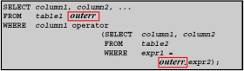
Example - 1: MySQL Correlated Subqueries
Following query find all employees who earn more than the average salary in their department.
employees table:
mysql> SELECT last_name, salary, department_id
FROM employees outerr
WHERE salary > (SELECT AVG(salary) FROM employees WHERE department_id = outerr.department_id);
+-----------+----------+---------------+
| last_name | salary | department_id |
+-----------+----------+---------------+
| King | 24000.00 | 90 |
| Hunold | 9000.00 | 60 |
| Ernst | 6000.00 | 60 |
| Greenberg | 12000.00 | 100 |
| Faviet | 9000.00 | 100 |
| Raphaely | 11000.00 | 30 |
| Weiss | 8000.00 | 50 |
| Fripp | 8200.00 | 50 |
| -------- | -------- | ------------ |
+-----------+----------+---------------+
38 rows in set (0.02 sec)
Example - 2: MySQL Correlated Subqueries
From the employees and job_history tables display details of those employees who have changed jobs at least once.
employees table:

job_history table:
mysql> SELECT first_name, last_name, employee_id, job_id
FROM employees E
WHERE 1 <= (SELECT COUNT(*) FROM Job_history WHERE employee_id = E.employee_id);
+------------+-----------+-------------+---------+
| first_name | last_name | employee_id | job_id |
+------------+-----------+-------------+---------+
| Neena | Kochhar | 101 | AD_VP |
| Lex | De Haan | 102 | AD_VP |
| Den | Raphaely | 114 | PU_MAN |
| Payam | Kaufling | 122 | ST_MAN |
| Jonathon | Taylor | 176 | SA_REP |
| Jennifer | Whalen | 200 | AD_ASST |
| Michael | Hartstein | 201 | MK_MAN |
+------------+-----------+-------------+---------+
7 rows in set (0.00 sec)
MySQL Subqueries in the FROM Clause
Subqueries work in a SELECT statement's FROM clause. The syntax is :
SELECT ... FROM (subquery) [AS] name ...
Every table in a FROM clause must have a name, therefore the [AS] name clause is mandatory. Any columns in the subquery select list must have unique names.
Example: MySQL Subqueries in the FROM Clause
We have the following table tb1.
mysql> CREATE TABLE tb1 (c1 INT, c2 CHAR(5), c3 FLOAT); Query OK, 0 rows affected (0.73 sec)
Let insert some values into tb1.
mysql> INSERT INTO tb1 VALUES (1, '1', 1.0);
Query OK, 1 row affected (0.11 sec)

mysql> INSERT INTO tb1 VALUES (2, '2', 2.0);
Query OK, 1 row affected (0.07 sec)

mysql> INSERT INTO tb1 VALUES (3, '3', 3.0);
Query OK, 1 row affected (0.03 sec)

mysql> select * from tb1;
+------+------+------+
| c1 | c2 | c3 |
+------+------+------+
| 1 | 1 | 1 |
| 2 | 2 | 2 |
| 3 | 3 | 3 |
+------+------+------+
3 rows in set (0.00 sec)

Here is how to use a subquery in the FROM clause, using the example table (tb1) :
mysql> SELECT sc1, sc2, sc3
FROM (SELECT c1 AS sc1, c2 AS sc2, c3*3 AS sc3 FROM tb1) AS sb
WHERE sc1 > 1;
+------+------+------+
| sc1 | sc2 | sc3 |
+------+------+------+
| 2 | 2 | 6 |
| 3 | 3 | 9 |
+------+------+------+
2 rows in set (0.02 sec)
Previous: NATURAL JOIN
Next: MySQL Procedure

