Understanding the Maven Build Lifecycle: A Detailed Guide | by PV Prasanth | Medium
Understanding the Maven Build Lifecycle: A Detailed Guide



PV Prasanth
Follow
8 min read
·
Jan 13, 2025
55

When you work with Maven, understanding its build lifecycle is like learning the steps to bake a delicious cake. 🍰 Each step is important to create the final product — your application. Whether you’re a beginner or an experienced developer looking for a refresher, this guide will walk you through Maven’s build lifecycle in a way that’s simple and relatable.
Press enter or click to view image in full size
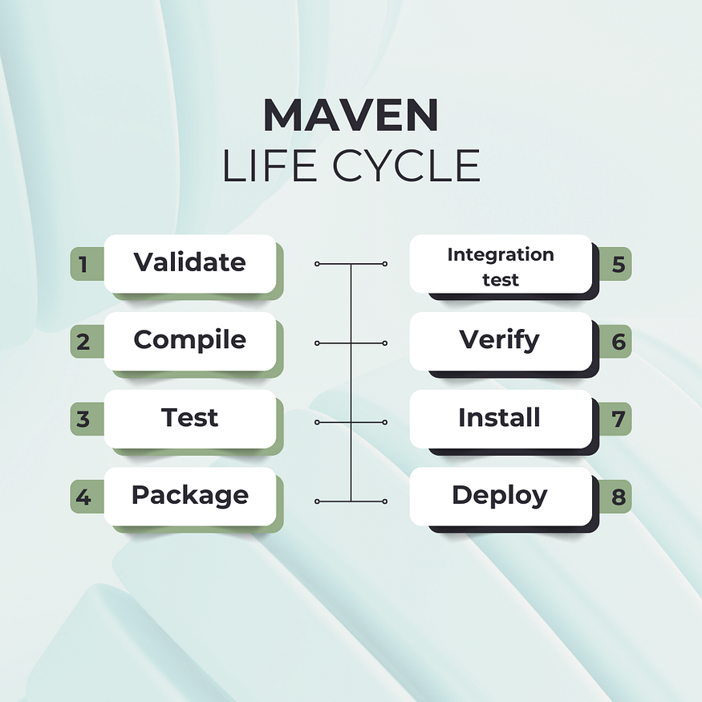
Maven lifecycle
What is the Build Lifecycle? 🤔
Imagine you’re building a house. 🏠 You need to follow specific steps in a certain order: lay the foundation, build walls, add the roof, and finally, paint and decorate. Maven’s build lifecycle works in a similar way — it’s a series of predefined steps (called phases) that ensure your project is built correctly and efficiently.
Whenever you run Maven, it goes through these steps to compile your code, test it, package it, and even share it with others. Each step is part of a lifecycle phase.
There are three standard lifecycles in Maven:
- Default Lifecycle 🏗️
The core lifecycle, responsible for building and deploying the project.
- Clean Lifecycle 🧹
Focused on cleaning up old files before building.
- Site Lifecycle 📄
Used to generate documentation for your project.
1. Default Lifecycle: Building the Heart of Your Application 🏗️
The default lifecycle is the core of Maven’s build process. It’s the step-by-step guide that ensures your application is compiled, tested, packaged, and ready for deployment. Whether you’re creating a simple Java application or a complex enterprise system, this lifecycle is the backbone of Maven’s power.
Here’s the sequence of phases in the default lifecycle:
1. validate
- Ensures that the project is correct and all necessary information is available.
- Example: Checks for missing or invalid dependencies in pom.xml.
2. initialize
- Initializes the build state.
- Example: Creates or sets up directories for output.
3. generate-sources
- Generates any additional source code for the project.
- Example: Generates Java code from a WSDL file for a web service.
4.process-sources
- Processes the source code.
- Example: Applies transformations or filters to the source files before compilation.
5. generate-resources
- Generates additional resources needed for the project.
- Example: Compiles resource files like .properties
6. process-resources
- Copies and processes resource files to the output directory.
- Example: Moves configuration files to the target/classes folder.
7. compile
- Compiles the source code of the project.
- Example: Converts .java files to .class files.
8. process-classes
- Post-processes the compiled classes.
- Example: Enhances or modifies .class files.
9. generate-test-sources
- Generates test source code for the project.
- Example: Creates test stubs or mocks for testing.
10. process-test-sources
- Processes the test source code.
- Example: Prepares the test code for compilation.
11. test-compile
- Compiles the test source code.
- Example: Compiles JUnit test cases into .class files.
12. process-test-classes
- Post-processes the compiled test classes.
- Example: Enhances test .class files if needed.
13. test
- Runs the unit tests using a testing framework like JUnit or TestNG.
- Example: Executes all tests and generates a report.
14. prepare-package
- Prepares the project for packaging.
- Example: Gathers all compiled code and resources into one directory.
15. package
- Packages the compiled code into a distributable format.
- Example: Creates a .jar or .war file.
16. pre-integration-test
- Sets up the environment for integration tests.
- Example: Starts a database or a web server.
17. integration-test
- Runs the integration tests.
- Example: Tests how components work together in a production-like environment.
18. post-integration-test
- Cleans up the environment after integration tests.
- Example: Shuts down the database or server.
19. verify
- Verifies that the project meets quality standards.
- Example: Ensures the package is valid and all tests pass.
20. install
- Installs the built artifact to the local Maven repository.
- Example: Copies the .jar file to ~/.m2/repository.
21. deploy
- Deploys the built artifact to a remote repository.
- Example: Uploads the .jar or .war to a Nexus or Artifactory repository for sharing.
Out of all the below eight phases of the Default Lifecycle are considered the most important because they represent the core steps required to build, test, and deploy a Maven-based application. Let me explain why each of these phases is crucial:
1. validate: Ensuring Readiness 🛠️
- Why it’s important: Before anything else, Maven checks if your project is valid. Missing dependencies, incorrect configurations, or incomplete details can stop the build process right at the start.
- Example: Ensures the pom.xml has all necessary plugins, dependencies, and project details.
2. compile: Transforming Code 🖥️
- Why it’s important: Without compilation, your source code cannot become executable. This phase turns your .java files into .class files using the configured Java compiler.
- Example: Converts src/main/java files into bytecode.
3. test: Ensuring Code Quality ✅
- Why it’s important: Unit tests ensure individual parts of your application work correctly. A project without tests is prone to bugs.
- Example: Runs tests located in src/test/java using frameworks like JUnit.
4. package: Bundling the Application 📦
- Why it’s important: Once your code is compiled and tested, it needs to be packaged into a deployable format, such as a .jar or .war. This step creates the final product.
- Example: Creates target/myapp.jar if your project builds a library or application.
5. integration-test: Checking Real-World Behavior 🌐
- Why it’s important: Beyond unit tests, this phase ensures components interact correctly in a production-like environment.
- Example: Testing the database connectivity or API communication in a staging setup.
6. verify: Final Quality Check 🕵️
- Why it’s important: Verifies everything meets expected standards, including running additional checks like code quality analysis.
- Example: Ensures compliance with predefined quality gates or audit rules.
7. install: Making It Reusable 🔄
- Why it’s important: Installing the packaged application in your local Maven repository allows you or your team to reuse it in other projects without rebuilding.
- Example: Adds your myapp.jar to ~/.m2/repository.
8. deploy: Sharing with the World 🌍
- Why it’s important: Deploys the final artifact to a remote repository (like Nexus or Artifactory) for broader use, such as in a CI/CD pipeline or by other teams.
- Example: Pushes the .jar to a shared Maven repository.
Other phases, like generate-sources or process-resources, are helpful but act as supporting steps rather than the primary milestones. These 8 phases ensure a smooth journey from code creation to deployment! 🚀
2. Clean Lifecycle: Starting Fresh 🧹
The clean lifecycle is responsible for removing any previously built files or artifacts from the project. This ensures that your build starts fresh without any leftover or potentially conflicting files.

Phases in the Clean Lifecycle:
1. pre-clean
- A preparatory phase for any tasks needed before cleaning.
- Example: Logging the cleanup operation.
2. clean
- Deletes the files created during the build process, typically in the target/ directory.
- Example: Removes compiled .class files and packaged .jar files.
3. post-clean
- Any cleanup tasks that need to occur after the cleaning phase.
- Example: Logging or resetting environment variables.
Example Command:
mvn clean
Advantages of Clean Lifecycle
- Prevents conflicts with leftover files.
- Ensures consistent builds every time.
3. Site Lifecycle: Generating Documentation 📄
The site lifecycle helps you create professional, organized documentation for your project. Maven can automatically generate reports such as code coverage, dependency analysis, and test results, giving stakeholders or developers a clear view of the project.
Phases in the Site Lifecycle:
1. pre-site
- Performs tasks needed before site generation.
- Example: Prepares metadata for documentation.
2. site
- Generates the project’s website or documentation in the target/site/ directory.
- Example: Produces reports on dependencies, code quality, and test results.
3. post-site
- Executes tasks after site generation.
- Example: Logs or validates the generated site.
4. site-deploy
- Deploys the generated site to a remote server or repository for sharing.
- Example: Uploads the documentation to a web server.
Example Command:
mvn site
Customizing the Site Lifecycle
Maven uses plugins like the Maven Site Plugin to generate reports. You can customize the reports in your pom.xml file:
<reporting>
<plugins>
<plugin>
<groupId>org.apache.maven.plugins</groupId>
<artifactId>maven-site-plugin</artifactId>
<version>3.9.1</version>
</plugin>
</plugins>
</reporting>
Advantages of Site Lifecycle
- Automatically generates comprehensive project documentation.
- Provides valuable insights into the project’s health and progress.
Combining Clean, Default, and Site Lifecycles:
You can chain lifecycles together to perform multiple tasks with a single command. For example:
mvn clean package site
- clean: Cleans the project directory.
- package: Builds and packages the application.
- site: Generates documentation for the project.
This command ensures a fresh build, creates the application, and provides its accompanying documentation.
Advantages of Combining Lifecycles 🌟
- Efficiency: Saves time by executing multiple steps in sequence.
- Consistency: Ensures that your build, tests, and reports are in sync.
- Automation: Reduces manual intervention, making builds more reliable.
Advanced Concepts
Skipping Steps to Save Time
Using -DskipTests or -Dmaven.test.skip
-DskipTests: Skips the execution of tests but still compiles them.
mvn clean install -DskipTests
-Dmaven.test.skip: Skips both the compilation and execution of tests.
mvn clean install -Dmaven.test.skip=true
When to use: Ideal for development cycles where you’re confident in your code and don’t need to run tests every time.
Skip Documentation (-DskipDocs)
Command: Skip generating site documentation to save time.
mvn install -DskipDocs
Build Only Required Modules
If you have a multi-module project, you can target specific modules to avoid rebuilding everything.
mvn install -pl module-name -am
- -pl (projects list): Build the specified module(s).
- -am (also make): Build the dependencies of the specified module(s).
Excluding Modules
Exclude unnecessary modules to speed up the build.
mvn install -pl !module-to-skip
Use Parallel Builds
Enable parallel execution to speed up builds on multi-core systems.
mvn clean install -T 1C
- -T 1C: Uses 1 thread per CPU core.
- -T 2: Uses 2 threads for parallel execution.
Offline Builds
Avoid downloading dependencies during the build by enabling offline mode.
mvn install -o
- Tip: Ensure all dependencies are cached locally before using offline mode.
Dependency Optimization
Use the dependency:analyze goal to identify unused or redundant dependencies.
mvn dependency:analyze
Use appropriate dependency scopes (compile, provided, runtime, test) to reduce unnecessary inclusions in your build.
Advantages of These Techniques:
- Time Efficiency: Skip unnecessary phases and modules to focus on what’s critical.
- Resource Optimization: Prevent excessive memory and CPU usage.
- Customization: Tailor builds for specific environments or requirements.
Disadvantages of Over-Optimization
- Potential Errors: Skipping tests or phases might introduce undetected issues.
- Dependency on Local State: Offline builds or incremental builds may lead to inconsistent results.
- Learning Curve: Advanced techniques require deeper knowledge of Maven’s behavior.
Conclusion: Clean, Default, and Site Lifecycles in Harmony 🎯
Maven’s clean, default, and site lifecycles work together seamlessly to streamline project management.
- Use clean to start fresh.
- Use default to build, test, and package your application.
- Use site to generate meaningful documentation.
By understanding and leveraging these lifecycles, you can automate repetitive tasks, ensure consistent builds, and present polished documentation — all while focusing on writing great code.
Thank You for Reading! 🙏
Thank you for taking the time to explore this article! I hope it made Maven easier to understand and gave you the confidence to dive deeper. If it helped you, please share it with friends who are starting their Maven journey — it might make their path smoother too! 🌟
For more beginner-friendly tips and tricks about Maven and Java, don’t forget to follow and stay tuned. If you enjoyed this article, a little clap 👏 would mean a lot — it’s your encouragement that keeps me inspired to share more.
Thanks again for stopping by! Wishing you smooth builds, faster deployments, and happy coding! 🚀

