What is the API Gateway Pattern ? - GeeksforGeeks

What is the API Gateway Pattern ?
Last Updated : 10 Oct, 2021

API - It stands for "Application Programming Interface". In general APIs are built-in libraries or collections of libraries that perform some specific task or function. In general, we use API to get connected with other web applications. We generally connect with other web applications by following certain protocols, methods. We can also use the data through the API that is used by another web application or software through the use of API of that software. In other words, we can exchange our data through API with other web applications/software.
What is API Gateway Pattern: The API Gateway Pattern in some cases stands for "Backend for frontend". It basically the entry gate for taking entry in any application by an external source. The pattern which is going on in a programmer's mind while they are making the client's application. It acts as a medium between the client applications and microservices. For example-Netflix is the most famous example of an API gateway.
Use of the API Gateway Pattern: The main responsibility of this pattern is that it routes the request means basically provide a road map for how our request goes, approve or may be canceled, API composition, and app authentication.
How API Gateway Handles the Client requests:
- API requests mostly come from clients who are external and firstly go to API gateway.
- It is the working of API gateway which routes the request to their place.
- The other additive requests i.e. using multiple services and the aggregating result are handled by API gateway.
It helps in preventing our software from malicious cyber fault with its two different layers one is a common layer that is used for authentication among the client-side and the API layer. The layers secure us from attacks like XML Parser exploits, SQL injection, etc. It helps clients to get communicate very easily.
The architecture of API gateway - It basically consists of two layers -
- A common layer helps in the working of edge function which helps in the authentication.
- In the API layer, each API module helps in making an API for specific clients. API layers consist of one or more independent API modules.
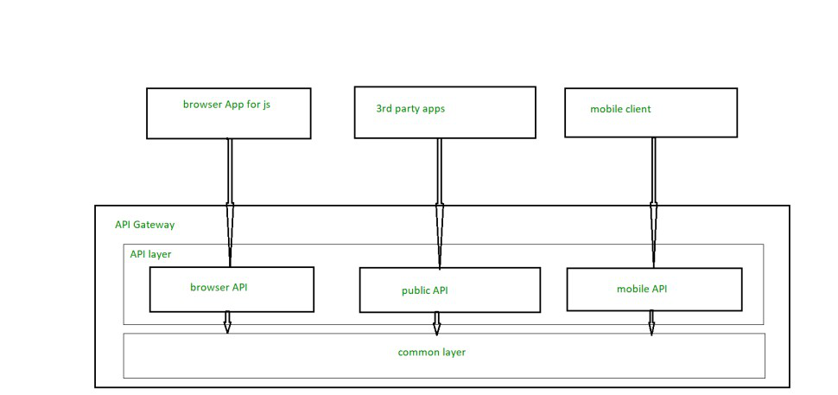
Advantages of API gateway pattern -
- It encloses the whole internal structure of web applications.
- It never calls a particular service. For example, client interaction with API gateway.
- It helps in the simplification of code of the client-side.
Disadvantages of API gateway pattern -
- It is an important component for every web application means the web application services will be shown only if the API is up-to-date means updated.
- It becomes very important for each process for being lightweight because otherwise their time complexity will get increased because their developer has to wait in the process of updating API.
Comment

M

mihikasingh1501
Follow

Microservices API Gateway Pattern in Java: Simplifying Service Access with a Unified Endpoint | Java Design Patterns
Microservices API Gateway Pattern in Java: Simplifying Service Access with a Unified Endpoint
IntegrationAPI designCloud distributedDecouplingEnterprise patternsIntegrationMicroservicesScalabilitySecurityAbout 3 min

On This Page
- Intent of Microservices API Gateway Design Pattern
- Also known as
- Detailed Explanation of Microservices API Gateway Pattern with Real-World Examples
- Programmatic Example of Microservice API Gateway in Java
- When to Use the Microservices API Gateway Pattern in Java
- Microservices API Gateway Pattern Java Tutorials
- Benefits and Trade-offs of Microservices API Gateway Pattern
- Real-World Applications of Microservices API Gateway Pattern in Java
- Related Java Design Patterns
- References and Credits
Intent of Microservices API Gateway Design Pattern
The API Gateway design pattern aims to provide a unified interface to a set of microservices within a microservices architecture. It acts as a single entry point for clients, routing requests to the appropriate microservices and aggregating results, thereby simplifying the client-side code.
Also known as
- API Facade
- Backend for Frontends (BFF)
Detailed Explanation of Microservices API Gateway Pattern with Real-World Examples
Real-world example
In a large e-commerce platform, an API Gateway is used as the single entry point for all client requests, simplifying client-side development. When a user visits the site or uses the mobile app, their requests for product information, user authentication, order processing, and payment are all routed through the API Gateway. The API Gateway handles tasks such as user authentication, rate limiting to prevent abuse, and logging for monitoring purposes, enhancing overall security optimization. This setup simplifies the client interface and ensures that all backend microservices can evolve independently without affecting the client directly, thereby enhancing microservices communication. This also enhances security by providing a centralized point to enforce policies and monitor traffic.
In plain words
For a system implemented using microservices architecture, API Gateway is the single entry point that aggregates the calls to the individual microservices.
Wikipedia says
API Gateway is a server that acts as an API front-end, receives API requests, enforces throttling and security policies, passes requests to the back-end service and then passes the response back to the requester. A gateway often includes a transformation engine to orchestrate and modify the requests and responses on the fly. A gateway can also provide functionality such as collecting analytics data and providing caching. The gateway can provide functionality to support authentication, authorization, security, audit and regulatory compliance.
Sequence diagram
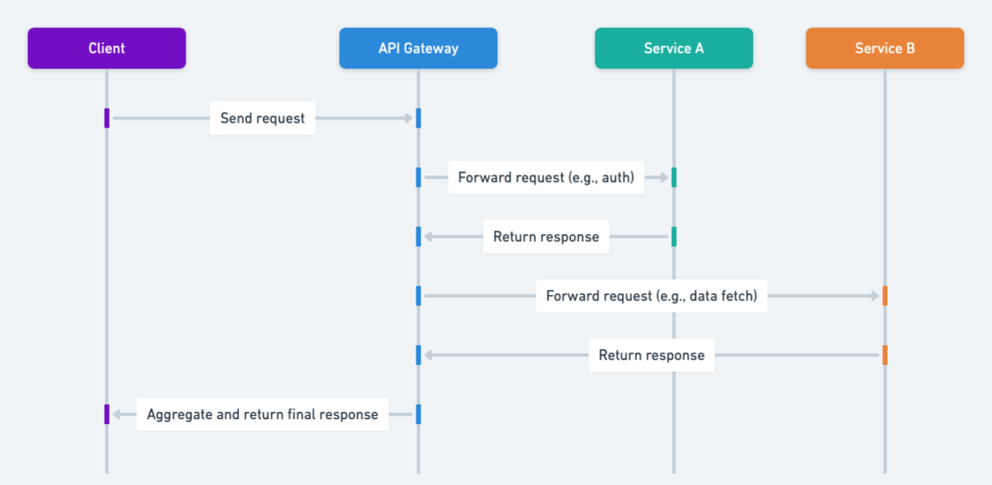
Programmatic Example of Microservice API Gateway in Java
This implementation shows what the API Gateway pattern could look like for an e-commerce site. TheApiGateway makes calls to the Image and Price microservices using the ImageClientImpl and PriceClientImpl respectively. Customers viewing the site on a desktop device can see both price information and an image of a product, so the ApiGateway calls both of the microservices and aggregates the data in the DesktopProduct model. However, mobile users only see price information; they do not see a product image. For mobile users, the ApiGateway only retrieves price information, which it uses to populate the MobileProduct.
Here's the Image microservice implementation.
public interface ImageClient {
String getImagePath();
}

public class ImageClientImpl implements ImageClient {
@Override
public String getImagePath() {
var httpClient = HttpClient.newHttpClient();
var httpGet = HttpRequest.newBuilder()
.GET()
.uri(URI.create("http://localhost:50005/image-path"))
.build();

try {
var httpResponse = httpClient.send(httpGet, BodyHandlers.ofString());
return httpResponse.body();
} catch (IOException | InterruptedException e) {
e.printStackTrace();
}

return null;
}
}
Here's the Price microservice implementation.
public interface PriceClient {
String getPrice();
}

public class PriceClientImpl implements PriceClient {

@Override
public String getPrice() {
var httpClient = HttpClient.newHttpClient();
var httpGet = HttpRequest.newBuilder()
.GET()
.uri(URI.create("http://localhost:50006/price"))
.build();

try {
var httpResponse = httpClient.send(httpGet, BodyHandlers.ofString());
return httpResponse.body();
} catch (IOException | InterruptedException e) {
e.printStackTrace();
}

return null;
}
}
Here we can see how API Gateway maps the requests to the microservices.
public class ApiGateway {

@Resource
private ImageClient imageClient;

@Resource
private PriceClient priceClient;

@RequestMapping(path = "/desktop", method = RequestMethod.GET)
public DesktopProduct getProductDesktop() {
var desktopProduct = new DesktopProduct();
desktopProduct.setImagePath(imageClient.getImagePath());
desktopProduct.setPrice(priceClient.getPrice());
return desktopProduct;
}

@RequestMapping(path = "/mobile", method = RequestMethod.GET)
public MobileProduct getProductMobile() {
var mobileProduct = new MobileProduct();
mobileProduct.setPrice(priceClient.getPrice());
return mobileProduct;
}
}
When to Use the Microservices API Gateway Pattern in Java
- When building a microservices architecture, and there's a need to abstract the complexity of microservices from the client.
- When multiple microservices need to be consumed in a single request.
- For authentication, authorization, and security enforcement at a single point.
- To optimize communication between clients and services, especially in a cloud environment.
Microservices API Gateway Pattern Java Tutorials
- Exploring the New Spring Cloud Gateway (Baeldung)
- Spring Cloud - Gateway(tutorialspoint)
- Getting Started With Spring Cloud Gateway (DZone)
Benefits and Trade-offs of Microservices API Gateway Pattern
Benefits:
- Decouples client from microservices, allowing services to evolve independently.
- Simplifies client by aggregating requests to multiple services.
- Centralized location for cross-cutting concerns like security, logging, and rate limiting.
- Potential for performance optimizations like caching and request compression.
Trade-offs:
- Introduces a single point of failure, although this can be mitigated with high availability setups.
- Can become a bottleneck if not properly scaled.
- Adds complexity in terms of deployment and management.
Real-World Applications of Microservices API Gateway Pattern in Java
- E-commerce platforms where multiple services (product info, pricing, inventory) are aggregated for a single view.
- Mobile applications that consume various backend services but require a simplified interface for ease of use.
- Cloud-native applications that leverage multiple microservices architectures.
Related Java Design Patterns
- Aggregator Microservice - The API Gateway pattern is often used in conjunction with the Aggregator Microservice pattern to provide a unified interface to a set of microservices.
- Circuit Breaker - API Gateways can use the Circuit Breaker pattern to prevent cascading failures when calling multiple microservices.
- Proxy - The API Gateway pattern is a specialized form of the Proxy pattern, where the gateway acts as a single entry point for clients, routing requests to the appropriate microservices and aggregating results.
References and Credits

